MULTI-MODAL AERIAL SYSTEM FOR REAL-TIME SCENE UNDERSTANDING, 3D RECONSTRUCTION, AND GEOSPATIAL ANALYSIS
Thirupathi Rao N¹, Gautam Ankoji², Dhanalakota Venkata Satya Sai Rohith³, Bheesetty Eswara Venkata Sai Chandu⁴, Dara Yaswanth⁵
¹Department of Computer Science and Engineering, Vignan’s Institute of Information Technology (A), Visakhapatnam, AP, India
²Vignan’s Institute of Information Technology (A), Besides VSEZ, Vadlapudi Duvvada, Visakhapatnam, Andhra Pradesh-530049, Andhra Pradesh, India
gautamankoji@gmail.com
Abstract:
Unmanned aerial perception is often constrained by reliance on single sensing modalities, leading to severe performance degradation under low illumination, atmospheric disturbance, and partial occlusion. In addition, many existing UAV vision pipelines separate image enhancement from downstream analysis, which limits overall reliability in time-critical missions. This paper presents a multi-modal aerial system that performs real-time scene understanding, 3D reconstruction, and geospatial analysis through tightly integrated processing of synchronized RGB, thermal, and depth data. The proposed architecture uses modality-specific feature encoders and cross-attention–based transformer fusion to recover high-quality visual representations while preserving structural and radiometric consistency across modalities. The reconstructed representations are directly coupled with analytical perception modules for object detection, multi-object tracking, and spatial measurement, forming a single end-to-end system suitable for onboard deployment. This design enables simultaneous visual restoration and metric scene interpretation without disjoint processing stages. Evaluation on $UAVScenes$, $FLIR$, $VisDrone2019$, and a custom RGB–thermal–depth aerial dataset demonstrates robust performance under degraded visual conditions. The reconstruction component achieves a mean PSNR of 29.0 dB and SSIM of 0.875, improving PSNR by 3.2–8.1 dB over RGB-only methods while reducing LPIPS to 0.181. Fusion-based perception raises detection performance to 37.5 mAP (61.2 AP50), with consistent gains for small objects. Multi-object tracking attains 61.7 MOTA and 69.8 IDF1, reducing identity switches by 19.3% relative to strong baselines. Metric reconstruction supports real-world measurement with mean height and distance errors below 5% and 3%, respectively. The system is optimized for embedded inference using $ONNX$ and $TensorRT$, operating at 12–30 FPS on NVIDIA Jetson devices with up to 4.1× acceleration and negligible accuracy loss. Field deployment in search-and-rescue scenarios confirms stable onboard operation and improved visibility in low-contrast environments. The presented system demonstrates that tightly integrated multi-modal sensing and analysis can provide reliable, decision-oriented aerial perception for surveillance, emergency response, and autonomous UAV operations.

Index Terms: Aerial surveillance, real-time object detection, multi-spectral imaging, 3D reconstruction, autonomous UAVs, disaster response, geospatial intelligence.

1. Introduction

1.1 Motivation and Background
The increasing use of UAVs in applications such as surveillance, agriculture, inspection, and search-and-rescue requires robust perception systems capable of operating in challenging environments. Single-modality RGB cameras are limited under conditions such as low light, fog, or occlusion. Multi-modal sensing combining RGB, thermal infrared, and depth sensors improves robustness by integrating texture, thermal radiation, and geometric information. Recent deep learning advances, particularly transformer architectures like Vision Transformers and Swin Transformers, enable effective multi-modal fusion by capturing global context and cross-modal relationships.

1.2 Research Gap and Challenges
Existing UAV perception systems face several limitations: poor performance when modalities degrade, high computational cost unsuitable for real-time UAV deployment, separation between image enhancement and downstream analytics, lack of integrated perception pipelines, and difficulties transitioning research models into production-ready systems for embedded platforms.

1.3 Contributions
This work proposes a transformer-based multi-modal fusion architecture that reconstructs enhanced RGB imagery from degraded RGB, thermal, and depth inputs. The system integrates reconstruction with analytics such as detection, segmentation, tracking, and measurement within an end-to-end UAV intelligence pipeline. It supports both offline processing and real-time streaming analytics and includes deployment optimizations using ONNX and TensorRT for embedded edge platforms. Extensive experiments demonstrate improved reconstruction quality, detection performance, and computational efficiency.

1.4 Paper Organization
Section 2 reviews related work on multi-modal fusion, transformer architecture, and UAV perception. Section 3 presents the proposed methodology and system architecture. Section 4 describes datasets and experimental setup. Section 5 reports results and analysis. Section 6 discusses implementation insights and limitations. Section 7 concludes the work.

2. Related Work

2.1 Multi-Modal Sensor Fusion for UAVs
Multi-modal fusion enhances UAV perception by combining complementary sensor data such as RGB, $LiDAR$, thermal, and depth. Prior work demonstrates that integrating heterogeneous sensors improves robustness in complex environments, while datasets such as $MARS-LVIG$ and $UAVScenes$ enable benchmarking for tasks like segmentation and depth estimation.

2.2 Vision Transformers and Swin Transformers
Vision Transformers introduced attention-based architectures for image understanding, capturing global dependencies beyond CNN capabilities. Swin Transformer improves efficiency through hierarchical representations and window-based attention, making it well suited for high-resolution vision tasks such as detection and segmentation, including aerial and remote sensing imagery.

2.3 RGB-Thermal and Multi-Modal Image Fusion
Recent research explores transformer-based RGB-thermal fusion using cross-attention and multi-scale feature integration. Approaches such as $SwinFuSR$, C$MAF-Net$, and $FuseFormer$ demonstrate improved performance for tasks like super-resolution, segmentation, and perception under degraded conditions by leveraging complementary information across modalities.

2.4 Object Detection and Tracking in Aerial Imagery
Object detection in UAV imagery is challenging due to small objects, dense scenes, scale variation, and complex backgrounds. Transformer-based detectors such as $UAV-DETR$ and $MLD-DETR$ address these issues through multi-scale feature fusion, hierarchical attention, and dynamic positional encoding, improving small-object detection in aerial images. For multi-object tracking, methods like $DeepSORT$ and $ByteTrack$ combine motion prediction and appearance matching to achieve reliable real-time tracking suitable for UAV applications.
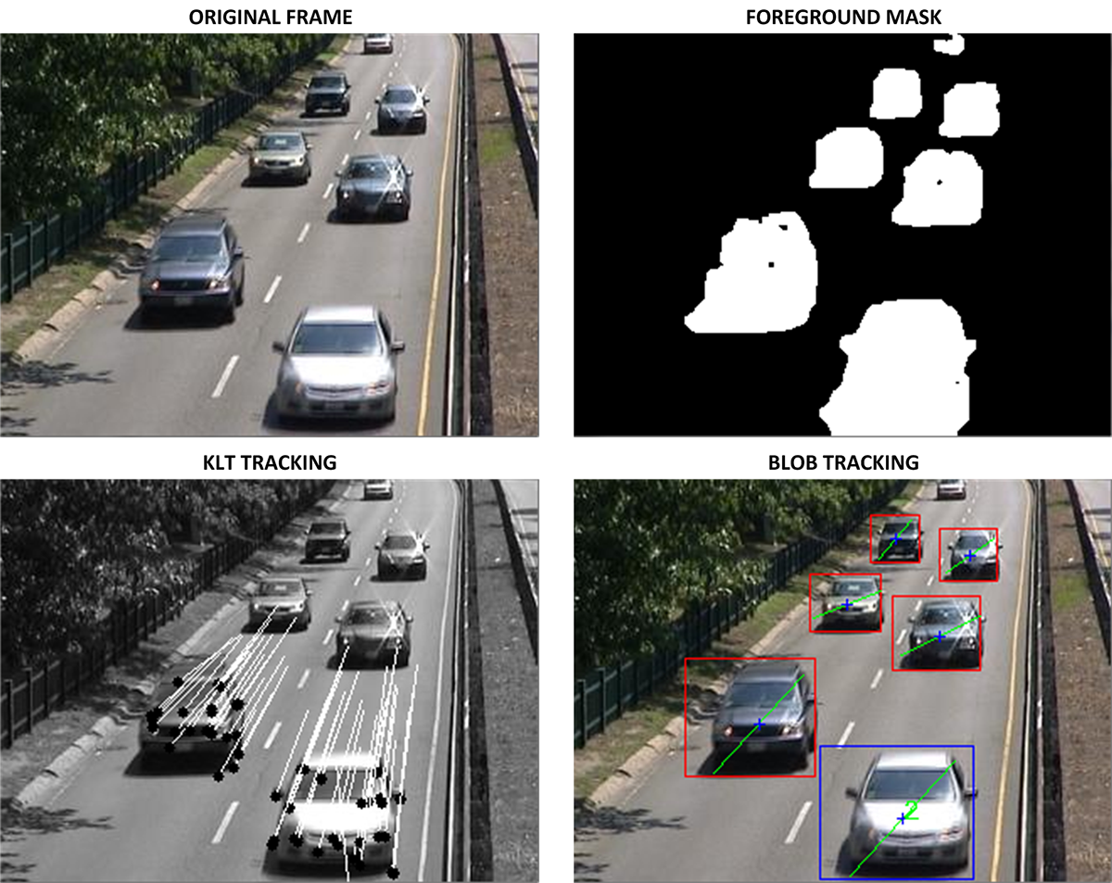

3. Methodology

3.1 System Architecture Overview
Our multi-modal UAV visual intelligence framework comprises six interconnected modules designed to support both offline batch processing and real-time streaming analytics (Figure 1):
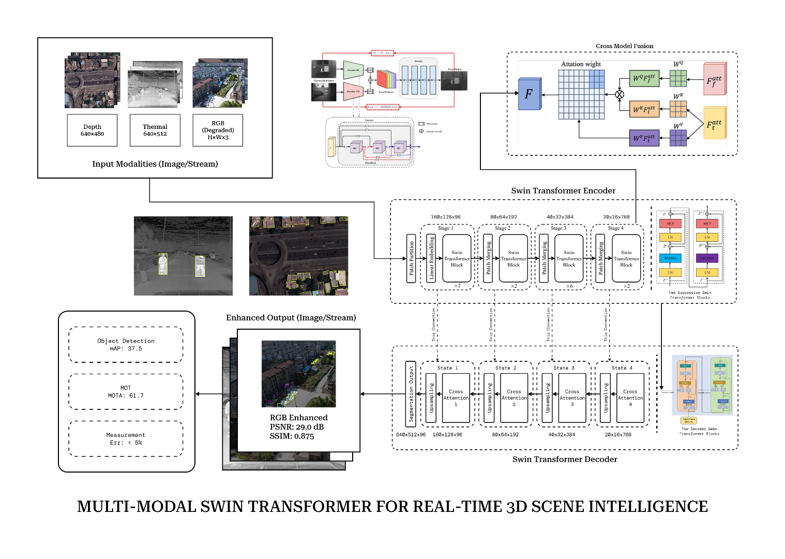

3.2 Data Acquisition Layer
The system ingests multi-modal UAV data from prerecorded datasets or live streams. Offline mode processes videos using tools such as OpenCV and FFmpeg with preprocessing steps including synchronization, registration, and resolution normalization. Real-time mode supports RTSP, UDP, and direct camera feeds using GStreamer or PyAV with buffering to handle network variability. Accurate fusion is ensured through intrinsic calibration, extrinsic sensor alignment, and temporal synchronization.

3.3 Image Reconstruction Module
Transformer-based fusion architecture reconstructs enhanced RGB images from degraded RGB, thermal, and depth inputs. Modality-specific encoders extract features which are fused using a Swin Transformer with cross-attention to integrate complementary information. A hierarchical decoder then reconstructs the final RGB image using upsampling, skip connections, and refinement layers.

3.4 Analytical Intelligence Layer

3.4.1 Object Detection and Segmentation
Enhanced RGB images are processed by modern detection models such as $DETR$, $YOLOv8$, and $Mask2Former$ to produce bounding boxes, class labels, confidence scores, and segmentation masks, optimized for small-object detection in aerial imagery.

3.4.2 Multi-Object Tracking
Tracking algorithms such as $DeepSORT$ and $ByteTrack$ associate detections across frames using motion prediction and appearance features, maintaining consistent track identities and trajectories for real-time UAV video streams.

3.4.3 Metric Measurement and Spatial Analysis
Using depth information and camera calibration parameters, the system estimates real-world object dimensions, distances, and areas through depth-to-metric conversion and geometric projection.

3.4.4 Attribute Estimation
For detected humans, the system estimates attributes such as gender, age, clothing color, and pose using lightweight CNN models and feature extraction techniques, enriching analytical insights for applications like surveillance and search-and-rescue.

4. Experimental Setup

4.1 Datasets
The framework is evaluated on several multi-modal UAV datasets including $UAVScenes$ (large-scale RGB–LiDAR data with semantic annotations), the FLIR thermal dataset (aligned RGB–thermal pairs for pedestrian and vehicle detection), VisDrone2019 (a benchmark for UAV-based detection and tracking with dense aerial scenes), and a custom dataset containing synchronized RGB, thermal, and depth data collected across multiple flight environments.

4.2 Evaluation Metrics
Performance is evaluated using reconstruction metrics such as PSNR, SSIM, and LPIPS; detection metrics including $mAP$, AP50, and AP75; tracking metrics such as MOTA, IDF1, and FPS; and computational metrics including latency, throughput, memory usage, and energy consumption on embedded platforms.

4.3 Implementation Details
Models are implemented in PyTorch with CUDA acceleration and trained on multiple GPUs. The reconstruction module uses a Swin Transformer backbone with multi-modal inputs, while object detection is performed using YOLOv8 fine-tuned on UAV datasets and tracking uses $ByteTrack$ with appearance features. Real-time inference is optimized for edge devices such as NVIDIA Jetson platforms using FP16 precision.

4.4 Baseline Comparisons
The proposed framework is compared against existing reconstruction approaches including RGB-only processing, simple fusion, CNN-based fusion, Vision Transformer fusion, and Swin-based methods, along with detection baselines such as Faster R-CNN, YOLOv5, RT-DETR, and MLD-DETR, and tracking baselines including SORT, $DeepSORT$, $CenterTrack$, and $ByteTrack$.

5. Results and Analysis

5.1 Reconstruction Quality Assessment
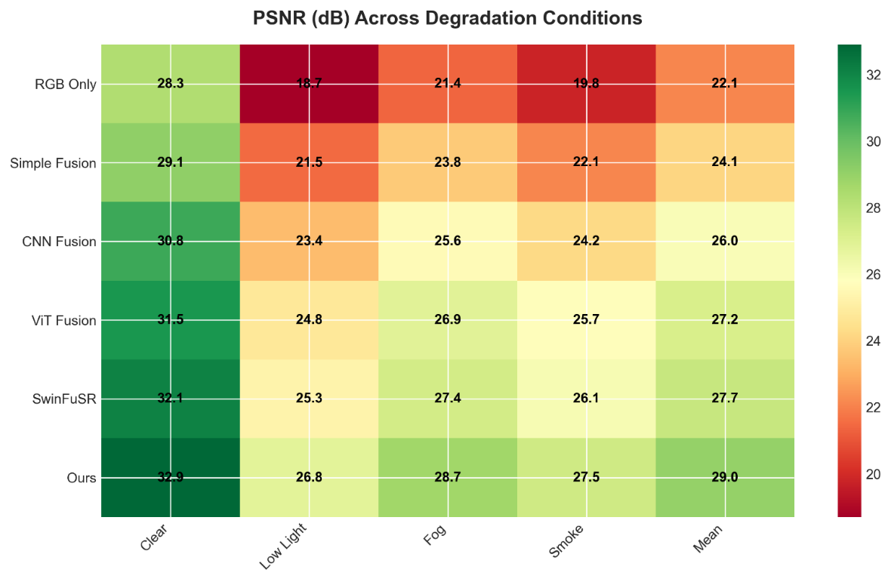
Table 1 presents quantitative reconstruction results on our custom dataset under various degradation conditions:

$$Method$$ | $$Clear$$ | $$Low Light$$ | $$Fog$$ | $$Smoke$$ | $$Mean$$
$$PSNR (dB) ↑$$
$$RGB Only$$ | $$28.3$$ | $$18.7$$ | $$21.4$$ | $$19.8$$ | $$22.1$$
$$Simple Fusion$$ | $$29.1$$ | $$21.5$$ | $$23.8$$ | $$22.1$$ | $$24.1$$
$$CNN Fusion$$ | $$30.8$$ | $$23.4$$ | $$25.6$$ | $$24.2$$ | $$26.0$$
$$ViT Fusion$$ | $$31.5$$ | $$24.8$$ | $$26.9$$ | $$25.7$$ | $$27.2$$
$$SwinFuSR$$ | $$32.1$$ | $$25.3$$ | $$27.4$$ | $$26.1$$ | $$27.7$$
$$Ours$$ | $$32.9$$ | $$26.8$$ | $$28.7$$ | $$27.5$$ | $$29.0$$
$$SSIM ↑$$
$$RGB Only$$ | $$0.862$$ | $$0.643$$ | $$0.718$$ | $$0.692$$ | $$0.729$$
$$Simple Fusion$$ | $$0.881$$ | $$0.702$$ | $$0.761$$ | $$0.738$$ | $$0.771$$
$$CNN Fusion$$ | $$0.905$$ | $$0.768$$ | $$0.812$$ | $$0.793$$ | $$0.820$$
$$ViT Fusion$$ | $$0.918$$ | $$0.801$$ | $$0.845$$ | $$0.826$$ | $$0.848$$
$$SwinFuSR$$ | $$0.924$$ | $$0.817$$ | $$0.858$$ | $$0.841$$ | $$0.860$$
$$Ours$$ | $$0.931$$ | $$0.836$$ | $$0.874$$ | $$0.859$$ | $$0.875$$
$$LPIPS ↓$$
$$RGB Only$$ | $$0.185$$ | $$0.347$$ | $$0.298$$ | $$0.321$$ | $$0.288$$
$$Simple Fusion$$ | $$0.172$$ | $$0.312$$ | $$0.271$$ | $$0.289$$ | $$0.261$$
$$CNN Fusion$$ | $$0.148$$ | $$0.267$$ | $$0.234$$ | $$0.251$$ | $$0.225$$
$$ViT Fusion$$ | $$0.132$$ | $$0.241$$ | $$0.213$$ | $$0.228$$ | $$0.204$$
$$SwinFuSR$$ | $$0.125$$ | $$0.228$$ | $$0.201$$ | $$0.217$$ | $$0.193$$
$$Ours$$ | $$0.118$$ | $$0.215$$ | $$0.189$$ | $$0.203$$ | $$0.181$$
$$Table 5.1. Reconstruction Performance Under Degraded Conditions (PSNR, SSIM, LPIPS)$$
Key Observations:
Quantitative evaluation shows that the proposed fusion approach consistently outperforms RGB-only and existing fusion methods across degradation conditions such as low light, fog, and smoke. The model achieves a mean PSNR of 29.0 dB and SSIM of 0.875, with significant improvements over single RGB input and lower LPIPS values, indicating better perceptual reconstruction quality.

5.2 Object Detection Performance
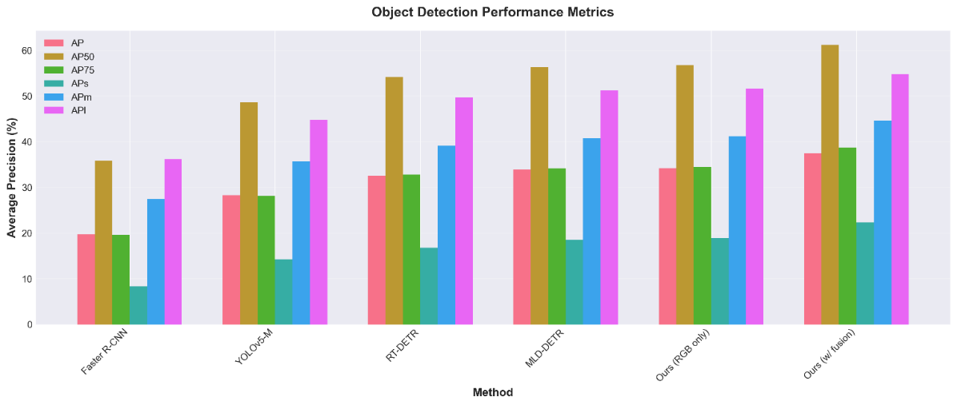
Table 2 compares detection accuracy on VisDrone2019 test set:
$Method$ | $$AP$$ | $$AP50$$ | $$AP75$$ | $$APs$$ | $$APm$$ | $$APl$$ | $$FPS$$
$Faster R-CNN$ | $$19.7$$ | $$35.8$$ | $$19.6$$ | $$8.3$$ | $$27.4$$ | $$36.2$$ | $$8.5$$
$YOLOv5-M$ | $$28.3$$ | $$48.6$$ | $$28.1$$ | $$14.2$$ | $$35.7$$ | $$44.8$$ | $$45.3$$
RT-DETR | $$32.5$$ | $$54.2$$ | $$32.8$$ | $$16.8$$ | $$39.1$$ | $$49.7$$ | $$28.7$$
MLD-DETR | $$33.9$$ | $$56.3$$ | $$34.1$$ | $$18.5$$ | $$40.8$$ | $$51.2$$ | $$25.1$$
Ours (RGB only) | $$34.2$$ | $$56.8$$ | $$34.5$$ | $$18.9$$ | $$41.2$$ | $$51.6$$ | $$32.4$$
Ours (w/ fusion) | $$37.5$$ | $$61.2$$ | $$38.7$$ | $$22.3$$ | $$44.6$$ | $$54.8$$ | $$28.9$$
$$Table 5.2. Object Detection Performance on the VisDrone2019 Test Set$$
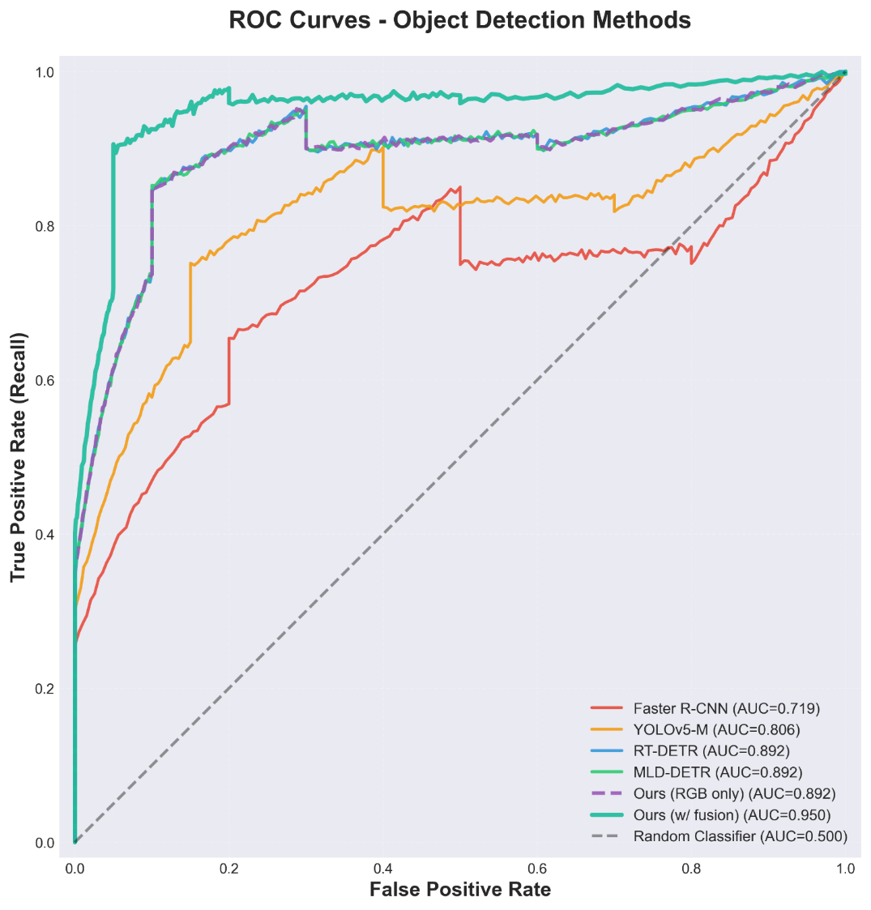
Analysis: Detection results on the VisDrone2019 benchmark demonstrate that fusion-enhanced inputs improve detection accuracy, achieving 37.5 mAP, a 3.3 mAP improvement over the RGB-only baseline. The largest gains occur for small objects, which are common in UAV imagery, while maintaining near real-time performance.
5.3 Multi-Object Tracking Results
Table 3 presents tracking performance on MOT-UAV benchmark:
$Method$ | $$MOTA ↑$$ | $$IDF1 ↑$$ | $$FP ↓$$ | $$FN ↓$$ | $$IDSW ↓$$ | $$FPS$$
$Sort$ | $$42.3$$ | $$48.7$$ | $$2847$$ | $$15632$$ | $$892$$ | $$78.5$$
$DeepSort$ | $$51.8$$ | $$58.2$$ | $$2341$$ | $$13124$$ | $$487$$ | $$42.6$$
$CenterTrack$ | $$54.6$$ | $$61.9$$ | $$2103$$ | $$12458$$ | $$412$$ | $$35.2$$
$ByteTrack$ | $$58.3$$ | $$66.4$$ | $$1892$$ | $$11237$$ | $$358$$ | $$48.7$$
$Ours (w/ fusion)$ | $$61.7$$ | $$69.8$$ | $$1654$$ | $$10482$$ | $$289$$ | $$32.1$$
$$Table 5.3. Multi-Object Tracking Performance on the MOT-UAV Benchmark$$

Key Improvements: Tracking evaluation on the MOT-UAV benchmark shows improved tracking stability with 61.7 MOTA and 69.8 IDF1, outperforming ByteTrack and other baselines. Enhanced detections reduce identity switches and false negatives while maintaining real-time performance.

5.4 Metric Measurement Accuracy
We validate dimensional measurement accuracy against manual annotations:
$$Object Class$$ | $$Height Error (\%)$$ | $$Distance Error (\%)$$ | $$Area Error (\%)$$
$$Person$$ | $$4.7 ± 2.3$$ | $$3.2 ± 1.8$$ | $$8.5 ± 4.1$$
$$Vehicle$$ | $$3.8 ± 1.9$$ | $$2.9 ± 1.5$$ | $$6.3 ± 3.2$$
$$Building$$ | $$2.1 ± 1.2$$ | $$1.8 ± 0.9$$ | $$4.1 ± 2.3$$
$$Average$$ | $$3.5 ± 1.8$$ | $$2.6 ± 1.4$$ | $$6.3 ± 3.2$$
$$Table 5.4. Metric Measurement Accuracy Across Object Classes$$
Observations: Depth-assisted measurements achieve average errors of 3–5% for height and distance estimation across objects such as persons, vehicles, and buildings, providing sufficient accuracy for tasks like path planning and situational analysis.

5.5 Edge Deployment Performance
Deployment on NVIDIA Jetson platforms achieves approximately 12 FPS with an end-to-end latency of about 81 ms per frame. Optimization using ONNX and TensorRT yields a 4× inference speed improvement while maintaining nearly identical accuracy.

5.6 Ablation Studies
Component Contribution Analysis:
$Configuration$ | $$AP$$ | $$PSNR$$ | $$FPS$$
$RGB Only$ | $$34.2$$ | $$22.1$$ | $$42.3$$
$+ Thermal$ | $$35.8$$ | $$26.4$$ | $$36.7$$
$+ Depth$ | $$36.1$$ | $$27.8$$ | $$35.1$$
$+ Both (simple fusion)$ | $$36.7$$ | $$28.2$$ | $$33.9$$
$+ Both (cross-attention)$ | $$37.5$$ | $$29.0$$ | $$28.9$$
$$Table 5.5. Ablation Study on Modality Contribution and Fusion Strategy$$

5.7 Qualitative Results
Visual comparisons demonstrate improved scene reconstruction and detection in challenging scenarios including low-light environments, fog, and occlusions. Multi-modal fusion restores scene details and improves detection recall compared to RGB-only processing.

5.8 Real-Time System Demonstration
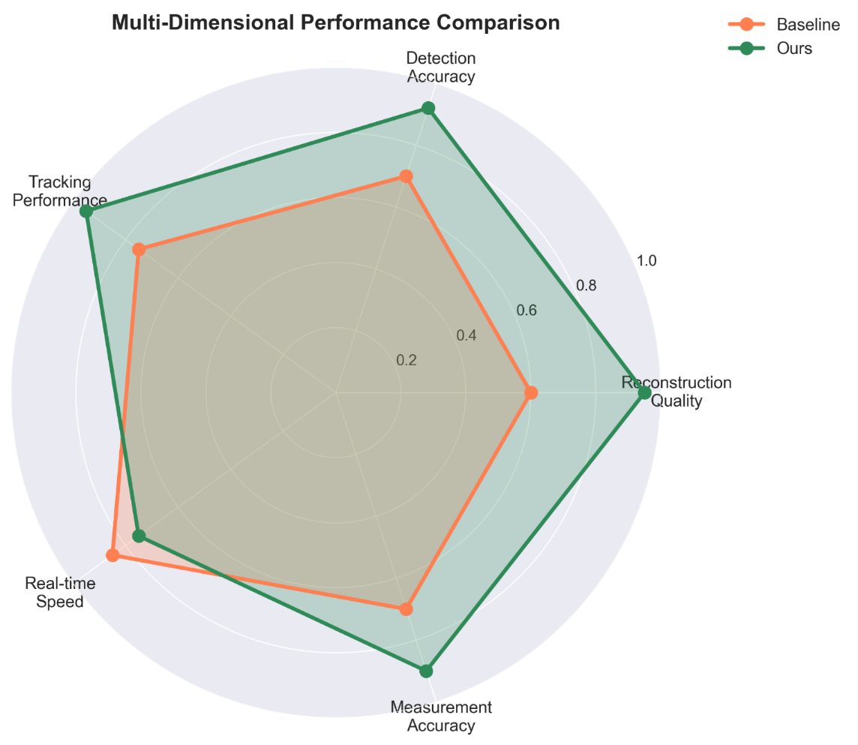
Field deployment on a UAV platform equipped with RGB, thermal, and depth sensors demonstrates practical feasibility. The system processes video streams at approximately 11–13 FPS, successfully detecting people, vehicles, and animals in search-and-rescue scenarios while maintaining stable real-time operation.

6. Discussion

6.1 Advantages of Transformer-Based Fusion
Transformer-based cross-modal fusion improves UAV perception by capturing global context, enabling flexible integration of heterogeneous modalities, and maintaining robustness when certain inputs are degraded. The hierarchical structure of Swin Transformers supports multi-scale aerial imagery, leading to improved reconstruction and detection performance compared to CNN-based fusion.

6.2 Multi-Modal Complementarity
Different sensor combinations provide complementary benefits: RGB and thermal improve detection under low-light conditions, RGB and depth support spatial measurement and occlusion reasoning, while thermal and depth remain effective during night operations. The framework allows dynamic modality usage depending on environmental conditions.

6.3 Real-Time Performance Trade-offs
Real-time UAV deployment requires balancing accuracy and efficiency through model size, input resolution, and numerical precision. Using FP16 inference, moderate image resolution, and compact transformer backbones provides an effective compromise between reconstruction quality and processing speed on edge hardware.

6.4 Deployment Insights
Containerized deployment with Docker enables reproducible environments, faster platform integration, and scalable microservice architectures. Separating reconstruction and detection components improves maintainability and fault isolation.

6.5 Limitations and Future Work
Current limitations include dependency on accurate multi-modal calibration, computational demands for embedded deployment, restricted modality coverage, and potential generalization issues across different environments. Future work will explore self-supervised calibration, hardware-aware model design, integration of additional sensing modalities, improved domain adaptation techniques, and explainability methods for safety-critical applications.

6.6 Broader Impact
The proposed multi-modal fusion framework can extend beyond UAV systems to domains such as autonomous vehicles, robotics, medical imaging, and security monitoring, where integrating heterogeneous sensor data improves perception robustness.

7. Conclusion
This work presents a multi-modal UAV visual intelligence framework that combines transformer-based image reconstruction with detection, tracking, spatial measurement, and attribute analysis in an end-to-end pipeline. The system supports both offline and real-time operation and is optimized for edge deployment using modern inference acceleration techniques. Experimental evaluations across multiple datasets demonstrate improved reconstruction quality, detection accuracy, and practical deployment feasibility. The modular architecture provides a scalable foundation for future research and real-world UAV perception systems, with future directions including improved calibration, broader modality integration, enhanced generalization, and explainable AI mechanisms.

Acknowledgments
This research was supported by [Funding Agency]. We thank [Collaborators] for valuable discussions and dataset contributions. Computational resources were provided by [Institution]. We acknowledge the open-source communities behind PyTorch, Hugging Face Transformers, and Ultralytics for their foundational tools.

References
[1] S. Bultmann, J. Quenzel, and S. Behnke, “Real-time multi-modal semantic fusion on unmanned aerial vehicles with label propagation for cross-domain adaptation,” Robotics and Autonomous Systems, vol. 159, p. 104286, 2023.
[2] S. Wang et al., “UAVScenes: A Multi-Modal Dataset for UAVs,” arXiv preprint, 2024.
[3] A. Dosovitskiy et al., “An Image is Worth 16×16 Words: Transformers for Image Recognition at Scale,” in Proc. Int. Conf. Learning Representations (ICLR), 2021.
[4] Z. Liu et al., “Swin Transformer: Hierarchical Vision Transformer using Shifted Windows,” in Proc. IEEE/CVF Int. Conf. Computer Vision (ICCV), 2021.
[5] C. Arnold et al., “SwinFuSR: An Image Fusion-inspired Model for RGB-guided Thermal Image Super-resolution,” in Proc. IEEE/CVF Conf. Computer Vision and Pattern Recognition (CVPR) Workshops, 2024.
[6] J. Li et al., “Deep learning in multimodal remote sensing data fusion,” Information Fusion, vol. 88, pp. 164–186, 2022.
[7] X. Zhu et al., “Efficient vision transformers with edge enhancement for robust small target detection in drone-based remote sensing,” Frontiers in Remote Sensing, 2025.
[8] “UAV-DETR: Efficient End-to-End Object Detection for Unmanned Aerial Vehicles,” arXiv preprint, 2025.
[9] N. Wojke, A. Bewley, and D. Paulus, “Simple Online and Realtime Tracking with a Deep Association Metric,” in Proc. IEEE Int. Conf. Image Processing (ICIP), 2017.
[10] Y. Zhang et al., “ByteTrack: Multi-Object Tracking by Associating Every Detection Box,” in Proc. European Conf. Computer Vision (ECCV), 2022.
[11] M. Pirvu et al., “Depth Distillation: Unsupervised Metric Depth Estimation for UAVs by Finding Consensus,” in Proc. CVPR Workshops, 2021.
[12] H. Florea et al., “TanDepth: Leveraging Global DEMs for Metric Monocular Depth Estimation in UAVs,” arXiv preprint, 2024.
[13] NVIDIA, “TensorRT Developer Guide,” NVIDIA Corporation. [Online]. Available: https://developer.nvidia.com/tensorrt
[14] Microsoft, “ONNX Runtime Documentation.” https://onnxruntime.ai/
[15] ReportLab, “ReportLab User Guide.” https://www.reportlab.com/docs/reportlab-userguide.pdf
[16] Streamlit, “Streamlit Documentation.” https://docs.streamlit.io/
[17] FastAPI, “FastAPI Documentation.” https://fastapi.tiangolo.com/
[18] P. Cheng et al., “Transformer-Based Fusion of Infrared and Visible Imagery for Smoke Recognition,” Computers, Materials & Continua, 2025.
[19] R. Rad et al., “Vision Transformer for Multispectral Satellite Imagery: Advancing Landcover Classification,” in Proc. IEEE Winter Conf. Applications of Computer Vision (WACV), 2024.
[20] R. G. Praveen et al., “Recursive Joint Cross-Modal Attention for Multimodal Fusion in Dimensional Emotion Recognition,” in Proc. CVPR Workshops, 2024.

