**ART 210** | ***Introduction to Digital Arts***

Colby Jennings - Associate Professor  
bcjennings@missouristate.edu

Office: BRK1 Room 327

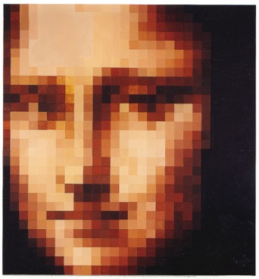Pixelated image of mushroom from the Super Mario series of console games.
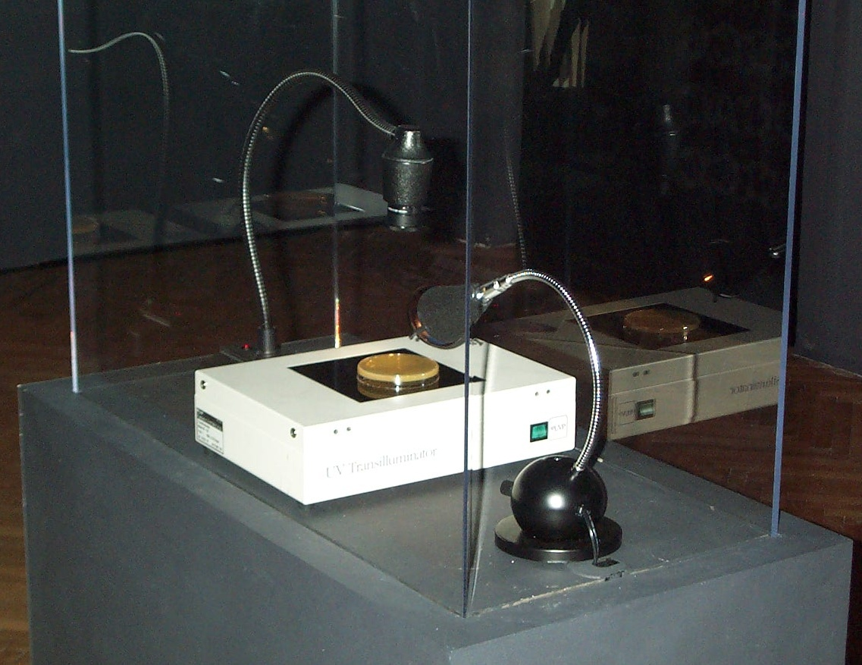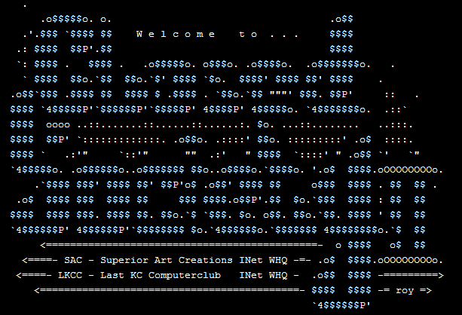

**Introduction | What is Digital Art?**

From Wikipedia:

Digital art is an artistic work or practice that uses [digital technology](https://en.wikipedia.org/wiki/Digital_technology) as part of the creative or presentation process. Since the 1960s, various names have been used to describe the process, including [computer art](https://en.wikipedia.org/wiki/Computer_art) and [multimedia art](https://en.wikipedia.org/wiki/Multimedia_art).[[1]](https://en.wikipedia.org/wiki/Digital_art#cite_note-1) Digital art is itself placed under the larger umbrella term [new media art](https://en.wikipedia.org/wiki/New_media_art).[[2]](https://en.wikipedia.org/wiki/Digital_art#cite_note-2)[[3]](https://en.wikipedia.org/wiki/Digital_art#cite_note-3)

After some initial resistance,[[4]](https://en.wikipedia.org/wiki/Digital_art#cite_note-4) the impact of digital technology has transformed activities such as [painting](https://en.wikipedia.org/wiki/Painting), [drawing](https://en.wikipedia.org/wiki/Drawing), [sculpture](https://en.wikipedia.org/wiki/Sculpture) and music/[sound art](https://en.wikipedia.org/wiki/Sound_art), while new forms, such as [net art](https://en.wikipedia.org/wiki/Net_art), digital [installation art](https://en.wikipedia.org/wiki/Installation_art), and [virtual reality](https://en.wikipedia.org/wiki/Virtual_reality), have become recognized artistic practices.[[5]](https://en.wikipedia.org/wiki/Digital_art#cite_note-5) More generally the term digital artist is used to describe an artist who makes use of [digital technologies](https://en.wikipedia.org/wiki/Digital_technology) in the production of art. In an expanded sense, "digital art" is [contemporary art](https://en.wikipedia.org/wiki/Contemporary_art) that uses the methods of [mass production](https://en.wikipedia.org/wiki/Mass_production) or digital media.[[6]](https://en.wikipedia.org/wiki/Digital_art#cite_note-6)

The techniques of digital art are used extensively by the mainstream [media](https://en.wikipedia.org/wiki/Mass_media) in advertisements, and by film-makers to produce [visual effects](https://en.wikipedia.org/wiki/Visual_effects). [Desktop publishing](https://en.wikipedia.org/wiki/Desktop_publishing) has had a huge impact on the publishing world, although that is more related to [graphic design](https://en.wikipedia.org/wiki/Graphic_design). Both digital and traditional artists use many sources of electronic information and programs to create their work.[[7]](https://en.wikipedia.org/wiki/Digital_art#cite_note-7) Given the parallels between visual and musical arts, it is possible that general acceptance of the value of digital visual art will progress in much the same way as the increased acceptance of electronically produced music over the last three decades.[[8]](https://en.wikipedia.org/wiki/Digital_art#cite_note-8)

This is a studio course first and foremost. In keeping with the tradition of a studio arts course, the focus of the classroom experience will be on art and art-making. We will be specifically looking at trends and themes present within Contemporary Art by way of presentations, readings, and class discussion.

Our time together in class is formatted as a combination of seminar and studio time including presentations of contemporary digital artworks and artists, discussions pertaining to assigned readings, software and technique tutorials, as well as group critiques. In addition to work time provided in class, outside work will be required.

This course will focus on core intentional or inherent aspects of digital art. Some of these aspects are properties unique to digital media such as dynamic data, interactivity, or networking. Other aspects are subjects commonly taken up in the creation of digital art, such as telematic space, the architecture of time, the body and identity, decentralized authorships and hive-mind behavior. This class will introduce the core skills necessary to employ digital media in the generative and investigative context of art making.

The course is broken up into diverse topical units of approximately three weeks each. Within each unit the assignments, lectures, presented projects, and readings relate to the topic. These topics include: space, time, body + identity, data, and context. There are other topics / concerns inherent to the medium that will be with us throughout the semester including: authorship, remix, appropriation, composition, interface, input / output, and interactivity.

**statement**

As you will likely realize throughout this course, much of the language and tradition to be found in other mediums of creative production / research are relatively settled… even if only as a foundation upon which new paradigms evolve. This is barely true, if at all, for the realm of Digital Art. Even the term “Digital Art” is problematic as it does not accurately depict or describe the practices, products, artifacts, and artists that will be observed this semester.

“Digital media art has been practiced and theorized within frameworks of more traditional media, such as television, avant-garde art, and fluxus art. However, the understanding of what is radically new about digital media often eludes such frameworks, because digital media challenges many of the paradigms which these frameworks are built upon. The need for an original framework which emerges from digital media is imperative for a new medium.”

* *excerpt from the Thesis statement from DXARTS 201 syllabus, offered in the DXARTS Program at the University of Washington, Seattle, WA.*

The medium in question for this course is better defined loosely by the terms “flux” or “emerging” in that it is constantly changing and evolving. If there are roots, they are bonded to the first transmission of signal over distance using electricity. Communication in the form of analog signals provide an appropriate starting point, but even this communication relied heavily on earlier forms of long-distance communication (smoke signals ≈ Morse code).

**catalogue description**

Exploration of Digital Art forms, focusing on the interrelationship of the digital technology on art and culture. The goal of the course is to weave technical skills into creative vision.

**goals**

* Creation of art projects in various formats based on assignments
* Understanding of basic techniques for digital art production
* Exploration of digital art practices in the context of course topics
* Investigation of the historical and theoretical concerns relevant to Digital Art
* Developing personal strategies for art making
* Expansion of creative realization

**materials**

In order to succeed in this course, you will need the following:

* A dedicated storage solution of your choice with approx. 16GB available. This can be a thumb drive, cloud storage, portable hard drive, etc. This should be something that you can access at home and on campus.
* Access to a computer outside of class time. Please note that open lab hours will be posted for each room either on the door or just outside of the door. These open lab times should be in effect for the entire semester.

**readings**

*Sentences on Conceptual Art* by Sol Lewitt

http://www.altx.com/vizarts/conceptual.html

*The Work of Art in the Age of Mechanical Reproduction* by Walter Benjamin

https://web.mit.edu/allanmc/www/benjamin.pdfs

*The Unique Phenomenon of a Distance* by Ken Goldberg

https://goldberg.berkeley.edu/art/tele/intro.html

*Akademie X - Lessons in Art + Life*

https://www.phaidon.com/store/art/akademie-x-9780714867366/#tab-1

*Notes for an Introductory Lecture* by Walead Beshty

<https://www.actionstakenunderthefictitiousnamewaleadbeshtystudiosinc.com/lesson-notes-for-an-introductory-lecture>

*New Media Installation* by Sandu Publications

Gingko Press Inc, Nov., 2018. -

*Form + Code in Design, Art, and Architecture* by Casey Reas and Chandler McWilliams

Princeton Architectural Press, Nov. 2010 -

**resources**

*Photoshop*

helpx.adobe.com - <https://helpx.adobe.com/photoshop/tutorials.html>

Complete Beginner’s Guide (2014) - [link](https://www.youtube.com/watch?v=sF_jSrBhdlg&list=PLYfCBK8IplO6v0QjCj-TSrFUXnRV0WxfE)

Photoshop 2020 Beginner - [link](https://youtu.be/TPKHO52AQ-U)

*Processing + p5js*

[processing.org](http://processing.org) | [p5js.org](http://p5js.org) | [openprocessing.org](http://openprocessing.org)

[learnprocessing.com](http://learnprocessing.com) | [natureofcode.com](http://natureofcode.com) | [shiffman.net](http://shiffman.net)

[Learn processing YouTube](https://www.youtube.com/c/TheCodingTrain/playlists?view=50&sort=dd&shelf_id=10) | [Learn p5js Youtube](https://www.youtube.com/playlist?list=PLRqwX-V7Uu6Zy51Q-x9tMWIv9cueOFTFA) | [Nature of Code Youtube](https://www.youtube.com/c/TheCodingTrain/playlists?view=50&sort=dd&shelf_id=9)

**student responsibilities**

* Be Respectful (of your peers, the instructor, the facilities, and the education process)
* Be Resourceful and seek out help from multiple sources when needed
* Participate in all class activities
* Share your knowledge with your peers
* Take care of your data
* Finally, you are expected to come to class prepared

**attendance //Modify based on Mask / COVID Data**

Attendance credit for this course will be generated through the scheduled meeting times with the faculty member. It is also expected that the students will have a rigorous, individual work schedule that will support ample productivity throughout the semester. Setting a consistent work schedule with ample dedicated time to research and practice is expected. As life can and does certainly happen, you should notify the faculty member if anything will keep you from making a scheduled appointment as soon as you know of the conflict. Reasonable accommodations will be made in the following instances suggested by MSU’s attendance policy: 1) participation in University-sanctioned activities and programs; 2) personal illness; or 3) family and/or other compelling circumstances.

**communication / etiquette**

I am here to help, and I want you and your work to truly flourish. If you would like to meet outside of our regular schedule, please email with ample notice so as to find where our schedules align. For email, please allow 24 to 48 hours for response. If you need a faster response or the message is time sensitive, please put “Urgent” in the subject line, and then detail the response time required in the first line of the body or your email, before the greeting.

**grading policy**

Your final grade for this course is based on quality and quantity of work, your dedication to your research and creative practice, and conceptual development of your work during the semester.

**studio / lab safety**

You will be required to use the appropriate safety equipment and practice safe operation procedures when using any hazardous equipment or materials. Your ability to adhere to these safety requirements is essential to your success in this course. These policies also help to protect your health and ensure a long and fruitful career!

* + Know where the nearest first aid kit is located.
  + When using hazardous materials / chemicals / etc. know where these are permitted and use proper protective gear at all times.
  + Food and Drink should never be found near hazardous materials. Be mindful of what you are putting in your body.
  + Food and Drink should never be found near hazardous equipment. You should be focused on the task at hand when using potentially dangerous tools.

**units / projects**

**unit 1 | Space**

**unit 2 | Time**

**unit 3 | Body + Identity**

**unit 4 | Data**

**unit 5 | Context**

**references**

In the spirit of academic integrity and in order to support open access to information, listed below are resources that were referenced while developing this syllabus.

<<MLA Formatting>>

<<Professor’s Name. *Course Syllabus Title*. Date of the Course. Department and Institution Name, Location. Publication Medium.>>

**Missouri State University Required Policies:**

**Academic Integrity Policy** - Missouri State University is a community of scholars committed to developing educated persons who accept the responsibility to practice personal and academic integrity. You are responsible for knowing and following the university’s student honor code, *Student Academic Integrity Policies and Procedures*, available at [ww.missouristate.edu/policy/academicintegritystudents.htm](http://ww.missouristate.edu/policy/academicintegritystudents.htm) and also available at the Reserves Desk in Meyer Library.

**Department of Art and Design supplemental policy -** Any student participating in any form of academic dishonesty, including but not limited to the submission of texts or images (still and moving, digital or physical) that are not the student’s individual academic or artistic property will be subject to sanctions as described in the University policy. Submitted work - both textual and visual - must be formally, materially, and creatively / intellectually the student’s own production.

Particular coursework or assignments that may involve the use of appropriated images or works in the public domain; in these circumstances, work that appropriates or responds to photographs, published images, and / or other artists’ works must show significant and synthetic development or manipulation of the formal qualities, design, and / or concept of the source material beyond duplication. In a manner analogous to the citation of textual sources in written assignments, students should clearly acknowledge any source material used.

**Statement of Non-Discrimination** - Missouri State University is an equal opportunity/affirmative action institution, and maintains a grievance procedure available to any person who believes he or she has been discriminated against. At all times, it is your right to address inquiries or concerns about possible discrimination to the Office for Institutional Equity and Compliance, Park Central Office Building, 117 Park Central Square, Suite 111, 417-836-4252. Other types of concerns (i.e., concerns of an academic nature) should be discussed directly with your instructor and can also be brought to the attention of your instructor’s Department Head.   Please visit the OED website at [www.missouristate.edu/equity/](http://www.missouristate.edu/equity/).

**Statement of Disability Accommodation** - If you are a student with a disability and anticipate barriers related to this course, it is important to request accommodations and establish an accommodation plan with the University. Please contact the Disability Resource Center (DRC) (<https://www.missouristate.edu/disability/>), Meyer Library, Suite 111, 417-836-4192, to initiate the process to establish your accommodation plan. The DRC will work with you to establish your accommodation plan, or it may refer you to other appropriate resources based on the nature of your disability. In order to prepare an accommodation plan, the University usually requires that students provide documentation relating to their disability. Please be prepared to provide such documentation if requested. Once a University accommodation plan is established, you may notify the class instructor of approved accommodations. If you wish to utilize your accommodation plan, it is suggested that you do so in a timely manner, preferably within the first two weeks of class. Early notification to the instructor allows for full benefit of the accommodations identified in the plan. Instructors will not receive the accommodation plan until you provide that plan, and are not required to apply accommodations retroactively.

**Cell Phone Policy** - As a member of the learning community, each student has a responsibility to other students who are members of the community.  When cell phones or pagers ring and students respond in class or leave class to respond, it disrupts the class. Therefore, the Office of the Provost prohibits the use by students of cell phones, pagers, PDAs, or similar communication devices during scheduled classes. All such devices must be turned off or put in a silent (vibrate) mode and ordinarily should not be taken out during class. Given the fact that these same communication devices are an integral part of the University’s emergency notification system, an exception to this policy would occur when numerous devices activate simultaneously. When this occurs, students may consult their devices to determine if a university emergency exists. If that is not the case, the devices should be immediately returned to silent mode and put away. Other exceptions to this policy may be granted at the discretion of the instructor.

**Emergency Response Statement** - At the first class meeting, students should become familiar with a basic emergency response plan through a dialogue with the instructor that includes a review and awareness of exits specific to the classroom and the location of evacuation centers for the building. All instructors are provided this information specific to their classroom and/or lab assignments in an e-mail prior to the beginning of the fall semester from the Office of the Provost and Safety and Transportation. Students with disabilities impacting mobility should discuss the approved accommodations for emergency situations and additional options when applicable with the instructor. For more information go to <http://www.missouristate.edu/safetran/51597.htm> and <http://www.missouristate.edu/safetran/erp.htm>.

**Dropping a Course** - It is your responsibility to understand the University’s procedure for dropping a class. If you stop attending this class but do not follow proper procedure for dropping the class, you will receive a failing grade and will also be financially obligated to pay for the class. For information about dropping a class or withdrawing from the university, contact the Office of the Registrar at 836-5520.

**Audio and Video Recording Statement** - Students who wish to record lectures or class activities for study purposes should inform the faculty member first. Distribution or sale of recordings or other course materials is prohibited without the written permission of the instructor and other students who are recorded. Distribution without permission is a violation of copyright law and the Code of Student Rights and Responsibilities (Sections 4.6, 4.8, 4.9).

**Religious Accommodation** - The University may provide a reasonable accommodation based on a person’s sincerely held religious belief.  In making this determination, the University reviews a variety of factors, including whether the accommodation would create an undue hardship. The accommodation request imposes responsibilities and obligations on both the individual requesting the accommodation and the University. Students who expect to miss classes, examinations, or other assignments as a consequence of their sincerely held religious belief shall be provided with a reasonable alternative opportunity to complete such academic responsibilities. It is the obligation of students to provide faculty with reasonable notice of the dates of religious observances on which they will be absent by submitting a *Request for Religious Accommodation* *Form* to the instructor by the end of the third week of a full semester course or the end of the second week of a half semester course.

**Mental Health and Stress Management** - As a student you may experience a range of personal issues that can impede learning, such as strained relationships, increased anxiety, alcohol/drug problems, feeling down, difficulty concentrating and/or lack of motivation. These mental health concerns or stressful events may lead to diminished academic performance and may reduce your ability to participate in daily activities. You can learn more about free and confidential Missouri State University Counseling Center services available to assist you at <https://counselingcenter.missouristate.edu/>.

**Title IX Policy** -Missouri State University has a Title IX policy that guides our response to instances of sexual violence. Sexual Violence includes: Rape, Sexual Assault, Sexual Misconduct, Sexual Discrimination, Domestic Violence, Dating Violence, Stalking, Sexual Harassment and Pregnancy issues. The Title IX policy can be located on the MSU Title IX website at [www.missouristate.edu/titleix/](http://www.missouristate.edu/titleix/). This website is also a good resource for any questions or issues involving Title IX and contains contact information for the MSU Title IX Office and staff.  Read an [overview of the Title IX office](https://www.missouristate.edu/assets/Provost/TitleIX_OfficeOverview.pdf).

If an MSU student discloses a Title IX related issue to a MSU faculty or staff member who is deemed to be a “Responsible Employee” under the policy, that faculty or staff member is required to report such disclosure to the Title IX Coordinator. A responsible employee includes any employee who has the authority to take action to redress sexual violence; who has been given the duty of reporting incidents of sexual violence or any other misconduct by students to the Title IX Coordinator or other appropriate school designee; or whom a student could reasonably believe has the authority or duty to take action. Taylor Health employees and MSU Counseling Center Clinicians are not considered to be Responsible Employees under the policy, and therefore, are not required to report Title IX issues to the Title IX Coordinator.

**Chosen Name Policy** - A student may choose a name other than their legal name to identify themselves at Missouri State University. A chosen name is different than the student’s legal name. Refer to the [Chosen Name policy](http://www.missouristate.edu/policy/Op1_07_ChosenName.htm) for more information. Students can provide their chosen first and middle names in the *Profile* tab of [My Missouri State](https://my.missouristate.edu/).

**Food and Drink policy** - For your health and safety, no foods are to be consumed in certain studio rooms indicated in class when in use as some materials used are hazardous if ingested. Only water bottles or beverages with lids are permissible when indicated. To prevent accidental consumption of hazardous materials through contaminated food or exposed beverages, wash your hands thoroughly with soap and water and only consume food outside of the studios.

**Mask policy** - To be added once finalized from the university.

**Fall 2020 Calendar (tentative)**

Class meets on Tuesdays and Thursdays from 11:00am to 1:45pm

|  |  |
| --- | --- |
| **Unit 1**  Space | Week 1:  Syllabus | Introductions  Lecture 001 | Introduction of first unit of the course  Reading -  Tutorials - Assign tutorials to watch online in preparation for class  Assignment 001 - in-class Photoshop exercise  Project 01 - Assign Project 01 to introduce Unit 1 Concepts and Skills |
|  | Week 2:  Lecture 002  Tutorials - Check-in on Tutorial progress and assign additional materials as needed |
|  | Week 3:  Lecture 003  Tutorials - Assign tutorials to watch online in preparation for class  Assignment 001 - in-class Photoshop exercise  Project 01 - Assign Project 01 to introduce Unit 1 Concepts and Skills |
| **Unit 2**  Time | Week 4:  Lecture 004  Tutorials - Assign tutorials to watch online in preparation for class  Assignment 001 - in-class Photoshop exercise  Project 01 - Assign Project 01 to introduce Unit 1 Concepts and Skills |
|  | Week 5:  Lecture 005  Tutorials - Assign tutorials to watch online in preparation for class  Assignment 001 - in-class Photoshop exercise  Project 01 - Assign Project 01 to introduce Unit 1 Concepts and Skills |
|  | Week 6:  Lecture 006  Tutorials - Assign tutorials to watch online in preparation for class  Assignment 001 - in-class Photoshop exercise  Project 01 - Assign Project 01 to introduce Unit 1 Concepts and Skills |
| **Unit 3**  Body + Identity | Week 7:  Lecture 007  Tutorials - Assign tutorials to watch online in preparation for class  Assignment 001 - in-class Photoshop exercise  Project 01 - Assign Project 01 to introduce Unit 1 Concepts and Skills |
|  | Week 8:  Lecture 008  Tutorials - Assign tutorials to watch online in preparation for class  Assignment 001 - in-class Photoshop exercise  Project 01 - Assign Project 01 to introduce Unit 1 Concepts and Skills |
|  | Week 9:  Lecture 009  Tutorials - Assign tutorials to watch online in preparation for class  Assignment 001 - in-class Photoshop exercise  Project 01 - Assign Project 01 to introduce Unit 1 Concepts and Skills |
| **Unit 4**  Data | Week 10:  Lecture 010  Tutorials - Assign tutorials to watch online in preparation for class  Assignment 001 - in-class Photoshop exercise  Project 01 - Assign Project 01 to introduce Unit 1 Concepts and Skills |
|  | Week 11:  Lecture 011  Tutorials - Assign tutorials to watch online in preparation for class  Assignment 001 - in-class Photoshop exercise  Project 01 - Assign Project 01 to introduce Unit 1 Concepts and Skills |
|  | Week 12:  Lecture 012  Tutorials - Assign tutorials to watch online in preparation for class  Assignment 001 - in-class Photoshop exercise  Project 01 - Assign Project 01 to introduce Unit 1 Concepts and Skills |
| **Unit 5**  Context | Week 13:  Lecture 013  Tutorials - Assign tutorials to watch online in preparation for class  Assignment 001 - in-class Photoshop exercise  Project 01 - Assign Project 01 to introduce Unit 1 Concepts and Skills |
|  | Week 14:  Lecture 014  Tutorials - Assign tutorials to watch online in preparation for class  Assignment 001 - in-class Photoshop exercise  Project 01 - Assign Project 01 to introduce Unit 1 Concepts and Skills |
|  | Week 15:  Lecture 015  Tutorials - Assign tutorials to watch online in preparation for class  Assignment 001 - in-class Photoshop exercise  Project 01 - Assign Project 01 to introduce Unit 1 Concepts and Skills |
| **Finals Week** | Week 16: Finals Week!! |

**Master Copy Only**

**Unit 1 – Space**

Concepts

Digital Media - Grids, Codes, Colors and More

Digital Images

Skills

Photoshop

* Basic operation, user interface, opening documents, closing, saving, file type, etc. (note: this should be a refresher, not a dedicated tutorial investment).

P5.js

* Familiar with either the web editor or the integration of p5.js into Visual Studio or the Processing downloadable editor
* Able to understand the different files that are important for a p5.js project to function properly. Staging and organization of those files
* Shapes, Vectors, Drawing, Color
* Debugging simple errors, aware of console and inline comments in code
* Possibly working with variables and “objects”.

In-Class Assignments / Exercises

<<Using Photoshop, recombine images, final presentation utilizes P5 and the web editor to call / load an image. >>

Project 1

**Unit 2 – Time**

Concepts

Skills

P5.js

* Solid understanding of Variables, both provided and created
* Working with “objects”, and an understanding how these can translate to other development environments
* Adding other functions that exist within p5.js and working to create custom functions
* Conditionals, loops, etc.
* Theory of program construction… organization methods and reasoning.

In-Class Assignments / Exercises

Project 2

**Unit 3 – Body + Identity**

Concepts

Skills

P5.js

* Ability to plan out the structure / design / organization of a simple project
* Refining basic programming skills within p5js environment
* Able to source code and solutions from online resources and implement in projects / exercises
* Arrays, working with media files and types, images / video / audio / etc.

In-Class Assignments / Exercises

Project 3

**Unit 4 - Data**

Concepts

Skills

In-Class Assignments / Exercises

Project 4

**Unit 5 - Context**

Concepts

Skills

In-Class Assignments / Exercises

Project 5

Books –