**ART 210** | ***Introduction to Digital Arts***

Colby Jennings - Associate Professor  
bcjennings@missouristate.edu

Office: BRK1 Room 327

Pixelated image of mushroom from the Super Mario series of console games.
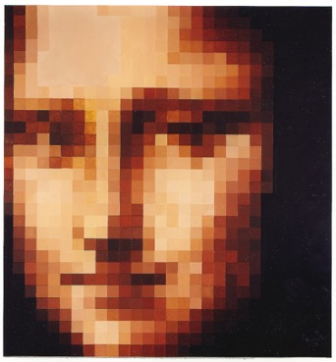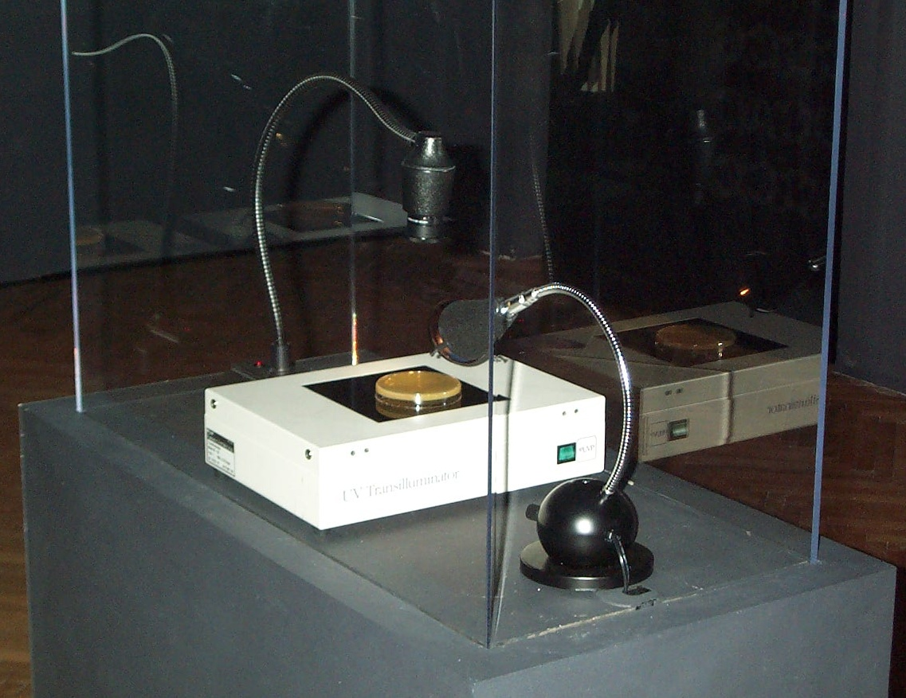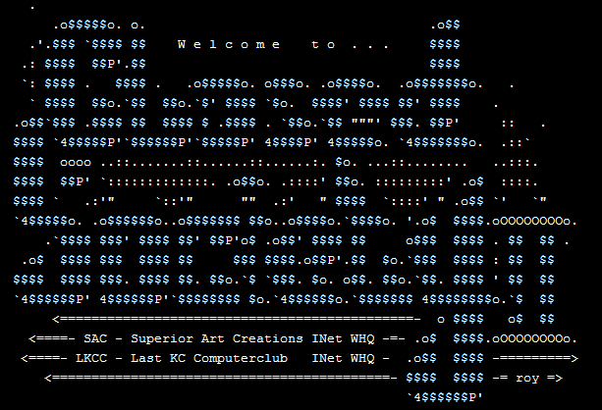

**Introduction | What is Digital Art?**

From Wikipedia:

Digital art is an artistic work or practice that uses [digital technology](https://en.wikipedia.org/wiki/Digital_technology) as part of the creative or presentation process. Since the 1960s, various names have been used to describe the process, including [computer art](https://en.wikipedia.org/wiki/Computer_art) and [multimedia art](https://en.wikipedia.org/wiki/Multimedia_art).[[1]](https://en.wikipedia.org/wiki/Digital_art#cite_note-1) Digital art is itself placed under the larger umbrella term [new media art](https://en.wikipedia.org/wiki/New_media_art).[[2]](https://en.wikipedia.org/wiki/Digital_art#cite_note-2)[[3]](https://en.wikipedia.org/wiki/Digital_art#cite_note-3)

After some initial resistance,[[4]](https://en.wikipedia.org/wiki/Digital_art#cite_note-4) the impact of digital technology has transformed activities such as [painting](https://en.wikipedia.org/wiki/Painting), [drawing](https://en.wikipedia.org/wiki/Drawing), [sculpture](https://en.wikipedia.org/wiki/Sculpture) and music/[sound art](https://en.wikipedia.org/wiki/Sound_art), while new forms, such as [net art](https://en.wikipedia.org/wiki/Net_art), digital [installation art](https://en.wikipedia.org/wiki/Installation_art), and [virtual reality](https://en.wikipedia.org/wiki/Virtual_reality), have become recognized artistic practices.[[5]](https://en.wikipedia.org/wiki/Digital_art#cite_note-5) More generally the term digital artist is used to describe an artist who makes use of [digital technologies](https://en.wikipedia.org/wiki/Digital_technology) in the production of art. In an expanded sense, "digital art" is [contemporary art](https://en.wikipedia.org/wiki/Contemporary_art) that uses the methods of [mass production](https://en.wikipedia.org/wiki/Mass_production) or digital media.[[6]](https://en.wikipedia.org/wiki/Digital_art#cite_note-6)

The techniques of digital art are used extensively by the mainstream [media](https://en.wikipedia.org/wiki/Mass_media) in advertisements, and by film-makers to produce [visual effects](https://en.wikipedia.org/wiki/Visual_effects). [Desktop publishing](https://en.wikipedia.org/wiki/Desktop_publishing) has had a huge impact on the publishing world, although that is more related to [graphic design](https://en.wikipedia.org/wiki/Graphic_design). Both digital and traditional artists use many sources of electronic information and programs to create their work.[[7]](https://en.wikipedia.org/wiki/Digital_art#cite_note-7) Given the parallels between visual and musical arts, it is possible that general acceptance of the value of digital visual art will progress in much the same way as the increased acceptance of electronically produced music over the last three decades.[[8]](https://en.wikipedia.org/wiki/Digital_art#cite_note-8)

This is a studio course first and foremost. In keeping with the tradition of a studio arts course, the focus of the classroom experience will be on art and art-making. We will be specifically looking at trends and themes present within Contemporary Art by way of presentations, readings, and class discussion.

Our time together in class is formatted as a combination of seminar and studio time including presentations of contemporary digital artworks and artists, discussions pertaining to assigned readings, software and technique tutorials, as well as group critiques. In addition to work time provided in class, outside work will be required.

This course will focus on core intentional or inherent aspects of digital art. Some of these aspects are properties unique to digital media such as dynamic data, interactivity, or networking. Other aspects will be common or occasional subjects taken up in the creation of digital art, such as telematic space, the architecture of time, the body and identity, decentralized authorships and hive-mind behavior. This class will introduce the core skills necessary to employ digital media in the generative and investigative context of art making.

The course is broken up into diverse topical units of approximately three weeks each. Within each unit the assignments, lectures, presented projects, and readings relate to the topic. These topics include: space + place, body + identity, time + change, data + information, and context + meaning. There are other topics / concerns inherent to the medium that will be with us throughout the semester including: authorship, remix, appropriation, composition, interface, input / output, and interactivity.

**statement**

As you will likely realize throughout this course, much of the language and tradition to be found in other mediums of creative production / research are relatively settled… even if only as a foundation upon which new paradigms evolve. This is barely true, if at all, for the realm of Digital Art. Even the term “Digital Art” is problematic as it does not accurately depict or describe the practices, products, artifacts, and artists that will be observed this semester.

“Digital media art has been practiced and theorized within frameworks of more traditional media, such as television, avant-garde art, and fluxus art. However, the understanding of what is radically new about digital media often eludes such frameworks, because digital media challenges many of the paradigms which these frameworks are built upon. The need for an original framework which emerges from digital media is imperative for a new medium.”

* *excerpt from the Thesis statement from DXARTS 201 syllabus, offered in the DXARTS Program at the University of Washington, Seattle, WA.*

The medium in question for this course is better defined loosely by the terms “flux” or “emerging” in that it is constantly changing and evolving. If there are roots, they are bonded to the first transmission of signal over distance using electricity. Communication in the form of analog signals provide an appropriate starting point, but even this communication relied heavily on earlier forms of long-distance communication (smoke signals ≈ Morse code).

**catalogue description**

Exploration of Digital Art forms, focusing on the interrelationship of the digital technology on art and culture. The goal of the course is to weave technical skills into creative vision.

**goals**

* Creation of art projects in various formats based on assignments
* Understanding of basic techniques for digital art production
* Exploration of digital art practices in the context of course topics
* Investigation of the historical and theoretical concerns relevant to Digital Art
* Developing personal strategies for art making
* Expansion of creative realization

**materials**

In order to succeed in this course, you will need the following:

* A dedicated storage solution of your choice with approx. 16GB available. This can be a thumb drive, cloud storage, portable hard drive, etc. This should be something that you can access at home and on campus.
* Access to a computer outside of class time. Please note that open lab hours will be posted for each room either on the door or just outside of the door. These open lab times should be in effect for the entire semester.

**Readings (this list will grow throughout the semester)**

*Sentences on Conceptual Art* by Sol Lewitt

http://www.altx.com/vizarts/conceptual.html

*The Work of Art in the Age of Mechanical Reproduction* by Walter Benjamin

https://web.mit.edu/allanmc/www/benjamin.pdfs

*The Unique Phenomenon of a Distance* by Ken Goldberg

https://goldberg.berkeley.edu/art/tele/intro.html

*Akademie X - Lessons in Art + Life*

https://www.phaidon.com/store/art/akademie-x-9780714867366/#tab-1

*Notes for an Introductory Lecture* by Walead Beshty

<https://www.actionstakenunderthefictitiousnamewaleadbeshtystudiosinc.com/lesson-notes-for-an-introductory-lecture>

*New Media Installation* by Sandu Publications

Gingko Press Inc, Nov., 2018. -

*Form + Code in Design, Art, and Architecture* by Casey Reas and Chandler McWilliams

Princeton Architectural Press, Nov. 2010 -

**resources**

*Photoshop*

helpx.adobe.com - <https://helpx.adobe.com/photoshop/tutorials.html>

Complete Beginner’s Guide (2014) - [link](https://www.youtube.com/watch?v=sF_jSrBhdlg&list=PLYfCBK8IplO6v0QjCj-TSrFUXnRV0WxfE)

Photoshop 2020 Beginner - [link](https://youtu.be/TPKHO52AQ-U)

*Processing + p5js*

[processing.org](http://processing.org) | [p5js.org](http://p5js.org) | [openprocessing.org](http://openprocessing.org)

[learnprocessing.com](http://learnprocessing.com) | [natureofcode.com](http://natureofcode.com) | [shiffman.net](http://shiffman.net)

[Learn processing YouTube](https://www.youtube.com/c/TheCodingTrain/playlists?view=50&sort=dd&shelf_id=10) | [Learn p5js Youtube](https://www.youtube.com/playlist?list=PLRqwX-V7Uu6Zy51Q-x9tMWIv9cueOFTFA) | [Nature of Code Youtube](https://www.youtube.com/c/TheCodingTrain/playlists?view=50&sort=dd&shelf_id=9)

**student responsibilities**

* Be Respectful (of your peers, the instructor, the facilities, and the education process)
* Be Resourceful and seek out help from multiple sources when needed
* Participate in all class activities
* Share your knowledge with your peers
* Take care of your data
* Finally, you are expected to come to class prepared

**attendance**

Attendance credit for this course will be generated through the scheduled meeting times with the faculty member. These scheduled meetings may be in person, digital, or a combination of both. It is also expected that the students will have a rigorous, individual work schedule that will support ample productivity throughout the semester. Setting a consistent work schedule with ample dedicated time to research and practice is expected. As life can and does certainly happen, you should notify the faculty member if anything will keep you from making a scheduled appointment as soon as you know of the conflict. Reasonable accommodations will be made in the following instances suggested by MSU’s attendance policy: 1) participation in University-sanctioned activities and programs; 2) personal illness; or 3) family and/or other compelling circumstances.

**communication / etiquette**

I am here to help, and I want you and your work to truly flourish. If you would like to meet outside of our regular schedule, please email with ample notice so as to find where our schedules align. For email, please allow 24 to 48 hours for response. If you need a faster response or the message is time sensitive, please put “Urgent” in the subject line, and then detail the response time required in the first line of the body or your email, before the greeting.

**grading policy**

Your final grade for this course is based on quality and quantity of work, your dedication to your research and creative practice, and conceptual development of your work during the semester.

**studio / lab safety**

You will be required to use the appropriate safety equipment and practice safe operation procedures when using any hazardous equipment or materials. Your ability to adhere to these safety requirements is essential to your success in this course. These policies also help to protect your health and ensure a long and fruitful career!

* + Know where the nearest first aid kit is located.
  + When using hazardous materials / chemicals / etc. know where these are permitted and use proper protective gear at all times.
  + Food and Drink should never be found near hazardous materials. Be mindful of what you are putting in your body.
  + Food and Drink should never be found near hazardous equipment. You should be focused on the task at hand when using potentially dangerous tools.

**units / projects**

**unit 1 | space + place**

**unit 2 | body + identity**

**unit 3 | time + change**

**unit 4 | data + information**

**unit 5 | context + meaning**

**references**

In the spirit of academic integrity and in order to support open access to information, listed below are resources that were referenced while developing this syllabus.

<<MLA Formatting>>

<<Professor’s Name. *Course Syllabus Title*. Date of the Course. Department and Institution Name, Location. Publication Medium.>>

**Course Plan for the Unexpected (updated for Fall 2020)**

The COVID-19 Stay-at-Home orders we experienced during Spring 2020 reinforced the need to plan for the unexpected. In our area we can experience inclement weather and influenza outbreaks that could prevent us from meeting on campus. Below is how we will communicate and continue our work in this course should the unexpected occur.

|  |  |
| --- | --- |
| Question | Statement |
| How will our class meet? | If we are unable to come to campus to meet for a class where the need to meet in person was identified, the instructors will notify students as to the change via email. Any necessary and pressing needs or concerns will be addressed a virtual meeting platform such as Zoom in place of a campus meeting. |
| How will I meet with my Instructor? | My office hours are already set up as virtual meetings via Zoom or by phone. These meetings will retain this format so long as the needs of students are met by the virtual setting. This is to reduce meetings where all business could be conducted without a physical meet up.  For class related questions, please use email or previously established communication platforms, such as Blackboard and / or Discord. For all emails sent / received during the weekend, please allow 48 hours for a reply. |
| How will instruction be delivered? | Instruction will be delivered via the online meeting platform Zoom when on campus meetings are not essential or are ill-advised. |
| How often do I need to go the online course? | You are expected to participate in our digital meetings via Zoom during our regularly scheduled class periods. |
| Is it possible to receive course announcements as a text? | The only possible texts that may be provided would be through the Blackboard App. You must have already allowed these notifications to come through this application, after which new course notifications should be sent to your mobile device. |
| How will I turn in homework? | If alternative / online delivery of course materials is required for an extended period of time, Blackboard will be used to turn in any written materials and / or finished artworks. |
| What about exams? | There are no traditional exams for this course. Instead, our focus is on the conceptualization and production process. |
| How will I know what grade I received on an assignment or test? | **You will receive feedback via critique and review as projects are turned in. Your final grade will be available during the normal grade submission process after the semester is complete.** |

**Missouri State University Required Policies:**

**Academic Integrity Policy** - Missouri State University is a community of scholars committed to developing educated persons who accept the responsibility to practice personal and academic integrity. You are responsible for knowing and following the university’s student honor code, *Student Academic Integrity Policies and Procedures*, available at [ww.missouristate.edu/policy/academicintegritystudents.htm](http://ww.missouristate.edu/policy/academicintegritystudents.htm) and also available at the Reserves Desk in Meyer Library.

**Department of Art and Design supplemental policy -** Any student participating in any form of academic dishonesty, including but not limited to the submission of texts or images (still and moving, digital or physical) that are not the student’s individual academic or artistic property will be subject to sanctions as described in the University policy. Submitted work - both textual and visual - must be formally, materially, and creatively / intellectually the student’s own production.

Particular coursework or assignments that may involve the use of appropriated images or works in the public domain; in these circumstances, work that appropriates or responds to photographs, published images, and / or other artists’ works must show significant and synthetic development or manipulation of the formal qualities, design, and / or concept of the source material beyond duplication. In a manner analogous to the citation of textual sources in written assignments, students should clearly acknowledge any source material used.

**Statement of Non-Discrimination** - Missouri State University is an equal opportunity/affirmative action institution and maintains a grievance procedure available to any person who believes he or she has been discriminated against. At all times, it is your right to address inquiries or concerns about possible discrimination to the Office for Institutional Equity and Compliance, Park Central Office Building, 117 Park Central Square, Suite 111, 417-836-4252. Other types of concerns (i.e., concerns of an academic nature) should be discussed directly with your instructor and can also be brought to the attention of your instructor’s Department Head.   Please visit the OED website at [www.missouristate.edu/equity/](http://www.missouristate.edu/equity/).

**Statement of Disability Accommodation** - If you are a student with a disability and anticipate barriers related to this course, it is important to request accommodations and establish an accommodation plan with the University. Please contact the Disability Resource Center (DRC) (<https://www.missouristate.edu/disability/>), Meyer Library, Suite 111, 417-836-4192, to initiate the process to establish your accommodation plan. The DRC will work with you to establish your accommodation plan, or it may refer you to other appropriate resources based on the nature of your disability. In order to prepare an accommodation plan, the University usually requires that students provide documentation relating to their disability. Please be prepared to provide such documentation if requested. Once a University accommodation plan is established, you may notify the class instructor of approved accommodations. If you wish to utilize your accommodation plan, it is suggested that you do so in a timely manner, preferably within the first two weeks of class. Early notification to the instructor allows for full benefit of the accommodations identified in the plan. Instructors will not receive the accommodation plan until you provide that plan and are not required to apply accommodations retroactively.

**Cell Phone Policy** - As a member of the learning community, each student has a responsibility to other students who are members of the community.  When cell phones or pagers ring and students respond in class or leave class to respond, it disrupts the class. Therefore, the Office of the Provost prohibits the use by students of cell phones, pagers, PDAs, or similar communication devices during scheduled classes. All such devices must be turned off or put in a silent (vibrate) mode and ordinarily should not be taken out during class. Given the fact that these same communication devices are an integral part of the University’s emergency notification system, an exception to this policy would occur when numerous devices activate simultaneously. When this occurs, students may consult their devices to determine if a university emergency exists. If that is not the case, the devices should be immediately returned to silent mode and put away. Other exceptions to this policy may be granted at the discretion of the instructor.

**Emergency Response Statement** - At the first class meeting, students should become familiar with a basic emergency response plan through a dialogue with the instructor that includes a review and awareness of exits specific to the classroom and the location of evacuation centers for the building. All instructors are provided this information specific to their classroom and/or lab assignments in an e-mail prior to the beginning of the fall semester from the Office of the Provost and Safety and Transportation. Students with disabilities impacting mobility should discuss the approved accommodations for emergency situations and additional options when applicable with the instructor. For more information go to <http://www.missouristate.edu/safetran/51597.htm> and <http://www.missouristate.edu/safetran/erp.htm>.

**Dropping a Course** - It is your responsibility to understand the University’s procedure for dropping a class. If you stop attending this class but do not follow proper procedure for dropping the class, you will receive a failing grade and will also be financially obligated to pay for the class. For information about dropping a class or withdrawing from the university, contact the Office of the Registrar at 836-5520.

**Audio and Video Recording Statement** - Students who wish to record lectures or class activities for study purposes should inform the faculty member first. Distribution or sale of recordings or other course materials is prohibited without the written permission of the instructor and other students who are recorded. Distribution without permission is a violation of copyright law and the Code of Student Rights and Responsibilities (Sections 4.6, 4.8, 4.9).

**Religious Accommodation** - The University may provide a reasonable accommodation based on a person’s sincerely held religious belief.  In making this determination, the University reviews a variety of factors, including whether the accommodation would create an undue hardship. The accommodation request imposes responsibilities and obligations on both the individual requesting the accommodation and the University. Students who expect to miss classes, examinations, or other assignments as a consequence of their sincerely held religious belief shall be provided with a reasonable alternative opportunity to complete such academic responsibilities. It is the obligation of students to provide faculty with reasonable notice of the dates of religious observances on which they will be absent by submitting a *Request for Religious Accommodation* *Form* to the instructor by the end of the third week of a full semester course or the end of the second week of a half semester course.

**Mental Health and Stress Management** - As a student you may experience a range of personal issues that can impede learning, such as strained relationships, increased anxiety, alcohol/drug problems, feeling down, difficulty concentrating and/or lack of motivation. These mental health concerns or stressful events may lead to diminished academic performance and may reduce your ability to participate in daily activities. You can learn more about free and confidential Missouri State University Counseling Center services available to assist you at <https://counselingcenter.missouristate.edu/>.

**Title IX Policy** -Missouri State University has a Title IX policy that guides our response to instances of sexual violence. Sexual Violence includes: Rape, Sexual Assault, Sexual Misconduct, Sexual Discrimination, Domestic Violence, Dating Violence, Stalking, Sexual Harassment and Pregnancy issues. The Title IX policy can be located on the MSU Title IX website at [www.missouristate.edu/titleix/](http://www.missouristate.edu/titleix/). This website is also a good resource for any questions or issues involving Title IX and contains contact information for the MSU Title IX Office and staff.  Read an [overview of the Title IX office](https://www.missouristate.edu/assets/Provost/TitleIX_OfficeOverview.pdf).

If an MSU student discloses a Title IX related issue to a MSU faculty or staff member who is deemed to be a “Responsible Employee” under the policy, that faculty or staff member is required to report such disclosure to the Title IX Coordinator. A responsible employee includes any employee who has the authority to take action to redress sexual violence; who has been given the duty of reporting incidents of sexual violence or any other misconduct by students to the Title IX Coordinator or other appropriate school designee; or whom a student could reasonably believe has the authority or duty to take action. Taylor Health employees and MSU Counseling Center Clinicians are not considered to be Responsible Employees under the policy, and therefore, are not required to report Title IX issues to the Title IX Coordinator.

**Chosen Name Policy** - A student may choose a name other than their legal name to identify themselves at Missouri State University. A chosen name is different than the student’s legal name. Refer to the [Chosen Name policy](http://www.missouristate.edu/policy/Op1_07_ChosenName.htm) for more information. Students can provide their chosen first and middle names in the *Profile* tab of [My Missouri State](https://my.missouristate.edu/).

**Food and Drink policy** - For your health and safety, no foods are to be consumed in certain studio rooms indicated in class when in use as some materials used are hazardous if ingested. Only water bottles or beverages with lids are permissible when indicated. To prevent accidental consumption of hazardous materials through contaminated food or exposed beverages, wash your hands thoroughly with soap and water and only consume food outside of the studios.

**Mask policy** – In accord with the MSU Mask and Face Covering policy (<https://www.missouristate.edu/Coronavirus/masking-policy.htm>), Greene County Health Department (<https://www.springfieldmo.gov/5140/Masks-and-Face-Coverings>), and the Springfield City Ordinance (<https://www.springfieldmo.gov/AgendaCenter/ViewFile/Item/14780?fileID=203417>), masks or face coverings must be worn at all times during a traditional (seated) class. This measure is being implemented to reduce COVID-19 related health risks for everyone engaged in the educational process. Masks or face coverings must be worn over the nose and mouth, in accordance with the Centers for Disease Control and Prevention (CDC) guidelines (<https://www.cdc.gov/coronavirus/2019-ncov/prevent-getting-sick/how-to-wear-cloth-face-coverings.html>). Face shields are not considered masks or face coverings for purposes of this requirement.

Students who cannot wear a mask or face covering due to a disability must contact the Disability Resource Center (DRC) (<https://www.missouristate.edu/disability/>) to initiate the interactive accommodation process.

In the absence of an approved accommodation, a student’s refusal to wear a mask or face covering will be considered a classroom disruption, consistent with Op3.04-11 Class Disruption, and may result in the student being administratively dropped from the class section.

**Fall 2020 Calendar (detailed calendar on website)**

Class meets on Tuesdays and Thursdays from 11:00am to 1:45pm

|  |  |
| --- | --- |
| Week 1  August 17 – 21  Unit 1 | Space + Place | Day 001 – August 18  Syllabus, Introduction to policies for the semester, Lecture 00 Introduction to ART 210 and the semester, assign p5js videos Intro and Drawing, assign reading 01  Day 002 – August 20  Introduce and assign Project 1, reading 001 discussion, assign reading 02, Workshop 01 part 1 – Geometric Abstraction and P5.js |
| Week 2  August 24 – 28  Unit 1 | Space + Place | Day 003 – August 25  Lecture 001, tutorial and check-in, revisit discussion of Project 1, reading discussion, discuss reading 02, assign reading 03  Day 004 – August 27  Workshop 01 part 2 – Geometric Abstraction and P5.js |
| Week 3  August 31 – September 4  Unit 1 | Space + Place | Day 005 – September 1  Tutorial and check-in, Project 1 check-in, discuss reading 03  Day 006 – September 3  Workday in preparation for turning in Project 1, refresher from Workshops previous. |
| Week 4  September 7 – 11  Unit 2 | Body + Identity | Day 007 – September 8  Critique for Project 1, Lecture 02 to introduce next unit, discussion, assign reading 03, assign p5.js tutorial videos for unit, assign Project 2  Day 008 – September 10  Reading 03 discussion, Workshop 02 part 1 – The Body ++ (The Body Extended and P5.js) |
| Week 5  September 14 – 18  Unit 2 | Body + Identity | Day 009 – September 15  Artist presentation, continuation of Lecture 02 materials, assign reading 04, tutorial refresher  Day 010 – September 17  Reading 04 discussion, Workshop 02 part 2 – The Body ++ (The Body Extended and P5.js) |
| Week 6  September 21 – 25  Unit 2 | Body + Identity | Day 011 – September 22  Check-in for Project 2, revisit lecture discussions and concepts, Artist presentation  Day 012 – September 24  Work Day in preparation for Project 2 turn in |
| Week 7  September 28 – October 2  Unit 3 | Time + Change | Day 013 – September 29  Project 2 critique, Begin Unit 3, Lecture 03, assign reading 05, assign p5.js tutorials for unit, assign Project 3  Day 014 – October 1  Reading 05 discussion, Workshop 03 part 1 – Stories, Loops, and P5.js |
| Week 8  October 5 – 9  Unit 3 | Time + Change | Day 015 – October 6  Continuation of lecture 03, assign reading 06, Workshop 03 part 2  No classes October 8 + 9 |
| Week 9  October 12 – 16  Unit 3 | Time + Change | Day 016 – October 13  Reading 06 discussion, Workshop 03 part 2 – Stories, Loops, and P5.js  Day 017 – October 15  Workday in preparation for turning in Project 3, check-ins regarding concepts and tutorials |
| Week 10  October 19 – 23  Unit 4 | Data + Information | Day 018 – October 20  Critique for Project 3, Lecture 04 Unit Introduction, assign Project 4, assign reading 007  Day 019 – October 22  Reading 07 discussion, Workshop 04 part 1 – Systems, Data, Networks and P5.js |
| Week 11  October 26 – 30  Unit 4 | Data + Information | Day 020 – October 27  Lecture 04 continuation, concepts and tutorials check-in,  Day 021 – October 29  Workshop 04 part 2 – Systems, Data, Networks and P5.js |
| Week 12  November 2 – 6  Unit 4 | Data + Information | Day 022 – November 3  Revisit Unit 4 concepts and tutorials, Workday in preparation for turning in Project 4  Day 023 – November 5  Workday in preparation for turning in Project 4 |
| Week 13  November 9 – 13  Unit 5 | Context + Meaning | Day 024 – November 10  Project 4 critique, Lecture 05 and introduction of Unit 5, assign Project 5, assign reading 08  Day 025 – November 12  Reading 08 discussion, Workshop 005 part 1 |
| Week 14  November 16 – 20  Unit 5 | Context + Meaning | Day 026 – November 17  Lecture 05 continuation, assign reading 09,  Day 027 – November 19  Reading 09 discussion, Workshop 005 part 2 |
| Week 15  November 23 – 27  Unit 5 | Context + Meaning | Day 028 – November 24  In Progress Critique and Project 5 Check-in. (Flex Day)  No classes November 25 – 27 |
| Week 16  November 30 – December 4  Unit 5 | Context + Meaning | Day 029 – December 1  In Progress Critique and Project 5 Check-in. (Flex Day)  Day 030 – December 3  Workday in preparation for turning in Project 5 |
| Week 17  Dec. 5 - 10 | Finals Week |