RECRUITTRUCKER
PRESS & MEDIA KIT
The Modern Trucking Marketplace
RecruitTrucker.com
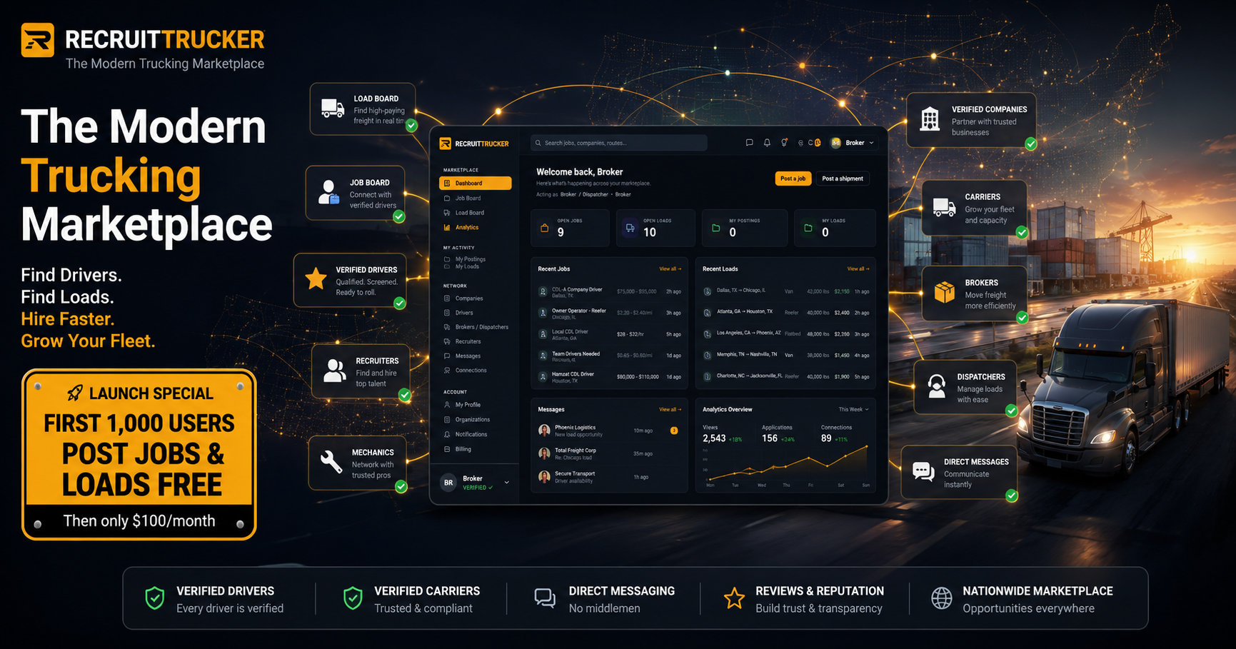

Company Overview
RecruitTrucker is a modern trucking marketplace and logistics platform designed to connect drivers, carriers, recruiters, brokers, dispatchers and trucking businesses in one connected experience. Rather than operating as only a job board or only a load board, RecruitTrucker brings people, companies, freight opportunities and professional relationships together.

Launch Promotion
FIRST 1,000 USERS CAN POST JOBS & LOADS FREE.
The launch offer rewards early members and helps seed the marketplace with real trucking opportunities.

Who RecruitTrucker Serves
- Truck drivers and owner-operators
- Carriers and fleet operators
- Recruiters
- Brokers
- Dispatchers
- Trucking companies and industry businesses
- Mechanics and service professionals

Core Features
- Job Board
- Load Board
- Verified member profiles
- Driver and company discovery
- Recruiter and broker/dispatcher discovery
- Direct messaging and professional connections
- Company and organization profiles
- Reviews and reputation
- Marketplace analytics and dashboards
- Notifications and saved opportunities

Key Messages
- Where verified drivers and real freight meet.
- The modern trucking marketplace.
- Find drivers. Find loads. Hire faster. Grow your fleet.
- One connected marketplace for trucking professionals.
- First 1,000 users post jobs and loads free.

Founder Quote
“Trucking professionals should not need a collection of disconnected, outdated tools just to find work, freight, drivers and trusted industry connections. We are building RecruitTrucker as a modern operating system and marketplace for the trucking industry.”
— Aleksandr Goretoy, Founder

Suggested Story Angles
- A modern alternative to fragmented trucking software
- Why trucking recruitment and freight discovery belong in one connected marketplace
- Building trust through verified professional profiles and reputation
- How modern SaaS design can improve trucking workflows
- An early-stage founder building a logistics operating system for trucking
- The first 1,000-user launch promotion for free job and load postings

Media Contact
Aleksandr Goretoy
Founder, RecruitTrucker
RecruitTrucker.com
Media interviews, product screenshots and additional information are available upon request.

Press Release
FOR IMMEDIATE RELEASE
RecruitTrucker Launches a Modern Marketplace Connecting the Trucking Industry
First 1,000 users can post jobs and loads free
RecruitTrucker.com is introducing a modern trucking marketplace designed to bring drivers, carriers, recruiters, brokers, dispatchers and other trucking professionals into one connected platform.
Built around verified profiles, direct communication and industry-specific discovery, RecruitTrucker combines a job board and load board with professional networking tools, company pages, messaging, reviews and reputation features.
“Trucking professionals should not need a collection of disconnected, outdated tools just to find work, freight, drivers and trusted industry connections,” said Aleksandr Goretoy, founder of RecruitTrucker. “We are building RecruitTrucker as a modern operating system and marketplace for the trucking industry.”
The platform is designed to help drivers discover opportunities, carriers recruit talent, brokers and dispatchers connect around freight, and trucking businesses build trusted professional reputations.
As part of its launch promotion, the first 1,000 users can post jobs and loads free.
RecruitTrucker is available at RecruitTrucker.com.
Media inquiries, interviews, screenshots and additional information are available upon request.

Company Boilerplate
RecruitTrucker is a modern trucking marketplace and logistics platform built to connect drivers, carriers, recruiters, brokers, dispatchers and trucking businesses. The platform combines jobs, loads, professional discovery, verified profiles, direct messaging, company pages, reviews and reputation tools in one modern experience. RecruitTrucker's mission is to make trucking opportunities easier to discover and industry relationships easier to build.

Product Screenshot
