PIMPRI CHINCHWAD EDUCATION TRUST'S
PIMPRI CHINCHWAD COLLEGE OF ENGINEERING

Department of Applied Science and Humanities.
Report of FA-2 activity
Subject: Statistical Data Analysis using R
Academic Year 2024-25
Semester I
Submitted by 1.

Submitted to :
Date:
Sign:

Project Title : "Retail Sales Analysis and Customer Insights"
Data used: Retail sales dataset (sales_data.csv) - 20,000 orders placed between 01-01-2023 and 31-12-2025 by 3,985 customers across 17 cities in India. Total sales are INR 222.08 million and total profit is INR 34.34 million (overall margin 15.5%). Only the rating column has missing values (200 records, 1%); it is not used in the six problems below.
Details of the data :
Column Name | Description
order_id | Unique order ID
order_date | Date of order (YYYY-MM-DD)
customer_id | Customer ID (repeat buyers included)
gender | Male / Female
age | Customer age (18-65)
region | North / South / East / West
city | City of purchase
category | Electronics, Clothing, Home & Kitchen, Beauty, Books & Stationery
product | Product name (25 products)
unit_price | Price per unit (INR)
quantity | Units ordered (1-5)
discount | Discount rate (0 to 0.30)
sales | unit_price x quantity x (1 - discount), in INR
profit | Profit in INR (can be negative on heavy discounts)
channel | Online / Store / Mobile App
payment_method | UPI, Credit Card, Debit Card, Cash on Delivery, Net Banking
rating | Customer rating 1-5 (~1% missing)

All analysis is done in R (packages dplyr, tidyr, ggplot2, lubridate). The complete script is submitted along with this report as sales_analysis.R. A 5% significance level is used for every hypothesis test.

Problem statement 1:
Does a higher discount lead to larger quantities per order, and at what discount level does average profit per order turn negative?
Intro (Purpose and Approach):
Discounts are given to attract bigger purchases, but they directly reduce the profit earned on every unit. The purpose of this analysis is to check whether higher discounts really increase the number of units bought per order, and to find the discount level at which profit starts to disappear. The approach is to group orders into discount bands, compare the average quantity and average profit per order in each band, and test the relationships statistically.
Approach / Algorithm with Explanation:
- Data preparation: discount is cut into four bands: 0%, 1-10%, 11-20% and 21-30% (the actual discount values in the data are 0, 5, 10, 15, 20 and 30%).
- Grouping and aggregation: for each band, the number of orders, average quantity, average profit per order and profit margin (total profit / total sales) are calculated.
- Loss analysis: for each individual discount rate, the percentage of orders with negative profit is calculated.
- Hypothesis tests: a Kruskal-Wallis test checks whether quantity differs across bands (H0: quantity is the same in all bands). A Spearman correlation measures the discount-quantity relationship and a Pearson correlation measures the discount-profit relationship.
df$band <- cut(df$discount, breaks=c(-0.001,0,0.10,0.20,0.30),
labels=c("0%","1-10%","11-20%","21-30%"))
p1 <- df %>% group_by(band) %>%
summarise(orders=n(), avg_qty=mean(quantity),
avg_profit=mean(profit), margin=sum(profit)/sum(sales))
kruskal.test(quantity ~ band, data = df)
cor.test(df$discount, df$quantity, method = "spearman")
Output with Description:
Discount band | Orders | Avg quantity | Avg profit / order (INR) | Profit margin
0% | 9,988 | 2.26 | 2,042.26 | 17.41%
1-10% | 5,992 | 2.22 | 1,681.02 | 15.06%
11-20% | 3,212 | 2.23 | 1,103.96 | 11.70%
21-30% | 808 | 2.29 | 395.37 | 4.13%

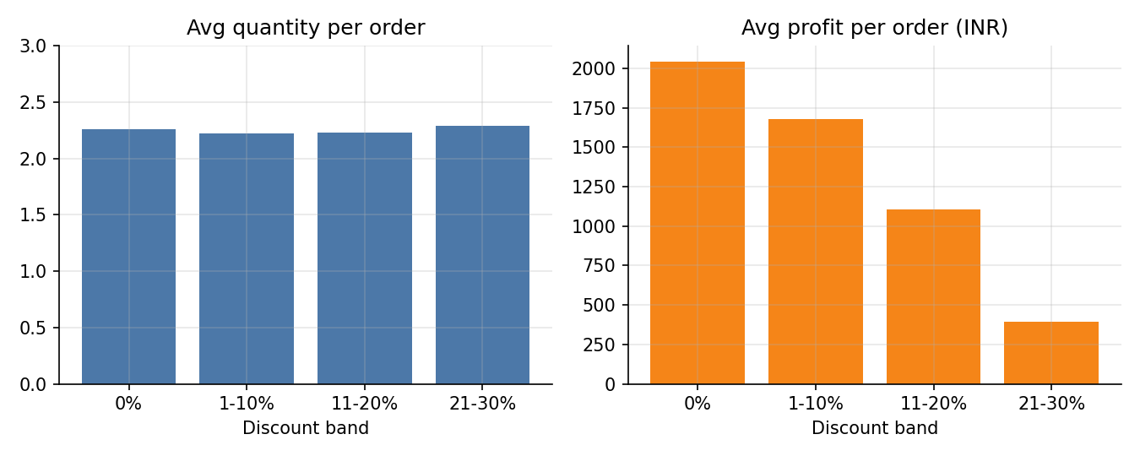
Figure 1.1: Average quantity and average profit per order by discount band
- Quantity: the average basket stays at about 2.2-2.3 units in every band. The Kruskal-Wallis test gives H = 2.61 with p = 0.455, and the Spearman correlation between discount and quantity is -0.008 (p = 0.275). We fail to reject H0: there is no evidence that higher discounts increase quantity.
- Profit: average profit per order falls steadily from INR 2,042 (no discount) to INR 395 (21-30%), and the profit margin falls from 17.4% to 4.1%. The Pearson correlation between discount and profit is -0.076 (p < 0.001).
Discount | Orders | Avg quantity | Avg profit / order (INR) | Loss-making orders
0% | 9,988 | 2.26 | 2,042.26 | 0.0%
5% | 2,995 | 2.25 | 1,780.14 | 0.0%
10% | 2,997 | 2.18 | 1,581.98 | 0.0%
15% | 1,973 | 2.23 | 1,192.89 | 0.7%
20% | 1,239 | 2.21 | 962.35 | 8.6%
30% | 808 | 2.29 | 395.37 | 32.9%

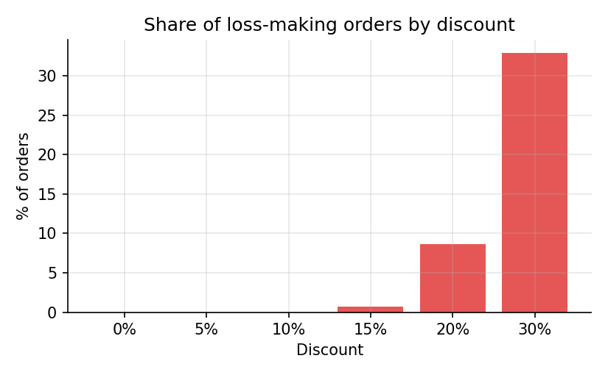
Figure 1.2: Percentage of loss-making orders at each discount rate
- Average profit per order stays positive even at 30%, so it never turns negative on average. However, individual orders begin to make a loss from a 15% discount, and the share of loss-making orders rises sharply: 8.6% at 20% and 32.9% (one order in three) at 30%.
Conclusion:
Higher discounts do not lead to larger quantities per order in this data; the average basket is the same with or without a discount. The discounts only reduce profit. Average profit per order does not become negative at any discount level, but the loss zone starts at 15% and becomes serious at 20% and above. Discounts above 10% should be restricted, and a 30% discount is hard to justify because a third of such orders lose money.

Problem statement 2:
Which channel has the best profit margin, and how does that margin change across categories?
Intro (Purpose and Approach):
The business sells through three channels: Online, Store and Mobile App. The purpose is to find which channel earns the best profit margin and whether the ranking changes from category to category. The approach is to compute margin = total profit / total sales for each channel, build a channel x category pivot table, and test whether the order-level margin differs across channels.
Approach / Algorithm with Explanation:
- Channel summary: orders, total sales, total profit, average order value and margin are calculated for every channel.
- Pivot table: profit margin is calculated for each channel and category combination and displayed as a heat map.
- Mix check: the category share inside each channel is checked, so that a channel does not look better only because of what it sells.
- Hypothesis test: a Kruskal-Wallis test compares the order-level margin (profit / sales) across the three channels (H0: no difference).
p2b <- df %>% group_by(channel, category) %>%
summarise(margin = 100*sum(profit)/sum(sales), .groups="drop")
pivot_wider(p2b, names_from = category, values_from = margin)
kruskal.test(margin_order ~ channel, data = df)
Output with Description:
Channel | Orders | Sales (INR M) | Profit (INR M) | Avg order value | Margin
Online | 9,014 | 100.11 | 15.65 | 11,106 | 15.64%
Store | 5,993 | 68.55 | 10.57 | 11,438 | 15.41%
Mobile App | 4,993 | 53.42 | 8.12 | 10,698 | 15.19%

Channel | Beauty | Books & Stat. | Clothing | Electronics | Home & Kitchen
Online | 15.68% | 16.24% | 15.52% | 15.60% | 16.18%
Store | 15.58% | 16.41% | 15.64% | 15.34% | 15.96%
Mobile App | 15.35% | 16.11% | 15.22% | 15.18% | 15.06%

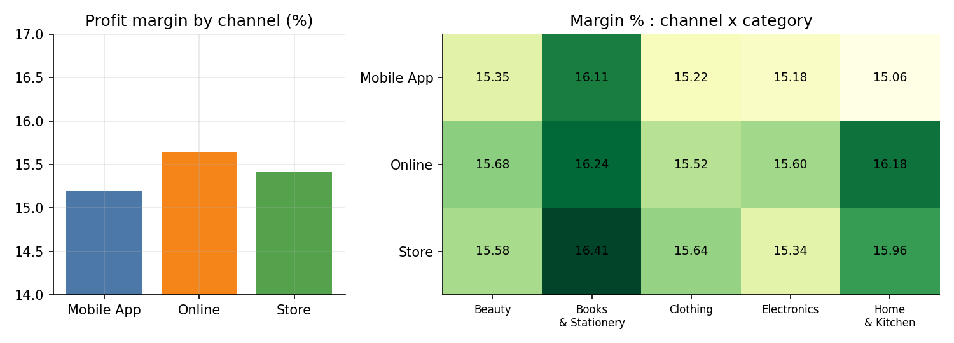
Figure 2.1: Profit margin by channel and by channel x category
- Online has the best overall margin (15.64%) and the largest sales (INR 100.1 M), followed by Store (15.41%) and Mobile App (15.19%). The gap between best and worst channel is only 0.45 percentage points.
- Category mix is almost identical in all three channels (Electronics is about 28% of orders in each), so the small differences are not caused by mix.
- Across categories, the highest margin is Books & Stationery in Store (16.41%) and the lowest is Home & Kitchen in Mobile App (15.06%). Mobile App has the lowest margin in every one of the five categories; Store is best for Books & Stationery, Clothing and Online is best for the others.
- The Kruskal-Wallis test gives H = 0.69, p = 0.709, so the differences between channels are not statistically significant.
Conclusion:
Online has the best profit margin in the sample, and Mobile App the weakest, but the differences are very small and statistically insignificant. Channel does not materially change profitability; margin is essentially the same (about 15-16%) in every channel and category. Channel decisions should therefore be based on volume and cost of operation rather than margin.

Problem statement 3:
Which products have high total sales but a low profit margin?
Intro (Purpose and Approach):
Products that sell a lot but earn a thin margin tie up effort and inventory for little return. The purpose is to identify such products among the 25 products sold. The approach is to calculate total sales and profit margin for each product and divide the products into four quadrants using the median sales and the median margin as cut-offs.
Approach / Algorithm with Explanation:
- Aggregation: total sales, total profit and margin (profit / sales) are calculated for each product.
- Cut-offs: the median of total sales (INR 1.67 M) and the median margin (15.51%) are used as dividing lines.
- Flagging: a product is flagged "high sales, low margin" if its sales are at or above the median sales and its margin is below the median margin.
- Visualisation: a scatter plot of sales (log scale) against margin, coloured by category, shows the four quadrants.
p3 <- df %>% group_by(product, category) %>%
summarise(sales=sum(sales), profit=sum(profit), .groups="drop") %>%
mutate(margin = 100*profit/sales)
p3$flag <- ifelse(p3$sales >= median(p3$sales) &
p3$margin < median(p3$margin), "High sales, low margin", "Other")
Output with Description:
Flagged product | Category | Total sales (INR M) | Margin
Laptop | Electronics | 130.72 | 15.40%
Smartwatch | Electronics | 11.48 | 15.24%
Jacket | Clothing | 5.90 | 15.23%
Wireless Earbuds | Electronics | 4.88 | 15.50%
Sneakers | Clothing | 4.66 | 15.44%
Pressure Cooker | Home & Kitchen | 3.33 | 15.48%
Power Bank | Electronics | 3.16 | 15.38%

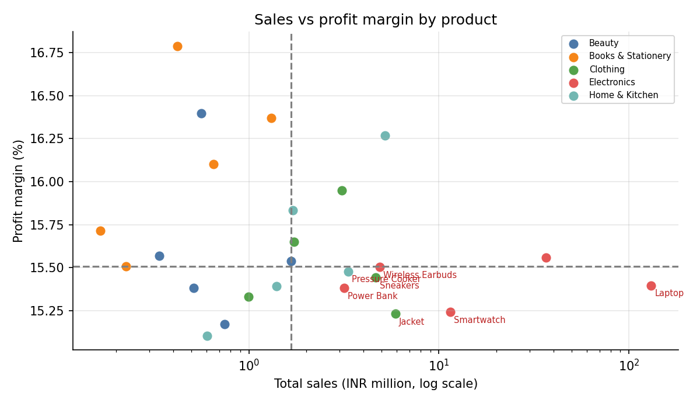
Figure 3.1: Sales vs profit margin for the 25 products (flagged products in red)
- Seven products fall in the "high sales, low margin" quadrant. Laptop is by far the most important: it earns INR 130.7 M, which is 58.9% of all sales, at a margin of 15.40%.
- Product margins lie in a very narrow range, from 15.10% (Water Bottle) to 16.79% (Novel). Flagged products are therefore only 0.0-0.3 percentage points below the median, so "low margin" is relative rather than serious. No product makes a loss.
- The best margins are on low-sales products from Books & Stationery and Beauty: Novel (16.79%), Lipstick (16.40%) and Backpack (16.37%).
Conclusion:
Laptop, Smartwatch, Jacket, Wireless Earbuds, Sneakers, Pressure Cooker and Power Bank combine high sales with below-median margin. Of these, Laptop deserves the most attention because even a small change in its margin affects the entire business (a 1-point margin change on laptops is worth about INR 1.3 M). As margins differ by less than two percentage points across all products, improving profit will depend more on controlling discounts (Problem 1) than on dropping any product.

Problem statement 4:
How does the payment method mix differ across age groups and channels?
Intro (Purpose and Approach):
Understanding how Indian customers pay (UPI, cards, Net Banking or Cash on Delivery) helps in planning payment offers and cash-handling costs. The purpose is to check whether payment preferences differ by age group and by sales channel. The approach is to build contingency tables, convert them to row percentages, and apply the Chi-Square test of independence with Cramer's V as the effect size.
Approach / Algorithm with Explanation:
- Age groups: age is divided into 18-25, 26-35, 36-45, 46-55 and 56-65.
- Contingency tables: age group x payment method and channel x payment method are created with table().
- Row percentages: prop.table() gives the payment mix inside each age group and channel.
- Hypothesis test: H0: payment method is independent of age group (and of channel). chisq.test() is applied to each table and Cramer's V measures the strength of any association.
tab_age <- table(df$age_group, df$payment_method)
tab_chan <- table(df$channel, df$payment_method)
round(prop.table(tab_age, 1) * 100, 1)
chisq.test(tab_age); chisq.test(tab_chan)
Output with Description:
Overall, UPI is the most used method (42.4% of orders), followed by Credit Card (18.0%), Cash on Delivery (17.5%), Debit Card (15.1%) and Net Banking (7.0%).
Age group | UPI | Credit Card | Cash on Delivery | Debit Card | Net Banking
18-25 | 41.9% | 19.8% | 16.6% | 15.1% | 6.6%
26-35 | 42.3% | 17.1% | 18.8% | 14.3% | 7.5%
36-45 | 42.9% | 17.8% | 17.0% | 15.3% | 7.1%
46-55 | 43.0% | 18.2% | 17.4% | 14.7% | 6.7%
56-65 | 42.1% | 17.5% | 17.5% | 15.9% | 7.0%

Channel | UPI | Credit Card | Cash on Delivery | Debit Card | Net Banking
Online | 42.8% | 17.8% | 17.0% | 14.9% | 7.5%
Store | 42.0% | 18.1% | 17.8% | 15.6% | 6.5%
Mobile App | 42.2% | 18.4% | 17.9% | 14.8% | 6.7%

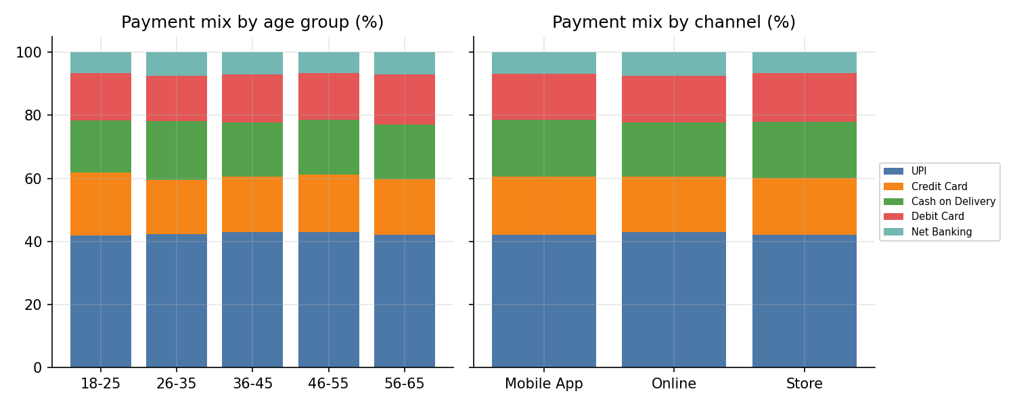
Figure 4.1: Payment method mix (%) by age group and by channel
Test | Chi-Square (X-squared) | df | p-value | Cramer's V
Age group x Payment | 22.39 | 16 | 0.131 | 0.017
Channel x Payment | 9.95 | 8 | 0.268 | 0.016

- UPI accounts for about 42-43% of orders in every age group and channel. Cash on Delivery stays between 16.6% and 18.8% by age (highest for 26-35, lowest for 18-25) and between 17.0% and 17.9% by channel. It does not skew older or toward any one channel.
- Both p-values are above 0.05 and Cramer's V is about 0.02 (practically zero), so we fail to reject H0: payment method is independent of age group and of channel.
Conclusion:
UPI is the dominant payment method for all customers, and the payment mix is essentially the same across age groups and channels. Cash on Delivery remains about 17-18% of orders everywhere. Payment strategy (UPI offers, COD handling) can therefore be set uniformly and does not need to be tailored by age or channel.

Problem statement 5:
Which categories peak in the Oct-Nov festive season, and which stay flat through the year?
Intro (Purpose and Approach):
Indian retail demand rises around the festive season (Diwali and the wedding period). The purpose is to measure how large the October-November spike is for each category and to see whether any category is unaffected. The approach is to compute monthly sales for each category and year, compare festive months (October, November) with all other months using a festive index, and test the difference with a Welch t-test.
Approach / Algorithm with Explanation:
- Date features: month and year are extracted from order_date using lubridate.
- Monthly sales: sales are summed by category, year and month (3 years x 12 months = 36 values per category).
- Festive index: average monthly sales in Oct-Nov divided by average monthly sales in the other ten months.
- Hypothesis test: for each category, a Welch two-sample t-test compares the festive and non-festive monthly sales (H0: equal means).
- Visualisation: a seasonality index (monthly sales divided by the category's average month) is plotted as a line chart for all categories.
monthly <- df %>% group_by(category, year, month) %>%
summarise(sales = sum(sales), .groups = "drop") %>%
mutate(festive = month %in% c(10, 11))
fest <- monthly %>% group_by(category, festive) %>%
summarise(avg = mean(sales), .groups="drop") %>%
pivot_wider(names_from = festive, values_from = avg) %>%
mutate(festive_index = `TRUE` / `FALSE`)
Output with Description:
Category | Avg monthly sales, other months (INR 000) | Avg monthly sales, Oct-Nov (INR 000) | Festive index | Welch t-test p-value
Electronics | 4,624.4 | 8,027.1 | 1.74 | < 0.001
Home & Kitchen | 306.4 | 505.3 | 1.65 | < 0.001
Books & Stationery | 69.7 | 114.1 | 1.64 | < 0.001
Beauty | 96.3 | 156.4 | 1.62 | 0.003
Clothing | 414.4 | 653.7 | 1.58 | < 0.001

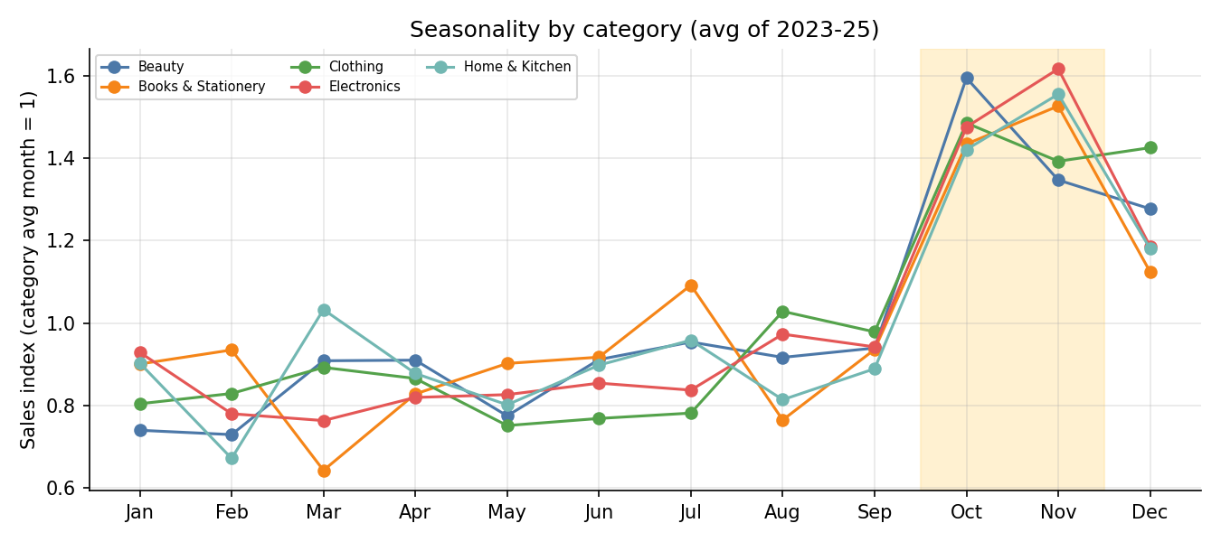
Figure 5.1: Seasonality index by category (shaded area = Oct-Nov)
- Every category peaks in October-November. Electronics shows the strongest festive effect (1.74 times a normal month), while Clothing shows the smallest (1.58 times). All five differences are statistically significant (p < 0.01).
- Across all categories, October sales are 1.47 times and November sales 1.59 times an average month. December is also elevated (1.20), while January to September are 0.78-0.96. The number of orders shows the same pattern: about 2,400 orders in each of October and November against 1,350-1,500 in most other months.
- Category-wise peak months: Electronics, Home & Kitchen and Books & Stationery peak in November, Beauty and Clothing in October (Clothing stays almost as high in December).
- No category stays flat through the year; the festive index of all five lies in the narrow range 1.58-1.74.
Conclusion:
The festive spike is large and universal: monthly sales in October-November are roughly 60-75% higher than in the rest of the year for every category, and the increase is statistically significant in all five. No category is seasonally flat. Stock, staffing and marketing budgets for all categories should be planned around October-November, with extra attention to Electronics, where the absolute rupee increase is the largest.

Problem statement 6:
What share of customers are repeat buyers, and do they have a higher average order value than one-time buyers?
Intro (Purpose and Approach):
Repeat customers are cheaper to serve than new ones. The purpose is to measure what share of customers buy more than once and whether they spend more per order than one-time buyers. The approach is to count orders per customer_id, label each customer as one-time or repeat, and compare order value, discount, quantity and lifetime profit between the two groups with hypothesis tests.
Approach / Algorithm with Explanation:
- Customer table: orders, total spend and total profit are calculated for each customer_id.
- Labelling: a customer with more than one order is labelled "Repeat", otherwise "One-time".
- Order-level comparison: average order value (AOV), median order value, average discount and quantity are compared between the two groups.
- Hypothesis tests: a Welch t-test and a Mann-Whitney (wilcox.test) test compare order value (H0: equal AOV). A Welch t-test compares total profit per customer.
cust <- df %>% group_by(customer_id) %>%
summarise(orders=n(), spend=sum(sales), profit=sum(profit)) %>%
mutate(type = ifelse(orders > 1, "Repeat", "One-time"))
mean(cust$orders > 1)
df <- left_join(df, select(cust, customer_id, type), by="customer_id")
t.test(sales ~ type, data = df); wilcox.test(sales ~ type, data = df)
Output with Description:
Of the 3,985 customers, 3,877 (97.3%) bought more than once and only 108 (2.7%) bought exactly once. A customer places 5.0 orders on average (median 5, maximum 15) over the three years.
Customer type | Customers | Avg orders | Avg total spend (INR) | Avg total profit (INR)
One-time | 108 | 1.00 | 10,192 | 1,908
Repeat | 3,877 | 5.13 | 56,997 | 8,803

Customer type | Orders | Avg order value (INR) | Median order value (INR) | Avg discount | Avg quantity
One-time | 108 | 10,192 | 1,970 | 5.83% | 1.96
Repeat | 19,892 | 11,109 | 2,130 | 6.18% | 2.24

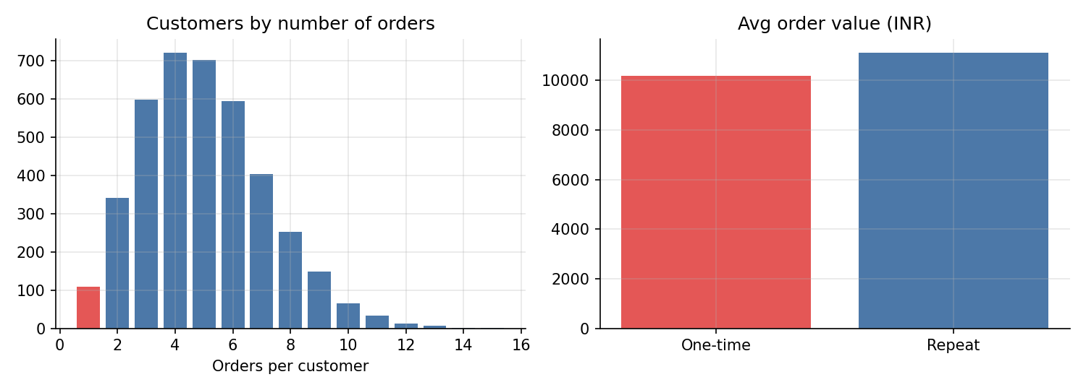
Figure 6.1: Customers by number of orders, and average order value by customer type
- Repeat buyers have a slightly higher AOV (INR 11,109 against INR 10,192), but the difference is not significant: Welch t-test p = 0.771 and Mann-Whitney p = 0.399. Average discount (p = 0.818) is also similar.
- The real difference is in how often customers buy. A repeat customer is worth about INR 57,000 in sales and INR 8,800 in profit over the period, compared with INR 10,200 and INR 1,900 for a one-time customer (profit difference significant, p < 0.001). Repeat buyers generate 99.5% of sales and 99.4% of profit.
- The one-time group has only 108 orders, so its averages are less reliable.
Conclusion:
Almost every customer in this dataset is a repeat buyer (97.3%). Repeat buyers do not spend significantly more per order than one-time buyers; they are more valuable because they place about five times as many orders, giving roughly five times the lifetime sales and profit. Retention efforts should therefore aim to increase purchase frequency. Because nearly all customers repeat, a finer split (for example by number of orders) would be more useful than repeat versus one-time for future segmentation.

