Pattern of Missing Data

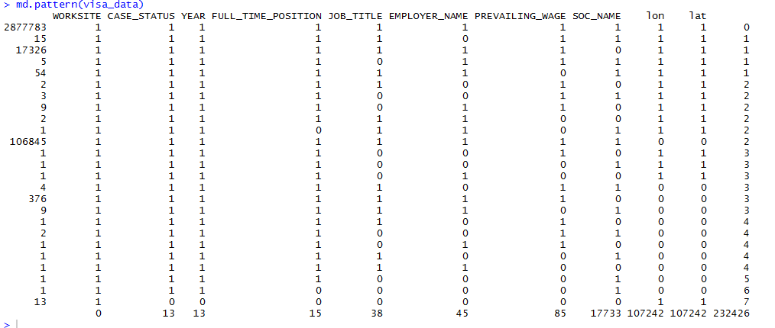

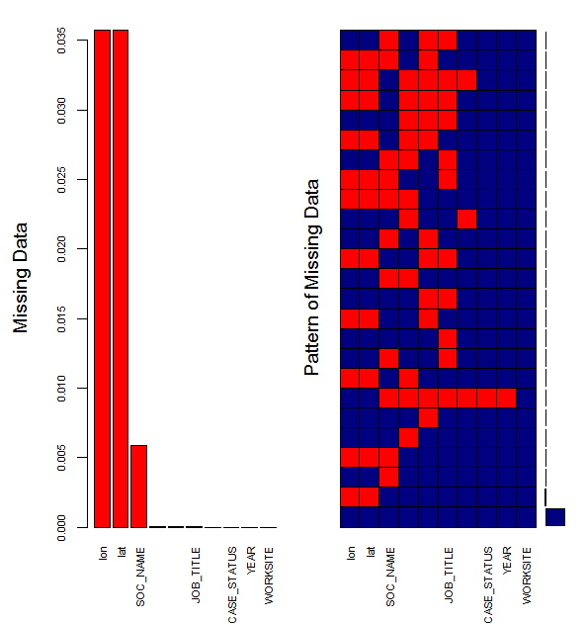

**Summary Stats from EDA**

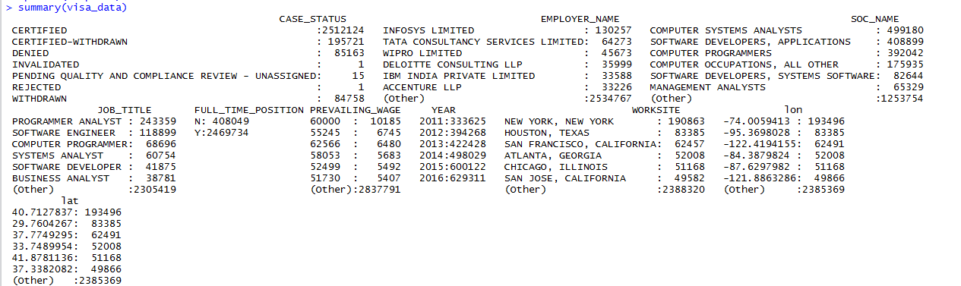

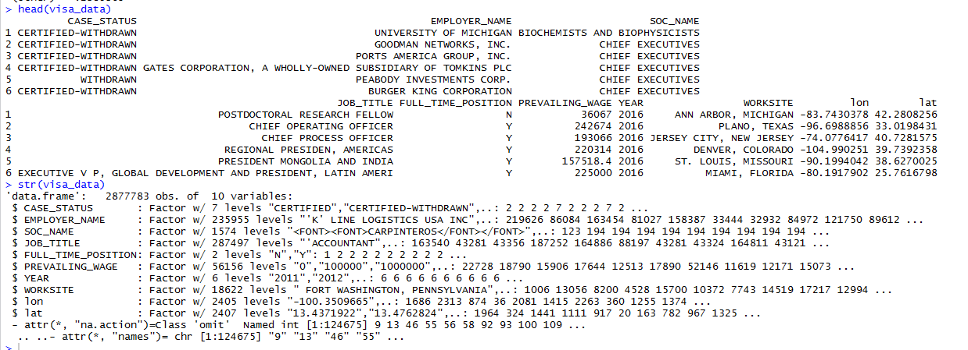

**Bar Charts**

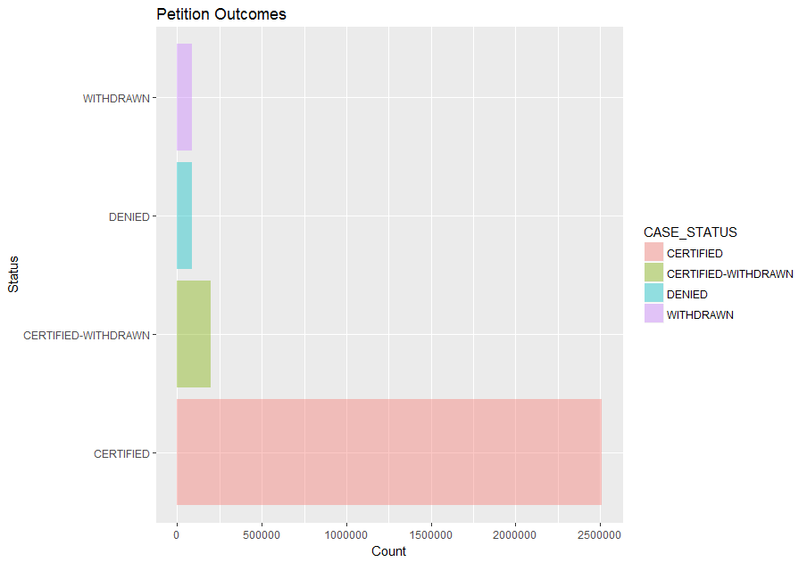

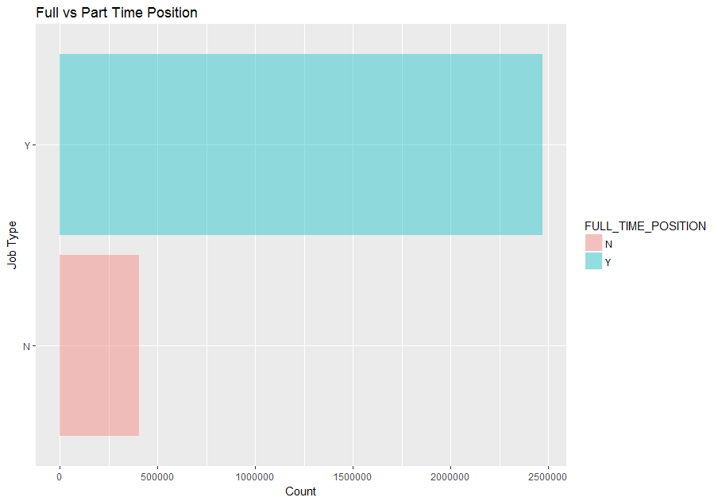

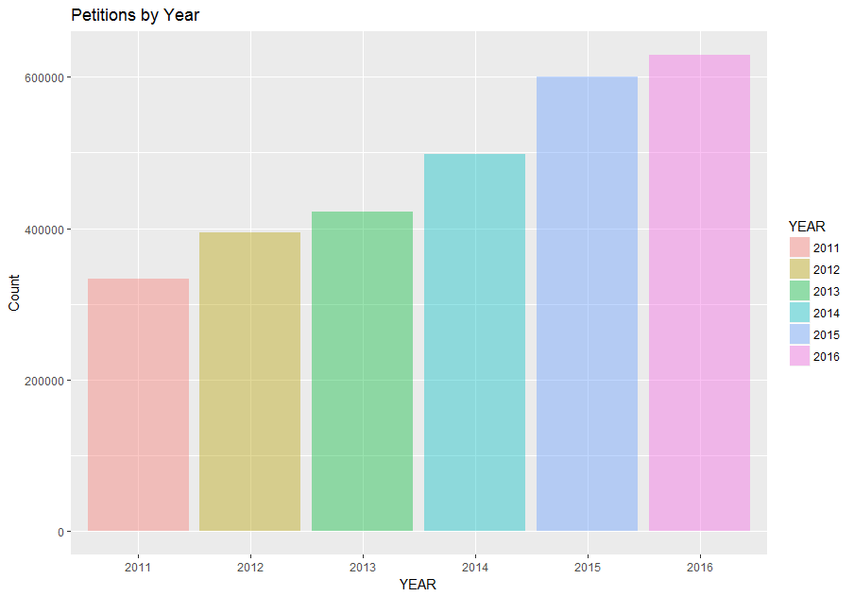

**Full Time vs Half Time Position Status by Year**

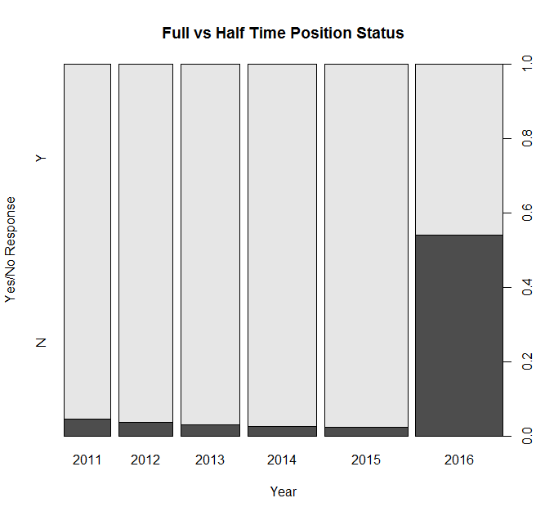

**Denied Case Status Petitions by Year**

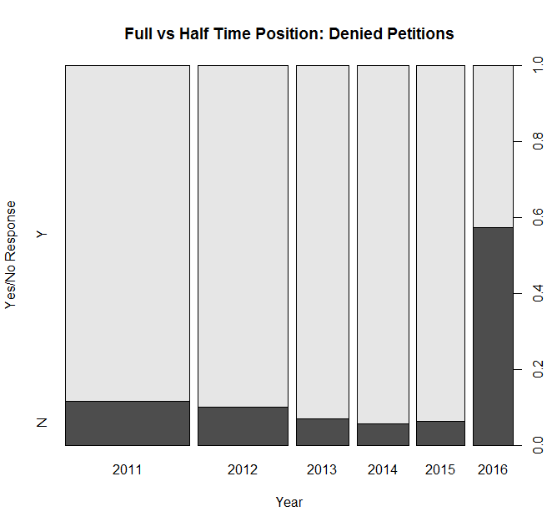

**Certified Case Status Petitions by Year**

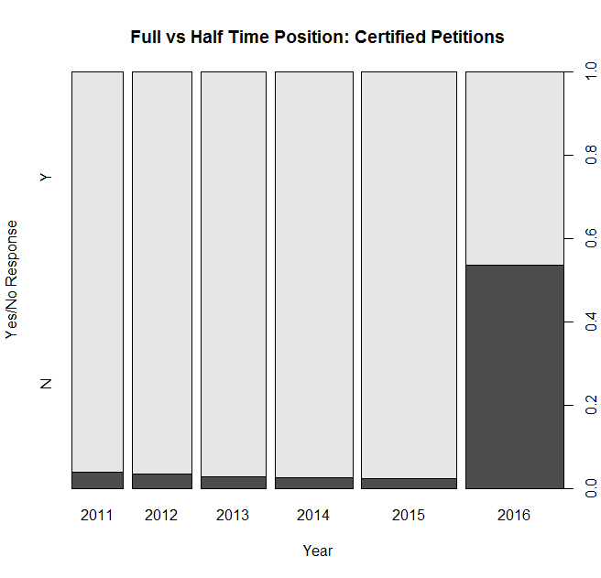

**Breakdown of Job Title**

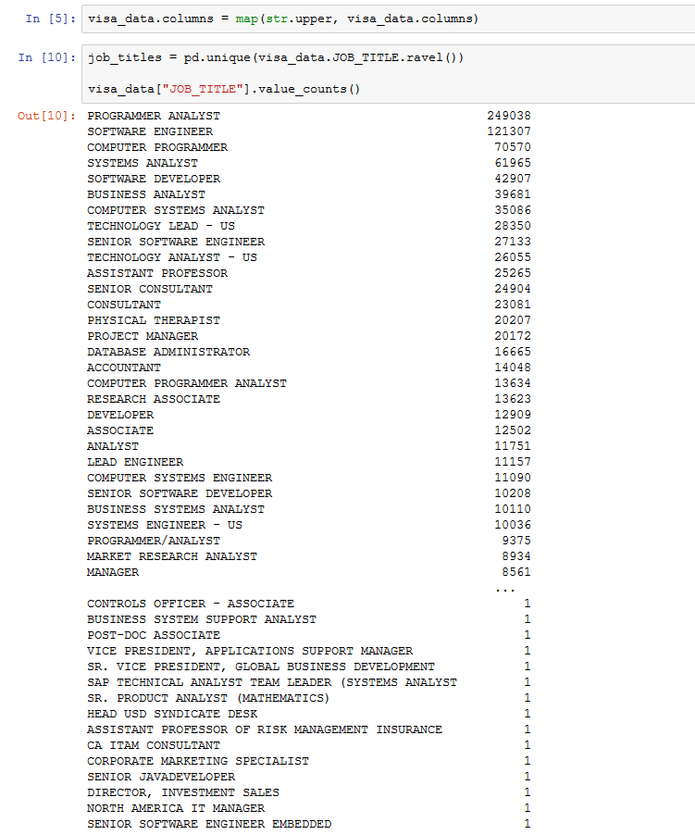

Name: JOB_TITLE, Length: 287549, dtype: int64

**Density Plots**

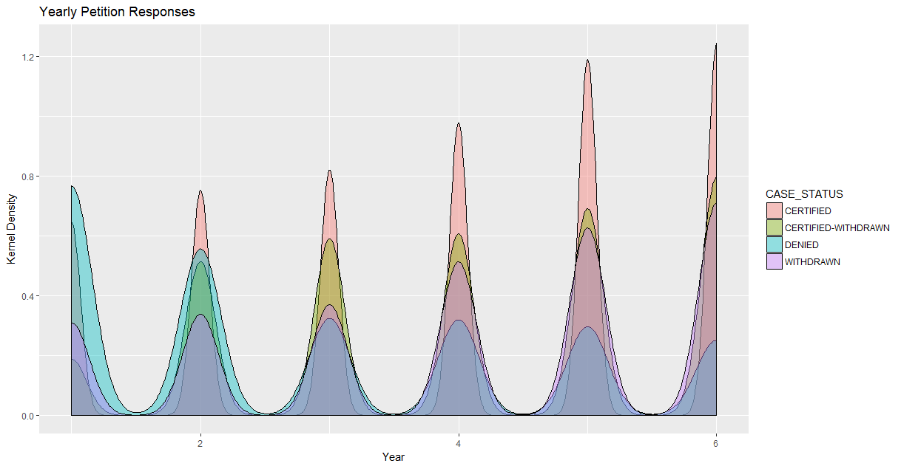

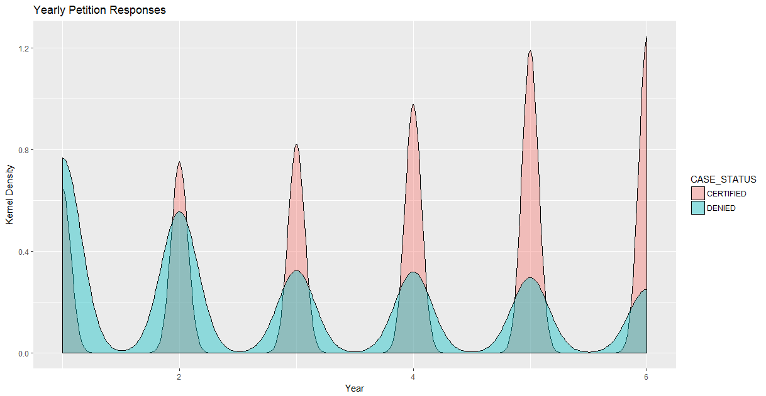

**SVM Results**

Radial Kernel Method:

rad_svm_pred CERTIFIED DENIED

CERTIFIED 524 263

DENIED 227 461

> confusionMatrix(rad_svm_table)

Confusion Matrix and Statistics

rad_svm_pred CERTIFIED DENIED

CERTIFIED 524 263

DENIED 227 461

Accuracy : 0.6678

95% CI : (0.6431, 0.6918)

No Information Rate : 0.5092

P-Value [Acc > NIR] : <2e-16

Kappa : 0.3348

Mcnemar's Test P-Value : 0.1138

Sensitivity : 0.6977

Specificity : 0.6367

Pos Pred Value : 0.6658

Neg Pred Value : 0.6701

Prevalence : 0.5092

Detection Rate : 0.3553

Detection Prevalence : 0.5336

Balanced Accuracy : 0.6672

'Positive' Class : CERTIFIED

Linear Kernel Method:

> confusionMatrix(lin_svm_table)

Confusion Matrix and Statistics

lin_svm_pred CERTIFIED DENIED

CERTIFIED 472 229

DENIED 279 495

Accuracy : 0.6556

95% CI : (0.6307, 0.6799)

No Information Rate : 0.5092

P-Value [Acc > NIR] : <2e-16

Kappa : 0.3118

Mcnemar's Test P-Value : 0.0297

Sensitivity : 0.6285

Specificity : 0.6837

Pos Pred Value : 0.6733

Neg Pred Value : 0.6395

Prevalence : 0.5092

Detection Rate : 0.3200

Detection Prevalence : 0.4753

Balanced Accuracy : 0.6561

'Positive' Class : CERTIFIED

**Association Rules**