README

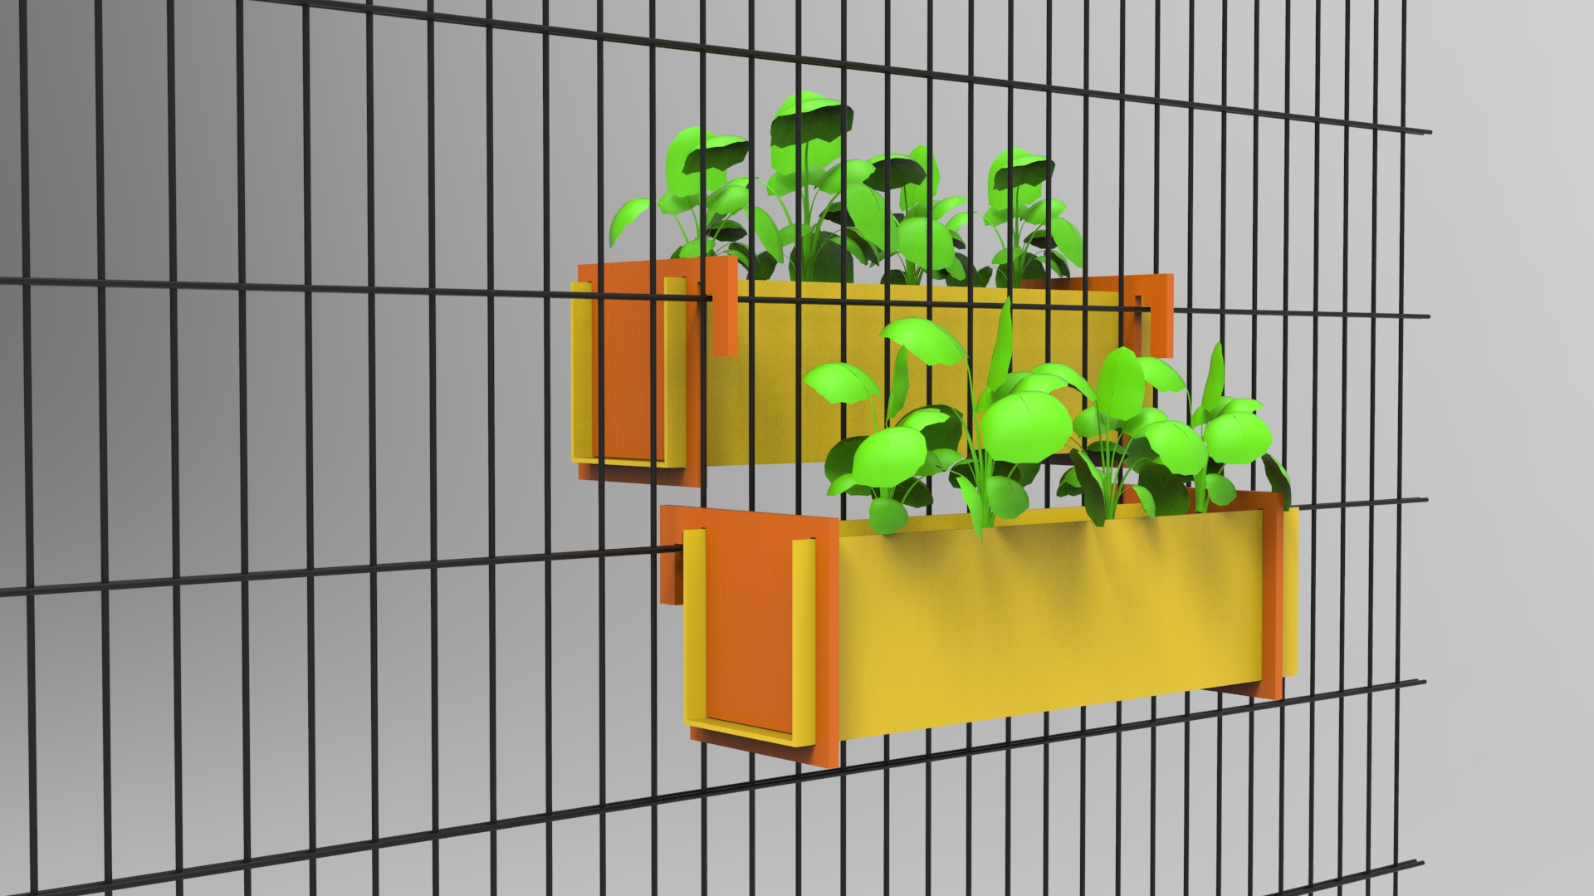

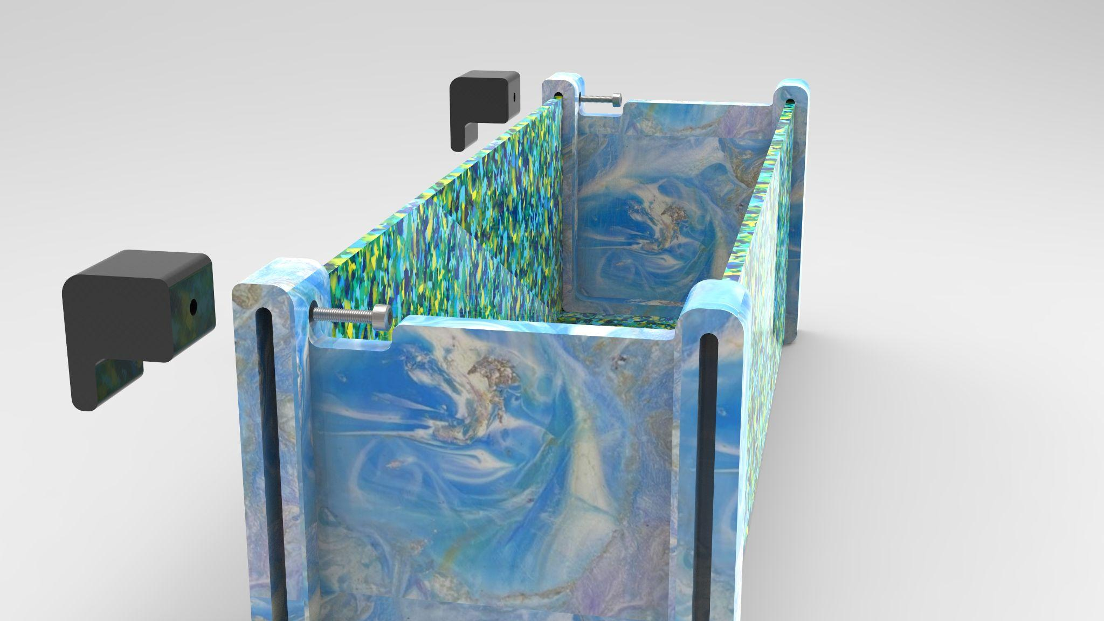

**Introduction**

The development of this repositoy took place in the context of the Fab City Interfacer project 2023. In contains two methods of production concerning the research question, how solar-irrigated vertical planting systems can be easily and low-threshold developed in plastics and other materials. In addition: How can they be produced in a Fab Lab by using digital tools, as well as by using hand tools. Last but not least an additional research objective was low-threshold environmental education and also the distribution of open source hardware in urban areas for climate change adaption.

The hereby used plastic-recyclate of Polypropylene/Polythelene are suitable circular materials, consisting of household-leftover-recyclables, mainly bottle caps. Due thermoplastic deformation, you will get dimensionally stable brackets, inlays and the mounting system. The system is especially suitable to be attached on wire mesh fences. These kind of fences where identified by the workshop participants as a problem to be solved, because these fences exist in a high number in urban areas and therefore they offer a high area for vertical greening.

Vertical greening in cities has many benefits. It can make your residential environment more beautiful, shading, cooling, purifying the air, store rain water, and much more.

According to our calculation, for each German citizen an area of 3,43 km² would need to be greened with ivy (10 cm thickness), to compensate their average CO2-Emissions. That means, that our solution can be only a small contribution to overall climate action, but still it can be imparted to all those involved that CO2-Reduction is a crucial part of preserving our ecological environment.

We were looking for a special solution for wire mesh fences, because they are to be found nearly everywhere in urban areas, but only in a few cases are used for vertical greening. If multiple metallic rods are welded together cross- and lengthways – this makes an element for a wire mesh fence. There are one- and two-wire mesh fences, for the latter the metallic rods are doubled for stability reasons. The construction of the elements makes nearly every shape possible and is suitable for multiple kinds of enclosure. Because a fence like this is very robust (even in greater heights) and it is hard to climb over it, it is very popular, especially for industrial companies, communities and bigger properties. Also the long lifetime is a big advantage, as in comparison they do not need to repaired or renewed for a quite long time. The metal, mostly steel, is protected of corrosion by a coating of plastic or paint. This protection should not be damaged by attaching the planting modules.

The benefits of the planting modules are:

* Modules from recycled plastic (also other materials are possible)
* Production is possible with different machines
* Suitable for wire mesh fences, as well as railings in different sizes
* Easy attachment with a reliable grip, possible to install it in variable lengths
* Integrated, automatic, solar-powered irrigation system
* No damaging of the fences
* Also suitable for wider roots

This repository contains the manual for producing 2 different modular vertical greening containers, one mounting system (as displayed in the pictures above), as well as an affordable and easy to build automatic drip-irrigation system, which is powered by solar energy.

**Low-threshold vertical greening of public spaces**

The planting modules make a small distribution for the usage of public spaces despite the effects of climate change. They are low-threshold and inexpensively to produce. Thus, they make a distribution for the self-efficacy of citizens in the face of climate change.

**Sustainable**

Through the usage of the secondary resource recycled plastic, re-/upcycling is being done. The plastic can be recycled again, as appropriate under addition of further recyclate. The usage of scrap wood is also possible, but here the durability in the outdoor area is less persistent (even more, if the recycled plastic is stabilized with an appropriate UV-protection).

**Replicatable in Fab labs, Open Workspaces and at home**

In the creation of the production method it was emphasized that the planting modules can be made from recycled plastics, alternatively also from other materials. Also it was one of the collectively developed criteria (9 criteria in total) that the system comes close to the principles of simplicity and that the modules therefore can be replicated with the possibilities of Fab Labs and Open Workspaces, as well as in a basement hobby room.

**Repository**

The repository is contructed in a modular way. The Readme Contruction of Materials is filed in the folder mod/material_fabrication and describes the basic manufacturing process of plastic sheets, based on Precious Plastic processes, and of the parts being produced with mould and extrusion process. The Readme irrigation system in the folder mod/irrigation_system describes the construction of the irrigation system with 5V fort he irrigation of approx. 2 plants. A bigger version with 12V (using the SolarBox or an old car battery) is still in testing and will be added to the repository.

A user manual is described in the user manuel. We would really welcome comments or improvement proposals regarding this documentation. How you can do this, you will find in the Contribution guide.

**User manual for the usage of this repository for the prototype-production**

1. Please read the README Contruction of Materials for a basic understanding of the whole process, if you choose plastics as a material.
2. Please consider the manufacturing of a mould regarding the budget, workshop equipment and number of pieces you want to produce. For a small amount of products or just for trying you can do it without making a mould. Instead of this you can manufacture the brackets with a CNC mill or a saw. This is also the case, if you choose another material than plastics. Furthermore the mould can also be dony by founding. For this we recommend 3D-printing of a positive shape and as the next step a multiple casting with gypsum.
3. Remember to start in time with the collection of PP/PE-plastics, that you want to recycle. For the plant pot 1 (extrusion) you need approx. 1863 g for the sheets, each approx. 256 g for the brackets & the mounting system (total approx.2.631 g). For the module 2 (milled) you need approx. 1150 g for the sheets, as well as approx. 440 g for each bracket and approx. 56 g for each mounting system (total approx. 2.582 g).
4. Depending on the material you choose, different machines are needed. Reserve these at your local Fab Lab or Open Workspace.
5. Now the practical part can start!

**Annotation**

In the workshops there were four more designs developed, which will be further worked on and finalized during the year. If you are interested, please contact us:

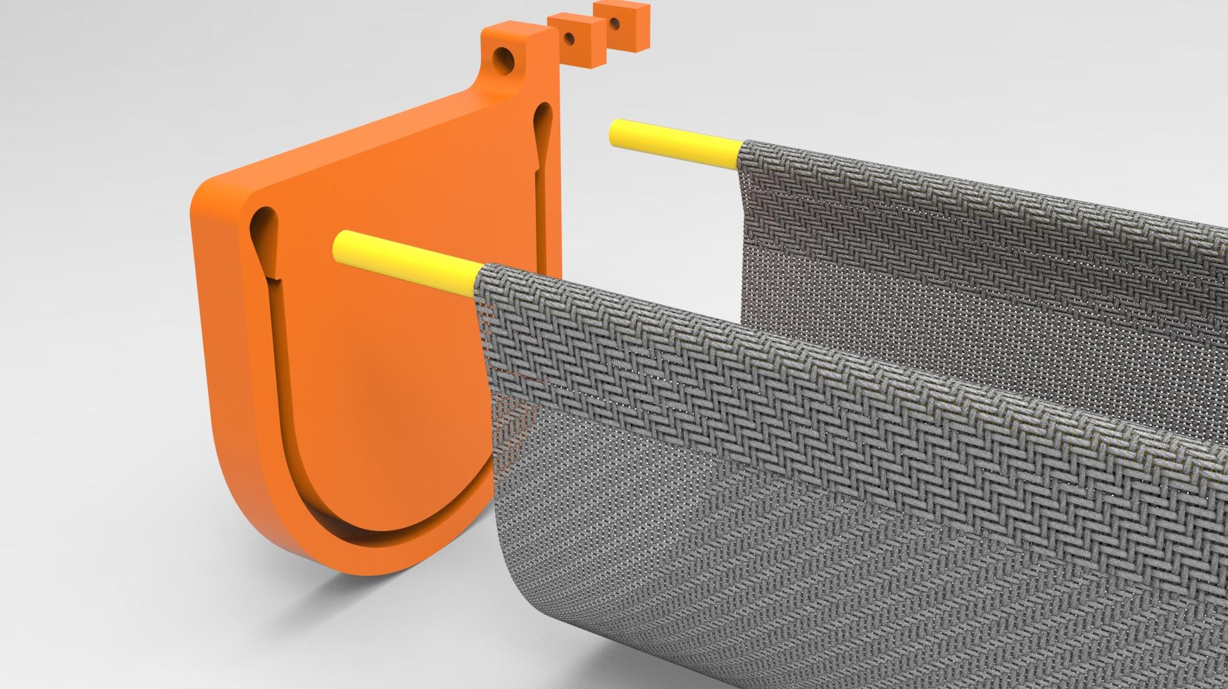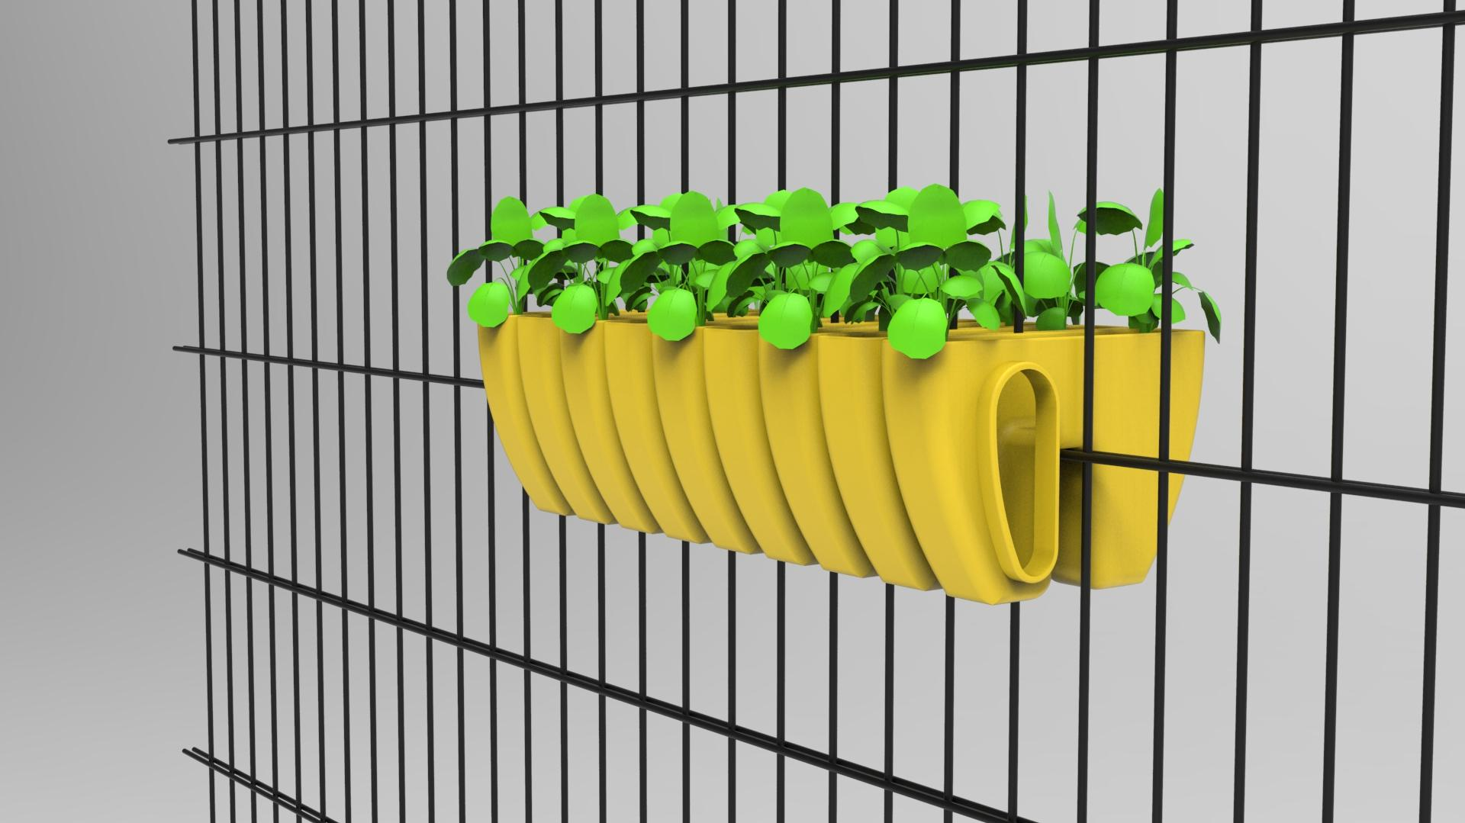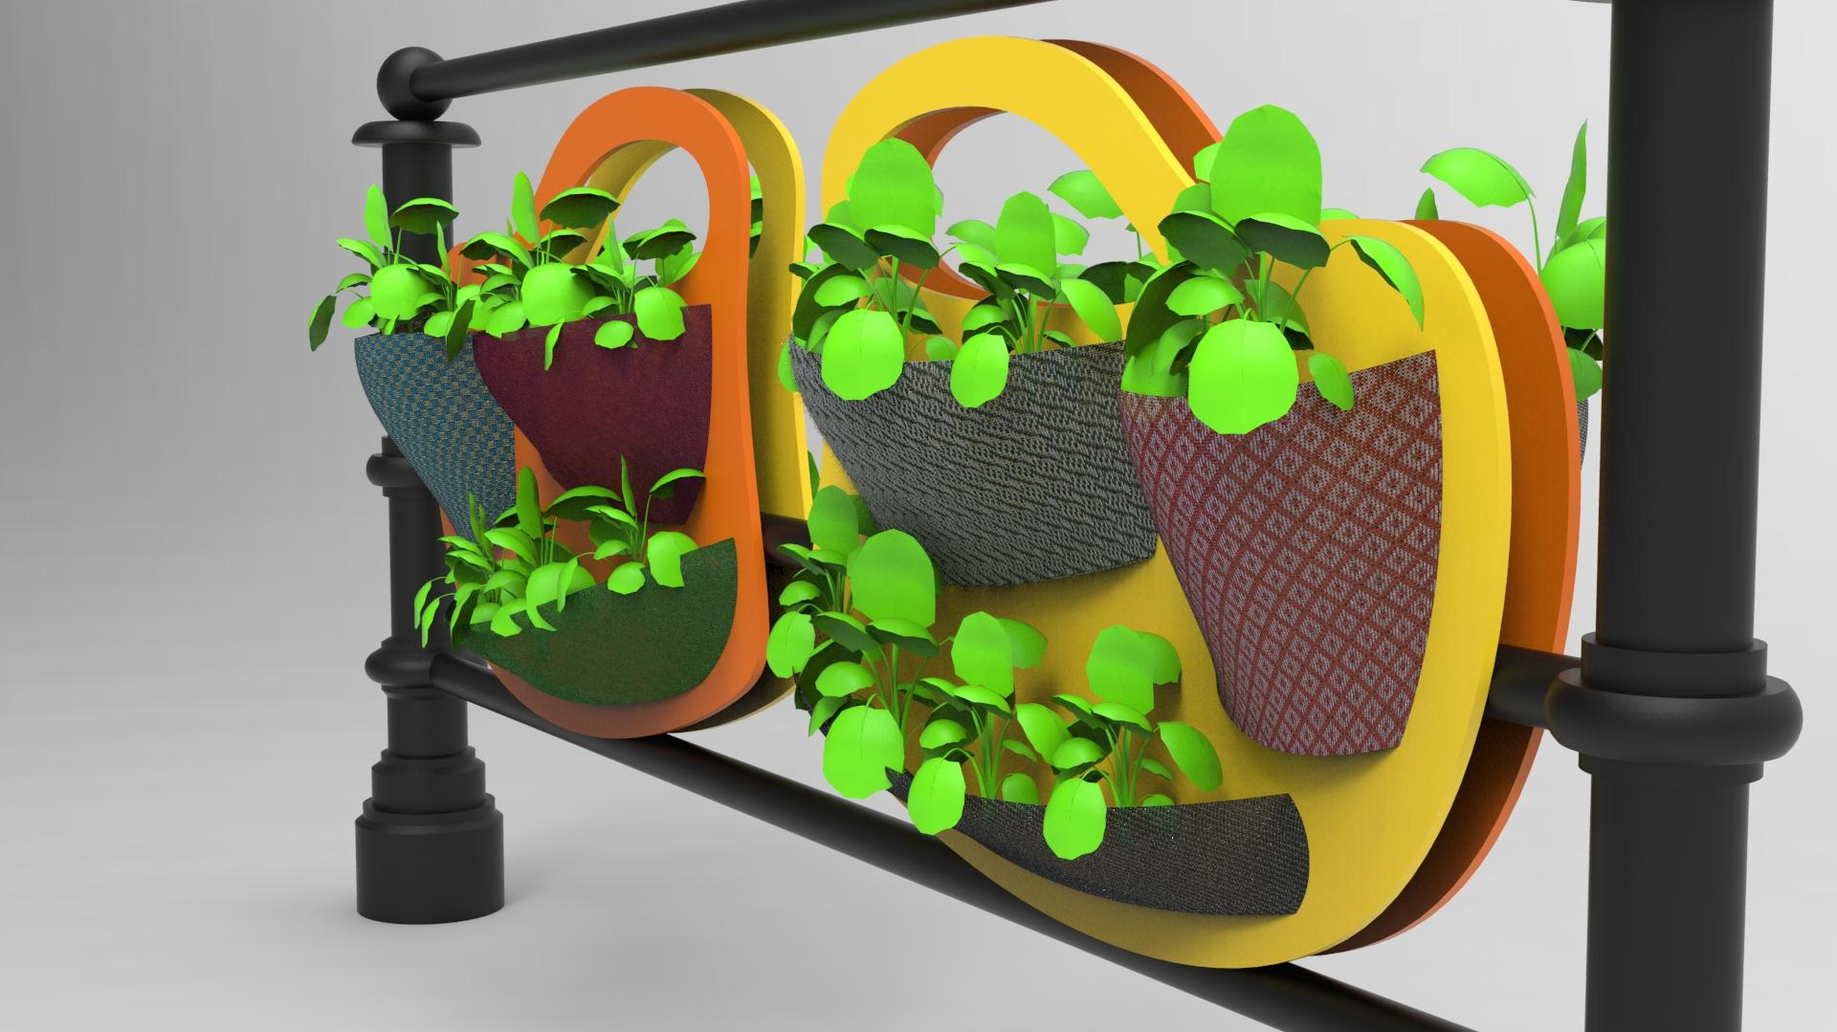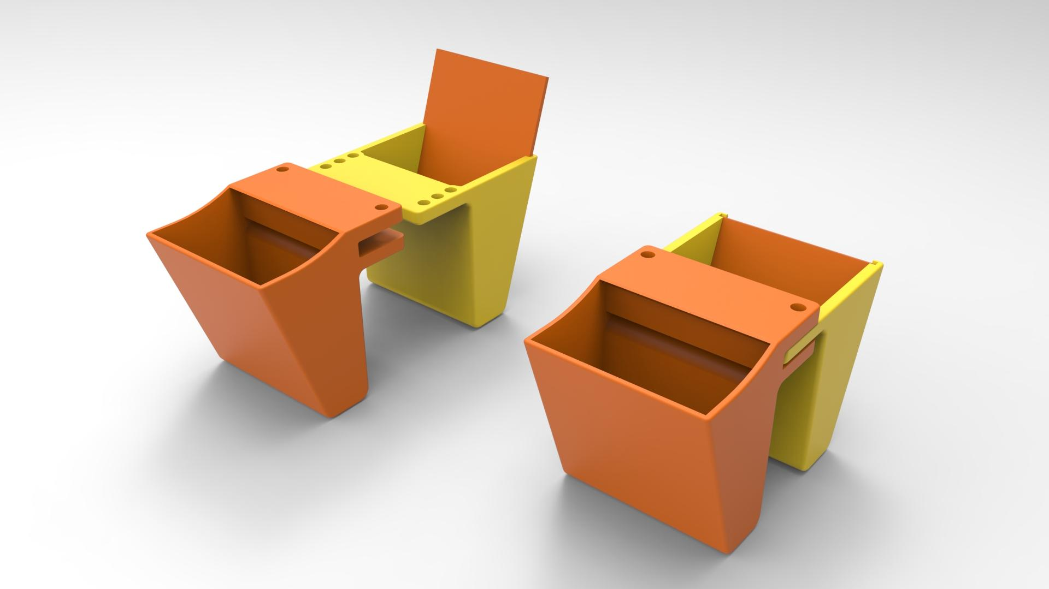

**Lizenz**

[Vertikale Pflanzenbehälter für Stabmattenzäune](https://werkstatt.insel-ev.de/vertikalbegruenung) © 2023 by [insel e.V. Offene Recycling-Werkstatt](https://werkstatt.insel-ev.de) is licensed under [Attribution-NonCommercial-ShareAlike 4.0 International https://chooser-beta.creativecommons.org/img/cc-logo.f0ab4ebe.svghttps://chooser-beta.creativecommons.org/img/cc-by.21b728bb.svg](http://creativecommons.org/licenses/by-nc-sa/4.0/?ref=chooser-v1)



Contributors and participants of the workshop (in alphabetical order):

Alberto Porri

Anais

Ariane

Ayushija Batz

Dennis Neumann / Tukki

Frau Mendez

Frau Weimheuer

Fred Zange

Ivonne zum Felde

Jasmin Zuehlke

Johannes Kriet

Kristina Vietz-Schmidt

Leven Hennig

Michi Koch

Mike Lehmhaus

Nick Haimerl

Pieter Mossel

Paula Passos

Raissa Bloedorn

Smilla Ebeling

Susanne Milenz

Walter Sauf

Wilhelm Schütze

Supported by Fab City Hamburg and the Helmut-Schmidt-University Hamburg.