1. Write a MongoDB query to display all the documents in the collection restaurants

**db.restaurant.find()**

2. Write a MongoDB query to display the fields restaurant_id, name, borough and cuisine for all the documents in the collection restaurant.

**db.restaurent.find({},{restaurant_id:1,name:1, borough:1, cuisine:1, _id:0})**

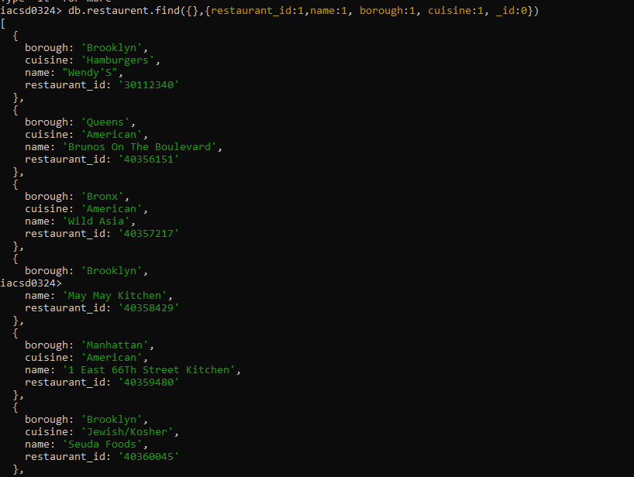

3. Write a MongoDB query to display the fields restaurant_id, name, borough and cuisine, but exclude the field _id for all the documents in the collection restaurant.

**db.restaurent.find({},{restaurant_id:1,name:1, borough:1, cuisine:1, _id:0})**

4. Write a MongoDB query to display the fields restaurant_id, name, borough and zip code, but exclude the field _id for all the documents in the collection restaurant.

**db.restaurent.find({},{restaurant_id:1,name:1,borough:1, 'address.zipcode':1,_id:0})**

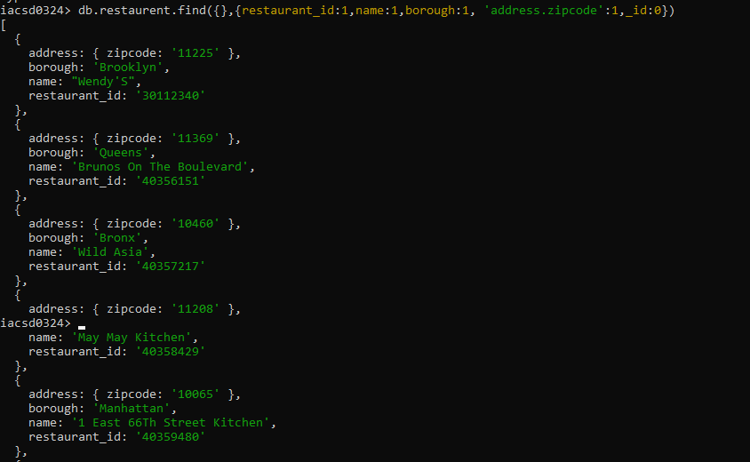

5. Write a MongoDB query to display all the restaurant which is in the borough Bronx

**db.restaurent.find({borough:'Bronx'},{_id:0, grades:0})**

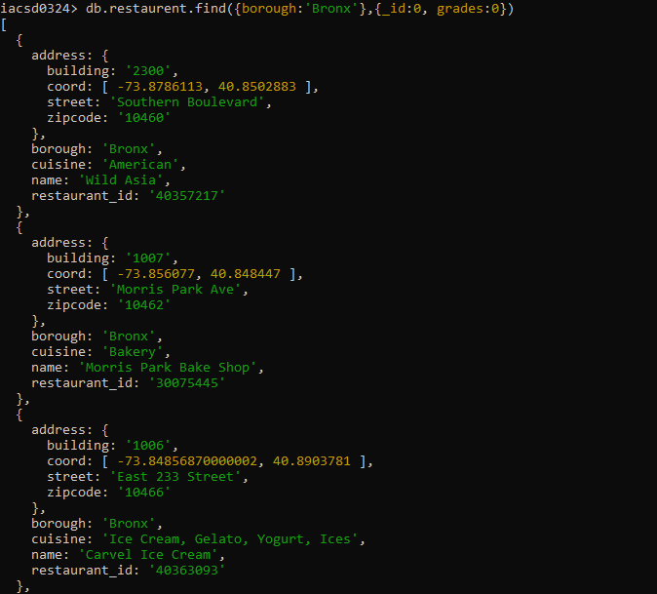

6. Write a MongoDB query to display the first 5 restaurant which is in the borough Bronx.

**db.restaurent.find({borough:'Bronx'},{_id:0,grades:0,address:0}).limit(5)**

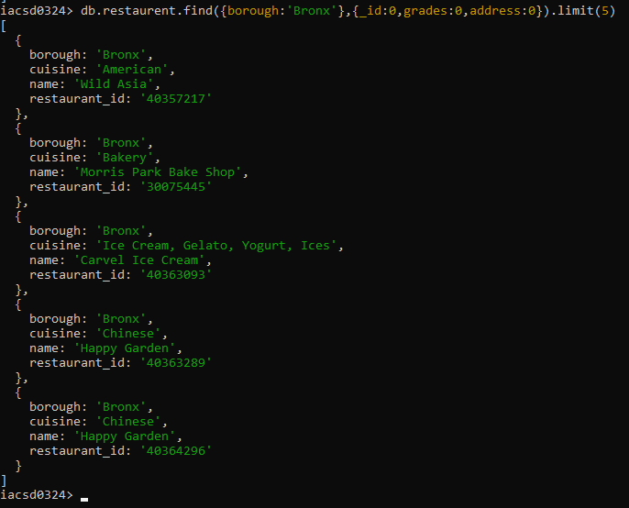

7.Write a MongoDB query to display the next 5 restaurants after skipping first 5 which are in the borough Bronx.

**db.restaurent.find({borough:Bronx},{_id:0,grade:0,address:0}).limit(5).skip(5)**

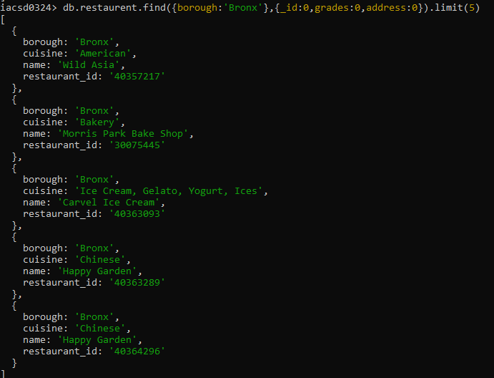

8. Write a MongoDB query to find the restaurants who achieved a score more than 10.

**db.restaurent.find({'grades.score':{$gt:10}},{_id:0,address:0})**

9. Write a MongoDB query to find the restaurants that achieved a score, more than 80 but less than 100.

**db.restaurent.find({'grades.score':{$gt:10},'grades.score':{$lt:15}},{_id:0,address:0})**

10. Write a MongoDB query to find the restaurants which locate in latitude value less than -95.754168.

**db.restaurent.find({'address.coord.0':{$lt:-95.754168}},{_id:0,grades:0})**

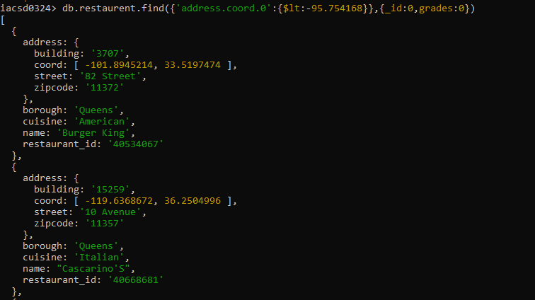

11. Write a MongoDB query to find the restaurants that do not prepare any cuisine of 'American' and their grade score more than 10 and latitude less than -65.754168.

**db.restaurent.find({cuisine:{$ne:'American'},'grades.score':{$gt:10},'address.coord.0':{$lt:-65.754168}},{_id:0})**

12. Write a MongoDB query to find the restaurants which do not prepare any cuisine of 'American' and achieved a score more than 10 and located in the longitude less than -65.754168.

**db.restaurent.find({cuisine:{$ne:'American'},'grades.score':{$gt:10},'address.coord.0':{$lt:-65.754168}},{_id:0})**

13. Write a MongoDB query to find the restaurants which do not prepare any cuisine of 'American ' and achieved a grade point 'A' not belongs to the borough Brooklyn. The document must be displayed according to the cuisine in descending order.

**db.restaurent.find({cuisine:{$ne:'American'},'grades.grade':'A',borough:{$ne:'Brooklyn'}},{_id:0,address:0}).sort({cuisine:-1})**

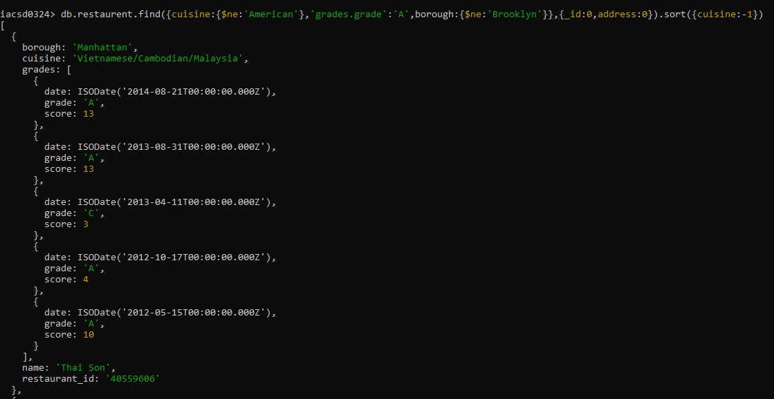

14. Write a MongoDB query to find the restaurant Id, name, borough and cuisine for those restaurants which contain 'Wil' as first three letters for its name.

**db.restaurent.find({name:/^wil/i},{restaurant_id:1,name:1,borough:1,cuisine:1,_id:0})**

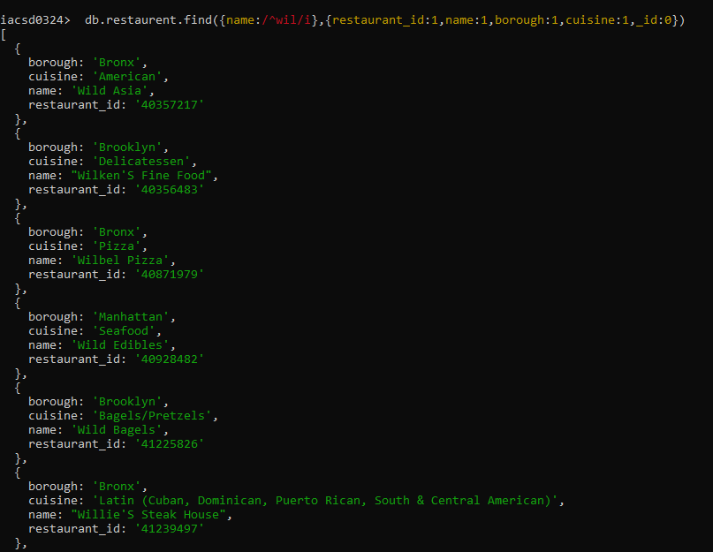

15. Write a MongoDB query to find the restaurant Id, name, borough and cuisine for those restaurants which contain 'ces' as last three letters for its name.

**db.restaurent.find({name:/ces$/i},{restaurant_id:1,name:1,borough:1,cuisine:1,_id:0})**

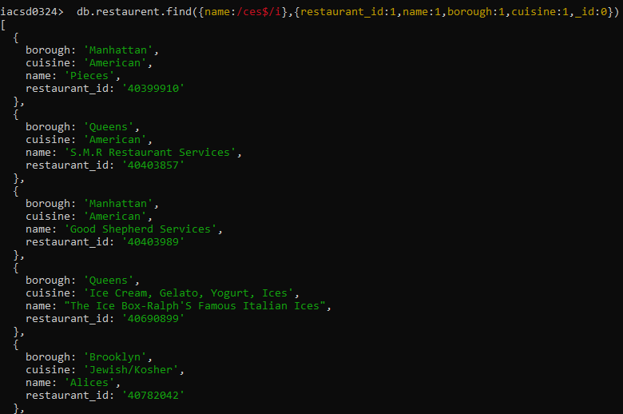

16. Write a MongoDB query to find the restaurant Id, name, borough and cuisine for those restaurants which contain 'Reg' as three letters somewhere in its name.

**db.restaurent.find({name:/Reg/i},{restaurant_id:1,name:1,borough:1,cuisine:1,_id:0})**

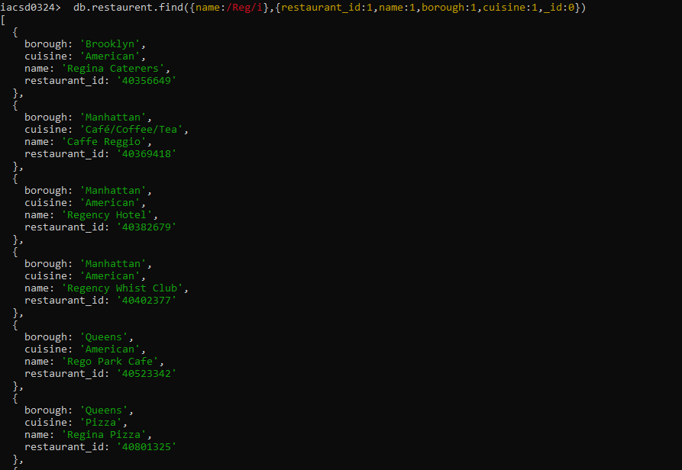

17. Write a MongoDB query to find the restaurants which belong to the borough Bronx and prepared either American or Chinese dish.

**db.restaurent.find({borough:'Bronx',cuisine:{$in:['American','Chinese']}},{_id:0,address:0,grades:0})**

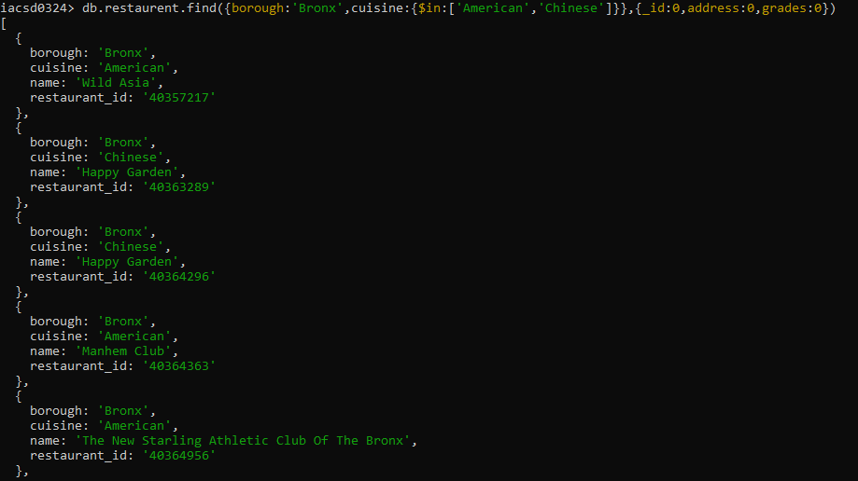

18. Write a MongoDB query to find the restaurant Id, name, borough and cuisine for those restaurants which belong to the borough Staten Island or Queens or Bronxor Brooklyn.

**db.restaurent.find({borough:{$in:['Staten Island','Queens','Bronxor', 'Brooklyn']}},{restaurant_id:1,name:1,borough:1,cuisine:1,_id:0})**

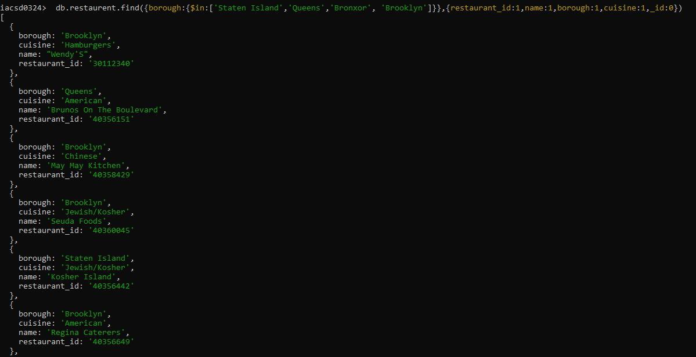

19. Write a MongoDB query to find the restaurant Id, name, borough and cuisine for those restaurants which are not belonging to the borough Staten Island or Queens or Bronxor Brooklyn.

**db.restaurent.find({borough:{$nin:['Staten Island','Queens','Bronxor', 'Brooklyn']}},{restaurant_id:1,name:1,borough:1,cuisine:1,_id:0})**

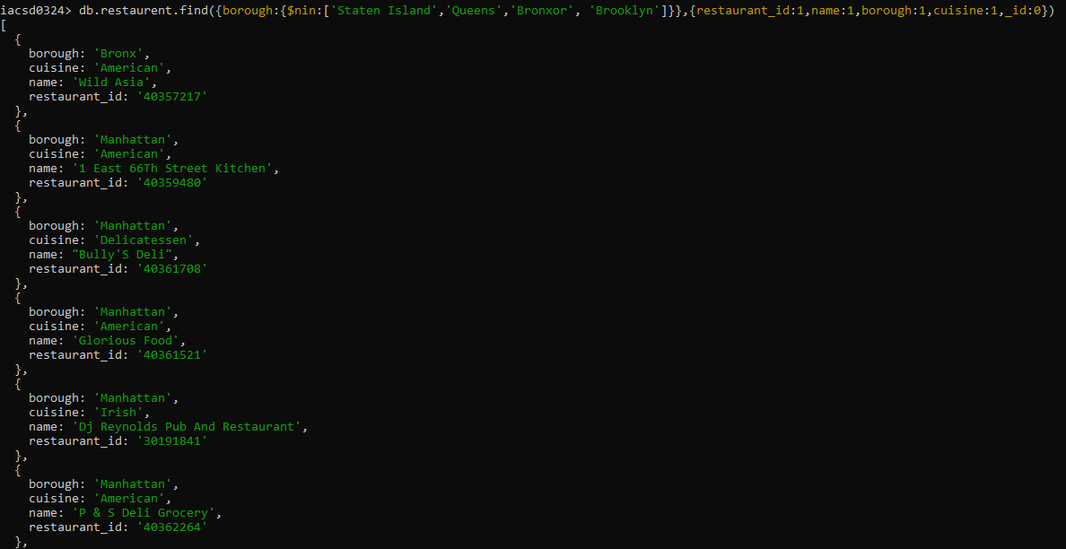

20. Write a MongoDB query to find the restaurant Id, name, borough and cuisine for those restaurants which achieved a score which is not more than 10.

**db.restaurent.find({'grades.score':{$lt:10}},{restaurant_id:1,name:1,borough:1,cuisine:1,_id:0,grades:1})**

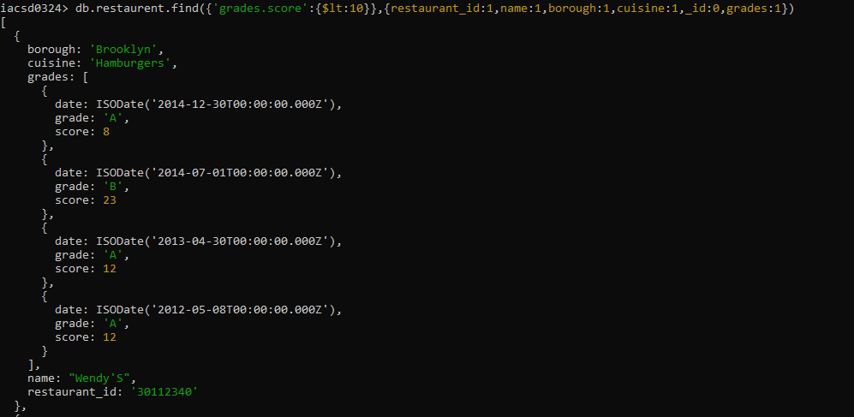

21. Write a MongoDB query to find the restaurant Id, name, borough and cuisine for those restaurants which prepared dish except 'American' and 'Chinees' or restaurant's name begins with letter 'Wil'.

**db.restaurent.find({cuisine:{$nin:['American','Chinese']},name:/^wil/i},{restaurant_id:1,name:1,borough:1,cuisine:1,_id:0})**

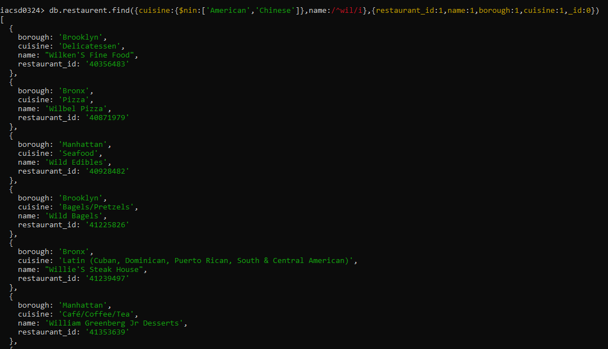

22. Write a MongoDB query to find the restaurant Id, name, and grades for those restaurants which achieved a grade of "A" and scored 11 on an ISODate "2014-08-11T00:00:00Z" among many of survey dates

**db.restaurent.find({grades:{$elemMatch:{grade:'A',score:11,date:ISODate("2014-08-11T00:00:00Z")}}},{restaurant_id:1,name:1,grades:1,_id:0})**

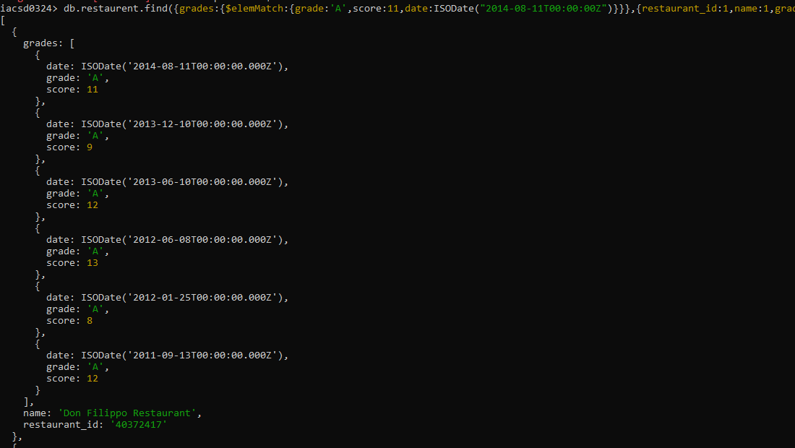

23. Write a MongoDB query to find the restaurant Id, name and grades for those restaurants where the 2nd element of grades array contains a grade of "A" and score 9 on an ISODate "2014-08-11T00:00:00Z".

**db.restaurent.find({grades:{$elemMatch:{grade:'A',score:9,date:ISODate("2014-08-11T00:00:00Z")}}},{restaurant_id:1,name:1,grades:1,_id:0}).skip(1)**

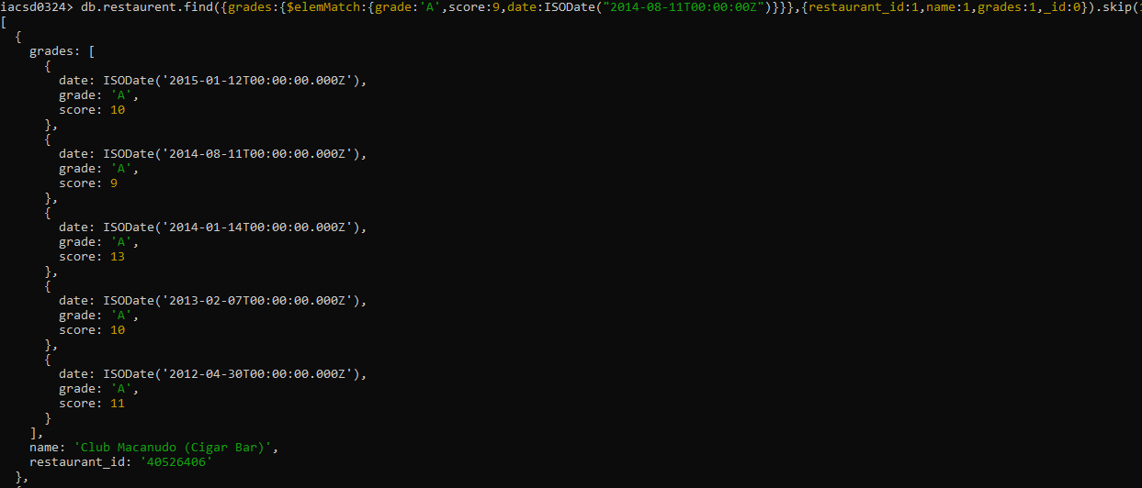

24. Write a MongoDB query to find the restaurant Id, name, address and geographical location for those restaurants where 2nd element of coord array contains a value which is more than 42 and upto 52

**db.restaurent.find({'address.coord.1':{$gt:42,$lt:52}},{restaurant_id:1,name:1,address:1,_id:0})**

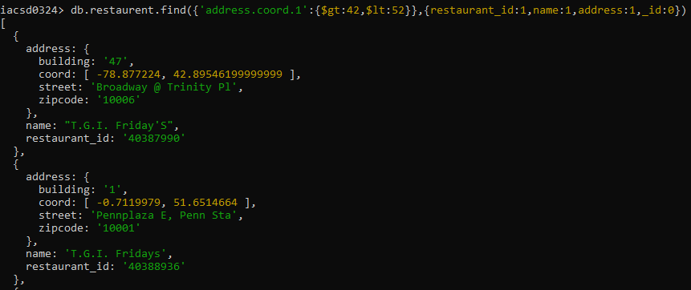

25. Write a MongoDB query to arrange the name of the restaurants in ascending order along with all the columns.

**db.restaurent.find({},{_id:0,name:1}).sort({name:1}).skip(1000)**

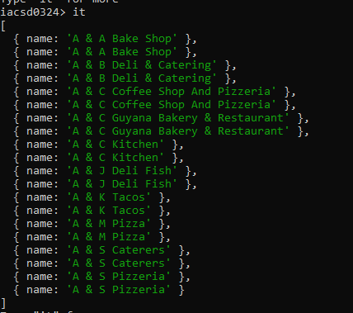

26. Write a MongoDB query to arrange the name of the restaurants in descending along with all the columns.

**db.restaurent.find({},{_id:0,name:1}).sort({name:-1}).skip(1000)**

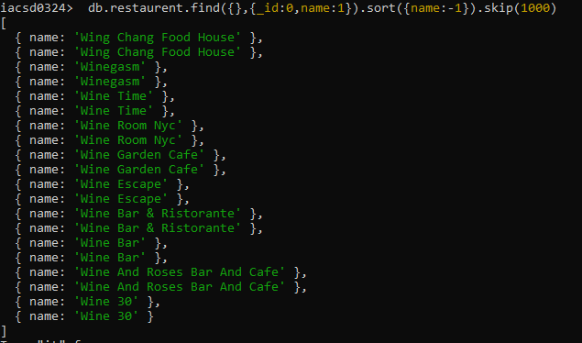

27. Write a MongoDB query to arranged the name of the cuisine in ascending order and for that same cuisine borough should be in descending order.

**values in collection are--->50736**

**db.restaurent.find({},{_id:0,cuisine:1,borough:1}).sort({cuisine:1,borough:-1}).skip(20000)**

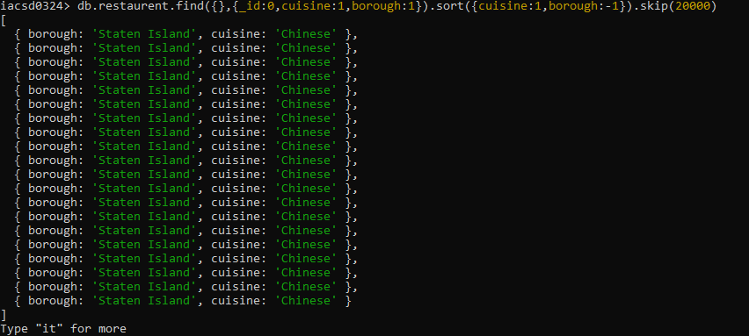

28. Write a MongoDB query to know whether all the addresses contains the street or not.

**values in collection are--->50736**

**Values in collection that contains street are —---->50718**

**db.restaurent.find().count()**

**db.restaurent.find({'address.street':{$exists:true}},{_id:0}).count()**





29. Write a MongoDB query which will select all documents in the restaurants collection where the coord field value is Double.

**db.restaurent.find({'address.coord':{$type:'double'}},{address:1,_id:0})**

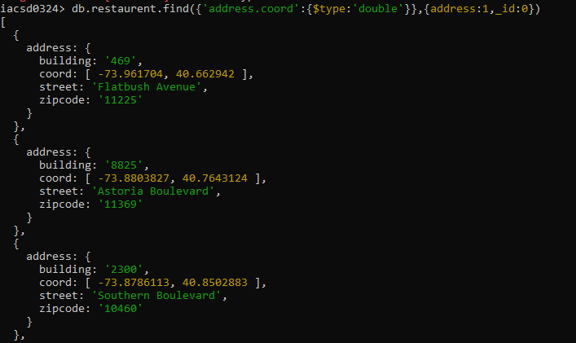

30. Write a MongoDB query which will select the restaurant Id, name and grades for those restaurants which returns 0 as a remainder after dividing the score by 7.

**db.restaurent.find({'grades.score':{$mod:[7,0]}},{restaurant_id:1,name:1, grades:1,_id:0})**

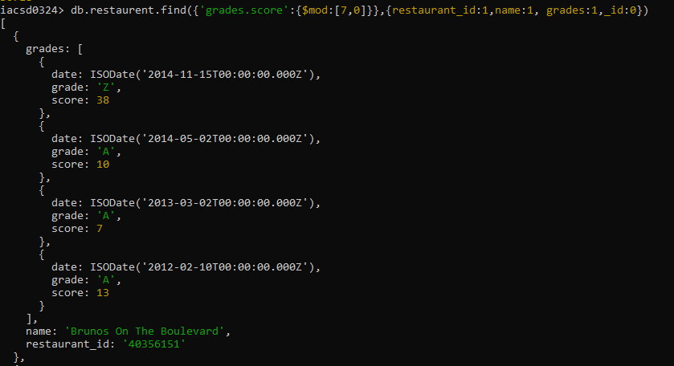

31. Write a MongoDB query to find the restaurant name, borough, longitude and attitude and cuisine for those restaurants which contains 'mon' as three letters somewhere in its name.

**db.restaurent.find({name:/mon/i},{name:1,cuisine:1,'address.coord':1,borough:1,_id:0})**

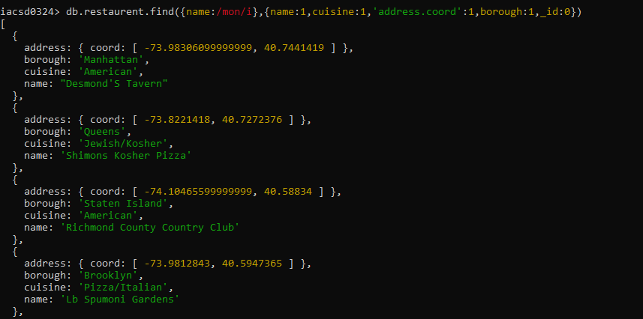

32. Write a MongoDB query to find the restaurant name, borough, longitude and latitude and cuisine for those restaurants which contain 'Mad' as first three letters of its name.

**db.restaurent.find({name:/^mad/i},{name:1,cuisine:1,'address.coord':1,borough:1,_id:0})**

