1. Write a query to display the first day of the month (in datetime format) three months before the current month.

Sample current date : 2014-09-03

Expected result : 2014-06-01

**select date_sub(date_sub('2014-09-03', interval 3 month), interval 2 day);**

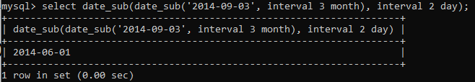

2. Write a query to display the last day of the month (in datetime format) three months before the current month.

**select (date_sub(date_sub(curdate(), interval 1 month),interval day(curdate()) day)) as Last_Day_of_Month;**

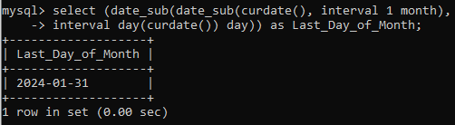

3. Write a query to get the distinct Mondays from hiredate in emp tables.

**select distinct hiredate, dayname(hiredate)**

**-> from emp**

**-> where dayname(hiredate)='Monday';**

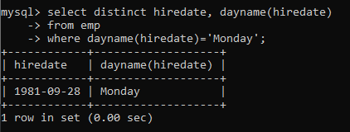

4. Write a query to get the first day of the current year.

**SELECT dayname(MAKEDATE(year(now()),1)) as FIRST_DAY_OF_YEAR;**

**MAKEDATE(year, dayofyear);**

**year:**The year for which you want to create a date.

**dayofyear:**The day of the year (1 to 366) for the specified year.

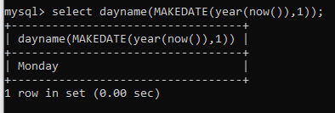

5. Write a query to get the last day of the current year.

**select dayname(MAKEDATE(year(now()), 366)) as LAST_DAY_OF_YEAR;**

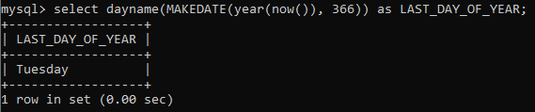

6. Write a query to calculate your age in year.

**select floor(datediff(curdate(),'2001-08-28')/365) as MY_AGE;**

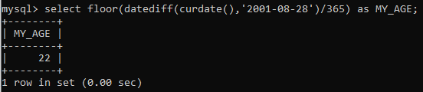

7. Write a query to get the current date in the following format.

Sample date : 04-sep-2014

Output : September 4, 2014

**select date_format('2014-09-04', "%M %d, %Y") as TODAY_DATE;**

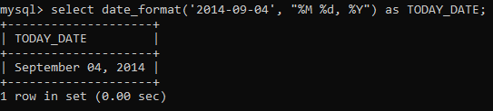

8. Write a query to get the current date in Thursday September 2014 format.

Thursday September 2014

**select date_format(curdate(), '%W %M %Y') as DAY_MONTH_YEAR;**

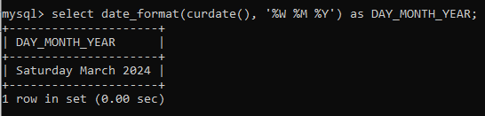

9. Write a query to extract the year from the current date.

**select year(now());**

**OR**

**select date_format(curdate(), '%Y') as YEAR;**

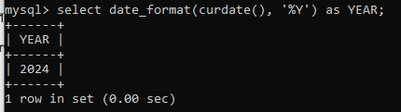

10. Write a query to get the first name and hire date from employees table

where hire date between '1987-06-01' and '1987-07-30'

**select ename, hiredate from emp**

**-> where hiredate between '1987-06-01' and '1987-07-30' ;**



11. Write a query to display the current date in the following format.

Sample output: Thursday 4th September 2014 00:00:00

**select date_format(curdate(), '%W %D %M %Y %T');**

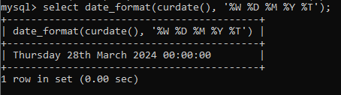

12. Write a query to display the current date in the following format.

Sample output: 05/09/2014

**select date_format(curdate(), '%d/%m/%Y ');**

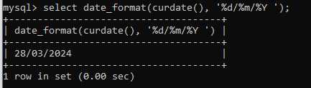

13. Write a query to display the current date in the following format.

Sample output: 12:00 AM Sep 5, 2014

**select date_format(curdate(), '%r %b %e, %Y');**

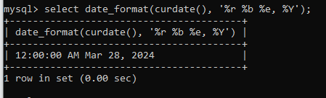

14. Write a query to get the employees who joined in the month of June.

**select * from emp**

**where month(hiredate)=6;**

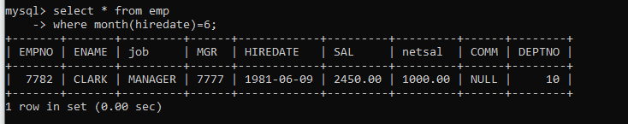

15. Write a query to get the years in which more than 5 employees joined.

**select deptno, year(hiredate),count(empno) from emp**

**-> group by deptno,year(hiredate)**

**-> having count(empno)>5**

**-> order by deptno;**

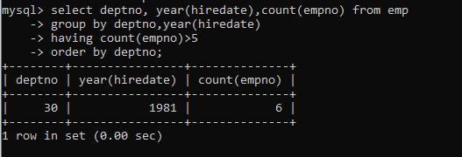

16. Write a query to get first name of employees who joined in 1981.

**select ename from emp where year(hiredate)=1981;**

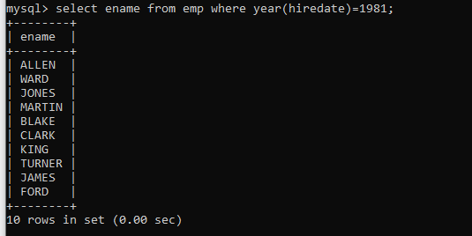

17. Write a query to get employees whose experience is more than 42 years.

**select * from emp where floor(datediff(curdate(),hiredate)/365)>42;**

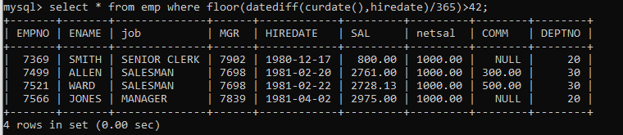

18. Write a query to get employee ID, last name, and date of first salary of the employees.

**select empno, ename, date_add(hiredate, interval 30 day) "Date_of_1st_sal" from emp ;**

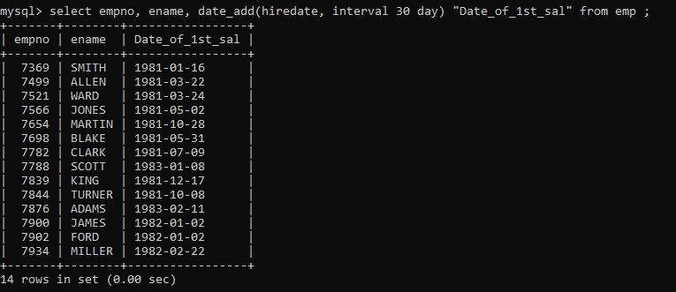

19. Write a query to get first name, hire date and experience of the

employees. Sample table: employees

**select empno, ename, floor(datediff(curdate(),hiredate)/365) "Experience" from emp ;**

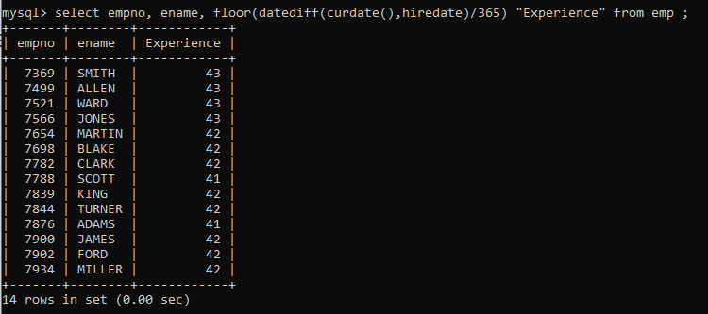

20. Write a query to get the department ID, year, and number of employees joined.

**select deptno, year(hiredate),count(empno) from emp**

**-> group by deptno,year(hiredate)**

**-> order by deptno;**

