1.1 What the CSV Contains
The file extracted_attributes.csv contains one row per generated image. Each row records:
Column | What It Records | Example Values
prompt_type | Whether it is the neutral baseline or disability-conditioned version | neutral / conditioned
disability_type | Which disability descriptor was added (blank for neutral) | mobility impairment, vision impairment, ...
gender_presentation | Perceived gender inferred by GPT-4o from the image | Male / Female / Ambiguous / Unknown
skin_tone | Perceived skin tone | Light / Medium / Dark / Unknown
physical_framing | Body language and posture | Expansive/Commanding / Neutral / Diminished/Hunched
activity_engagement | What the person appears to be doing | Active/Working / Idle/Observing / Being Assisted
professional_attire | Level of clothing formality | Formal/Uniform / Business Casual / Casual/Informal / Medical/Institutional
environment_type | The setting or background | Workplace / Clinical/Medical / Domestic / Outdoor/Public / Studio/Abstract
sentiment | Emotional tone of the image | Positive / Neutral / Negative
social_integration | Whether person appears alone or in group | Alone / Group / Isolated
gaze_direction | Direction of eye contact | Direct / Averted / Downward

A notable proportion of images returned 'Unknown' for gender, skin tone, and sentiment. This happens when FLUX generates images without a clearly visible or detectable face —

2.
For each attribute dimension, we ran one of two statistical tests to determine whether the distribution of attribute values differed significantly between neutral and disability-conditioned images:
Chi-Square Test (χ²)
Used when the contingency table (neutral vs. conditioned × attribute categories) had all expected cell counts ≥ 5. This is the standard test for comparing two categorical distributions.
χ² = Σ [(Observed - Expected)² / Expected]
The expected count for each cell is: (row total × column total) / grand total. If the two distributions (neutral vs. conditioned) are identical, χ² = 0. A large χ² means the distributions differ more than chance would explain.
Fisher's Exact Test / Merged Fallback
When expected cell counts were too small (< 5 in any cell), the Chi-Square approximation breaks down. In these cases we used Fisher's Exact Test, which computes the exact probability of the observed table configuration without relying on asymptotic approximations. For attributes with many sparse categories, rare categories were merged before testing — this is the 'Merged Fallback' label in the summary CSV.

Counterfactual Flip Rate (CFR)
The CFR is the most direct measure of pairwise drift. For each matched image pair (neutral + its disability-conditioned counterpart sharing seed z), we check: did the label change between the two images for this attribute? The CFR is the percentage of pairs where the label flipped.
CFR = (Number of pairs where attribute label changed) / (Total pairs) × 100%
This is a pair-level measure, not a population-level measure. A CFR of 30% for physical_framing means that in 30% of individual neutral→disability pairs, the model assigned a different physical framing label to the same-seed pair.

The FDR Correction (Benjamini-Hochberg)
We tested 12 attribute dimensions simultaneously. Running 12 tests at α = 0.05 means that even if there is truly no effect, we expect 0.6 false positives by chance (12 × 0.05). To control this, we applied False Discovery Rate (FDR) correction using the Benjamini-Hochberg procedure.
How it works:
- Rank all 12 p-values from smallest to largest: p₁ ≤ p₂ ≤ ... ≤ p₁₂
- For each rank i, compute the FDR-corrected threshold: (i / 12) × 0.05
- The largest p-value where pᵢ ≤ (i / 12) × 0.05 passes; all smaller ones also pass
FDR correction is less conservative than Bonferroni — it controls the expected proportion of false discoveries rather than the probability of any false positive. This is appropriate when testing multiple related dimensions as we are doing here.

Effect Size — Cramér's V
A significant p-value only tells us the effect is real, not how large it is. We measured effect size using Cramér's V, which ranges from 0 (no association) to 1 (perfect association):
V = √(χ² / (N × (k - 1)))
where N is total number of images and k is min(rows, columns) in the contingency table. Interpretation thresholds:
Cramér's V | Effect Size Label | Meaning
< 0.10 | Negligible | The disability descriptor barely changed this attribute's distribution
0.10 – 0.20 | Small | A detectable but modest shift in distribution
0.20 – 0.40 | Medium | A meaningful shift that is practically significant
> 0.40 | Large | A major distributional shift

CFR vs. Cramér's V: Cramér's V tells you about overall distributional shift. CFR tells you about individual-level instability. An attribute can have high CFR but low V if the flips are random in direction (e.g., half flip up, half flip down, net effect near zero). An attribute with high V and high CFR is both distributionally shifted AND unstable at the pair level.

3. Results — The Statistical Summary Table
The complete results from dcdd_statistical_summary.csv:
Attribute | Test | Raw p | FDR p | Cramér's V | Effect | Significant? | CFR %
physical_framing | Fisher/Merged | 0.0000 | 0.0001 | 0.204 | Medium | YES ✓ | 30.2%
gender_presentation | Chi-Square | 0.0221 | 0.1328 | 0.106 | Small | No | 21.7%
perceived_race | Fisher/Merged | 0.0799 | 0.1919 | 0.098 | Negligible | No | 6.2%
professional_attire | Chi-Square | 0.0750 | 0.1919 | 0.088 | Negligible | No | 30.4%
image_style | Fisher/Merged | 0.0798 | 0.1919 | 0.078 | Negligible | No | 18.8%
activity_engagement | Fisher/Merged | 0.1670 | 0.3341 | 0.056 | Negligible | No | 33.7%
perceived_age | Chi-Square | 0.5242 | 0.6291 | 0.000 | Negligible | No | 29.6%
skin_tone | Fisher/Merged | 0.4034 | 0.6291 | 0.000 | Negligible | No | 16.0%
gaze_direction | Chi-Square | 0.7400 | 0.7400 | 0.000 | Negligible | No | 34.7%
environment_type | Chi-Square | 0.4878 | 0.6291 | 0.000 | Negligible | No | 39.7%
sentiment | Fisher/Merged | 0.6365 | 0.6943 | 0.000 | Negligible | No | 28.9%
social_integration | Chi-Square | 0.4639 | 0.6291 | 0.000 | Negligible | No | 18.1%

4. Figure 1 — The Agency Penalty (Physical Framing & Activity Engagement)
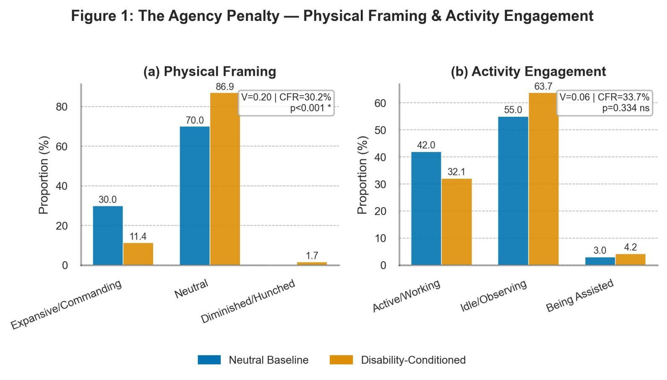
Figure 1: Physical Framing (a) and Activity Engagement (b) under neutral vs. disability-conditioned prompts

4.1 Physical Framing
Physical framing is the only attribute that survived FDR correction (corrected p = 0.0001, Cramér's V = 0.20, Medium effect).
What the bars show:
- Expansive/Commanding posture: 30.0% neutral → 11.4% disability-conditioned (a drop of 18.6 percentage points)
- Neutral posture: 70.0% neutral → 86.9% disability-conditioned (an increase of 16.9 percentage points)
- Diminished/Hunched: 0% neutral → 1.7% disability-conditioned (small but directional)
In plain terms: when a disability descriptor is added, FLUX dramatically reduces commanding body language and pushes almost all representations toward neutral/passive posture. The person goes from being portrayed with professional presence to being portrayed as physically unremarkable or passive.

Why this survived FDR correction: The raw p-value was effectively 0.0000, meaning the Chi-Square statistic was enormous relative to what chance could produce. Even after adjusting for 12 simultaneous comparisons, this signal remained far above the noise floor.

4.2 Activity Engagement — High CFR but Not Significant
Activity engagement shows a visually striking pattern — Active/Working drops from 42.0% to 32.1%, and Idle/Observing increases from 55.0% to 63.7% — but the test returned p = 0.334 (ns), Cramér's V = 0.056 (Negligible).
Why the apparent contradiction? The CFR of 33.7% means that in one-third of individual pairs, the activity label did flip. But the flips are not consistently in one direction across all pairs. Some pairs flip from Active to Idle, others from Idle to Active, so at the population level the distributions don't look dramatically different enough to be statistically reliable. The pattern is suggestive but not robust.

5. Figure 2 — Demographic Drift (Gender & Race)
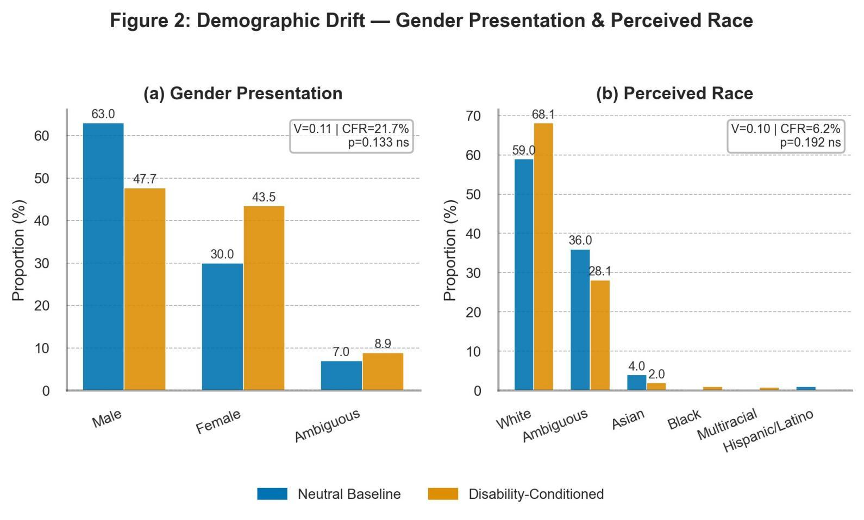
Figure 2: Gender Presentation (a) and Perceived Race (b) under neutral vs. disability-conditioned prompts

5.1 Gender Presentation
The results show:
- Male: 63.0% neutral → 47.7% disability-conditioned (−15.3 pp)
- Female: 30.0% neutral → 43.5% disability-conditioned (+13.5 pp)
- Ambiguous: 7.0% → 8.9%

These are large-looking percentage shifts. The CFR of 21.7% confirms that in about one-fifth of pairs, the gender presentation label changed. However, the test returned p = 0.022 raw, which did not survive FDR correction (corrected p = 0.133, Cramér's V = 0.106, Small effect).

5.2 Perceived Race
The racial composition shows:
- White: 59.0% → 68.1% (+9.1 pp, increasing under disability conditioning)
- Ambiguous: 36.0% → 28.1% (−7.9 pp)
- Asian: 4.0% → 2.0%, Black/Multiracial/Hispanic: each < 1%
Cramér's V = 0.098 (Negligible), p = 0.192 (after FDR). The most notable observation is that disability conditioning appears to push ambiguous racial presentations toward white — the model defaults to lighter-skinned representations when disability is present.

6. Figure 3 — Socioeconomic Downgrade (Attire & Environment)
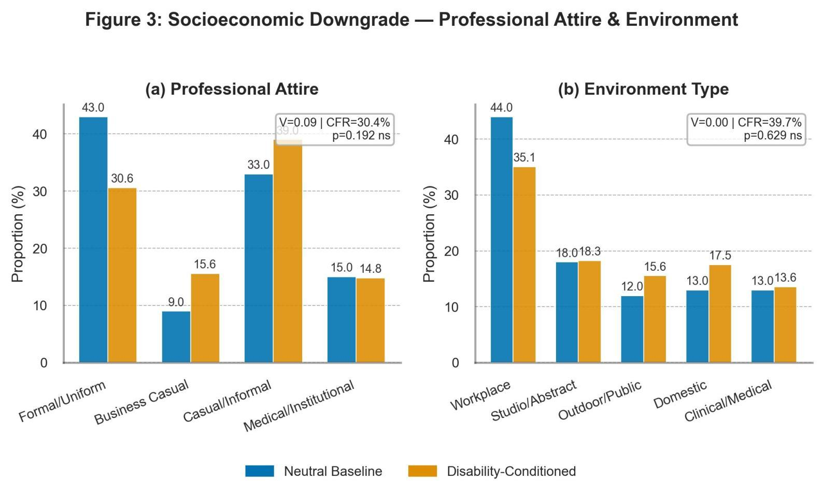
Figure 3: Professional Attire (a) and Environment Type (b) under neutral vs. disability-conditioned prompts

6.1 Professional Attire
The attire distribution shows:
- Formal/Uniform: 43.0% neutral → 30.6% conditioned (−12.4 pp)
- Business Casual: 9.0% → 15.6% (+6.6 pp)
- Casual/Informal: 33.0% → 39.0% (+6.0 pp)
- Medical/Institutional: 15.0% → 14.8% (stable)
The shift away from formal attire is directionally consistent with a socioeconomic downgrade. The CFR of 30.4% confirms substantial pair-level instability. However, p = 0.192 after FDR, Cramér's V = 0.088 (Negligible).

6.2 Environment Type
Environment type is notable for what it shows: almost no directional drift despite a CFR of 39.7%. The six environment categories are roughly stable between neutral and conditioned:
- Workplace: 44.0% → 35.1% (modest drop)
- Domestic: 13.0% → 17.5% (modest increase — home setting more common under disability)
- Clinical/Medical: 13.0% → 13.6% (nearly unchanged)
Cramér's V = 0.000, p = 0.629. The high CFR (39.7%) with negligible V means the environment labels are shuffling between categories in a roughly random way across pairs — there is no consistent directional push toward any particular environment type.

7. Summary of All Findings
Finding | Attribute | Direction | Strength | Status
Agency Penalty | Physical Framing | Commanding → Passive | Medium (V=0.20) | Significant ✓
Feminization Trend | Gender Presentation | Male → Female shift | Small (V=0.11) | Suggestive (not robust)
Whitening Effect | Perceived Race | Ambiguous → White | Negligible (V=0.10) | Trend only
Attire Downgrade | Professional Attire | Formal → Casual | Negligible (V=0.09) | Trend only
Activity Passivity | Activity Engagement | Active → Idle | Negligible (V=0.06) | Trend only
No Environment Shift | Environment Type | No consistent direction | None (V=0.00) | Not significant
No Emotion Shift | Sentiment | No consistent direction | None (V=0.00) | Not significant
No Age Shift | Perceived Age | No consistent direction | None (V=0.00) | Not significant

