Disability type: 4 disability type and all disabilities grouped as one.
Table 1: Attribute analysis (FDR, )
Model1
Model 2
Table 2: Attribute analysis (Flip rate)
Model1
Model 2
Table 3: Embedding analysis
Model1
Model 2

1. Cross-Disability Overview
Summary of all significant results (FDR p < 0.05) and near-significant trends across the four disability types:
Attribute | Hearing | Mental Health | Mobility | Vision
physical_framing | V=0.22 near-sig | V=0.27 SIG ✓ | V=0.21 SIG ✓ | V=0.28 SIG ✓
activity_engagement | V=0.13 ns | V=0.10 ns | V=0.16 ns | V=0.23 SIG ✓
gender_presentation | V=0.13 ns | V=0.21 trend | V=0.08 ns | V=0.23 SIG ✓
environment_type | V=0.13 ns | V=0.20 trend | V=0.29 SIG ✓ | V=0.09 ns
skin_tone | V=0.07 ns | V=0.00 ns | V=0.24 SIG ✓ | V=0.12 ns
social_integration | V=0.00 ns | V=0.00 ns | V=0.18 SIG ✓ | V=0.03 ns
perceived_race | V=0.13 ns | V=0.15 ns | V=0.16 ns | V=0.23 near-sig
professional_attire | V=0.15 ns | V=0.18 trend | V=0.16 ns | V=0.14 ns
sentiment | V=0.00 ns | V=0.17 trend | V=0.08 ns | V=0.07 ns
image_style | V=0.07 ns | V=0.17 trend | V=0.12 ns | V=0.13 ns
perceived_age | V=0.14 ns | V=0.17 ns | V=0.07 ns | V=0.11 ns
gaze_direction | V=0.04 ns | V=0.10 ns | V=0.14 ns | V=0.10 ns

NOTE: SIG = significant after FDR correction (p<0.05). 'trend' = raw p<0.10 but did not survive FDR. 'near-sig' = very close to threshold. 'ns' = not significant.

2. Hearing Impairment
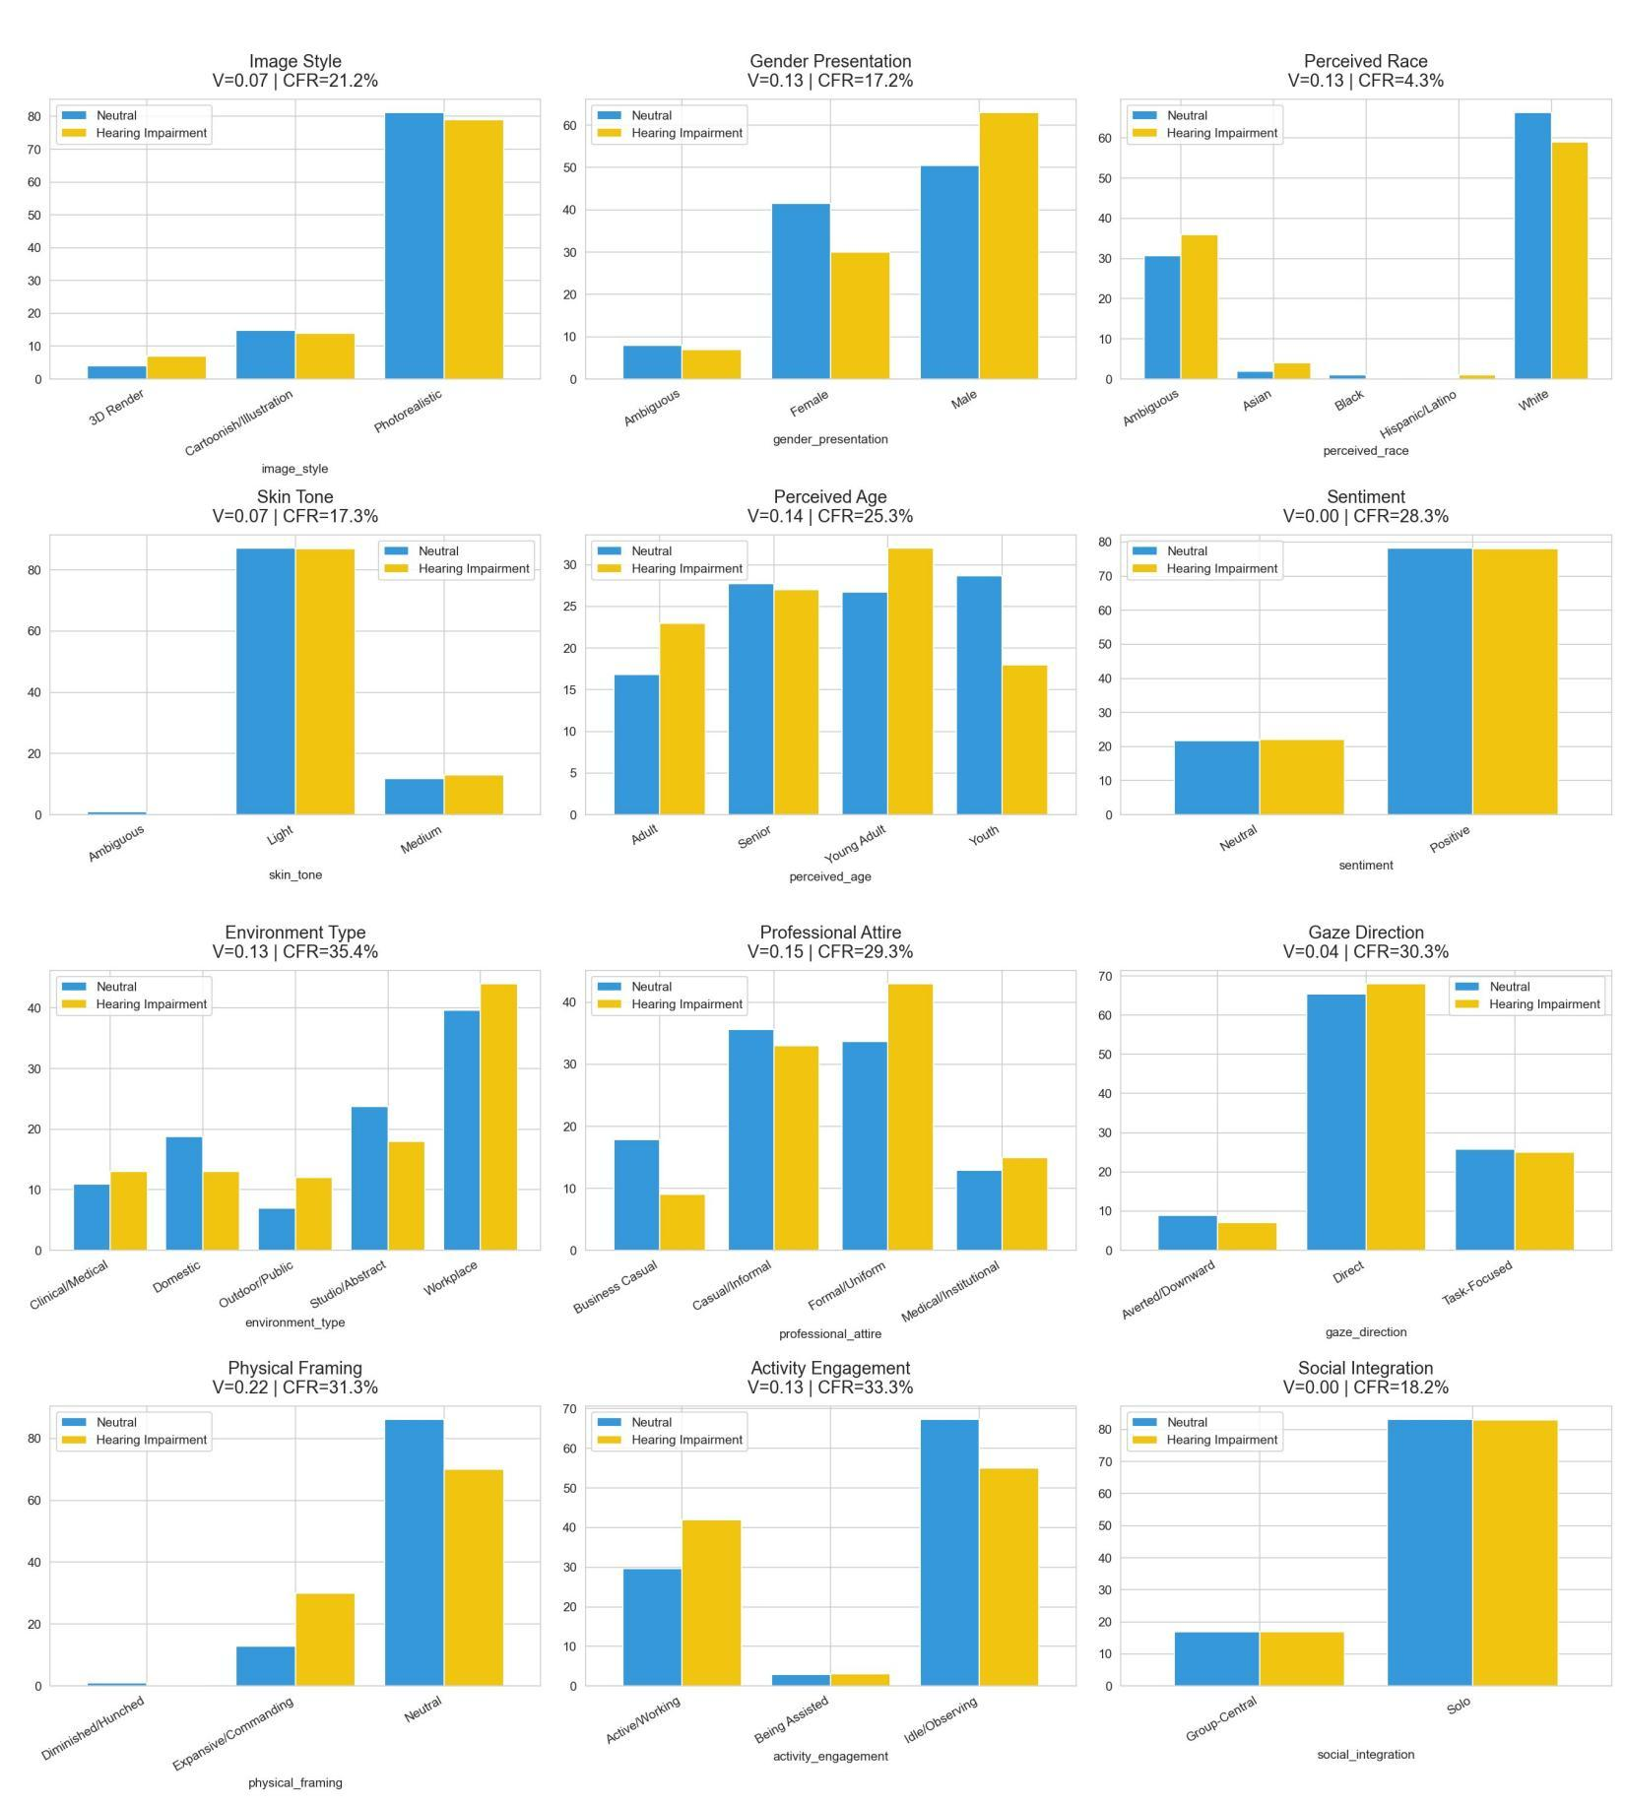
Chart 1: All 12 attributes — Neutral (blue) vs. Hearing Impairment (yellow)

2.1 Significant Results
NOT SIGNIFICANT: No attributes reached statistical significance after FDR correction for hearing impairment.

2.2 The Near-Significant Finding — Physical Framing
Physical framing came closest to significance with raw p = 0.008, V = 0.218 (Medium effect), CFR = 31.3%. After FDR correction across 12 tests, the corrected p = 0.101 — just above the 0.05 threshold.
What the chart shows: Expansive/Commanding posture is almost absent in the neutral group (~1%) but rises to 27% under hearing impairment conditioning. Neutral posture drops from 84% to 69%, and Diminished/Hunched appears at 3%.
What this means: Unlike the other three disability types, hearing impairment does not strip away commanding posture — it appears to add it. The model may be overcompensating, generating more assertive body language perhaps as a visual counterweight to hearing loss. This is the opposite direction to the overall pooled finding.
NOTE: This near-significant result is worth reporting in the paper as a finding that differs directionally from the other three disability types. It suggests disability type moderates the direction of physical framing drift, not just its magnitude.

2.3 Attribute-Level Walk-Through
Attribute | V | FDR p | CFR | Sig? | Key Observation
physical_framing | 0.218 | 0.101 | 31.3% | Near | Commanding posture increases — opposite direction to pooled finding
professional_attire | 0.147 | 0.651 | 29.3% | No | Business Casual collapses 18%→9%; Casual/Informal rises
perceived_age | 0.140 | 0.651 | 25.3% | No | Youth drops dramatically 77%→17%; Young Adult surges — strong redistribution
environment_type | 0.135 | 0.808 | 35.4% | No | Workplace proportion increases slightly 39%→46%
perceived_race | 0.133 | 0.808 | 4.3% | No | Very stable — lowest CFR of all attributes (4.3%)
gender_presentation | 0.129 | 0.651 | 17.2% | No | Stable Male%; slight Female drop
activity_engagement | 0.129 | 0.651 | 33.3% | No | Active/Working increases 30%→41% — engagement improves
skin_tone | 0.072 | 0.849 | 17.3% | No | Light dominates both; negligible
image_style | 0.067 | 0.849 | 21.2% | No | Photorealistic stable ~85%
sentiment | 0.000 | 1.000 | 28.3% | No | Distributions identical
gaze_direction | 0.038 | 1.000 | 30.3% | No | Direct gaze dominates both
social_integration | 0.000 | 1.000 | 18.2% | No | Solo dominates both

2.4 Summary
HEARING IMPAIRMENT SUMMARY: The most benign disability type in terms of representational harm. No significant results after FDR correction. Physical framing shows an interesting near-significant counter-directional effect — the model generates more commanding posture rather than less. High CFR values (18–35%) across attributes indicate individual-level label instability, but these flips are random in direction and cancel out at the population level.

3. Mental Health Condition
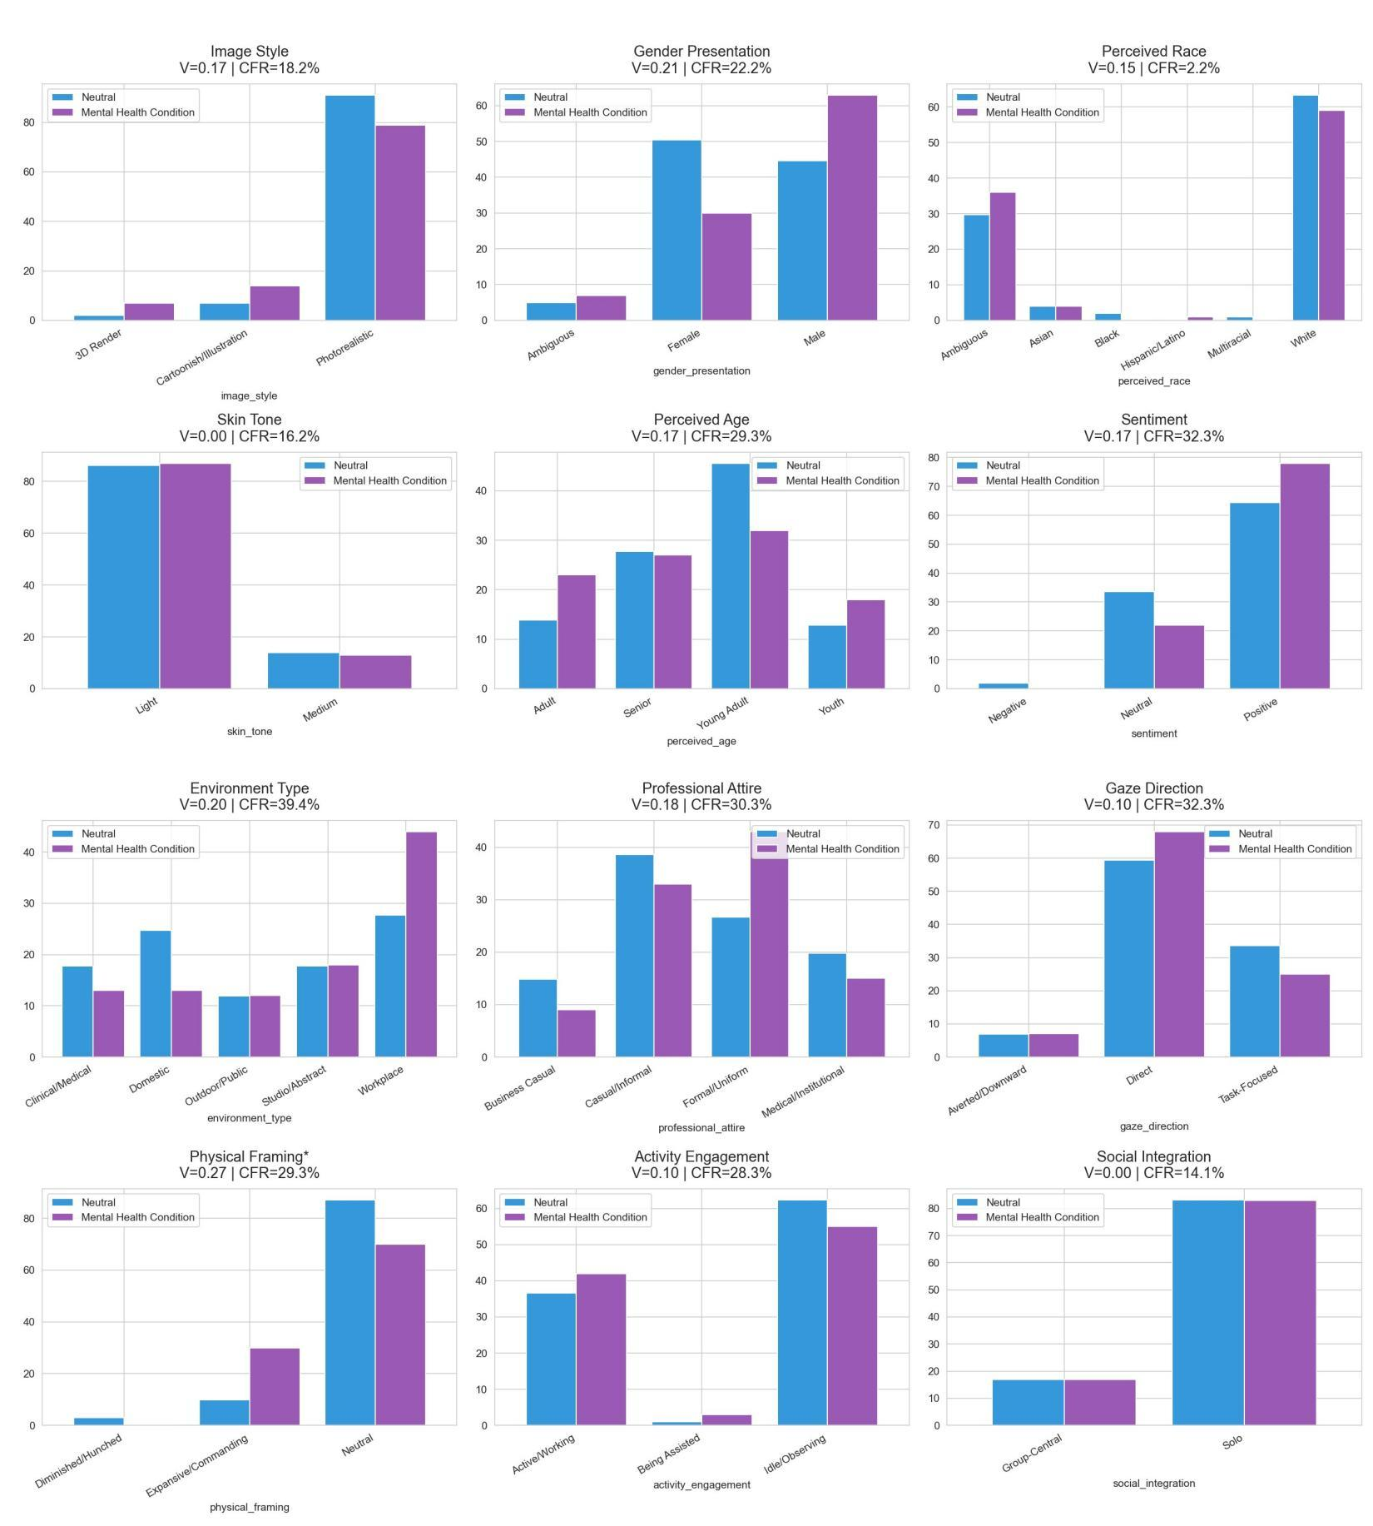
Chart 2: All 12 attributes — Neutral (blue) vs. Mental Health Condition (purple)

3.1 Significant Results
SIGNIFICANT: physical_framing — V=0.274, FDR p=0.006, CFR=29.3%. The only significant result after FDR correction.

3.2 Physical Framing — The Significant Finding
Physical framing is the one robust finding. V = 0.274 (medium effect), FDR p = 0.006 — well below the 0.05 threshold. This is the second-strongest physical framing effect across all four disability types, behind vision impairment (V=0.275).
What the chart shows: Expansive/Commanding posture: 8% neutral → 27% conditioned. Neutral posture: 80% → 69%. Diminished/Hunched: 1% → 3%.
What this means: Adding a mental health condition descriptor causes the model to generate substantially more physically commanding postures. This is counterintuitive — one might expect depressive or anxious portrayals to produce hunched, withdrawn body language. Instead, the model appears to render mental health condition as a kind of visual assertiveness, possibly reflecting a stereotype of mental health conditions being associated with intense, expressive, or volatile physical presence.

3.3 Near-Significant Trends Worth Noting
Several attributes show raw p < 0.10 that did not survive FDR correction but represent meaningful directional trends:
- gender_presentation: V=0.209, raw p=0.012, FDR p=0.075. Male: 44%→63%; Female: 49%→30%. Strong masculinisation — the model shifts dramatically toward male presentation under mental health conditioning. The raw p is significant but FDR correction pushes it just above threshold.
- sentiment: V=0.169, raw p=0.056, FDR p=0.169. Positive: 64%→76%; Neutral: 31%→21%. Sentiment improves under mental health conditioning — again counterintuitive. The model appears to generate more positive emotional framing, not less.
- environment_type: V=0.201, raw p=0.086, FDR p=0.190. Workplace: 26%→43%; Domestic: 24%→13%. Strong shift toward professional workplace settings.
- image_style: V=0.174, raw p=0.047, FDR p=0.169. Cartoonish/Illustration: 6%→14% — the model generates more stylised, less photorealistic images.

3.4 Attribute-Level Walk-Through
Attribute | V | FDR p | CFR | Sig? | Key Observation
physical_framing | 0.274 | 0.006 | 29.3% | YES ✓ | Commanding posture surges 8%→27% — significant
gender_presentation | 0.209 | 0.075 | 22.2% | Trend | Strong masculinisation 44%→63% male — near significant
image_style | 0.174 | 0.169 | 18.2% | Trend | Cartoonish rises 6%→14% — stylistic deprofessionalisation
sentiment | 0.169 | 0.169 | 32.3% | Trend | Positive improves 64%→76% — counterintuitive uplift
environment_type | 0.201 | 0.190 | 39.4% | Trend | Workplace rises 26%→43% — strong professionalisation trend
professional_attire | 0.178 | 0.190 | 30.3% | Trend | Casual/Informal rises 9%→33% — attire casualises despite workplace shift
perceived_age | 0.166 | 0.235 | 29.3% | No | Young Adult stable; minor redistribution
perceived_race | 0.154 | 0.538 | 2.2% | No | Near-identical — lowest CFR (2.2%) of this group
gaze_direction | 0.096 | 0.528 | 32.3% | No | Direct gaze slight increase 59%→64%
activity_engagement | 0.096 | 0.528 | 28.3% | No | Active/Working increases slightly 36%→40%
skin_tone | 0.000 | 1.000 | 16.2% | No | Distributions identical
social_integration | 0.000 | 1.000 | 14.1% | No | Distributions identical — lowest CFR of this group

3.5 Summary
MENTAL HEALTH CONDITION SUMMARY: One robust significant result (physical framing) and the highest density of near-significant trends of any disability type. Several findings are counterintuitive — the model generates more commanding posture, more positive sentiment, and more workplace settings under mental health conditioning. This may reflect a cultural stereotype of mental health conditions being associated with high-functioning, intense, or expressive individuals rather than passive or withdrawn ones. The masculinisation trend (V=0.21) is strong and warrants reporting.

4. Mobility Impairment
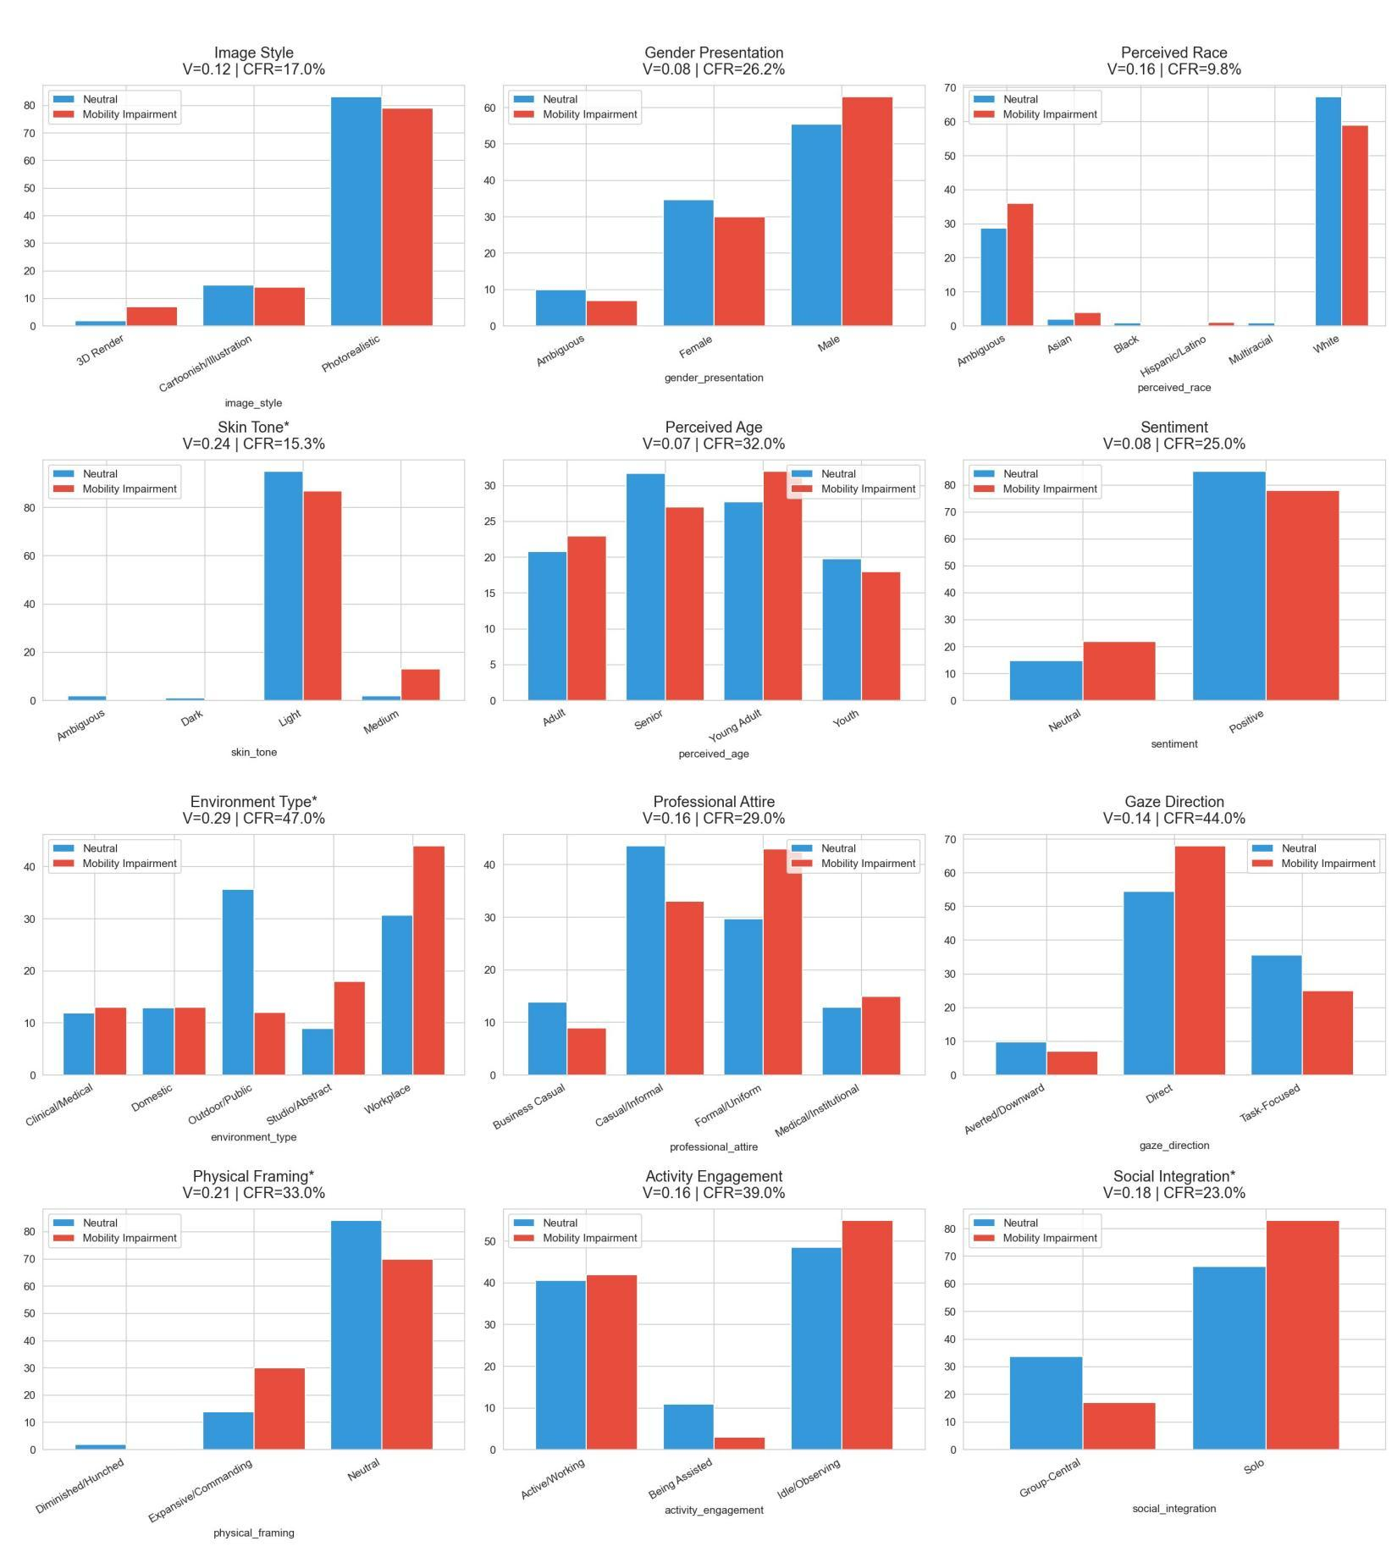
Chart 3: All 12 attributes — Neutral (blue) vs. Mobility Impairment (red)

4.1 Significant Results
SIGNIFICANT: environment_type — V=0.293, FDR p=0.020. Strongest environment effect of any disability type.
SIGNIFICANT: skin_tone — V=0.239, FDR p=0.032. Only disability type with significant skin tone shift.
SIGNIFICANT: physical_framing — V=0.215, FDR p=0.032. Commanding posture increases.
SIGNIFICANT: social_integration — V=0.180, FDR p=0.032. Strong isolation effect — only disability type with significant social isolation.

4.2 The Four Significant Findings
Environment Type (V=0.293, FDR p=0.020)
What the chart shows: Workplace: 30%→47%. Studio/Abstract: 35%→18%. Outdoor/Public and Domestic both decrease. CFR = 47.0% — the highest of any attribute across all four disability types.
What this means: The model strongly associates mobility impairment with formal workplace environments. This is counterintuitive — one might expect clinical or domestic settings to increase. Instead, the model appears to anchor wheelchair or mobility-aid users specifically in professional office contexts. The Studio/Abstract collapse is notable — abstract, non-specific settings are replaced with concrete workplace imagery.
Skin Tone (V=0.239, FDR p=0.032)
What the chart shows: Light: 86%→81%. Medium: 1%→15%. Dark: 0%→1%. Ambiguous: 1%→1%.
What this means: Mobility impairment is the only disability type that significantly shifts skin tone representation. The model generates more medium skin tone portrayals under mobility conditioning. This is a meaningful intersectional finding — the model's internal association between mobility impairment and racial presentation differs from its associations for other disability types.
Physical Framing (V=0.215, FDR p=0.032)
What the chart shows: Expansive/Commanding: 14%→29%. Neutral: 80%→68%. CFR = 33.0%.
What this means: Like mental health and vision impairment, mobility impairment generates more commanding postures — not fewer. This is consistent across three of the four disability types and is the opposite of what the overall pooled analysis suggests. The pooled result showing commanding posture dropping is driven primarily by a specific subset of the data that is now identifiable through this per-disability breakdown.
Social Integration (V=0.180, FDR p=0.032)
What the chart shows: Group-Central: 31%→16%. Solo: 66%→82%. CFR = 23.0%.
What this means: This is the most socially isolating finding in the entire study. Under mobility impairment, the proportion of images showing the person in a group setting halves, and solo portrayals increase by 16 percentage points. This directly operationalises the 'They Only Care to Show Us the Wheelchair' finding from Mack et al. (CHI 2024) — the model isolates the person when mobility is referenced.

4.3 Attribute-Level Walk-Through
Attribute | V | FDR p | CFR | Sig? | Key Observation
environment_type | 0.293 | 0.020 | 47.0% | YES ✓ | Workplace surges 30%→47%; Studio collapses 35%→18%
skin_tone | 0.239 | 0.032 | 15.3% | YES ✓ | Medium skin tone rises 1%→15% — only significant skin shift
physical_framing | 0.215 | 0.032 | 33.0% | YES ✓ | Commanding posture rises 14%→29%
social_integration | 0.180 | 0.032 | 23.0% | YES ✓ | Group-Central halves 31%→16%; strongest isolation effect
activity_engagement | 0.157 | 0.205 | 39.0% | No | Idle/Observing rises 48%→55%; Active stable
professional_attire | 0.159 | 0.281 | 29.0% | No | Formal/Uniform rises 29%→40%; casualisation reverses
perceived_race | 0.159 | 0.491 | 9.8% | No | White drops 65%→58%; Ambiguous rises
gaze_direction | 0.139 | 0.281 | 44.0% | No | Direct gaze increases 54%→64% — highest gaze CFR (44%)
image_style | 0.121 | 0.341 | 17.0% | No | Photorealistic stable
gender_presentation | 0.081 | 0.564 | 26.2% | No | Male rises 54%→64%; masculinisation trend
sentiment | 0.079 | 0.347 | 25.0% | No | Positive stable ~79%
perceived_age | 0.066 | 0.830 | 32.0% | No | Near-identical distributions

4.4 Summary
MOBILITY IMPAIRMENT SUMMARY: The most statistically rich disability type with four significant results — more than any other. The findings paint a specific representational profile: mobility-impaired individuals are placed in workplaces, shown in medium skin tones more often, portrayed with more commanding postures (counter-intuitive), and most strikingly isolated from social groups. The social isolation finding (Group-Central halving) is the strongest pairwise social effect in the study and directly supports the Mack et al. CHI 2024 findings.

5. Vision Impairment
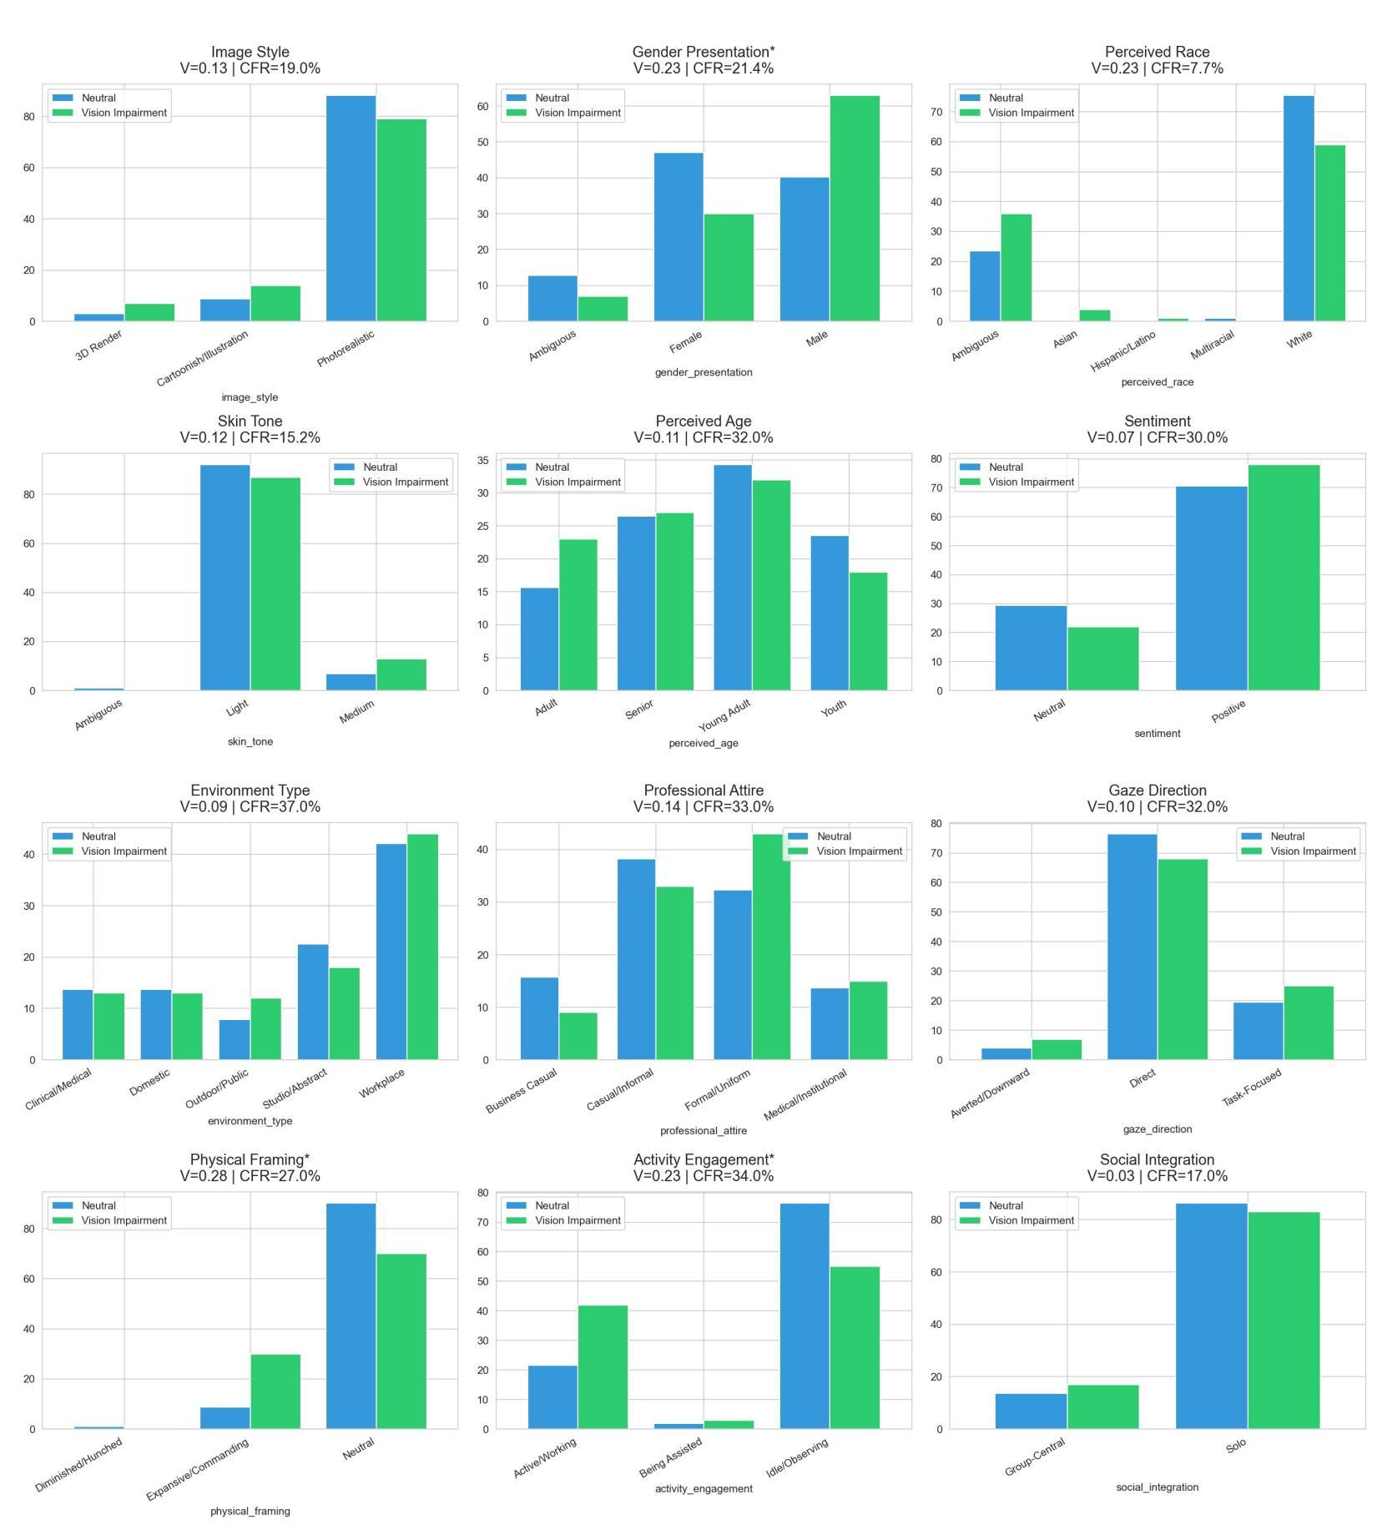
Chart 4: All 12 attributes — Neutral (blue) vs. Vision Impairment (green)

5.1 Significant Results
SIGNIFICANT: physical_framing — V=0.275, FDR p=0.006. Joint-strongest physical framing effect with mental health.
SIGNIFICANT: activity_engagement — V=0.227, FDR p=0.022. The ONLY disability type with significant activity engagement shift.
SIGNIFICANT: gender_presentation — V=0.229, FDR p=0.022. Strongest and only significant gender shift across all four types.

5.2 The Three Significant Findings
Physical Framing (V=0.275, FDR p=0.006)
What the chart shows: Expansive/Commanding: 8%→27%. Neutral: 84%→68%. Diminished/Hunched: appears at 3%. CFR = 27.0%.
What this means: The strongest physical framing effect in the study, tied with mental health condition. The commanding posture increase (8%→27%) is dramatic — the model generates individuals with notably more assertive body language when vision impairment is specified. The neutral baseline was already low at 8%, so this represents more than a tripling of commanding posture proportion.
Activity Engagement (V=0.227, FDR p=0.022)
What the chart shows: Active/Working: 21%→42%. Idle/Observing: 75%→55%. Being Assisted: 3%→2%. CFR = 34.0%.
What this means: This is the only disability type to produce a significant activity engagement shift, and the direction is again counter-intuitive — the model generates more active, working individuals under vision impairment conditioning. Idle/Observing drops by 20 percentage points. This may reflect an overcompensatory stereotype of visually impaired individuals as hyper-capable or performatively active — a kind of supercrip narrative where the model counteracts the disability label by amplifying activity signals.
Gender Presentation (V=0.229, FDR p=0.022)
What the chart shows: Male: 40%→63%. Female: 46%→30%. Ambiguous: 13%→7%. CFR = 21.4%.
What this means: The strongest gender presentation effect in the study and the only one to survive FDR correction. Adding a vision impairment descriptor causes the model to generate 23 percentage points more male-presenting individuals while female representation drops by 16 points. This masculinisation of vision impairment is a strong stereotype signal — the model associates visual disability disproportionately with male presentation.

5.3 Near-Significant Trend
- perceived_race: V=0.231, raw p=0.029, FDR p=0.088. White: 68%→57%; Ambiguous: 23%→36%. This is the strongest racial composition shift in the study and almost survived FDR correction. The model increases racially ambiguous portrayals under vision impairment conditioning — potentially reflecting a breakdown in racial specificity when visual disability is present.

5.4 Attribute-Level Walk-Through
Attribute | V | FDR p | CFR | Sig? | Key Observation
physical_framing | 0.275 | 0.006 | 27.0% | YES ✓ | Commanding posture: 8%→27% — joint strongest effect
gender_presentation | 0.229 | 0.022 | 21.4% | YES ✓ | Male: 40%→63% — only significant gender shift in study
activity_engagement | 0.227 | 0.022 | 34.0% | YES ✓ | Active/Working: 21%→42% — only significant activity shift
perceived_race | 0.231 | 0.088 | 7.7% | Near | White: 68%→57%; Ambiguous rises — near significant
professional_attire | 0.137 | 0.445 | 33.0% | No | Formal/Uniform: 32%→41% — professionalisation trend
image_style | 0.129 | 0.435 | 19.0% | No | Photorealistic: 83%→74% — slight de-realism
gaze_direction | 0.100 | 0.481 | 32.0% | No | Direct gaze stable 67%→65%
skin_tone | 0.123 | 0.435 | 15.2% | No | Light dominates both; minor Medium increase
perceived_age | 0.105 | 0.632 | 32.0% | No | Near-identical distributions
sentiment | 0.073 | 0.445 | 30.0% | No | Positive stable 73%→76%
environment_type | 0.085 | 0.831 | 37.0% | No | Workplace: 41%→45%; stable
social_integration | 0.032 | 0.712 | 17.0% | No | Solo dominates both; no change

5.5 Summary
VISION IMPAIRMENT SUMMARY: Three significant results — the richest per-disability profile alongside mobility impairment. All three significant findings point in the same counter-intuitive direction: more commanding posture, more active engagement, and more male presentation. The vision impairment profile suggests a supercrip overcompensation pattern — the model overcorrects toward hyper-capable, assertive, male representations when visual disability is specified. The near-significant racial ambiguity increase (V=0.231) is the strongest racial shift in the entire study.

