Roll no : 23BCE051
Practical : 1

Branch : Server
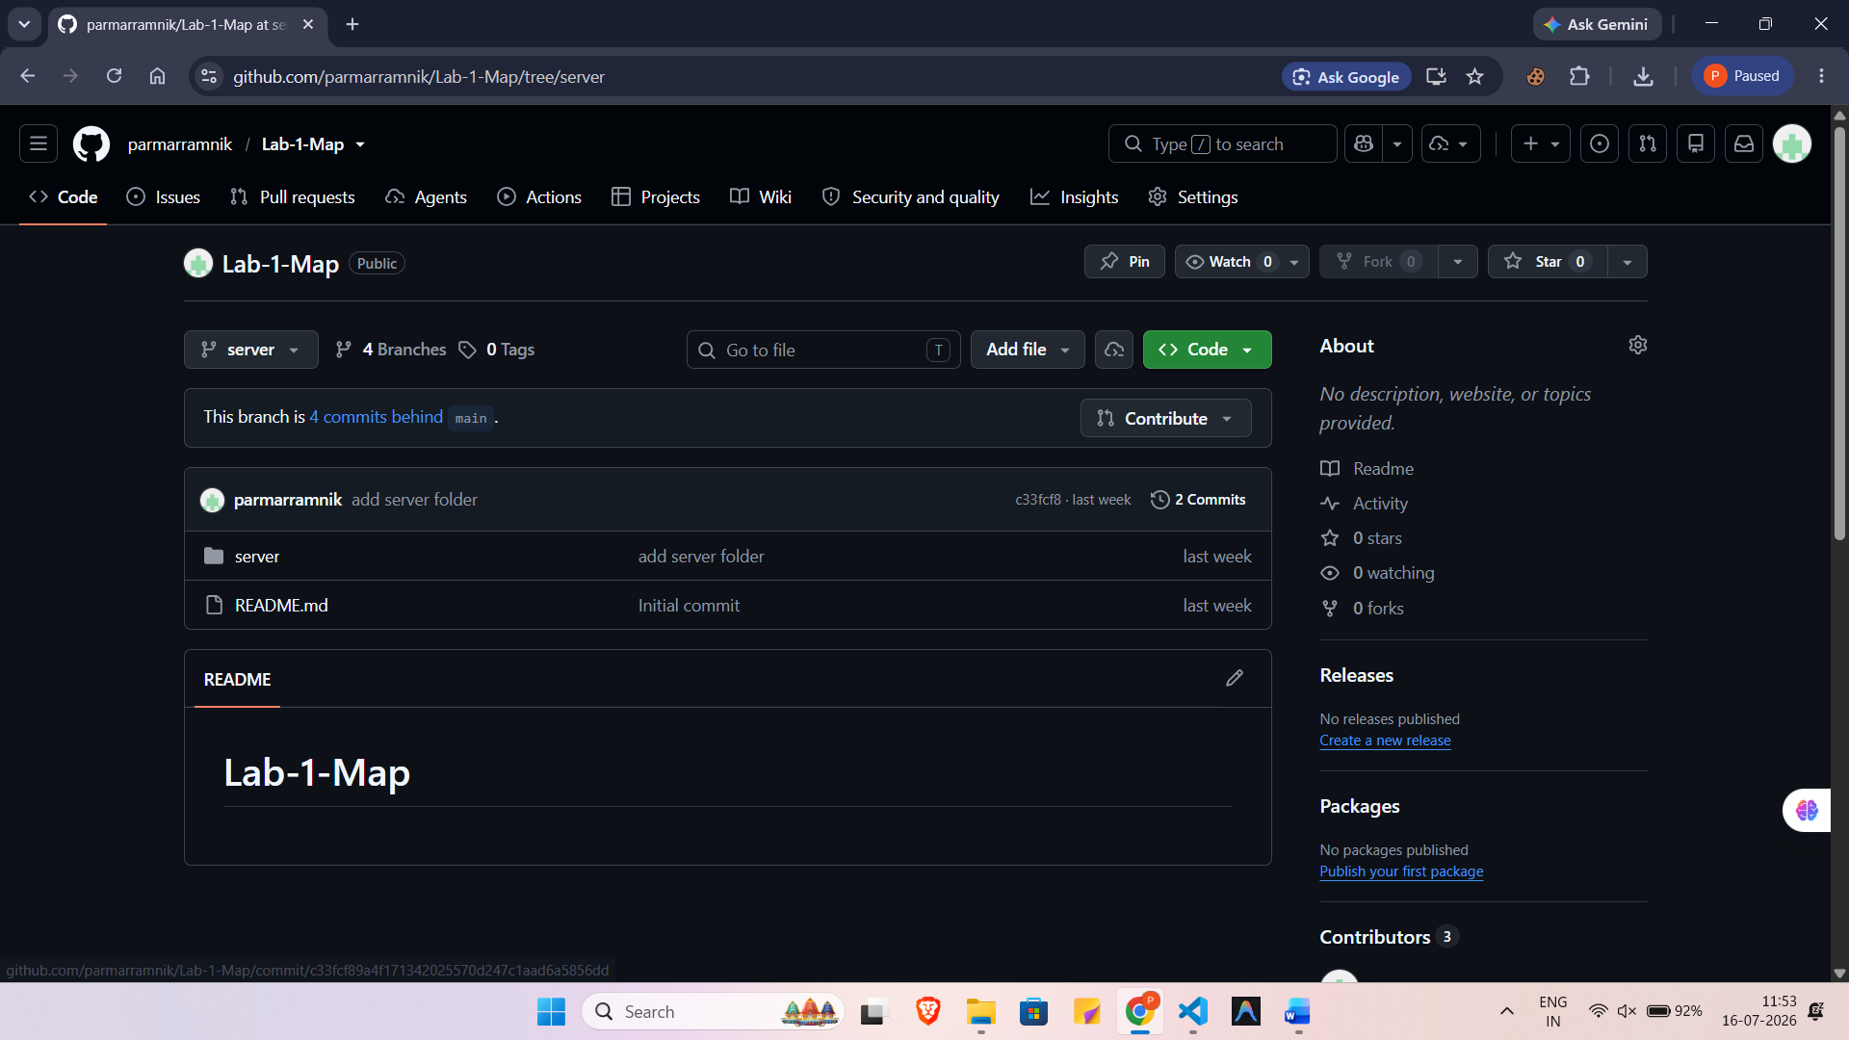
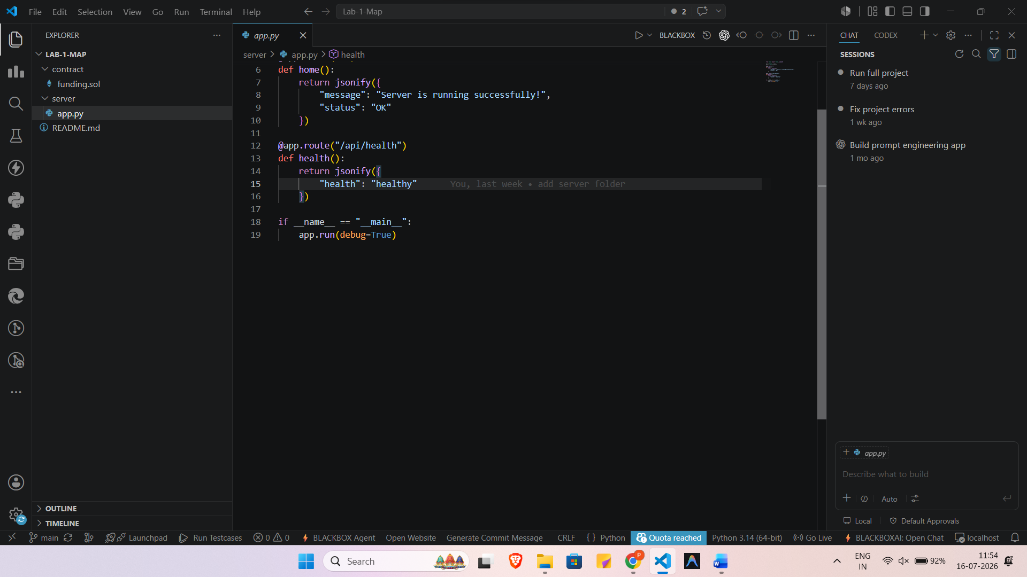

Branch : Middleware
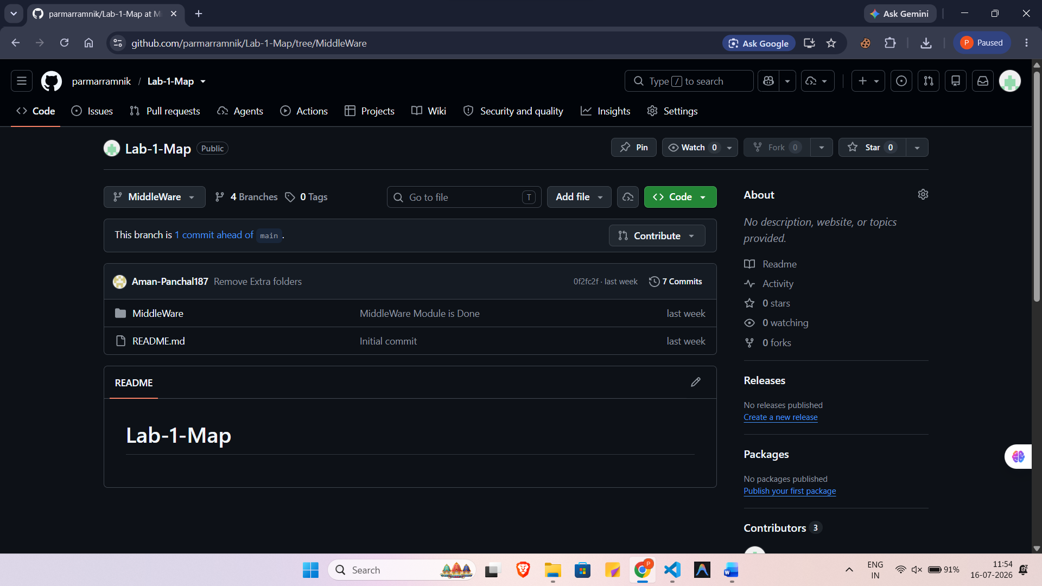
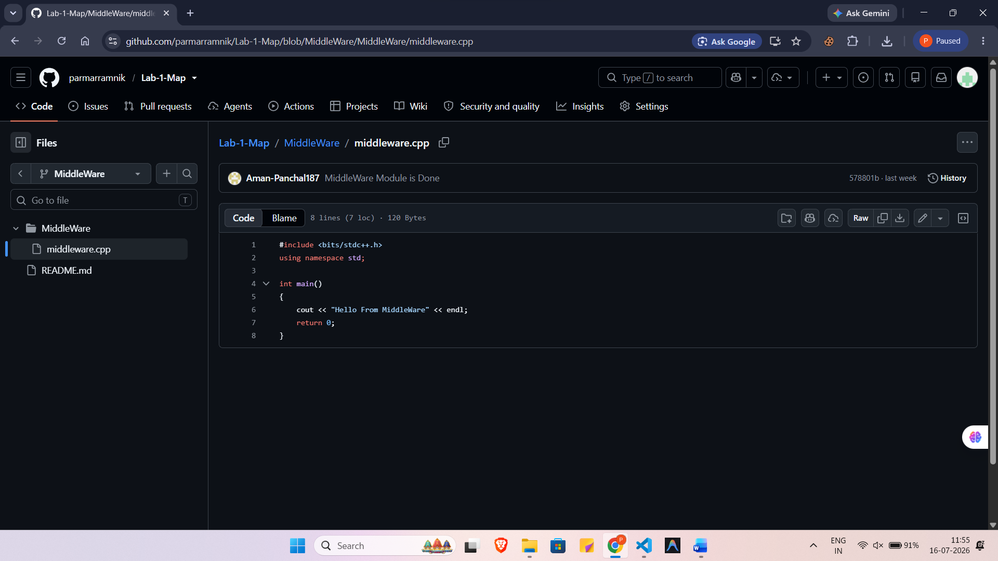

Branch : Dapps
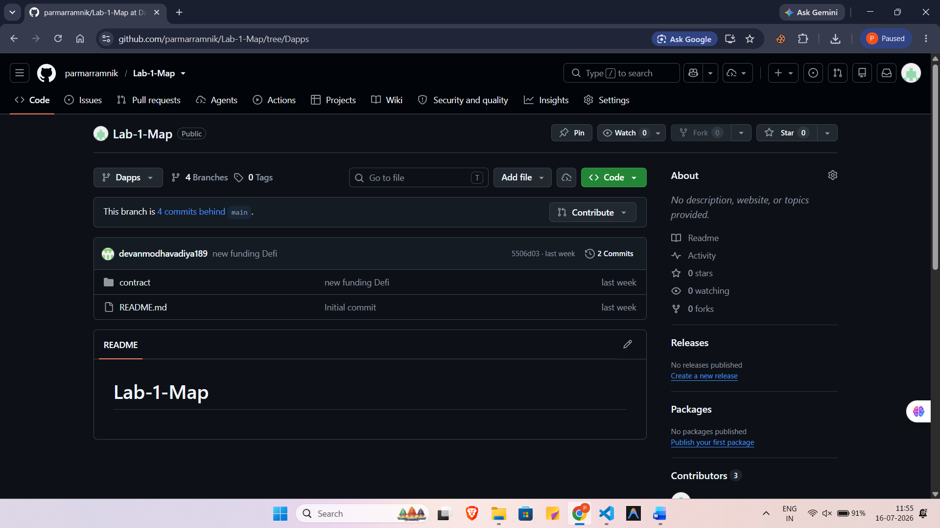
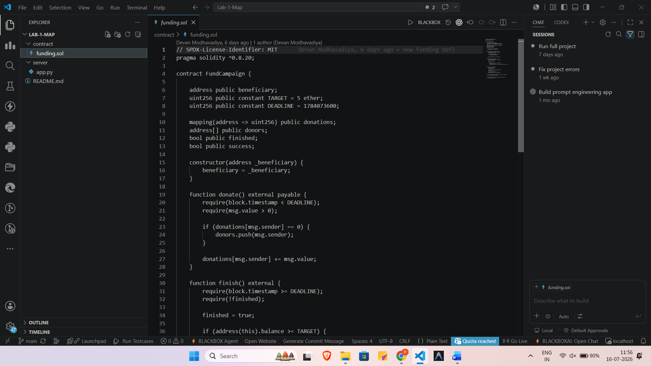

Merge all Branches in Main Branch :
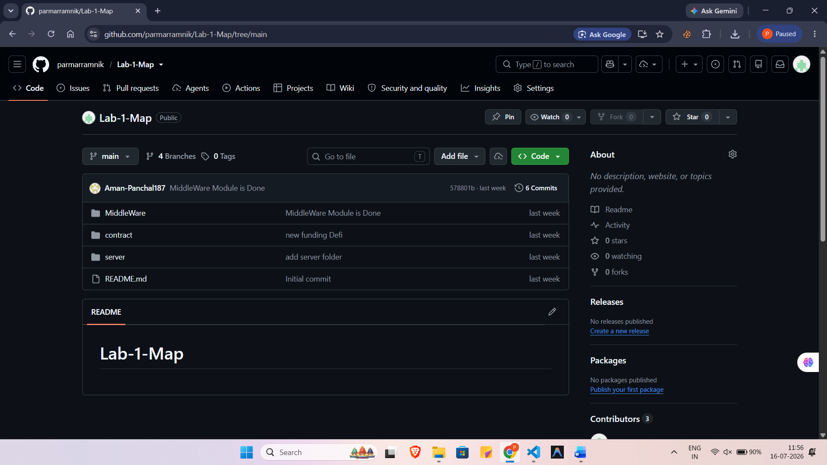

Commands Used :
git init
git branch
git branch branchname
git checkout branchname
git branch
git add .
git commit -m "Added new feature"
git push -u origin branchname
git checkout main
git pull origin main
git merge branchname
git push origin main

