ROLL NO. : 23BCE051
NAME : Devarsh Dalwadi
SUBJECT : CLOUD NATIVE AND APPLICATIONS
PRACTICAL : 2

Screenshot 1
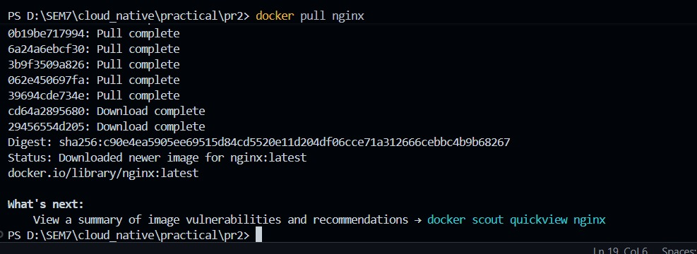
Screenshot 1: Pulling the Nginx image using Docker.

Screenshot 2
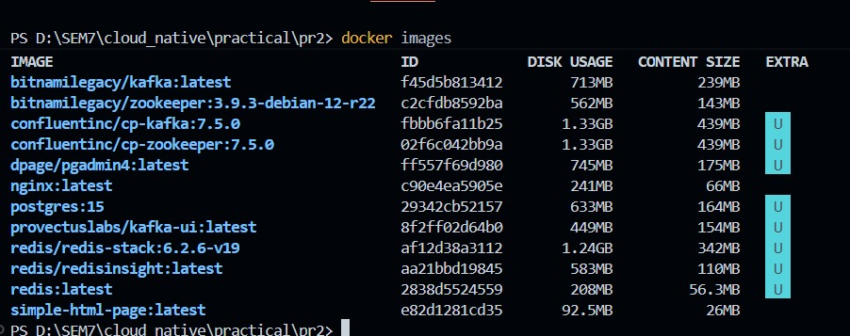
Screenshot 2: Checking downloaded Docker images.

Screenshot 3
Screenshot 3: Starting the Nginx container.

Screenshot 4
Screenshot 4: The container is running.

Screenshot 5
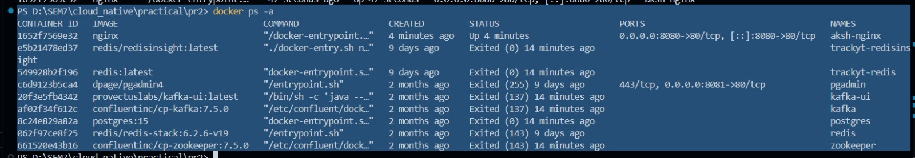
Screenshot 5: Listing all containers in Docker.

Screenshot 6
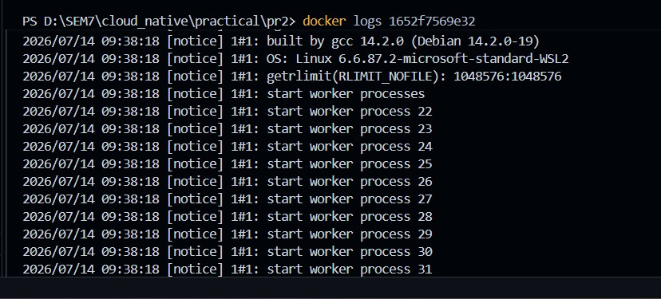
Screenshot 6: Viewing the container logs.

Screenshot 7
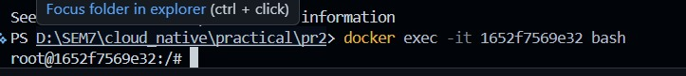
Screenshot 7: Docker terminal session.

Screenshot 8
Screenshot 8: Copying the HTML file into the Nginx container.

Screenshot 9
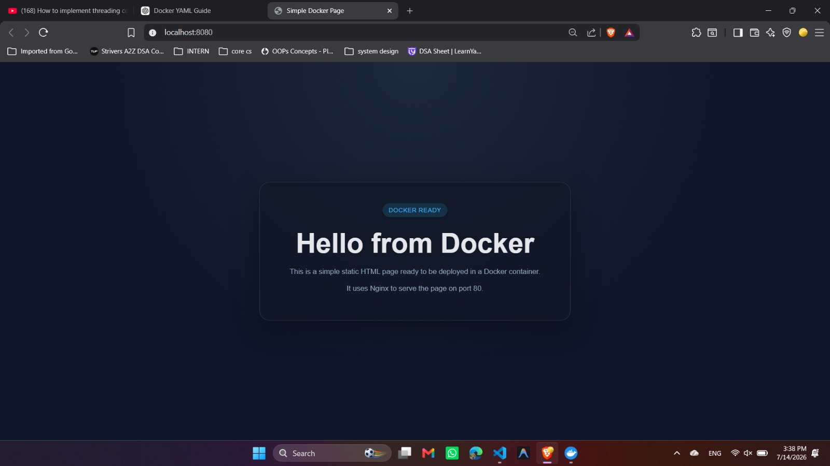
Screenshot 9: The final web page running in the browser.

