Practical 3
Name: Devarsh Dalwadi
Roll No.: 23BCE051

Objective:
Implement a Multi-Container Application Using Docker Compose. The application should include networking to communicate using a custom bridge network.

Implementation Details:
We have implemented a multi-container application using Python Flask and Redis. The Flask web app increments a hit counter stored in the Redis cache. Both containers communicate over a custom bridge network called "app-network".

Source Code:

File: docker-compose.yml
version: "3.9"
services:
web:
build: .
ports:
- "5000:5000"
networks:
- app-network
depends_on:
- redis
redis:
image: "redis:alpine"
networks:
- app-network
networks:
app-network:
driver: bridge

File: app.py
import time
import redis
from flask import Flask
app = Flask(__name__)
cache = redis.Redis(host='redis', port=6379)
def get_hit_count():
retries = 5
while True:
try:
return cache.incr('hits')
except redis.exceptions.ConnectionError as exc:
if retries == 0:
raise exc
retries -= 1
time.sleep(0.5)
@app.route('/')
def hello():
count = get_hit_count()
return f'Hello from Docker! I have been seen {count} times.\n'
if __name__ == "__main__":
app.run(host="0.0.0.0", port=5000)

File: Dockerfile
FROM python:3.9-alpine
WORKDIR /code
ENV FLASK_APP=app.py
ENV FLASK_RUN_HOST=0.0.0.0
COPY requirements.txt requirements.txt
RUN pip install -r requirements.txt
EXPOSE 5000
COPY . .
CMD ["flask", "run"]

File: requirements.txt
flask
redis

Execution & Screenshots:

1. Starting the application
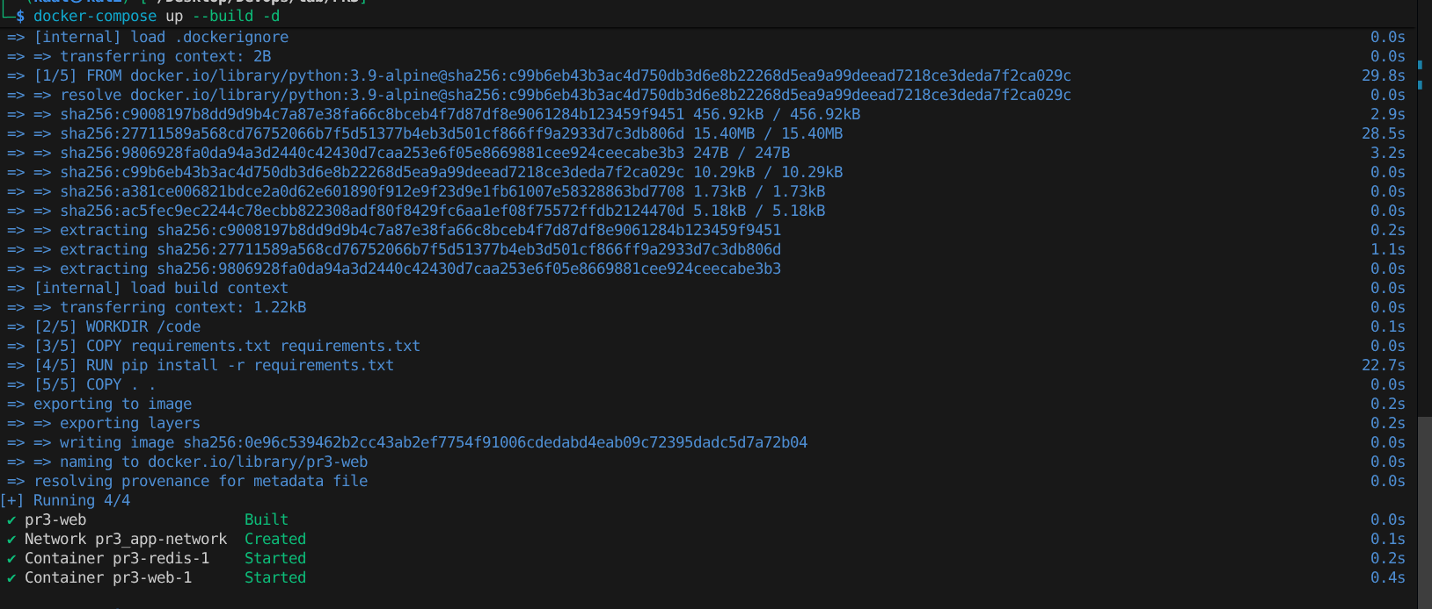

2. Application Output (Browser/Curl)
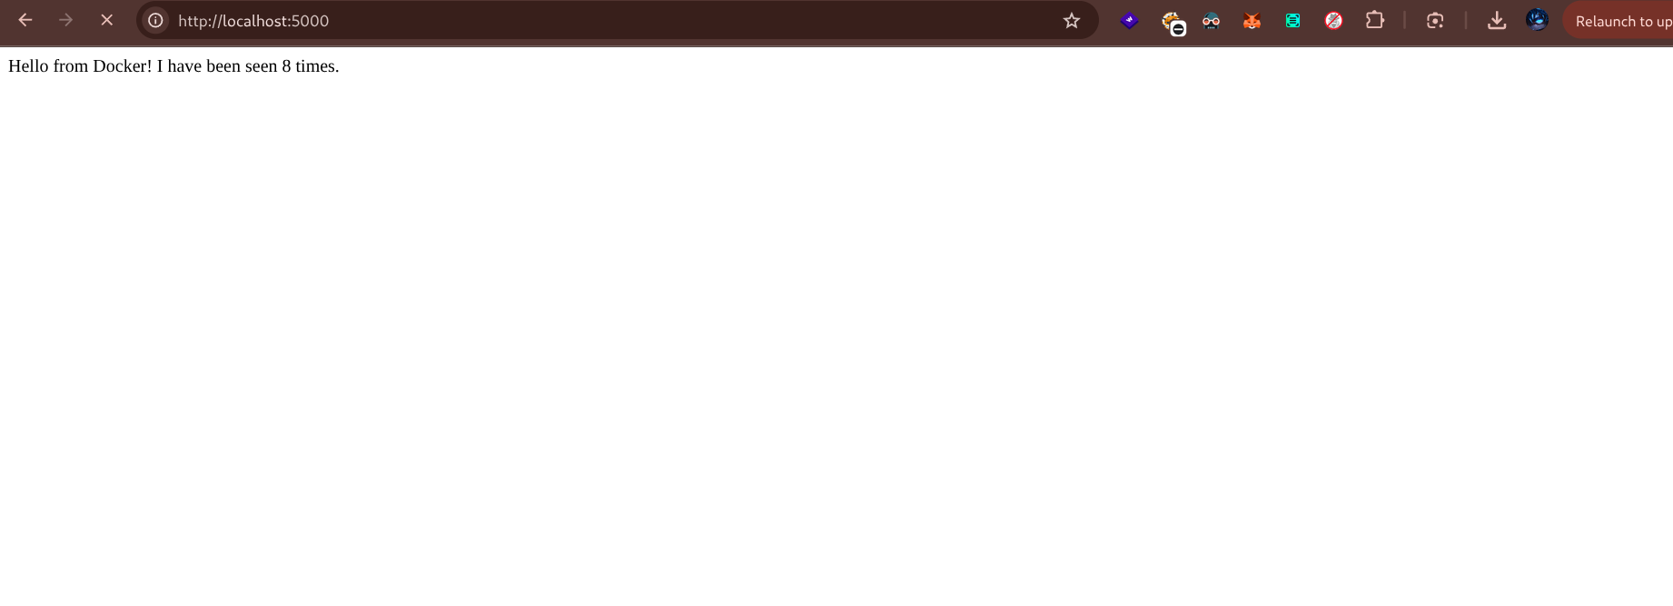

3. Inspecting the Bridge Network
Command run: `docker network inspect pr3_app-network`

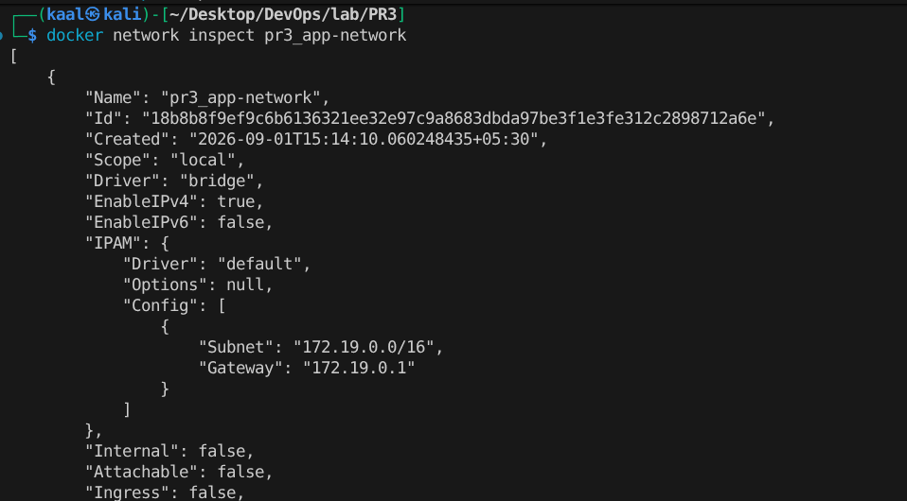

Communication between containers.
