Report on
Practical 5
For
CNA&DevOps
B. Tech. Semester VI
(23BCE051)


School of Engineering
Institute of Technology
Nirma University
Ahmedabad 382481
September 10, 2026

Practical No : 5
BUILDING A MICROSERVICE-BASED APPLICATION AND DEPLOYING APPLICATIONS ON KUBERNETES

1. Aim
To build a microservice-based application consisting of a web application and a MongoDB database, and deploy it on a Kubernetes cluster using Minikube.

2. Objectives
- Understand the microservice architecture and its benefits over monolithic applications.
- Create Kubernetes manifests (Deployments, Services, ConfigMaps, Secrets) for deploying a multi-container application.
- Deploy a web application (Node.js) and a MongoDB database as separate microservices on Kubernetes.
- Verify inter-service communication between the web application and the database.

3. Theory

3.1 Microservice Architecture
Microservice architecture is an approach to software development where an application is structured as a collection of loosely coupled, independently deployable services. Each service runs in its own process and communicates with other services through well-defined APIs. This is in contrast to the monolithic architecture where all components are tightly coupled in a single deployable unit.
Key advantages of microservices include:
- Independent deployment and scaling of individual services
- Technology diversity - each service can use different programming languages and databases
- Fault isolation - failure in one service does not bring down the entire application
- Easier maintenance and development by smaller, focused teams

3.2 Kubernetes Overview
Kubernetes (K8s) is an open-source container orchestration platform that automates the deployment, scaling, and management of containerized applications. It provides a framework to run distributed systems resiliently, handling failover, scaling, and deployment patterns.
Key Kubernetes components used in this practical:
- Pod - The smallest deployable unit in Kubernetes, containing one or more containers.
- Deployment - Manages the desired state of Pods, ensuring the specified number of replicas are running.
- Service - Provides a stable network endpoint for accessing Pods, enabling service discovery and load balancing.
- ConfigMap - Stores non-sensitive configuration data as key-value pairs.
- Secret - Stores sensitive data (e.g., passwords) in base64-encoded format.

3.3 Minikube
Minikube is a tool that runs a single-node Kubernetes cluster locally for development and testing purposes. It supports various container runtimes including Docker and provides all the features of a full Kubernetes cluster in a local environment.

4. Implementation

4.1 Application Architecture
The application consists of two microservices:
- Web Application (nanajanashia/k8s-demo-app:v1.0) - A Node.js web application that provides a user profile management interface. It connects to MongoDB for data persistence.
- MongoDB Database (mongo:5.0) - A NoSQL database that stores user profile data. It is configured with authentication credentials via Kubernetes Secrets.

4.2 Kubernetes Manifests

4.2.1 MongoDB Secret (mongo-secret.yml)
The Secret stores MongoDB credentials in base64-encoded format:
mongo-secret.yml:
apiVersion: v1
kind: Secret
metadata:
name: mongo-secret
type: Opaque
data:
mongo-username: bW9uZ291c2Vy
mongo-password: bW9uZ29wYXNzd29yZA==

4.2.2 MongoDB ConfigMap (mongo-config.yml)
The ConfigMap stores the MongoDB service URL:
mongo-config.yml:
apiVersion: v1
kind: ConfigMap
metadata:
name: mongo-config
data:
mongo-url: "mongo-service:27017"

4.2.3 MongoDB Deployment and Service (mongo.yml)
The MongoDB Deployment creates a pod running MongoDB 5.0, and the Service exposes it internally via ClusterIP:
mongo.yml:
apiVersion: apps/v1
kind: Deployment
metadata:
name: mongo-deployment
labels:
app: mongo
spec:
replicas: 1
selector:
matchLabels:
app: mongo
template:
metadata:
labels:
app: mongo
spec:
containers:
- name: mongodb
image: mongo:5.0
ports:
- containerPort: 27017
env:
- name: MONGO_INITDB_ROOT_USERNAME
valueFrom:
secretKeyRef:
name: mongo-secret
key: mongo-username
- name: MONGO_INITDB_ROOT_PASSWORD
valueFrom:
secretKeyRef:
name: mongo-secret
key: mongo-password
---
apiVersion: v1
kind: Service
metadata:
name: mongo-service
spec:
selector:
app: mongo
ports:
- protocol: TCP
port: 27017
targetPort: 27017

4.2.4 Web Application Deployment and Service (webapp.yml)
The webapp Deployment creates a pod running the Node.js application. It reads credentials from the Secret and the database URL from the ConfigMap. The Service is of type NodePort to allow external access:
webapp.yml:
apiVersion: apps/v1
kind: Deployment
metadata:
name: webapp-deployment
labels:
app: webapp
spec:
replicas: 1
selector:
matchLabels:
app: webapp
template:
metadata:
labels:
app: webapp
spec:
containers:
- name: webapp
image: nanajanashia/k8s-demo-app:v1.0
ports:
- containerPort: 3000
env:
- name: USER_NAME
valueFrom:
secretKeyRef:
name: mongo-secret
key: mongo-username
- name: USER_PWD
valueFrom:
secretKeyRef:
name: mongo-secret
key: mongo-password
- name: DB_URL
valueFrom:
configMapKeyRef:
name: mongo-config
key: mongo-url
---
apiVersion: v1
kind: Service
metadata:
name: webapp-service
spec:
type: NodePort
selector:
app: webapp
ports:
- protocol: TCP
port: 3000
targetPort: 3000
nodePort: 30100

5. Deployment Steps and Output

5.1 Applying Kubernetes Manifests
All manifests are applied to the Kubernetes cluster:
$ kubectl apply -f mongo-secret.yml -f mongo-config.yml -f mongo.yml -f webapp.yml
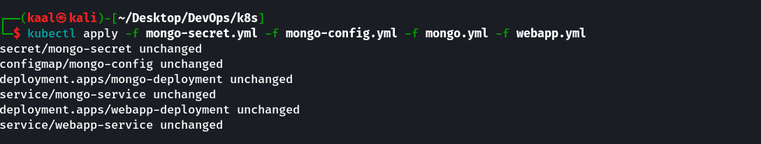

5.2 Verifying All Resources
Checking the status of all deployed resources:
$ kubectl get all
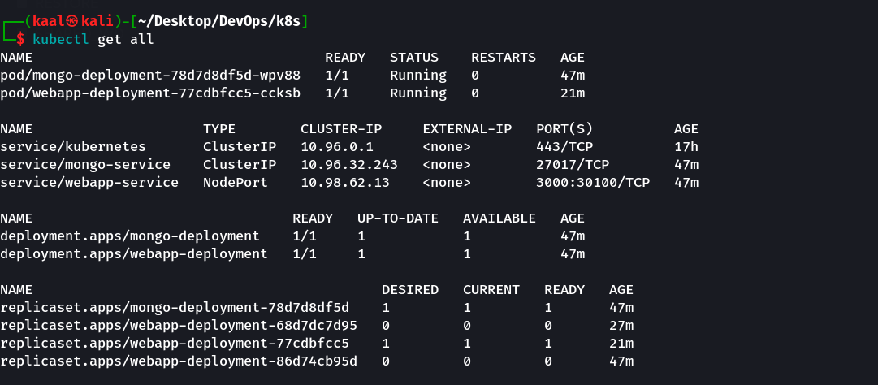

5.3 Verifying Pods
Both microservice pods are running:
$ kubectl get pods
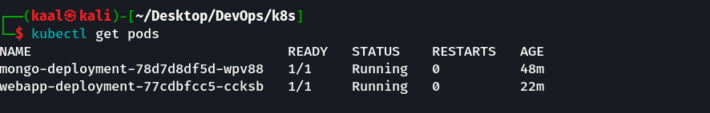

5.4 Verifying Services
Services are correctly configured:
$ kubectl get svc
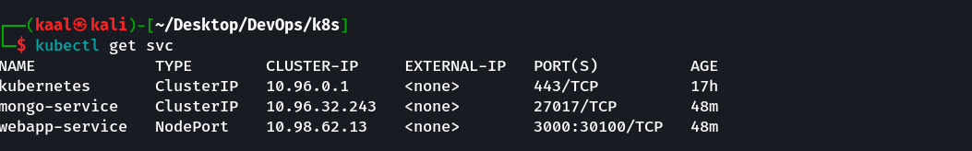

5.5 Web Application Pod Details
$ kubectl describe pod -l app=webapp
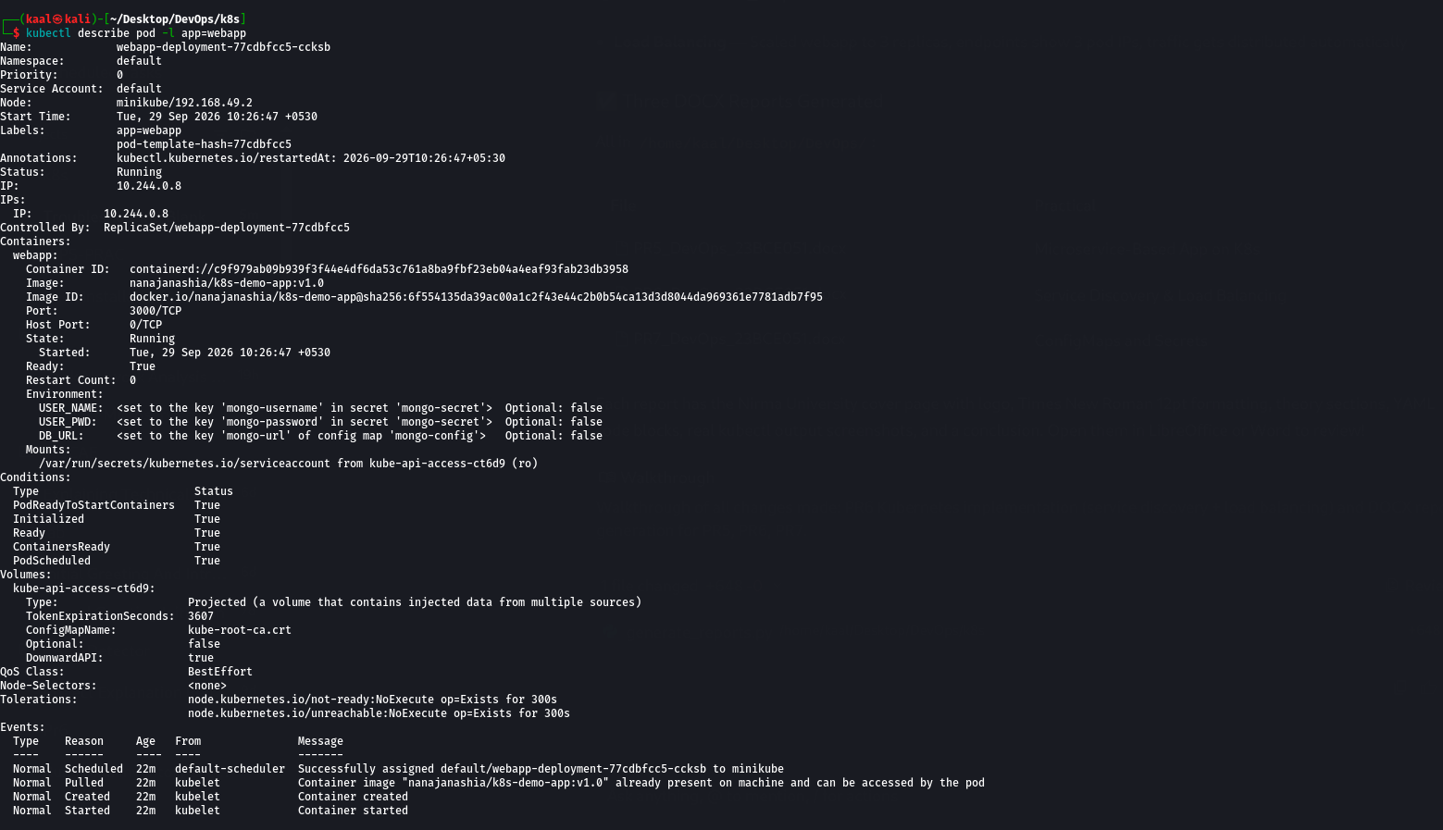

5.6 MongoDB Pod Details
$ kubectl describe pod -l app=mongo
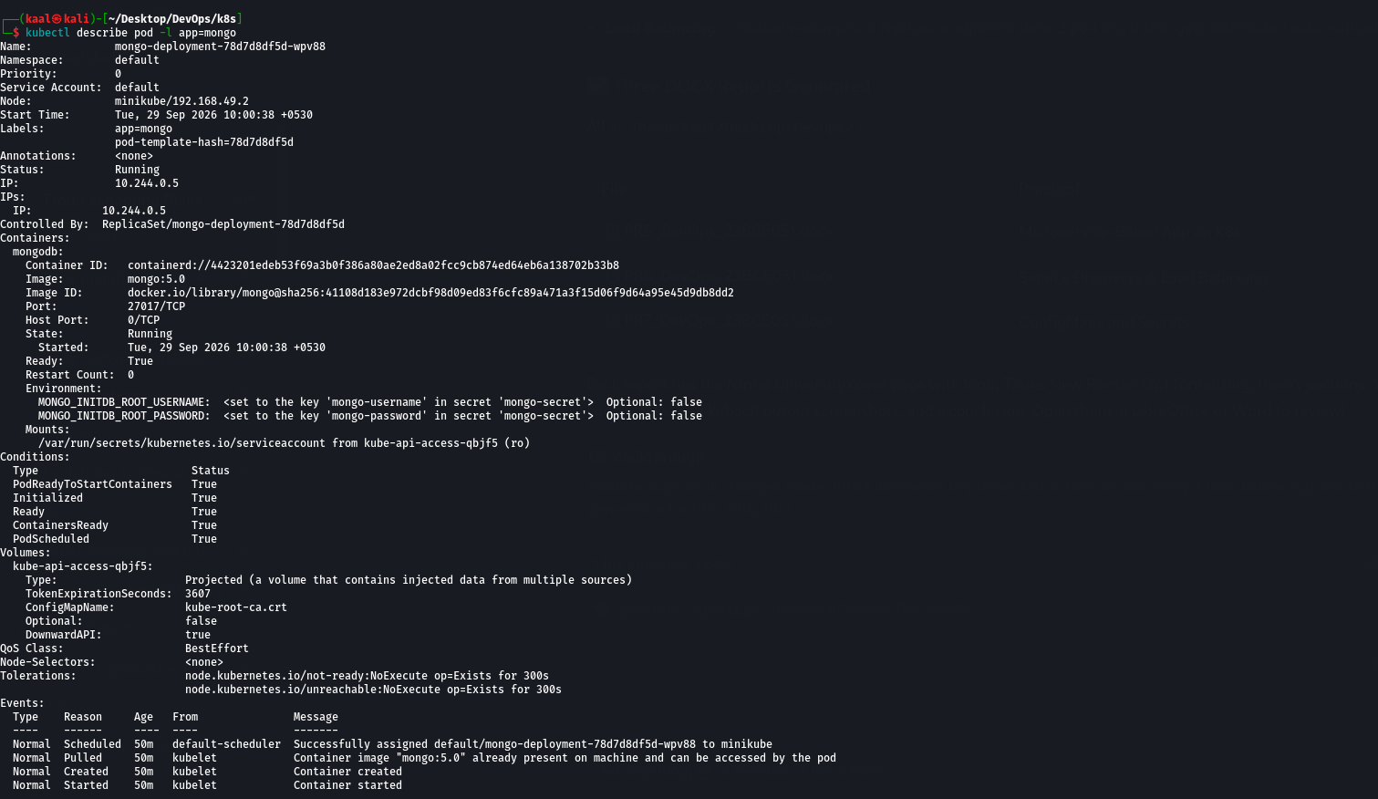
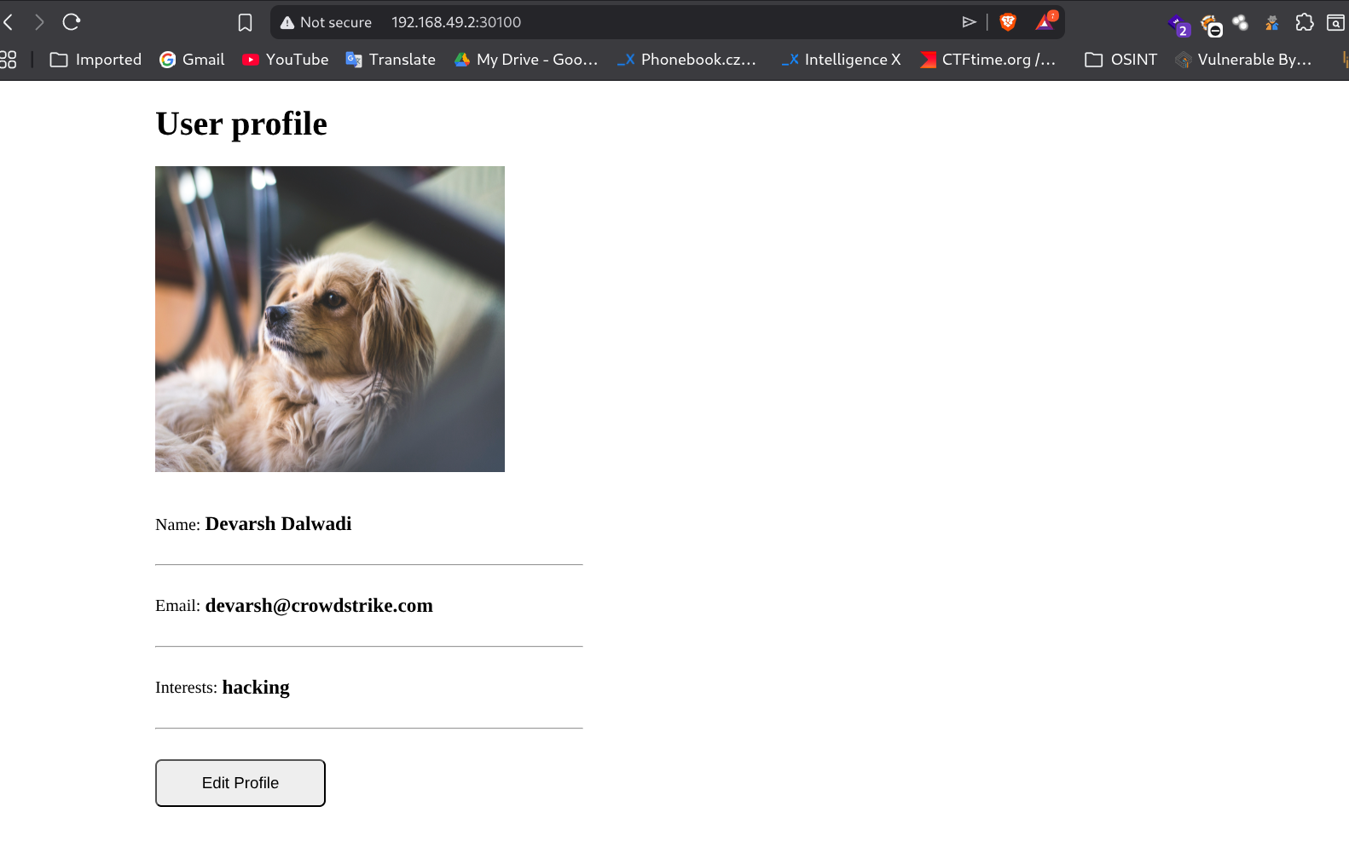

6. Conclusion
In this practical, we successfully built and deployed a microservice-based application on Kubernetes using Minikube. The application consists of two independent services - a Node.js web application and a MongoDB database - each running in its own pod. We used Kubernetes Deployments for managing pod lifecycles, Services for network access, ConfigMaps for non-sensitive configuration, and Secrets for sensitive credentials. The inter-service communication was established through Kubernetes DNS-based service discovery, demonstrating the core principles of microservice architecture in a container orchestration environment.

