Report on
Practical 6
For
CNA & DevOps
B. Tech. Semester VI
(23BCE051)


School of Engineering
Institute of Technology
Nirma University
Ahmedabad 382481
September 29, 2026

Practical No : 6
IMPLEMENT SERVICE DISCOVERY, LOAD BALANCING IN KUBERNETES

1. Aim
To implement and demonstrate service discovery and load balancing mechanisms in Kubernetes using CoreDNS and Kubernetes Services.

2. Objectives
- Understand how Kubernetes Services provide automatic service discovery via DNS.
- Demonstrate DNS-based service discovery using nslookup within the cluster.
- Implement load balancing by scaling application replicas.
- Verify that Kubernetes distributes traffic across multiple pod replicas via Service endpoints.

3. Theory

3.1 Service Discovery in Kubernetes
Service discovery is the process by which microservices locate each other within a cluster. In Kubernetes, service discovery is handled automatically through DNS. When a Service is created, Kubernetes registers a DNS entry for it in the cluster's DNS server (CoreDNS). Other pods can then reach the service using its name as a hostname.
Kubernetes supports two primary mechanisms for service discovery:
- DNS-based discovery - CoreDNS assigns a DNS name to each Service (e.g., mongo-service.default.svc.cluster.local). Pods can resolve this name to the Service's ClusterIP.
- Environment variable-based discovery - Kubernetes injects environment variables for each active Service into newly created Pods (e.g., MONGO_SERVICE_SERVICE_HOST).

3.2 CoreDNS
CoreDNS is the default DNS server in Kubernetes clusters. It runs as a Deployment in the kube-system namespace and provides DNS resolution for all Services and Pods. Each Service gets a DNS record in the format: <service-name>.<namespace>.svc.cluster.local.

3.3 Load Balancing in Kubernetes
Kubernetes provides built-in load balancing through its Service abstraction. When a Service has multiple backend Pods (replicas), the kube-proxy component distributes incoming traffic across all healthy Pods. This is achieved through iptables rules or IPVS (IP Virtual Server) depending on the cluster configuration.
Types of load balancing in Kubernetes:
- ClusterIP (internal) - Distributes traffic to pods within the cluster using round-robin by default.
- NodePort - Exposes the service on each node's IP at a static port, load balancing across pods.
- LoadBalancer - Integrates with cloud provider load balancers for external traffic distribution.

3.4 kube-proxy
kube-proxy is a network proxy that runs on each node in the cluster. It maintains network rules that allow communication to Pods from inside or outside the cluster. It uses iptables to create rules that route traffic from the Service's ClusterIP to the individual Pod IPs, achieving load balancing.

4. Implementation

4.1 Prerequisite Setup
We use the microservice application from Practical 5, which consists of a webapp (Node.js) and MongoDB deployed on a Minikube cluster. The webapp is exposed via a NodePort Service and MongoDB via a ClusterIP Service.

4.2 Part A: Service Discovery Demonstration

4.2.1 Verifying CoreDNS
First, we verify that CoreDNS pods are running in the kube-system namespace:
$ kubectl get pods -n kube-system -l k8s-app=kube-dns


4.2.2 Listing Services
The following services are available in the cluster:
$ kubectl get svc
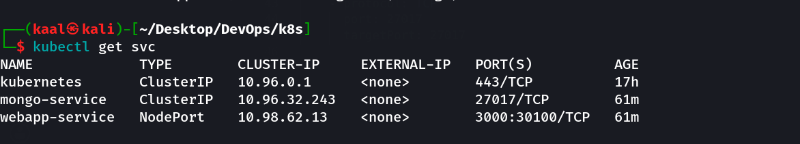

4.2.3 DNS Resolution - mongo-service
We use a BusyBox pod to perform DNS lookup for the mongo-service, demonstrating that Kubernetes automatically creates DNS records for Services:
$ kubectl run busybox --image=busybox:1.36 --rm -it --restart=Never -- nslookup mongo-service
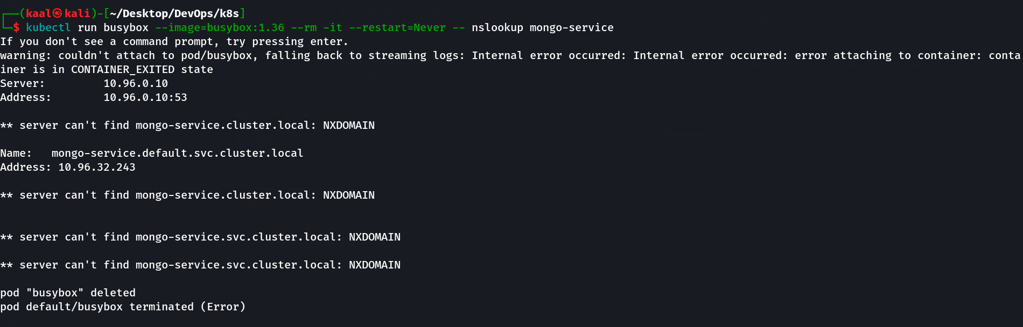

4.2.4 DNS Resolution - webapp-service
Similarly, we resolve the webapp-service DNS entry:
$ kubectl run busybox --image=busybox:1.36 --rm -it --restart=Never -- nslookup webapp-service
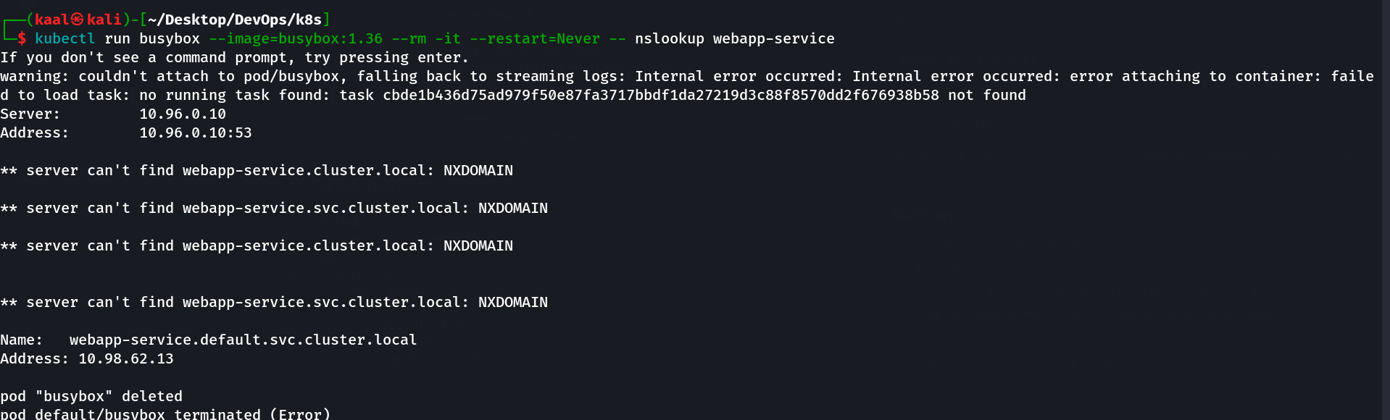

4.3 Part B: Load Balancing Demonstration

4.3.1 Scaling the Deployment
We scale the webapp deployment to 3 replicas to demonstrate load balancing:
$ kubectl scale deployment webapp-deployment –replicas=3
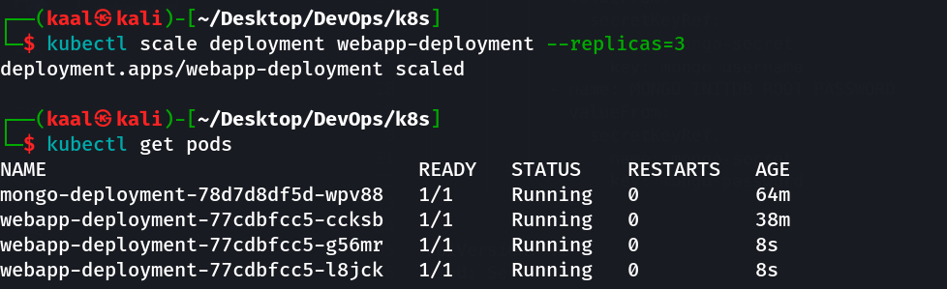

4.3.2 Verifying Multiple Pods
After scaling, we can see 3 webapp pods running on different IP addresses:
$ kubectl get pods -o wide

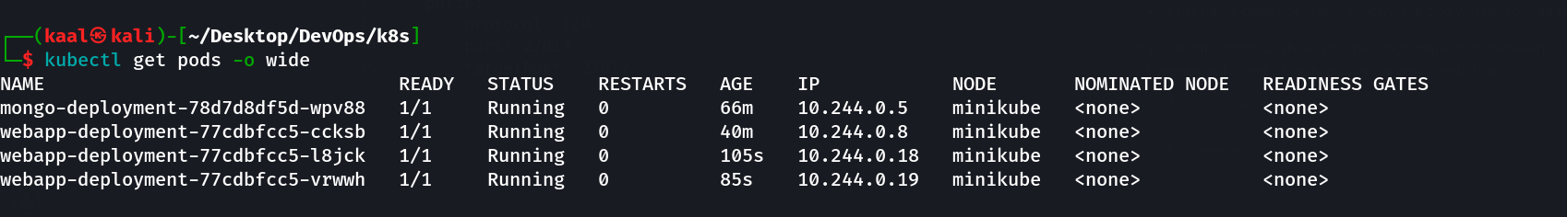

4.3.3 Service Endpoints After Scaling
The webapp-service now shows 3 endpoints, one for each pod replica. Kubernetes will distribute traffic across all these endpoints:
$ kubectl describe svc webapp-service
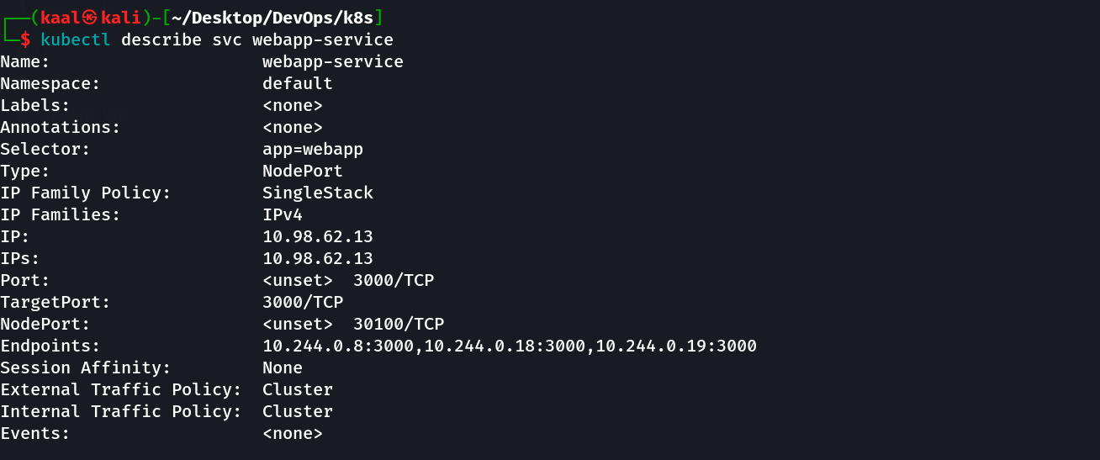

4.3.4 Load Balancing Test
We test load balancing by sending multiple HTTP requests to the webapp-service from within the cluster. Kubernetes distributes these requests across the available pod replicas:
$ kubectl run curl-test --image=curlimages/curl --rm -it --restart=Never -- sh -c 'for i in 1 2 3 4 5 6; do curl -s http://webapp-service:3000 | head -1; echo ---; done'

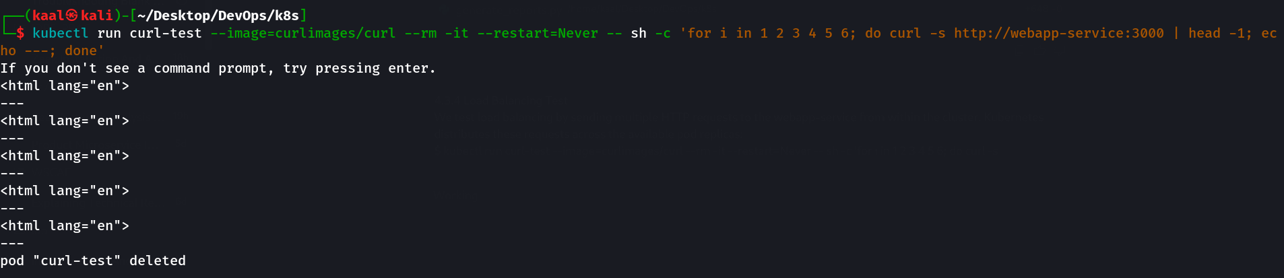

5. Conclusion
In this practical, we successfully demonstrated service discovery and load balancing in Kubernetes:
- Service Discovery: We verified that CoreDNS automatically creates DNS records for Kubernetes Services. Using nslookup from within the cluster, we resolved both mongo-service and webapp-service to their respective ClusterIP addresses, proving that pods can discover and communicate with each other using service names instead of IP addresses.
- Load Balancing: By scaling the webapp deployment to 3 replicas, we demonstrated that the Kubernetes Service automatically updated its endpoints to include all pod IPs. The kube-proxy component distributes incoming requests across all healthy pod replicas, providing built-in load balancing without any additional configuration.
These features - automatic service discovery via DNS and transparent load balancing via Services - are fundamental to running reliable, scalable microservice applications in Kubernetes.

