Report on
Practical 7
For
CNA & DevOps
B. Tech. Semester VI
(23BCE051)


School of Engineering
Institute of Technology
Nirma University
Ahmedabad 382481
September 29, 2026

Practical No : 7
IMPLEMENT CONFIGURATION MANAGEMENT IN KUBERNETES USING CONFIGMAPS AND SECRETS

1. Aim
To implement configuration management in Kubernetes using ConfigMaps and Secrets, and deploy a containerized application that consumes both non-sensitive and sensitive configuration data.

2. Objectives
- Understand the purpose and use cases of ConfigMaps and Secrets in Kubernetes.
- Create ConfigMaps to store non-sensitive configuration data (e.g., database URLs).
- Create Secrets to store sensitive data (e.g., usernames, passwords) in base64-encoded format.
- Inject configuration data into Pods as environment variables.
- Verify that the deployed application correctly consumes the injected configuration.

3. Theory

3.1 Configuration Management in Kubernetes
In containerized environments, applications often need configuration data such as database URLs, API keys, feature flags, and credentials. Hardcoding these values in container images is a bad practice because it violates the principle of separating configuration from code. Kubernetes provides two native resources for externalizing configuration:
- ConfigMap - For non-sensitive configuration data
- Secret - For sensitive configuration data

3.2 ConfigMap
A ConfigMap is a Kubernetes API object that stores non-confidential data as key-value pairs. ConfigMaps allow you to decouple environment-specific configuration from your container images, making your applications portable across different environments (development, staging, production).
ConfigMaps can be consumed by Pods in several ways:
- As environment variables injected into containers
- As command-line arguments
- As configuration files mounted in a volume

3.3 Secrets
A Secret is a Kubernetes object that stores sensitive data such as passwords, tokens, and SSH keys. Secrets are similar to ConfigMaps but are specifically designed for confidential information. The data in a Secret is base64-encoded (not encrypted by default) and can be encrypted at rest if configured.
Key characteristics of Secrets:
- Data is stored in base64-encoded format
- Secrets are only sent to nodes that need them
- They are stored in tmpfs on the node (not written to disk)
- Access can be restricted via RBAC (Role-Based Access Control)
- Types include Opaque (generic), docker-registry, TLS, and service-account-token

3.4 Environment Variable Injection
Kubernetes allows injecting ConfigMap and Secret data as environment variables in Pod containers using the env field with valueFrom. This approach is used in this practical:
- configMapKeyRef - References a key from a ConfigMap
- secretKeyRef - References a key from a Secret

4. Implementation

4.1 Creating the Secret
The Secret stores MongoDB credentials (username and password) in base64-encoded format:
mongo-secret.yml:
apiVersion: v1
kind: Secret
metadata:
name: mongo-secret
type: Opaque
data:
mongo-username: bW9uZ291c2Vy
mongo-password: bW9uZ29wYXNzd29yZA==
The base64-encoded values decode to: mongo-username = 'mongouser', mongo-password = 'mongopassword'.

4.2 Creating the ConfigMap
The ConfigMap stores the MongoDB connection URL as a non-sensitive configuration value:
mongo-config.yml:
apiVersion: v1
kind: ConfigMap
metadata:
name: mongo-config
data:
mongo-url: "mongo-service:27017"

4.3 Consuming Configuration in the Webapp Deployment
The webapp deployment injects values from both the ConfigMap and Secret as environment variables:
Environment variables section from webapp.yml:
env:
- name: USER_NAME
valueFrom:
secretKeyRef:
name: mongo-secret
key: mongo-username
- name: USER_PWD
valueFrom:
secretKeyRef:
name: mongo-secret
key: mongo-password
- name: DB_URL
valueFrom:
configMapKeyRef:
name: mongo-config
key: mongo-url
The mapping is as follows:
- USER_NAME ← Secret (mongo-secret / mongo-username)
- USER_PWD ← Secret (mongo-secret / mongo-password)
- DB_URL ← ConfigMap (mongo-config / mongo-url)

5. Verification and Output

5.1 ConfigMap Details

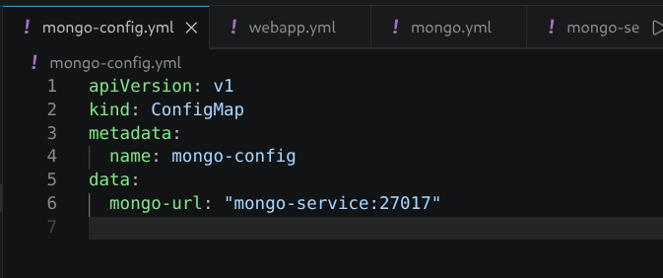

5.2 Secret Details

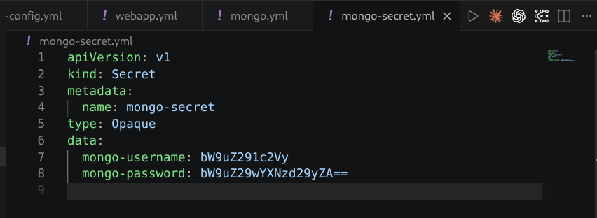

5.3 Describing the ConfigMap
$ kubectl describe configmap mongo-config
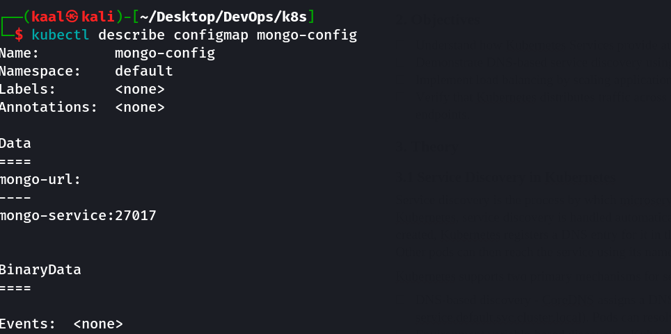

5.4 Describing the Secret
Note that kubectl describe does not display the actual Secret values for security reasons:
$ kubectl describe secret mongo-secret
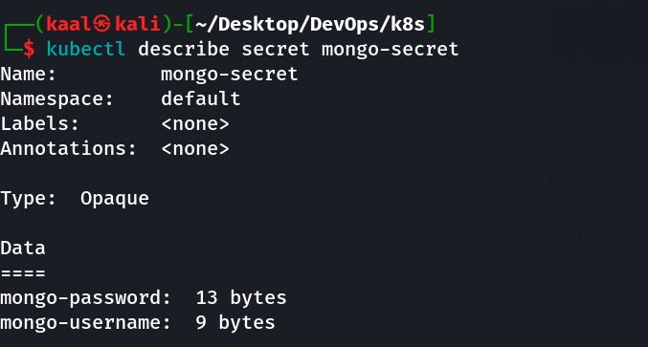

5.5 Verifying Environment Variables Inside the Pod
We exec into the webapp pod to verify that the ConfigMap and Secret values have been correctly injected as environment variables:
$ kubectl exec <webapp-pod> -- env | grep -E 'USER_NAME|USER_PWD|DB_URL'
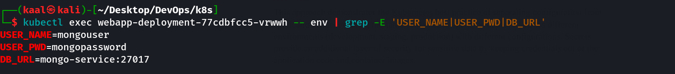

6. Conclusion
In this practical, we successfully implemented configuration management in Kubernetes using ConfigMaps and Secrets. We created a ConfigMap (mongo-config) to store the MongoDB connection URL as non-sensitive data, and a Secret (mongo-secret) to store database credentials as base64-encoded sensitive data. These configuration values were injected into the webapp container as environment variables using configMapKeyRef and secretKeyRef references in the Deployment manifest.
This approach demonstrates the Kubernetes best practice of separating configuration from application code, enabling the same container image to be deployed across different environments (development, staging, production) with different configurations. Secrets provide an additional layer of security for sensitive data by keeping credentials out of the application code and container images.

