**Questions:**

Hardware

What is the technology behind our qubits?

Superconducting.

This technology allows the development of the 3 main metrics: Scale, Quality and Speed. The other technologies, like Trapped Ions or Silicon Spin put limits to the development of the 3 criteria.

*Source :* [*https://youtu.be/UpKseR066DQ*](https://youtu.be/UpKseR066DQ) *,* [*https://research.ibm.com/blog/circuit-layer-operations-per-second*](https://research.ibm.com/blog/circuit-layer-operations-per-second)

Why do we need to be at few mK?

Having a cold quantum computer allows two things:

* A qubit needs to be cooled to start computation.
* A qubit will take longer to collapse and go back to its initial state.
* When computing, each qubit is heating up and so, expelling energy, possibly disturbing its neighbors or even the whole system.
* The less energy there is flying around in the system, the less voltage fluctuates, and so the less errors are induced because of parameters outside of human reach.

*Source:* [*https://www.qats.com/cms/2019/08/02/quantum-computing-cooling/#:~:text=Cooling%20the%20quantum%20computer%20chip,their%20interaction%20with%20each%20other*](https://www.qats.com/cms/2019/08/02/quantum-computing-cooling/#:~:text=Cooling%20the%20quantum%20computer%20chip,their%20interaction%20with%20each%20other)*.*

What is a coherence time?

Coherence time defines the amount of time a quantum superposition lives before collapsing.

In 2013, the coherence time of a silicon hosted qubit was 39 minutes.

*Source :* [*https://jqi.umd.edu/news/quantum-bit/2013/11/25/coherence-time-survival-quantum-state*](https://jqi.umd.edu/news/quantum-bit/2013/11/25/coherence-time-survival-quantum-state)

What are T1 and T2?

T1 is the relaxation time: how long a qubit in state |1> takes to collapse to state |0> (its base energy).

The formula to determine the probability for a qubit to stay in state |1> is: $P\left(|1>\right)=e^{-\frac{t}{T_{1}}}$, where $t$ is the time.

T2 is the dephasing time: like T1, but for |+> collapsing to |->

*Source:* [*https://quantumcomputing.stackexchange.com/questions/9752/whats-the-difference-between-t1-and-t2*](https://quantumcomputing.stackexchange.com/questions/9752/whats-the-difference-between-t1-and-t2)

Why do we need to run experiments several times (shots=1024 for example)?

Experiments needs to run multiple times because current quantum computers are noisy and subjects to decoherence. By running an experiment multiple times and interpreting the distribution of results, we have a better chance of finding the right answer.

*Source: Own interpretation.*

Why do we have different results when we run a job on a simulator or on a real quantum hardware?

In the case of a computation using a real quantum computer, the errors are induced by decoherence and noise, which are random events that can’t be accurately controlled.

In the case of a simulator, and more particularly on IBM’s, the errors are computed with a statistical basis that comes from data from a quantum computer. As the computer these data comes from is not the same as the computer the simulation is compared to, the environment the computer lives in is different, and so are the errors. That can possibly lead to variations in the results, that can be attenuated by running the simulations multiple times.

*Source:* [*https://quantumcomputing.stackexchange.com/questions/5484/why-is-there-a-difference-between-the-simulation-results-and-the-actual-quantum*](https://quantumcomputing.stackexchange.com/questions/5484/why-is-there-a-difference-between-the-simulation-results-and-the-actual-quantum)

What is error correction?

Error correction is the process of applying gates to the already existing circuit to detect and correct potential errors. The most common way to correct X and Z errors is to apply the following gates before any computations and to apply its inverse after all computations:

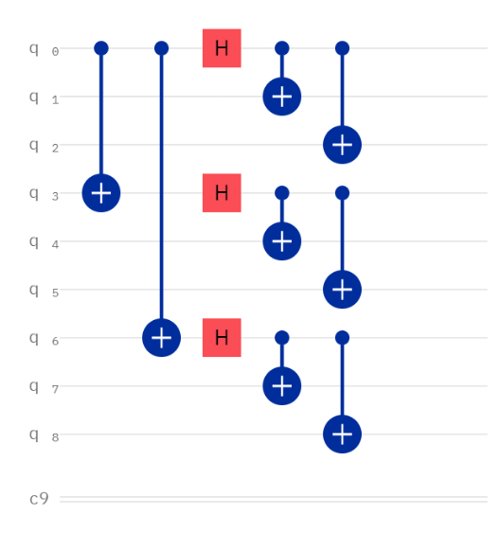

*Source: Advanced Quantum Computing and Error Correction course, given at Université Paris Saclay for the QDCS Master 2*

What is error mitigation?

Error mitigation is deducting a way to correct our circuit’s measures. It is done in multiple steps:

* A simple circuit is computed, as for example a circuit that gives us the base states of $n$ qubits.
* This circuit is measured, and this measure is added, in column, to a matrix. The final matrix will be of size $n*n$.
* This matrix (let’s call it $M$ is inversed)
* For every measurement on an $n$-qubits circuit, called $C_{noisy}$, we get the mitigated measurement by applying $C_{ideal}=M^{-1}C_{noisy}$.

This process is called error mitigation.

*Source:* [*https://qiskit.org/textbook/ch-quantum-hardware/measurement-error-mitigation.html*](https://qiskit.org/textbook/ch-quantum-hardware/measurement-error-mitigation.html)

Software

What are the main components in qiskit?

The four main components of Qiskit are:

* Terra: the basis for Qiskit. You can find the implementation of gates, circuits, transpilers, …
* Aer: the simulators of Qiskit. You can find the different simulators such as QASM or UnitarySimulator.
* Ignis: the part that tackles errors. This is where the code to optimize or reduce errors is located.
* Aqua: the algorithms pf Qiskit. A set of already implemented algorithms for chemistry, AI, Optimization, …

*Source:* [*https://qiskit.org/documentation/stable/0.24/the_elements.html*](https://qiskit.org/documentation/stable/0.24/the_elements.html)

One Qiskit component has parts not written in python. Which one is it ? Why?

Aer has parts written in C++, because it contains the simulators that are much more optimized in a compiled language. Furthermore, using C++ allows the use of the CUDA library that allows the simulations to take place on a GPU.

*Source:* [*https://github.com/Qiskit/qiskit-aer*](https://github.com/Qiskit/qiskit-aer)

Lets assume I am a chemistry researcher, which Qiskit composants should I look for?

As a chemistry researcher, the components you are looking for is Aqua.

What are the different steps when someone do ‘job = execute(circuit, backend,shots)’ ?

When one is calling execute, the circuit is first transpiled to fit the specifications of the machine or the simulator. Then the circuit is assembled to have a Qobj, used for simulation. Then the circuit is executed a number of time defined in shots and an object containing the data of the circuit and of the simulation is returned.

*Source:* [*https://quantumcomputing.stackexchange.com/questions/12757/what-is-the-difference-between-qiskit-execute-and-the-ibmqjobmanager#:~:text=on%20this%20post.-,qiskit.,transpile%20%2C%20but%20it%20does%20assemble%20*](https://quantumcomputing.stackexchange.com/questions/12757/what-is-the-difference-between-qiskit-execute-and-the-ibmqjobmanager#:~:text=on%20this%20post.-,qiskit.,transpile%20%2C%20but%20it%20does%20assemble%20)*.*

Where is qubit 0 in |000100101> ?

In the vector, qubit 0 is located at the end, i.e. the last 1.

*Source:* [*https://qiskit.org/documentation/tutorials/circuits/1_getting_started_with_qiskit.html#:~:text=Qiskit%20uses%20an%20ordering%20in,Q1%E2%8A%97Q0*](https://qiskit.org/documentation/tutorials/circuits/1_getting_started_with_qiskit.html#:~:text=Qiskit%20uses%20an%20ordering%20in,Q1%E2%8A%97Q0)*.*

What is a pass in qiskit? Why do we need passes?

Pass is a transpiler step to modify a circuit or give information to another pass. We need this kind of code because not all quantum computers nor simulators support the whole set of Pauli’s instruction. These gates need to be translated to a combination of the allowed gates to be able to be computed.

*Source:* [*https://qiskit.org/documentation/tutorials/circuits_advanced/04_transpiler_passes_and_passmanager.html*](https://qiskit.org/documentation/tutorials/circuits_advanced/04_transpiler_passes_and_passmanager.html)

What are the Clifford gates? Is there a way to compute circuits which are only composed of those gates?

The Clifford group, in which the Clifford gates lives, is the group of unitaries that normalize the Pauli group, i.e. $C_n=\{V∈U_{2^{n}}|VP_{n}V^{†}=P_{n}\}$.

The Clifford group is generated by the C-Not, Hadamard and S ( $= √Z)$ gates.

The Clifford gates are not universal however, meaning that not all gates belonging to the Pauli group, or generated with the Pauli group, verify the Clifford group’s requisite.

In Qiskit (Terra), you can convert your circuit to one with Clifford gates (given that your circuit only uses gates that belongs to the Clifford group or can be decomposed to gates belonging to the Clifford group).

*Source:* [*https://en.wikipedia.org/wiki/Clifford_gates*](https://en.wikipedia.org/wiki/Clifford_gates) *,* [*https://qiskit.org/documentation/stubs/qiskit.quantum_info.Clifford.html*](https://qiskit.org/documentation/stubs/qiskit.quantum_info.Clifford.html)

How can we check Quantum Volume of one backend with Qiskit?

Qiskit (ignis) allows us to compute the quantum volume of a backend, using the quantum volume definition of this paper: <https://arxiv.org/pdf/1811.12926.pdf> .

*Source:* [*https://qiskit.org/documentation/tutorials/noise/5_quantum_volume.html*](https://qiskit.org/documentation/tutorials/noise/5_quantum_volume.html)

Code a half-adder in Qiskit:

 Here is a half-adder that adds two bits:

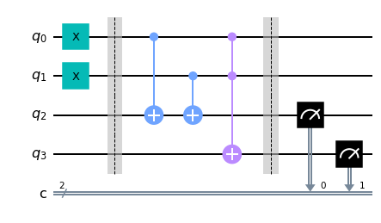

The result of this operation is correct:

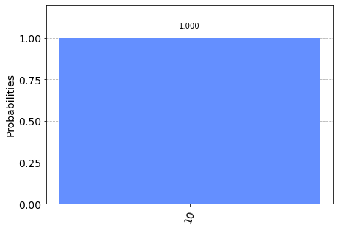

*Source:* [*https://qiskit.org/textbook/ch-states/atoms-computation.html*](https://qiskit.org/textbook/ch-states/atoms-computation.html)

Algorithm

What is quantum advantage? What is the difference with quantum supremacy at Google?

Quantum advantage represents the point when a quantum computer will be able to execute an algorithm that no classical computers at the time can execute in reasonable time. This supremacy is measured by executing algorithms that can’t run in reasonable time on classical systems. The most commonly known are Shor’s algorithm, Boson sampling and Sampling the output of random quantum circuits. The latter is the one that is the most used.

The main difference between the terms “quantum supremacy” and “quantum advantage” comes from the meaning we give to these words. While quantum supremacy can be understood as “no other classical computers can do the work”, quantum advantage better represent the reality by reminding that a quantum computer can perform better than any classical computers, at a certain point in time.

*Source:* [*https://en.wikipedia.org/wiki/Quantum_supremacy*](https://en.wikipedia.org/wiki/Quantum_supremacy) *,* [*https://www.techopedia.com/definition/34023/quantum-advantage#:~:text=Sometimes%20the%20two%20are%20used,a%20set%20of%20reasonable%20parameters*](https://www.techopedia.com/definition/34023/quantum-advantage#:~:text=Sometimes%20the%20two%20are%20used,a%20set%20of%20reasonable%20parameters)

What are the topics or research areas for which quantum computing may give us advantage over classical computers?

The main topics of research that will “benefit” from the rise of quantum computers are:

* Cybersecurity: With the execution of Shor’s algorithm rise the problem that most (if not all) cyphering algorithms are based on hard integer factoring.
* Drug development: The best way to simulate our quantum universe is to use a device that follows the same set of rules.
* Financial modeling: The similarities between the financial structures and the quantum structure makes mathematical operator such as the covariance matrix emerge naturally.
* …

*Source:* [*https://builtin.com/hardware/quantum-computing-applications*](https://builtin.com/hardware/quantum-computing-applications)

What is the favorite algorithm used currently by chemistry researchers on our device?

The most used algorithm used by chemist on IBM’s devices today is the variational quantum eigensolver.

*Source:* [*https://quantum.utk.edu/quantum-algorithms-for-quantum-chemistry*](https://quantum.utk.edu/quantum-algorithms-for-quantum-chemistry)

What is Shor algorithm? Can we run Shor algorithm on actual quantum hardware? If yes what is the highest number that we can factor? If no why?

Shor’s algorithm is an algorithm to factor an integer. Today we can run Shor’s algorithm on actual quantum hardware, and even make slight modifications to the algorithm to use less qubits at once, and so allowing us to factor larger integers.

The largest number factored reliably on a quantum computer today is 21. Other bigger numbers have been factored, but with differently built quantum computer that runs at room temperature.

Source: <https://quantumcomputing.stackexchange.com/questions/8326/is-it-possible-to-run-a-general-implementation-shors-algorithm-on-a-real-ibm-qu> , <https://en.wikipedia.org/wiki/Integer_factorization_records#:~:text=The%20largest%20number%20reliably%20factored,been%20factored%20by%20several%20labs>

Miscellaneous

What is IBM Quantum Network ?

The IBM quantum network is the network of companies, university, researcher, schools, … which works with IBM on quantum computers

*Source:* [*https://www.ibm.com/quantum-computing/ibm-quantum-network/*](https://www.ibm.com/quantum-computing/ibm-quantum-network/)

What is Qiskit community?

Qiskit community is the Github page that gathers all the content created for the Qiskit library, such as textbooks, tutorials, challenges, …

*Source:* [*https://github.com/qiskit-community*](https://github.com/qiskit-community)

How can we contribute to Qiskit?

To contribute to Qiskit, you can do it the usual Github way: making a pull request. The only thing you have to have to make your pull request is the signed CLA (or the corporate CLA if you are working for a firm).  
Then you can code. You have to comply to multiple requirements for code cleanness, Github management or deprecation management.

*Source:* [*https://qiskit.org/documentation/contributing_to_qiskit.html*](https://qiskit.org/documentation/contributing_to_qiskit.html)