How the Trading Signal System Works
A plain-English guide — no jargon required
June 2026
This guide explains, in everyday language, how our system spots promising trading opportunities, how it decides which ones are worth flagging, and where the results end up. You do not need any trading or technical background to follow it.

1. The big picture
Every day the system automatically looks at hundreds of markets — shares, indices, gold, oil and currencies — and asks one question for each: “is this setting up for a worthwhile move?”
It is looking for a very specific, repeatable pattern (explained next). When it finds one, it works out where you would get in, where you would get out if wrong, and where it could reasonably go if right. It then ranks the best opportunities and shares them. It does this the same way every time, with no emotion and no guesswork.

2. The core idea — the “coiling spring”
The method we use is called the Hunt Volatility Funnel. The idea is simple to picture. After a market has had a strong run in one direction, it often pauses and “coils” — the price swings get smaller and smaller, squeezing into a tightening funnel, like a spring being wound up. When the spring finally releases, the price often moves quickly in the direction of the original trend.
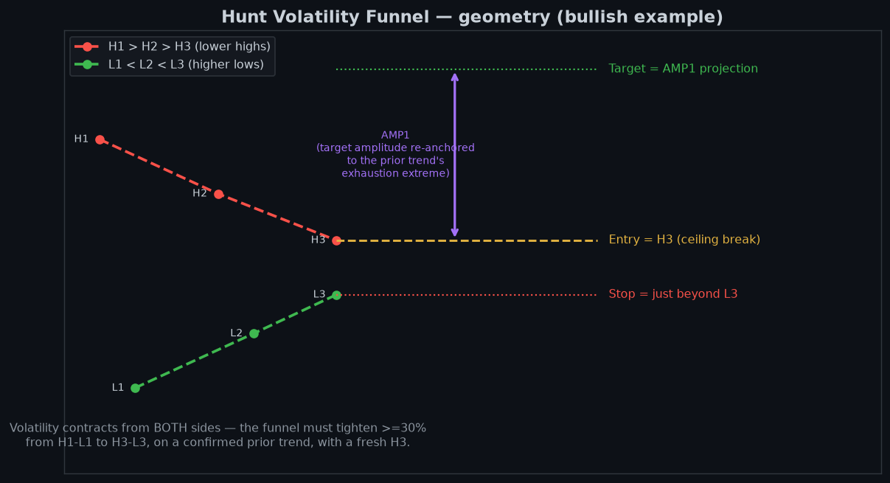
The funnel: the ceiling (red) drifts down while the floor (green) rises, squeezing price to a point. The system marks where to get in, where the safety exit (stop) sits, and a realistic target.
Three things matter: the highs keep getting lower, the lows keep getting higher, and the gap between them shrinks. That squeeze is the “wound spring.” The tighter it gets, the more meaningful the eventual breakout.

3. What has to be true before a setup is flagged
Not every wobble counts. A setup must pass five plain checks before the system treats it as real:
- A clear prior trend — the market must have been moving decisively first. No trend, no setup.
- Falling highs — each peak is lower than the last (the ceiling is coming down).
- Rising lows — each dip is higher than the last (the floor is coming up).
- A real squeeze — the funnel must have tightened by at least a third from where it began.
- Freshness — the breakout point must be recent, not weeks stale.
Only when all five are true does the system measure up the trade. There is also a final money check: the potential reward must be at least three times the amount being risked (more on that next). If it is not, the idea goes on a watch-list rather than being recommended.

4. What goes into the decision
The headline number is the reward-to-risk ratio (often written “R:R”). If a trade risks £1 to potentially make £3, that is 3:1. The system leads with this — the better the reward for the risk, the higher the idea ranks.
Reward-to-risk comes first, then the readiness of the signal, then a quality score for how clean the pattern is. The picture below shows that order of priority:
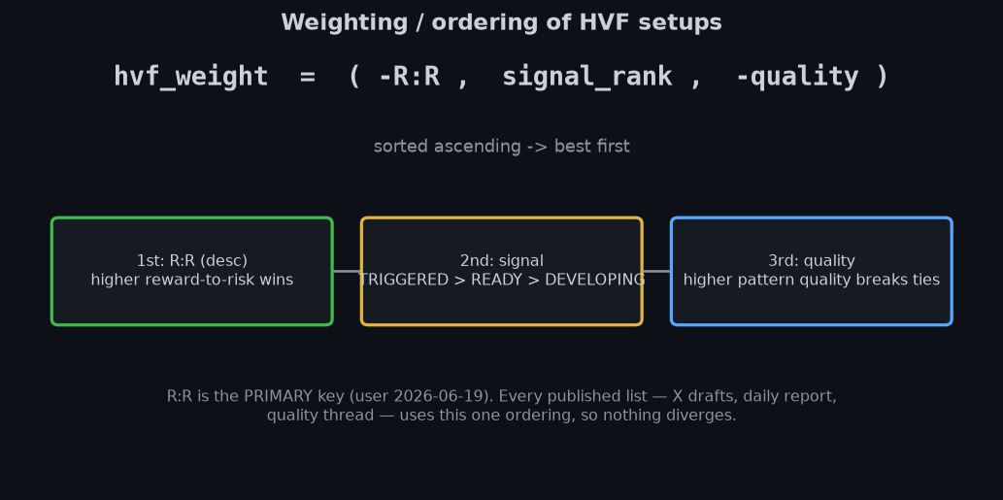
Reward-for-risk is the main driver; the signal’s readiness and the pattern’s quality settle ties.
Alongside the pattern itself, the system gathers supporting evidence to add confidence — for example:
- Analyst views — what professional analysts rate the share and their price targets.
- Insider and large-holder ownership — e.g. if a major investor such as Berkshire Hathaway holds a large stake, and whether they are adding to it or trimming.
- Market positioning — what the big “smart money” players are doing (the COT report).
- Options activity, valuation (P/E), volume and trend strength.
- Support and resistance — the price floors and ceilings traders watch; if price is sitting right on one, the system gives that extra thought, because price can bounce or stall there.
These do not override the pattern — they add or subtract confidence around it. Where a figure comes from a trusted provider (Bloomberg, S&P Global, Morningstar, FactSet, Investing.com), that figure takes priority.

5. Where the results go — and what happens next
Once the best ideas are ranked, they are shared in two places, in this order:
- Slack (internal) first — the full picture for the team: more instruments, with the live price, how far each level is from it, the reward-to-risk and the expected time to target.
- X / Twitter second — a curated, public-facing selection of only the very best, higher-quality ideas.
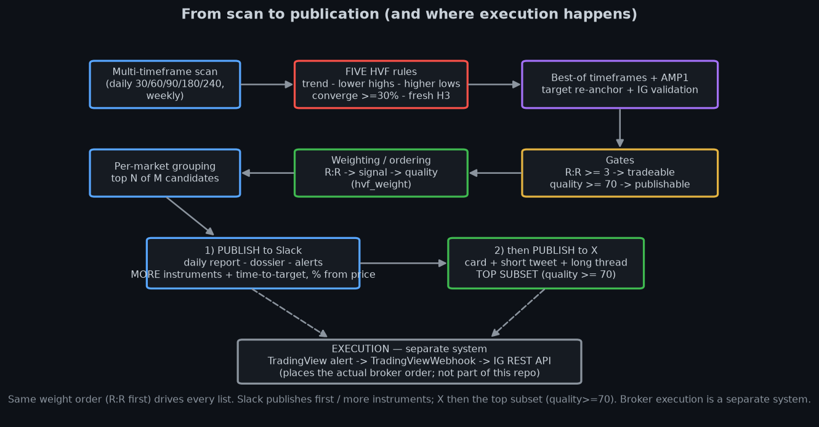
The journey: scan every market → apply the five checks → rank by reward-for-risk → publish to Slack (more) then X (the top few).
One important point: this system finds and publishes ideas — it does not place the trades itself. Actually buying or selling is handled by a separate system, only when its own conditions are met. The published lists are candidates to consider, not orders that have been placed.

A few terms, in plain words
Reward-to-risk (R:R) | How much you could make versus how much you risk. 3:1 means three times the reward for the risk.
Entry / Stop / Target | Where you get in, where you get out if it goes wrong (the safety exit), and where you aim to take profit.
Support / Resistance | Price levels where a market has tended to stop falling (support) or stop rising (resistance).
The funnel (HVF) | The coiling-spring pattern: smaller and smaller price swings after a strong trend, then a breakout.
Smart money (COT) | What large professional hedgers are doing — often a useful tell on direction.
Quality score | A 0–100 mark for how clean and textbook the pattern looks.
Not financial advice. This document explains how the system works; it is not a recommendation to buy or sell anything.

