Comparing a Learned Policy and a Model-Based IK/TROT Controller for Quadruped Locomotion in Isaac Sim
A. V. Papin Bauman Moscow State Technical University Moscow, Russia papinav@student.bmstu.ru
Abstract—Quadruped robots are increasingly used in inspection, logistics, and search-and-rescue, and their development relies heavily on physics simulation. We compare two different locomotion-control paradigms for the Unitree Go2 quadruped: a pre-trained reinforcement-learning (RL) policy distributed with NVIDIA Isaac Sim, and a classical model-based controller that implements a TROT gait generator with analytic inverse kinematics (IK), written in Rust and integrated through ROS 2. Both controllers drive the robot through the same low-level joint-position interface, emulating the robot's native low-level mode. Experiments in Isaac Sim 6.0 with IsaacLab 3.0, with three runs per controller at a commanded speed of 0.3 m/s, show that both paradigms walk at comparable speed (model-based 0.215 m/s, RL 0.231 m/s) and comparable cost of transport (2.83 vs 2.84). The RL policy is markedly more stable (maximum roll 2.3° vs 27.8°, lateral drift 0.37 m vs 1.09 m) and tracks the commanded velocity over the full range 0.1–0.4 m/s, whereas the model-based controller is stable only near 0.3 m/s. Conversely, the model-based controller holds body height more tightly (standard deviation 0.025 m vs 0.040 m) and is fully deterministic, requiring no GPU training and no learned weights. We also report five concrete integration defects found and fixed in the model-based controller, and show that it was unpredictably coupled to real time, while the RL policy is not. The model-based controller is a transparent baseline and a reliable fallback.
Keywords—quadruped robot, Isaac Sim, inverse kinematics, TROT gait, reinforcement learning, locomotion control (key words)

Introduction
Legged robots are attractive where wheeled platforms are ineffective: inspection of unstructured environments, search and rescue, logistics, and operation on rough terrain. Among commercially available quadrupeds, the Unitree Go2 [1] is widely used in research because of its open low-level control interface, its SDK, and the availability of simulation assets. Developing and validating locomotion controllers requires physics simulation; NVIDIA Isaac Sim and IsaacLab [2], [3] have become a de-facto standard for GPU-accelerated training and testing of legged robots.
Two fundamentally different paradigms are used to control walking. The first is learned policies: a neural network maps observations to joint commands [4]–[7]. Such policies are flexible and can handle complex terrain, but they require GPU training, behave as a black box, generalize poorly outside the training distribution, and do not always recover after a fall. The second is model-based control: deterministic algorithms that combine a gait generator with inverse kinematics [8]–[11], often with an inertial attitude-compensation loop. Model-based controllers are transparent and can run on a CPU, but they are less adaptive to unexpected disturbances.
Direct comparisons of the two paradigms in a single simulator, on a single robot, and through a single interface remain rare. The closest work [12] compares model-predictive control (MPC) and RL in MuJoCo on the Unitree Go1. Our work differs in three ways: the model-based controller is an analytic IK/TROT controller (not MPC), the environment is Isaac Sim / IsaacLab (not MuJoCo), and the robot is the Unitree Go2 with the official NVIDIA RL policy. Other work trains RL policies for the Go1 with domain randomization and transfers them to hardware [13]; the comparison there is against the built-in controller. Kine2Go [14] provides a kinematic dataset for the Go2 and confirms the popularity of the platform, but does not compare against a model-based controller.
The contributions of this paper are: (1) the implementation of a model-based IK/TROT controller in Rust and its integration with Isaac Sim through IsaacLab and ROS 2; (2) a direct comparison against the official NVIDIA RL policy on a single asset and through one low-level joint interface; (3) a set of practical integration patterns (joint re-mapping, angle convention calibration, amplitude limiting, and time-base correction); (4) a quantitative evaluation of stability, body height, speed, lateral drift, energy, and the operating range of both paradigms; and (5) a reproducible finding that the model-based controller was coupled to real time, whereas the learned policy was not.

Problem Statement and Research Questions
Given a single quadruped (Unitree Go2), a single simulator (Isaac Sim / IsaacLab), and a single low-level joint-position interface, we address the following questions:
- RQ1. How do a pre-trained RL policy and a hand-tuned IK/TROT controller compare in speed, body-height stability, roll, lateral drift, and cost of transport on flat terrain? - RQ2. What is the operating range of each controller in commanded speed? - RQ3. Is the model-based controller's behavior reproducible, or is it coupled to the simulator's real-time performance? - RQ4. What are the practical integration defects that must be addressed to run a model-based controller through a modern GPU-accelerated simulator, and what is the limit of a simple proportional attitude stabilizer?

Theory
This section presents the theory behind the implemented system. It first describes the overall architecture and the two controllers, then summarizes the practical integration problems and the telemetry used for the evaluation. The emphasis is on the model-based controller, which is the subject of this work, and on the points where it differs from the learned policy.

System Architecture
The system consists of a Rust controller running in a container, a ROS 2 bridge, and the IsaacLab environment:
```mermaid graph LR RC["Rust controller<br/>(container, ROS 2)"] --> ROS["ROS 2 Jazzy<br/>/robot1/joint_group_controller/commands"] ROS --> IS["IsaacLab 3.0<br/>ManagerBasedEnv"] IS --> SIM["Isaac Sim 6.0<br/>PhysX (GPU)"] SIM --> GO2["Unitree Go2"] ```
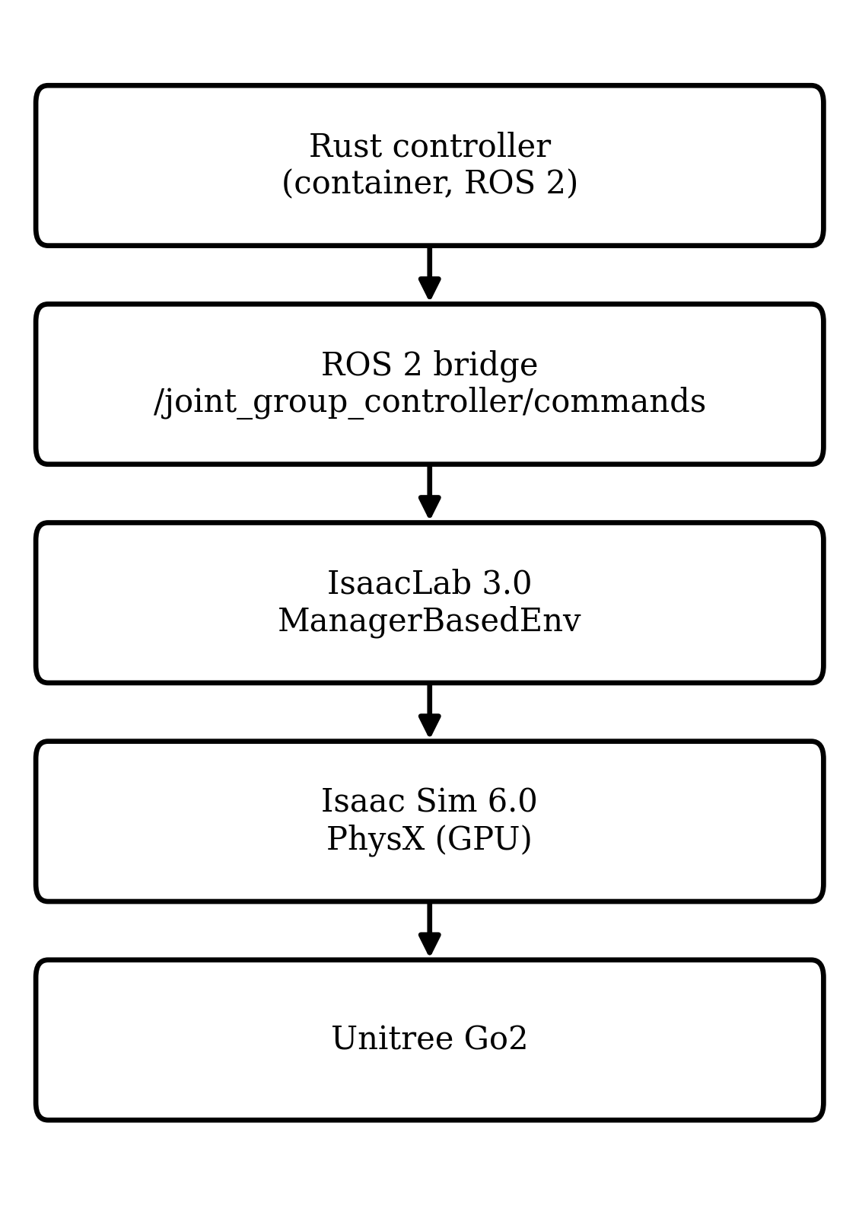
- Fig. 1. System architecture.
The controller publishes twelve joint-position targets as a `std_msgs/Float64MultiArray`. IsaacLab applies them through position actuators with a proportional–derivative law, emulating the low-level mode of the real robot. The RL path uses the same asset and the same joint-position interface; the policy is a TorchScript model executed inside the simulator.

Robot and Actuation
The Unitree Go2 has twelve actuated joints: four legs (front-right, front-left, rear-right, rear-left), each with a hip (ab/adduction), a thigh, and a calf joint. Control is performed through target joint positions and a PD law; the model-based controller uses stiffness 75 and damping 0.5, while the NVIDIA policy uses stiffness 25 and damping 0.5, as specified by its environment configuration.

Mathematical Formulation
The metrics and control relations used in this work are summarized below.
Stance foot velocity:
$v_{st}=−\frac{step_{dist}}{4dtτ_{st}}$
where $step_{dist}$ is the commanded stride distance, $dt$ is the control time step, and $τ_{st}$ is the stance duration.
Joint torque estimate:
$τ_{i}=k_{p}(q_{i}^{cmd}−q_{i})−k_{d}{\overset{˙}{q}}_{i}$
where $q_{i}^{cmd}$ is the commanded joint angle, $q_{i}$ is the measured angle, ${\overset{˙}{q}}_{i}$ is the joint velocity, and $k_{p}$ and $k_{d}$ are the stiffness and damping gains.
Cost of transport:
$CoT=\frac{E}{mgd}$
where $E$ is the mechanical energy, $m$ is the robot mass, $g$ is the gravitational acceleration, and $d$ is the distance travelled.
Capture point:
$y_{foot}=y_{cm}+\frac{v_{y}}{ω}$
$ω=\sqrt{\frac{g}{h}}$
where $y_{foot}$ is the required foot placement, $y_{cm}$ is the center-of-mass position, $v_{y}$ is the lateral velocity, $ω$ is the natural frequency, $g$ is the gravitational acceleration, and $h$ is the center-of-mass height.
Positive-feedback mode of the roll loop:
$\overset{˙}{φ}=αφ$
where $φ$ is the body roll and $α$ is the growth rate of the unstable mode caused by the hip coupling.

Model-Based IK/TROT Controller
The controller is a finite-state machine with REST, STAND, and TROT states. The TROT generator drives two diagonal pairs in antiphase (FR–RL and FL–RR) with stance and swing phases and a double-support phase. Foot trajectories are generated in the body frame: during stance the foot is fixed in the world and therefore moves backwards in the body frame at the commanded velocity; during swing a Raibert-style heuristic [8] places the foot at the neutral point shifted by the velocity. The foot positions are converted to joint angles by an analytic inverse-kinematics solution using the Go2 link lengths (thigh and calf 0.213 m).
An attitude-compensation loop uses the IMU orientation to keep the feet level: the pitch error is compensated by rotating the feet about the lateral axis, and the roll error by a differential leg-length adjustment, which avoids driving the hip joints into saturation. A proportional yaw-stabilization term keeps the heading fixed.

Learned RL Policy
The RL baseline is the pre-trained NVIDIA policy distributed with Isaac Sim [15]. Its observation is a 48-dimensional vector (base linear and angular velocity in the body frame, gravity direction, commanded velocities, joint position error from the default, joint velocities, and the previous action). The policy outputs twelve actions at a decimated rate, which are converted to joint-position targets. The policy is executed step-by-step, so its behavior does not depend on wall-clock time.

Practical Problems and Their Solutions
Five concrete defects were found and fixed, each confirmed by telemetry (125 columns: pose, angles, velocities, torques, foot positions and contacts):
1. Stance foot drift. The stance foot velocity was computed as $−\frac{step_dist}{4dtτ_{st}}$, where `stance_ticks` is the length of one stance phase, whereas the leg is on the ground for several phases in a row. The foot drifted backwards (up to −1.2 m) and the IK saturated (`calf = 0`). It was replaced by the physically correct velocity, Eq. (1) with v_st = -cmd_vel. 2. IMU compensation accumulation. The compensation was applied incrementally to the gait state, so the tilt accumulated. It is now applied only to the copy used for IK. 3. Inverted IMU sign. The compensation used `R(-comp)` instead of `R(comp)`, amplifying the tilt. After correction, roll dropped from a full flip (180°) to about 8°. 4. Inverted yaw sign. The yaw stabilization used `-0.5·yaw_err`, which spun the robot up. With `+0.5·yaw_err` the heading is maintained. 5. Wall-clock PID. After switching the controller to a simulation-time step, the PID still used wall-clock `dt`, causing a mismatch in the integral and derivative terms.
A structural defect was also identified: compensating the roll by rotating the feet created a positive feedback loop through the hip joints. The roll is now compensated by a differential leg length, which does not actuate the hip; the roll dropped from 50° to about 8° (Fig. 2).
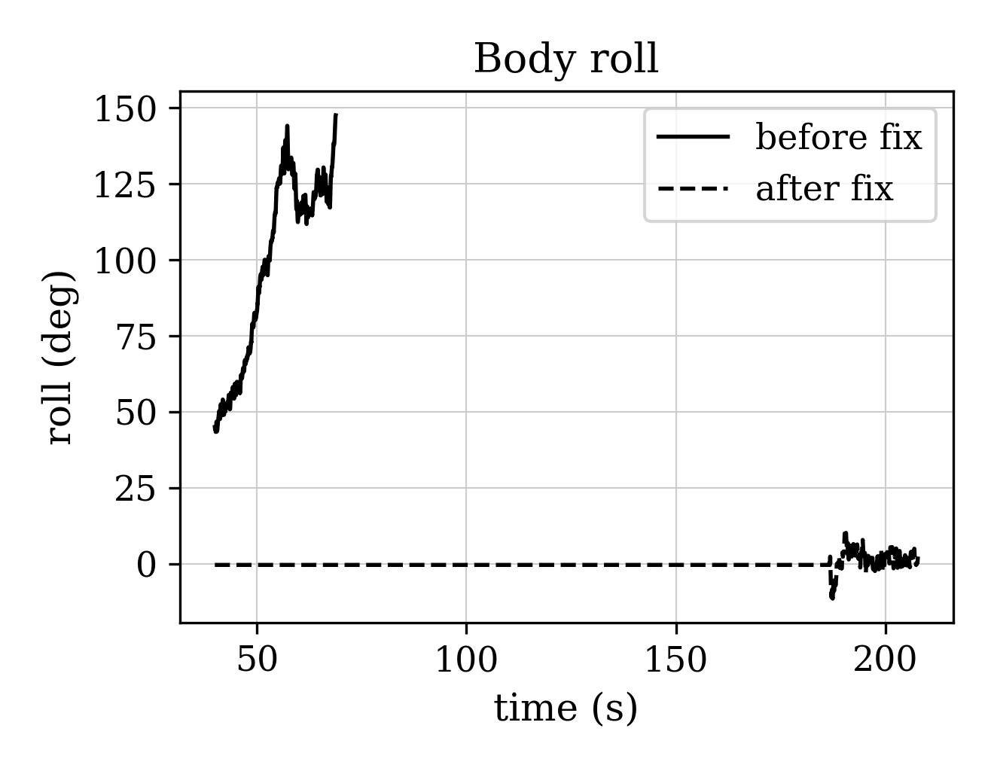
- Fig. 2. Body roll over time before (solid) and after (dashed) the differential leg-length fix.

Telemetry and Reproducibility
A unified telemetry system records 125 quantities per physics step in CSV format: the body pose and orientation, linear and angular velocities in the world and body frames, accelerations and the gravity direction, commanded velocities and the controller mode, world positions and contacts of the four feet, angles and velocities of the twelve joints, an estimate of the joint torques, instantaneous powers and accumulated energy, joint tracking errors, and flags for falls, hip saturation, and NaNs. The same format is used for both controllers. The joint torque is estimated by Eq. (2); the energy is the integral of the sum of joint powers, and the cost of transport is given by Eq. (3). To remove the influence of performance, the model-based controller steps on simulation time, published by the environment on a dedicated topic, which makes its behavior deterministic and independent of the frame rate.

Experimental Results
This section reports the experimental comparison of the two controllers. We first describe the setup and the metrics, then present the results of forward walking, the operating range in commanded speed, additional metrics, and the failure taxonomy with the negative results. All numbers are reported as the mean and standard deviation over three runs unless stated otherwise.

Setup
The simulator is Isaac Sim 6.0.1 with IsaacLab 3.0 on an Ubuntu 26.04 workstation with an NVIDIA RTX 5070 Ti GPU. The terrain is a flat plane with a friction coefficient of 1.0. The robot is the Unitree Go2 with the IsaacLab asset. The commanded velocity is 0.3 m/s (with a sweep from 0.1 to 0.4 m/s). Each controller was run three times; telemetry was recorded at the physics rate.

Metrics
To compare the two controllers objectively we use a set of kinematic and energetic metrics computed from the recorded telemetry. The distance travelled and the mean speed characterize the locomotion performance; the mean and standard deviation of the body height quantify how steadily the robot holds its posture; the maximum roll and pitch quantify the body attitude; the lateral drift quantifies how well the controller keeps a straight line; the cost of transport (CoT) quantifies the energy efficiency; and the time to reach a steady gait quantifies the transient response. All metrics are averaged over the three runs of each controller.

Results
Table 1 summarizes the forward-walking comparison at the commanded speed of 0.3 m/s. Both controllers walk at a comparable speed and a comparable cost of transport, but they differ markedly in stability: the learned policy keeps a small roll and a small lateral drift, whereas the model-based controller has a larger roll and drift. In return, the model-based controller holds the body height more tightly and is fully deterministic.
Table 1. Forward walking (vx = 0.3 m/s, mean ± std, n = 3).
Metric | RL policy (NVIDIA) | IK/TROT (ours)
Mean body height (m) | 0.159 ± 0.000 | 0.235 ± 0.001
Std of height (m) | 0.040 ± 0.000 | 0.025 ± 0.001
Mean speed (m/s) | 0.231 ± 0.000 | 0.215 ± 0.012
Distance (m) | 3.34 ± 0.00 (15 s) | 2.75 ± 0.12 (19.3 s)
Lateral drift (m) | 0.37 ± 0.00 | 1.09 ± 0.16
Max roll (deg) | 2.3 ± 0.0 | 27.8 ± 3.7
Max pitch (deg) | 4.1 ± 0.0 | 35.6 ± 0.0 *
Falls | none | none
CoT | 2.84 | 2.83 ± 0.41
\* the IK pitch maximum is a startup transient; the steady-state pitch is about 2°. The RL policy is deterministic across runs (standard deviation zero). The trajectories of the two controllers are compared in Fig. 3.
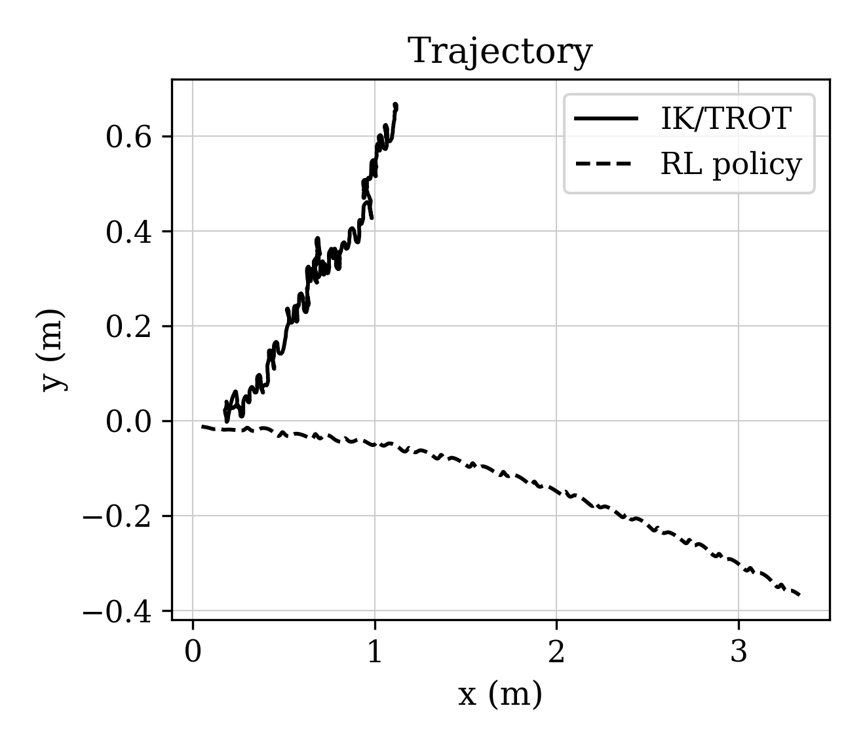
- Fig. 3. Trajectory in the horizontal plane: model-based IK/TROT (solid) and RL policy (dashed).
The operating range of both controllers is reported in Table 2, which lists the achieved speed, the maximum roll, and the lateral drift for four commanded speeds.
Table 2. Operating range (speed / roll / drift).
vx (m/s) | RL policy | IK/TROT
0.1 | 0.026 / 2.6° / 0.09 m | 0.001 / 69° / 0.28 m
0.2 | 0.116 / 3.6° / 0.21 m | 0.024 / 47° / 0.23 m
0.3 | 0.222 / 2.3° / 0.37 m | 0.141 / 25° / 0.77 m
0.4 | 0.344 / 3.0° / 0.80 m | 0.066 / 31° / 0.60 m
The RL policy tracks the commanded velocity over the whole range with a small roll, whereas the model-based controller is stable only near 0.3 m/s. The speed tracking of both controllers is shown in Fig. 4.
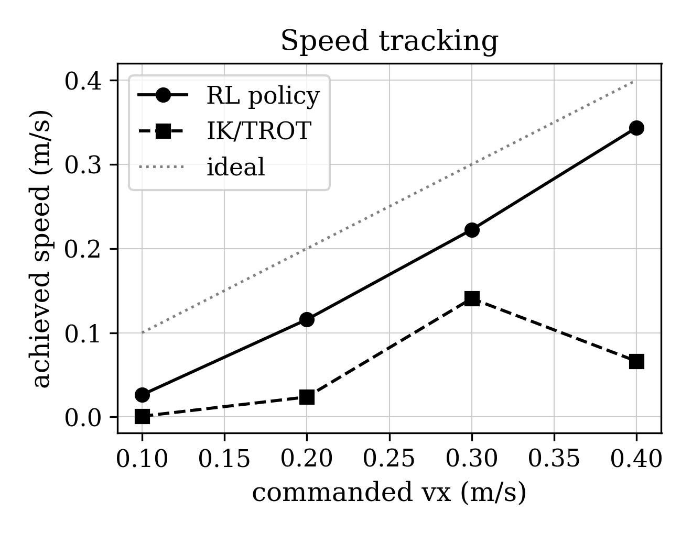
- Fig. 4. Achieved speed versus commanded speed for the RL policy (circles) and the IK/TROT controller (squares); the dotted line is the ideal.

Additional Metrics
The body jerk (root-mean-square of the derivative of the body-frame acceleration) is high for the model-based controller (about 370, 580, and 620 m/s³ on the three axes), reflecting the impulsive stance/swing transitions. The energy distribution across joint groups is about 8% in the hip joints, 37% in the thigh joints, and 55% in the calf joints; the calf joints dominate, consistent with their role in supporting and propelling the body.

Failure Taxonomy and Negative Results
Table 3 collects the failure modes that were identified during integration, together with their symptoms, root causes, and resolutions.
Table 3. Failure modes of the model-based controller.
Defect | Symptom | Root cause | Resolution
Stance foot drift | IK saturation (`calf=0`) | wrong velocity divisor | `velocity = -cmd_vel`
IMU accumulation | growing tilt | fed back into gait state | apply to IK copy only
Inverted IMU sign | flip over 180° | `R(-comp)` | correct sign, `kp=1.0`
Inverted yaw sign | yaw spin | `-0.5·yaw_err` | `+0.5·yaw_err`
Wall-clock PID | fps-dependent behavior | wall-clock `dt` | simulation-time PID
Roll via hip | hip saturated at −0.30 | positive feedback via hip | differential leg length
Forward-motion loss | lateral motion | wrong gait `time_step` | restore `time_step=0.02`
Several plausible remedies did not help: increasing the attitude gain (`kp=1.0→2.0`), relaxing the hip limit (`0.3→0.6`), inverting the roll-compensation sign, and a symmetric stance/swing trot all degraded stability. Only the differential leg-length compensation reduced the roll substantially.

Conclusions
The two paradigms trade off differently. The learned policy is markedly more stable, keeps the course, and works over a wide speed range; it is the natural choice when a trained policy is available and a GPU is present. The model-based controller is fully deterministic, transparent, requires no GPU or training, and holds the body height more tightly, but it is stable only in a narrow regime and has a residual roll and drift.
A key observation concerns time-base coupling. Before correction, the model-based controller ran its 60 Hz loop on wall-clock time while the simulation advanced by fixed steps; when the simulation slowed down, the number of physics steps per control command changed, and the robot's behavior changed with it. After switching the controller to simulation time, the behavior became deterministic. The learned policy, being step-based, never had this problem.
The residual roll of the model-based controller is not an implementation defect but a reproducible limit of a simple proportional attitude stabilizer. A linearized view explains why: compensating the roll by rotating the feet necessarily actuates the hip, and if the sign of this coupling reinforces the roll, the loop has positive feedback, Eq. (6), limited only by the hip clamp. Compensating the roll through the leg length removes the feedback and reduced the roll from 50° to about 8°. Full elimination requires placing the feet outside the center of mass — a capture-point condition, Eq. (4) — which the simple proportional loop does not satisfy.
These findings can be summarized in a few concise statements. First, the behavior of a model-based controller that runs its loop on wall-clock time is unpredictably coupled to the real-time performance of the simulator, whereas a loop driven by simulation time is deterministic. Second, compensating the roll by rotating the feet actuates the hip and can create positive feedback; a differential leg length reduces but does not eliminate it. Third, the learned policy is more stable and tracks a wider velocity range, while the model-based controller is deterministic, training-free, and holds the height better, so the two are complementary rather than substitutable. Fourth, despite the stability gap, both achieve a comparable cost of transport (2.83 vs 2.84), so energy efficiency alone does not discriminate between the paradigms.
These conclusions hold within the scope of the present study, which is limited to simulation; sim-to-real was not verified. The two controllers also use different assets and PD gains, so part of the difference may be attributable to these rather than to the control paradigm, and the operating range of the model-based controller is narrow. The RL policy is a ready-made NVIDIA model and was not trained by us. Building on these results, the natural next steps are to implement a capture-point balancer and a turning controller that eliminate the residual roll and drift, to equalize the comparison conditions by running both controllers on a single asset with identical PD gains, to conduct disturbance experiments such as a lateral push or a slippery surface, and to transfer the result to a real robot.

Acknowledgment
The author thanks the Department of Robotics and Mechatronics of Bauman Moscow State Technical University for supporting this work.

References
Unitree Robotics, "Unitree Go2 — quadruped robot and SDK," documentation, 2024.
NVIDIA, "Isaac Lab: A unified and modular framework for robot learning," documentation, 2024.
NVIDIA, "Isaac Sim," documentation, 2026.
J. Hwangbo et al., "Learning agile and dynamic motor skills for legged robots," *Science Robotics*, vol. 4, no. 26, 2019.
J. Lee, J. Hwangbo, L. Sentis, V. Kim, and P. Fankhauser, "Learning quadrupedal locomotion over challenging terrain," *Science Robotics*, vol. 5, no. 47, 2020.
T. Miki et al., "Learning robust perceptive locomotion for quadrupedal robots in the wild," *Science Robotics*, vol. 7, no. 62, 2022.
N. Rudin, D. Hoeller, P. Reist, and M. Hutter, "Learning to walk in minutes using massively parallel deep reinforcement learning," in *Proc. Conf. Robot Learning (CoRL)*, 2021.
M. H. Raibert, *Legged Robots That Balance*. Cambridge, MA, USA: MIT Press, 1986.
B. Katz, J. Di Carlo, and S. Kim, "Mini Cheetah: A platform for pushing the limits of dynamic quadruped control," in *Proc. IEEE Int. Conf. Robotics and Automation (ICRA)*, 2019, pp. 6295–6301.
J. M. Jimeno, "CHAMP: Controller for highly agile multi-legged platforms," GitHub repository, 2021.
G. Bledt et al., "MIT Cheetah 3: Design and control of a robust, dynamic quadruped robot," in *Proc. IEEE/RSJ Int. Conf. Intelligent Robots and Systems (IROS)*, 2018, pp. 2245–2252.
*Benchmarking MPC and RL for legged robot locomotion in MuJoCo*, arXiv:2501.16590, 2025.
*Isaac Sim-to-real: RL-based locomotion for quadrupeds*, arXiv:2607.18135, 2026.
*Kine2Go: A kinematic dataset for the Unitree Go2*, arXiv:2606.14433, 2026.
NVIDIA, "Isaac Gym: High performance GPU-based physics simulation for robot learning," arXiv:2108.10470, 2021.

