# Multiple Reports Selection Usage Scenario

## Prerequisites

Use a clean Business Central sandbox with demo data. Delete all entries in the Red Layout Selection. Go to the Report Layout Selection. Ensure that reports 206 and 1306 have no Custom Layouts selected.

## If there are one or less Custom Report Layouts for the current report Business Central will print the default layout.

Go to Report Selection Sales. Select Usage Invoice and select report 206.

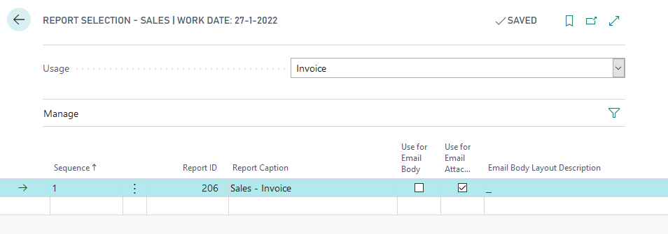

Go to Posted Sales Invoices and print a sales invoice. The default layout for report 206 will print.

## If there are more than one Custom Report layouts for the current report and one applicable entry in the Red Layout Selection Business Central will use that layout.

Go to Report Selection Sales. Select Usage Invoice and select report 1306.

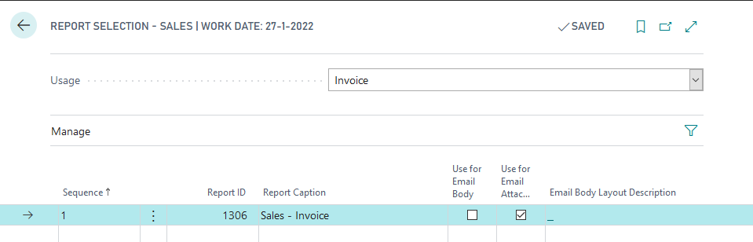

Go to the Red Layout Selection, insert a new line for report 1306. Select Table No. 112, Field No. 2, select a customer that has a posted sales invoice and select a Custom Layout.

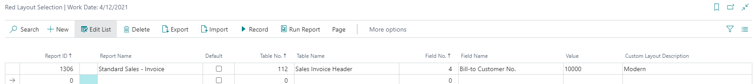

Go to Posted Sales Invoices, find an invoice for the selected customer and print. The selected Custom Layout will print.

## If there are more than one Custom Report layouts for the current report but no entries in the Red Layout Selection Business Central will let the user choose which layout to use.

Go to Report Selection Sales. Select Usage Invoice and select report 1306.



Go to the Red Layout Selection, insert a new line for report 1306. Select Table No. 112, Field No. 2, select a customer that has a posted sales invoice and select a Custom Layout.



Print an invoice for another customer than you selected. You will get a selection screen for the layout selection.

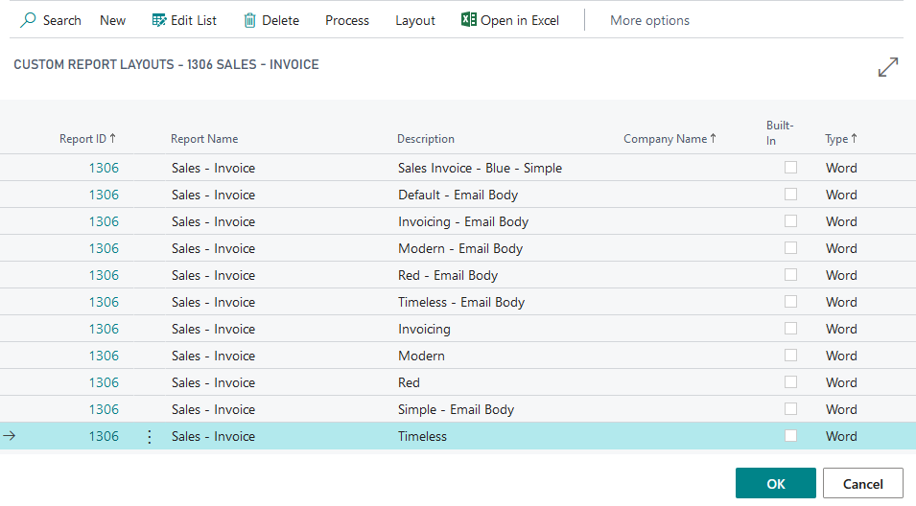

## If there are more than one Custom Report layouts for the current report and a default entry in the Red Layout Selection that default layout will be used.

Go to Report Selection Sales. Select Usage Invoice and select report 1306.



Go to the Red Layout Selection, insert a new line for report 1306. Set Default to true and select a Custom Layout.



Print an invoice for any customer. The default layout will be used.

## If there are more than one Custom Report layouts for the current report and more than one applicable entries in the Red Layout Selection Business Central will let the user choose which of the applicable entries to use.

Go to Report Selection Sales. Select Usage Invoice and select report 1306.



Go to the Red Layout Selection, insert a new line for report 1306. Select Table No. 112, Field No. 2, select a customer that has a posted sales invoice and select a Custom Layout. Then, insert another line for another condition that overlaps for certain invoices, like a dimension code.

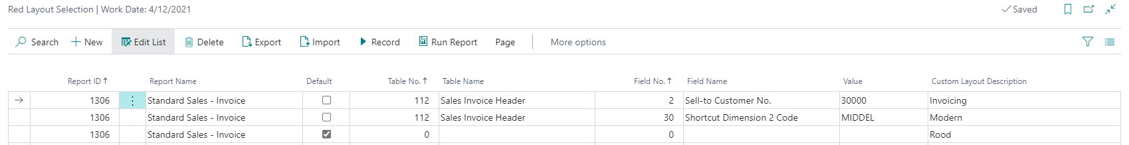

Go to Posted Sales Invoices, find an invoice that matches both criteria. You will get a selection screen for the matching Custom Report Layouts.

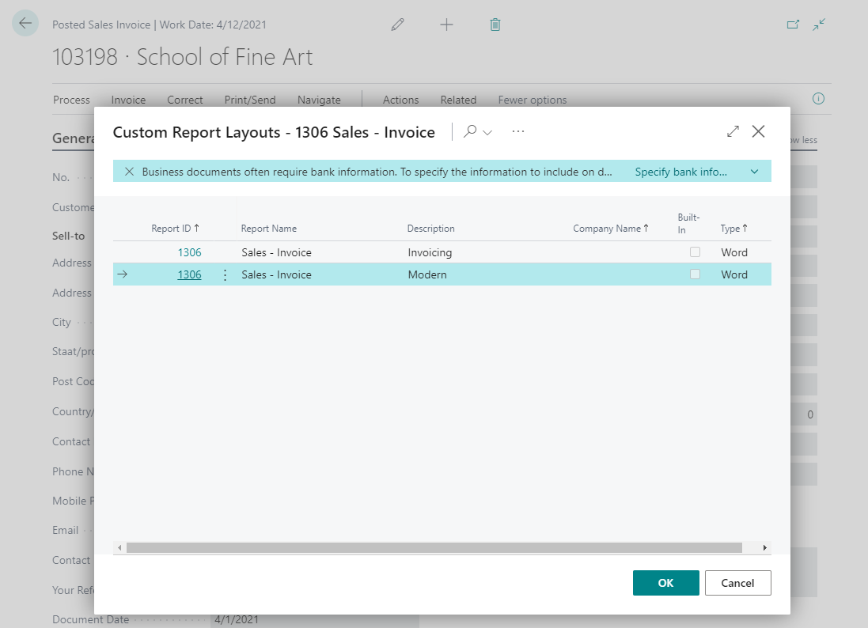

Then find an invoice that matches only one of the criteria in the Red Layout Selection. The selected layout will print.

# Record the report and source table

In some cases it is difficult to find the report and source tables that are needed. In this case you can use the Record function.

Open the Red Layout Selection page and select Record.

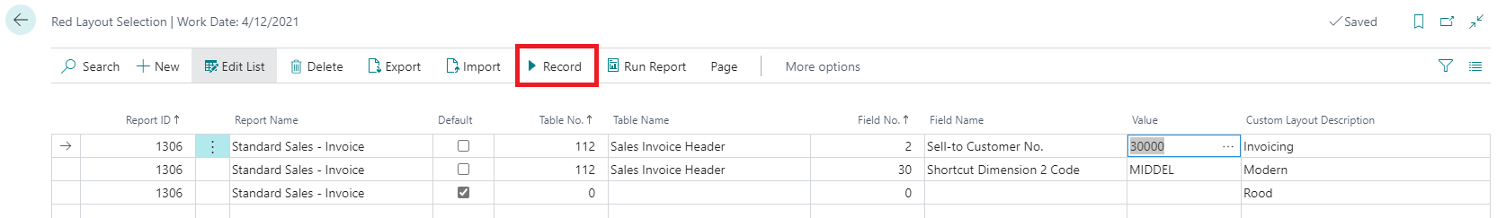

Then, in the same user window, open the Sales Orders page and print an Order confirmation.

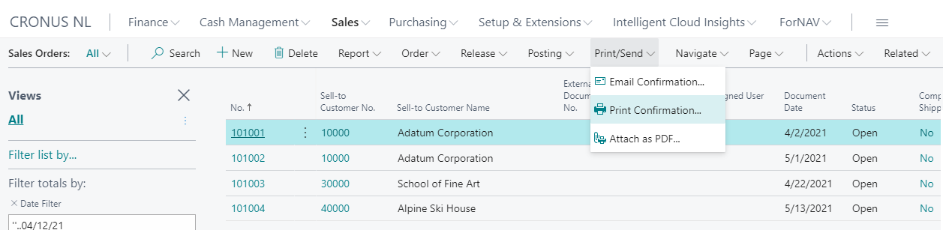

A message will inform you that the layout has been added to the Red Layout Selection.

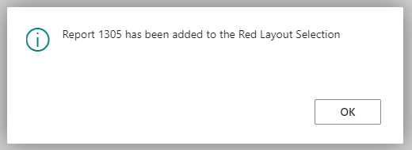

Open the red layout selection. A new record will have been added. Select Stop Record to stop the recording.

