

Capstone Project Report
Report 4 – Software Design Specification

– Hanoi, Nov 2026 –

Table of Contents
Change Log 4
I. High Level Design 5
1. Software Architecture 5
2. Package Diagram 9
3. Database Design 11
3.1 contract 14
3.2 milestone 14
3.3 signature 15
3.4 signature_otp 15
3.5 consent_evidence 16
3.6 contract_document 16
3.7 breach_case 17
3.8 attribution_decision 17
3.9 remedy_decision and remedy_leg 18
3.10 price_adjustment 18
3.11 milestone_sync_outbox 18
3.12 deposit_leg 19
3.13 escrow_milestone and remedy_leg_command 19
3.14 ledger_entry 19
3.15 system_lock and used_nonce 20
3.16 level1_5_inspection_assignment 20
3.17 inspection_report 21
3.18 inspector_signature 21
3.19 level2_inspection_commission 21
3.20 lock_entry 22
3.21 completed_contract_fact and dispute_outcome_fact 22
3.22 lock_override_event and governance tables 23
3.23 audit_record and audit_anchor 23
3.24 user_profiles 24
3.25 kyc_read_audit 24
3.26 categories, products and listings 24
3.27 listing_reservations and plot_registry_entry 25
3.28 listing_plot 25
3.29 file 26
3.30 email_intake_failure 26
3.31 price_history and notification_logs 26
3.32 price_ingestion_failure 27
3.33 analytics read models 27
3.34 event_outbox and processed_event 28
II. Detailed Code Design 28
1. Contract Signing (Consent + Step-up + OTP) 28
1.1 Class Diagram 29
1.2 Initiate Sign 30
1.3 Verify OTP and Sign 31
2. Milestone Delivery and Settlement 31
2.1 Class Diagram 32
2.2 Weigh and Confirm Clean 33
2.3 Money Movement and Completion Reconciliation 34
3. Quality Dispute, Level 1.5 Inspection and Remedy 34
3.1 Class Diagram 35
3.2 Flag, Contest and Inspector Assignment 36
3.3 Inspection Result to remedy.finalized 36
III. Design for Non-Functional Requirements 37
1. Security Design 37
1.1 Authentication Flow 37
1.2 Authorization & RBAC Implementation 38
1.3 Data Protection 39
2. Performance & Scalability Design 39
2.1 Caching Strategy 39
2.2 Database Query Optimization 40
2.3 Scalability and Resilience 40
IV. Other Design Specifications 41
1. Event and Integration Contracts 41
2. State Machines 41
3. Key Algorithms 42
4. Backup and Disaster Recovery 42
5. API Surface Summary 43
6. Verification Matrix and Release Gate 44

Change Log
Date | A*  M, D | In charge | Change Description
31/10/26 | A | Minh Cuong | I.1 Software architecture: tier diagram, component descriptions, communication matrix
31/10/26 | A | Minh Cuong | I.2 Backend (Clean Architecture) and frontend package diagrams with naming conventions
31/10/26 | A | Minh Cuong | I.3 Database design: contract_db ERD, money/evidence ERD, table specifications
31/10/26 | A | Minh Cuong | II. Detailed design: contract signing, milestone settlement, dispute → Level 1.5 → remedy
31/10/26 | A | Minh Cuong | III–IV. Security, performance, event contracts, state machines, algorithms, DR
31/10/26 | M | Minh Cuong | Diagrams redrawn in UML style; added missing tables, API surface and verification matrix
02/11/26 | M | Minh Cuong | Gateway rate limit kept in memory; breach_case contest columns, contest endpoint and contest window (GB-50); activation-failure transitions; role fix (Operator reviews email intake failures); all 14 figures redrawn in UML notation (sources: docs/reports/figures/sds)
04/11/26 | M | Minh Cuong | Breach case review/resolve restricted to ARBITRATOR (OpenAPI x-roles); an Inspector result reaches the case through inspection.report_confirmed
10/11/26 | M | Minh Cuong | Contract signing brought in line with the code (code first): II.1 text and class table; Figure 6 split into 6a (application layer) and 6b (domain model); Figures 6-8 redrawn from the code in Visual Paradigm UML notation (editable .drawio in docs/reports/figures/sds); tables contracts, signature, signature_otp, consent_evidence and the contract_db schema row as implemented
10/11/2026 | M | Group 6 | Figures 4a, 4b, 5a, 5b redrawn as crow's foot ERDs (editable .drawio in docs/reports/figures/sds) from the schema the migrations produce; planned tables marked «planned». Figure 4a now shows activation_recovery and activation_cancel_request (D42). Schema overview marks implemented / planned tables; 3.12 deposit_leg adds the V10/V11 columns; 3.16 adds level1_5_assignment_lock
10/11/2026 | M | Group 6 | Figure 1 redrawn as a UML component diagram (editable .drawio); object storage is SeaweedFS (S3 API), which replaced MinIO
10/11/2026 | M | Group 6 | Figure 2 redrawn from the packages and imports of contract-service (editable .drawio); the backend package table adds application.service and infrastructure.notification / otp / terms / consent, and drops the infrastructure.client package that does not exist
10/11/2026 | M | Group 6 | Figure 3 redrawn from the folders of frontend/src (editable .drawio); auth shown as the reference feature
10/11/2026 | M | Group 6 | Figures 9-14 redrawn (editable .drawio); the classes that exist (bank-service ledger, inspection-service assignment, shared eventing) carry their names from the code, the rest stays the design; class tables follow (ProcessLedgerCommandUseCase, ManageLevel15Assignments)
10/11/2026 | A | Minh Cuong | 3 Database Design: rationale for one database per service instead of a shared database, and the accepted cost (no cross-service transaction or join)
*A - Added M - Modified D - Deleted

I. High Level Design

1. Software Architecture
AgriContract is a B2B forward-contract platform for domestic Vietnamese coffee trading with milestone-based escrow. The target architecture consists of a React single-page application, an edge tier (Nginx, API Gateway, Keycloak), 12 business microservices and a shared data/messaging tier. Services follow database-per-service; state changes that other services must see are published through a transactional outbox to RabbitMQ and consumed idempotently (at-least-once delivery, dedup by eventId). The money path is guarded more strictly than the rest of the system: bank-service owns the only authoritative ledger, every money leg has its own idempotency key, and a contract only reaches a terminal state after ledger reconciliation shows zero remaining lock.
The guiding rule across the diagram is decision before consequence: contract-service is the single owner of business decisions (signature, settlement, attribution, remedy); escrow-service only translates decided legs into bank commands; bank-service only records ledger effects; reputation-service only applies a lock when a final decision allows it. Lifecycle events (contract.settled, contract.terminated) are facts for audit/analytics, never triggers for money.
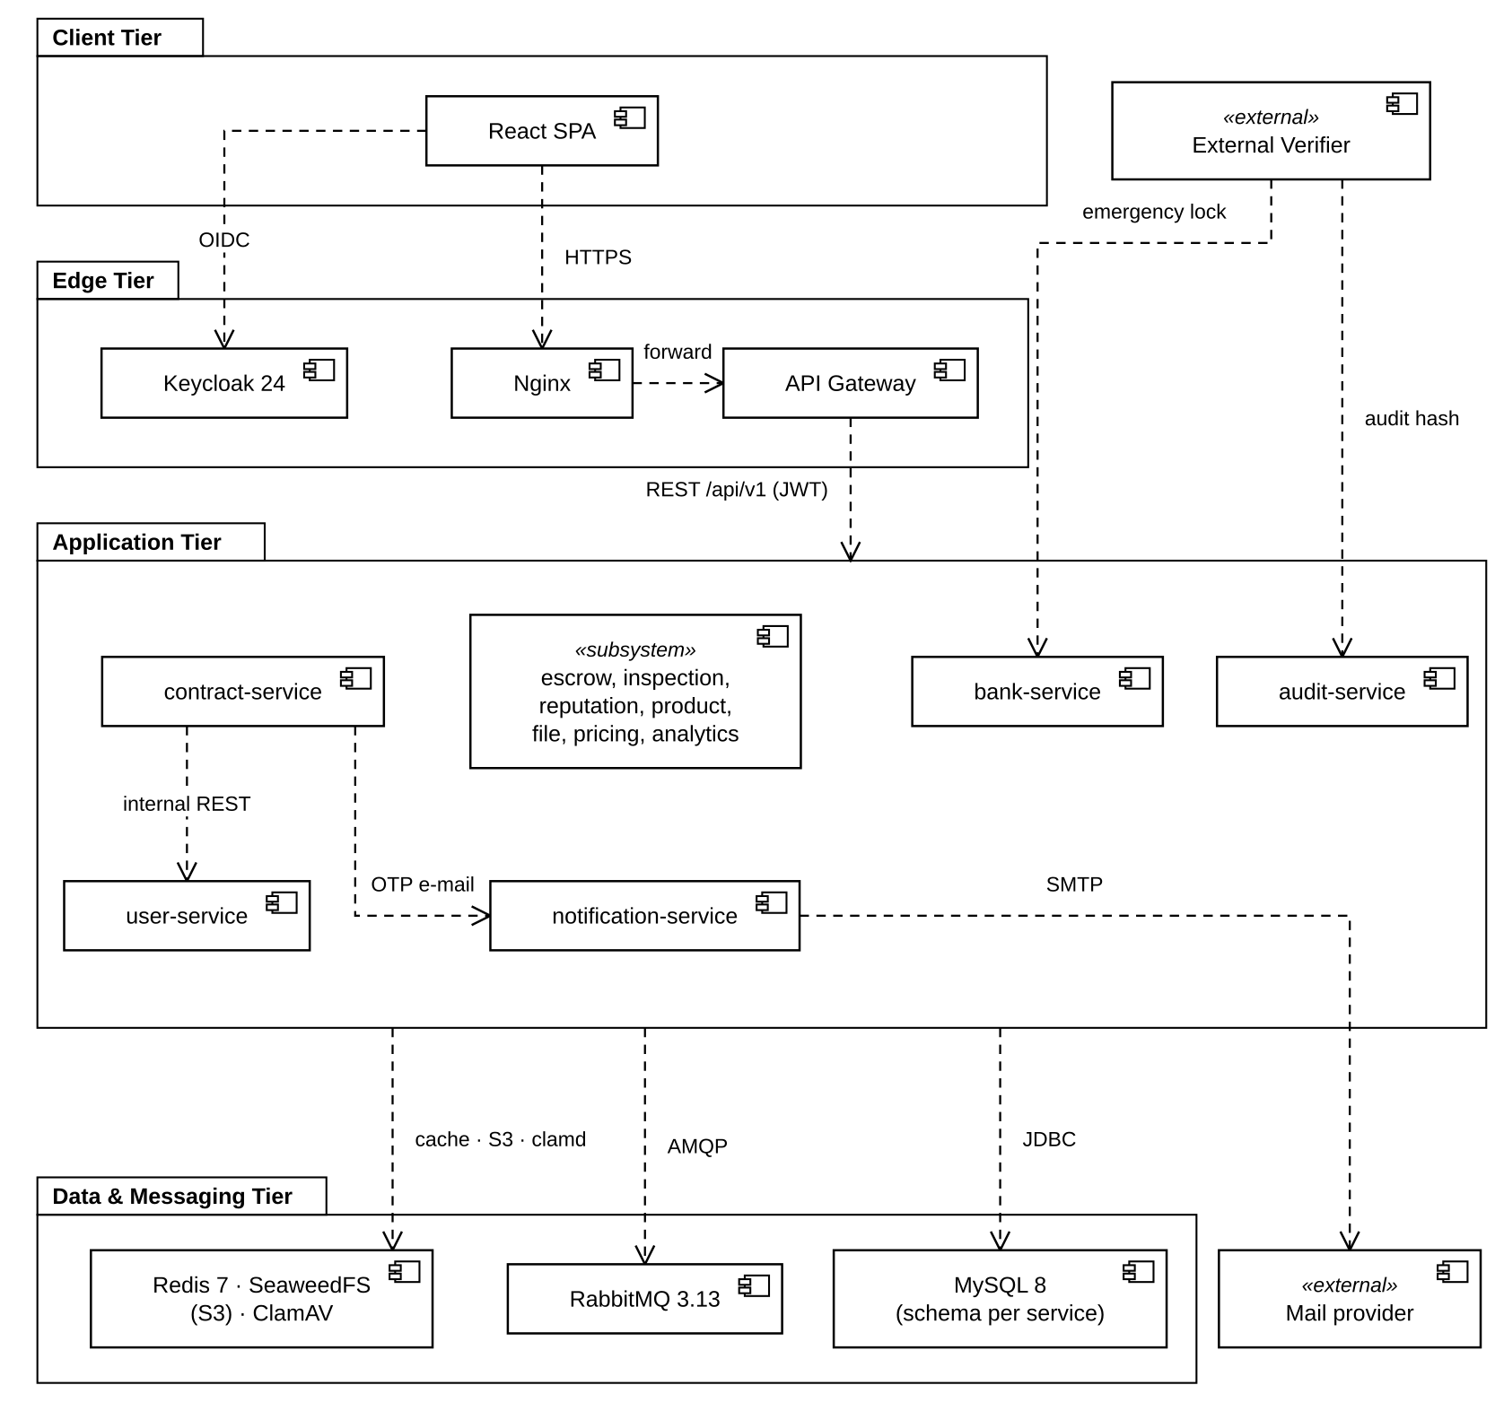
Figure 1. AgriContract overall architecture (target Phase 2)
Architecture component descriptions
No | Component | Description
Client Tier
01 | routes/ (pages) | One page component per route (marketplace, listing detail, escrow, prices, public reputation, auth). Pages only compose feature components; they hold no API logic.
02 | features/<feature>/{api, hooks, components, lib} | Feature slices for auth, listings, contracts, escrow and notifications. api/ wraps Axios calls typed from the OpenAPI contract, hooks/ exposes TanStack Query queries/mutations, components/ renders feature UI (e.g. SignContractDialog, MilestoneActions).
03 | shared/{ui, api, hooks, lib} | Design-system primitives (shadcn/Base UI, Tailwind), the single Axios instance with the auth interceptor (Bearer token, Idempotency-Key, X-Correlation-Id) and cross-feature helpers.
04 | TanStack Query · Zustand | Server state cache keyed by resource id with invalidation after mutations; Zustand only for UI/session state.
05 | keycloak-js | OIDC Authorization Code + PKCE (S256) login; keeps tokens in memory and refreshes them; triggers step-up re-authentication (prompt=login) right before contract signing.
Edge Tier
01 | Nginx | TLS termination, coarse per-IP rate limit, request-size caps, CORS allow-list, forwards to the gateway only. Service ports are never exposed.
02 | API Gateway (Spring Cloud Gateway) | Verifies JWT signature via Keycloak JWKS, applies the route/role matrix (public → role-gated → authenticated default), strips any client-supplied X-User-*/secret headers and injects X-User-Id, X-User-Role, X-Correlation-Id, X-Gateway-Secret. Denies /internal/**. No business authorization, no retry of non-idempotent writes.
03 | Keycloak 24 | Identity provider: credentials, realm roles (BUYER, SELLER, INSPECTOR, OPERATOR, ARBITRATOR, ADMIN), RS256 tokens, step-up login. Platform databases never store passwords or tokens.
Application Tier — business core
01 | contract-service | Owner of Contract, ContractTerms snapshot, Milestone, Signature/OTP, ConsentEvidence, ContractDocument, BreachCase, AttributionDecision and RemedyDecision. Publishes contract.*, milestone.*, remedy.finalized and notification commands.
02 | escrow-service | Escrow projection per contract/milestone; turns contract.signed, milestone.settled and each remedy leg into exactly one bank.*_requested command; exposes buyer/seller statements after ownership check. Stores states, not balances.
03 | bank-service | Append-only ledger_entry (INSERT/SELECT grants only), lock/release/refund/seize processing, emergency security lock controlled by the External Verifier (ES256), large-transaction signals.
04 | inspection-service | Level 1.5 inspector assignment (random among eligible inspectors) and report submission with result/report hashes; Level 2 commission and email intake with human confirmation. Never decides money.
05 | reputation-service | Immutable completion/dispute facts and lock entries; at most one lock per remedy decision; score derived at read; maker-checker early unlock.
Application Tier — data / support
06 | user-service | Organization profile, KYC/authorization expiry, roles, public vs internal DTOs, lock projection (locked_until) from reputation events; internal eligibility API used fail-closed by sign/listing/offer.
07 | product-service | Plot registry (KML/pin, SRID 4326 geometry), coffee products/listings, partial-fill reservations, orphan-reservation reaper.
08 | file-service | Three ingest channels (DIRECT_UPLOAD, EMAIL_INTAKE, SYSTEM_GENERATED), ClamAV scan + SHA-256 before READY, retention, legal hold, two-step deletion.
09 | audit-service | Append-only dual hash chain (global + per-subject), periodic verification, OpenTimestamps anchoring, evidence export.
10 | pricing-service (NestJS) | VNSAT coffee price scraping and operator manual fallback; MySQL append-only history, Redis cache. Advisory only.
11 | analytics-service (NestJS) | CQRS read models (termination, escrow effectiveness, force-majeure trends), monthly recompute, AML structuring-pattern scan. Non-critical.
12 | notification-service (NestJS) | Consumes notification commands, sends email with evidence attachments, synchronous OTP endpoint; dedup by (event, recipient, type).
13 | Shared libraries | java-eventing (EventEnvelope, OutboxWriter, OutboxPoller, ProcessedEventStore), node-eventing, java-web-error (ErrorEnvelope) — identical envelope and error contract in every service.
Data & Messaging Tier
01 | RabbitMQ 3.13 | Topic exchanges for domain events, bank commands/results and notification commands; one durable queue + DLQ per consumer; DLQ replay keeps the original eventId.
02 | MySQL 8 (one schema per service) | contract_db, escrow_db, bank_db, inspection_db, reputation_db, audit_db, user_db, product_db, file_db, pricing_db, analytics_db, notification_db. Flyway migrations, per-service DB user.
03 | Redis 7 | Pricing cache and analytics API cache. Never caches money. Gateway rate-limit counters stay in gateway memory in Phase 2.
04 | SeaweedFS (S3 API) | Evidence files and generated PDFs; object keys never leave file-service.
05 | ClamAV | Malware scan in the file pipeline; infected files become FAILED and never emit file.ready.
External Systems
01 | SMTP / mail provider | OTP, notices, final contract PDF and anchor emails (via notification-service only).
02 | External Verifier | Independent party holding an ES256 key; the only actor that can lock/unlock all money movement (no admin bypass).
03 | VNSAT price portal | Source of reference coffee prices per province.
04 | Level 2 inspection organization | Accredited external inspector; sends reports to the platform intake mailbox.
05 | OpenTimestamps | Public timestamp anchoring of audit digests.
06 | Custodian bank | Future adapter; in the capstone scope bank-service is a simulated ledger.

Main communication between components
From → To | Channel | Trust / reliability | Purpose
SPA → Gateway → service | HTTPS REST/JSON | Bearer JWT; Idempotency-Key on every write | All user commands and queries under /api/v1/**; errors use ErrorEnvelope {timestamp, status, error, code, message, path, traceId}.
Service → user-service | Internal REST (/internal/v1/users/{id}) | Gateway/internal secret | Eligibility (KYC, authorization expiry, lock) — callers fail closed when unavailable.
contract → notification | Internal REST (/internal/v1/notifications/otp-email) | Internal secret | The only synchronous notification: OTP must be confirmed by the mail provider before the UI says "sent".
contract → product | Internal REST reserve/release | Internal secret | Listing reservation before an offer is persisted; idempotent compensation on failure.
contract → escrow → bank | RabbitMQ events/commands | Outbox + processed_event | contract.signed, milestone.settled, remedy.finalized → bank.*_requested → bank.*_completed/failed.
contract ⇄ inspection | RabbitMQ | Outbox + processed_event | inspection.level1_5_requested → inspection.report_confirmed.
contract reconciler → bank | Internal REST (/internal/v1/bank/ledger) | serviceAuth | Reads ledger per contract to prove expected legs are complete and remaining lock is zero.
Any producer → notification | RabbitMQ notification commands | Dedup (event, recipient, type) | 17 command types; business services decide recipients and purpose.
External Verifier → bank | HTTPS (signed body) | ES256 + RFC 8785 + timestamp ±300 s + nonce | Emergency lock/unlock; 64 KB cap; no retry; 10 req/min per IP at the edge.

2. Package Diagram
Every Spring Boot service uses the same Clean Architecture layout under com.agricontract.<service>: domain (business rules, no Spring imports), application (use cases and ports) and infrastructure (Spring adapters). Dependencies point inwards only; repositories and ports are interfaces owned by inner layers and implemented by infrastructure adapters. Figure 2 uses contract-service, the largest service, as the reference; escrow, bank, inspection, reputation, user and product services apply the same packages with fewer classes. The NestJS services (pricing, analytics, notification) mirror the split with domain/, application/, infrastructure/ folders and a Nest module per service.
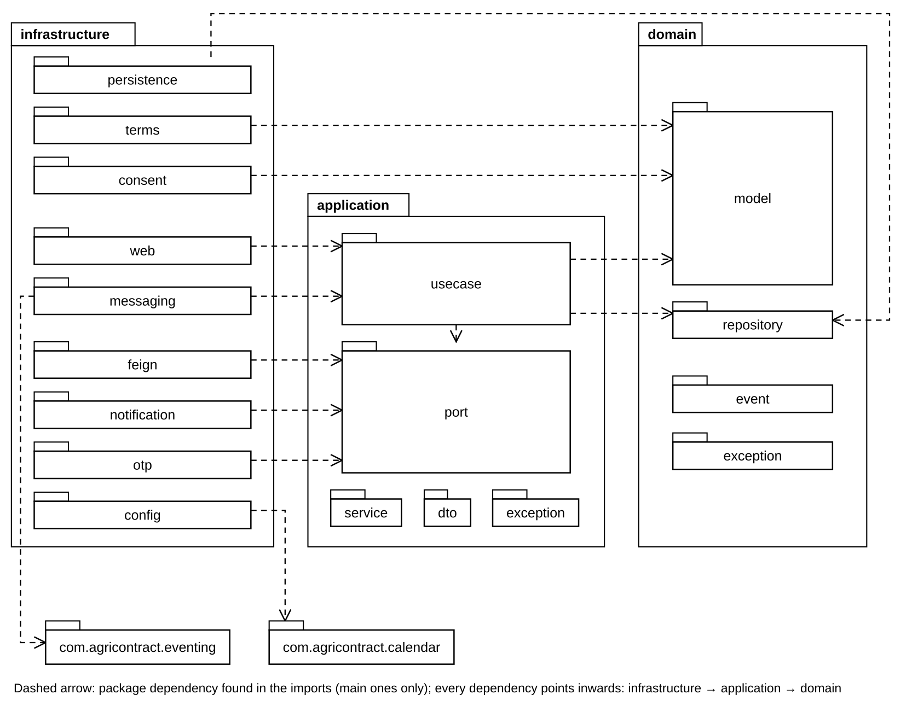
Figure 2. Backend package diagram (contract-service as reference)
Package descriptions — backend
No | Package | Description + class naming conventions
01 | domain.model (+ vo) | Aggregates, entities and value objects: Contract, Milestone, BreachCase (aggregate roots), Signature, OtpChallenge, ConsentEvidence, CanonicalTerms, ContractDocument, AttributionDecision, RemedyDecision; vo: ContractTerms, Money, Quantity, ContractStatus. State transitions are methods on the aggregate (consentToSign, sign, withdraw, activate; settleClean, resolve planned) — controllers and repositories never set state. Naming: noun in PascalCase; value objects are immutable records.
02 | domain.service | Stateless domain services for rules that span aggregates or are pure calculations (planned): SettlementCalculator, QualityDispositionCalculator, RemedyCalculator, DisputeRoutingService. Naming: <Concept>Calculator / <Concept>Service.
03 | domain.event | Domain events raised by aggregates (ContractSignedEvent, MilestoneSettledEvent, RemedyFinalizedEvent) and the DomainEvent base. Naming: <Aggregate><PastTenseVerb>Event; wire name is dotted lower case (milestone.settled).
04 | domain.repository | Repository interfaces per aggregate (ContractRepository, MilestoneRepository, BreachCaseRepository). Naming: <Aggregate>Repository.
05 | domain.exception | Rule violations independent of transport (InvalidStateTransitionException, DomainRuleViolationException).
06 | application.usecase | One class per business action, transactional boundary (@Transactional), orchestrates domain + ports + outbox: InitiateSignUseCase, VerifyOtpAndSignUseCase, RecordSellerWeighedUseCase, ConfirmMilestoneCleanUseCase, FlagMilestoneIssueUseCase, ApplyInspectionResultUseCase. Naming: <Verb><Noun>UseCase (+Impl when an interface is required for testing).
07 | application.port | Outbound interfaces for other services/infrastructure: UserPort, ListingPort, OtpEmailPort, OtpCodes, IdempotencyStore, ContractEventPublisher (implemented); ListingReservationPort, FileStoragePort, BankLedgerQueryPort (planned). Naming: <Capability>Port.
08 | application.dto / exception | Commands (input of use cases), results/responses and application errors mapped to HTTP codes (ContractNotFoundException → 404, StateConflictException → 409).
09 | application.service | Application services shared by several use cases, no transaction of their own: SignerEligibility, SigningConsentRecorder, OtpChallengeIssuer, ActivationRefundStarter. Naming: <Noun><Role>.
10 | infrastructure.web | REST controllers (ContractController, MilestoneController), request DTOs with Bean Validation, GlobalExceptionHandler producing ErrorEnvelope. Naming: <Resource>Controller, <Action>Request.
11 | infrastructure.messaging | RabbitMQ consumers (@RabbitListener) and publishers; DlqMonitor. Every consumer first records processed_event(consumer, eventId). Naming: <Event>Consumer, Outbox<Name>Publisher.
12 | infrastructure.persistence | JPA entities (<Aggregate>JpaEntity), mappers, Spring Data repositories and <Aggregate>RepositoryImpl adapters; JDBC repositories (Jdbc<Aggregate>Repository) for append-only tables where JPA dirty-checking is unwanted (ledger, deposit legs).
13 | infrastructure.feign | OpenFeign clients for internal REST (UserServiceClient, ProductServiceClient; NotificationServiceClient in infrastructure.notification) and the <Capability>PortAdapter that implements an application port.
14 | infrastructure.notification | NotificationServiceClient (OpenFeign) and OtpEmailPortAdapter, which implements OtpEmailPort: the OTP e-mail is the only synchronous call to notification-service.
15 | infrastructure.otp | HmacOtpCodes implements the OtpCodes port (HMAC of the code, never the code itself); OtpProperties holds length, lifetime and attempt limit.
16 | infrastructure.terms | JcsTermsCanonicalizer turns the contract terms into their RFC 8785 canonical text, the input of the SHA-256 both parties sign; ContractTemplateProperties names the template.
17 | infrastructure.consent | ConsentStatementProperties: the code, version and text of each consent statement a user confirms.
18 | infrastructure.config | SecurityConfig, HeaderAuthenticationFilter (trusts X-User-* only with a valid gateway secret), RabbitMQConfig (exchanges/queues/DLQ), OpenApiConfig, ClockConfig.
19 | common | ApiResponse wrapper, pagination request/response.
20 | com.agricontract.eventing (shared) | EventEnvelope + codec, OutboxWriter (same transaction as the business write), OutboxPoller (publishes PENDING rows, retries, marks PUBLISHED), ProcessedEventStore (consumer dedup), EventOutboxStaleMonitor.

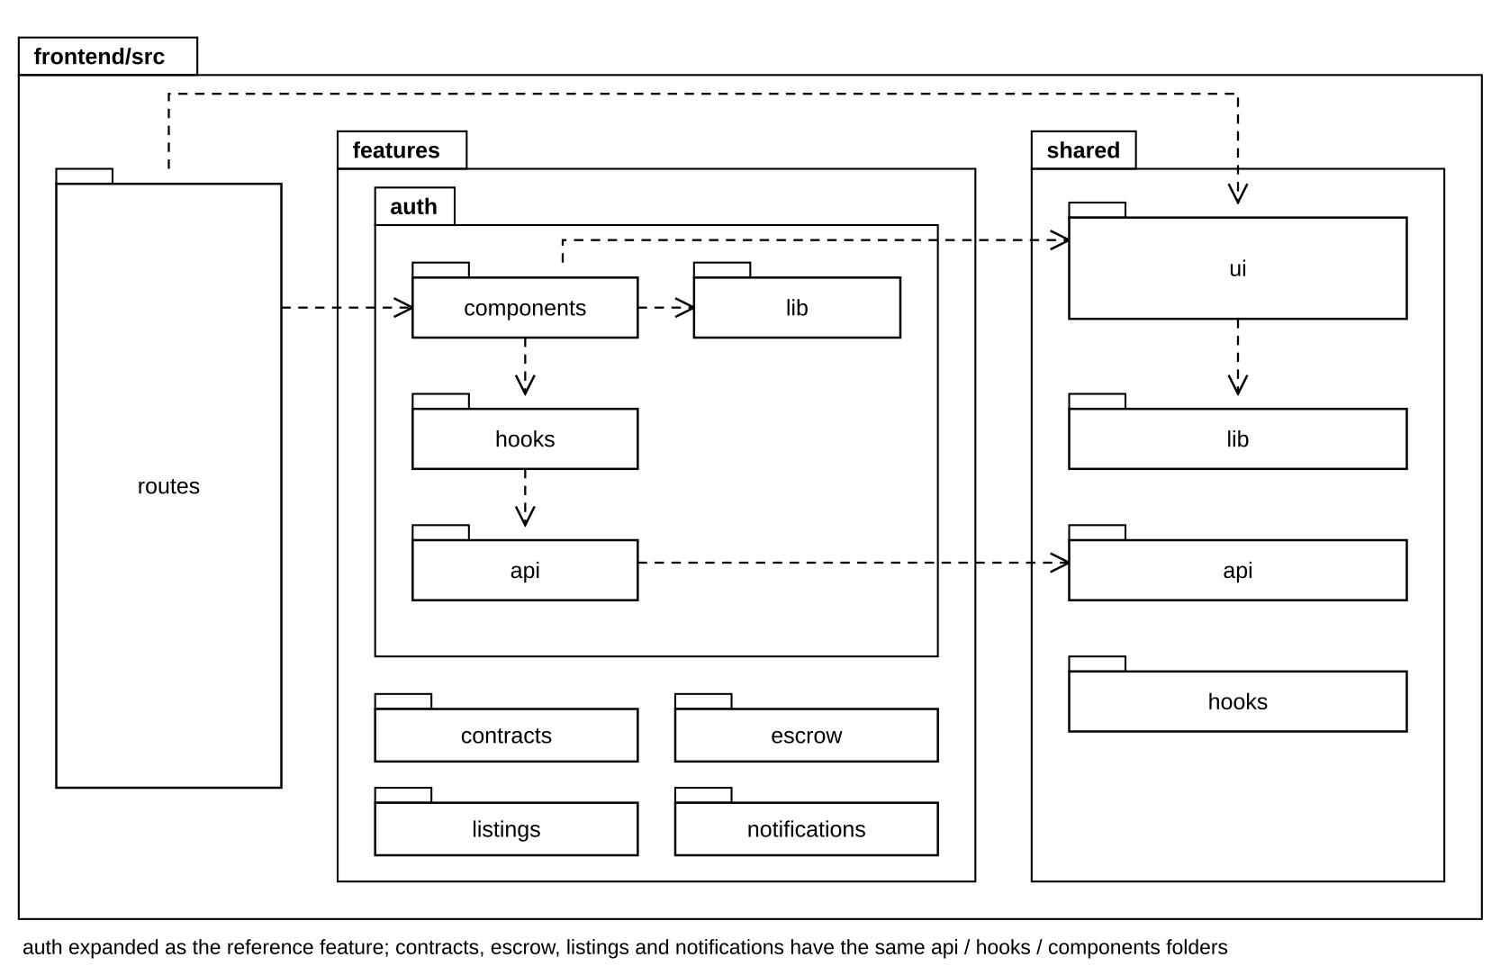
Figure 3. Frontend package diagram (React SPA)
Package descriptions — frontend
No | Package | Description + naming conventions
01 | routes/ | Route-level pages (<name>-page.tsx). Compose feature components, read route params, no direct HTTP.
02 | features/<feature>/api | <feature>-api.ts functions per endpoint, typed request/response DTOs mirroring the OpenAPI schemas; generate an Idempotency-Key per user action.
03 | features/<feature>/hooks | use<Thing>Query / use<Action>Mutation wrappers around TanStack Query with stable query keys and invalidation on success.
04 | features/<feature>/components | Feature UI in PascalCase (SignContractDialog, MilestoneActions, ListingCard). Forms use react-hook-form + zod schemas from lib/.
05 | features/<feature>/lib | Feature-local zod schemas, mappers, formatters (money strings, kg, ICT dates).
06 | shared/ui | Reusable primitives (button, modal, drawer, otp-input, milestone-timeline, deadline-pill, file-upload, toast).
07 | shared/api · hooks · lib | Axios instance and interceptors (token, correlation id, ErrorEnvelope → typed error), generic hooks and utilities. A feature may import shared/ but never another feature’s internals.

3. Database Design
Each service owns one MySQL 8 schema and one DB user; there are no cross-schema foreign keys or joins. Cross-service references are UUIDs (CHAR(36)) copied into snapshots. Common conventions: money is DECIMAL(18,2) rounded HALF_UP only in contract-service; quantities are kilograms (DECIMAL(15,3)); timestamps are stored in UTC (DATETIME(6) or TIMESTAMP(6), as each table states), deadlines are calculated in Asia/Ho_Chi_Minh; every schema contains the shared event_outbox and processed_event tables. Immutability is enforced by DB grants (INSERT/SELECT only on ledger_entry, lock_entry, audit_record, audit_anchor) and idempotency by UNIQUE constraints. Figure 4 shows the target contract_db and Figure 5 the money, trust and evidence stores of the other core services; both show keys and a few key columns only — full column specifications follow in 3.1–3.34. Tables already created by Flyway in the repository are documented from the schema their migrations produce (contract_db: contracts, signing, consent and activation recovery; bank, escrow, reputation, inspection, user, product, pricing, notification); the other tables are the planned Phase 2 design. Figures 4 and 5 draw a planned table with a dashed border, marked «planned»; a line is a foreign key, and an id that points into another service has no line.
Why one database per service and not one shared database. (1) Ownership of money and evidence is enforced by the database, not by discipline: only bank-service's DB user can reach ledger_entry and lock_entry, and it may only INSERT and SELECT them; in a shared database every service holding a connection could update a ledger row, and the rule that bank-service is the only writer of money facts would depend on every developer never writing that query. The same holds for audit_record and the hash chain. (2) No hidden coupling: a service never joins another service's tables; what it needs is copied as a snapshot at the moment it matters (for example the parties, goods and plots in terms_snapshot when the offer is made), so a schema change in user-service or product-service cannot break contract-service, and a signed contract does not change when a profile or listing is edited later. (3) Failure isolation: heavy analytics queries, a notification outage or a long migration in one service cannot lock or slow the tables used by signing and settlement. (4) Independent evolution: each service versions its own Flyway migrations, so team members change their schemas without colliding.
The cost is accepted on purpose: there is no ACID transaction and no JOIN across services. Consistency between services is kept by the transactional outbox and idempotent consumers (processed_event), by saga steps with explicit compensations (for example the activation refund), and by ledger reconciliation before any terminal contract state; reports that need data from several services read the analytics-service read model. For a system that moves deposits and payments, a wrong balance caused by a shared, writable table is a worse risk than this extra complexity.
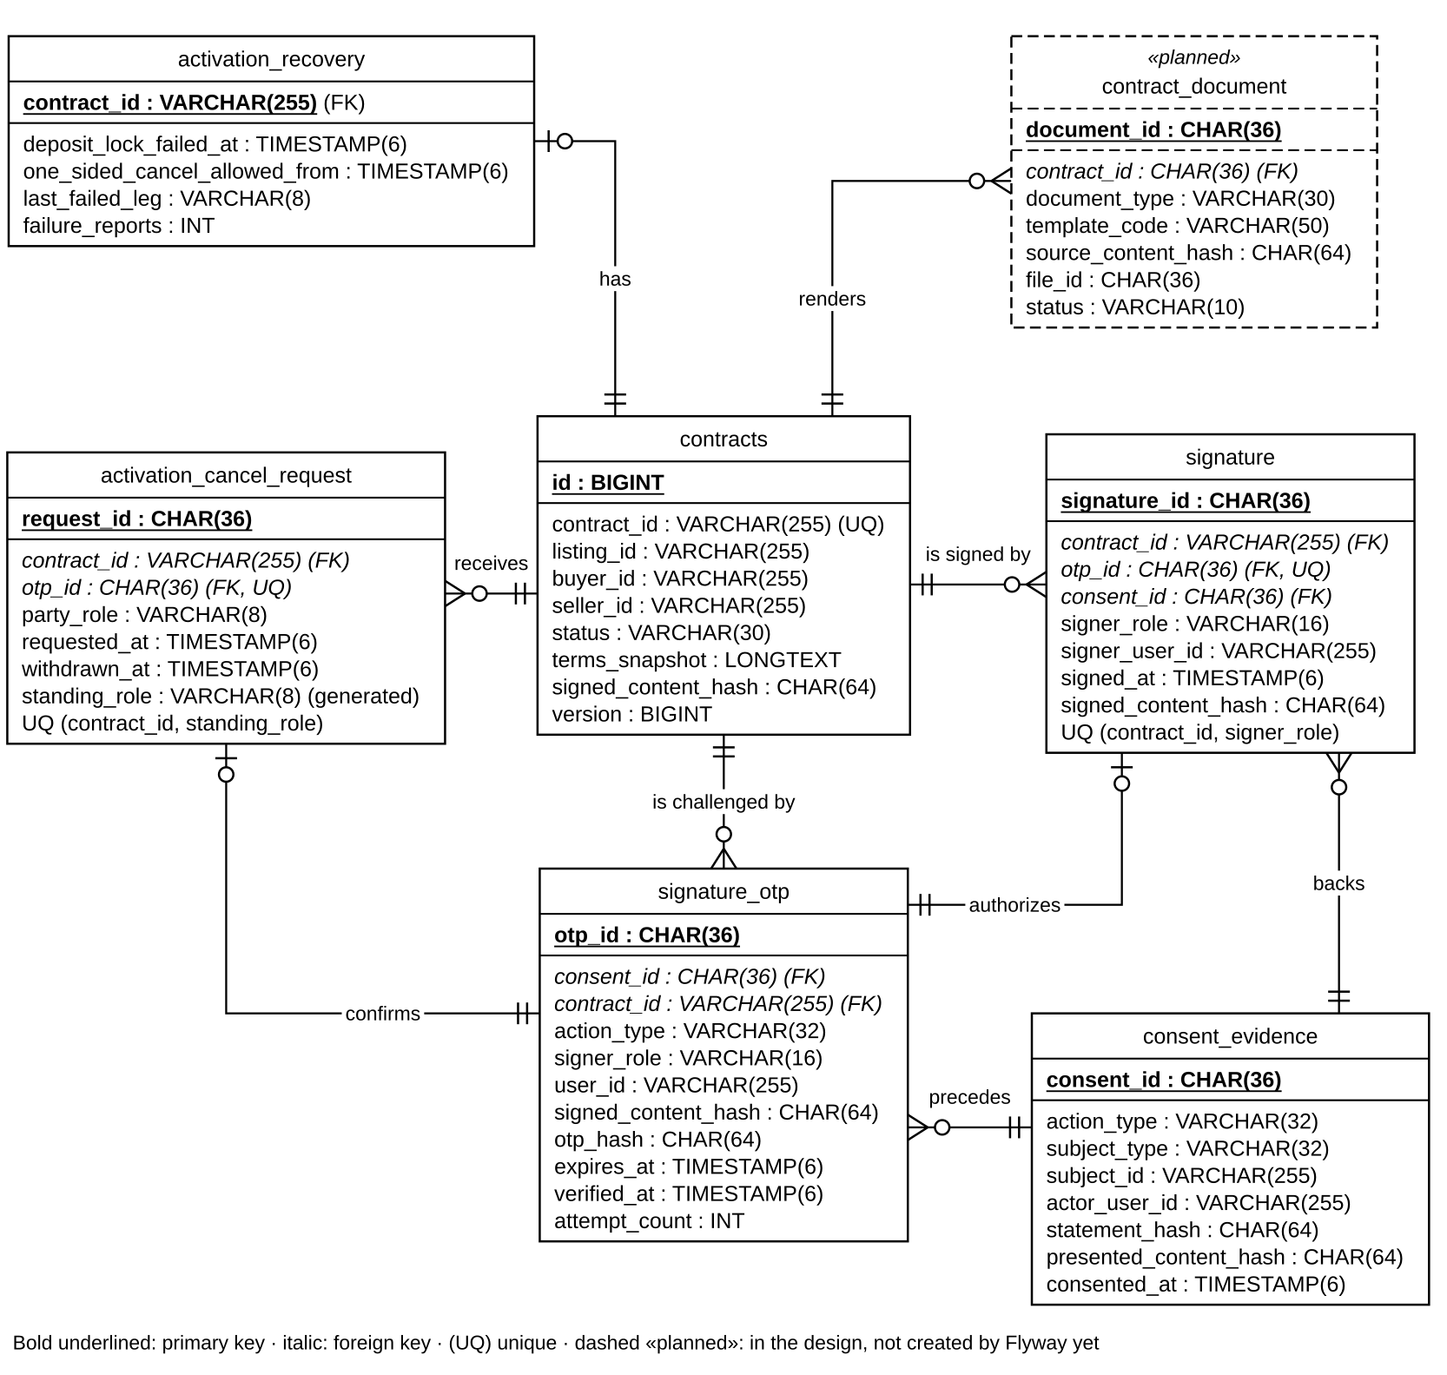
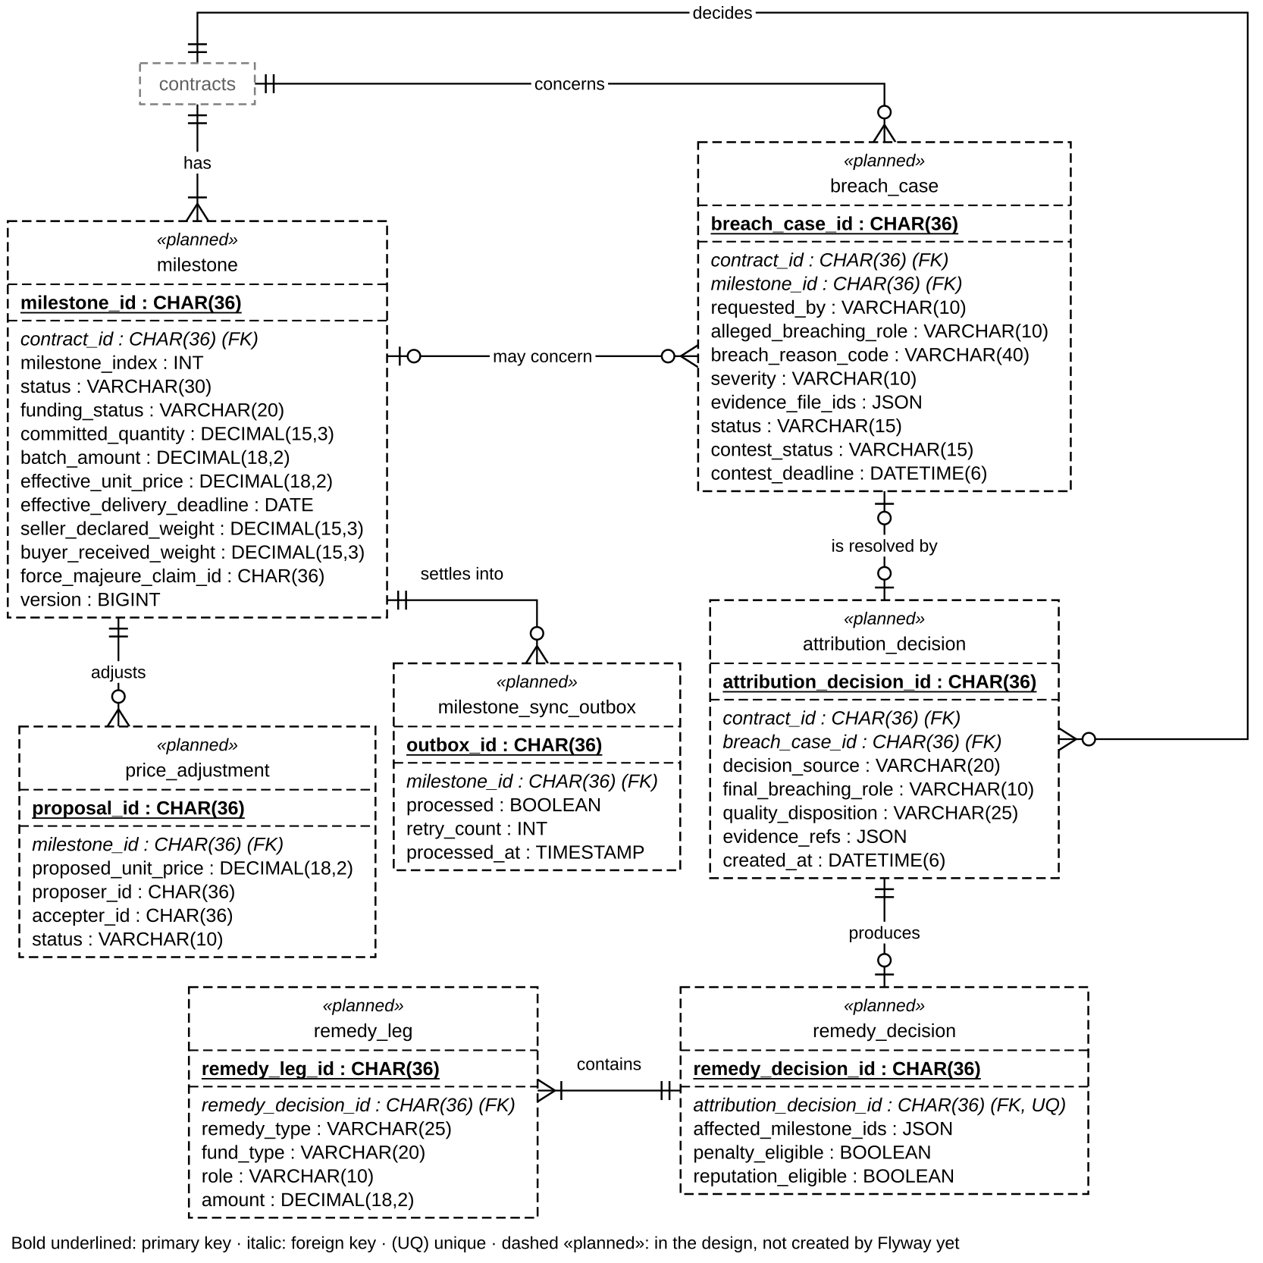
Figure 4. contract_db entity-relationship diagram: (a) contract and signing, (b) milestone, dispute and remedy
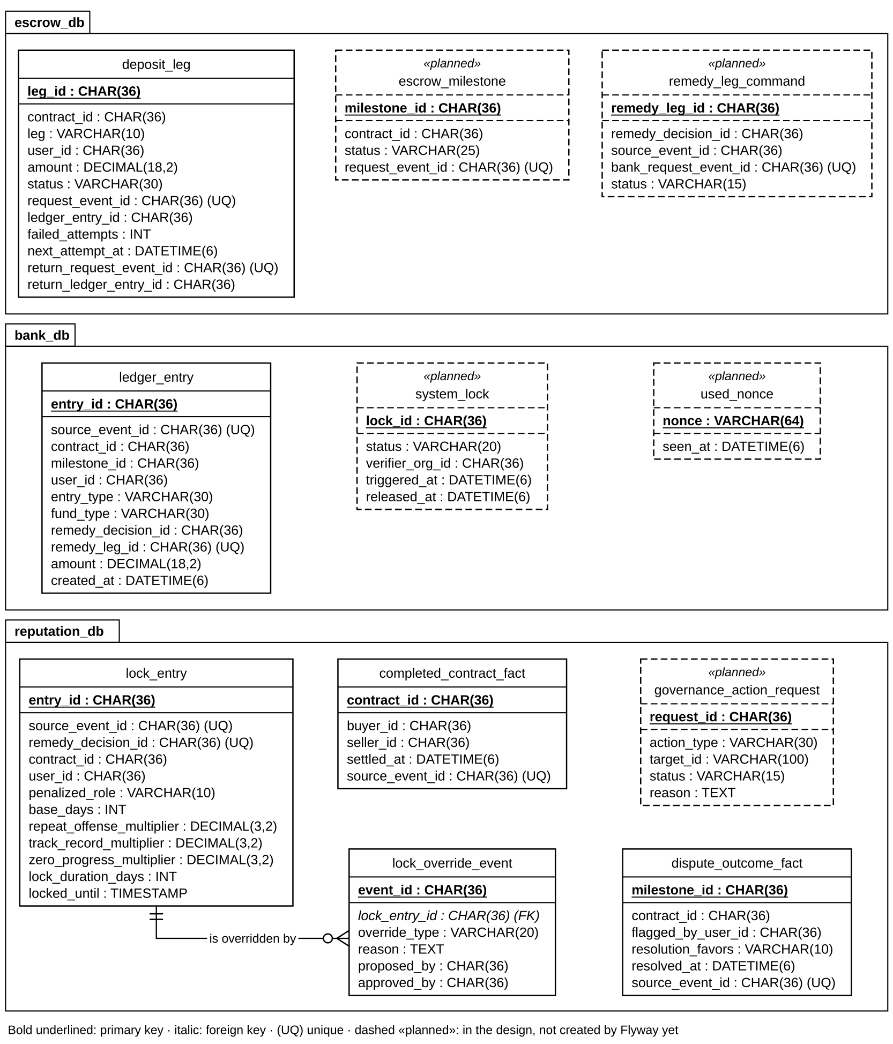
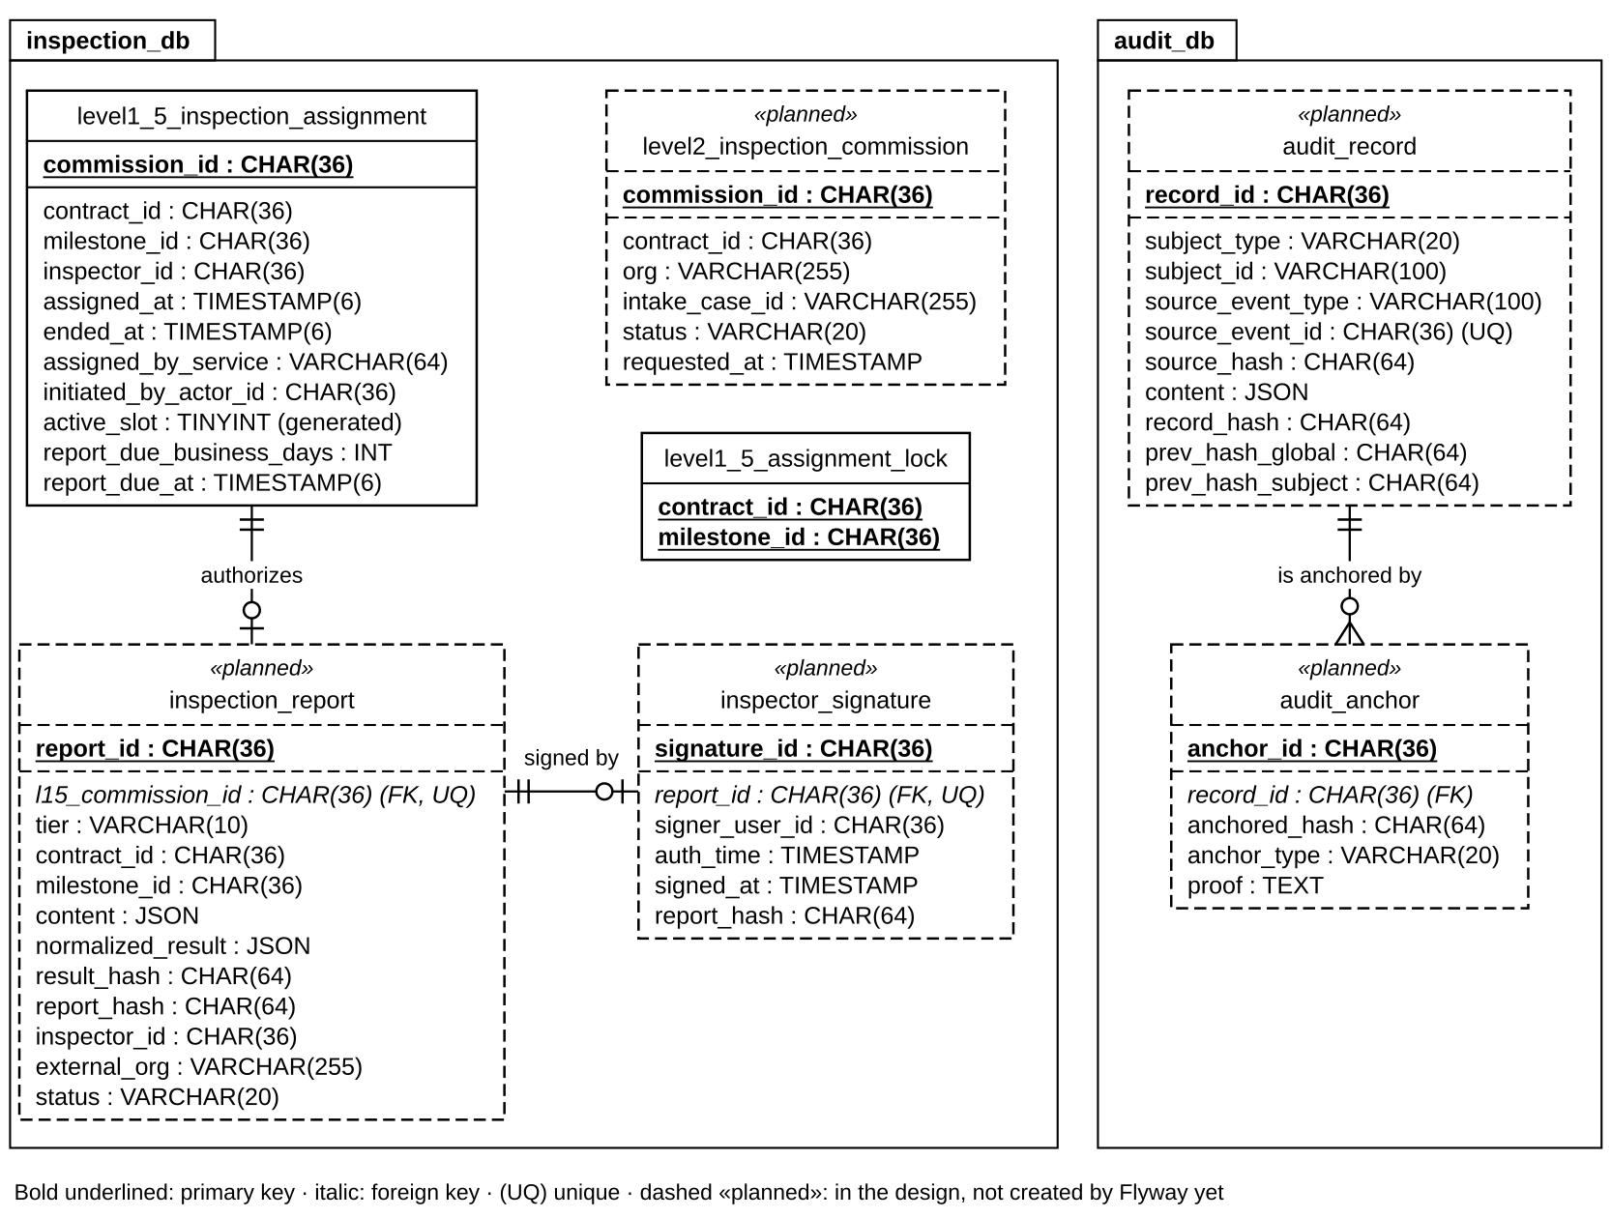
Figure 5. Money, trust and evidence stores: (a) escrow, bank and reputation, (b) inspection and audit
Schema overview
Schema | Owner | Tables
contract_db | contract-service | contracts, signature, signature_otp, consent_evidence, idempotency_record, activation_recovery, activation_cancel_request, event_outbox, processed_event (implemented); milestone, contract_document, breach_case, attribution_decision, remedy_decision, remedy_leg, price_adjustment, milestone_sync_outbox (planned)
escrow_db | escrow-service | deposit_leg (implemented, V9–V11); escrow_milestone, remedy_leg_command (planned; leg → bank request mapping)
bank_db | bank-service | ledger_entry (implemented); system_lock, used_nonce (planned)
inspection_db | inspection-service | level1_5_inspection_assignment, level1_5_assignment_lock (implemented); inspection_report, inspector_signature, level2_inspection_commission (planned)
reputation_db | reputation-service | completed_contract_fact, dispute_outcome_fact, lock_entry, lock_override_event (implemented); governance_action_request, pair_risk_state (planned)
audit_db | audit-service | audit_record, audit_anchor (planned; audit-service not built yet)
user_db | user-service | user_profiles, kyc_read_audit, user_event_idempotency
product_db | product-service | categories, products, listings, listing_reservations, plot_registry_entry, listing_plot
file_db | file-service | file, email_intake_failure (blobs in SeaweedFS)
pricing_db / analytics_db / notification_db | Node services | price_history, price_ingestion_failure · analytics_ingested_event, dim_contract, fact_milestone_performance, fact_contract_termination, fact_contract_settlement, agg_monthly_commodity_stats · notification_logs

3.1 contracts
contract_db · Aggregate root of a forward contract (table contracts). The terms are stored as their exact canonical JSON text with its SHA-256; the Phase 1 columns are kept as a read projection until the Phase 1 cleanup.
Column | Type | Constraints | Notes
id | BIGINT | PK, AUTO_INCREMENT | Technical key
contract_id | VARCHAR(255) | NOT NULL, UNIQUE | UUID, cross-service identity; referenced by signature, signature_otp and the activation tables
listing_id | VARCHAR(255) | NOT NULL | product-service listing (no FK)
buyer_id / seller_id | VARCHAR(255) | NOT NULL, indexed | Keycloak sub of the parties; ownership checks use these
product_name, buyer_org_name, seller_org_name, buyer_email, seller_email | VARCHAR(255) | NOT NULL | Snapshot taken at offer time; the e-mails address the notifications
status | VARCHAR(30) | NOT NULL, indexed | OFFERED, NEGOTIATING, SIGNED, ACTIVE, SETTLED, ACTIVATION_REFUND_PENDING, ACTIVATION_FAILED, WITHDRAWN (ContractStatus; checked in the domain, no CHECK constraint)
terms_snapshot | LONGTEXT utf8mb4_bin | NULL | ContractTermsSnapshot as its exact RFC 8785 text (not the MySQL JSON type, which rewrites the text and would change the hash); NULL only for Phase 1 rows
signed_content_hash | CHAR(64) ascii_bin | NULL, CHECK chk_contracts_terms_hash_pair | SHA-256 of terms_snapshot; both NULL or both set, 64 lowercase hex
quantity, quantity_unit, agreed_price, currency, delivery_deadline, buyer_penalty_rate, seller_deposit_rate, quality_spec, signatories | Phase 1 types | Phase 1 | Read projection of the coffee terms; removed in the Phase 1 cleanup
version | BIGINT | NOT NULL DEFAULT 0 | Optimistic locking
created_at / updated_at | DATETIME | NOT NULL | Set by MySQL
reserved_quantity | DECIMAL(15,3) | planned (#232) | kg reserved on the listing; must equal Σ committedQuantity before SIGNED (F18)

3.2 milestone
contract_db · Separate aggregate per delivery batch (settling batch 3 never locks batches 1–2).
Column | Type | Constraints | Notes
milestone_id | CHAR(36) | PK
contract_id | CHAR(36) | FK → contract, NOT NULL
milestone_index | INT | NOT NULL, UQ(contract_id, milestone_index) | 1..100
status | VARCHAR(30) | NOT NULL | CREATED, IN_PROGRESS, SELLER_WEIGHED, BUYER_RECEIVED, AWAITING_SELLER_RESPONSE, CONTESTED, FORCE_MAJEURE_PENDING_REVIEW, SETTLED
funding_status | VARCHAR(20) | NOT NULL | FUNDING_PENDING, LOCKED, FUNDING_FAILED
committed_quantity | DECIMAL(15,3) | NOT NULL, > 0 | ≤ 1,000,000 kg
batch_amount | DECIMAL(18,2) | NOT NULL | Amount locked for this batch
effective_unit_price | DECIMAL(18,2) | NOT NULL | Agreed price or accepted in-band adjustment
expected_delivery_date / effective_delivery_deadline | DATE | NOT NULL | Deadline = expected + funding delay + grace days (ICT business days)
seller_declared_weight / buyer_received_weight | DECIMAL(15,3) | NULL | Delivered quantity > 0
seller_/buyer_evidence_file_id | CHAR(36) | NULL | file-service READY files
force_majeure_claim_id | CHAR(36) | NULL
version | BIGINT | NOT NULL | Optimistic locking

3.3 signature
contract_db · One row per signing party; two rows with the same hash make the contract SIGNED. The table is the only source of who signed.
Column | Type | Constraints | Notes
signature_id | CHAR(36) | PK
contract_id | VARCHAR(255) | NOT NULL, FK → contracts(contract_id)
signer_role | VARCHAR(16) | NOT NULL, CHECK BUYER | SELLER, UQ(contract_id, signer_role) | Each party signs exactly once
signer_user_id | VARCHAR(255) | NOT NULL | JWT sub
otp_id | CHAR(36) | NOT NULL, UNIQUE, FK → signature_otp | The challenge that was answered
consent_id | CHAR(36) | NOT NULL, FK → consent_evidence | The checkbox consent behind it
auth_time | TIMESTAMP(6) | NOT NULL | Login time of the session that signed (step-up, ≤ 300 s)
signed_at | TIMESTAMP(6) | NOT NULL | Server time of the OTP verification
signed_content_hash | CHAR(64) ascii_bin | NOT NULL, CHECK 64 hex | Must equal the other party's hash; append-only (triggers refuse UPDATE and DELETE)
ip_address | VARCHAR(45) | NULL | Supporting evidence only

3.4 signature_otp
contract_db · OTP challenge bound to (signer, contract, terms hash). Retention 90 days after expiry.
Column | Type | Constraints | Notes
otp_id | CHAR(36) | PK | Returned to the client; verification is by otp_id, never "latest OTP"
consent_id | CHAR(36) | NOT NULL, FK → consent_evidence | Consent recorded with the challenge
action_type | VARCHAR(32) | NOT NULL DEFAULT SIGN_CONTRACT, CHECK | SIGN_CONTRACT or CANCEL_ACTIVATION (D42): a code only confirms the action it was issued for
contract_id / signer_role / user_id | VARCHAR(255) / VARCHAR(16) / VARCHAR(255) | NOT NULL, FK → contracts, CHECK BUYER | SELLER | Binding tuple; indexed with signed_content_hash
auth_time | TIMESTAMP(6) | NOT NULL | Carried from initiate to verify
signed_content_hash | CHAR(64) ascii_bin | NOT NULL | Terms hash at issue time; a mismatch kills the code
otp_hash | CHAR(64) ascii_bin | NOT NULL | HMAC-SHA256(code, OTP_PEPPER), never the plain code
sent_at / expires_at | TIMESTAMP(6) | NOT NULL | expires_at = sent_at + 300 s; a resend or a withdrawn offer sets earlier challenges' expires_at = now
verified_at | TIMESTAMP(6) | NULL | Set once by the right code
attempt_count | INT | NOT NULL DEFAULT 0, CHECK ≥ 0 | Refused from 5 wrong codes

3.5 consent_evidence
contract_db · Append-only proof that an actor confirmed a specific statement for specific content.
Column | Type | Constraints | Notes
consent_id | CHAR(36) | PK
action_type | VARCHAR(32) | NOT NULL | SIGN_CONTRACT, CANCEL_ACTIVATION (other actions planned)
subject_type / subject_id | VARCHAR(32) / VARCHAR(255) | NOT NULL | CONTRACT and its contract_id
actor_user_id / actor_role | VARCHAR(255) / VARCHAR(16) | NOT NULL
statement_code / statement_version / statement_hash | VARCHAR(64) / VARCHAR(16) / CHAR(64) | NOT NULL, CHECK hash 64 hex | Server-resolved; SHA-256 of the exact checkbox text
presented_content_hash | CHAR(64) | NOT NULL, CHECK 64 hex | Must equal the current terms hash
consented_at | TIMESTAMP(6) | NOT NULL | Append-only: triggers refuse UPDATE and DELETE
correlation_id | VARCHAR(64) | NULL | The request's Idempotency-Key

3.6 contract_document
contract_db · Immutable generated representations (PDF stored in file-service).
Column | Type | Constraints | Notes
document_id | CHAR(36) | PK | Idempotency key of the render job
contract_id | CHAR(36) | FK → contract
document_type | VARCHAR(30) | NOT NULL | DRAFT_PREVIEW, PARTIALLY_SIGNED, FINAL_SIGNED_CONTRACT, ACTIVATION_CONFIRMATION, DELIVERY_RECEIPT, INSPECTION_RECORD
template_code / template_version | VARCHAR(50) / VARCHAR(20) | NOT NULL | VN_COFFEE_B2B for the final contract
source_content_hash | CHAR(64) | NOT NULL | Hash of the legal content (= signed_content_hash)
document_file_hash | CHAR(64) | NULL | SHA-256 of PDF bytes, set when READY
file_id | CHAR(36) | NULL | file-service id
status | VARCHAR(10) | NOT NULL | PENDING → READY | FAILED; READY rows are never updated
generated_at / failure_reason | DATETIME(6) / TEXT | NULL

3.7 breach_case
contract_db · An allegation; it never moves money or reputation until RESOLVED.
Column | Type | Constraints | Notes
breach_case_id | CHAR(36) | PK
contract_id | CHAR(36) | FK → contract
milestone_id | CHAR(36) | FK → milestone, NULL | NULL for contract-level breach
requested_by | VARCHAR(10) | NOT NULL | BUYER | SELLER | SYSTEM (intent only)
alleged_breaching_role | VARCHAR(10) | NULL
breach_reason_code | VARCHAR(40) | NOT NULL | e.g. SHORTFALL, QUALITY_BELOW_COMMITTED, FUNDING_FAILURE, WRONGFUL_REJECTION
severity | VARCHAR(10) | NOT NULL | MINOR | MATERIAL
evidence_file_ids | JSON | NOT NULL | READY file ids
status | VARCHAR(15) | NOT NULL | REPORTED → UNDER_REVIEW → RESOLVED
contest_status | VARCHAR(15) | NOT NULL | NOT_APPLICABLE | OPEN | CONTESTED | EXPIRED (GB-50); NOT_APPLICABLE for contract-level cases and decisions without a sanction
contest_deadline | DATETIME(6) | NULL | resolved_at + 2 business days (ICT); NULL when contest_status = NOT_APPLICABLE

3.8 attribution_decision
contract_db · Single convergence point of objective (system) and reviewed attribution.
Column | Type | Constraints | Notes
attribution_decision_id | CHAR(36) | PK
contract_id | CHAR(36) | FK → contract
breach_case_id | CHAR(36) | FK → breach_case, NULL | NULL for system/no-case decisions
decision_source | VARCHAR(20) | NOT NULL | SYSTEM, ARBITRATOR, INSPECTOR_L1_5, INSPECTOR_L2, MUTUAL
final_breaching_role | VARCHAR(10) | NULL | NULL = no-fault ⇒ no penalty, no reputation effect
breach_reason_code | VARCHAR(40) | NULL
quality_disposition | VARCHAR(25) | NULL | CONFORMING, PARTIALLY_CONFORMING, NON_CONFORMING (quality path only)
evidence_refs | JSON | NOT NULL | File ids or timeout metadata
created_at | DATETIME(6) | NOT NULL

3.9 remedy_decision and remedy_leg
contract_db · The canonical money/reputation consequence published as remedy.finalized.
Column | Type | Constraints | Notes
remedy_decision.remedy_decision_id | CHAR(36) | PK | Groups legs; not a ledger dedup key
remedy_decision.attribution_decision_id | CHAR(36) | FK, UNIQUE | One remedy per decision
remedy_decision.affected_milestone_ids | JSON | NOT NULL | [] for contract-level deposit return
remedy_decision.penalty_eligible / reputation_eligible | BOOLEAN | NOT NULL | Both false when final role is NULL
remedy_leg.remedy_leg_id | CHAR(36) | PK | Ledger dedup key (UNIQUE in bank_db)
remedy_leg.remedy_decision_id | CHAR(36) | FK → remedy_decision
remedy_leg.remedy_type | VARCHAR(25) | NOT NULL | PAYMENT_SETTLEMENT, PAYMENT_REFUND, DEPOSIT_FORFEITURE, CONTRACTUAL_PENALTY, DAMAGES_COMPENSATION
remedy_leg.fund_type / role | VARCHAR(20) / VARCHAR(10) | NOT NULL | BUYER_DEPOSIT | SELLER_DEPOSIT | MILESTONE_PAYMENT; BUYER | SELLER
remedy_leg.amount | DECIMAL(18,2) | NOT NULL, > 0 | Zero legs are omitted

3.10 price_adjustment
contract_db · In-band milestone price change accepted by both parties before funding (design).
Column | Type | Constraints | Notes
proposal_id | CHAR(36) | PK
milestone_id / contract_id | CHAR(36) | FK → milestone
proposed_unit_price | DECIMAL(18,2) | NOT NULL | Must lie inside the signed priceBand
proposer_id / accepter_id | CHAR(36) | NOT NULL / NULL | Self-accept rejected
status | VARCHAR(10) | NOT NULL | PENDING → ACCEPTED; max 1 accepted per milestone
proposed_at / accepted_at | DATETIME(6) |  | Only before the funding request cut-off

3.11 milestone_sync_outbox
contract_db · Local outbox that triggers the completion check after a milestone settles (design).
Column | Type | Constraints | Notes
outbox_id | CHAR(36) | PK
milestone_id / contract_id | CHAR(36) | NOT NULL
processed | BOOLEAN | DEFAULT FALSE | Inserted in the same transaction as Milestone.settle()
retry_count / last_attempt_at | INT / TIMESTAMP | DEFAULT 0 | At-least-once polling
created_at / processed_at | TIMESTAMP

3.12 deposit_leg
escrow_db · (implemented, V9–V11) One activation deposit leg per party per contract, with the bank result of its lock and, when the parties cancel after a failed lock (D42), of its return.
Column | Type | Constraints | Notes
leg_id | CHAR(36) ascii_bin | PK
contract_id | CHAR(36) | NOT NULL, UQ(contract_id, leg) | Redelivered contract.signed adds no leg
leg | VARCHAR(10) | CHECK IN (BUYER, SELLER)
user_id | CHAR(36) | NOT NULL
amount | DECIMAL(18,2) | CHECK > 0 | Pre-computed by contract-service
status | VARCHAR(30) | NOT NULL, CHECK IN (…) | REQUESTED → LOCKED / FAILED; cancel after a failed lock: CANCEL_PENDING, CANCELLED, RETURN_REQUESTED, RETURN_FAILED, RETURNED
request_event_id | CHAR(36) | UNIQUE | eventId of the emitted bank.lock_requested (= payload.sourceEventId)
ledger_entry_id | CHAR(36) | NULL; CHECK set exactly while the money is locked | bank ledger row of the lock (LOCKED and the return states)
failed_attempts | INT | NOT NULL DEFAULT 0, CHECK ≥ 0 | bank.lock_failed results; drives the retry backoff
next_attempt_at / last_failure_reason | DATETIME(6) / VARCHAR(500) | NULL | when the same request_event_id is resent; NULL once the retries are used up
return_request_event_id | CHAR(36) | UNIQUE, NULL; CHECK set in the return states | eventId of bank.refund_requested / bank.release_requested; a retry resends the same id
return_ledger_entry_id | CHAR(36) | NULL; CHECK set exactly when RETURNED | bank ledger row of the return
created_at / updated_at | DATETIME(6) | CHECK updated_at ≥ created_at

3.13 escrow_milestone and remedy_leg_command
escrow_db · Projections only — amounts stay authoritative in bank_db (design).
Column | Type | Constraints | Notes
escrow_milestone.milestone_id | CHAR(36) | PK | Mirror of the contract milestone
escrow_milestone.contract_id | CHAR(36) | NOT NULL
escrow_milestone.status | VARCHAR(25) | NOT NULL | LOCKED, PROVISIONALLY_RELEASED, RELEASED, REFUNDED, PENALIZED
escrow_milestone.request_event_id | CHAR(36) | UNIQUE | Last bank command emitted
remedy_leg_command.remedy_leg_id | CHAR(36) | PK | One bank command per remedy leg
remedy_leg_command.remedy_decision_id / source_event_id | CHAR(36) | NOT NULL | remedy.finalized consumed once
remedy_leg_command.bank_request_event_id | CHAR(36) | UNIQUE | = payload.sourceEventId of the bank command
remedy_leg_command.status | VARCHAR(15) | NOT NULL | REQUESTED → COMPLETED | FAILED

3.14 ledger_entry
bank_db · (implemented, V1) The only authoritative record of money. Runtime user has INSERT/SELECT only; balances are derived.
Column | Type | Constraints | Notes
entry_id | CHAR(36) | PK
source_event_id | CHAR(36) | UNIQUE | Request envelope eventId — duplicate command = no-op
contract_id / milestone_id | CHAR(36) | NOT NULL / NULL | CHECK milestone_id NOT NULL ⇔ fund_type = MILESTONE_PAYMENT
user_id | CHAR(36) | NOT NULL
entry_type | VARCHAR(30) | CHECK enum | LOCK_BUYER_DEPOSIT, LOCK_SELLER_DEPOSIT, LOCK_MILESTONE, RELEASE_TO_SELLER, REFUND_TO_BUYER, DEPOSIT_FORFEITURE, CONTRACTUAL_PENALTY, DAMAGES_COMPENSATION
fund_type | VARCHAR(30) | CHECK enum + entry/fund pairing | BUYER_DEPOSIT, SELLER_DEPOSIT, MILESTONE_PAYMENT
remedy_decision_id / remedy_leg_id | CHAR(36) | NULL; remedy_leg_id UNIQUE | Both NULL or both set; required for forfeiture/penalty/damages, forbidden for locks
amount | DECIMAL(18,2) | CHECK > 0 | Never re-rounded by bank-service
created_at | DATETIME(6) | NOT NULL | Index (contract_id, milestone_id), (user_id)

3.15 system_lock and used_nonce
bank_db · Emergency kill switch controlled by the External Verifier.
Column | Type | Constraints | Notes
system_lock.lock_id | CHAR(36) | PK
system_lock.status | VARCHAR(20) | NOT NULL | ACTIVE | RELEASED; ACTIVE makes every bank.*_requested fail
system_lock.verifier_org_id / reason | CHAR(36) / TEXT | NOT NULL / NULL
system_lock.triggered_at / released_at | DATETIME(6) | NOT NULL / NULL
used_nonce.nonce | VARCHAR(64) | PK | Replay protection → 409 NONCE_REPLAYED
used_nonce.seen_at | DATETIME(6) | NOT NULL

3.16 level1_5_inspection_assignment
inspection_db · (implemented, V1–V2) Authorization record: which inspector may report on which milestone. A second table, level1_5_assignment_lock, serializes the assignments of one milestone.
Column | Type | Constraints | Notes
commission_id | CHAR(36) | PK
contract_id / milestone_id | CHAR(36) | NOT NULL
inspector_id | CHAR(36) | NOT NULL | Chosen uniformly at random among eligible inspectors
assigned_at / ended_at | TIMESTAMP(6) | NOT NULL / NULL; CHECK ended ≥ assigned | ended_at is the only updatable column (NULL → value)
assigned_by_service / initiated_by_actor_id | VARCHAR(64) / CHAR(36) | NOT NULL / NULL | Source metadata, not a selection right
report_due_business_days / report_due_at | INT / TIMESTAMP(6) | CHECK 1..30 | Design addition for reassignment on timeout
active_slot | TINYINT generated | UQ(contract_id, milestone_id, active_slot) | 1 while active, NULL when ended ⇒ at most one active assignment
level1_5_assignment_lock.contract_id + milestone_id | CHAR(36) | PK (contract_id, milestone_id) | Upserted then read FOR UPDATE before an inspector is chosen, so two assignments of one milestone run one after the other; the row exists even when no assignment does

3.17 inspection_report
inspection_db · Hash-committed inspection result.
Column | Type | Constraints | Notes
report_id | CHAR(36) | PK
tier | VARCHAR(10) | CHECK LEVEL_1_5 | LEVEL_2
contract_id / milestone_id | CHAR(36) | Required for LEVEL_1_5
l15_commission_id | CHAR(36) | UNIQUE, composite FK → assignment | Binds report to the assignment that allowed it
content / normalized_result | JSON | NOT NULL / required when CONFIRMED | Raw report vs InspectionSettlementResultV1
result_hash / report_file_hash / report_hash | CHAR(64) | required when CONFIRMED | RFC 8785 hash of result; SHA-256 of file; commitment of identity+file+result+time+actor
inspector_id / external_org | CHAR(36) / VARCHAR(255) | by tier
status / confirmed_at | VARCHAR(20) / TIMESTAMP | NOT NULL | Level 2 adds PENDING_REVIEW → CONFIRMED by operator

3.18 inspector_signature
inspection_db · Level 1.5 inspector sign-off on a report (design).
Column | Type | Constraints | Notes
signature_id | CHAR(36) | PK
report_id | CHAR(36) | UNIQUE, FK → inspection_report | One signature per report
contract_id / signer_user_id | CHAR(36) | NOT NULL | JWT sub of the INSPECTOR
auth_time / signed_at | TIMESTAMP | NOT NULL | Step-up within 1800 s
report_hash | CHAR(64) | NOT NULL | Same role as signedContentHash for buyer/seller
ip_address | VARCHAR(45) | NULL

3.19 level2_inspection_commission
inspection_db · Request to an external Level 2 organization (design).
Column | Type | Constraints | Notes
commission_id | CHAR(36) | PK
contract_id | CHAR(36) | NOT NULL (not unique) | A contract may need several commissions
org | VARCHAR(255) | NOT NULL | Organization fixed in the signed terms
intake_case_id | VARCHAR(255) | NULL | Join key with the incoming report; set after operator confirmation
status | VARCHAR(20) | NOT NULL | REQUESTED → CASE_ID_CONFIRMED
requested_at / case_id_confirmed_at | TIMESTAMP | NOT NULL / NULL

3.20 lock_entry
reputation_db · (implemented, V2) Insert-only negative consequence.
Column | Type | Constraints | Notes
entry_id | CHAR(36) | PK
source_event_id | CHAR(36) | UNIQUE | remedy.finalized eventId
remedy_decision_id | CHAR(36) | UNIQUE | At most one lock per final decision
contract_id / user_id | CHAR(36) | NOT NULL | Index on user_id
penalized_role | VARCHAR(10) | CHECK BUYER | SELLER
base_days | INT | DEFAULT 30
repeat_offense_ / track_record_ / zero_progress_multiplier | DECIMAL(3,2) | NOT NULL | 1–3x / 0.7–1.3x / 1.0–1.5x snapshot
lock_duration_days / locked_until | INT / TIMESTAMP | CHECK > 0 | Snapshot, never recomputed

3.21 completed_contract_fact and dispute_outcome_fact
reputation_db · (implemented, V1) Positive and dispute facts; score is derived at read.
Column | Type | Constraints | Notes
completed_contract_fact.contract_id | CHAR(36) | PK
completed_contract_fact.buyer_id / seller_id | CHAR(36) | NOT NULL, indexed
completed_contract_fact.settled_at | DATETIME(6) | NOT NULL
completed_contract_fact.source_event_id | CHAR(36) | UNIQUE | contract.settled
dispute_outcome_fact.milestone_id | CHAR(36) | PK
dispute_outcome_fact.flagged_by_user_id | CHAR(36) | NOT NULL | Index (flagged_by_user_id, resolution_favors)
dispute_outcome_fact.resolution_favors | VARCHAR(10) | CHECK BUYER | SELLER
dispute_outcome_fact.source_event_id | CHAR(36) | UNIQUE | milestone.dispute_resolved

3.22 lock_override_event and governance tables
reputation_db · Maker-checker overrides and AML pair risk (lock_override_event implemented, V2; others design).
Column | Type | Constraints | Notes
lock_override_event.event_id | CHAR(36) | PK
lock_override_event.lock_entry_id | CHAR(36) | FK → lock_entry
lock_override_event.override_type | VARCHAR(20) | CHECK = UNLOCK_EARLY | Original lock row is never updated
lock_override_event.proposed_by / approved_by | CHAR(36) | CHECK proposed_by <> approved_by | OPERATOR proposes, ARBITRATOR approves
governance_action_request.request_id | CHAR(36) | PK
governance_action_request.action_type / target_id | VARCHAR(30) / VARCHAR(100) | NOT NULL | UNLOCK_EARLY, CLEAR_ELEVATED_RISK
governance_action_request.status / reason | VARCHAR(15) / TEXT | NOT NULL | PROPOSED → APPROVED | REJECTED
pair_risk_state.buyer_id + seller_id | CHAR(36) | PK
pair_risk_state.status / review_due_at | VARCHAR(20) / TIMESTAMP | NOT NULL / NULL | From analytics.structuring_pattern_detected; never holds money

3.23 audit_record and audit_anchor
audit_db · Tamper-evident evidence chain (append-only grants).
Column | Type | Constraints | Notes
audit_record.record_id | CHAR(36) | PK
subject_type / subject_id | VARCHAR(20) / VARCHAR(100) | NOT NULL | CONTRACT | USER_PAIR | SYSTEM
source_type / source_event_type | VARCHAR(50) / VARCHAR(100) | NOT NULL | e.g. CONTRACT_SIGNED, remedy.finalized
source_event_id | CHAR(36) | UNIQUE | Replay creates no second record/anchor
causation_id / correlation_id | CHAR(36) | NULL
source_hash | CHAR(64) | NULL | Hash of the source artefact (signed content, report)
content | JSON | NOT NULL | Minimal, no PII
record_hash / prev_hash_global / prev_hash_subject | CHAR(64) | NOT NULL / NULL / NULL | Dual chain
audit_anchor.anchor_id / record_id | CHAR(36) | PK / FK
audit_anchor.anchored_hash / anchor_type / proof | CHAR(64) / VARCHAR(20) / TEXT | NOT NULL | OTS proof (base64)

3.24 user_profiles
user_db · (implemented, V1–V6) Organization profile and KYC; credentials live in Keycloak.
Column | Type | Constraints | Notes
id | BIGINT | PK AUTO_INCREMENT | Surrogate key
user_id | VARCHAR(255) | UNIQUE | Keycloak sub
organization_name | VARCHAR(255) | NOT NULL | Public
role | ENUM | NOT NULL | SELLER, BUYER, ADMIN, INSPECTOR, OPERATOR, ARBITRATOR
email / phone / address | VARCHAR / VARCHAR / TEXT | email NOT NULL | PII — internal DTO only
verification_status | ENUM | NOT NULL | PENDING, VERIFIED, REJECTED; index (status, created_at) for the KYC queue
authorization_expires_at | DATETIME(6) | NULL | Expiry of representative authority (BLDS Art. 142)
verified_by_actor_id / verified_at / rejection_reason | VARCHAR / DATETIME(6) / TEXT | NULL | KYC decision trail
locked_until | DATETIME(6) | NULL | Projection of reputation locks (+ last_lock_revision in design)
version / created_at / updated_at | BIGINT / DATETIME | NOT NULL | Optimistic locking

3.25 kyc_read_audit
user_db · (implemented, V5) Every staff read of a Restricted KYC record is logged.
Column | Type | Constraints | Notes
id | BIGINT | PK AUTO_INCREMENT
actor_id / actor_role | VARCHAR(255) / VARCHAR(100) | NOT NULL
resource_type / resource_id | VARCHAR(32) / VARCHAR(255) | NOT NULL | Index (resource_id, accessed_at)
case_context | VARCHAR(255) | NULL | Why the record was opened
accessed_at | DATETIME(6) | NOT NULL | Index (actor_id, accessed_at)

3.26 categories, products and listings
product_db · (implemented, V1–V7) Coffee catalogue and seller listings.
Column | Type | Constraints | Notes
categories.category_id | VARCHAR(255) | UNIQUE | normalized_name UNIQUE
categories.status / commodity | VARCHAR(20) | CHECK commodity = COFFEE | Proposed by users, approved by OPERATOR
products.product_id | VARCHAR(255) | UNIQUE
products.name / unit / category_id | VARCHAR | NOT NULL | unit = KG
products.images / certifications | JSON |  | Certifications are seller-declared only
listings.listing_id | VARCHAR(255) | UNIQUE
listings.seller_id / product_id / category_id | VARCHAR(255) | NOT NULL, indexed
listings.quantity / quantity_available / min_order_quantity | DECIMAL(15,3) | CHECK 0 ≤ available ≤ quantity | NULL available = legacy, fail closed
listings.price_floor / currency | DECIMAL(15,2) / VARCHAR(10) | NOT NULL | VND
listings.status / close_reason | VARCHAR(20) / VARCHAR(30) | NOT NULL | AVAILABLE → PARTIALLY_COMMITTED → CLOSED (PAUSED)
listings.quality_type / moisture / foreign_matter / black_broken % | VARCHAR(20) / DECIMAL(5,2) | CHECK all-or-none, 0–100 | ARABICA | ROBUSTA
listings.crop_year / harvest_season / warehouse_location | INT / VARCHAR | NULL | Read-only metadata snapshotted into the contract
listings.updated_at | DATETIME(6) | NOT NULL | Source of the opaque listingVersionToken

3.27 listing_reservations and plot_registry_entry
product_db · (implemented, V4–V6) Inventory reservation and seller-owned plots.
Column | Type | Constraints | Notes
listing_reservations.contract_id | VARCHAR(255) | UNIQUE | Replay of reserve returns the same record
listing_reservations.listing_id | VARCHAR(255) | FK → listings | Index (listing_id, status)
listing_reservations.reserved_quantity | DECIMAL(15,3) | CHECK > 0
listing_reservations.status | VARCHAR(20) | CHECK enum | RESERVED → SIGNED_RELEASABLE → COMMITTED | RELEASED
plot_registry_entry.registry_entry_id | VARCHAR(255) | PK
plot_registry_entry.seller_id + household_label | VARCHAR | UNIQUE
plot_registry_entry.geo_json | GEOMETRY SRID 4326 | SPATIAL INDEX | POINT (manual pin) or POLYGON (KML)
plot_registry_entry.geometry_hash / area_hectares | CHAR(64) / DECIMAL(10,4) | CHECK area > 0 | Snapshotted into the contract
plot_registry_entry.geo_verification_status / geo_risk_level | VARCHAR(20) | CHECK | Risk signal for OPERATOR review, never auto-reject

3.28 listing_plot
product_db · (implemented, V6) Immutable copy of the plots declared for a listing.
Column | Type | Constraints | Notes
listing_id + source_registry_entry_id | VARCHAR(255) | PK; FKs → listings, plot_registry_entry
household_label / geometry_type | VARCHAR | NOT NULL
geo_json | GEOMETRY SRID 4326 | NOT NULL | Copied, so later plot edits do not change the listing
geometry_hash / area_hectares | CHAR(64) / DECIMAL(10,4) | NOT NULL
verification_level / declared_at | VARCHAR(20) / DATETIME(6) | NOT NULL

3.29 file
file_db · Evidence gate: only READY files can be attached.
Column | Type | Constraints | Notes
file_id | CHAR(36) | PK
storage_hash | CHAR(64) | NOT NULL | SHA-256 of stored bytes (verify after restore)
uploaded_by | VARCHAR(255) | NOT NULL | User or service id
ingest_channel | VARCHAR(20) | NOT NULL | DIRECT_UPLOAD | EMAIL_INTAKE | SYSTEM_GENERATED (server-derived)
content_type / file_size | VARCHAR(100) / BIGINT | NOT NULL | 10 MB direct, 20 MB email
status / failure_reason | VARCHAR(20) / TEXT | NOT NULL | PROCESSING → READY | FAILED
attached | BOOLEAN | DEFAULT FALSE | Orphans deleted after 1 week
retention_until / legal_hold | TIMESTAMP / BOOLEAN |  | Legal hold blocks deletion absolutely
deleted_at / deletion_reason | TIMESTAMP / TEXT | CHECK both or none | Tombstone, blob deletion follows

3.30 email_intake_failure
file_db · Failed Level 2 email ingestions waiting for operator review (design).
Column | Type | Constraints | Notes
failure_id | CHAR(36) | PK
file_id | CHAR(36) | NULL, FK → file | NULL when MIME parsing failed before a file row existed
source_mailbox | VARCHAR(255) | NOT NULL
failure_reason | TEXT | NOT NULL
detected_at / reviewed_by_operator | TIMESTAMP / BOOLEAN | NOT NULL

3.31 price_history and notification_logs
pricing_db, notification_db · (implemented)
Column | Type | Constraints | Notes
price_history.id | CHAR(36) | PK | Append-only
price_history.commodity | VARCHAR(20) | CHECK = COFFEE
price_history.item_slug / province_slug | VARCHAR | Index (commodity, province_slug, item_slug, captured_at, ingested_at) | Latest-price lookup
price_history.price / source | DECIMAL(10,2) / VARCHAR(20) | CHECK > 0; VNSAT_SCRAPE | OPERATOR_MANUAL | Manual rows require reference_source, reason, recorded_by
price_history.recorded_by + idempotency_key | VARCHAR | UNIQUE | Manual entry retry safety
notification_logs.notification_id | VARCHAR(36) | UNIQUE
notification_logs.event_id + user_id | VARCHAR | UNIQUE | Dedup per recipient (type added in design)
notification_logs.channel / status / retry_count | VARCHAR / VARCHAR / INT | NOT NULL | EMAIL; PENDING, SENT, FAILED

3.32 price_ingestion_failure
pricing_db · Scraper failures are recorded, never thrown; the old cache is kept (design).
Column | Type | Constraints | Notes
id | CHAR(36) | PK
commodity | VARCHAR(20) | NOT NULL | COFFEE
failure_reason | TEXT | NOT NULL | Parse error, network error, layout change
detected_at | TIMESTAMP | NOT NULL

3.33 analytics read models
analytics_db · (implemented, V1–V4 + design) CQRS projections; non-critical, rebuilt from events.
Column | Type | Constraints | Notes
analytics_ingested_event.event_id | CHAR(36) | PK | Raw envelope store; index (event_type, occurred_at)
analytics_idempotency_log.consumer_name + event_id | VARCHAR(100) + CHAR(36) | PK | Consumer dedup
dim_contract.contract_id | CHAR(36) | PK | commodity, buyer_id, seller_id, total_amount, signed_at
fact_milestone_performance.milestone_id | CHAR(36) | UNIQUE | locked_amount, actual_amount, delta_shortfall_amount, has_force_majeure, resolved_at
fact_contract_termination.contract_id | CHAR(36) | UNIQUE | termination_type, requested_by, final_breaching_role, breach_reason_code — mutual exits never counted as breach
fact_contract_settlement.contract_id | CHAR(36) | UNIQUE | settled_at
pending_force_majeure_flag / milestone_projection_lock | CHAR(36) | PK milestone_id | Out-of-order event helpers
agg_monthly_commodity_stats.month_id + commodity | VARCHAR(7) + VARCHAR(50) | PK (design) | Settled count, mutual/seller/buyer/no-fault exits, breach rates, FM incidents, value settled, escrow efficiency; recomputed monthly

3.34 event_outbox and processed_event
Every schema · (implemented, shared java-eventing V1) Reliable publish and idempotent consume.
Column | Type | Constraints | Notes
event_outbox.id | BIGINT | PK AUTO_INCREMENT | Publish order
event_outbox.event_id | CHAR(36) | UNIQUE | Envelope eventId
event_outbox.event_type / aggregate_id | VARCHAR(100) / VARCHAR(255) | NOT NULL
event_outbox.envelope | JSON | NOT NULL | Full EventEnvelope
event_outbox.status / attempts / last_error | VARCHAR(20) / INT / VARCHAR(1000) | DEFAULT PENDING / 0 | Index (status, id) for the poller
event_outbox.created_at / published_at | DATETIME(3)
processed_event.consumer_name + event_id | VARCHAR(100) + CHAR(36) | PK | Insert before side effect; duplicate key ⇒ skip
processed_event.event_type / processed_at | VARCHAR(100) / DATETIME(3)
user_event_idempotency / analytics_idempotency_log | event_id (+ consumer) | PK | Service-specific variants of processed_event (user-service, analytics-service)

Legacy Phase 1 tables (contracts, escrow_accounts, escrow_transactions, *_domain_events) are retired by additive Flyway migrations and are not part of the target design; historical rows without evidence remain marked legacy/unknown.

II. Detailed Code Design
The three design sets below follow the platform’s golden flow — the end-to-end demo path agreed by the team: sign a contract → lock funds → deliver and settle milestone 1 → dispute milestone 2 → Level 1.5 inspection → settle by the result → reputation and ledger reconcile to the last đồng. These are the features with the most integrations (Keycloak, user-service, notification-service, file-service, RabbitMQ, escrow, bank, inspection, reputation, audit). Class names follow the package conventions of section I.2; use cases are transactional and publish through the outbox.

1. Contract Signing (Consent + Step-up + OTP)
Signing is split into two HTTP calls on ContractSigningController. InitiateSignUseCase refuses a session older than 300 s (auth_time) and an ineligible signer (KYC VERIFIED, authorization not expired, not locked; fail-closed), then in one transaction claims the Idempotency-Key, records the checkbox ConsentEvidence (SigningConsentRecorder) and issues an OtpChallenge bound to (signer, contract, signedContentHash) (OtpChallengeIssuer); the code is e-mailed after commit, and the challenge is expired if the e-mail fails. VerifyOtpAndSignUseCase checks the eligibility of both parties, then in one transaction under the contract row lock matches the code, calls Contract.sign and inserts the Signature; the second signature on the same hash makes the contract SIGNED and writes contract.signed and notification.contract_anchor_requested to the outbox in that transaction. The final signed PDF (ContractDocument, issue #235) is not implemented yet.

1.1 Class Diagram
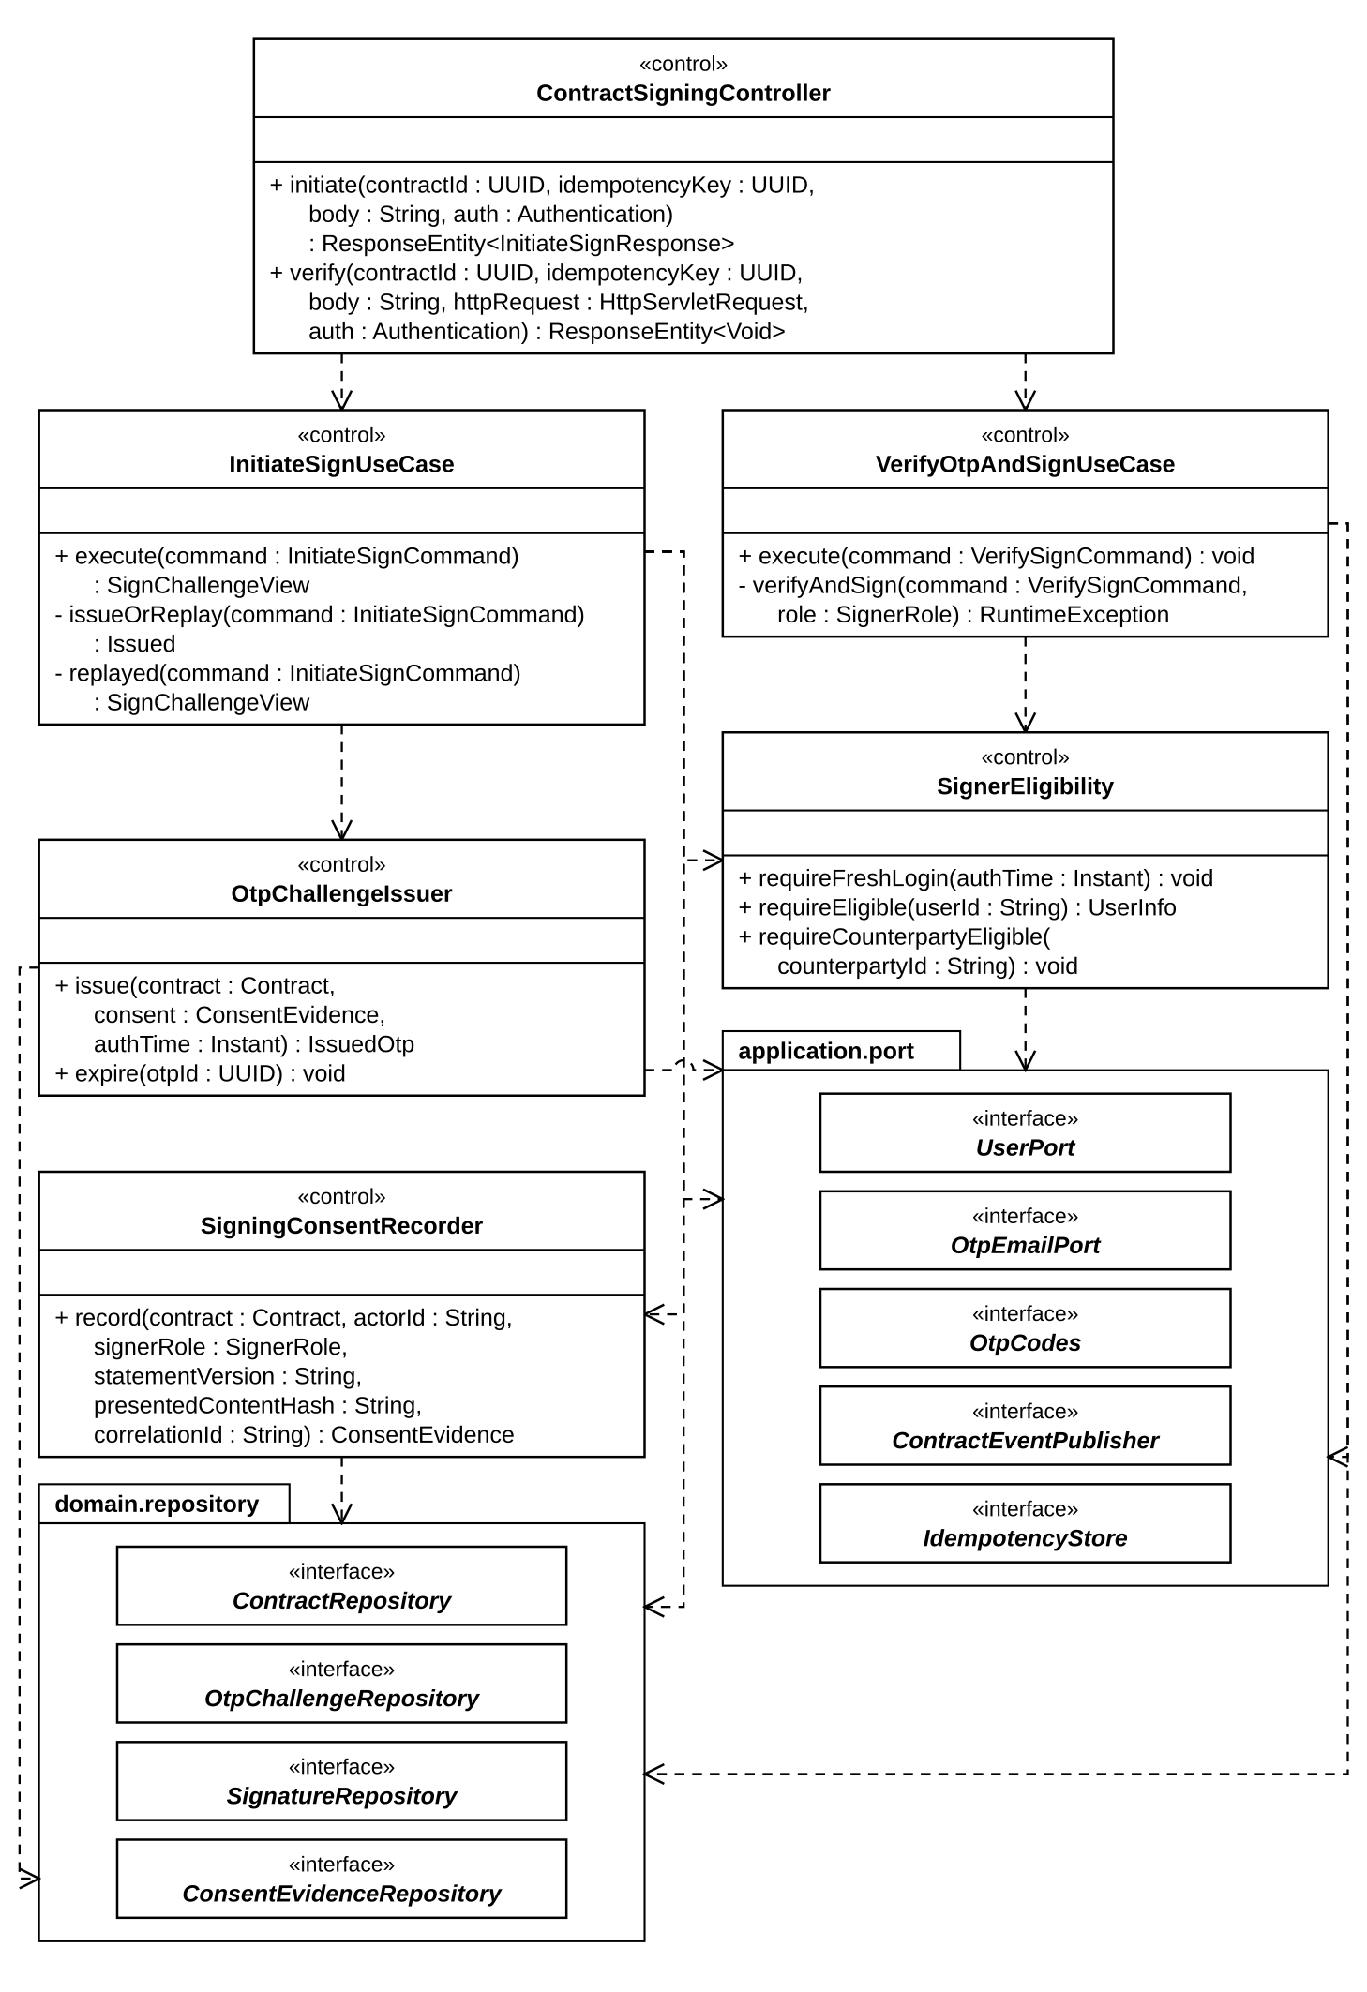
Figure 6a. Class diagram — contract signing, application layer
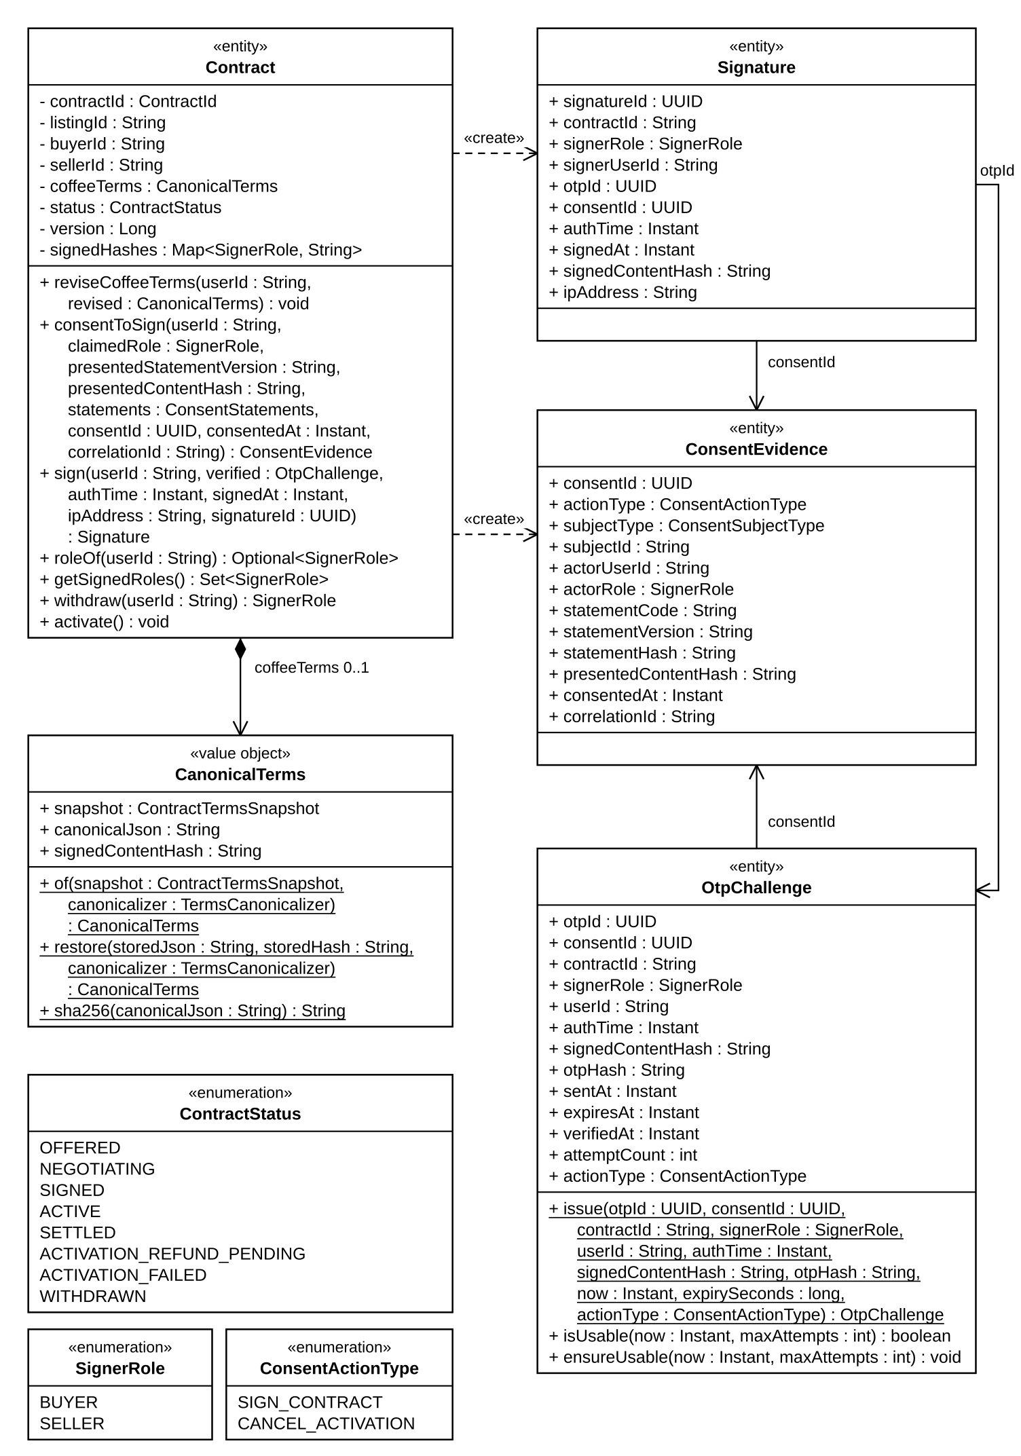
Figure 6b. Class diagram — contract signing, domain model
The diagrams show the classes of the signing path with the names used in the code; supporting classes (adapters, configuration) are listed in the table.
Class | Layer / stereotype | Responsibility
ContractSigningController | infrastructure.web «RestController» | Maps POST /api/v1/contracts/{id}/sign/initiate and /sign/verify for BUYER or SELLER; reads the body strictly; the caller and auth_time come from the authenticated principal set from the gateway headers.
InitiateSignUseCase | application.usecase | requireFreshLogin and requireEligible; in one transaction claims the Idempotency-Key, records ConsentEvidence and issues the OtpChallenge; e-mails the code after commit (challenge expired and 502 if the e-mail fails); a replayed key returns the same challenge while it is usable.
VerifyOtpAndSignUseCase | application.usecase | Checks both parties' eligibility; in one transaction under the contract row lock: idempotency lookup, challenge lock and checks (owner, contract, role, SIGN_CONTRACT, usable), terms unchanged, HMAC match (a wrong code is counted and committed), Contract.sign, Signature insert; on the second signature writes contract.signed and notification.contract_anchor_requested to the outbox.
Contract | domain.model «AggregateRoot» | consentToSign and sign guard the party, the state (OFFERED or NEGOTIATING), one signature per party and the same signedContentHash for both; two signatures make it SIGNED. reviseCoffeeTerms is refused after the first signature; withdraw is allowed until the second.
OtpChallenge / ConsentEvidence / Signature | domain.model (records) | Challenge with HMAC hash, expiry and attempt counter (isUsable, ensureUsable); append-only consent evidence; immutable signature.
CanonicalTerms ← JcsTermsCanonicalizer | domain.model / infrastructure.terms | RFC 8785 canonical JSON of ContractTermsSnapshot (template code, version and hash, coffee quality profile version included) and its SHA-256, the signedContentHash; restore recomputes the hash and refuses a mismatch.
SignerEligibility, UserPort ← UserPortAdapter | application.service / port / Feign adapter | Fresh login (auth_time within contract.signature.auth-max-age-seconds) and eligibility read from user-service: KYC VERIFIED, authorization not expired, not locked; user-service down → 503.
SigningConsentRecorder, OtpChallengeIssuer, OtpCodes ← HmacOtpCodes, OtpEmailPort ← OtpEmailPortAdapter | application.service / port / adapter | Consent from the active statement version. The issuer kills earlier codes of the same signer and terms, enforces a 60 s cooldown and 5 codes per hour, and stores only the HMAC of the 6-digit code (expiry 300 s, 5 attempts); the e-mail goes through notification-service synchronously.
ContractEventPublisher ← OutboxContractEventPublisher, IdempotencyStore ← JdbcIdempotencyStore | port / adapter | Events are written to event_outbox (java-eventing) in the caller's transaction and checked against the frozen schema; Idempotency-Key records are kept per (actor, operation, key) with the request hash.

1.2 Initiate Sign
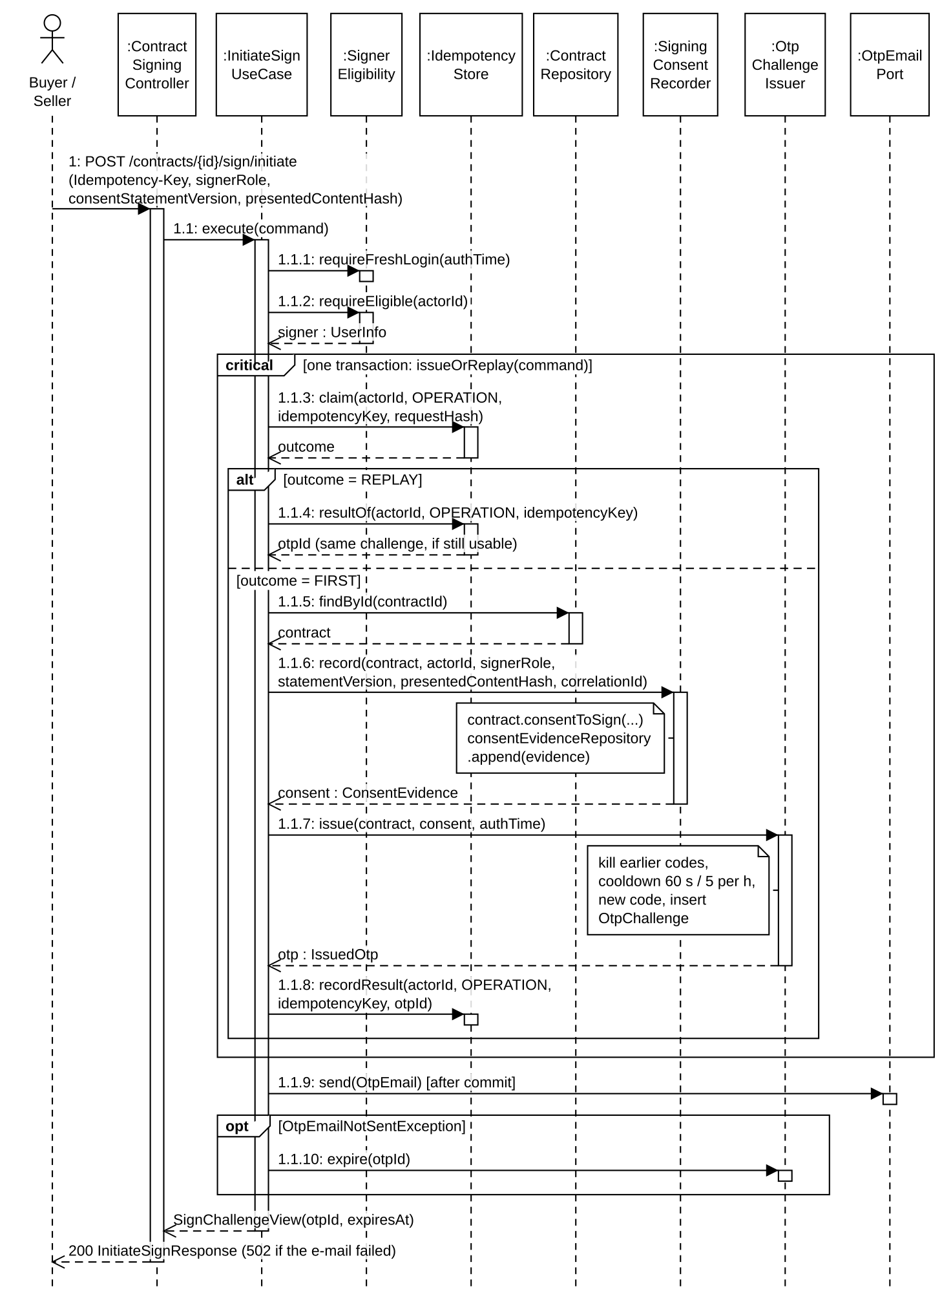
Figure 7. Sequence — initiate sign

1.3 Verify OTP and Sign
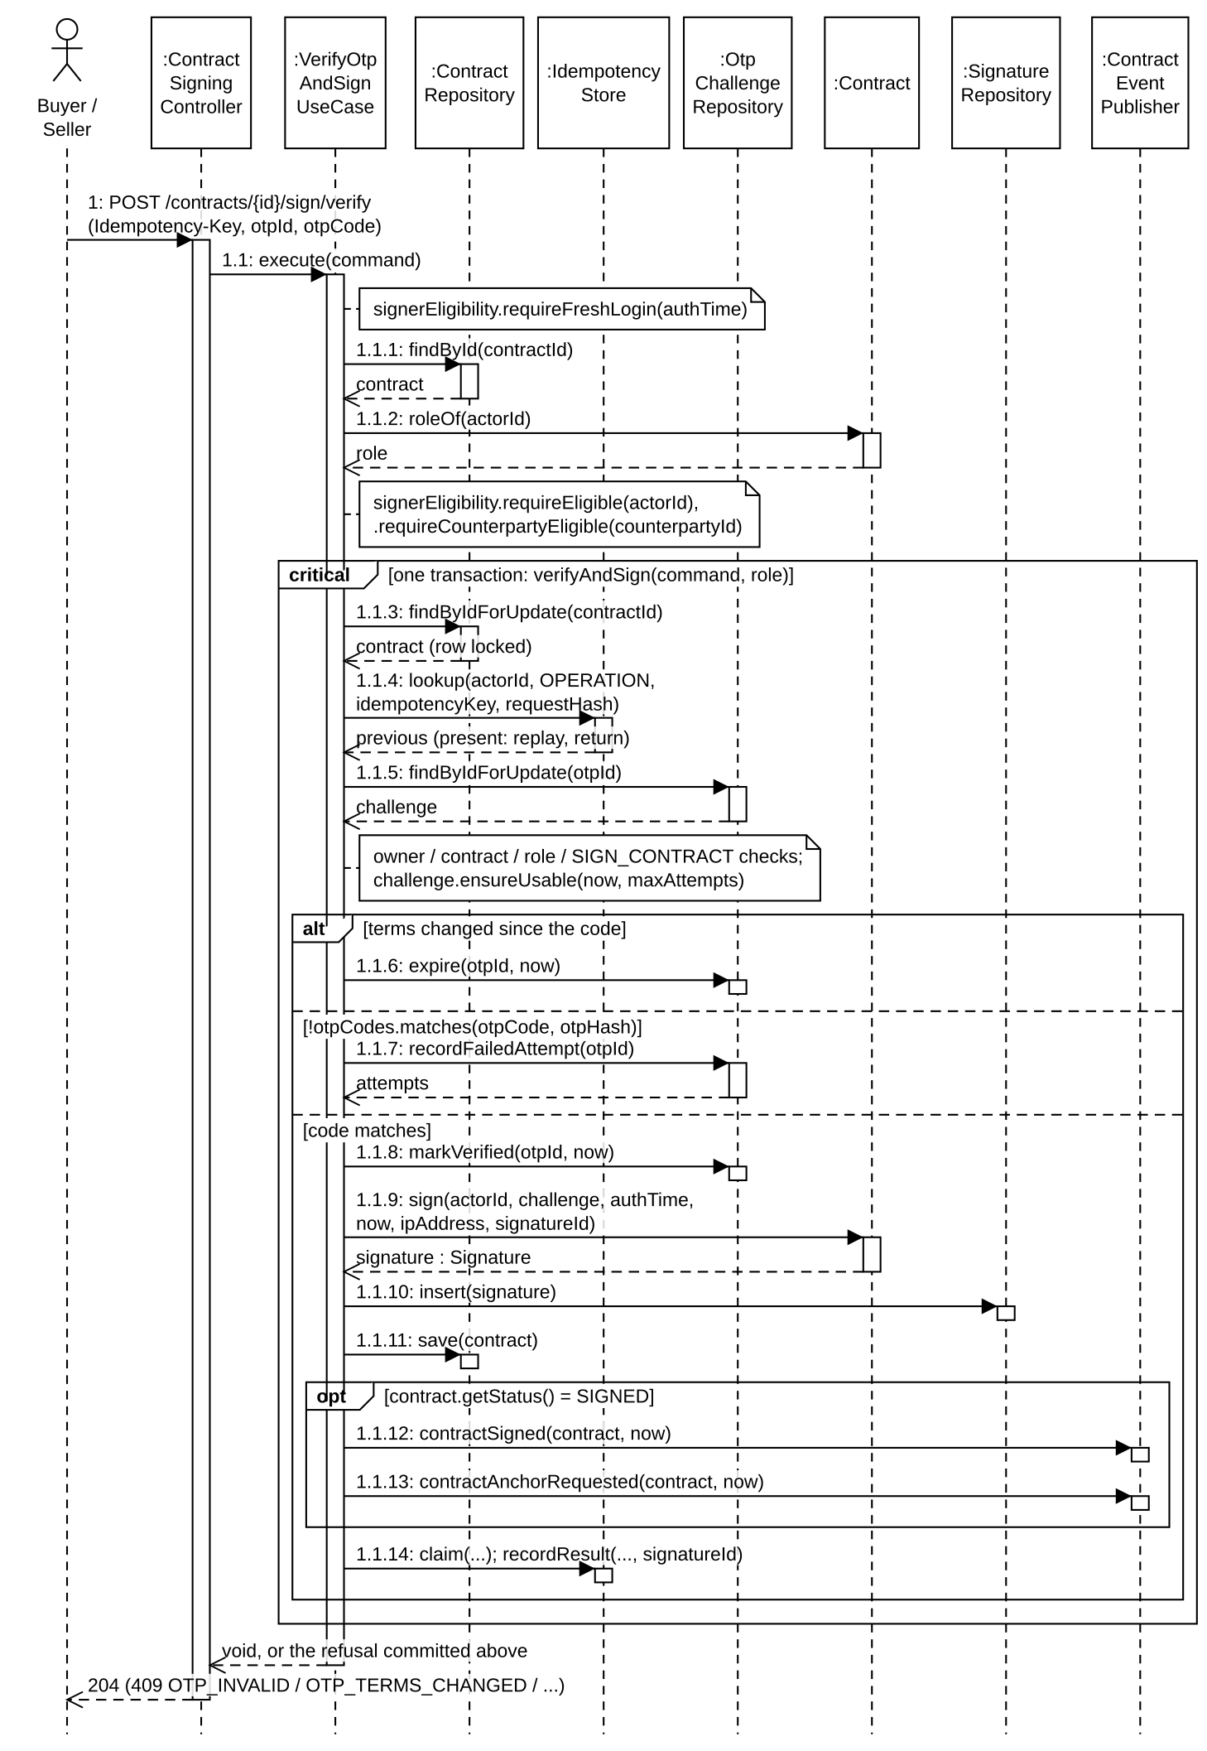
Figure 8. Sequence — verify OTP and sign

2. Milestone Delivery and Settlement
Each milestone is its own aggregate. The seller declares the weight with evidence, the buyer records the received weight and either confirms clean or flags. On clean confirmation (or buyer silence past buyerConfirmWindowDays, only if no inspection is pending) contract-service computes the settlement split once, commits SETTLED and publishes milestone.settled. escrow-service translates it into bank commands; bank-service appends ledger entries keyed by the command eventId. After the last milestone a completion reconciler returns deposits through a no-fault remedy.finalized and only marks the contract SETTLED when the ledger proves zero remaining lock.

2.1 Class Diagram
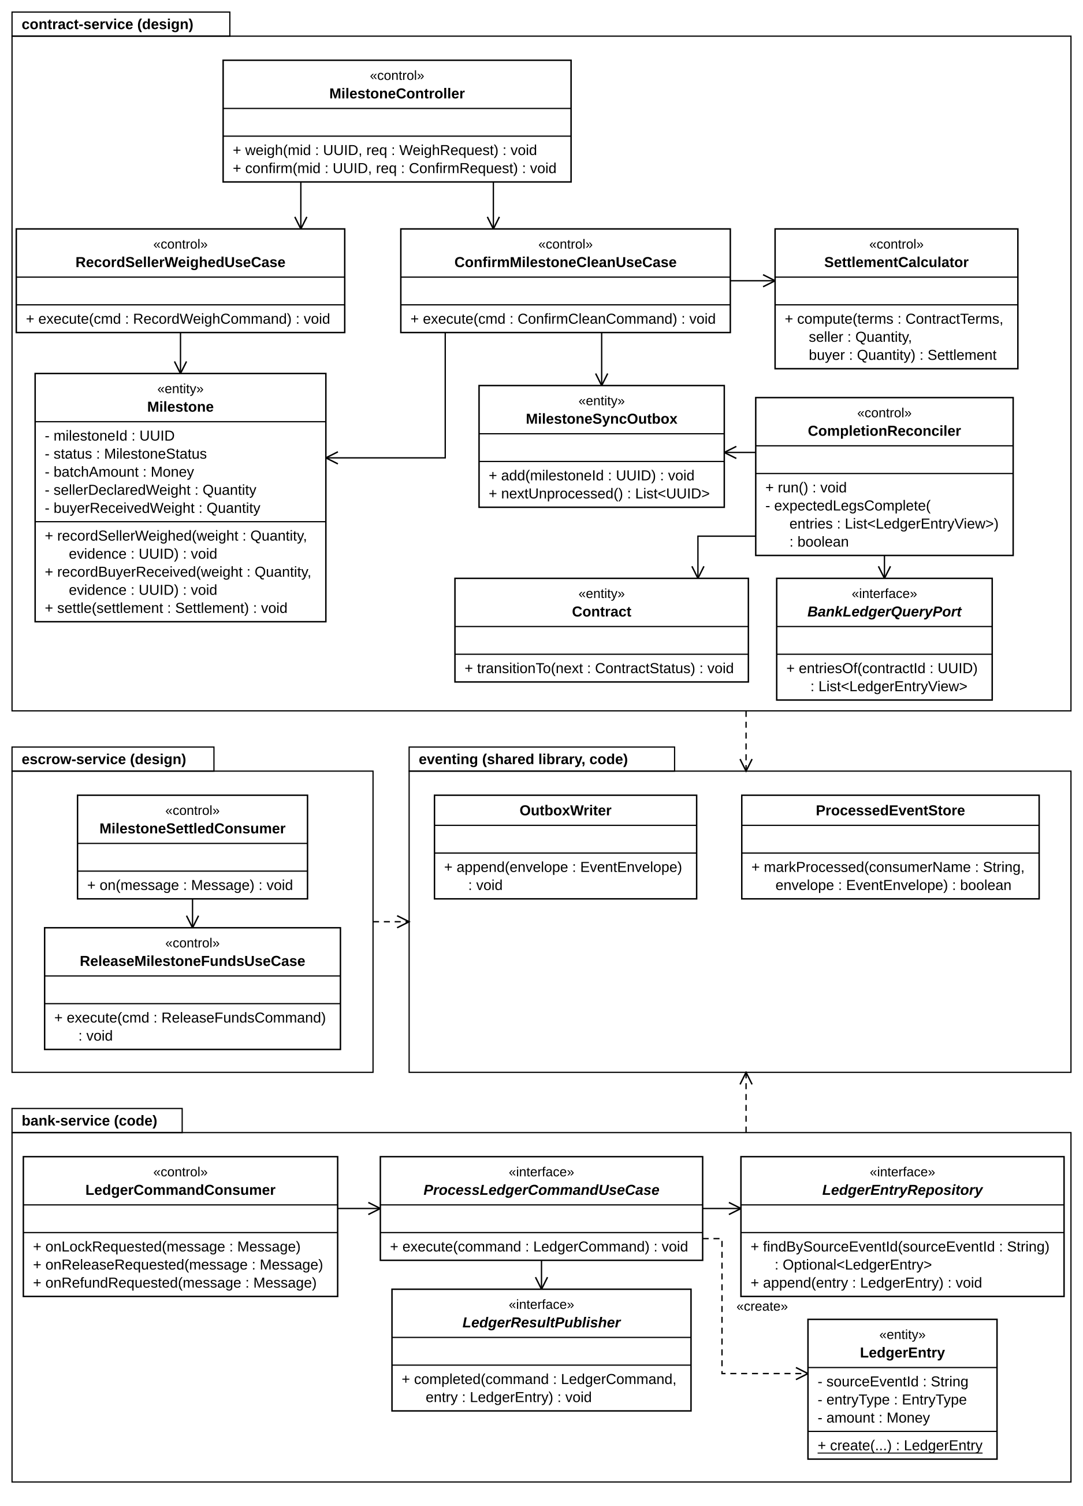
Figure 9. Class diagram — milestone settlement across contract, escrow and bank
The diagram shows the core classes only; supporting classes (schedulers, consumers, adapters) are listed in the table.
Class | Layer / stereotype | Responsibility
MilestoneController | contract · web | /weigh (SELLER) and /confirm (BUYER) with consent input and Idempotency-Key.
RecordSellerWeighedUseCase / ConfirmMilestoneCleanUseCase | contract · usecase | Validate state, ownership, evidence READY and consent; call the aggregate; persist milestone + consent + outbox (+ milestone_sync_outbox) in one transaction.
Milestone + SettlementCalculator | contract · domain | State machine and the only place money is calculated/rounded (Delta 1 quantity, Delta 2 pro-rata, DECIMAL(18,2) HALF_UP, conservation release + refund = locked).
AutoConfirmMilestoneJob | contract · scheduler | Applies the silent-buyer rule only while status is still BUYER_RECEIVED and no inspection is pending.
CompletionReconciler | contract · scheduler | Reads milestone_sync_outbox; when all milestones are settled creates the no-fault deposit-return remedy, then queries the bank ledger and commits SETTLED only when all expected legs exist and remaining lock is 0.
MilestoneSettledConsumer / ReleaseMilestoneFundsUseCase | escrow | Dedup by processed_event; emit one bank command per non-zero recipient leg; update escrow projection.
LedgerCommandConsumer / ProcessLedgerCommandUseCase | bank | Insert ledger_entry with source_event_id = command eventId (UNIQUE); a repeated command writes nothing and re-sends the result of the entry already recorded; publish bank.*_completed / _failed through LedgerResultPublisher (outbox). Planned: reject while system_lock is ACTIVE (UC52).
ProcessedEventStore / OutboxWriter | shared eventing | Consumer idempotency and atomic event publication.

2.2 Weigh and Confirm Clean
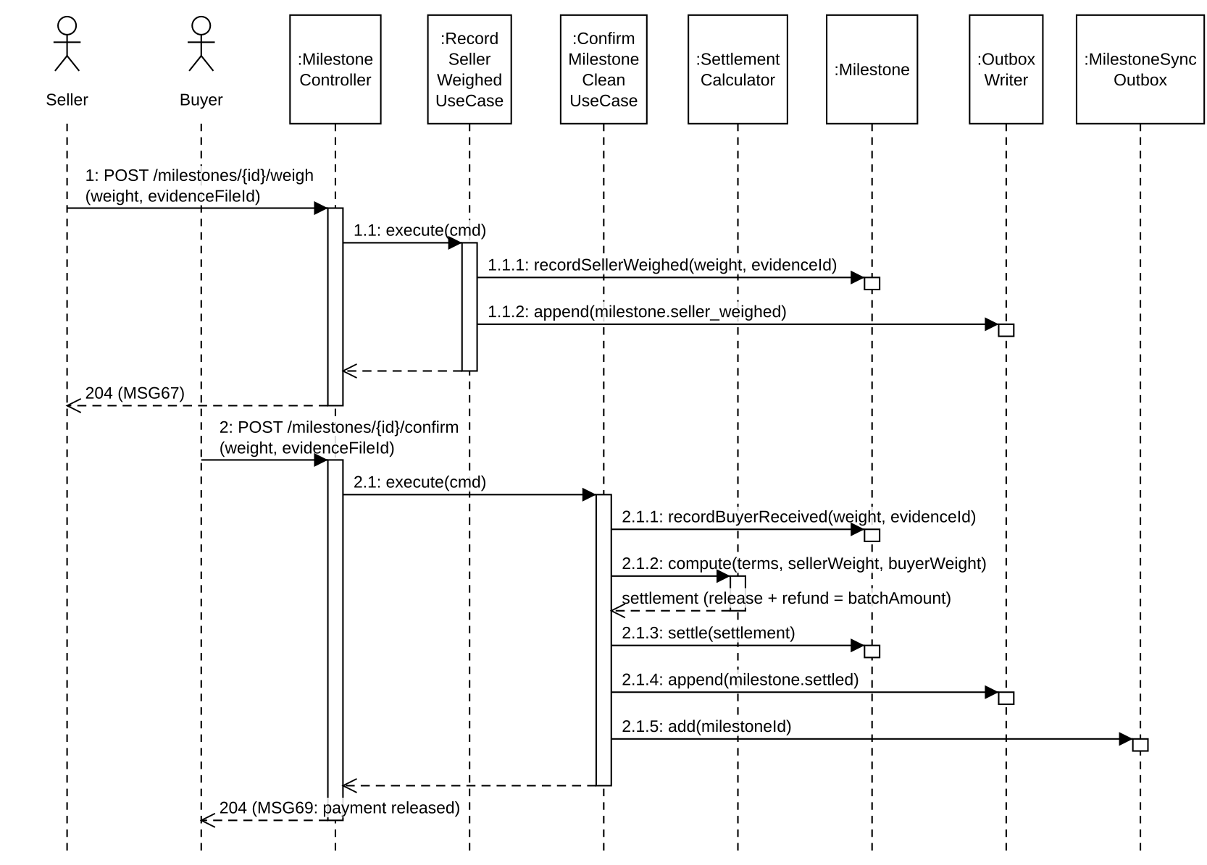
Figure 10. Sequence — weigh, receive and confirm clean

2.3 Money Movement and Completion Reconciliation
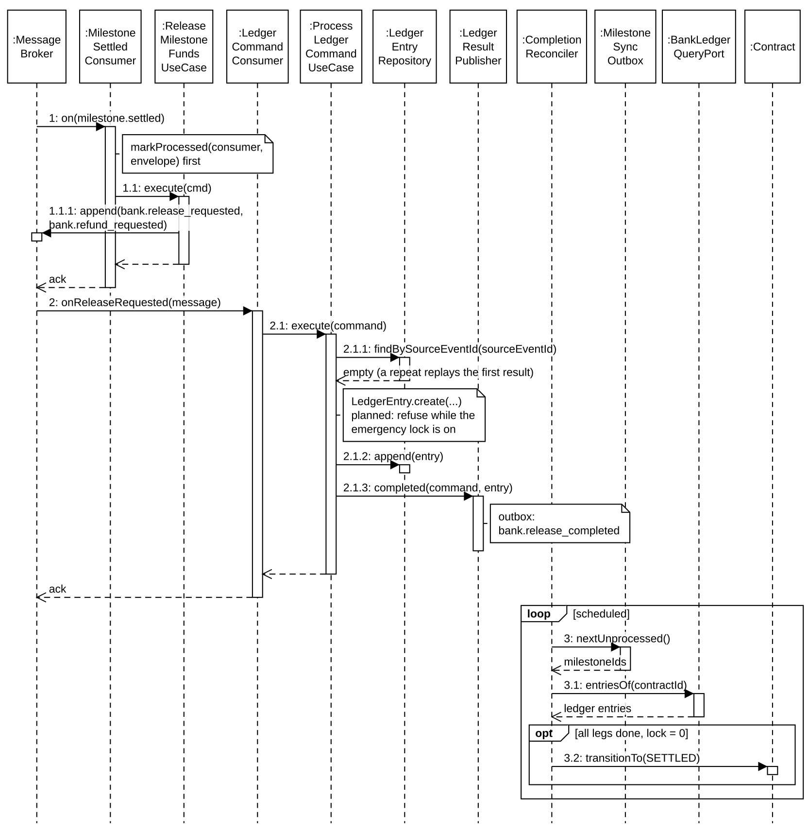
Figure 11. Sequence — escrow → bank ledger and completion reconciler

3. Quality Dispute, Level 1.5 Inspection and Remedy
A buyer flag only creates an allegation (BreachCase REPORTED). If the seller contests, DisputeRoutingService picks the tier (Arbitrator / Level 1.5 / Level 2); for Level 1.5, contract-service publishes inspection.level1_5_requested and inspection-service assigns a random eligible inspector. The inspector submits actual metrics; the report is hash-committed and confirmed. contract-service — not the inspector — computes the quality disposition from the signed spec and the committed result, creates the AttributionDecision and RemedyDecision, and publishes exactly one remedy.finalized, which is the single trigger for money legs and for a reputation lock. When an Arbitrator resolves a milestone-level case with a party at fault and a sanction, remedy.finalized is held until the 2-business-day contest window closes (GB-50); a contest routes the case to Level 1.5, whose decision replaces the Arbitrator's. Contract-level cases have no contest window.

3.1 Class Diagram
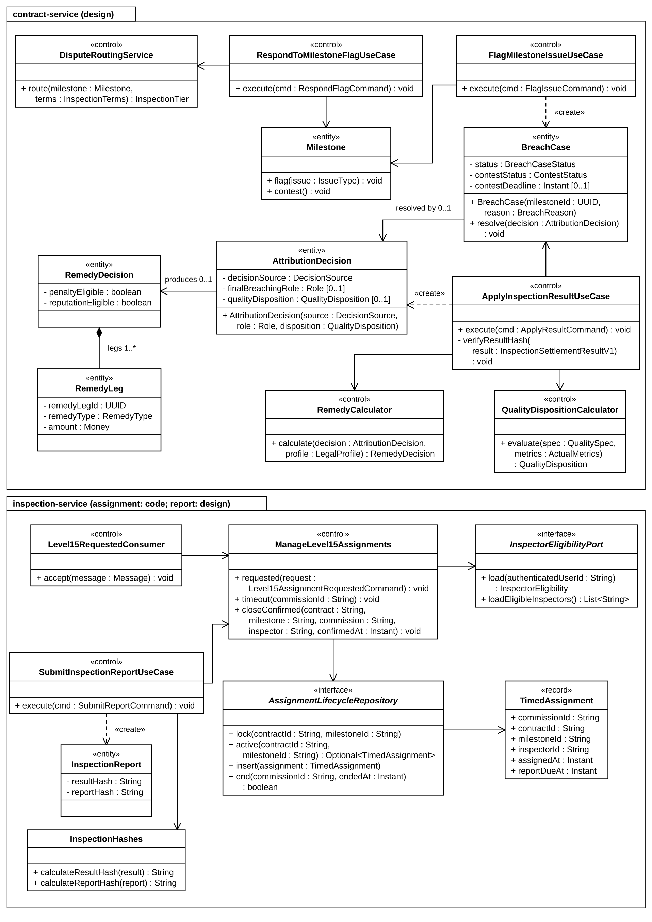
Figure 12. Class diagram — dispute, inspection and remedy
The diagram shows the core classes only; supporting classes (schedulers, consumers, adapters) are listed in the table.
Class | Layer / stereotype | Responsibility
FlagMilestoneIssueUseCase / RespondToMilestoneFlagUseCase | contract · usecase | BUYER_RECEIVED → AWAITING_SELLER_RESPONSE → CONTESTED; opens/advances BreachCase; never moves money.
DisputeRoutingService | contract · domain service | Chooses ARBITRATOR, LEVEL_1_5 or LEVEL_2 from inspection terms and dispute type (FM contests cap at Level 1.5).
Level15RequestedConsumer / ManageLevel15Assignments | inspection | Dedup; locks the milestone (level1_5_assignment_lock), keeps one active assignment, picks uniformly at random among the eligible inspectors from user-service, excluding previous assignees on a timeout; deadline in business days; closeConfirmed ends it with the report.
SubmitInspectionReportUseCase / ResultHasher | inspection | Checks active assignment + inspector step-up (≤ 1800 s); computes resultHash (RFC 8785) and reportHash; confirms report and ends assignment in one transaction; publishes inspection.report_confirmed.
ApplyInspectionResultUseCase | contract · usecase | Recomputes resultHash, evaluates disposition, resolves BreachCase, persists AttributionDecision/RemedyDecision/legs and the remedy.finalized outbox row.
QualityDispositionCalculator | contract · domain service | Deterministic comparison of actual metrics with committed spec and deviation policy (tolerance / penalty / reject zones; exact match for coffee type).
RemedyCalculator | contract · domain service | Builds legs: refund/release per milestone, penalty ≤ LegalProfile cap (8% VN commercial) on the affected milestone value, deposit forfeiture without double recovery, LOSER_PAYS inspection cost.
RemedyFinalizedConsumer (escrow / reputation) | escrow, reputation | escrow: one bank command per remedyLegId; reputation: lock only if reputationEligible and a strategic reason, UNIQUE(remedy_decision_id).

3.2 Flag, Contest and Inspector Assignment
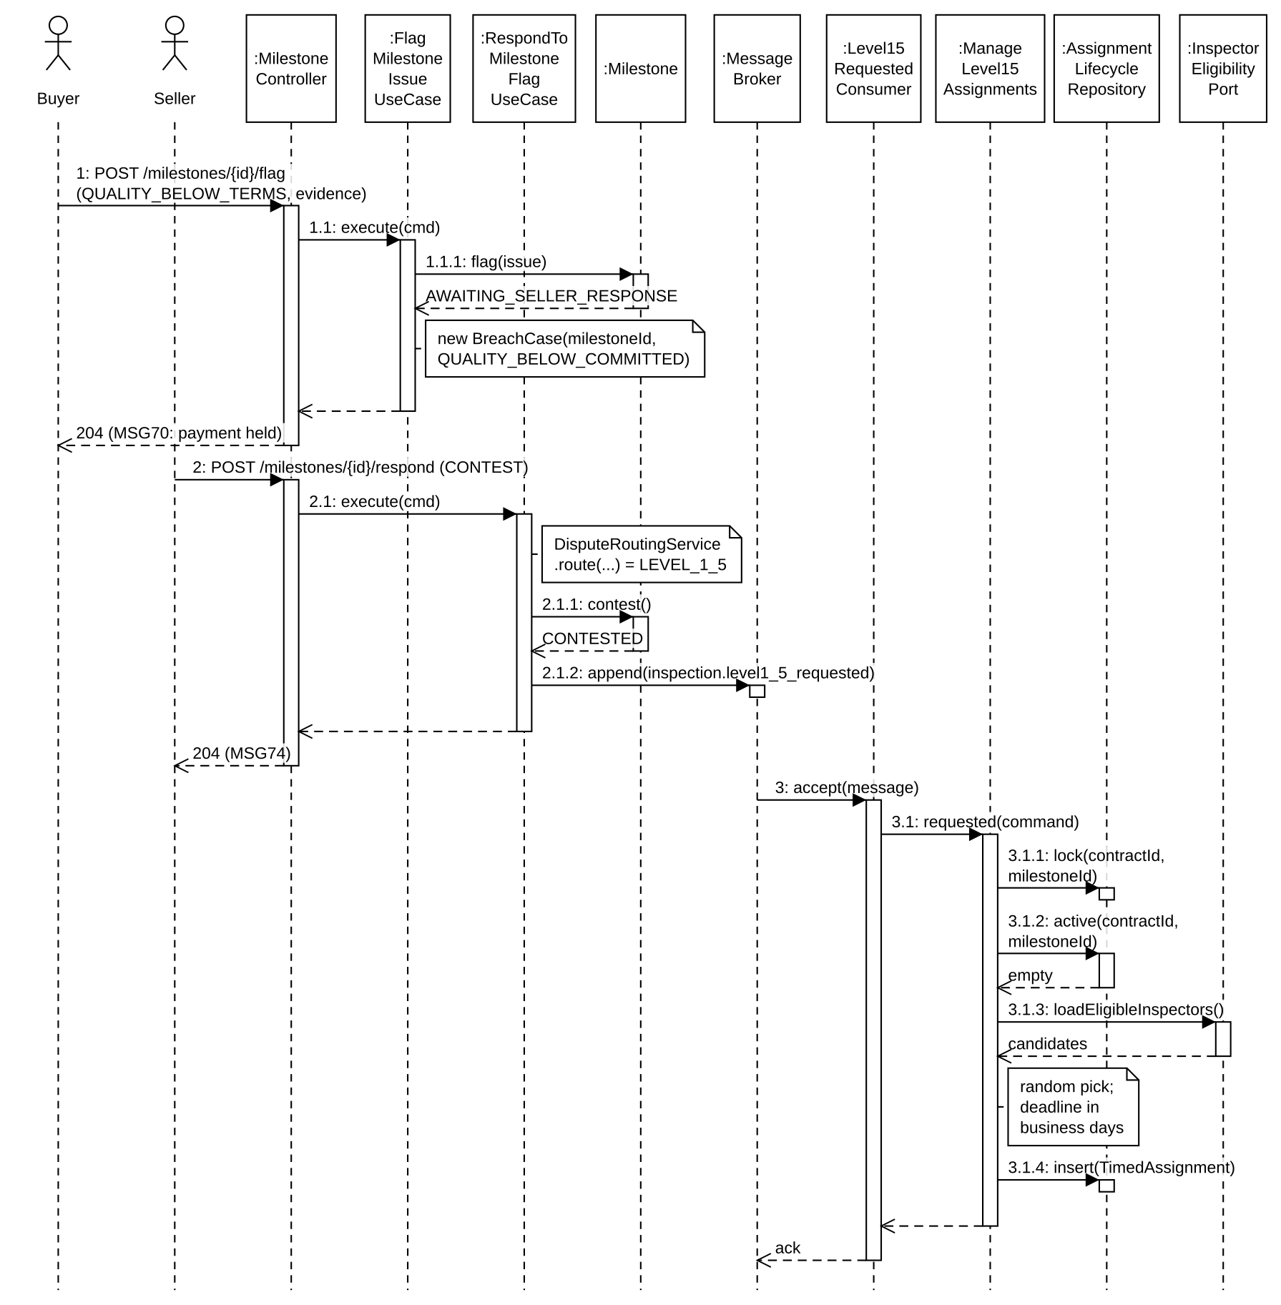
Figure 13. Sequence — flag, contest and Level 1.5 assignment

3.3 Inspection Result to remedy.finalized
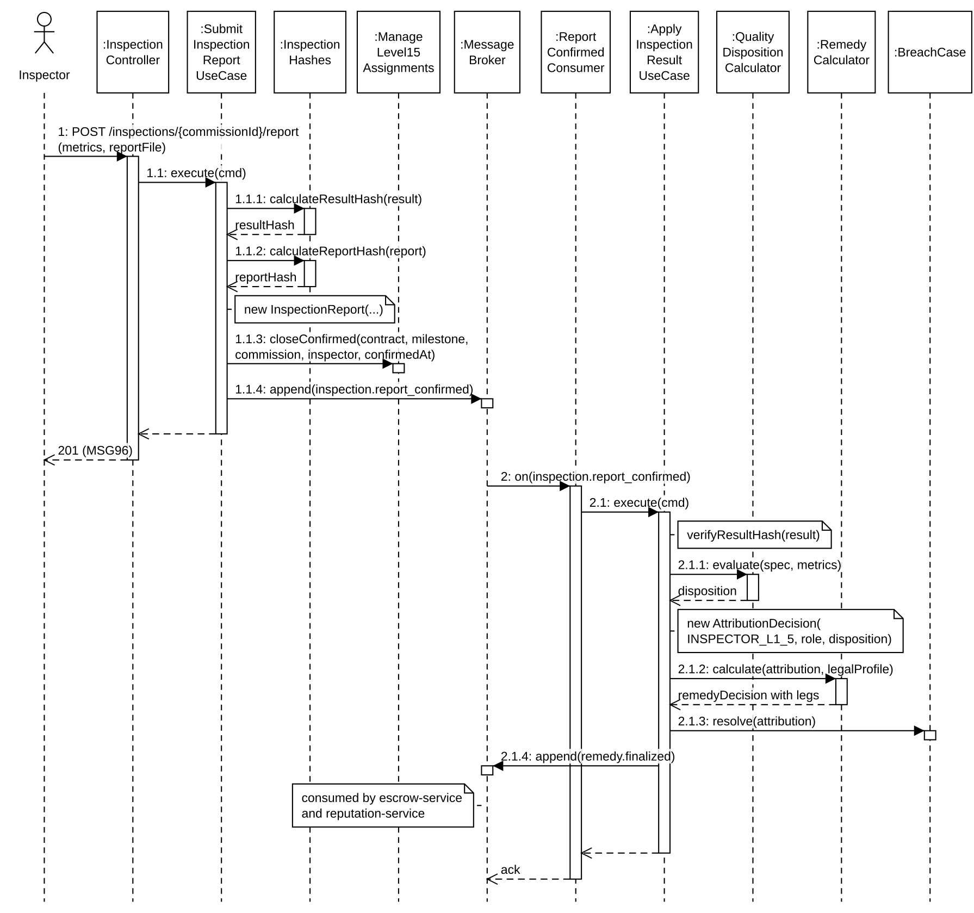
Figure 14. Sequence — report confirmation, disposition and remedy fan-out

III. Design for Non-Functional Requirements

1. Security Design

1.1 Authentication Flow
AgriContract delegates authentication to Keycloak (OIDC). The React SPA uses keycloak-js with the Authorization Code flow and PKCE (S256); tokens are held in memory by the adapter (never in localStorage) and refreshed silently. Every request carries Authorization: Bearer <access token>. The API Gateway validates the RS256 signature against Keycloak’s JWKS, rejects missing/invalid/expired tokens with 401 (never downgrades to anonymous), removes Authorization and any client-supplied identity headers, and injects X-User-Id (JWT sub), X-User-Role (application realm roles only), X-Correlation-Id and X-Gateway-Secret. Downstream services trust those headers only when the gateway secret is valid (HeaderAuthenticationFilter). High-risk actions add a second and third factor: contract signing requires a step-up login (prompt=login, auth_time ≤ 300 s) and an email OTP bound to the exact content hash.

a. Token and Credential Design
Aspect | Design Decision
Identity provider | Keycloak 24 realm agricontract, public client agricontract-frontend; credentials and password policy stay in Keycloak, no password/token column exists in any service DB.
Token format | JWT signed RS256 (Keycloak realm key); gateway verifies via JWKS with key caching and rotation support.
Access token lifetime | 300 s (realm accessTokenLifespan) — short window limits replay of a stolen token.
Session lifetime | SSO idle 30 min, SSO max 10 h; refresh handled by keycloak-js; logout ends the Keycloak session.
Step-up for signing | Re-authentication immediately before signing; signedAt − auth_time ≤ signatureAuthMaxAgeSeconds (300 s); inspectors use 1800 s for report submission.
Signing OTP | 6 digits, 300 s expiry, max 5 attempts, max 5 resends/hour, 60 s cooldown; stored as HMAC-SHA256(code, server pepper); bound to (signerUserId, contractId, signedContentHash); a resend invalidates older challenges.
Service-to-service | /internal/v1/** reachable only on the internal network with a shared internal secret; mTLS is the documented production evolution.
External Verifier | ES256 signature over an RFC 8785 canonical payload, deploy-time public key, timestamp window ±300 s, persisted nonce, action binding; errors EXTERNAL_SIGNATURE_INVALID / EXTERNAL_KEY_UNKNOWN / SIGNATURE_TIMESTAMP_OUT_OF_WINDOW (401), NONCE_REPLAYED / SYSTEM_ALREADY_LOCKED / SYSTEM_NOT_LOCKED (409).
Brute-force protection | Keycloak brute-force detection must be enabled per deployment (disabled in the local dev realm export); OTP attempt/resend counters live in contract-service; in-memory gateway rate buckets protect auth and public routes.

b. CORS Configuration
The SPA and the API are served from different origins, so CORS is configured at the edge from deployment configuration; wildcards are never combined with credentials. Because authentication uses a Bearer header (no cookies), credentials are not required.
Environment | Allowed Origins | Allowed Methods / Headers | Credentials | Max Age
Development | http://localhost:5173 (Vite; also the Keycloak client web origin) | GET, POST, PUT, PATCH, DELETE, OPTIONS; Authorization, Content-Type, Idempotency-Key, X-Correlation-Id | false | 3600 s
Staging | Exact staging SPA origin from CORS_ALLOWED_ORIGINS | Same | false | 3600 s
Production | Exact production SPA origin(s) from deployment config | Same | false | 86400 s

c. Edge Policies
Aspect | Design Decision
Route matching | Method + exact path pattern; order: deny /internal/** → public → role-gated → authenticated default; unknown path → 404 (no fallback).
Request size | JSON 1 MB; direct upload 10 MB and email intake 20 MB (enforced by file-service streaming); emergency lock/unlock 64 KB.
Rate limiting | Nginx coarse per-IP; in-memory gateway buckets per client IP and route (60 s fixed window, single gateway instance in Phase 2; several replicas would need a shared store) for pricing, reputation summary, audit-hash and auth; External Verifier 10 req/min per IP.
Timeout / retry | Explicit timeouts; GET retried only on connection errors before a response; POST/PUT/PATCH/DELETE never retried by the gateway; circuit breaker fast-fails without fabricating success (503/504 with correlation id).
Logging | Path template, status, latency, destination, correlation id; never Authorization, OTP or email bodies.

1.2 Authorization & RBAC Implementation
Aspect | Decision
Two layers | Gateway: coarse role per route (Keycloak realm roles). Owner service: fine-grained ownership, assignment and state guards inside the use case (e.g. caller must be the contract’s buyer for /confirm; inspector must hold the active assignment). Centralized fine-grained authorization is rejected on purpose.
Roles | BUYER, SELLER (participants) · INSPECTOR (Level 1.5 reports) · OPERATOR (KYC, plot-risk review, activation retry, price fallback, maker side) · ARBITRATOR (breach/force-majeure resolution, Level 2 initiation, checker side) · ADMIN (system/security/audit/analytics). No role fallback: each staff route accepts exactly its role.
Separation of duties | OPERATOR + ARBITRATOR on one account is rejected (403 on every request carrying both). Maker-checker for reputation early unlock / clear elevated risk: OPERATOR proposes, ARBITRATOR approves, DB CHECK proposed_by <> approved_by. ADMIN has no emergency-unlock path.
Fail-closed | Sign, create listing and create offer call user-service eligibility; if unavailable → 503, never anonymous or cached success.
Consent by action | Signing/mutual termination: checkbox + step-up + OTP. Weigh/confirm/flag/accept price: checkbox + authenticated ownership. Admin decisions: decision statement + privileged session.
Implementation | Gateway SecurityConfig (explicit permit list + authenticated default + path role rules); service SecurityConfig + HeaderAuthenticationFilter; ownership checks in use cases returning 403; tests: OPERATOR → ADMIN route = 403, forged X-User-* stripped, /internal/** from outside = 404/403.

1.3 Data Protection
Data Category | At Rest | In Transit | Notes / Retention
Passwords / credentials | Keycloak only (hashed by Keycloak) | TLS | Never stored, logged or returned by platform services
KYC documents, authorization papers (Restricted) | file-service (SeaweedFS) + metadata in user_db; every read logged in kyc_read_audit | TLS | 5 years after relationship ends, then file deleted, decision metadata kept
Ledger / balances (Restricted) | bank_db append-only, INSERT/SELECT grants | TLS / internal network | 10 years; statements only via escrow endpoint after ownership check
OTP artefacts (Restricted) | HMAC-SHA256 with pepper from secrets | TLS; OTP only in the email | 90 days after expiry
Contracts, signatures, evidence (Confidential) | contract_db + READY files with SHA-256 | TLS | 10 years after contract closes, then references anonymized
Contact PII (email, phone, address) | user_db only | TLS; not in gateway headers, events limited to need | Public DTOs exclude PII; anonymized 5 years after account closure
Audit chain + OTS proofs | audit_db append-only, hash-only content | TLS | Kept indefinitely (contains no PII)
Secrets / keys | Environment variables / secret store; never in images or source | — | CI fails on secrets in images; images pinned by digest
Message broker payloads | RabbitMQ queues (transient) | Internal network | TTL ≤ 14 days; outbox is the replay source

2. Performance & Scalability Design

2.1 Caching Strategy
Caching is applied only where a stale value cannot cause a wrong business decision. Money, contract state and reputation score are never cached: bank balances are derived from ledger_entry, and the reputation score is derived at read time from immutable facts (caching a number would be a second source of truth). A state flag such as locked_until may be projected because it is driven by ordered events with a persisted revision.
What is Cached | Key / Location | TTL | Invalidation Trigger | Rationale
Latest coffee price per province/item | Redis price:coffee:{province}:{itemSlug} | none | Overwritten right after each ingest/manual entry commits; cache-aside refill from price_history on miss | MySQL is the source of truth; stale flag computed dynamically
Analytics dashboard responses | Redis (per endpoint + query) | 1 h | Expiry; monthly recompute overwrites buckets | Macro statistics need not be second-fresh
Rate-limit buckets | Gateway memory (route + client IP) | 60 s | Fixed window resets | Protect auth/public routes cheaply without another dependency
User lock state | user_db locked_until projection | n/a | reputation.locked/unlocked with monotonic lockRevision | Avoids a synchronous reputation call on every sign/listing
JWKS keys | Gateway in-memory | key rotation | Unknown kid triggers reload | No Keycloak round-trip per request
Server state in SPA | TanStack Query cache | staleTime per query | Invalidate on mutation success | Fewer refetches, UI consistency

2.2 Database Query Optimization
Technique | Where / Why
Composite indexes matching access paths | ledger_entry(contract_id, milestone_id) for reconciler/statements; event_outbox(status, id) for the poller; listing_reservations(listing_id, status); price_history(commodity, province_slug, item_slug, captured_at, ingested_at) for latest price; audit_record(subject_type, subject_id, created_at) for per-subject chain; user_profiles(verification_status, created_at) for the KYC queue; spatial index on plot geometry for overlap checks.
UNIQUE constraints as idempotency | ledger_entry.source_event_id, remedy_leg_id, lock_entry.remedy_decision_id, audit_record.source_event_id, processed_event(consumer, event_id) — duplicates fail fast on the index instead of SELECT-then-INSERT races.
Concurrency control | Optimistic locking (version) on contract, milestone, escrow and user aggregates; SELECT … FOR UPDATE only to serialize OTP initiate/resend on one contract row; conditional UPDATE for reservation transitions.
Snapshots instead of cross-service joins | Terms, goods and plot data are copied into terms_snapshot JSON at create time; reads never call other services.
Pagination | List endpoints return ContractPage {content, page, size, totalElements, totalPages}; default and maximum page size bounded.
Short transactions | External calls (OTP provider, PDF render, file upload) run outside DB transactions or after commit.
Read models | analytics-service keeps pre-aggregated fact tables (monthly buckets) so dashboards never query transactional schemas.

2.3 Scalability and Resilience
Concern | Design
Horizontal scaling | Services are stateless behind the gateway; RabbitMQ consumers scale as competing consumers because handlers are idempotent.
Isolation of failures | Analytics/notification outages never block settlement (catch-up from queue backlog). OTP and eligibility are intentionally fail-closed.
Poison messages | Bounded retries then DLQ per queue; replay keeps the original eventId so consumers skip already-processed work; DLQ alerts for money/security/evidence queues.
Guardrails | Max 100 milestones per contract, max 1,000,000 kg per milestone, money strings with exactly two decimals and bounded length.

IV. Other Design Specifications

1. Event and Integration Contracts
The frozen contracts in contracts/ are the source of truth for integration: the golden-flow OpenAPI (51 operations) and the supplementary services API (18 operations), the event catalog (51 domain/bank events) and 17 notification commands. All share one envelope:
Envelope field | Required | Meaning
eventId | yes | UUID of this event; consumer dedup key; preserved on DLQ replay
eventType / eventVersion | yes | e.g. milestone.settled / 1
occurredAt | yes | UTC ISO-8601
producer / aggregateId | yes | Owner service and source aggregate id
correlationId | when part of a request/saga | Kept across the whole saga
causationId | null for root events | eventId/commandId that directly caused this event (bank result: request eventId)
subject | optional | Audit subject (CONTRACT, USER_PAIR, SYSTEM)
payload | yes | Closed schema (additionalProperties = false); required-but-nullable fields must be present

Idempotency per boundary
Boundary | Dedup key / constraint | Reason
HTTP write | Idempotency-Key + actor + resource + operation | Client retries do not repeat transitions
Bank request | payload.sourceEventId == envelope eventId; UNIQUE(source_event_id) | No second ledger entry
Remedy leg | UNIQUE(remedy_leg_id) | One decision has many legs
Reputation lock | UNIQUE(remedy_decision_id) | At most one lock per decision
Audit | UNIQUE(source_event_id) | No second record/anchor/email
Notification | (event_id, recipient_email, notification_type) | One command may target several recipients

2. State Machines
Contract state | Entered by | Leaves to / guard
OFFERED / NEGOTIATING | createContract / updateTerms | sign; WITHDRAWN before second signature; terms editable only before the first signature
SIGNED | Two signatures, same hash | ACTIVE when every required deposit is locked; stays SIGNED when lock retries are exhausted; ACTIVATION_REFUND_PENDING when the Operator marks the activation failed
ACTIVE | escrow.deposit_locked | SETTLED after completion reconciliation; breach / FM / mutual termination; REPLACEMENT_PENDING
REPLACEMENT_PENDING → SUPERSEDE_REFUND_PENDING | Valid mutual replacement signed | SUPERSEDED only when expected refund legs complete and lock = 0
ACTIVATION_REFUND_PENDING | MarkActivationFailed (OPERATOR) with locked deposit legs | ACTIVATION_FAILED only when refund complete and lock = 0
SETTLED / TERMINATED / SUPERSEDED / ACTIVATION_FAILED / WITHDRAWN | Reconciler commit (WITHDRAWN: pre-sign) | Terminal, immutable, zero lock

Milestone: CREATED → IN_PROGRESS → SELLER_WEIGHED → BUYER_RECEIVED → (clean | AWAITING_SELLER_RESPONSE → CONTESTED | FORCE_MAJEURE_PENDING_REVIEW) → SETTLED. Funding: FUNDING_PENDING → LOCKED | FUNDING_FAILED (bounded retry; seller clock starts only after LOCKED). Reservation: RESERVED → SIGNED_RELEASABLE → COMMITTED | RELEASED. File: PROCESSING → READY | FAILED. Document: PENDING → READY | FAILED.

3. Key Algorithms
Algorithm | Specification
signedContentHash | SHA-256 over RFC 8785 canonical JSON of the complete ContractTermsSnapshot, including LegalProfile, template {VN_COFFEE_B2B, version, hash} and coffeeQualityProfileVersion. Any change of a signed field changes the hash and invalidates outstanding OTP/consent.
Milestone settlement | Computed only in contract-service with DECIMAL(18,2) HALF_UP: Delta 1 compares delivered vs committed quantity (shortfall beyond threshold opens a BreachCase, never auto-breach); Delta 2 pro-rates on seller vs buyer weights; release + refund + remaining lock always equals batchAmount. Inspected paths use min(lockedAmount, acceptedQuantityKg × effectiveUnitPrice).
Quality disposition | Per metric deviationPolicy {direction, tolerance, penalty, reject, discountRate}; disjoint zones, inclusive on the stricter side; coffee type mismatch = reject. CONFORMING (allegation rejected, buyer pays inspection), PARTIALLY_CONFORMING (single max discount, no breach), NON_CONFORMING (seller breach on that milestone only), INCONCLUSIVE (reinspection, no money).
Remedy legs | finalBreachingRole = NULL ⇒ no forfeiture/penalty/damages and no reputation; penalty rate ≤ LegalProfile.maxContractualPenaltyRate (8% for VN_COMMERCIAL_LAW) on the breached milestone scope; damages only if the policy allows and evidence exists; forfeiture offsets penalty to avoid double recovery.
Reputation lock | lockDurationDays = 30 × repeatOffense (1/2/3, 24-month window) × trackRecord (0.7/1.0/1.3, after ≥ 5 contracts) × zeroProgress (1.5 only for strategic breach with zero settled milestones); snapshot, never recomputed. PRODUCTION_SHOCK_NON_FM does not lock.
Audit hash chain | record_hash = SHA-256(canonicalJson{recordId, subjectType, subjectId, sourceType, sourceEventType, sourceEventId, causationId, correlationId, content, prevHashGlobal, prevHashSubject, createdAt}); global and per-subject chains verified by a job before any anchor; failures alert independently.
Inspector assignment | Uniform random among eligible INSPECTOR accounts, excluding inspectors already assigned to the milestone; reassignment on report timeout; no manual choice by any staff role.

4. Backup and Disaster Recovery
Component | Backup | RPO | Notes
MySQL (each service) | Daily full dump | 24 h | Database-per-service backups
bank_db, audit_db | Daily + continuous binlog | ≤ 15 min | Restored first; traffic reopens only after ledger/audit verification jobs pass (ADMIN decision)
SeaweedFS | Bucket versioning / daily mirror | 24 h | storage_hash verifies files after restore
Keycloak | Realm export in config repo | per change
RabbitMQ | No message backup | — | Outbox re-publishes unconfirmed events; consumers dedup by eventId

Target RTO is 4 hours for the whole system; restore is tested at least once before the defense on a test environment.

5. API Surface Summary
The frozen OpenAPI contracts define 51 operations in golden-flow-api.yaml and 18 in supplementary-services-api.yaml. All writes require an Idempotency-Key and return ErrorEnvelope on failure; /internal/v1/** is never routed by the gateway.
Resource group | Owner | Main operations | Auth / role
/api/v1/contracts (lifecycle) | contract-service | create, list, get, PATCH terms, withdraw, document preview/list/get | BUYER creates; participants only
/contracts/{id}/sign/* | contract-service | initiate, verify | BUYER, SELLER (step-up + OTP)
/contracts/{id}/termination, /replacement, /breach-cases | contract-service | mutual propose/confirm, execute, report breach, review/resolve, contest | Participants; review/resolve ARBITRATOR (a Level 1.5 result arrives through inspection.report_confirmed); contest only by the party found at fault (GB-50)
/contracts/{id}/activation/* | contract-service | retry-deposit-lock, mark-failed | OPERATOR
/contracts/{id}/milestones/{mid}/* | contract / escrow | weigh, confirm, flag, respond, force-majeure (+resolve), funding/retry, price-adjustments propose/accept | SELLER / BUYER by action; FM resolve ARBITRATOR; funding retry OPERATOR
/api/v1/users, /admin/users | user-service | register, me, public profile; KYC queue, detail, verify, reject; set role | JWT; KYC OPERATOR; role ADMIN
/api/v1/reputation, /admin/reputation/actions | reputation-service | public summary; propose / approve / reject | JWT; propose OPERATOR, decide ARBITRATOR
/api/v1/plots, /listings, /listings/{id}/offers | product-service | register plot, create/search/update listing, create offer | SELLER / BUYER; search JWT
/api/v1/prices | pricing-service | latest quote, items, manual price | Public read; manual OPERATOR
/api/v1/inspections/.../reports | inspection-service | submit Level 1.5 report | INSPECTOR with active assignment
/api/v1/analytics/* | analytics-service | terminations, escrow effectiveness, force-majeure trends | ADMIN
/api/v1/escrows/statements | escrow-service | statement export | JWT + ownership
/api/v1/security/* | audit / bank | audit-hash; emergency-lock / unlock | X-Api-Key; External Verifier ES256
/internal/v1/* | user, notification, audit, bank, product, file | eligibility, eligible inspectors, OTP email, audit records, ledger, listing reservations, file store/get/delete/attach | serviceAuth only

6. Verification Matrix and Release Gate
Every critical invariant has one test that proves it at the right boundary (verification-matrix-phase2.md, 87 rows). The matrix is the test plan for this design and the release gate.
Priority | Rows | Scope | Example invariants
P0 | 32 | Money, immutability, evidence — gate before merging the golden flow | Duplicate bank request = one ledger entry; ledger/audit append-only; terminal contract has zero lock; kill switch blocks all money; two signatures on one hash; allegation never moves money
P1 | 20 | Access control and safe flows — gate before external exposure | Forged X-User-* stripped; /internal not reachable; OTP bound to user/contract/hash; OPERATOR cannot use ADMIN routes; no self-approval; sign() fail-closed
P2 | 35 | Business correctness — gate before pilot claims | Coffee-only scope; analytics outage does not block settlement; quality disposition deterministic; reputation locks only strategic breaches; listing partial-fill atomic

