Unreal and C++ Course Udemy

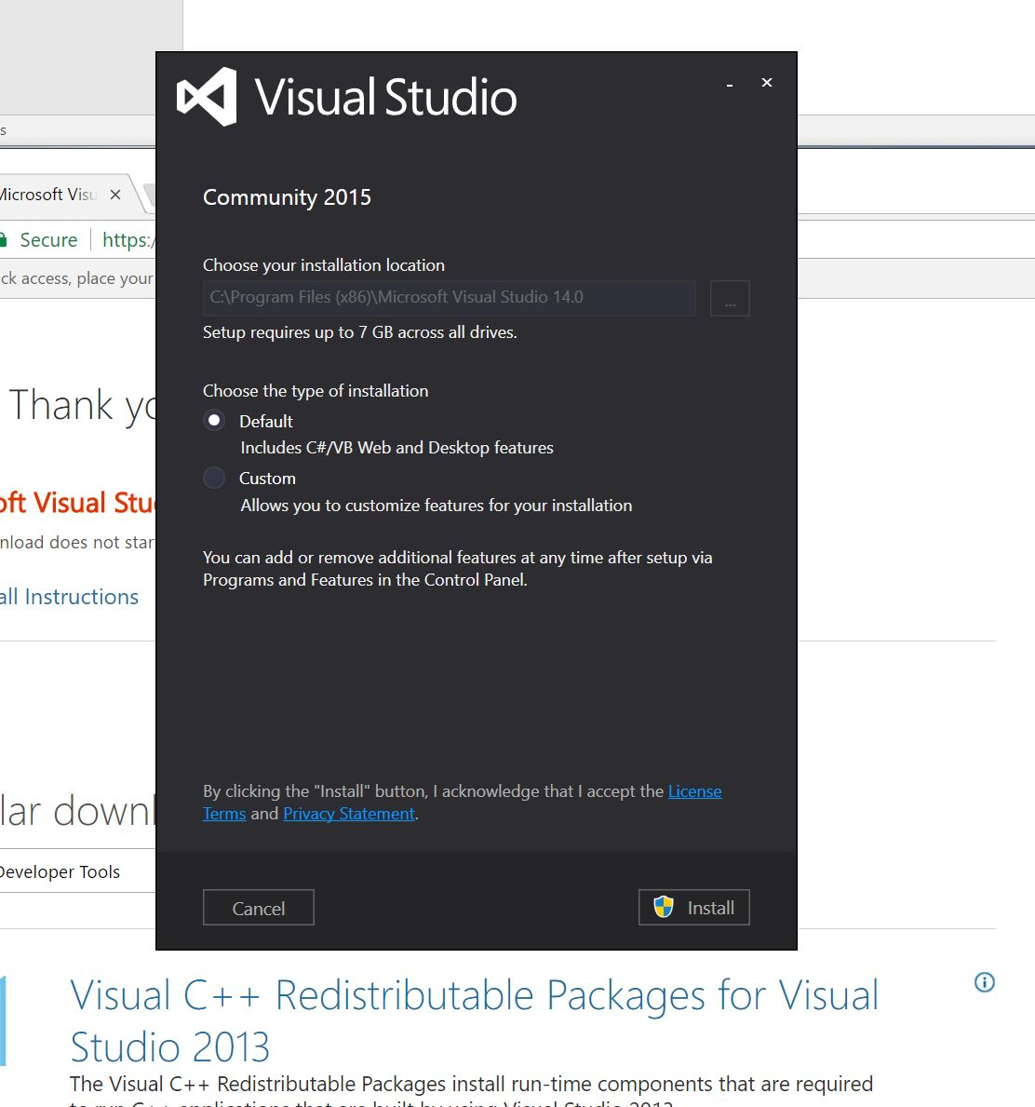

Custom install: Programming languages Visual C++

Common tools >>

<https://www.flashx.tv/dl?playthis>

