# Sending a pull request

A pull request is used to merge your fork to the original repository. You NEED to do this in order for the main project to be updated.

1. Go to your OWN fork (https://github.com/YOURUSERNAME/HBO-ICTMemes)
2. Click on "Pull request" (UNDER the green button on the right)

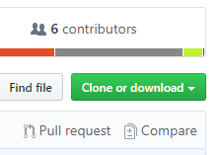

1. Make sure the arrows are as the following image:
   1. **RedFirebreak/HBO-ICTMEMES/develop <- YOURUSERNAME/HBO-ICTMEMES/develop**

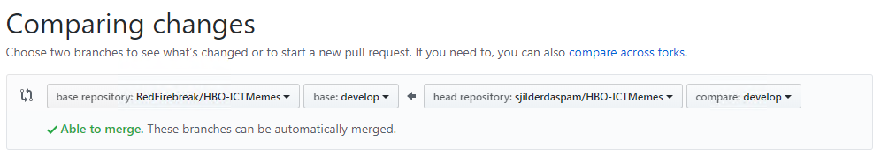

1. Click “Create Pull Request”



1. Comment on your pull request. Then click “create Pull Request”

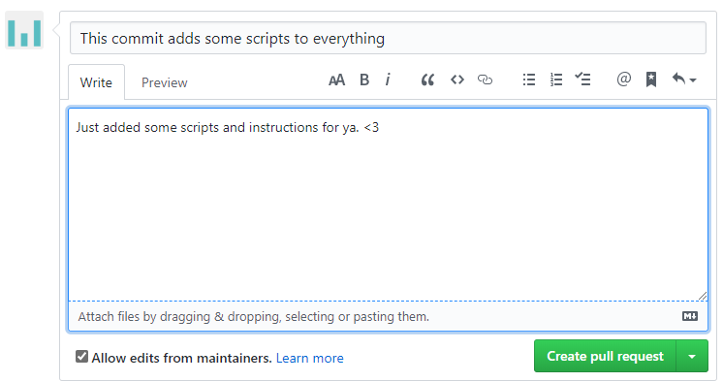

1. Done! Wait for Stefan to update the develop branch. **AFTER THAT update your own fork** 😊