Task : Configure your VCS. Initialize an empty repository
First of all, I downloaded and installed git for linux using sudo apt-get install git and set up the configuration details of my GitHub user. Basically, I introduced my user name and email from my GitHub account. Then, I created a local empty repository git init repozitoriu.

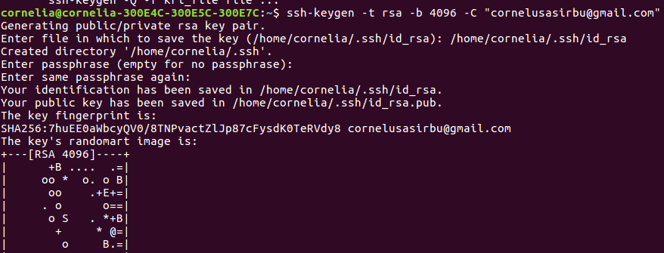
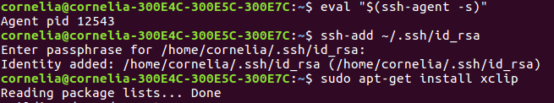
Than I connected to GitHub with SSH so I can connect without supplying my username and password at each visit. I generated a new SSH key with the command ssh- keygen –t rsa 4096 –C email@example.com and chose a passphrase. Then, I added the new key to the ssh-agent by typing in ssh-add ~/.ssh/id_rsa. After that, I just copied the generated key and added it on the GitHub site.

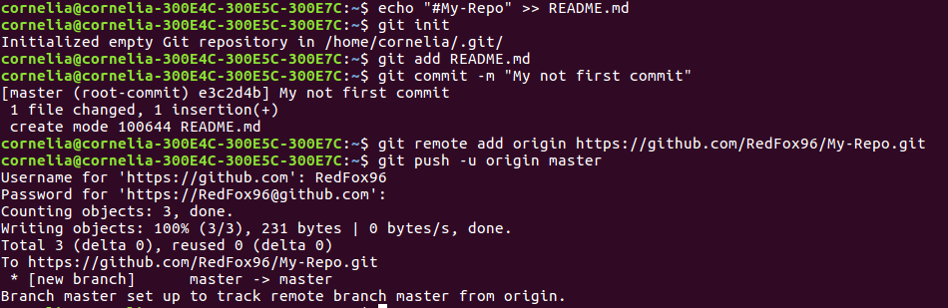
I created a new repository My-Repo on GitHub. Initialized the local directory as a Git repository. Added the files in my new local repository. This stages for the first commit. Commited the files that I’ve staged in my local repository than pushed the changes.
Task: Create branches. Commit to different branches

I crated a branch named MadWorld by using the command git branch MadWorld.
Then, I called the command git checkout MadWorld which switched me from the master
branch to the newly created MadWorld branch. Being on this branch, I committed several files
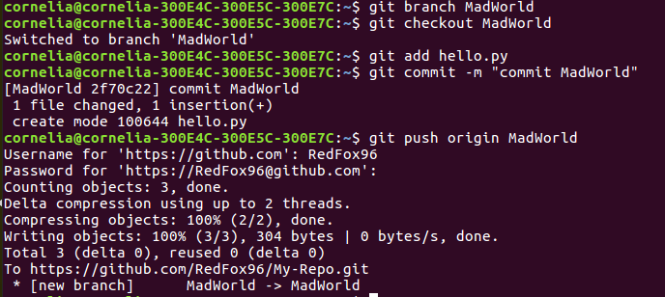
and pushed them on my remote repository.
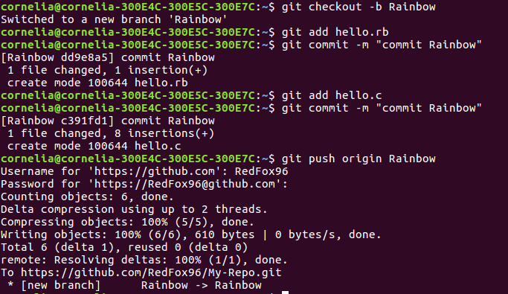
For the second branch, I used a slightly different command: git checkout –b beta. This creates a new branch and automatically switches to it. The –b option is a convenience flag that tells Git to run git branch <new-branch> before running gitcheckout <new-branch>. Again, I made two commits to this branch and pushed them to my remote repository.

