BAM MAIL is a revolutionary tool designed to save you time and money on a variety of training and corporate communication tasks. It is sent through a small, compact PDF file but with almost unlimited capabilities. Its interactive displays and functionality make employee development both new and exciting. BAM MAIL provides employers with instant feedback, which makes it ideal for company surveys, instructional training and newsletters. BAM MAIL is 'Mail That Delivers'.

\*BAM MAIL logo

\*Link to the CATMEDIA page

\*Contact Us section with ‘Jordan Mann, Business Development’ listed

CATMEDIA customizes your BAM MAIL to fit the needs of your business. This includes personalized videos, interviews and logos. We’re not satisfied until you’re satisfied. CATMEDIA is committed to providing the highest quality product and fitting your budget and schedule.

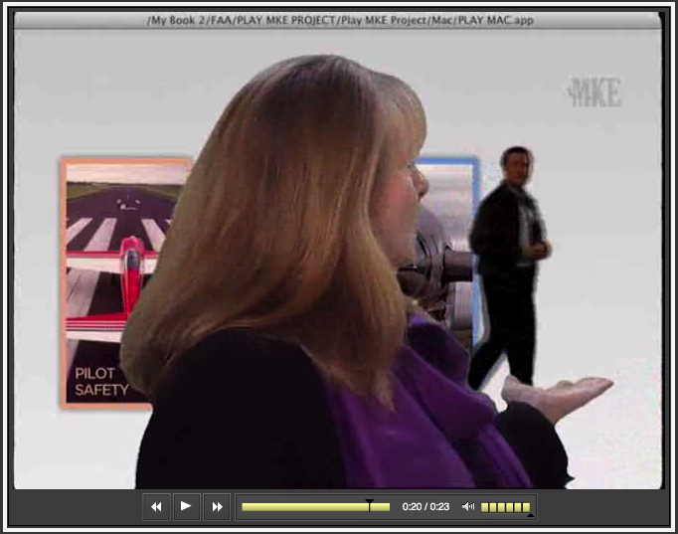

\*Screenshot of video with caption explaining how we can personalize every BAM MAIL to ensure that our clients get the most out of their service.

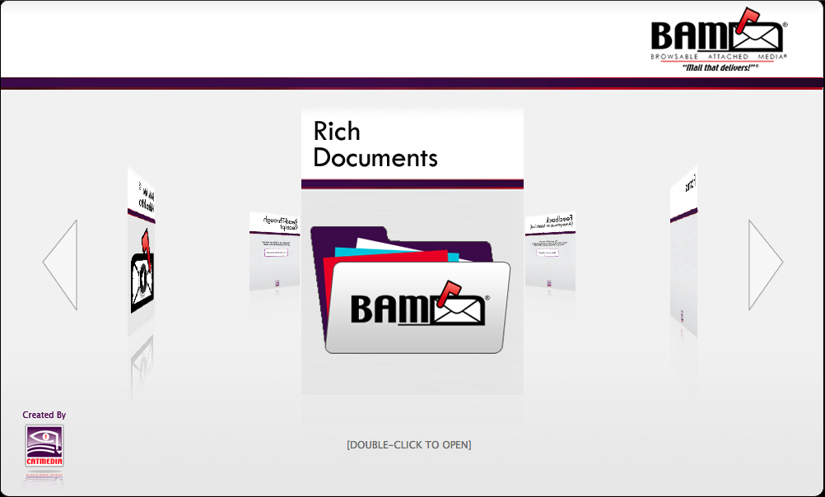

BAM MAIL features customizable folders that allow our clients to communicate both internally and externally in a variety of ways. BAM MAIL can include sections for editable PDF forms and documents. Interactive surveys and instant email feedback are available in your personalized BAM MAIL.

\*Screenshot of BAM MAIL mainpage with text about how many tabs/folders we can include and how many options are available to them. Also give an example of how they can use BAM MAIL.