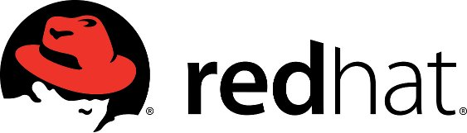
OpenShift 3.1 workshop

Session duration: 2hrs

Do you want to learn how to use popular technologies such as Docker and Kubernetes in an enterprise PaaS. Come to this session and get into the driving seat of your very own instance of OpenShift 3 running on Amazon.

You’ll learn how to

- Create applications from scratch and also from pre-existing templates
- Deploy applications to the PaaS
- Debug running applications inside of containers on the PaaS
- Perform rolling upgrades and rollbacks
- Promote applications without re-building
- Scale running instances on the PaaS

Requirements

Internet connection and a laptop. The session can use a web based VNC client but if you prefer to use your own we recommend updating it ahead of the session.

RSVP

Internet connection and a laptop. The session can use a web based (WebRTC) VNC client but if you prefer to use your own we recommend installing or updating your inc client ahead of the session.

