
OpenShift v3
Workshop
Document information
Date: 8th January 2016
Authors: Jim Minter <jminter@redhat.com>, Ed Seymour <eseymour@redhat.com>
About the workshop Environment
For the workshop, you have your own OpenShift Enterprise 3.1 instance running in EC2. The instance is designed to replicate both the server and the client of OpenShift in a single instance.
Getting Started
Your access details and credentials should be provided on a separate card. The card includes the following details:
- A unique URL, this provides a quick automatic connection to the desktop
- An IP address, the public IP address of your instance
- User. the user name provided for access to the instance
- Pass, the associated user password.

You can access the environment using three different methods:
- VNC – this opens a desktop on the remote server, and provides all client tools and services. VNC is needed for some exercises. A web-based novnc method is provided that operates over https (port 443).
- SSH – you can use SSH to run command line tools directly, requiring less bandwidth than VNC. The SSH method requires Internet access via port 22.
- Web – you can open your OpenShift web console and hosted applications using your local browser, requiring less bandwidth than VNC. The Web console method requires internet access via a non-standard HTTPS port (8443).

- IMPORTANT: Please ensure that you can connect properly to the environment before proceeding.

The following sections provide more details on accessing the OpenShift Enterprise instance:
- Logging into the desktop
- VNC full-screen mode
- SSH access
- Direct web-console access

Logging In
Connecting via the VNC method you will be presented with a desktop login screen that includes your user name, select the user and enter the provided password.
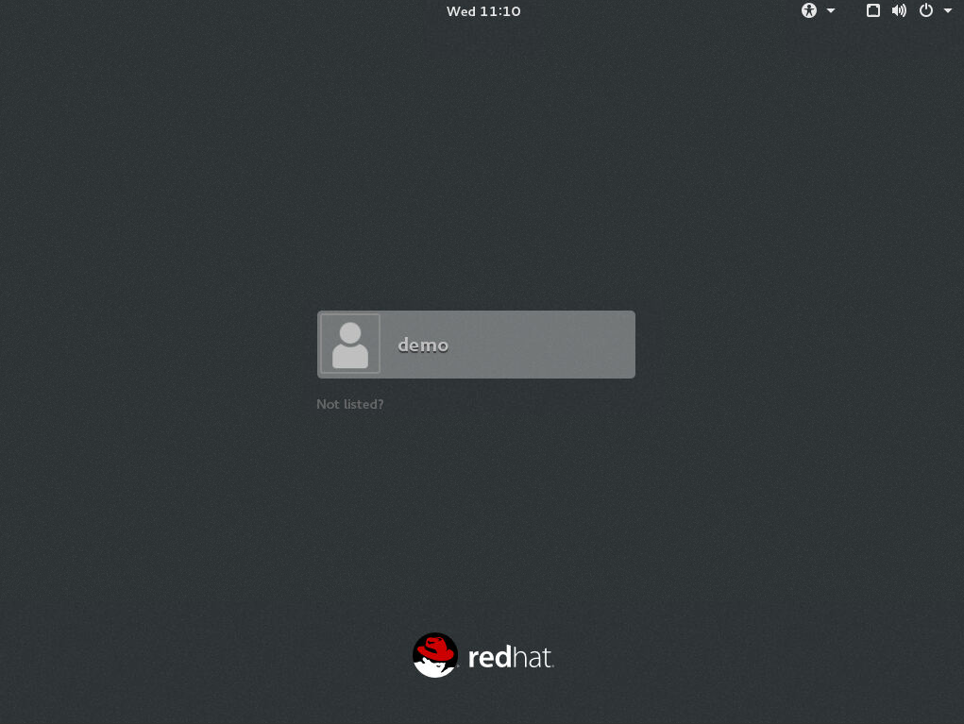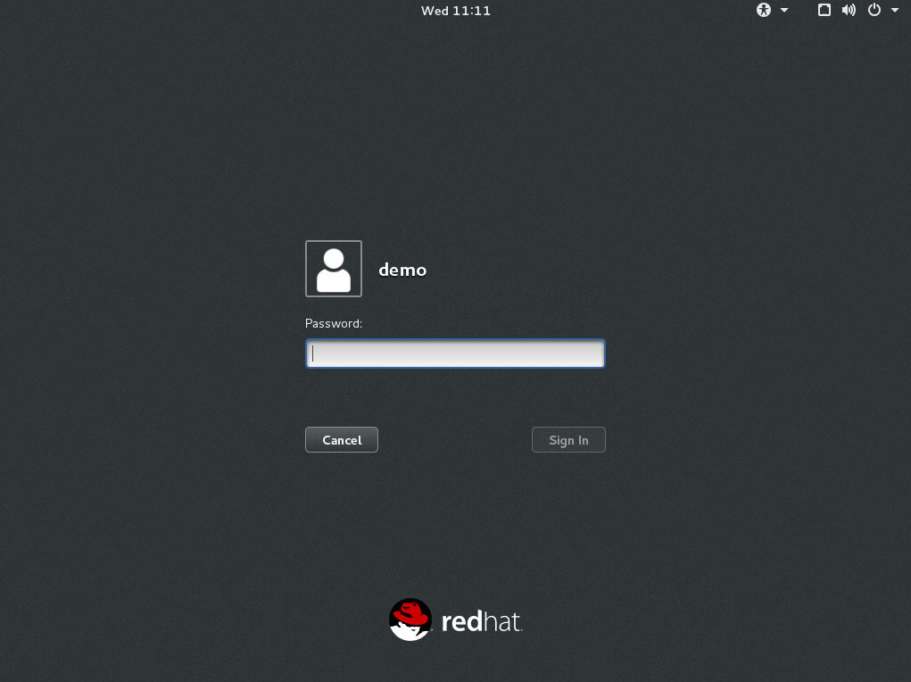
The desktop may take a moment to load, once completed it should match the following screenshot.
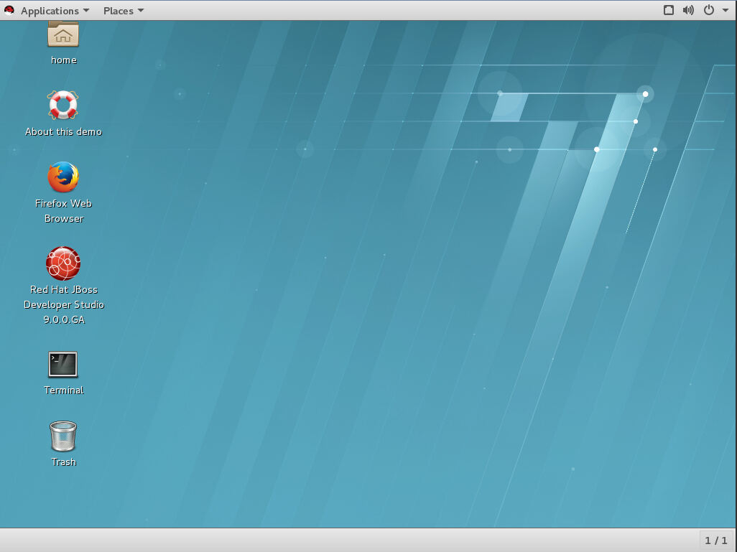
- About this demo – detailed instructions on demonstrating OpenShift Enterprise
- Firefox Web Browser – opens the OpenShift web console
- Red Hat JBoss Developer Studio 9.0.0.GA – a developer IDE pre-configured for the workshop.
- Terminal – access to command line tools.

NoVNC Client FullScreen Mode
You may simply enter the URL printed on the provided card, however, this view is a fixed resolution. It is possible to configure the VNC client to present the desktop in full-screen mode. To do this add /vnc.html to the URL and step through the following instructions.
Step | Screenshot
Enter the provided URL in your browser, adding /vnc.html

For example:
https://no-vnc.apps.<your IP>.xip.io/vnc.html
Configure to VNC scale view to full window  - Click the settings button (cog wheel, top right).  - Select Remote Resizing from the Scaling Mode option.  - Click the Apply button | 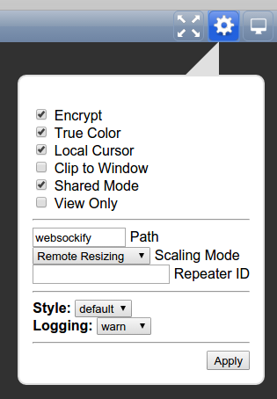
Connect to the Desktop  - Click the connect button (screen icon, top right). | 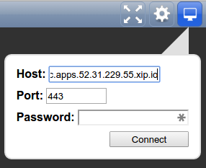
SSH Access
To connect using SSH ensure you have SSH client on your desktop machine. The SSH user and password are shown on the provided card. Use the IP address for the SSH host.
For example:
[you@localhost ~]$ ssh demo@<Your IP>
demo@<Your IP>'s password: ********
Last login: Fri Jan 8 09:30:00 from 127.0.0.1
[demo@ip-192-168-100-nnn ~]$

Direct Web Console Access
To connect directly to the OpenShift web console, construct a URL from the provided IP address using the following template:
https://openshift.<Your IP>.xip.io:8443
For example:
https://openshift.52.31.12.242.xip.io:8443
Note: as this is a non-standard port, it may be blocked by your Internet access method.

Getting Started With OpenShift
Browse the OpenShift web user interface
- Double-click the Firefox Web Browser icon on the desktop. The OpenShift web user interface will open on the login page.
- Enter your username (demo) and the password above, and click Log In.

Log in to OpenShift via the CLI
- Now double-click the Terminal icon on the desktop.
- Type oc login and press Enter to login to OpenShift.
- Enter your username (demo) and press Enter.
- Enter the password above and press Enter.
- Type exit to close the terminal window.

Create an application hosted on OpenShift from source code
These steps demonstrate how to import a simple application into OpenShift from a git source tree, and have OpenShift build and deploy the application. The steps demonstrate how easy it is to get started with OpenShift.
- Click the New Project button.
- Type test in the Name box and click Create.
- Click the Add to Project button.
- Type PHP to filter available templates
- Select one of the PHP builder templates, for example PHP:5.5 or PHP:5.6
- Enter a name for the application (php-example).
- Click the Try it out! label to fill the Repository URL box.
- Scroll down and click Create.
- On the Application Created information screen, click Continue to overview.
- Wait for the example application to be cloned, built and deployed. It will take up to a minute or two for the build process to begin automatically and then complete.
- Middle-click the application URL (http://php-example-test.apps.example.com) to launch the application in a new tab.
- Click the OPENSHIFT ENTERPRISE logo in the top left of the OpenShift web user interface to return to the Projects list.
- Click the Delete Project icon next to the test project, then click Delete this project.
IMPORTANT: do not delete the demo or prod projects.
Create an application hosted on OpenShift from a pre-defined template
These steps demonstrate how OpenShift can build and deploy a (possibly multi-component) traditional or modern application from a pre-defined template. This might be done by a developer, tester or operator to quickly set up a dedicated application instance according to its template, using OpenShift's self-service portal.
- IMPORTANT: in the Projects list, select the demo project. You must use the demo project at this point for the rest of the walk-through to proceed!
- Click the Add to Project button.
- Type monster in the Filter by keyword box
- Under Instant Apps, click monster.
- Scroll down and click Create, then on the Application created screen, click Continue to overview.
- Wait for the example application to be cloned, built and deployed. It will take up to a minute or two for the build process to begin automatically and then complete.
- (Optional/Advanced: open a terminal, and use the command oc logs build/monster-1 to follow the build process).
- Middle-click the application URL (http://monster-demo.apps.example.com) to launch the application in a new tab.

Commit a source code change to an application hosted on OpenShift
These steps demonstrate how a developer could make changes to their application source code and quickly see those changes replicated in their own application instance running on OpenShift.
- Make a small change to the source code.
  - Double-click the Red Hat JBoss Developer Studio 9.0.0.GA icon on the desktop.
  - Press CTRL + SHIFT + R to open the Open Resource window, and type home.html to select monster/src/main/webapp/resources/templates/desktop/home.html. Click Open.
  - Make a sample change to the text which is visible on the Ticket Monster home page, then click File/Save.

- Commit and push the source code.
  - Click the Link with Editor button in the Project window to find home.html in the Project window.
  - Right-click home.html, and select Team/Commit....
  - Enter a git commit message (e.g. "minor change"), ensure src/main/webapp/resources/templates/desktop/home.html is ticked, then click Commit and Push.
  - A message should be shown including the text "Triggering OSE3 build...". Click OK.

- See the change in the application.
  - Return to Firefox. OpenShift will clone, built and deploy a new version of the Ticket Monster application. It will be a faster process than the previous build.
  - Middle-click the application URL (http://monster-demo.apps.example.com), and the change you made should soon be visible in OpenShift.

Debug an application hosted on OpenShift
These steps demonstrate how a developer could debug the source code of an application running on OpenShift from their IDE.
- Set a breakpoint.
  - Return to JBoss Developer Studio.
  - Press CTRL + SHIFT + R to open the Open Resource window, and type BookingService.java to select monster/src/main/java/org/jboss/examples/ticketmonster/rest/BookingService.java. Click Open.
  - Scroll down to line 124, public Response createBooking.... Right-click in the blue bar to the left of the text and select Toggle Breakpoint to set a breakpoint on the function.

- Connect to the application debugger port.
  - Double-click the Terminal icon on the desktop.
  - Type oc get pods and find the name of the pod hosting the Ticket monster application. It will be of the form monster-2-[a-z0-9]{5} and will be in state Running. Call this $POD.
  - Port-forward the pod's debugger port locally. Type oc port-forward $POD 8787.

- Start debugging.
  - Return to JBoss Developer Studio.
  - Click Run/Debug Configurations....
  - Double-click Remote Java Application in the list on the left.
  - Change the port number on the right from 8000 to 8787 and click Debug.

- Trigger the breakpoint.
  - Return to Firefox and the Ticket Monster application.
  - Use the application to buy a ticket.
  - When you click Checkout, the breakpoint will be triggered. You will be taken back to JBoss Developer Studio, and it will ask to open the Debug perspective. Click Yes.

- Examine the state of the application.
  - In the Variables window at the top right of the screen, you will be able to see details of the booking you just entered.
  - Expand the variable bookingRequest and right-click email. Select Change Value... to change the application state in OpenShift.
  - Enter a different value in the box, and click OK.
  - Click Run/Resume to resume flow of the application.
  - Return to Firefox and click Bookings. You should see that you successfully modified the e-mail address of your booking through the debugger.
- Return to the terminal window and press CTRL + C to stop port forwarding.
- Type exit to close the terminal window.

Explore inside an application container
These steps demonstrate how a developer can explore the filesystem and processes of an application component running inside a container on OpenShift.
- Double-click the Terminal icon on the desktop.
- Type oc get pods and find the name of the pod hosting the Ticket monster application. It will be of the form monster-2-[a-z0-9]{5} and will be in state Running. Call this $POD.
- Type oc rsh $POD and press Enter.
- Type further commands to explore the container.
- Type exit to close the terminal window.

Rollback an application component (developer)
These steps demonstrate how a developer could rollback an unwanted change to an application component running on OpenShift.
- Double-click the Terminal icon on the desktop.
- Type oc rollback monster-1 and press Enter.
- Type exit to close the terminal window.
- Return to Firefox and wait for OpenShift to rollback the application.
- Navigate to the application front page, and press CTRL + SHIFT + R to refresh it. In due course you should find that the change you made earlier has been reverted.

Promote an application component without rebuild (operator)
These steps demonstrate how an operator could promote an application component into a subsequent environment (e.g. production) for deployment/upgrade without rebuilding the component, as well as rolling back an unwanted change if necessary.
- Prepare the prod project to host the application component.
  - In Firefox, select the prod project.
  - Click the Add to Project button.
  - Type monster-prod in the Filter by keyword box
  - Under Instant -prodApps, click monster-prod.
  - Scroll down and click Create, then on the Application created screen, click Continue to overview.
  - IMPORTANT: wait for the database pod to be deployed. It will take up to a minute or two to complete.

- Tag the the oldest version of the application component in order to deploy it into the prod project.
  - Double-click the Terminal icon on the desktop.
  - Type oc describe imagestream monster and press Enter.
  - Choose the oldest of the built docker images (it'll look like monster@sha256:[0-9a-f]{64}). Call this $TAG.
  - Type oc tag $TAG monster:prod and press Enter.
  - Return to Firefox and wait for OpenShift to deploy the application into the prod project. Note that the application manifest has been set to deploy three application pods.
  - Middle-click the application URL (http://monster-prod.apps.example.com) to launch the application in a new tab.

- Repeat the process with a newer version of the application component. Watch the Firefox window to see OpenShift automatically carrying out rolling upgrade of the application component in the prod project.
- Return to the terminal window and type exit to close the window.

Scale an application component
These steps demonstrate how an operator could manually scale up or down the number of instances of an application component running on OpenShift.
- Double-click the Terminal icon on the desktop.
- Type oc project prod and press Enter.
- Type oc scale --replicas=2 dc monster and press Enter.
- Type exit to close the terminal window.
- Return to Firefox. You should see that there are now only two Ticket Monster pods. Tip: try changing the Overview page to Topology View.
- Note: this task can also be completed via the Web console in Firefox.

Optional: Reset the demo and prod projects
- Double-click the Terminal icon on the desktop.
- Type oc project prod and press Enter.
- Type oc delete all --all to reset your project.
- Type oc project demo and press Enter.
- Type oc delete all --all to reset your project.
- Type exit to close the terminal window.

Advanced Topics
Use the OpenShift ("oc") command line tool as the system:admin user
- Double-click the Terminal icon on the desktop.
- Type sudo -i and press Enter to change to the root user.
- Type oc commands such as oc status and oc get pods as appropriate.
- IMPORTANT: take care not to inadvertently delete objects in the default project!
- Type logout to change back to the demo user.
- Type exit to close the terminal window.
Creating Projects

The OADM command
oadm new-project <name> --display-name=”Name” --description=”A B C” --node-selector=’region=primary’ --admin=<user name>

The OADM command can be used by the root user.
[demo ~]# sudo -i
[root ~]# oadm new-project oserocks --display-name='OSE Rocks' \
--description='OpenShift Example' --admin=demo
[root ~]# exit
[demo@openshift ~]$ oc login -u demo
[demo ~]# oc project oserocks
Now using project “oserocks” on server “https://openshift.example.com:8443”.

Tip: check you’re logged in
[demo ~]# oc login -u demo

Login context
Current login and project found in $HOME/.kube/config

[demo ~]# grep current ~/.kube/config
current-context: oserocks/openshift.example.com:8443/demo

Create a new S2I template
Hello world example using https://github.com/openshift/simple-openshift-sinatra-sti
Example:
[demo ~]# oc new-app \
https://github.com/openshift/simple-openshift-sinatra-sti.git \
-o json | tee ~/hello-world.json
{
"kind": "List",
"apiVersion": "v1",
"metadata": {},
"items": [
{
"kind": "ImageStream",
"apiVersion": "v1",
"metadata": {
"name": "simple-openshift-sinatra-sti",
...
Create new resources from template
Using the JSON file just created, use this to create all of the necessary resources within your project
[demo ~]# oc create -f ~/hello-world.json
imagestreams/simple-openshift-sinatra-sti
buildconfigs/simple-openshift-sinatra-sti
deploymentconfigs/simple-openshift-sinatra-sti
services/simple-openshift-sinatra
[demo ~]# oc get imagestreams
[demo ~]# oc get buildconfig
[demo ~]# oc get deploymentconfig
[demo ~]# oc get service

Try the abbreviatIONS
# oc get is
# oc get bc
# oc get dc
# oc get svc
Status of the build?
List builds for the current project.
[demo ~]# oc get builds
NAME TYPE STATUS POD
simple-openshift-sinatra-sti-1 Source Complete simple-openshift-sinatra-sti-1-build
- Name - the unique name of the build
- Type - what type of build was this, “source” == “s2i”
- Status - is it pending, running, or completed?
- Pod - the pod used to run the build, see also oc get pods
[demo ~]# oc logs -f build/simple-openshift-sinatra-sti-1
...
I0906 11:54:05.935082 1 sti.go:153] Successfully pushed 172.30.176.250:5000/oserocks/simple-openshift-sinatra-sti:latest
app STATUS
We can check all of the running pods for our project, Note: builds remain after exiting to allow you to view logs
[demo ~]$ oc get pods
NAME READY STATUS RESTARTS AGE
simple-openshift-sinatra-sti-1-build 0/1 ExitCode:0 0 1h
simple-openshift-sinatra-sti-1-e2m6u 1/1 Running 0 1h

View the application’s logs
[demo ~]# oc logs simple-openshift-sinatra-sti-1-e2m6u
Tip: add -f option to tail the application logs.
Tip: use “watch oc get pods” to view changes as they occur

Detailed pod info
We can request detailed pod info
[demo ~]# oc describe pod simple-openshift-sinatra-sti-1-e2m6u
Name: simple-openshift-sinatra-sti-1-e2m6u
Namespace: oserocks
Image(s): 172.30.176.250:5000/oserocks/simple-openshift-sinatra-sti@sha256:faba6e6e5ce815608c8f33da4a08e00ef312779260b6b81ca03defd195b8b534
Node: openshift.example.com/192.168.121.152
Labels: deployment=simple-openshift-sinatra-sti-1,deploymentconfig=simple-openshift-sinatra-sti
Status: Running
Reason:
Message:
IP: 10.1.0.8
...

ACCESSING APP DIRECTLY
In the previous step we discovered the IP of the pod
As we’re can route to this pod, we can make a direct request
[demo ~]# curl 10.1.0.8:8080
Hello, Sinatra!
Accessing via Services
Connecting with the pod IP isn’t very useful
The pod IPs will change with new deployments
If we scale, there will be many IPs
Services provide a stable entry point to the app
[demo ~]# oc get services
NAME LABELS SELECTOR IP(S) PORT(S)
simple-openshift-sinatra app=simple-openshift-sinatra-sti deploymentconfig=simple-openshift-sinatra-sti 172.30.147.159 8080/TCP
[demo ~] curl 172.30.147.159:8080
Hello Sinatra!
Creating routes
Services are useful within the OpenShift internal network
But to access with external devices, you will need a route into OpenShift
[demo ~]# oc expose service simple-openshift-sinatra
OpenShift will generate an external hostname based on the configured default application DNS zone. A custom fully-qualified domain name can be provided, but this domain name needs to be resolvable to the IP of the OpenShift router(s)
[demo ~]# oc get routes
NAME HOST/PORT PATH SERVICE LABELS TLS TERMINATION
simple-openshift-sinatra simple-openshift-sinatra-oserocks.apps.52.31.248.64.xip.io simple-openshift-sinatra app=simple-openshift-sinatra-sti
[demo ~]# curl simple-openshift-sinatra-oserocks.apps.52.31.248.64.xip.io
Hello Sinatra!
The demo environment is specially configured to resolve any routes added.

Instant Apps
Installing a Template
By default users can also create projects, although this feature can be disabled. Create a new project for this Lab
[demo ~]# oc new-project quickstart \
--display-name="Quickstart" \
--description='A demonstration of a "quickstart/template"'

Templates are added to projects will only be available to that project. Templates added by the cluster-admin to the openshift namespace are available to all users. In this example, we are adding the template to the project.
[demo ~]# curl -o nexus.yaml \
https://raw.githubusercontent.com/edseymour/ose-nexus/master/nexus-ephemeral.yaml
[demo ~]# oc create -f nexus.yaml -n quickstart
Create App
- Login to the web console
- Select the quickstart project
- Click the Add to Project button
- Type nexus into the Select Image or Template filter.
- Select the nexus-ephemeral template
- Accept defaults and click the Create button, then on the Application created screen, click Continue to overview.
- Wait for pod to launch and nexus to start
- Open nexus-quickstart URL in a new browser tab
- Optional: login to nexus, user id: admin, password: admin123
Editing resources
The template creates an Sonatype Nexus instance using Sonatype's official docker container (from docker.io). The template also creates a service, and exposes the service as a route.

Edit the route configuration
[demo ~]# oc project quickstart
[demo ~]# oc edit route nexus
Change the host property, for example, remove the “-quickstart” namespace. Note: the route will automatically change in the web console, and the old route will no longer work.

Tip: the editor is vi
- i – switch to insert mode
- ESC – exit to command mode
- u - undo
- :w – write changes
- :q – quit
- :q! - quit without saving changes
- :wq – save changes and exit

Deleting a project
Users may also delete projects. When a project is deleted all of its resources are removed including the running application.
[demo ~]# oc delete project quickstart

Wiring Apps Using Templates
As root, create a new project for this Lab
[demo ~]# oc new-project wiring --display-name="Wiring" \
--description='Application Wiring Example'

Create app front-end
The first step is to create the application front-end.
The example below is a ruby application that expects to connect to a DB

[demo ~]# oc project wiring
[demo ~]# oc new-app -i openshift/ruby \
https://github.com/openshift/ruby-hello-world

Application Build Configuration
Review the application’s buildconfig

[demo ~]# oc get buildconfig
NAME TYPE SOURCE
ruby-hello-world Source https://github.com/openshift/ruby-hello-world
[demo ~]# oc get bc ruby-hello-world -o yaml | less

Create a route
Expose the ruby-hello-world service

[demo ~]# oc expose service \
--name=frontend-route ruby-hello-world
[demo ~]# oc get route
NAME HOST/PORT PATH SERVICE LABELS
ruby-hello-world frontwire.wiring.apps.52.31.248.64.xip.io ruby-hello-world
Test the application
Open http://frontwire.wiring.apps.52.31.248.64.xip.io

We need a database!

Create the database
[demo ~]# oc new-app mysql-ephemeral -p \
DATABASE_SERVICE_NAME=database,\
MYSQL_USER=dbuser,\
MYSQL_PASSWORD=redhat,\
MYSQL_DATABASE=mydb
services/database
deploymentconfigs/database

View the DATABASE ENVs
[demo ~]# oc env dc/database --list
# deploymentconfigs mysql, container mysql
MYSQL_USER=dbuser
MYSQL_PASSWORD=redhat
MYSQL_DATABASE=mydb

Application Deployment Configuration
Review the application’s DeploymentConfig
Environmental variables are used to inject configuration

[demo ~]# oc get deploymentconfig
NAME TRIGGERS LATEST VERSION
ruby-hello-world ConfigChange, ImageChange 0
[demo ~]# oc env dc/ruby-hello-world --list

We need to configure the ruby application with the database settings. For this application the variables are the same.
[demo ~]# oc env dc/ruby-hello-world \
> MYSQL_USER=dbuser \
> MYSQL_PASSWORD=redhat \
> MYSQL_DATABASE=mydb
deploymentconfigs/ruby-hello-world

If we check again the deployment configuration, these should now be listed
[demo ~]# oc env dc/ruby-hello-world –list
MYSQL_USER=dbuser
MYSQL_PASSWORD=redhat
MYSQL_DATABASE=mydb

Changing the DeploymentConfig will trigger a new deployment.

[demo ~]# oc get deploymentconfig
NAME TRIGGERS LATEST VERSION
ruby-hello-world ConfigChange, ImageChange 2

Revist you application: http://frontend-route-wiring.apps.52.31.248.64.xip.io/

Replication Controllers
Lets see ReplicationControllers in action, by deliberately deleting a pod

[demo ~]# oc delete pods -l deploymentconfig=ruby-hello-world
[demo ~]# watch oc get pods

Wait a few seconds and see a new pod created
This is the ReplicationController maintaining the required state of 1 replica.

