**CO.LAB**

**Empowered by Red Hat**

The goal of CO.LAB is to introduce young people to the principles of open source -- and to a world of technology and collaboration that they may not have otherwise considered. Collaboration is a powerful driver of innovation and discovery, and open source methodology is a key part of STEAM (science, technology, engineering, arts, and mathematics) education. Empower your young people with collaborative skills that will help them succeed in their pursuit of science, technology, engineering and math careers.

**WHAT YOU’LL NEED**

|  |  |  |  |  |
| --- | --- | --- | --- | --- |
| **PARTS** | **MODEL** | **QTY** | **EST COST** | **SOURCE** |
| PiTop Ceed |  | 1 | $115.00 | Pi-Top |
| Raspberry Pi | Pi 3 Model B | 1 | $40.00 | Adafruit, Amazon, multiple distributors |
| Camera board | Pi Camera board - 8 megapixel V2.1 (product ID 3099) | 1 | $30.00 | Adafruit, Amazon |
| Touchscreen | Adafruit 2423 capacitive touchscreen - Model B+/Pi2 | 1 | $45.00 | Adafruit |
| Battery pack | Ramoss USB Battery pack - 4000mAh - 5V @1A | 1 | $24.50 | Adafruit |
| Keyboard and Mouse | ProHT USB Optical Mouse/ Keyboard combo (70126) | 1 | $10.39 | Amazon |
| Micro SD card | SanDisk 16GB Mobile MicroSDHC Class 4 Flash Memory Card With Adapter- SDSDQM-016G-B35A | 1 | $7.00 | Amazon |
| **OPTIONAL ITEMS (good to have just in case)** | |  |  |  |
| Ethernet cables |  |  |  |  |
| HDMI cables |  |  |  |  |
| HDMI-enabled monitors for displaying curriculum on large screen |  |  |  |  |
| Surge protectors |  |  |  |  |
| Raspberry Pi case |  |  |  |  |

THE CURRICULUM: OVERVIEW

2-3 day event

Broken down into 3 main sections -- Learn. Create. Share.

LEARN

Students are tutored on basic documentary photography and storytelling techniques, as well as introduced to the themes of interconnectedness and community. After that, they’re taught to build, program and operate their Raspberry Pi digital camera kits.

<Basic documentary>

<Storytelling>

<Raspberry Pi build>

CREATE

Day two will bring our students a more specific educational focus on artistic flair and Raspberry Pi photography guidelines. Then they’ll depart on their journey through Boston neighborhoods – finding inspiration, shooting photos, and forming stories.

SHARE

On their last day, all 25 girls will return to City Hall Plaza, where they’ll cull and curate the photos they took on day two. This is where our student teams will work together to create installations that tell the story of their overall experience. They’ll then share, critique, and refine — in preparation to bring their project to the public.

**DAY ONE: LEARN**

Set up the Pi-Top CEED

These instructions assume you have your micro SD card inside of your Raspberry Pi and that it is installed with the Pi-Top OS.

1. First you need to attach the camera board to the Raspberry Pi. We need to do this first because the Raspberry Pi will sit inside of the CEED monitor so you will not be able to move the Pi around when your monitor is on.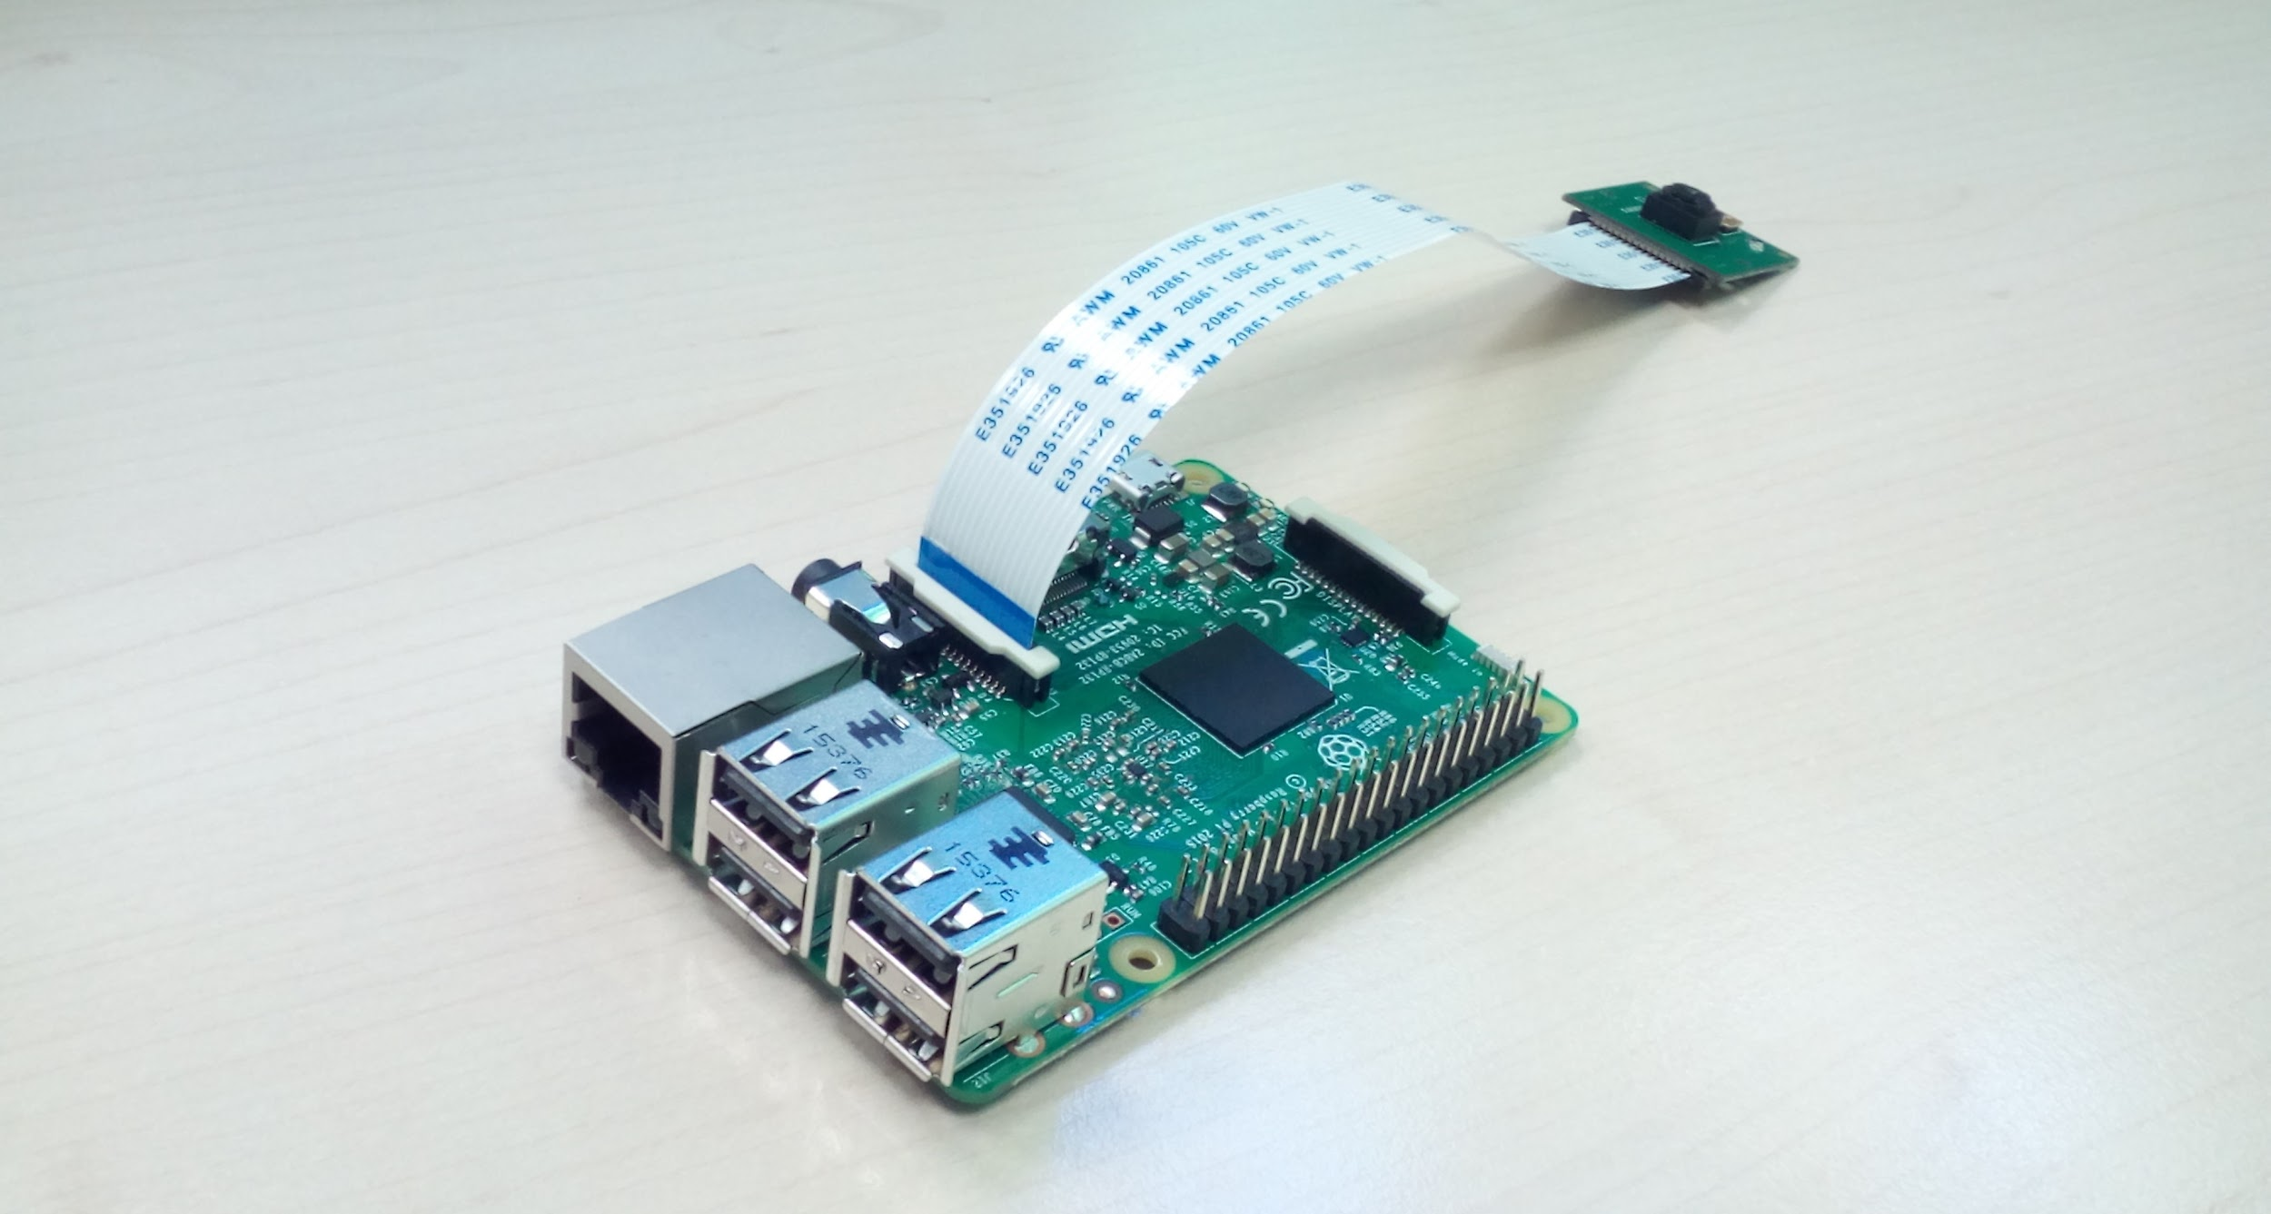
2. Follow the instructions inside the Pi-Top box to set up the monitor, inserting the Raspberry Pi within it.
   1. Attach a keyboard and a mouse to the USB ports on the side of the Raspberry Pi. These should be accessible from the side of the Pi.
3. Once you plug the Pi-Top CEED into the wall, press the power button on the left side for 2-3 seconds to power on. A “Get Started” screen will appear.
   1. Follow the on-screen instructions, connecting to WiFi when it prompts you to do so.

**[Here: Kids learned about using the Terminal and writing basic commands through the command line, and explored the games and activities on their CEED.]**

Assemble Camera

* 1. Assemble the camera using Card B:
     1. Remove the little piece of green protective film covering the camera ribbon slot. Attach the camera board to the Raspberry Pi (pinch into place). 
     2. Attach the TFT touchscreen onto the GPIO pins
     3. Plug into battery pack.
     4. The PI camera should power on if Card B was formatted properly.
  2. Test that you can tap screen on the camera to take a photo
  3. Test that you can remove thumbdrive from Raspberry Pi and plug into computer to retrieve files.

**[BELOW: This was done a bit differently, or done in advance of the time with the kids.]**

**Enable Pi Camera**

1. Next we need to enable Pi camera and try it out!
   1. To enable the camera on the Pi-Top OS, we need to adjust the configuration settings through the Terminal. To access the Terminal, open your Pi-Top Dashboard and scroll to the bottom of the Quick Launch icons.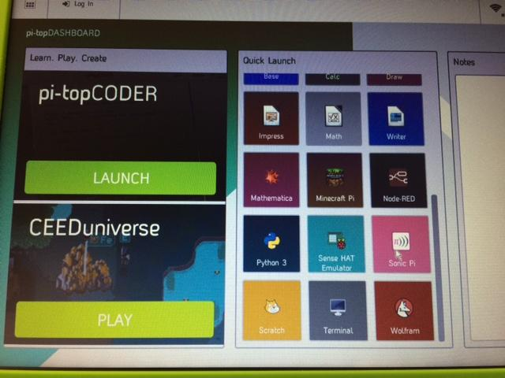
   2. In the Terminal, type “sudo raspi-config” and press Enter.
   3. The Raspberry Pi configuration tool will open. Use the arrows on your keyboard to move down to “Enable Camera” and press Enter. When it asks you if you want the camera enabled, use your keyboard arrows to move to “Yes” and press Enter again.
   4. 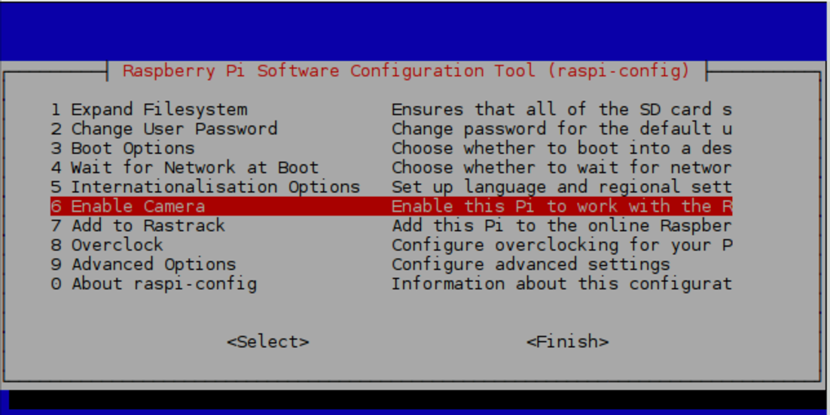
   5. You will need to reboot your Pi-Top CEED after this.

**Write your Camera script**

1. Go to your Pi Top Dashboard and open Python 3. This is where you will write Python scripts.
   1. Save your new Python file by going File > Save As “camera.py”
   2. Write the script below to try out your Pi camera and put a live feed on your monitor for 10 seconds. You need to write it EXACTLY like it is displayed below. When you’ve written this, save it (CTRL + S) and then run module (F5). The Python Shell will open, and then a live feed from your camera should appear on screen.
   3. NOTE: CTRL + D should stop the live feed if you get stuck in it (this tends to happen, don’t worry).

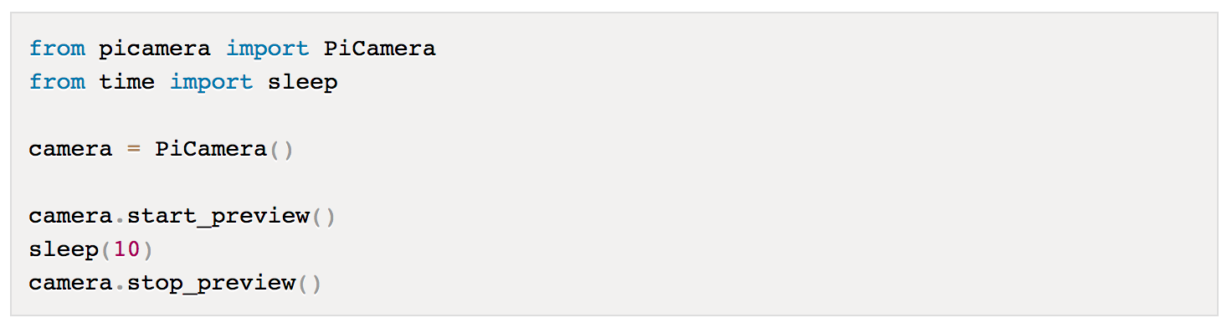

1. Now that we have taken a 10 second live feed, let’s take a picture!
   1. To take a real picture, you need to amend your code. You can use the same camera.py file. Adjust the sleep() to be 5 seconds: this means the camera will wait for 5 seconds before taking the photo. You also need to add a new line of code to capture the photo, and you need to name your photo and give it a file path on your Desktop. Add this:

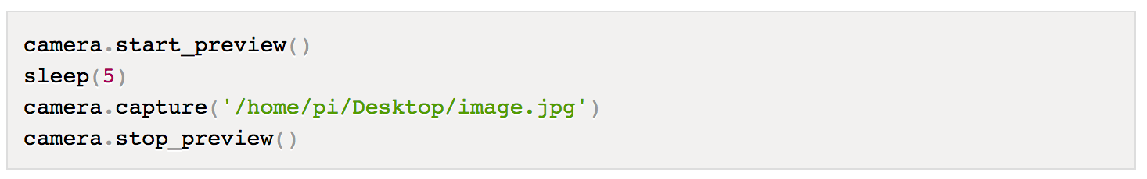

* 1. The photo that you took was saved to your Desktop. You can take more pictures using this script and changing ‘/image.jpg’ to a new file name and running the script again.

1. Now we need to adjust the script so that it will name each photo that you take something new, so that you do not have to rename every new file in the camera.py script every time you want to take a photo. To do this, we will create a “random” function using Python’s random library that will name each photo a random string of letters. In the script, we tell each file name to be 4 letters long (look at the script photo - can you figure out which part does that?!).
   1. Create a new Python file or rework your existing camera.py file and make it look just like the script below.
   2. The “filename” is where your photos will be stored. So we will modify this in the next step.
   3. 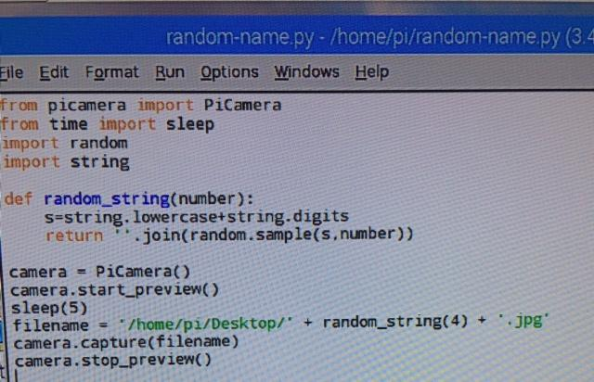
2. Now that we can generate a new file name each time we take a picture, we are going to have a lot of pictures. So let’s create a folder where all our photos can live!
   1. Create a new folder by going to the folders icon in the top left of the menu bar to open your files. Then go File > Create New and name your folder “Images”
   2. Now let’s adjust our script to assign the new folder as the destination for your photos. To do this, go to the filename variable and replace the current destination (desktop) with your folder’s name. In this case it should be: filename=’/images’
   3. Test it out to make sure your images are going into your folder! Then celebrate because you’re being so organized.

**Summary**

At this point we have:

* Set up the Pi Camera
* Tried out a live feed
* Taken photos with a 5 second delay
* Written a script to rename every photo something random
* Created a folder and told our camera to save all pictures there

NOTE: We should decide if there are other things we want to introduce the students to with the Pi Camera. The kids can extend the code to do things like:

* Take video
* Add cool effects to the photos
* Adjust brightness when taking photo
* Take multiple photos in a row

**Installing the PiTFT touchscreen**

We are going to install a touchscreen that connects to our Raspberry Pi so that we can use our camera when we are not connected to a monitor. The touchscreen will allow us to see our desktop and interact with the Raspberry Pi through a familiar graphical interface.

1. We need to download and install Kernel, which is the software that we need for our touch screen for the Raspberry Pi.
2. This [documentation](https://learn.adafruit.com/adafruit-pitft-28-inch-resistive-touchscreen-display-raspberry-pi/easy-install) tells you everything you need to do this in great detail.

NOTE: This takes a really long time (at least 30 minutes to install) and has some tricky steps of working within the Terminal . So we might need to install the software before working with the students, but involve them in the step of plugging in the touch screen.

1. Attach the touchscreen to the Pi (pictures and instructions coming)

Here is the [full documentation on using Pi Camera](https://picamera.readthedocs.io/en/release-1.13/index.html).