Problem Definition
We want to look for patterns who can identify the direction of price change in the next trading day. To do so, different discretization techniques have been applied to the next day price variation to split it in two or three classes:12
- Discretization in two classes (SELL/BUY) by thresholding on 0.0
- Discretization in two classes (SELL/BUY) by quantile binning at 50%
- Discretization in three classes (SELL/HOLD/BUY) by thresholding on -1.0 and +1.0
- Discretization in three classes (SELL/HOLD/BUY) by quantile binning at 33% and 66%

Feature Engineering
Feature engineering is the manipulation of existing features to change their statistical properties or produce new ones, allowing the embedding of domain knowledge into the model.
Working with time-series data normalization is especially important since classifier’s performance on non-stationary data (which presents trend and seasonality components) is usually very poor.

Feature Selection
Feature selection is one of the most important steps in developing a machine learning model.
Features can either be picked manually, or by applying automated methods: the difficulty of manually selecting features is the need of expert knowledge about the data at hand.
The objective is identifying a subset of the most descriptive features from a larger collection, the advantages of this step are numerous: it reduces the model’s complexity making it easier to find the best solution, it decreases the time it takes to train the model (which is proportional to the number of inputs) and most importantly, by combining automated methods with little domain knowledge, allows us to gain a deeper insight about the problem.
Thankfully, automated feature selection methods have been developed to aid in this task, however they must be applied with a grain of salt, as they might lead to erroneous conclusions. They can be divided in:
- Filter methods: Select features based on statistical measures such as variance (features with zero variance are not informative) and correlation (highly correlated features are likely linearly dependant, and therefore add no information). These methods are cheap, powerful, and simple relying only on the characteristics of the data.
- Wrapper methods: Consider feature selection as an optimization problem, employing an estimator and a search strategy to look through the space of possible feature subsets aiming to find the best performing model and subset of features
- Embedded methods: Exploit the fact that some classifiers such as decision trees intrinsically perform feature selection during the model training itself

Methodology
The first step of feature selection is dataset cleaning: variance threshold has been applied in the data pre-processing step to ensure the removal of non-informative features.
Correlation matrices have then been produced for each dataset, separately for differentiated features and percent variations. Correlation with target classes/percent variation is also examined: while correlation between features is not desirable, correlation (either positive or negative) between features and our targets would express a welcome linear relationship.
After splitting the data with a 70:30 train/test ratio, automated techniques have also been applied on the training set, in particular:
- A Random Forest Classifier (embedded method) has been trained on the whole feature set
- Recursive Feature Elimination with 5-fold cross-validation (RFECV) has been applied using a Random Forest Classifier as estimator
- Genetic Search with 5-fold cross-validation has been applied using a Random Forest Classifier as estimator
The feature_importances_ attributes of the resulting estimators are collected and compared, results are discussed separately for each cryptocurrency in the following paragraphs.

Feature Selection Results

ADA

Correlation Matrices
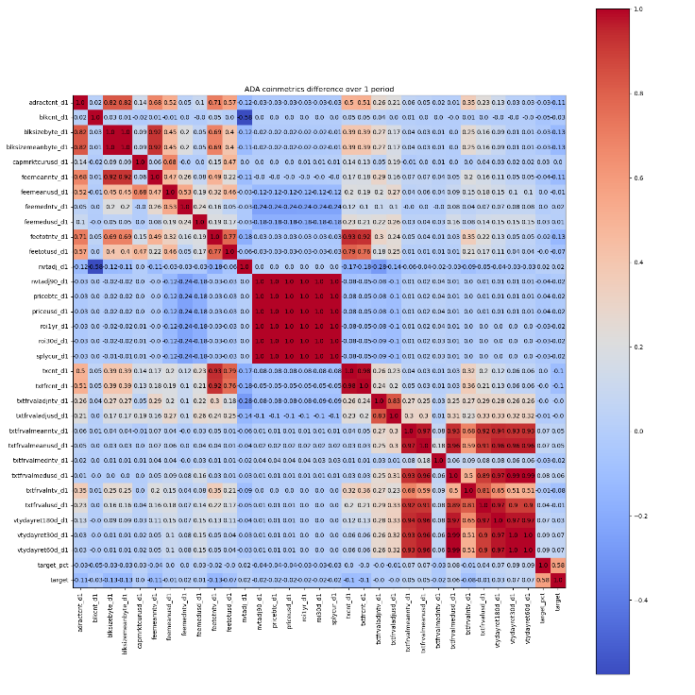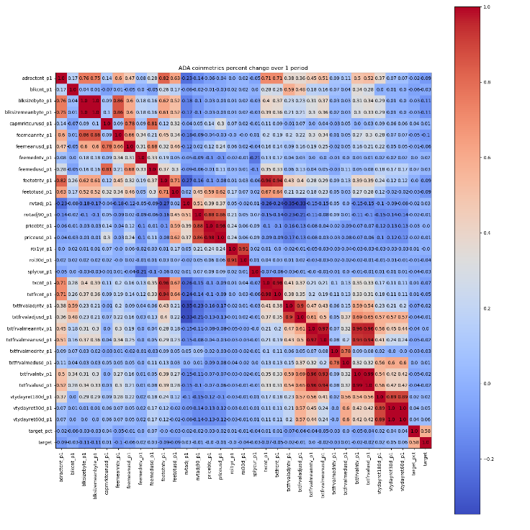

Feature Importances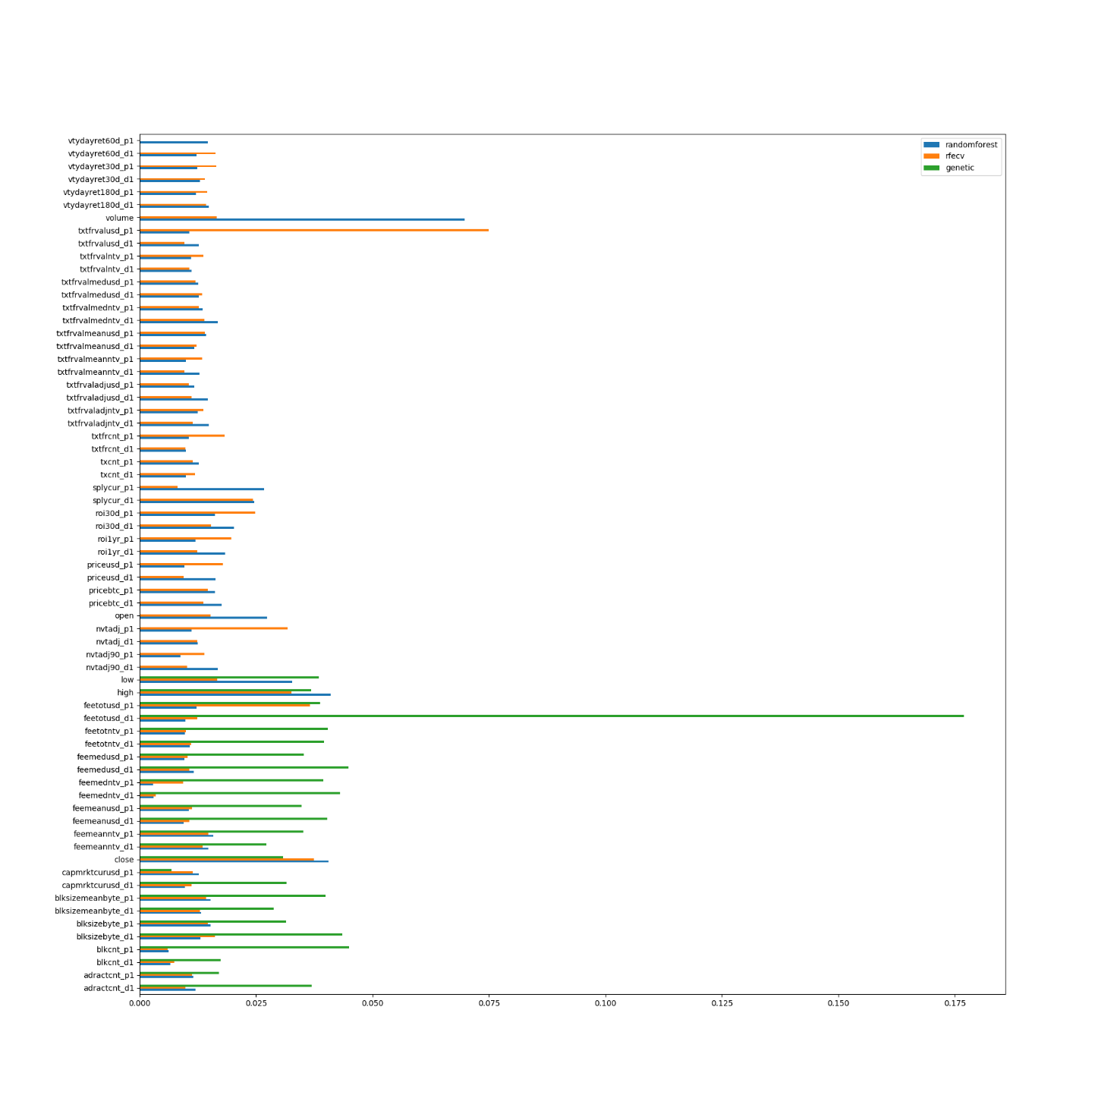

Discussion
Cardano, also known as ADA, is a platform allowing complex programmable transfers of value supporting smart contracts, as well as a cryptocurrency. It is based on a proof-of-stake protocol, which means coins are mined by “staking” them to verify transactions. The project is open source, and incentivizes user’s participation both in network improvement and governance with tokens.
Correlation matrices shows how there is no strong correlation between any of the features and our targets.
Analyzing the feature selection results, seems like RFECV has failed in identifying dependencies between features (as only one feature is left out of the support): as we can see from the correlation matrices, most of the features included in the support are highly correlated. Genetic search results on the other hand highlight the relevance of market activity (ohlcv, capitalization) and on-chain activity (fees, block size, block count and active address) in next day’s price direction classification, with particular importance given to total fees in USD, which directly influence staking rewards and ROI.

BCH

Correlation Matrices
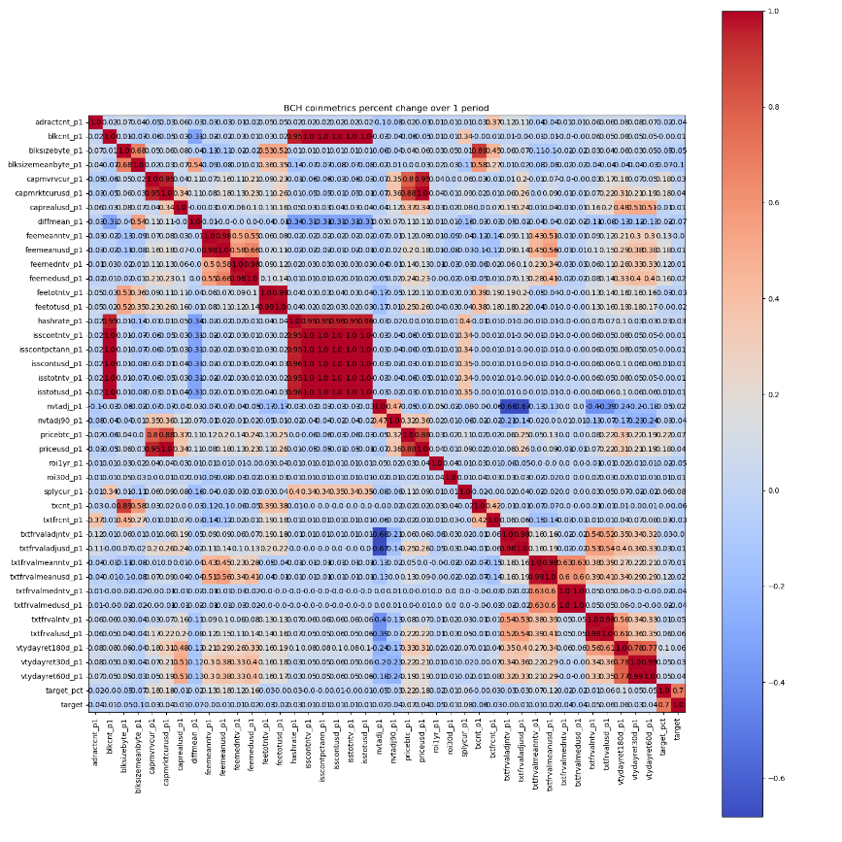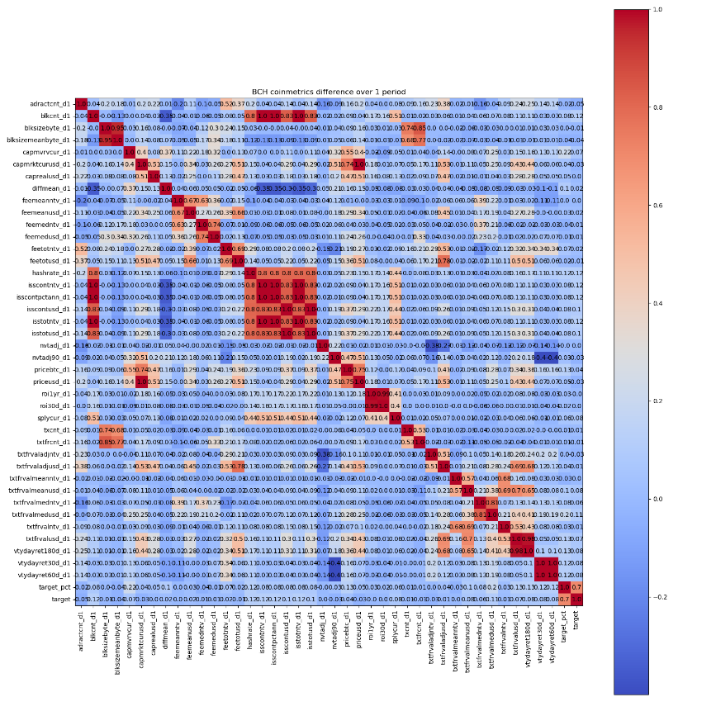

Feature Importances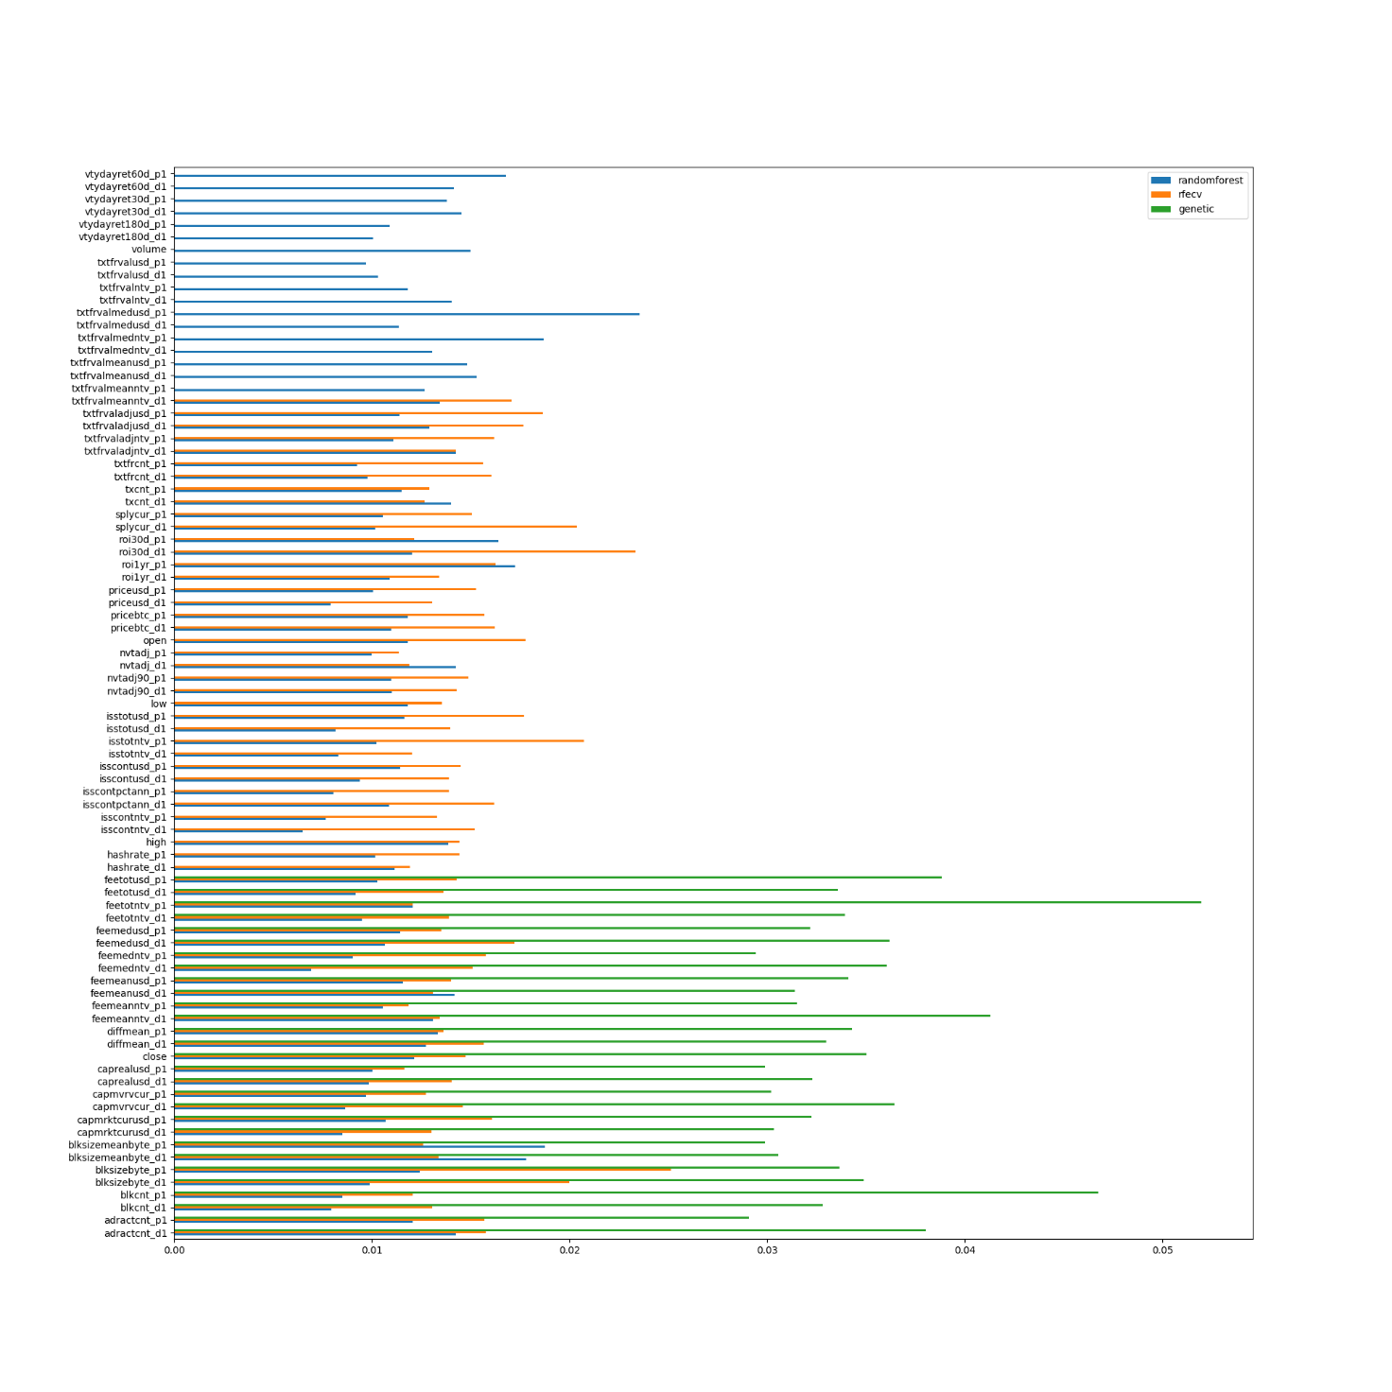

Discussion
Bitcoin Cash (BCH) is the first hard-fork of the original Bitcoin protocol, activated on 01/08/2017.
On 16/11/2018 the BCH blockchain was further split in BCH-ABC and BCH-SV (Satoshi Vision). Of these, the dominant chain (the one with most hashpower and nodes) was BCHABC so it kept the BCH ticker.
Correlation analysis shows the characteristics of a PoW blockchain: hashrate is known to be strongly correlated to difficulty and newly issued tokens, ROI presents a strong correlation with volatility and transaction fees. Market capacity, transaction fees and price action present a correlation with percentile next day price variation, but not with target classes.
Again, seems like Genetic Search performed better in identifying independent variables. Between difficulty and hashrate the former was chosen, as it is automatically adjusted by the network every fixed amount of blocks, in response to changes in hashrate. Most of the selected features are related to on-chain activity such as fees, block size and count and active addresses, however market capacity and closing price also play a role.

BNB
BNB was launched with an ICO in 2017, before the Binance cryptocurrency exchange went online. It was originally issued as an ERC-20 token hosted on the Ethereum network with a 200M coins cap, of which 100M were offered in the ICO.
In April 2019, with the launch of Binance Chain Mainnet, ERC-20 BNB tokens were swapped with BEP2 BNB native tokens in a 1:1 ratio. BNB tokens can be used as payment method, to pay for fees on the Binance exchange, to participate in token sales from Binance Launchpad and are at the heart of the Binance DEX decentralized exchange. They cannot be mined, since their blockchain uses the Byzantine Fault Tolerance consensus mechanism opposed to the PoW used in Bitcoin, instead validators earn from securing the network by validating blocks, while Binance itself periodically performs coin burns based on the number of trades in the exchange over the past three months.
Correlation analysis shows a strong bond between number of active addresses and transactions, justified by the fact that fees on Binance exchange are discounted if paid in BNB, transaction-related features also highlight the relationship between volatility and number of trades.
Feature selection results support this as selected features are mostly related to supply, transactions and ROI.

BTC
Bitcoin is the very first cryptocurrency ever created, it is completely decentralized allowing online payments to be sent without the need of a trusted third party.
Its protocol uses a Proof-of-Work (PoW) blockchain, which means miners use their hashpower in order to solve a cryptographic puzzle: when the correct solution is found the block is accepted into the blockchain, earning the miner a reward, as well as fees from the transactions he confirmed in the block.
Correlation analysis shows how newly issued (minted) coins are strongly related to block count and hashrate, while transaction fees features are related to hashrate and supply.

