Pedram Safaei
CS477
HW5
1.
a) There is a recursive relation on the below function so it counts as a recursive formula not a recursive implementation we are going to use a base case of 0, loop through our container which is a group of vectors at this case, and we start initializing this container m, so m[i][j] would be whatever is at i-j in our map’s max member (it is going to be a number of drones which is initialized to 0 at the beginning) plus the minimum of the xi that we have contained in a vector and f[j] which we have also decided to contain in a vector, at the end we get the max element of these group of vectors by looping through them and comparing them (I am just assuming the user will use the max element function from the STL so I am not implementing a method for finding this max element). The final time complexity would be O(n^2) which is not bad considering that without dynamic programming the time complexity would be exponential.

void Solution_Recursive_Relation(map<int, Drones>VALUE, vector<vector> m, vector Function_Value, vector Xi_Value )
{
i;
j;
maxPtr;

for( i = 1; i < Function_Value.size(); i++ )
{
m[i][0] = 0;

for(j = 1; j <= i; j++ )
{
m[i][j] = VALUE[i-j].MAX + min( Xi_Value[i], Function_Value[j] );
}

maxPtr = max_element(m[i].begin(), m[i].end());
j = distance(m[i].begin(), maxPtr);

// here we save optimal
MAP_VALUE[i];
MAP_VALUE[i].MAX = *maxPtr;
}

}

b) I am using the numbers that were given to us on the HW

void Solution_Recursive_Relation( std::unordered_map<int, Drones> &MAP_VALUE, std::vector<std::vector<int>> &m, std::vector<int> &Function_Value, std::vector<int> Xi_Value )
{
unsigned int i;
unsigned int j;
std::vector<int>::iterator maxPtr;
// Im using STL just to save time

// loop through
for( i = 1; i < Function_Value.size(); i++ )
{
m[i][0] = 0;
for(j = 1; j <= i; j++ )
{
m[i][j] = MAP_VALUE[i-j].MAX + std::min( Xi_Value[i], Function_Value[j] );
}
// find max for second
maxPtr = max_element(m[i].begin(), m[i].end());
j = distance(m[i].begin(), maxPtr );

// save optimal
MAP_VALUE[i];
MAP_VALUE[i].MAX = *maxPtr;
}

}

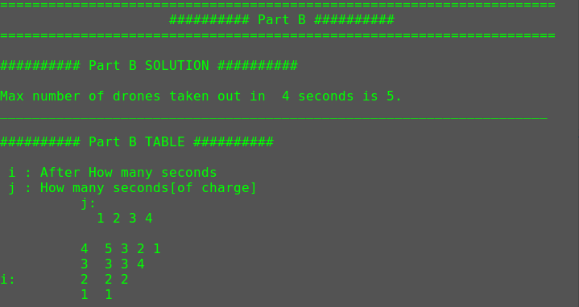
C) we basically add
MAP_VALUE[i].PREVIOUS = i – j;
to the end of the algorithm from part B

void Solution_Recursive_Relation( std::unordered_map<int, Drones> &MAP_VALUE, std::vector<std::vector<int>> &m, std::vector<int> &Function_Value, std::vector<int> Xi_Value ){
unsigned int i;
unsigned int j;
std::vector<int>::iterator maxPtr; // Im using STL just to save time

// loop through
for( i = 1; i < Function_Value.size(); i++ ){
m[i][0] = 0;
for(j = 1; j <= i; j++ ){
m[i][j] = MAP_VALUE[i-j].MAX + std::min( Xi_Value[i], Function_Value[j] );
}
// find max for second
maxPtr = max_element(m[i].begin(), m[i].end());
j = distance(m[i].begin(), maxPtr );

// save optimal
MAP_VALUE[i];
MAP_VALUE[i].MAX = *maxPtr;

// part C
MAP_VALUE[i].PREVIOUS = i - j;

//part D
MAP_VALUE[i].TIME = MAP_VALUE[i-j].TIME;
MAP_VALUE[i].TIME.push_back(i);
}

}
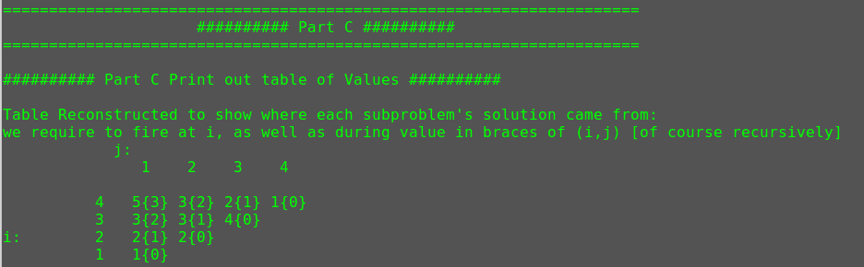
D) Again we only have to add a line to our algorithm from part B which is
MAP_VALUE[i].TIME = MAP_VALUE[i-j].TIME;
MAP_VALUE[i].TIME.push_back(i);

// solve solution, recursive relation solution
void Solution_Recursive_Relation( std::unordered_map<int, Drones> &MAP_VALUE, std::vector<std::vector<int>> &m, std::vector<int> &Function_Value, std::vector<int> Xi_Value )
{
unsigned int i;
unsigned int j;
std::vector<int>::iterator maxPtr; // Im using STL just to save time

// loop through
for( i = 1; i < Function_Value.size(); i++ )
{
m[i][0] = 0;
for(j = 1; j <= i; j++ )
{
m[i][j] = MAP_VALUE[i-j].MAX + std::min( Xi_Value[i], Function_Value[j] );
}
// find max for second
maxPtr = max_element(m[i].begin(), m[i].end());
j = distance(m[i].begin(), maxPtr );

// save optimal
MAP_VALUE[i];
MAP_VALUE[i].MAX = *maxPtr;

// part C
MAP_VALUE[i].PREVIOUS = i - j;

//part D
MAP_VALUE[i].TIME = MAP_VALUE[i-j].TIME;
MAP_VALUE[i].TIME.push_back(i);
}

}
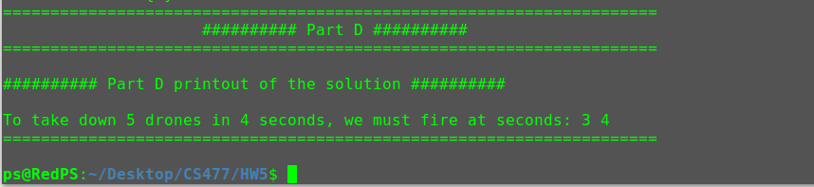
2.
I’ll show one, the others will be computed just like below
C and B
3*5*2 = 30
30 + 0 = 30
C and A
4*3*2 = 24
24+30 = 54
so our final result would be C*B*A

 | A | B | C
C | 54 | 30 | 0
B | 60 | 0 | -
A | 0 | - | -

3.

LCS = Longest Common Subsequence

A) True
Let’s say we start X and Y with A then A has been used as a prefix to the LCS of some sequence of x1 and Y1 which is the sequence – first character of their sequence)this way we are not reducing the possible LCS of our X and Y

B) True
This is the same as what we discussed earlier in part A if we add A to LCS of x2 and Y2 which are sequences with no last character of A then that will produce LCS result for X and Y

