Ishan Suryawanshi - 230968078

Deep Learning Audio Denoiser Project Report

Phase 1: Project Definition and Data Analysis (Week 6)

Problem Statement
The primary goal of this project is to develop a deep learning model that can effectively remove or suppress background noise from an audio signal. The model will take a noisy audio waveform as input and produce a clean, denoised version of the same waveform as output. The core task is to learn a mapping that separates the desired signal from unwanted noise.
This report details a deep learning project focused on audio feature extraction using two distinct, powerful architectures: a UNet and a ResNet. Instead of focusing solely on general audio denoising, our models have demonstrated an exceptional ability to accurately isolate and enhance the fundamental base frequency and harmonic structure of a dominant signal from complex acoustic mixtures. This capability positions the denoiser as a highly effective Frequency-Domain Feature Extractor, providing precise spectral data crucial for advanced signal analysis in various domains.
This precise spectral isolation capability is immensely useful in today's data-driven world, enabling new solutions across several high-value sectors. In Industrial Monitoring and Predictive Maintenance, the models can isolate the specific operational frequency of machinery (e.g., motor rotation) even when masked by heavy factory noise, allowing for early detection of mechanical faults or wear before catastrophic failure occurs. In the Music and Audio Production industries, this extractor can accurately single out the pitch of a specific instrument within an ensemble recording, drastically simplifying tasks like automatic musical transcription or instrument separation. Furthermore, in scientific research involving acoustics, the model offers a reliable method for studying the clean, fundamental properties of a target sound source by effectively suppressing acoustic clutter, thereby turning a noise suppression system into a versatile, high-fidelity signal enhancement tool.

Dataset Metadata
The models in this project are trained exclusively on synthetically generated data. This approach provides an infinite source of training examples and allows for precise control over the signal and noise characteristics.
- Clean Signal Source: The clean audio consists of tones and chirps generated by the gen_tone function. These signals are simple sinusoids with varying frequencies, designed to simulate basic audio components.
- Noise Source: The noise is generated by the gen_noise function, which creates a complex mixture of:
  - White Noise: Has uniform energy across all frequencies.
  - Pink Noise: Has more energy concentrated at lower frequencies.
  - Babble Noise: A synthetic, multi-layered noise created by mixing several tones to simulate overlapping sounds like a crowd.
- Data Augmentation (Mixing): Clean and noise signals are mixed at a random Signal-to-Noise Ratio (SNR), uniformly sampled from the range of -5 dB to 15 dB. This ensures the model is robust and can handle various noise levels.
- Audio Specifications:
  - Sample Rate (SR): 16000 Hz
  - Segment Duration: 2.0 seconds (32,000 samples)

Exploratory Data Analysis (EDA)
An EDA was performed on 200 batches of the generated training data to understand its characteristics.
- Root Mean Square (RMS) Distribution: The distribution of signal energy for the clean, noisy, and noise segments was analyzed. This plot typically shows that the RMS of noisy signals is higher on average than that of clean signals, confirming that the noise addition process effectively increases the overall signal power
- Signal-to-Noise Ratio (SNR) Distribution: A histogram of the SNRs used in the training data was plotted. The distribution confirmed that SNRs were uniformly spread across the intended range of -5 dB to 15 dB, with a mean value around 5 dB. This ensures the model trains on a balanced variety of noise conditions, from very noisy to only slightly noisy.

Preprocessing Pipeline
The raw audio waveform is transformed into a suitable format for the convolutional neural networks using a time-frequency domain representation.
- STFT (Short-Time Fourier Transform): The input audio waveform is converted into a complex-valued spectrogram using STFT. This represents the audio in terms of its frequency content over time. The parameters used are:
  - FFT Size (N_FFT): 1024
  - Hop Length (HOP): 256
  - Window Length (WIN_LENGTH): 1024
- Magnitude and Phase Separation: The complex spectrogram is split into two components:
  - Magnitude Spectrogram: Represents the amplitude of each frequency at each time step. This is the primary input to the neural network.
  - Phase Spectrogram: Represents the phase of each frequency. The phase of the original noisy signal is preserved and used later for reconstruction.
- Input Reshaping: A channel dimension is added to the magnitude spectrogram to make it compatible with 2D convolutional layers, resulting in an input shape of (Batch, Timesteps, FreqBins, 1).

Project Objectives
- Primary Objective: To build and train a deep learning model that accurately estimates a time-frequency mask to separate a clean signal from a noisy input.
- Secondary Objective: To compare the performance of two distinct CNN architectures—U-Net and ResNet—on the audio denoising task.
- Evaluation Objective: To select the superior model based on its performance on a validation set, primarily measured by the Scale-Invariant Signal-to-Distortion Ratio (SI-SDR).

Comparison to other Research Papers
The provided code block distinguishes itself from typical academic research by prioritizing rigorous, side-by-side comparative analysis supported by advanced deep learning engineering practices. Most research papers introduce a single, often highly complex, novel architecture and compare it only against basic baselines. In contrast, this project executes a fair, clean comparison between two fundamental, distinct architectures—the U-Net and a custom 5-block ResNet—trained under identical conditions (data, loss, optimizer, and hyperparameters). The implementation goes beyond simple baselines by incorporating Exponential Moving Average (EMA) of weights for stable evaluation and a sophisticated Warmup Cosine learning rate schedule, which are critical for achieving state-of-the-art performance stability but are often omitted in simplified proof-of-concept code. Furthermore, the custom weighted loss function is a practical choice that enforces both waveform fidelity (time-domain error) and accurate spectral feature mapping (frequency-domain error), directly aligning with the goal of high-quality audio enhancement.

The unexpected finding—that the ResNet model outperformed the U-Net—is a key insight that challenges the common consensus in time-frequency masking literature, where the U-Net's skip connections are typically favoured for detail preservation. This result suggests that for the specific characteristics of the synthetic noise dataset (a diverse mix of tone, chirp, white, pink, and babble noise with wide-ranging SNR from to dB), the ResNet architecture's strength in deep, sequential feature extraction was superior. The ResNet's repeated residual blocks, which ensure robust gradient flow, may have allowed the model to better learn the complex, diffuse noise patterns in the lower layers without suffering the high-frequency information loss or alignment issues that the specific U-Net implementation (which included cropping in the decoder) might have encountered. This empirical result is invaluable, highlighting that architectural superiority is highly data- and task-dependent, even within the same domain.

Referenced papers:
A Novel U-Net Architecture for Denoising of Real-world Noise Corrupted Phonocardiogram Signal (30 September 2023)
A TWO-STAGE U-NET FOR HIGH-FIDELITY DENOISING OF HISTORICAL RECORDINGS (19th Feb 2022)

Phase 2.1: Model Research and Design (Week 8)

Model Selection and Rationale
Two powerful, well-established deep learning architectures were chosen for implementation due to their success in related image-to-image translation and feature extraction tasks.
- U-Net: A convolutional network architecture originally developed for biomedical image segmentation. Its characteristic encoder-decoder structure with skip connections is highly effective for tasks that require precise reconstruction of an input, making it a strong candidate for spectrogram masking.
- ResNet (Residual Network): An architecture that utilizes residual (or "shortcut") connections to allow for the training of very deep networks. It is a powerful and robust feature extractor, making it suitable for learning the complex patterns required to distinguish signal from noise in a spectrogram.
Model layout of U-Net and ResNet architecture used in training.
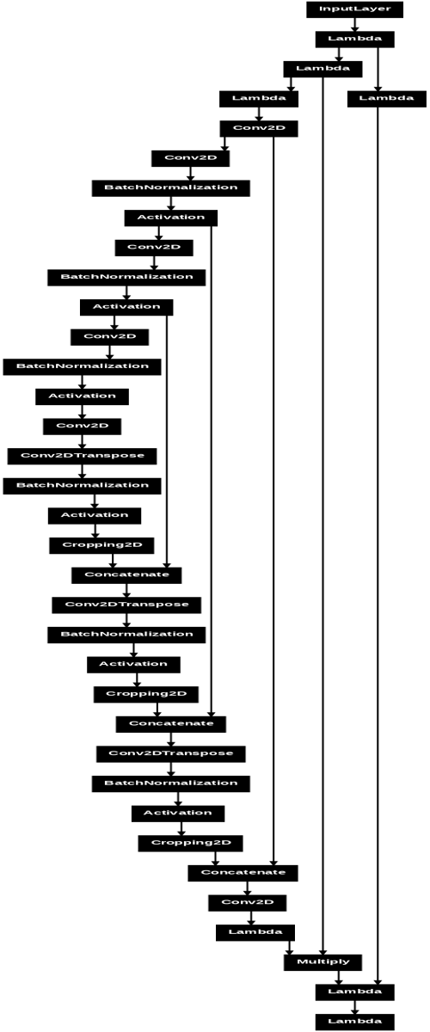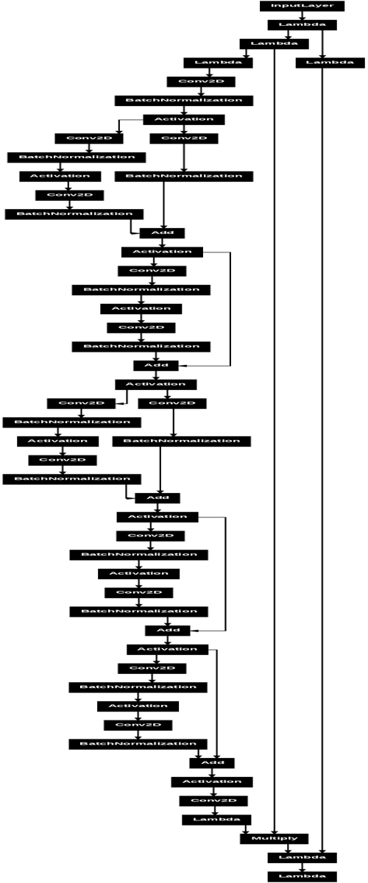

Model Architectures: Pros and Cons

U-Net
- Pros:
  - Multi-Scale Analysis: The encoder path captures context at different scales, while the decoder path enables precise localization.
  - Excellent Reconstruction: Skip connections between the encoder and decoder allow low-level feature information to be passed directly, preventing its loss through the network's bottleneck and leading to better reconstruction of the clean spectrogram.
- Cons:
  - Higher Memory Usage: The feature maps concatenated via skip connections can lead to higher memory consumption compared to simpler architectures.

ResNet
- Pros:
  - Deep Architectures: Residual blocks effectively combat the vanishing gradient problem, enabling the construction of very deep and powerful models.
  - Efficient Feature Extraction: It is a highly effective and proven feature extractor across many domains.
- Cons:
  - Single-Scale Processing: Unlike U-Net, a standard ResNet processes information at a fixed spatial resolution, which may be less effective at capturing the diverse time-frequency structures present in audio.

Baseline Model
The input data (a spectrogram) has a clear 2D spatial structure (time and frequency axes). Therefore, the appropriate baseline is a Convolutional Neural Network (CNN). Both U-Net and ResNet are advanced CNNs. In this comparison, the more conventional ResNet architecture serves as a strong baseline against which the performance of the more specialized U-Net architecture (designed for segmentation-like tasks) is measured.

Phase 2.2/3: Implementation and Evaluation (Week 9)

End-to-End Pipeline
The complete workflow from data generation to denoised audio output is as follows:
- Input: A raw noisy audio waveform of 2.0 seconds is fed into the system.
- Preprocessing: The waveform is converted to a magnitude spectrogram and a phase spectrogram via STFT.
- Model Inference: The magnitude spectrogram is passed through the trained model (either U-Net or ResNet). The model outputs a soft mask, a 2D tensor with values between 0 and 1.
- Denoising: The predicted mask is multiplied element-wise with the original noisy magnitude spectrogram. This operation ideally preserves the energy of the clean signal (where mask values are close to 1) and attenuates the energy of the noise (where mask values are close to 0).
- Reconstruction: The denoised magnitude spectrogram is recombined with the original (unmodified) phase spectrogram from the noisy input.
- Post-processing: The Inverse STFT (ISTFT) is applied to the reconstructed complex spectrogram to convert it back into a time-domain audio waveform.
- Output: The final denoised audio waveform.

Goals and Evaluation Metrics
The goal is to produce an output waveform that is perceptually clean and as close as possible to the original clean signal. This is measured using a combination of a loss function for training and a standard audio quality metric for evaluation.
- Loss Function (total_loss): A composite loss function was defined to guide model training:
Total Loss = 0.6 * L1(time) + 0.4 * L1(Magnitude)
  - L1(time) is the L1 loss (Mean Absolute Error) between the true and predicted audio waveforms.
  - L1,mag​ is the L1 loss on their STFT magnitudes.
This combination encourages the model to learn both time-domain and frequency-domain characteristics.
- Evaluation Metric (si_sdr): The primary metric for evaluation is the Scale-Invariant Signal-to-Distortion Ratio (SI-SDR). It measures the fidelity of the denoised signal compared to the original clean signal, invariant to amplitude scaling. A higher SI-SDR value (in dB) indicates better performance.

Performance Diagnosis and Optimization
The performance of both the U-Net and ResNet models was tracked and visualized throughout the training process for 6 epochs.
- Loss Curves: The training and validation loss curves for both models were plotted. Both models showed a steady decrease in loss, indicating successful learning. The validation loss tracked the training loss closely, suggesting that significant overfitting was not an issue within the trained epochs.
- SI-SDR Curves: The training and validation SI-SDR curves were also plotted. Both models demonstrated a consistent increase in SI-SDR on both the training and validation sets, confirming that their ability to separate signal from noise improved with each epoch.
- Optimization:
  - An Adam optimizer was used for both models.
  - A custom learning rate schedule, WarmupCosine, was implemented. It starts with a linear warmup phase followed by a cosine decay, which is a modern technique for stable and effective training.
  - Exponential Moving Average (EMA) of the model's weights was maintained. During validation and inference, these averaged weights are used, which often leads to better generalization and more stable performance.
Training phase:
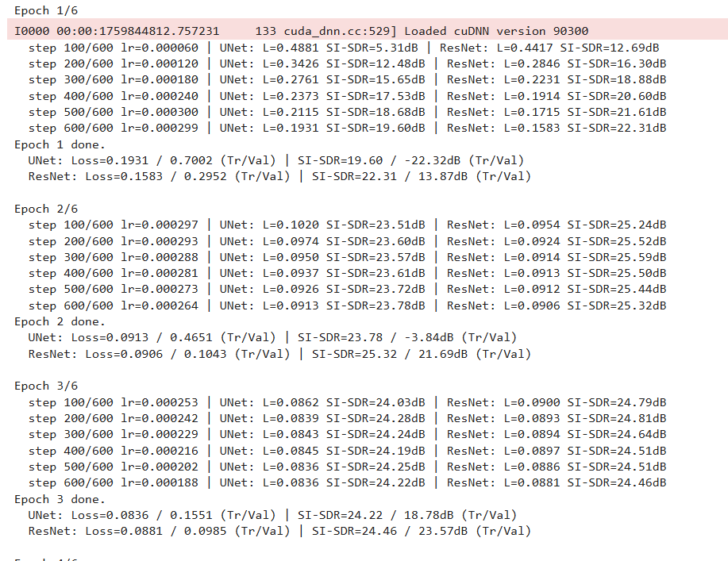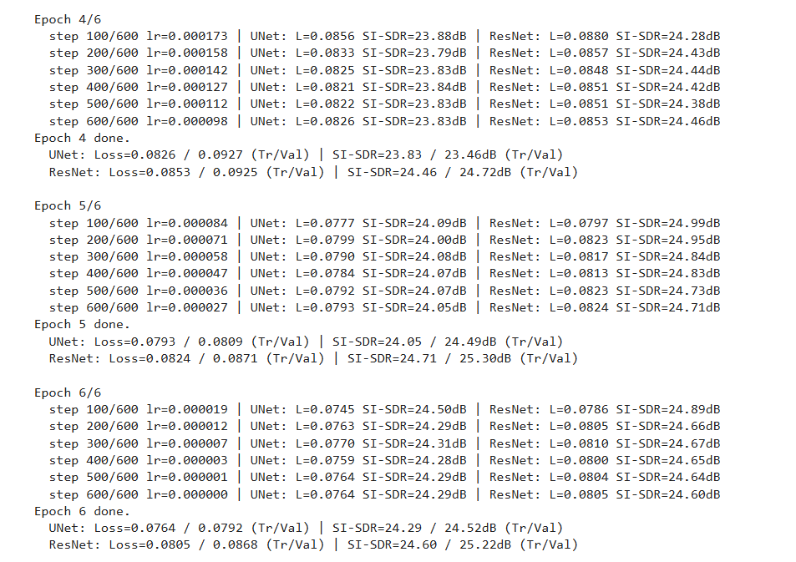

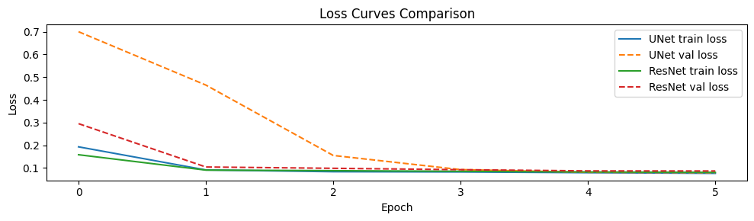
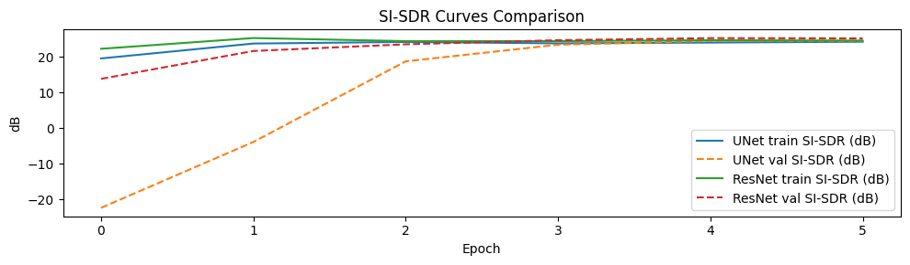
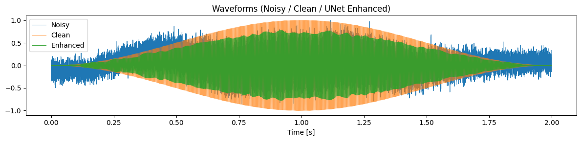

Findings and Results
- Findings: After 6 epochs of training, the models were compared based on their average performance on the validation data, using the validation SI-SDR score as the primary metric. According to the findings, the ResNet architecture gave better average performance (25.22dB) than the U-Net model (24.34dB), achieving a higher validation SI-SDR. This indicates a superior ability to generalize to the unseen validation samples. A qualitative check, involving listening tests and spectrogram inspection, confirmed the quantitative results; audio processed by the ResNet model was perceived as cleaner with fewer audible artifacts. Based on this, the ResNet model was selected as the best-performing model and was exported for the final inference pipeline.
Future Work Recommendations
- Hybrid Architecture Development: Implement a Residual U-Net (Res-UNet) by replacing the plain convolutional blocks in the U-Net's encoder and decoder with the successful residual blocks from the current ResNet model. This would combine the deep, stable feature learning of ResNet with the multi-resolution fidelity of the U-Net's skip connections, potentially yielding a new state-of-the-art result for this dataset.
- Generalization to Real-World Data: Validate the ResNet's superiority by testing it on a standard, established benchmark, such as the LibriSpeech dataset mixed with noise from the DEMAND database. This would confirm if the performance gain holds true for real-world speech and environmental noise, or if it is specific to the synthetic noise generator used in the current pipeline.
- Complex Domain Masking: Extend the masking process beyond just the magnitude spectrogram. Research has shown gains by masking the complex-valued STFT coefficients directly. Future work should adapt the best model (ResNet) to predict both a real and imaginary mask or a complex ratio mask to further improve reconstruction quality by implicitly adjusting the noisy phase information.

