Project Design

GiftPal – The Ultimate Gift Exchange and Reminder App

Submitted in fulfillment

Of the requirements of

CMSC 495 Current Trends and Projects in Computer Science

(Group Project)

Bazz Khurshid

Graham Primm

Kalala Kalamba

Nicholas Sink

|  |  |
| --- | --- |
| **Document ID** | GiftPal PD-v1.0 |
| **Version Number** | 1.0 |
| **Due Date** | April 11, 2023 |
| **Classification** | Public |
| **Instructor** | Hung Dao |
| **This submission is by** | Bazz Khurshid, Graham Primm, Kalala Kalamba, Nicholas Sink |

**Revision History**

|  |  |  |  |
| --- | --- | --- | --- |
| **Date** | **Version** | **Description** | **Author (s)** |
| 04/07/2023 | 1.0.0 | Draft Version | Nicholas Sink |
| 04/08/2023 | 1.0.1 | Added normal operations scenarios 1 to 5 event-trace descriptions and conditions | Nicholas Sink |
| 04/09/2023 | 1.0.2 | Added Pseudocode Screenshots | Graham Primm |
| 04/10/2023 | 1.0.3 | Added normal operations scenarios 1 to 5 event-trace diagrams | Nicholas Sink |
| 04/10/2023 | 1.0.4 | Added event-trace diagrams for normal operation scenarios 6 to 9 | Bazz Khurshid |
| 04/11/2023 | 1.0.5 | Added Start-up, Shut-down, Error handling scenarios | Kalala Kalamba |
| 04/11/2023 | 1.0.6 | Added Unresolved risk/ risk mitigation | Kalala Kalamba |
|  |  |  |  |
|  |  |  |  |
|  |  |  |  |
|  |  |  |  |
|  |  |  |  |

**Normal Operations Scenarios**

1. Account Creation

Description: The user creates an account with GiftPal.

Pre-condition: The application is running, and the database is initialized.

Post-condition: The user’s GiftPal account has been created.

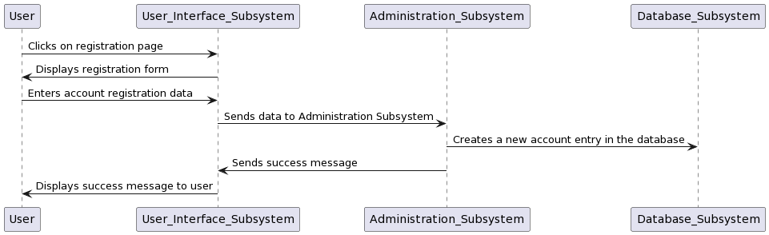

1. User Login

Description: The user logs in to their GiftPal account.

Pre-condition: The application is running, the database is initialized, and a user account has been created.

Post-condition: The user has logged in to their account and a logon message is displayed.

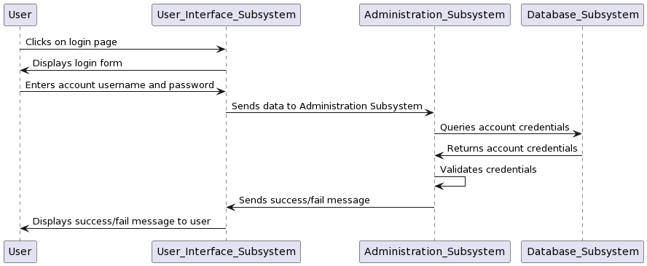

1. Gift Preference Addition

Description: The user adds gift preferences to their account.

Pre-condition: The application is running, the database is initialized, a user account has been created, and the user is logged in.

Post-condition: Gift preferences have been added by the user and stored in the database.

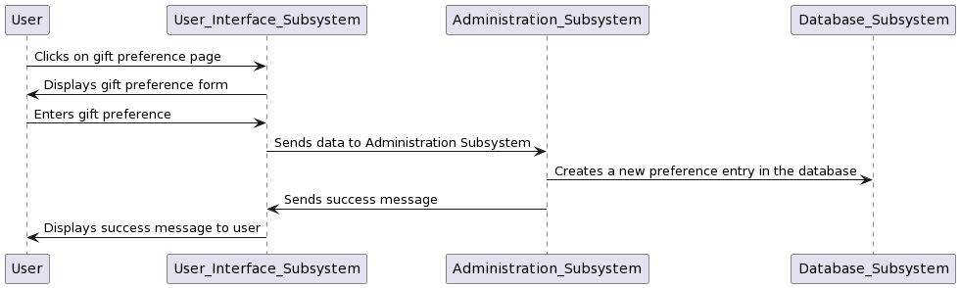

1. Loved One’s & Date Addition

Description: The user adds loved one's names and special dates to their account.

Pre-condition: The application is running, the database is initialized, a user account has been created, and the user is logged in.

Post-condition: Loved one's names and special dates have been added by the user and stored in the database.

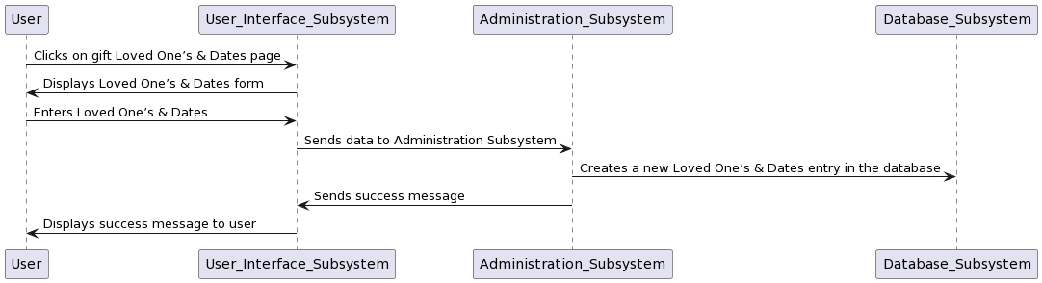

1. Group Registration

Description: The user registers others in their group

Pre-condition: The application is running, the database is initialized, multiple user accounts have been created, and the user is logged in.

Post-condition: The user has registered others in their group.

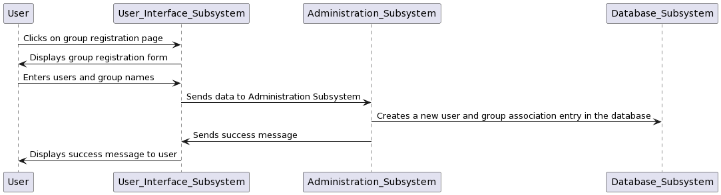

1. Gift Exchange Initiation

Description: The user initiates a gift exchange

Pre-condition: The application is running, the database is initialized, gift preferences have been added, and multiple user accounts have been created, and the user is logged in.

Post-condition: Gift pairs have been created, gift suggestions have been generated, and emails containing this information have been sent to the application users.

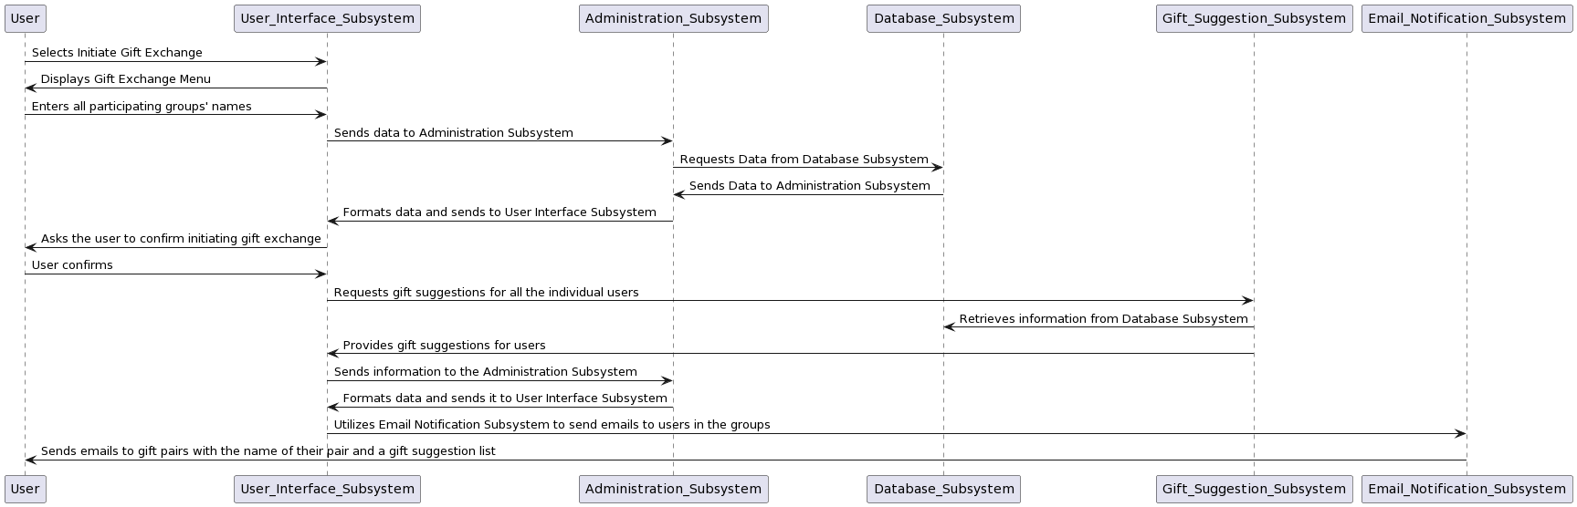

1. Admin Registration

Description: The user registers as an admin

Pre-condition: The application is running, the database is initialized, a user account has been created, and the user is logged in.

Post-condition: The user can log in to GiftPal with their admin account.

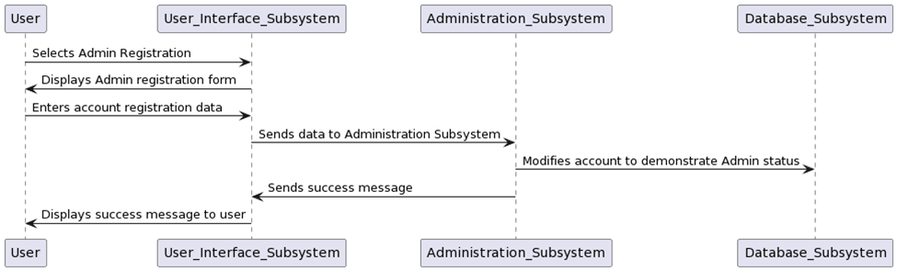

1. User Deletion

Description: The admin deletes a user

Pre-condition: The application is running, the database is initialized, multiple user accounts have been created, and the admin is logged in.

Post-condition: A user account has been deleted by the admin.

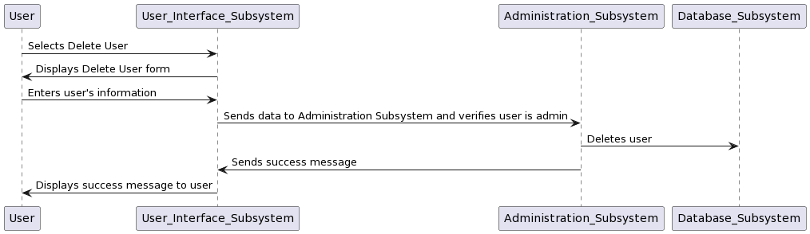

1. Minimum Dollar Amount Declaration

Description: The admin sets a minimum dollar amount for gifts

Pre-condition: The application is running, the database is initialized, an admin account has been created, and the admin is logged in.

Post-condition: A minimum dollar amount for gifts has been set by the admin.

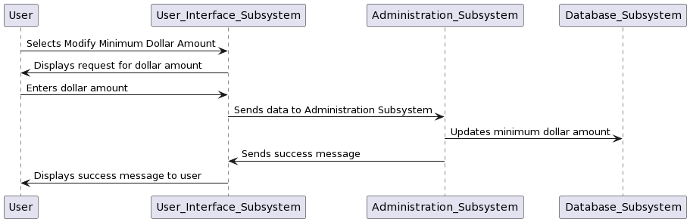

**Start-Up Scenario**

**Description**: The user starts the application.

**Pre-condition**: No hardware or system failure that would hinder the application occurs. Internet access is available.

**Post-condition**: The application (all subsystems) is running; website is loaded.

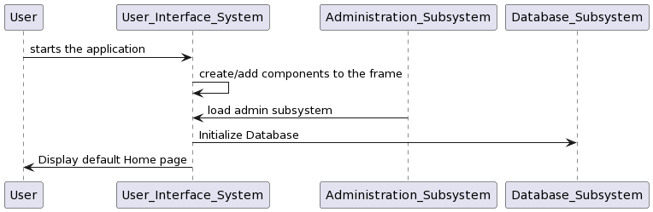

**Shut-Down Scenario**

**Description**: The user initiates the shutdown process.

**Pre-condition**: Program has been running successfully without crashing.

**Post-condition**: Program is terminated.

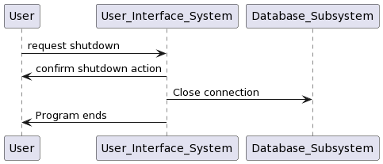

**Error-Handling Scenarios**

1. Invalid dollar minimum amount

**Description**: The User (with Admin privileges) enters the wrong an invalid minimum amount.

**Pre-condition**: System is running fine, user is logged in as administrator, form to enter the dollar amount is displayed correctly.

**Post-condition**: An error message is generated, prompting the user to enter the correct amount (greater than 0).

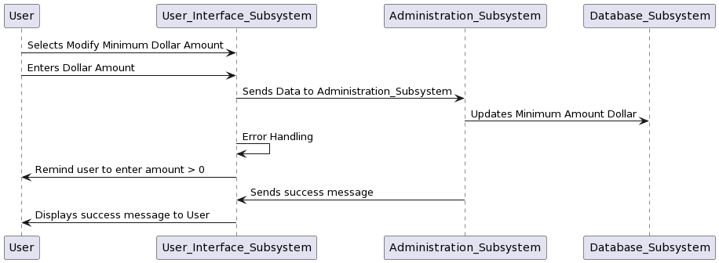

1. Invalid DOB entered

**Description**: The user enters the wrong DOB; this can be extended to check for other dates.

**Pre-condition**: System is running fine, user is authenticated, selects the registration option and form is displayed correctly.

**Post-condition**: An error message is generated, prompting the user to enter a date that is not in the future.

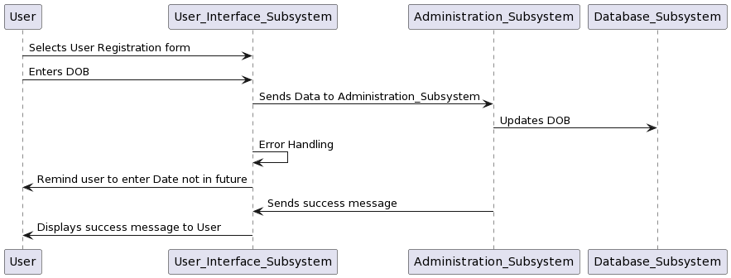

**Pseudocode**

1. User Interface Subsystem

1. Gift Suggestion Subsystem

1. Email Notification Subsystem

1. Administration Subsystem

1. Database Subsystem

**Unresolved risk/risk mitigation**

1. **Changes in Technology and market trends:** The rapid change in technology can make the GiftPal system obsolete or outdated. To mitigate this risk, the developers have adopted an agile methodology to allow for flexibility and quick adaptation to market changes.
2. **Software defects and bugs**: This can impact the user’s experience and affect the functionality of the GiftPal system. To mitigate this, we will conduct rigorous testing and quality assurance processes, including code reviews, and user acceptance testing.
3. **Security breaches and data theft:** the GiftPal system as a web application is vulnerable to cyber-attacks. To mitigate this risk, we will follow security best practices, and conduct regular security assessments and audits.