Project Design

GiftPal – The Ultimate Gift Exchange and Reminder App

Submitted in fulfillment

Of the requirements of

CMSC 495 Current Trends and Projects in Computer Science

(Group Project)

Bazz Khurshid

Graham Primm

Kalala Kalamba

Nicholas Sink

|  |  |
| --- | --- |
| **Document ID** | GiftPal PD-v2.0 |
| **Version Number** | 2.0 |
| **Due Date** | May 07, 2023 |
| **Classification** | Public |
| **Instructor** | Hung Dao |
| **This submission is by** | Bazz Khurshid, Graham Primm, Kalala Kalamba, Nicholas Sink |

**Revision History**

|  |  |  |  |
| --- | --- | --- | --- |
| **Date** | **Version** | **Description** | **Author (s)** |
| 04/07/2023 | 1.0.0 | Draft Version | Nicholas Sink |
| 04/08/2023 | 1.0.1 | Added normal operations scenarios 1 to 5 event-trace descriptions and conditions | Nicholas Sink |
| 04/09/2023 | 1.0.2 | Added Pseudocode Screenshots | Graham Primm |
| 04/10/2023 | 1.0.3 | Added normal operations scenarios 1 to 5 event-trace diagrams | Nicholas Sink |
| 04/10/2023 | 1.0.4 | Added event-trace diagrams for normal operation scenarios 6 to 9 | Bazz Khurshid |
| 04/11/2023 | 1.0.5 | Added Start-up, Shut-down, Error handling scenarios | Kalala Kalamba |
| 04/11/2023 | 1.0.6 | Added Unresolved risk/ risk mitigation | Kalala Kalamba |
| 04/11/2023 | 1.0.7 | Formatting changes | Bazz Khurshid |
| 04/11/2023 | 1.1 | Final review | Bazz Khurshid |
| 05/07/2023 | 1.2 | Modified normal operation 9 to emphasize the group admin changes the min dollar amount. New event-trace diagram added. | Bazz Khurshid |
| 05/07/2023 | 1.3 | Modified normal operation 6 to clarify that the email contains gift pairs and that these emails are sent to users in the group. New event-trace diagram added. | Bazz Khurshid |
| 05/07/2023 | 1.4 | Changed error handling scenario 1 from invalid minimum dollar amount to non-admin user of a group attempting to modify that group. New event-trace diagram added. | Bazz Khurshid |
| 05/07/2023 | 1.5 | Modified error-handling scenario 2 to clarify that user, on registration, did not enter their DOB and what follows from there. New event-trace diagram added. | Bazz Khurshid |
| 05/07/2023 | 1.6 | Modified normal operation 8. Emphasized the user deletion was happening from a group. New event-trace diagram added. | Bazz Khurshid |
| 05/07/2023 | 2.0 | Modified normal operation 4 to be about new events. New event-trace diagram added | Bazz Khurshid |

**Normal Operations Scenarios**

1. Account Creation

**Description**: The user creates an account with GiftPal.

**Pre-condition**: The application is running, and the database is initialized.

**Post-condition**: The user’s GiftPal account has been created.

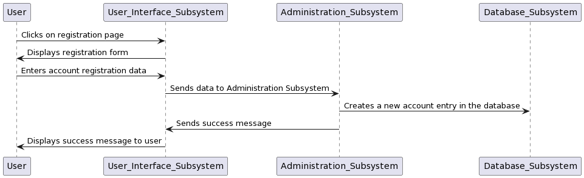

1. User Login

**Description**: The user logs in to their GiftPal account.

**Pre-condition**: The application is running, the database is initialized, and a user account has been created.

**Post-condition**: The user has logged in to their account and a logon message is displayed.

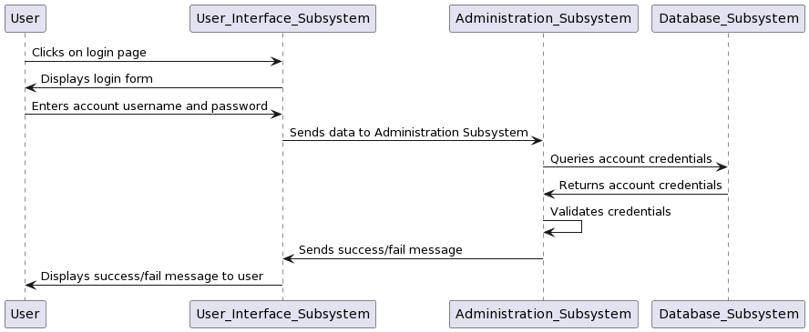

1. WishList Addition

**Description**: The user adds gift preferences to their account.

**Pre-condition**: The application is running, the database is initialized, a user account has been created, and the user is logged in.

**Post-condition**: Gift preferences have been added by the user and stored in the database.

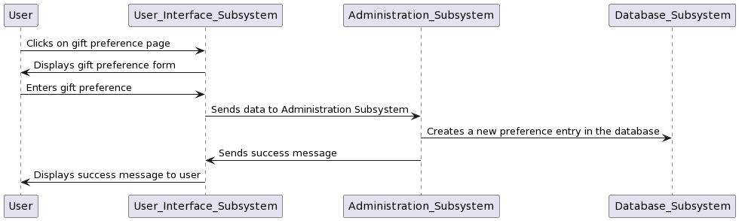

1. User Adds Events

**Description**: The user adds events such as loved one's names and special dates to their account.

**Pre-condition**: The application is running, the database is initialized, a user account has been created, and the user is logged in.

**Post-condition**: An event has been added by the user and stored in the database.

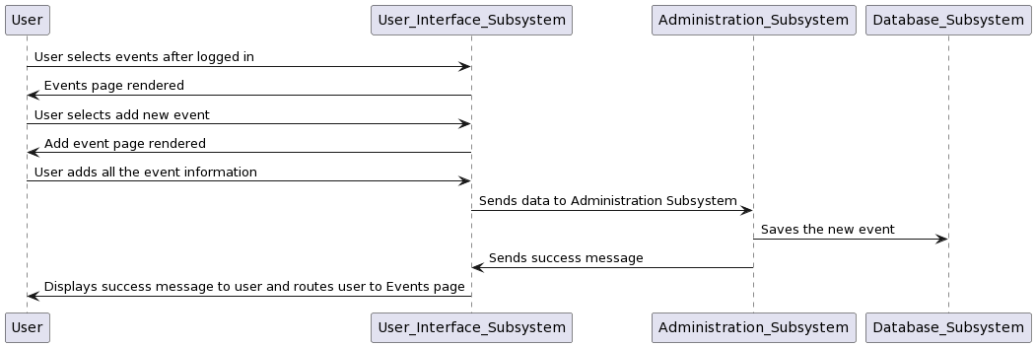

1. Group Registration

**Description**: The user registers others in their group

**Pre-condition**: The application is running, the database is initialized, multiple user accounts have been created, and the user is logged in.

**Post-condition**: The user has registered others in their group.

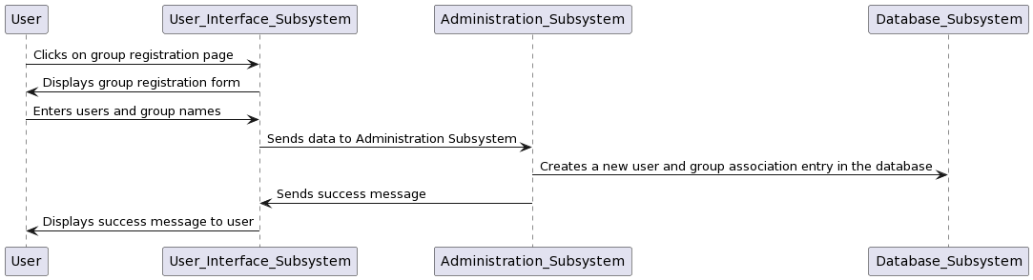

1. Gift Exchange Initiation

**Description**: The user initiates a gift exchange

**Pre-condition**: The application is running, the database is initialized, gift preferences have been added, and multiple user accounts have been created, and the user is logged in.

**Post-condition**: Gift pairs have been created, gift suggestions have been generated, and emails containing the gift pairs have been sent to the users in the group.

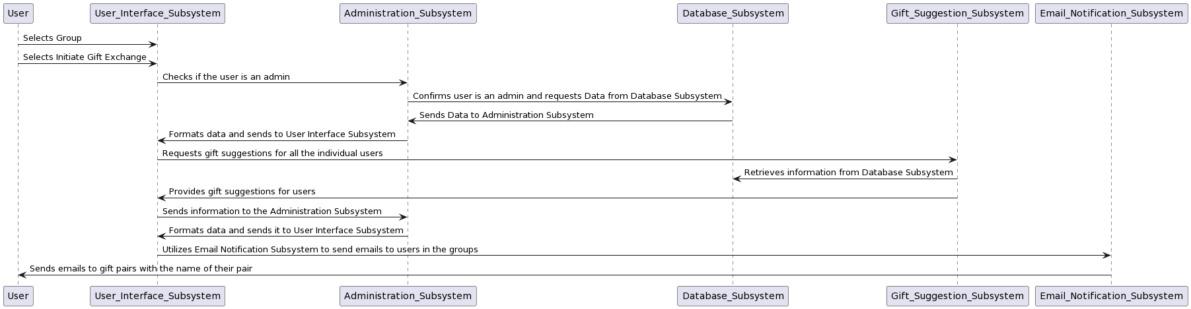

1. Admin Registration

**Description**: The user registers as an admin

**Pre-condition**: The application is running, the database is initialized, a user account has been created, and the user is logged in.

**Post-condition**: The user can log in to GiftPal with their admin account.

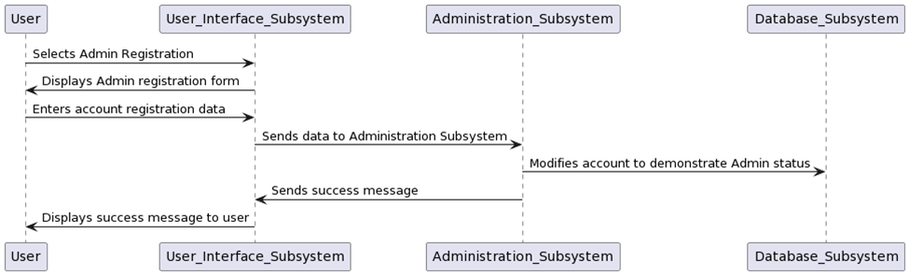

1. User Deletion from Group

**Description**: The admin deletes a user from a group.

**Pre-condition**: The application is running, the database is initialized, multiple user accounts have been created, and the admin is logged in.

**Post-condition**: The user has been deleted from the group by the admin.

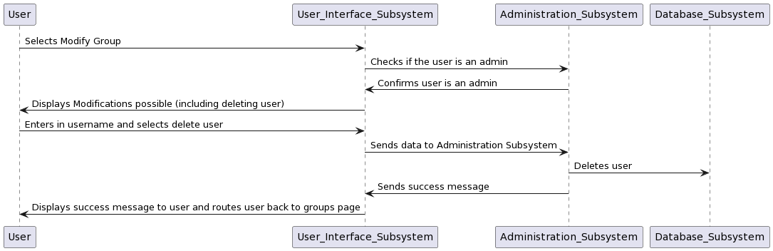

1. Minimum Dollar Amount Declaration

**Description**: The admin of the group sets a minimum dollar amount for gifts

**Pre-condition**: The application is running, the database is initialized, a user who is an admin of the group in question has been created, and that user is logged in.

**Post-condition**: A minimum dollar amount for gifts has been set by the admin of the group.

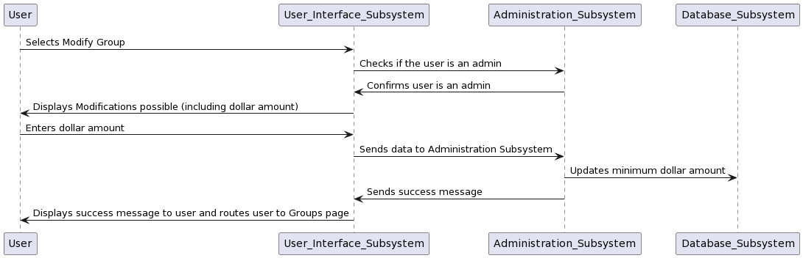

**Start-Up Scenario**

**Description**: The user starts the application.

**Pre-condition**: No hardware or system failure that would hinder the application occurs. Internet access is available.

**Post-condition**: The application (all subsystems) is running; website is loaded.

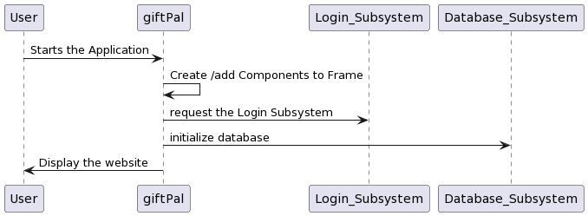

**Shut-Down Scenario**

**Description**: The user initiates the shutdown process.

**Pre-condition**: Program has been running successfully without crashing.

**Post-condition**: Program is terminated.

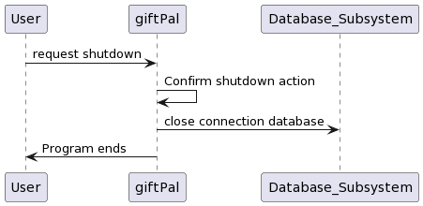

**Error-Handling Scenarios**

1. Non-Admin User of a Group Attempts Modification

**Description**: The User (who is not an admin of the group) attempts to modify a group.

**Pre-condition**: System is running fine, user is logged in. The user attempts to modify a group they are not an admin for.

**Post-condition**: The user is routed back to the group page with a message of how they are not an admin of the group.

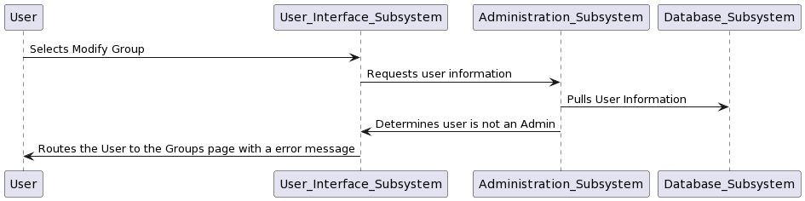

1. No DOB Entered on Registering User

**Description**: The user enters the wrong DOB; this can be extended to check for other dates.

**Pre-condition**: System is running fine, user is attempting to register themselves, selects the registration option and form is displayed correctly.

**Post-condition**: An error message is generated, informing the user to fill out the date of birth.

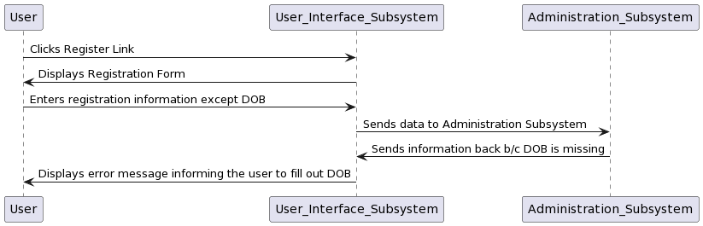

**Pseudocode**

1. User Interface Subsystem

1. Gift Suggestion Subsystem

1. Email Notification Subsystem

1. Administration Subsystem

1. Database Subsystem

**Unresolved risk/risk mitigation**

1. **Changes in Technology and market trends:** The rapid change in technology can make the GiftPal system obsolete or outdated. To mitigate this risk, the developers have adopted an agile methodology to allow for flexibility and quick adaptation to market changes.
2. **Software defects and bugs**: This can impact the user’s experience and affect the functionality of the GiftPal system. To mitigate this, we will conduct rigorous testing and quality assurance processes, including code reviews, and user acceptance testing.
3. **Security breaches and data theft:** the GiftPal system as a web application is vulnerable to cyber-attacks. To mitigate this risk, we will follow security best practices, and conduct regular security assessments and audits.