**User Guide**

GiftPal – The Ultimate Gift Exchange and Reminder App

Submitted in fulfillment

Of the requirements of

CMSC 495 Current Trends and Projects in Computer Science

(Group Project)

Bazz Khurshid

Graham Primm

Kalala Kalamba

Nicholas Sink

|  |  |
| --- | --- |
| **Document ID** | GiftPal UG-v1.0.5 |
| **Version Number** | 1.0.5 |
| **Due Date** | May 07, 2023 |
| **Classification** | Public |
| **Instructor** | Hung Dao |
| **This submission is by** | Bazz Khurshid, Graham Primm, Kalala Kalamba, Nicholas Sink |

**Revision History**

|  |  |  |  |
| --- | --- | --- | --- |
| **Date** | **Version** | **Description** | **Author (s)** |
| 05/04/2023 | 1.0.0 | Draft Version on github | Graham Primm |
| 05/06/2023 | 1.0.1 | Transferred draft to word | Bazz Khurshid |
| 05/06/2023 | 1.0.2 | Added system requirements and installation | Bazz Khurshid |
| 05/06/2023 | 1.0.3 | Added group registration, login and group modification | Bazz Khurshid |
| 05/06/2023 | 1.0.4 | Added screenshots for installation, user and group registration, adding wishlist items, deleting wishlist items | Bazz Khurshid |
| 05/07/2023 | 1.0.5 | Updated Requirements, installation, events, screenshots, figure descriptions, document structure | Nicholas Sink |

**Introduction**

Welcome to the user guide for our special dates and gift exchange application. This application helps you keep track of important dates for your loved ones, manage their wish lists, and participate in gift exchanges. The following guide will provide you with detailed instructions on how to use the application's features.

**Getting Started**

**System Requirements**

1. Hardware Requirements:
   1. CPU: Broadcom BCM2711, Quad core Cortex-A72 (ARM v8) 64-bit SoC @ 1.8GHz or comparable CPU
   2. RAM: 4GB LPDDR4-3200 SDRAM
   3. Storage: 16GB microSD card
2. Software Requirements:
   1. Operating System: Any modern operating system including but not limited to Windows 10, Raspberry Pi OS Kernel Version 5.15, macOS 10.8 (Mountain Lion)
   2. Python: version 3.10

**Installation**

1. Setup:
   1. Clone the repository: git clone <https://github.com/Samagoue/UMGC_CMSC495_SPRING_2023_GP2.git>
   2. Enter the cloned directory
   3. Install all requirements: pip install -r requirements.txt
   4. Run the run.py file
   5. Login to the setup interface at <http://localhost:5000/setup-login>
   6. The username is giftpaladmin
   7. The password is generated on application launch and printed to the console as shown in figure 2 (This will change each time the application is launched)

**Figure 1**

*Setup Login Form*

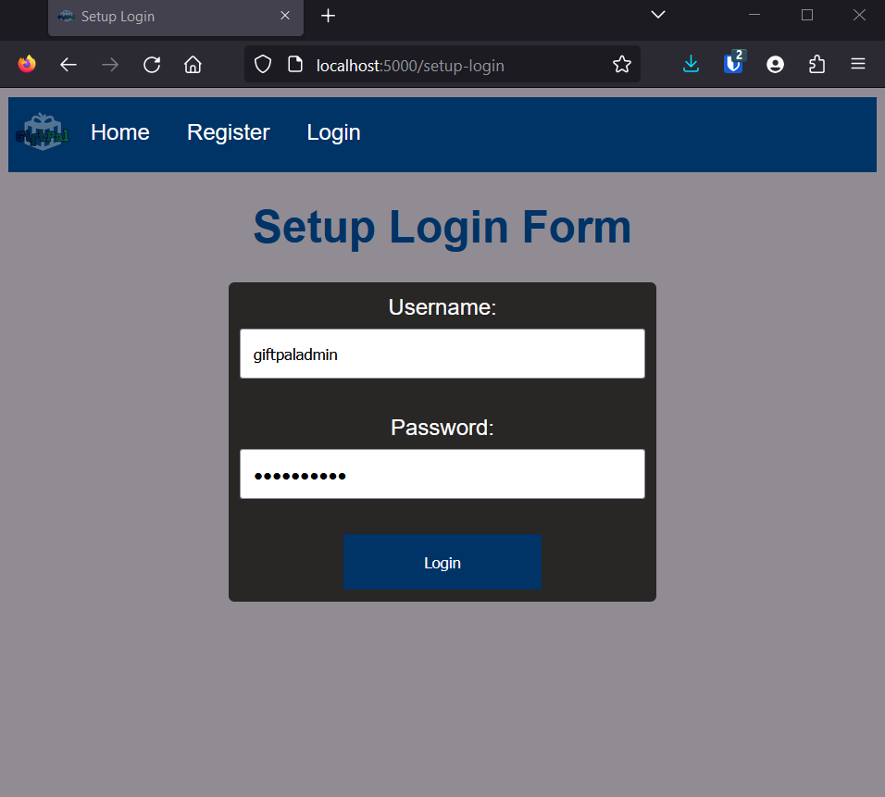

**Figure 2**

*Admin Password Generation*

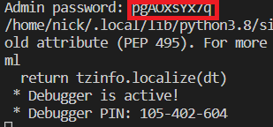

* 1. Set the email address and email and OpenAI API keys at <http://localhost:5000/setup-keys>
     1. Gmail app password instructions: <https://support.google.com/accounts/answer/185833?hl=en>
     2. OpenAI API key instructions: <https://platform.openai.com/docs/guides/production-best-practices/api-keys>

**Figure 3**

*Setup Keys Page*

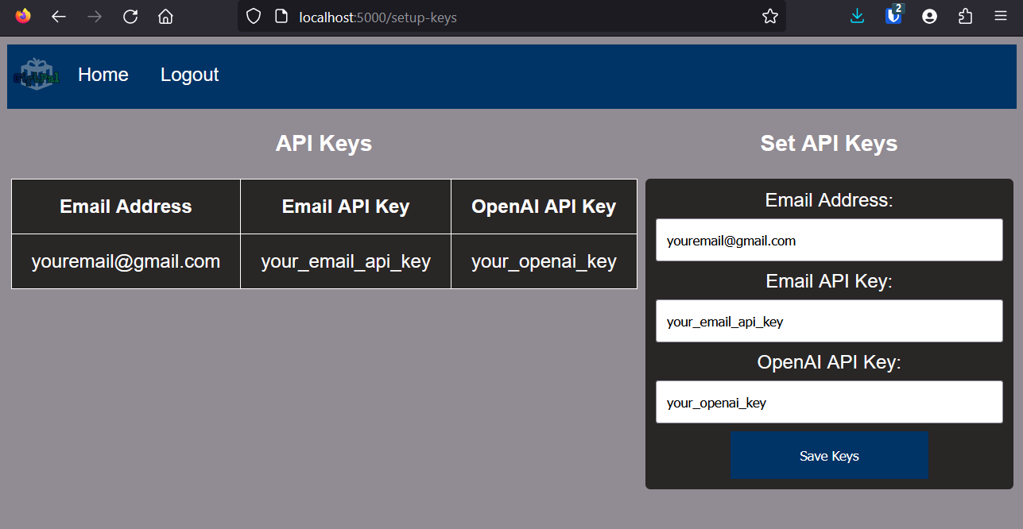

1. Using:
   1. Access the application at [http://localhost:5000](http://localhost:5000/)

**Figure 4**

*GiftPal Homepage*

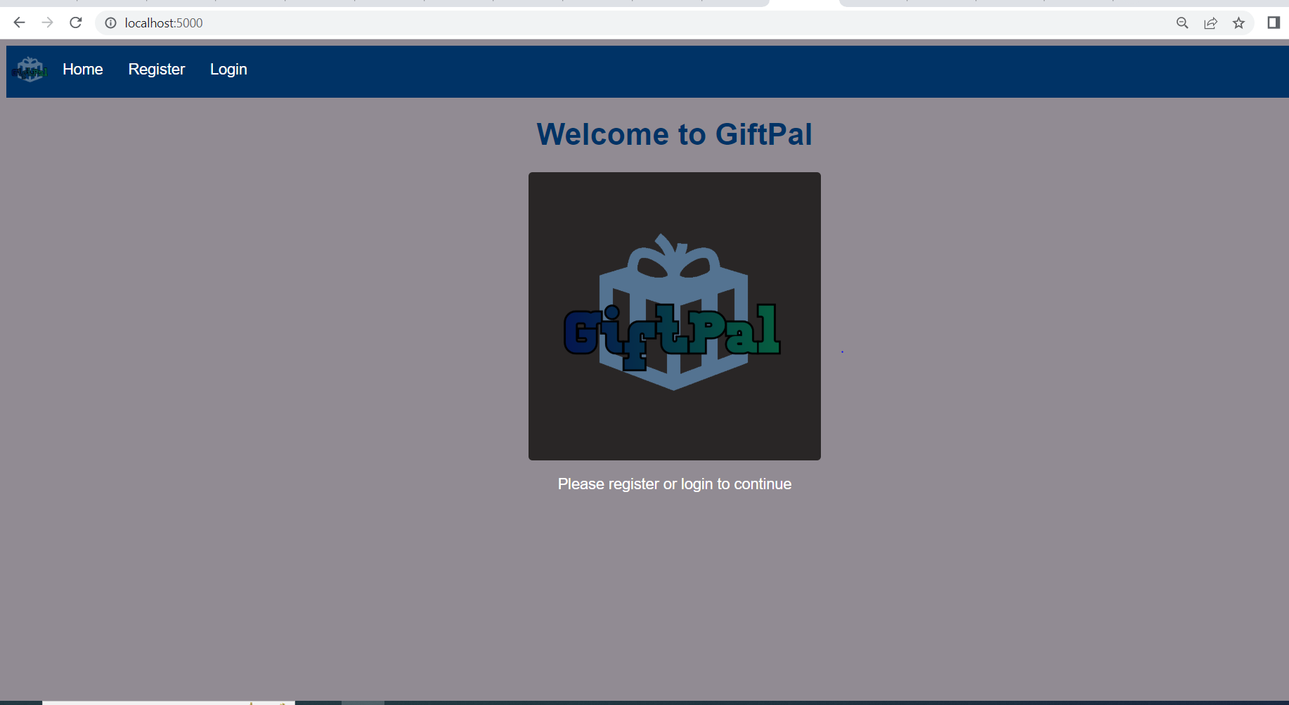

**Managing Accounts**

**User Registration**

1. To register yourself as a user, navigate to the registration page by clicking the "Register" button on the navigation menu at the top.
2. Fill in your personal information, including your name, email, and desired password.
3. Click "Submit" to complete your registration.

**Figure 5**

*User Registration Form*

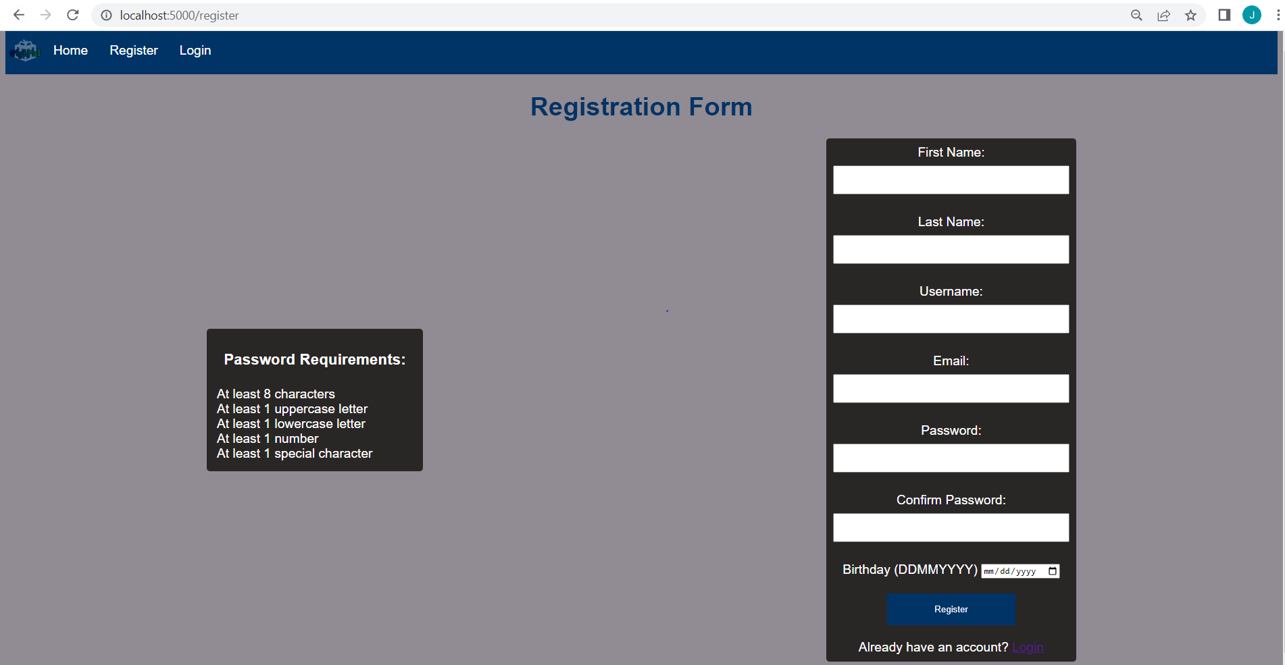

**Logging into a User Account**

1. From the initial page on start-up, navigate to the login page by clicking the “Login” button on the navigation menu at the top.
2. Enter your username and password.
3. Click the “Login” button and you will have successfully logged in.

**Figure 6**

*User Account Login*

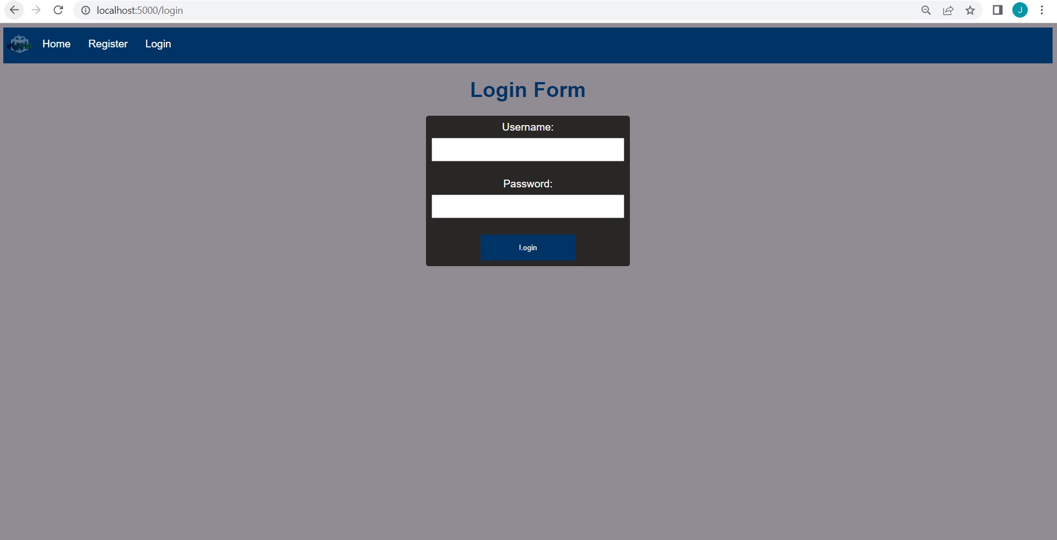

1. After logging in, you will be directed the the profile page which displays your profile information.

**Figure 7**

*User Profile Page*

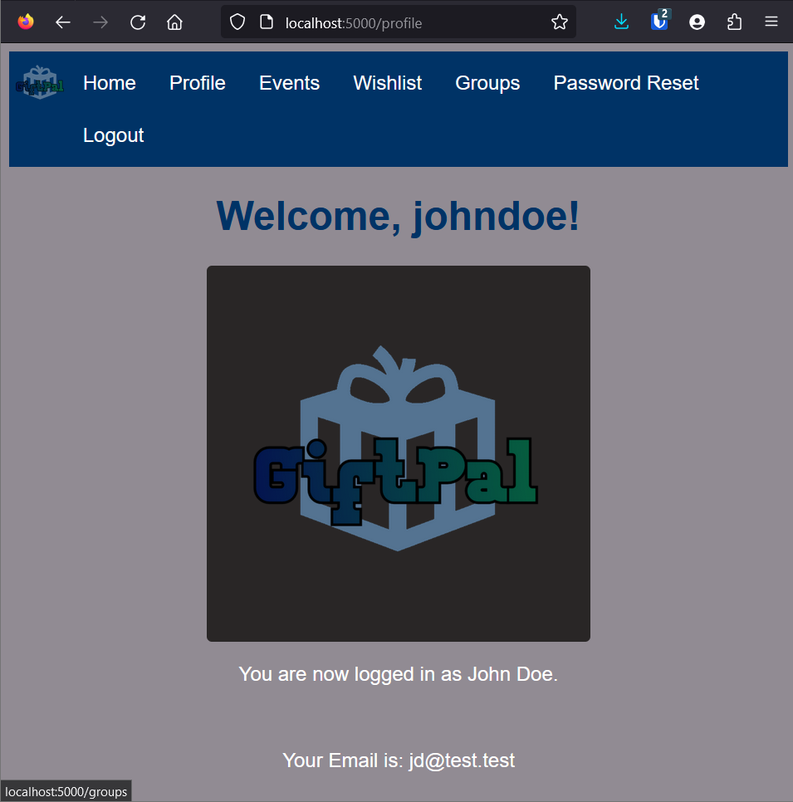

**Resetting User Account Passwords**

1. From the profile page while logged in to your account, navigate to the reset password page by clicking the “Password Reset” button on the navigation menu at the top.
2. Enter and confirm your password and click the “Reset Password” button at the bottom of the page.

**Figure 8**

*Password Reset Page*

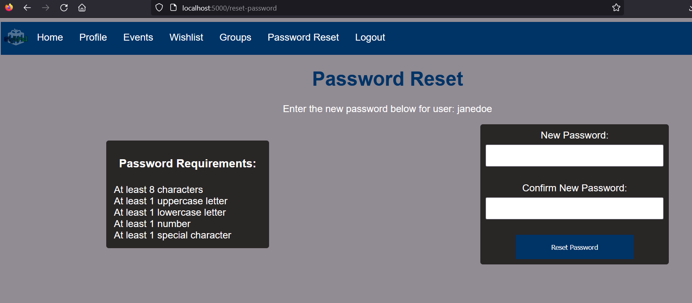

1. You will be redirected to the login page to login to your account with the new password.

**Figure 9**

*Login Page/Reset Confirmation*

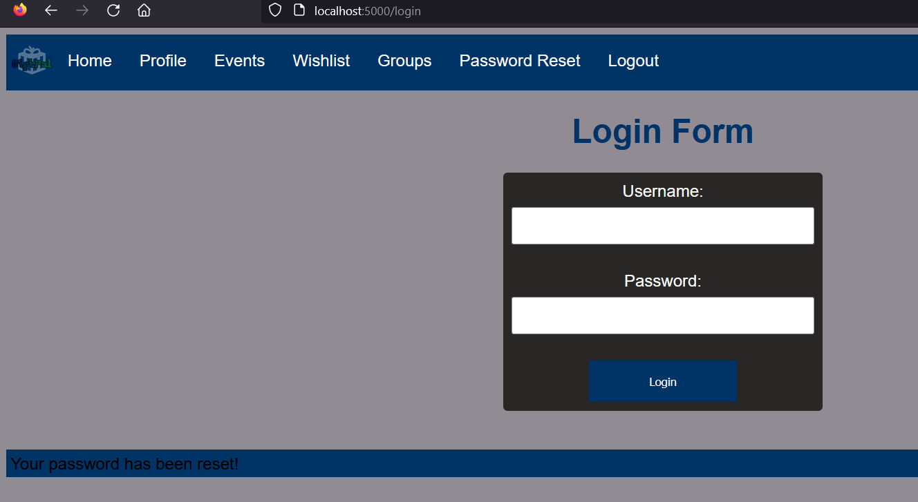

**Managing Groups**

**Group Registration**

1. After logging in, navigate to the Groups page by clicking “Groups” button on the navigation menu at the top.

**Figure 10**

*Groups Page*

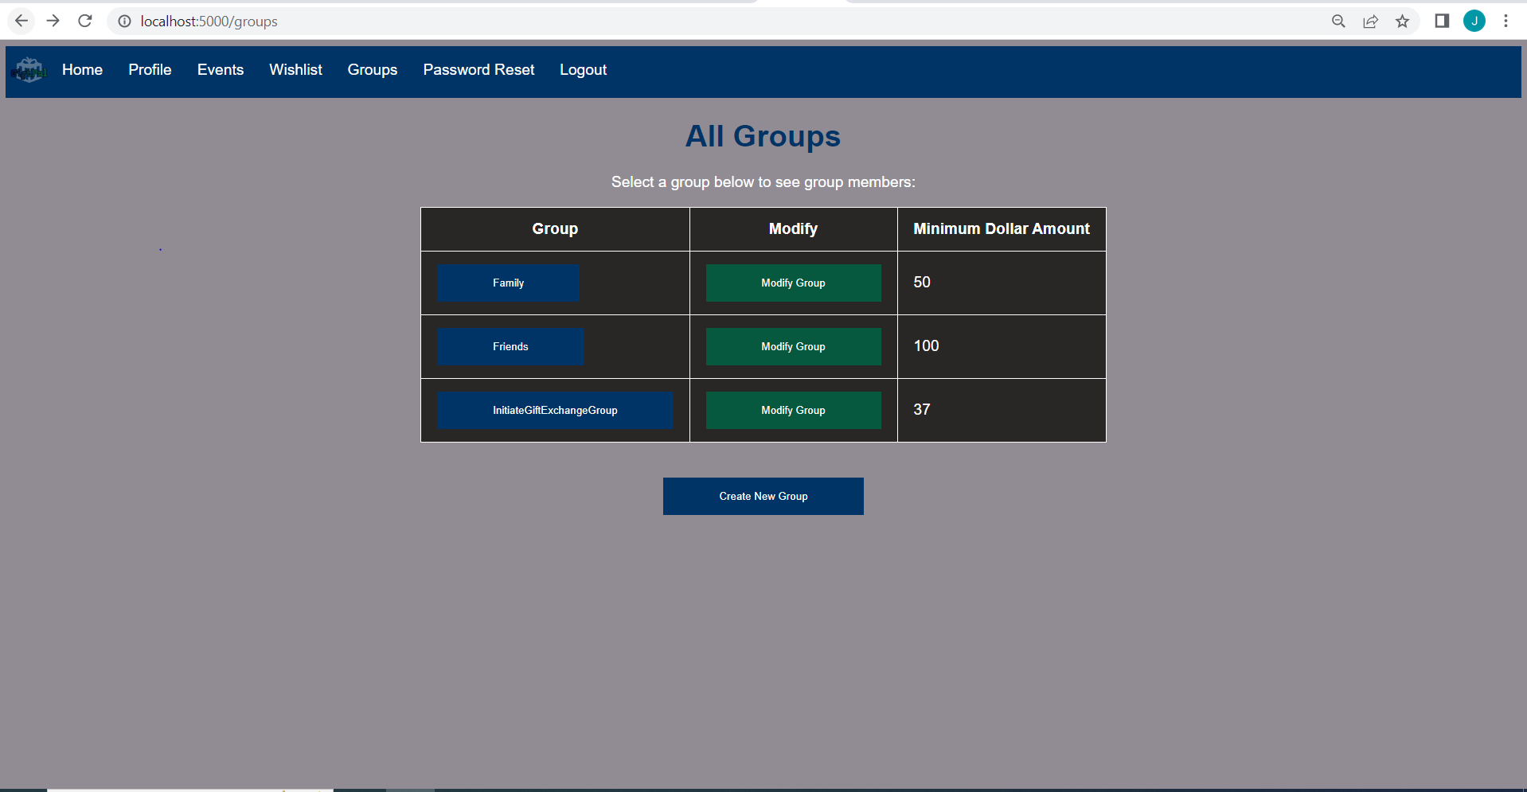

1. Click the “Create New Group” button.
2. Enter in the group name and the minimum dollar amount for the group.
3. Click “Register Group” and you will have successfully created a new group and will be set at the group admin.

**Figure 11**

*Group Registration Form*

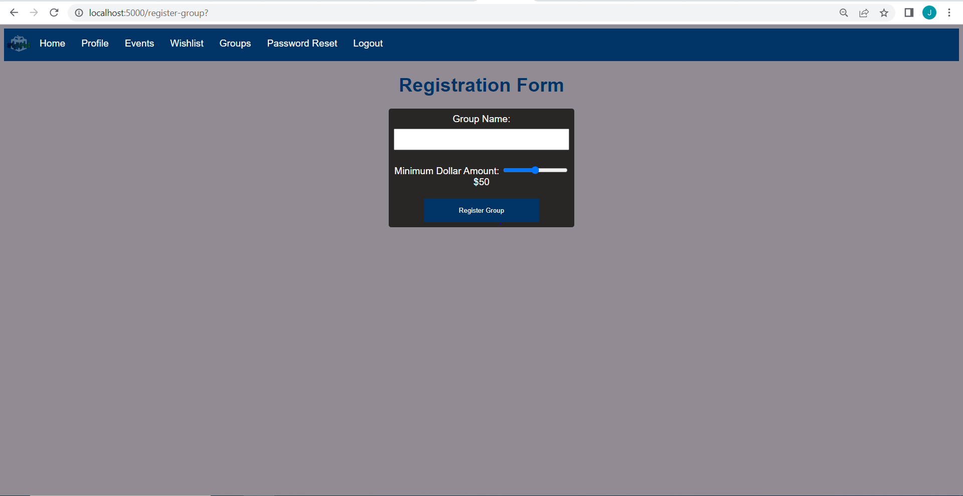

**Modifying a Group**

1. After logging in, navigate to the Groups page by clicking “Groups” button on the navigation menu at the top.
2. From your selection of groups, select the “Modify Group” button on the group you would like to modify. You will be navigated to the /modify-group/group# page only if you are an admin of that group.

**Figure 12**

*Groups Page*

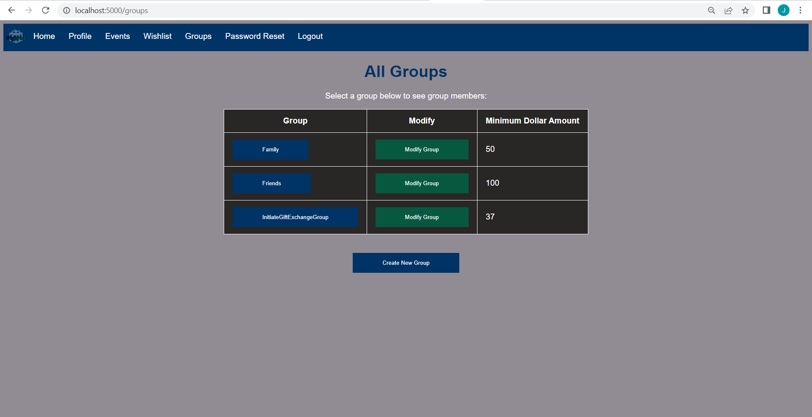

1. On the /modify-group/group# page, you may change the group name, the minimum dollar amount or add/delete/make an admin of any user whose username you put in the input box under “Enter Username”
2. After you have made your modifications, click the “Save Changes” button to save your modifications.

**Figure 13**

*Group Modification Form*

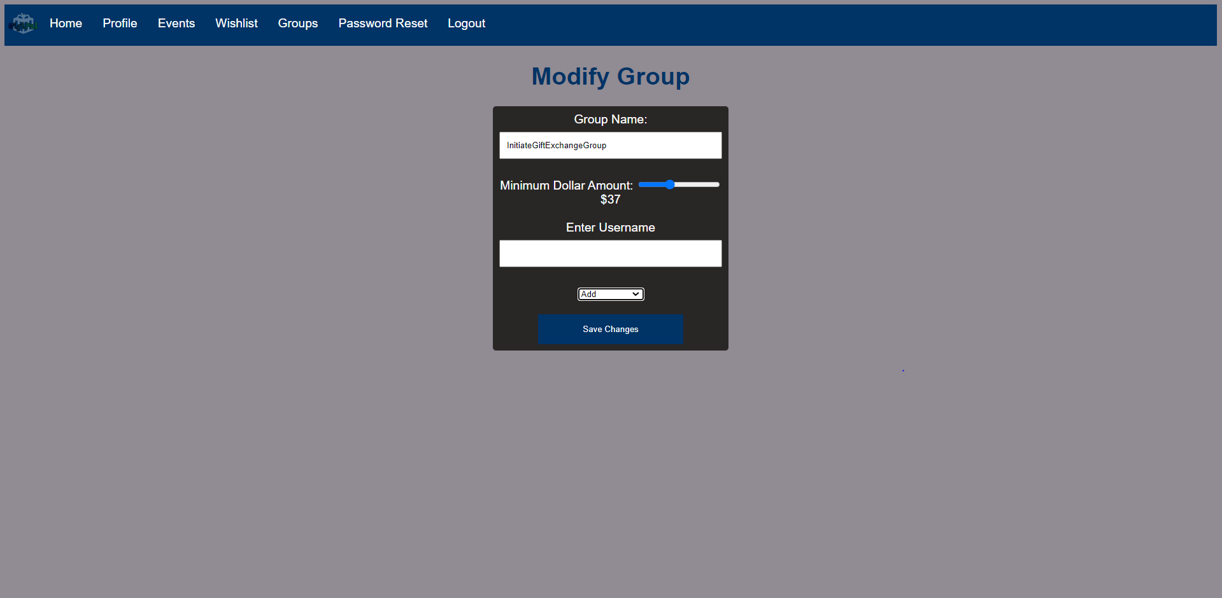

**Managing Events**

**Adding Special Dates**

1. After logging in, navigate to "Events" by clicking the "Event” button in the navigation menu on the top of the webpage.

**Figure 14**

*Events Page*

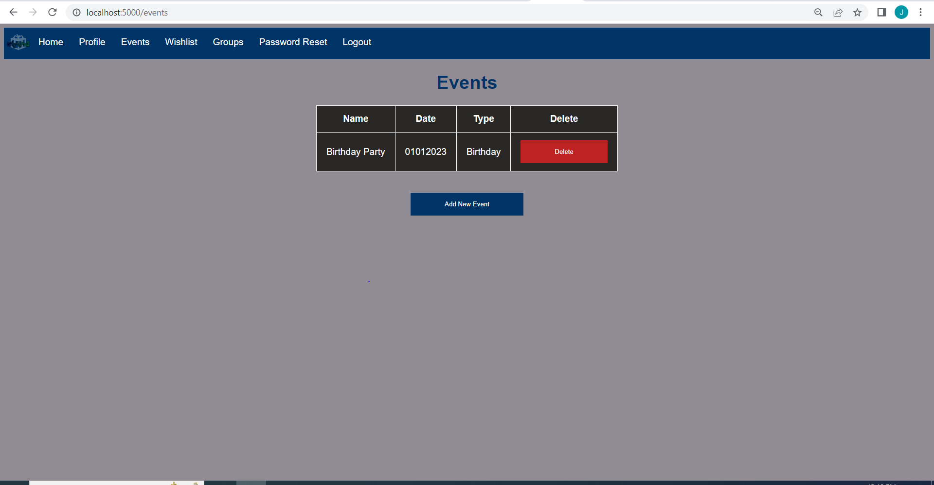

1. Click the "Add New Event" button.
2. Fill in the required fields, such as the name of your loved one and the type of special date (e.g., birthday, anniversary, or custom).
3. Click "Submit" to add the special date.

**Figure 15**

*Add Event Form*

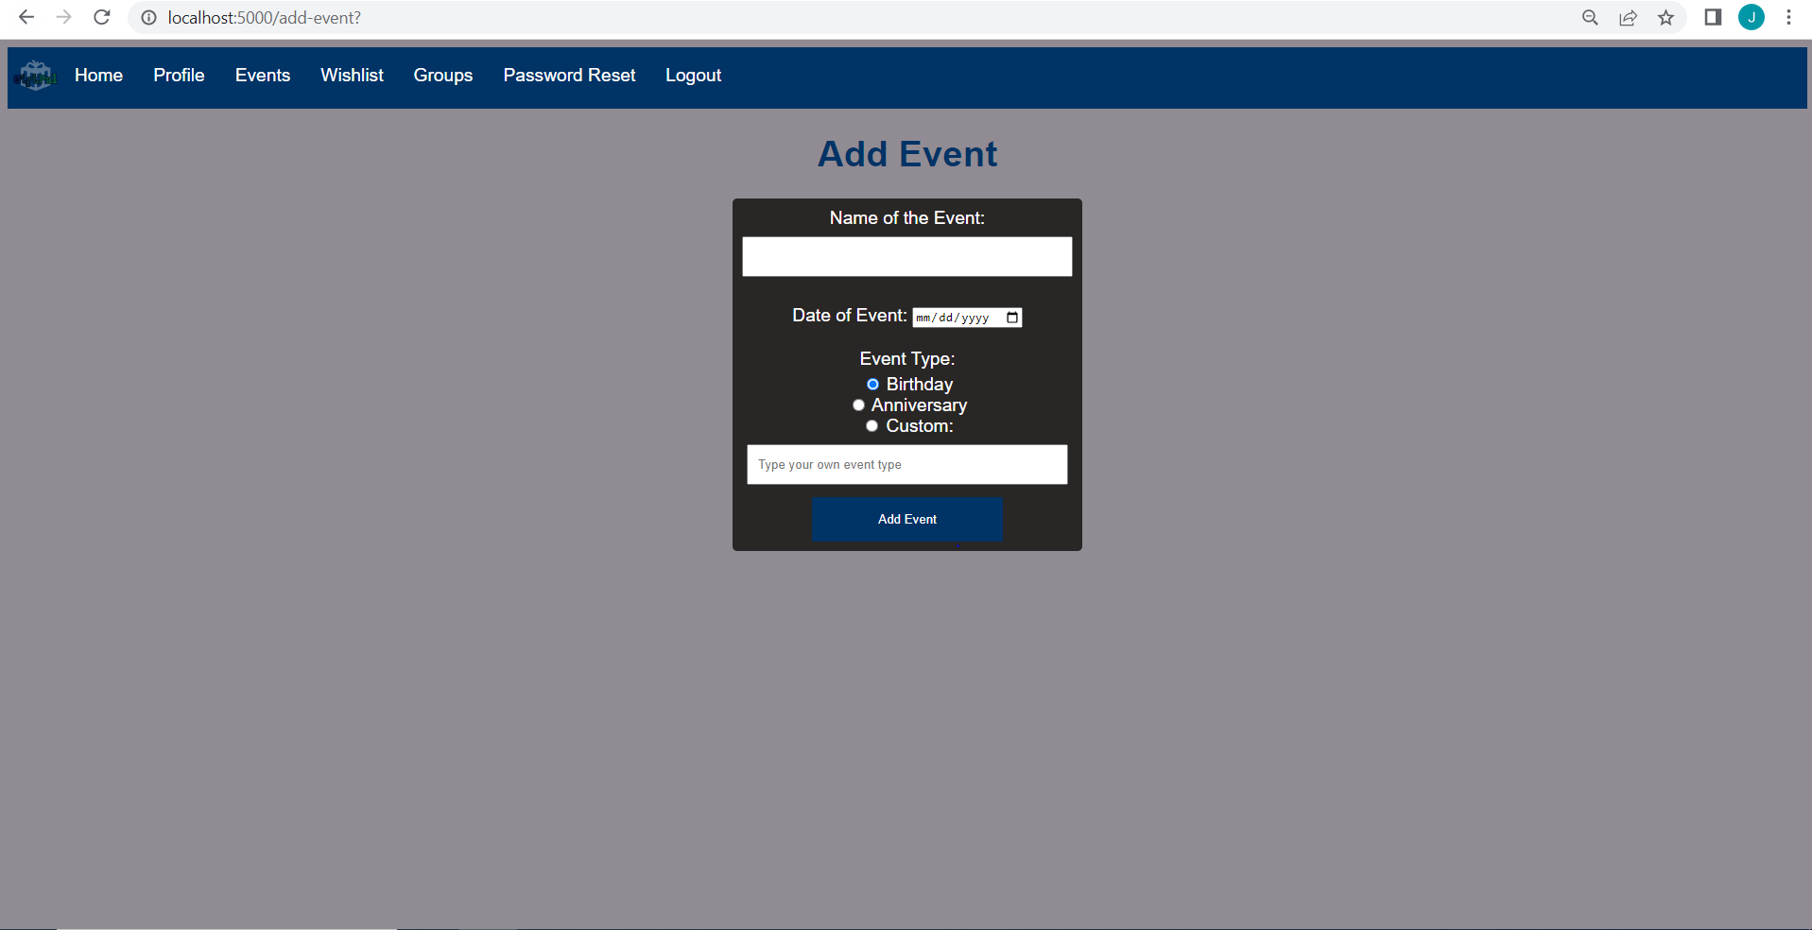

**Deleting Special Dates**

1. In the "Special Dates" section, locate the special date you want to delete.

**Figure 16**

*Events Page*

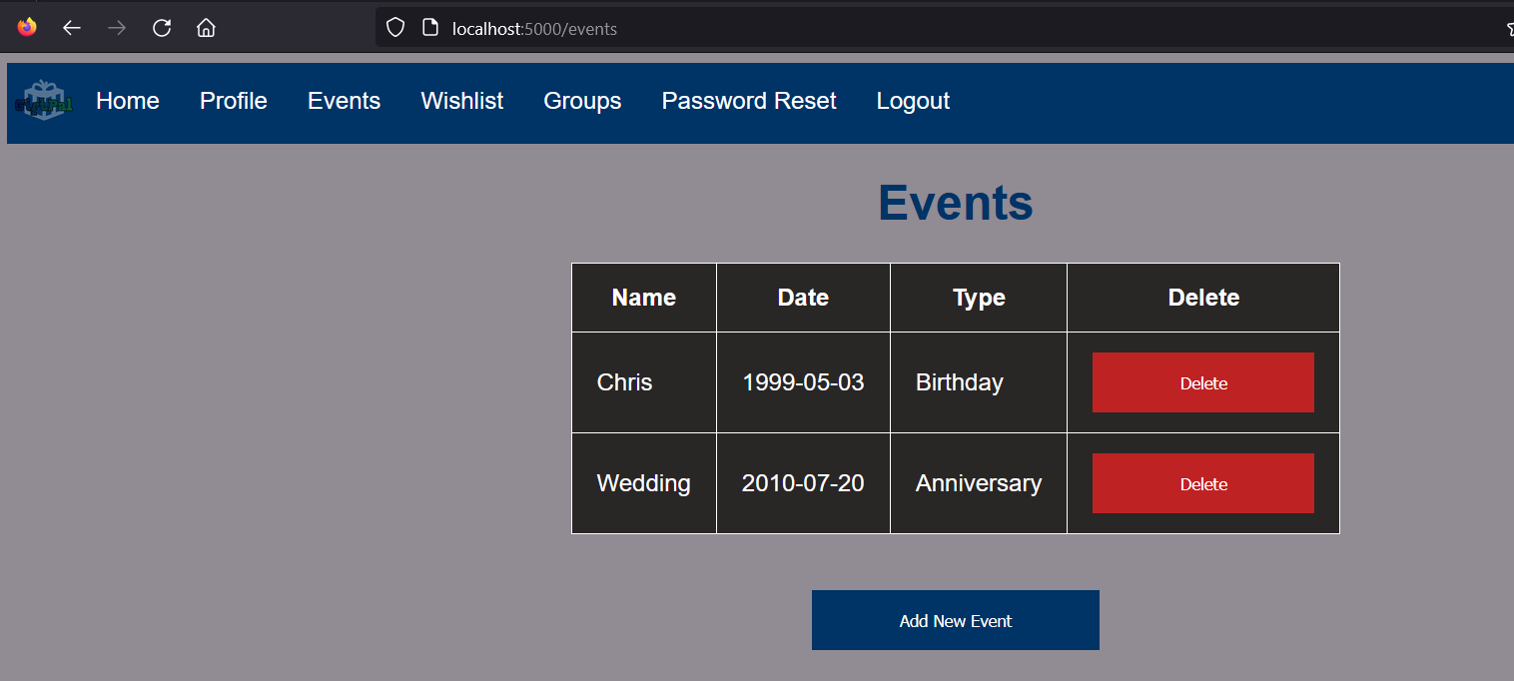

1. Click the "Delete" button next to the special date.
2. The special date will be deleted from your events.

**Figure 17**

*Event Deletion*

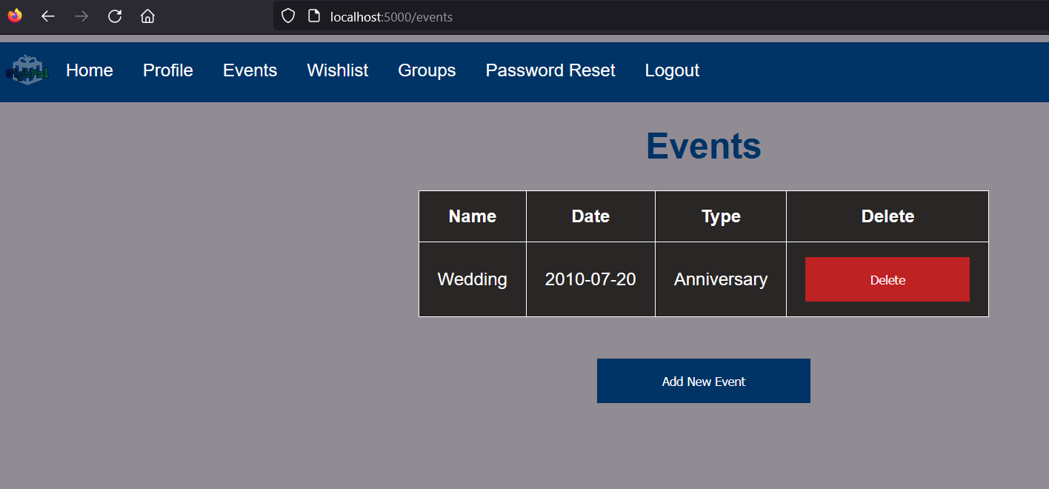

**Managing Wishlists**

**Adding Items to a Wishlist**

1. After logging in, navigate to the "Wishlists" section.
2. Click the "Add New Wish" button.

**Figure 18**

*Wishlist Page*

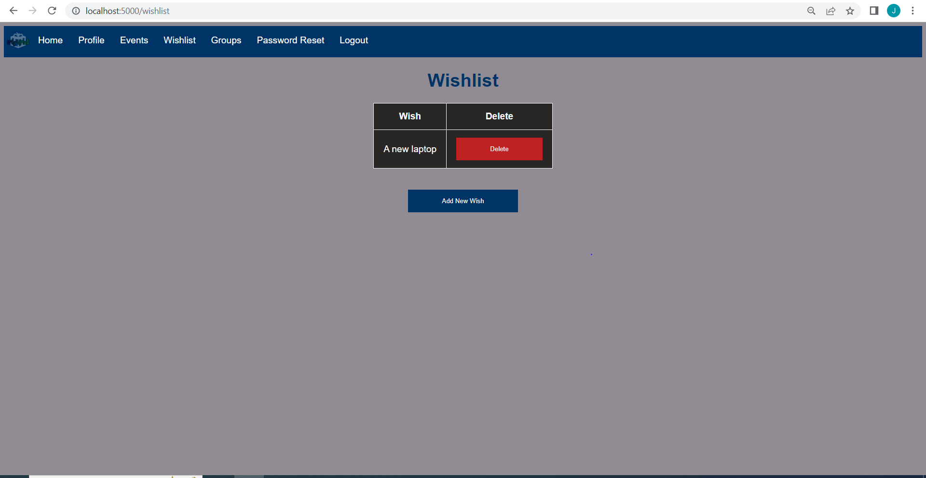

1. Fill in the name of the item.
2. Click the “Add Wish” button to submit your new item to the Wishlist

**Figure 19**

*Add Wish Form*

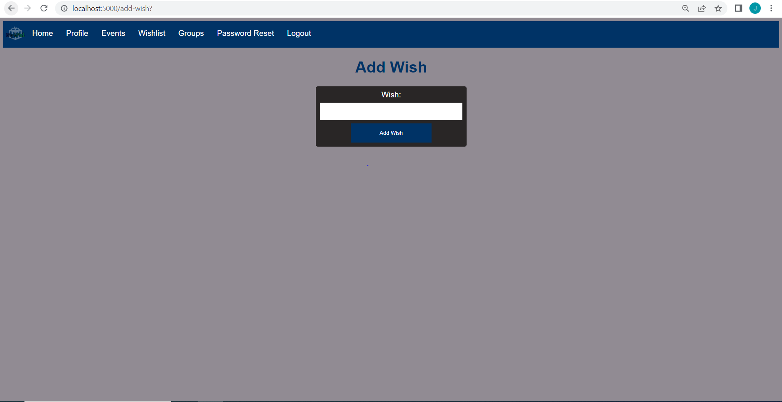

1. The item will be added to your Wishlist

**Figure 20**

*Wish Addition*

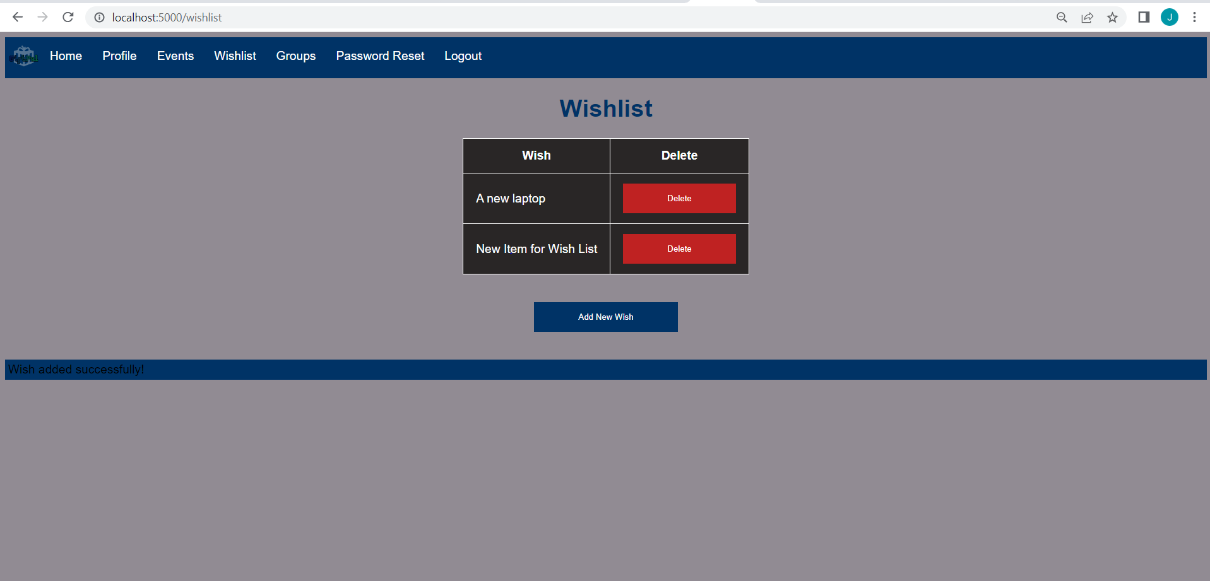

**Deleting Items from a Wishlist**

1. In the "Wishlists" section, locate the item you want to delete.
2. Click the "Delete" button next to the item.

**Figure 21**

*Wishlist Page*

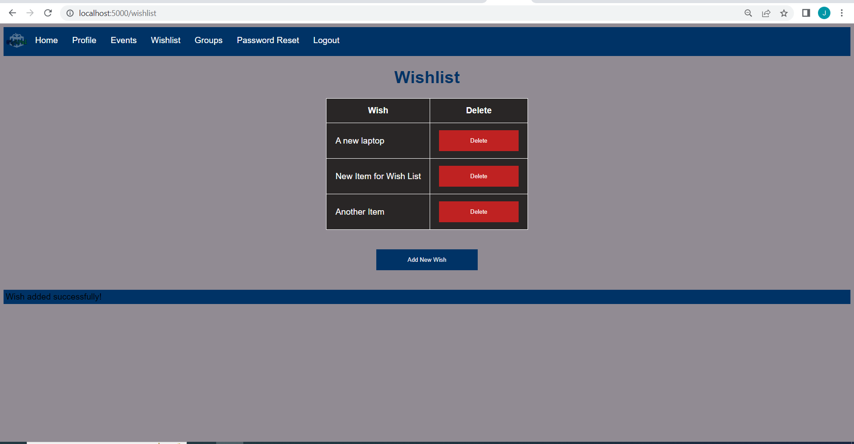

1. The item will be deleted from your wishlist.

**Figure 22**

*Wish Deletion*

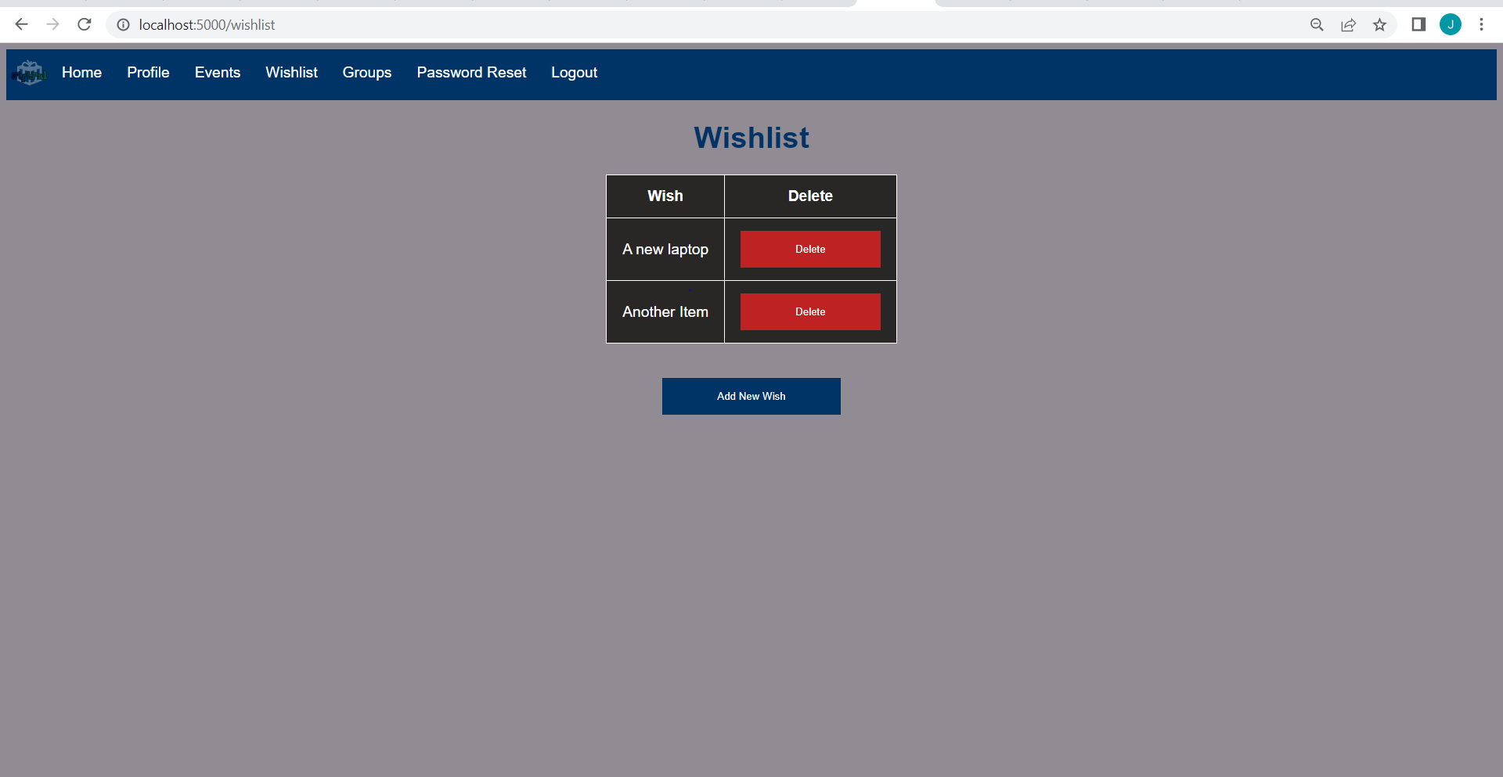

**Managing Gift Exchanges**

**Initiate a Gift Exchange**

1. After logging in, navigate to the "Groups" section.
2. Click the Group you want to initiate a gift exchange for.

**Figure 23**

*Groups Page*

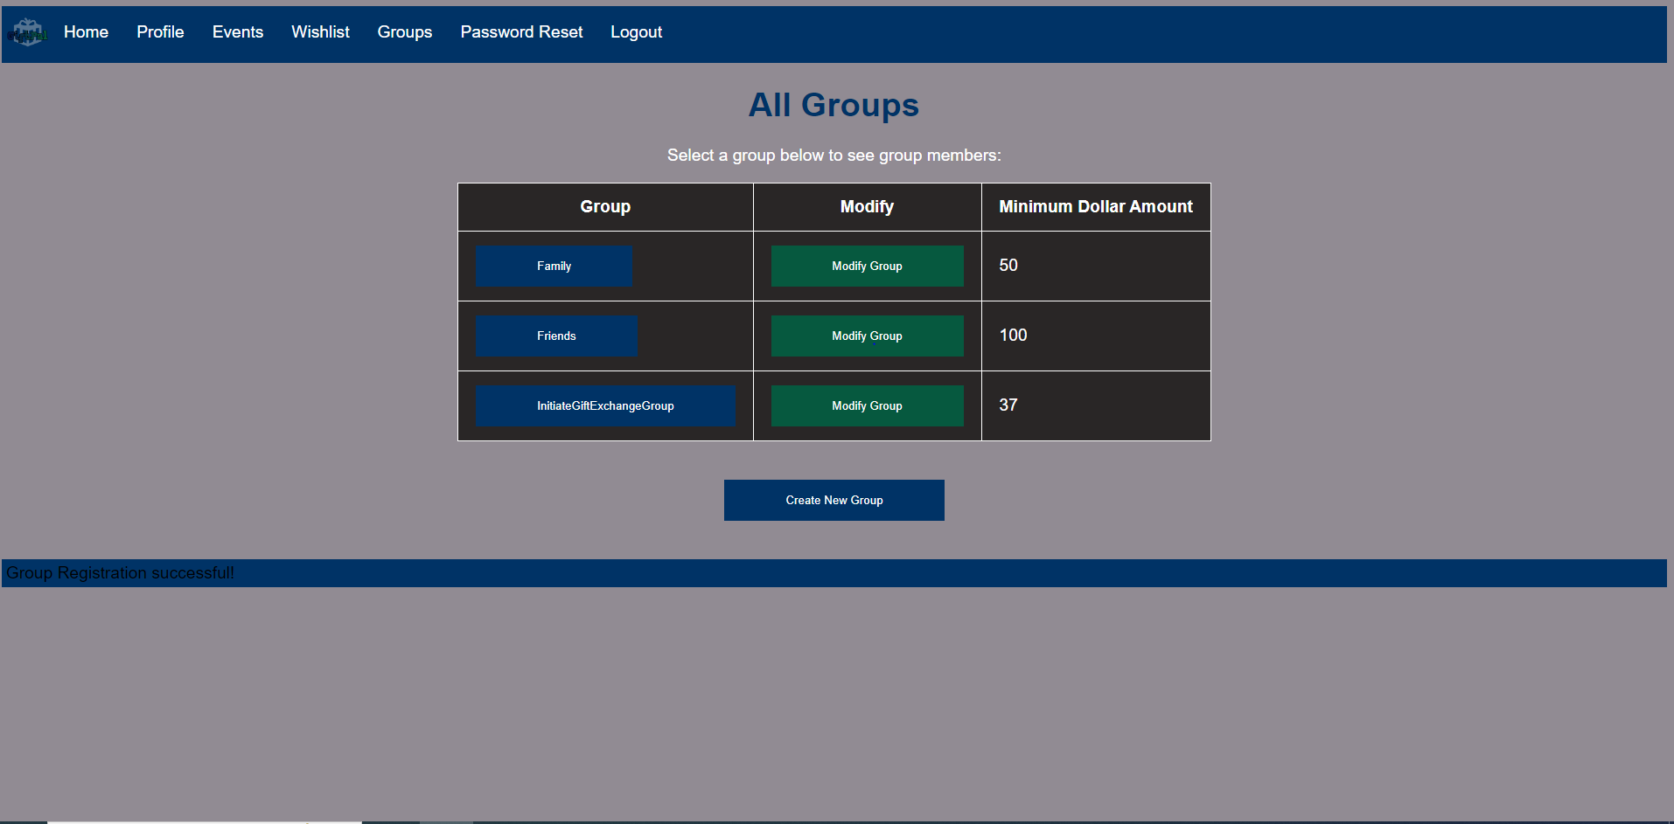

1. Click the "Initiate Gift Exchange" button.

**Figure 24**

*Gift Initiation Button*

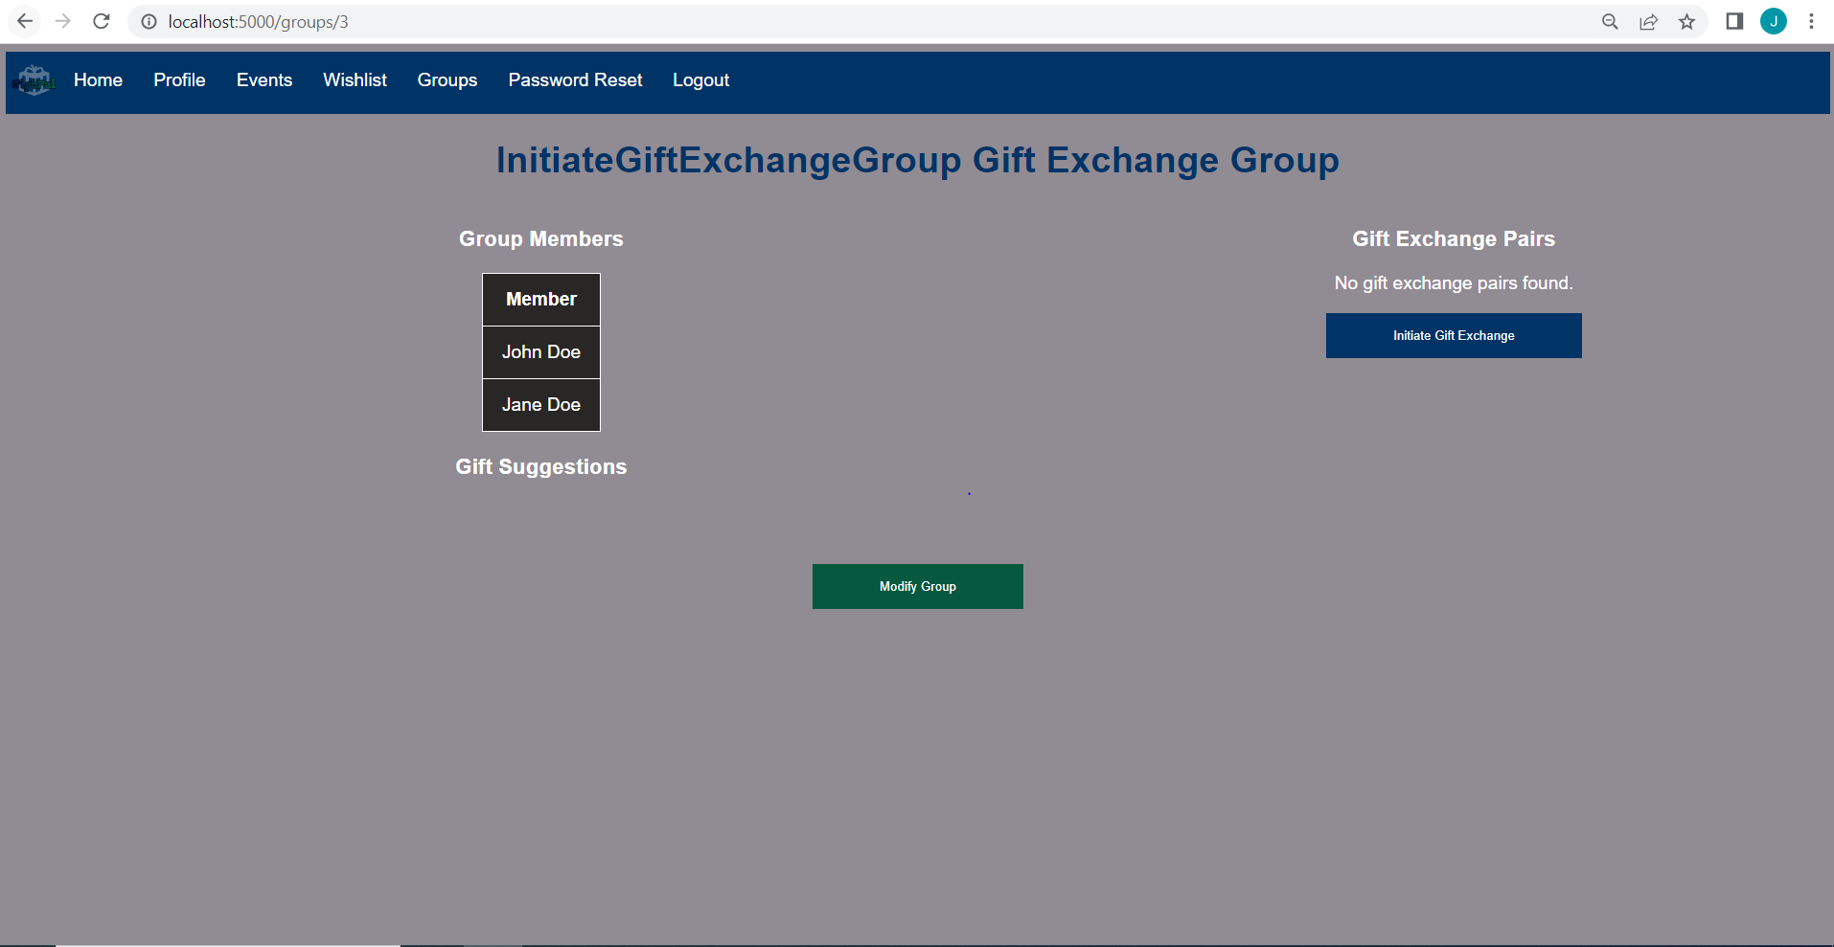

1. Gift pairs will be formed, and an email of the gift pairs will be sent to the users.

**Figure 25**

*Gift Pairs*

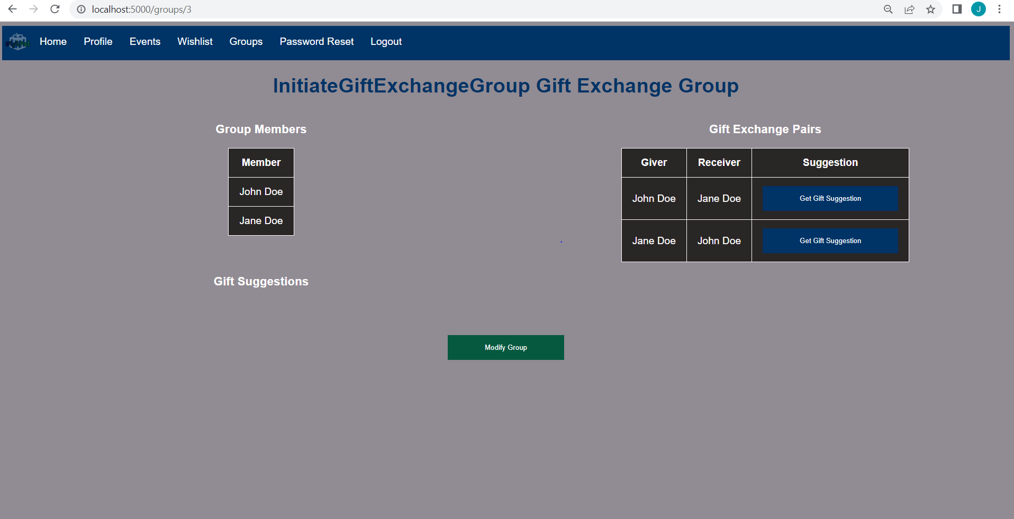

**Receiving Gift Pairings and Suggestions**

1. After logging in, navigate to the "Groups" section.
2. Click the Group you want to view gift pairings for.
3. View Gift Pairs in the right-hand table.
4. Press the "Get Suggestion" button to get gift suggestions for your partner.

**Figure 26**

*Gift Suggestion Generation*

