**East West University**

**CSE405**

Computer Networks

**Project Report**

**Design of a Full-Fledged Network with Multiple Subnets**

**Submitted by:**

Name: Md. Redwan Ahmed

ID: 2019-1-60-249

Section: 01

**Submitted to:**

Dr. Anisur Rahman

Associate Professor

Department of Computer Science and Engineering

East West University

**Submission Date: 18 September, 2022**

**Title:**

Design a full-fledged network for an organization with multiple subnets.

**Preface:**

The need for computer networking was borne out of the need to use personal computers for sharing information within an organization in form of messages, sharing files and data bases and so forth. Today’s network is a strategic instrument that must be accessible anytime from anywhere-simultaneously offering fast, secure, reliable services at scale regardless of location. All systems should be capable of communicating with others and should provide desired information. Hence, we need a simulation tool which offers a way to predict the

impact on the network of a hardware upgrade, a change in topology, an increase in traffic load or the use of a new application.

**Objective:**

The main goal was to create a full model of a complex network by identifying the interconnection of the systems and sub-networks, which would represent the structure and facilities of the University of professionals.

Moreover, a webpage for University of Professionals was to be made and it would be located through the address <http://www.Professionals.edu>. Each Campus was also given a wireless access point to access the network.

**Physical Diagram:**

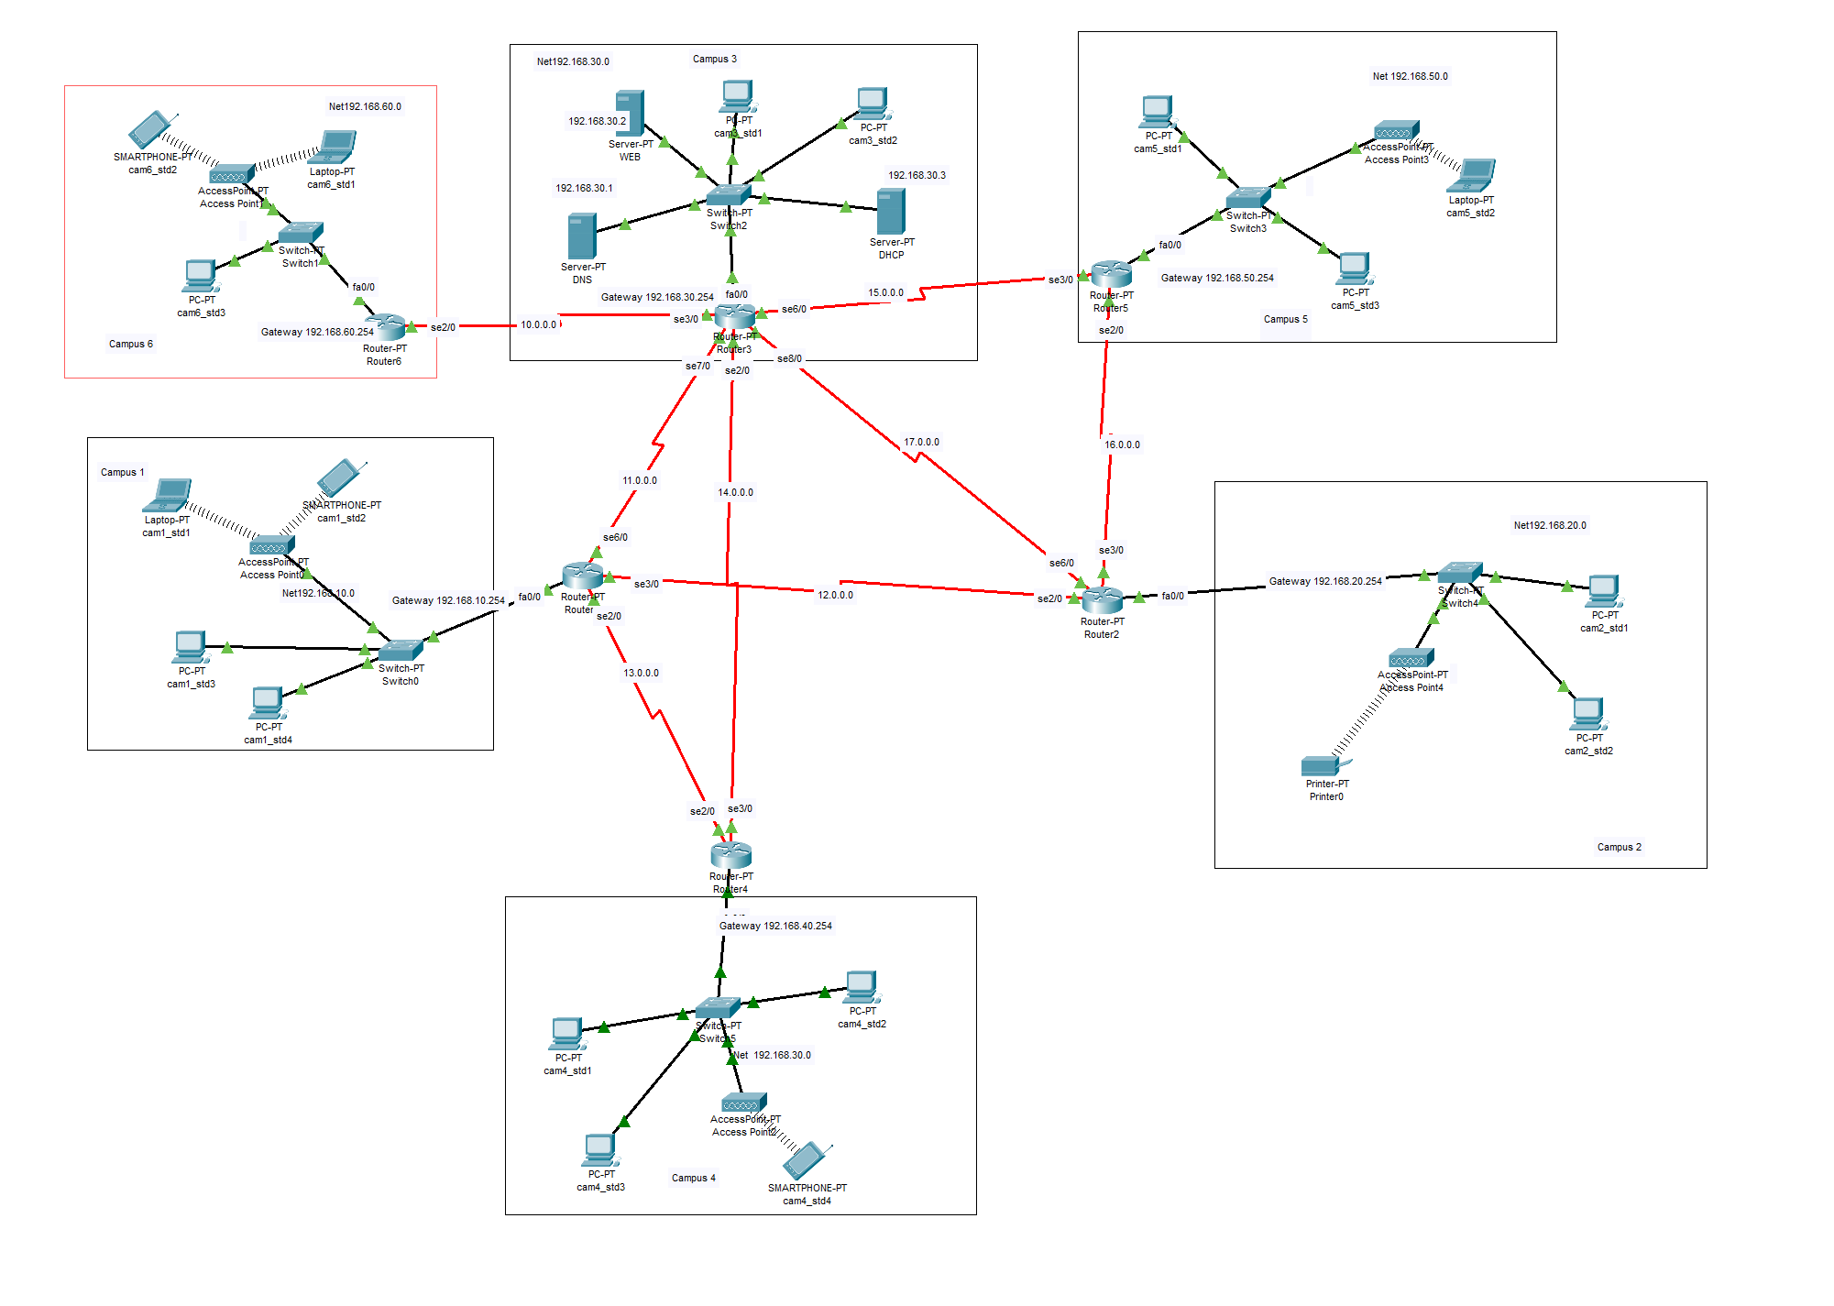

**Figure: Diagram of a Full-Fledged Network with Multiple Subnet**

**Design Details:**

The network design was implemented in Cisco Packet Tracer. To encompass all the 6 different campuses and campus 3 is also used as a server room where DNS, DHCP, WEB servers are located. A heptagonal network of routers was used. Two diagonal paths of the heptagon were also connected to provide alternate paths in case any of the routers go down. Each campus was given two sub-nets to differentiate the student PCs from the PCs used for Administration. A wireless Access Point was also provided in each campus through which other devices can connect to the network wirelessly.

The Network elements used in the project were:

1. Straight Through Cable and Serial DCE
2. Routers
3. Switches
4. Servers (DNS, DHCP, WEB)
5. PCs
6. Smart Phones
7. Laptops
8. Wireless Access points

There were 3 servers that were used. Those were DHCP, DNS and Web Server. All these servers were kept in Campus 3.

The DHCP server was used to dynamically provide IP addresses to all the hosts.

The Web Server was used to provide the webpage of University of Professionals, which can be accessed through any of the hosts in any network. The webpage had the required functionalities to display information about Faculties, Departments, Admission, Students, News & Events, Library etc.

The DNS server was used so that all the hosts can access the webpage in the Web Server through the required web address instead of the IP address of the Web Server.

In each of the campuses, the host PCs received their IP addresses dynamically through the single DHCP server. The hosts also received information about the DNS server through the DHCP.

Thus, the entire network was properly connected and communications between any devices in the complex network was established.

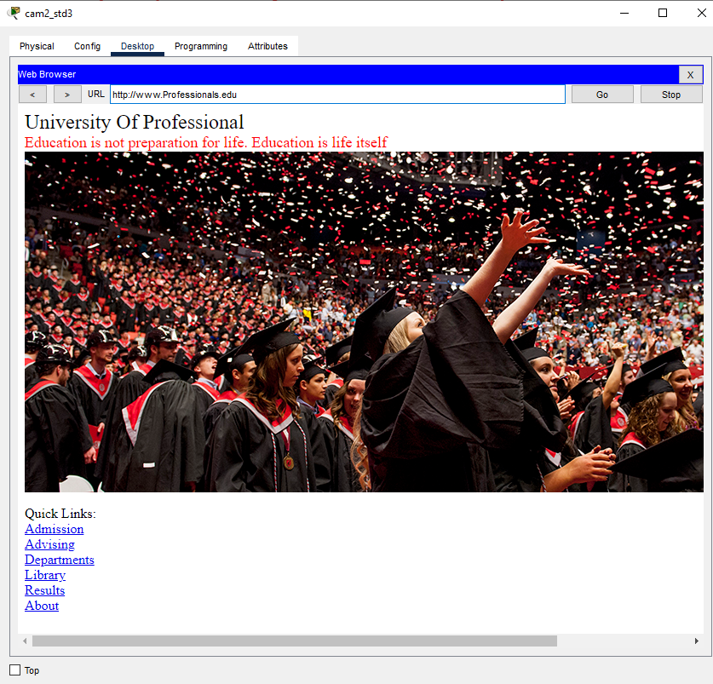

Figure: University of professionals is accessed by Campus2-Student3 host through the web server

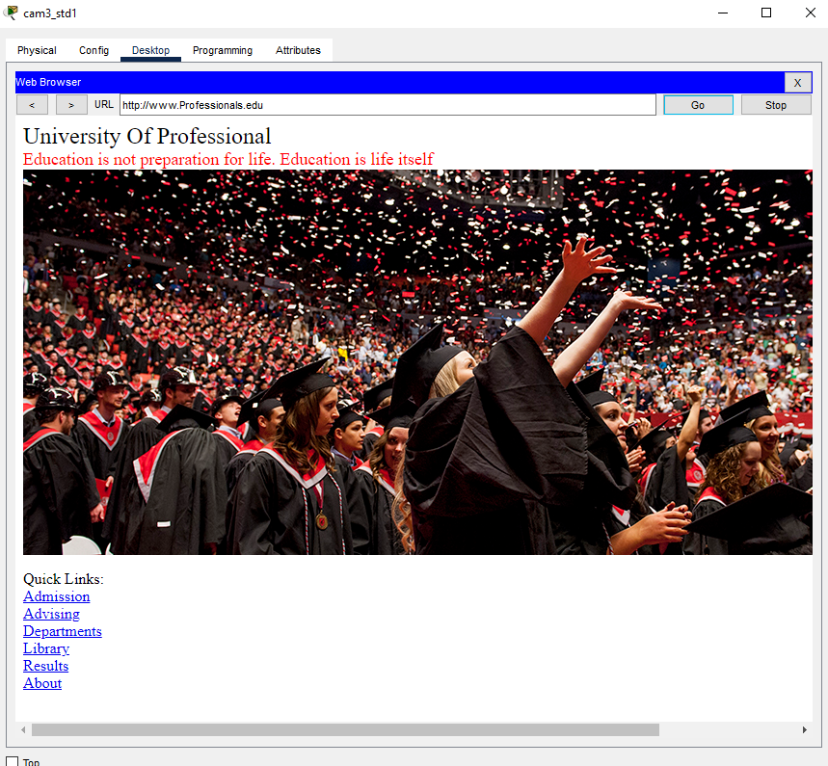

Figure: University of Professionals is accessed by Campus3-Student1 host through the web server

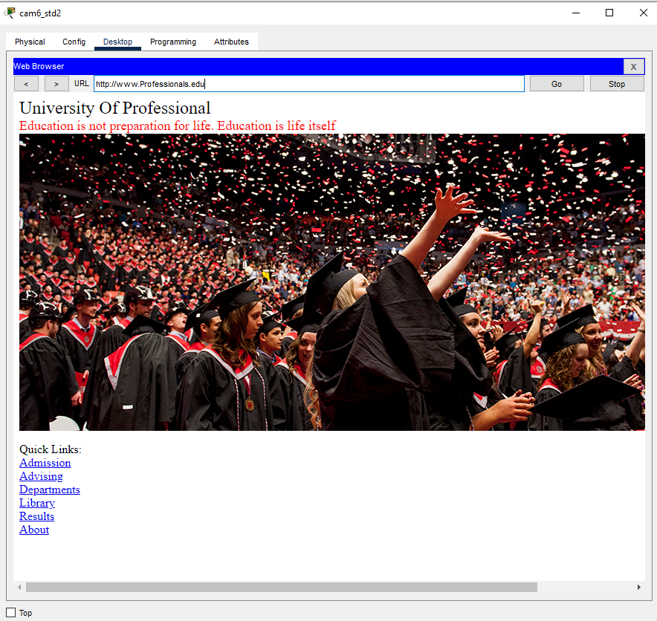

Figure: University of Professionals is accessed by Campus6-Student2 host through the web server

**Codes for Routers Configuration**

**<>Router 1<>!!**

interface fa0/0

ip addresss 192.168.10.254

no shut

do wr

exit

inteface se2/0

ip address 13.0.0.1 255.0.0.0

clock rate 64000

no shut

do write

exit

inteface se3/0

ip address 12.0.0.1 255.0.0.0

clock rate 64000

no shut

do write

exit

inteface se6/0

ip address 11.0.0.2 255.0.0.0

clock rate 64000

no shut

do write

exit

**<>Router 2<>!!**

interface fa0/0

ip addresss 192.168.20.254

no shut

do wr

exit

inteface se2/0

ip address 12.0.0.2 255.0.0.0

clock rate 64000

no shut

do write

exit

inteface se3/0

ip address 16.0.0.2 255.0.0.0

clock rate 64000

no shut

do write

exit

inteface se6/0

ip address 17.0.0.2 255.0.0.0

clock rate 64000

no shut

do write

exit

**<>Router 3<>!!**

interface fa0/0

ip addresss 192.168.30.254

no shut

do wr

exit

inteface se3/0

ip address 10.0.0.2 255.0.0.0

clock rate 64000

no shut

do write

exit

inteface se7/0

ip address 11.0.0.1 255.0.0.0

clock rate 64000

no shut

do write

exit

inteface se2/0

ip address 14.0.0.1 255.0.0.0

clock rate 64000

no shut

do write

exit

inteface se8/0

ip address 17.0.0.1 255.0.0.0

clock rate 64000

no shut

do write

exit

inteface se6/0

ip address 15.0.0.1 255.0.0.0

clock rate 64000

no shut

do write

exit

**<>Router 4<>!!**

interface fa0/0

ip addresss 192.168.40.254

no shut

do wr

exit

inteface se2/0

ip address 13.0.0.2 255.0.0.0

clock rate 64000

no shut

do write

exit

inteface se3/0

ip address 14.0.0.2 255.0.0.0

clock rate 64000

no shut

do write

exit

**<>Router 5<>!!**

interface fa0/0

ip addresss 192.168.50.254

no shut

do wr

exit

inteface se2/0

ip address 16.0.0.1 255.0.0.0

clock rate 64000

no shut

do write

exit

inteface se3/0

ip address 15.0.0.2 255.0.0.0

clock rate 64000

no shut

do write

exit

**<>Router 6<>!!**

interface fa0/0

ip addresss 192.168.60.254

no shut

do wr

exit

inteface se2/0

ip address 10.0.0.1 255.0.0.0

clock rate 64000

no shut

do write

exit

**Dynamic Routing Table**

Router 1

router ospf 1

network 192.168.10.0 0.0.0.255 area 1

network 11.0.0.0 0.0.0.255 area 1

network 12.0.0.0 0.0.0.255 area 1

network 13.0.0.0 0.0.0.255 area 1

exit

Router 2

router ospf 2

network 192.168.20.0 0.0.0.255 area 1

network 12.0.0.0 0.0.0.255 area 1

network 16.0.0.0 0.0.0.255 area 1

network 17.0.0.0 0.0.0.255 area 1

exit

Router 3

router ospf 3

network 192.168.30.0 0.0.0.255 area 1

network 10.0.0.0 0.0.0.255 area 1

network 11.0.0.0 0.0.0.255 area 1

network 14.0.0.0 0.0.0.255 area 1

network 15.0.0.0 0.0.0.255 area 1

network 17.0.0.0 0.0.0.255 area 1

exit

Router 4

router ospf 4

network 192.168.40.0 0.0.0.255 area 1

network 13.0.0.0 0.0.0.255 area 1

network 14.0.0.0 0.0.0.255 area 1

exit

Router 5

router ospf 5

network 192.168.50.0 0.0.0.255 area 1

network 15.0.0.0 0.0.0.255 area 1

network 16.0.0.0 0.0.0.255 area 1

exit

Router 6

router ospf 6

network 192.168.60.0 0.0.0.255 area 1

network 10.0.0.0 0.0.0.255 area 1

exit

**Special Requirements:**

* The servers were kept in campus 3 in the form of a server room.
* Only a single DHCP server was used to dynamically provide IP address to hosts belonging to all the different networks.
* Network addresses were selected from 2 classes (Class A and Class C).
* Sub-Nets were incorporated in each of the Campus Networks.
* Complex mesh was designed with extra diagonal paths to ensure that the other communications do not go down even if a router stops working.

**Limitations:**

Due to lack of knowledge of advanced networking strategies and routing algorithms and a more efficient routing technique could not be implemented.

**Conclusion:**

Thus, it can be concluded that the standards for the University of a professional's complicated network were generally satisfied. The network design that was created as practical and capable of providing an effective way of communicating with other campuses. Throughout this course, I learned compelling systems administration procedures, which positively further developed my systems administration aptitude. Last yet not the rundown, I need to offer my thanks for offering me the chance to do this undertaking.