**Di chuyển nhân vật**

[SerializeField]

float runSpeed = 5f;

[SerializeField]

float jumpForce = 10f;

float horizontalInput;

bool isGrounded;

bool isJumped;

int countJump = 1;

Animator animator;

Rigidbody2D rb2;

// Start is called before the first frame update

void Start()

{

animator = GetComponent<Animator>();

rb2 = GetComponent<Rigidbody2D>();

DontDestroyOnLoad(gameObject);

}

// Update is called once per frame

void Update()

{

// Run

horizontalInput = Input.GetAxis("Horizontal");

rb2.velocity = new Vector2(horizontalInput * runSpeed,rb2.velocity.y);

animator.SetFloat("speed", isJumped ? 0 : Mathf.Abs(horizontalInput));

// Jump

if (isGrounded)

{

isJumped = false;

countJump = 1;

}

if (Input.GetKeyDown(KeyCode.Space))

{

// Simple jump

if (isGrounded)

{

rb2.velocity = Vector2.up * jumpForce;

isJumped = true;

isGrounded = false;

}

// Double jump

else if (countJump < 2 && isJumped)

{

rb2.velocity = Vector2.up * jumpForce;

countJump++;

}

}

animator.SetBool("jump",isJumped);

// Flip

if(horizontalInput != 0f)

transform.localScale = new Vector3(Mathf.Sign(horizontalInput), 1, 1);

}

private void OnCollisionEnter2D(Collision2D collision)

{

if (collision.gameObject.tag == "Ground")

{

isGrounded = true;

}

}

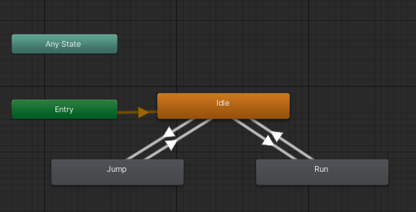

**Chuyển màn chơi**

using UnityEngine.SceneManagement;

public class LoadLevel : MonoBehaviour

{

[SerializeField]

int iLevelToLoad;

[SerializeField]

string nameLevelToLoad;

[SerializeField]

bool usingNumber = true;

private void OnTriggerEnter2D(Collider2D collision)

{

if (collision.gameObject.tag == "Player")

LoadScene();

}

void LoadScene()

{

if (usingNumber)

{

SceneManager.LoadScene(iLevelToLoad);

}

else

{

SceneManager.LoadScene(nameLevelToLoad);

}

}

}

Thêm vào PlayerMovement.cs

private void OnLevelWasLoaded(int level)

{

Vector2 pos = transform.position;

pos.x = GameObject.FindWithTag("StartLocation").transform.position.x;

transform.position = pos;

var players = GameObject.FindGameObjectsWithTag("Player");

if (players.Length > 1) Destroy(players[0]);

}

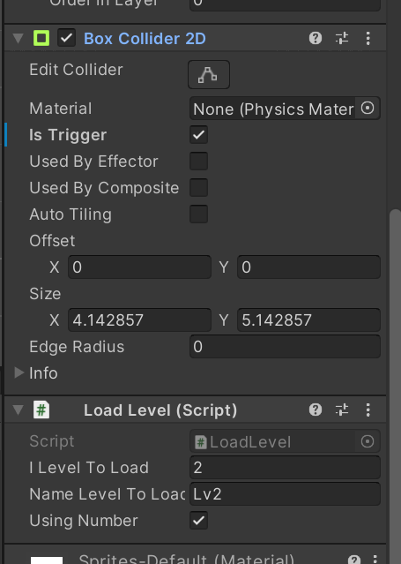

**Menu**

using UnityEngine.SceneManagement;

public class Menu : MonoBehaviour

{

[SerializeField]

Button btnStart;

// Start is called before the first frame update

void Start()

{

btnStart.onClick.AddListener(StartGame);

}

void StartGame()

{

SceneManager.LoadScene("lv1");

}

}

**Camera**

public class SmoothCamera : MonoBehaviour

{

[SerializeField]

Transform target;

[SerializeField]

float smooth;

[SerializeField]

Vector3 offset = new Vector3(0,0,-10);

void FixedUpdate()

{

Vector3 position = target.position + offset;

transform.position = Vector3.Lerp(transform.position, position, smooth * Time.fixedDeltaTime);

}

}

**Bot di chuyển Patrol**

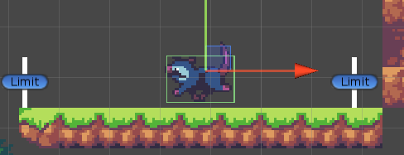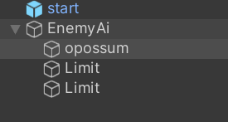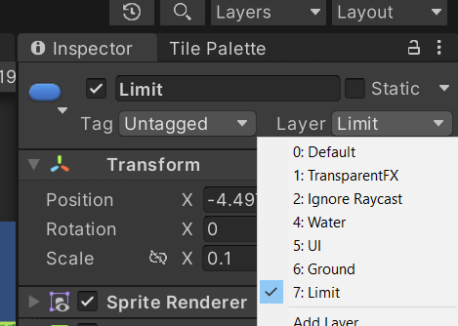

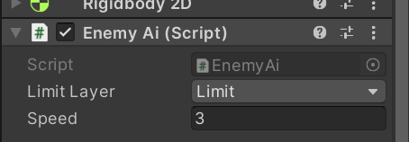

public class EnemyAi : MonoBehaviour

{

[SerializeField]

LayerMask limitLayer;

[SerializeField]

float speed = 10f;

int dir = -1;

// Start is called before the first frame update

void Start()

{

}

// Update is called once per frame

void Update()

{

RaycastHit2D hit = Physics2D.Raycast(transform.position, Vector2.right * dir, 1f, limitLayer);

if(hit.collider != null)

{

// Flip

dir *= -1;

transform.localScale = new Vector3(transform.localScale.x * -1, 1, 1);

}

transform.Translate(Vector2.right * speed * dir * Time.deltaTime);

}

}

Di chuyển A*

public class EnemyGFX : MonoBehaviour

{

public AIPath aiPath;

// Update is called once per frame

void Update()

{

if(aiPath.desiredVelocity.x >= 0.01f)

{

transform.localScale = new Vector3(-1, 1, 1);

}else if(aiPath.desiredVelocity.y <= -0.01f)

{

transform.localScale = new Vector3(1, 1, 1);

}

}

}

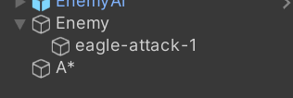

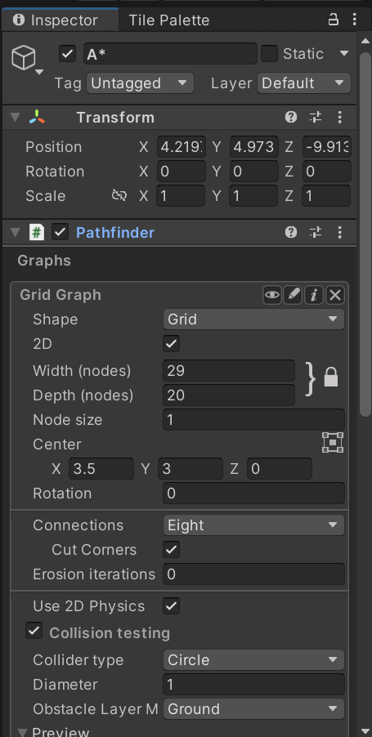

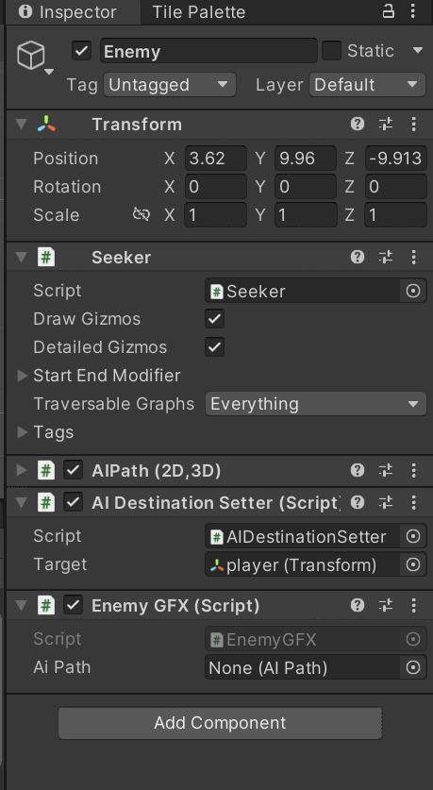

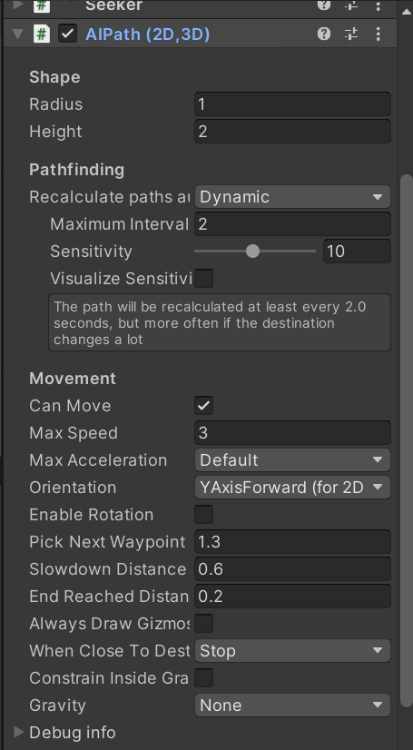

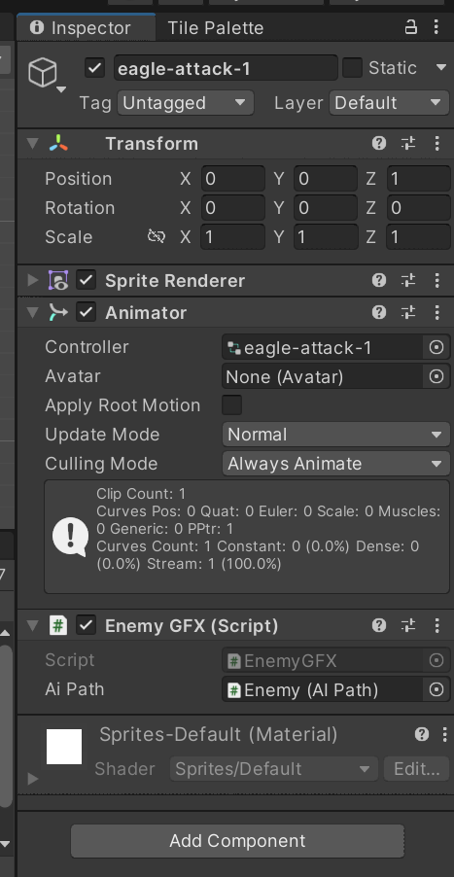

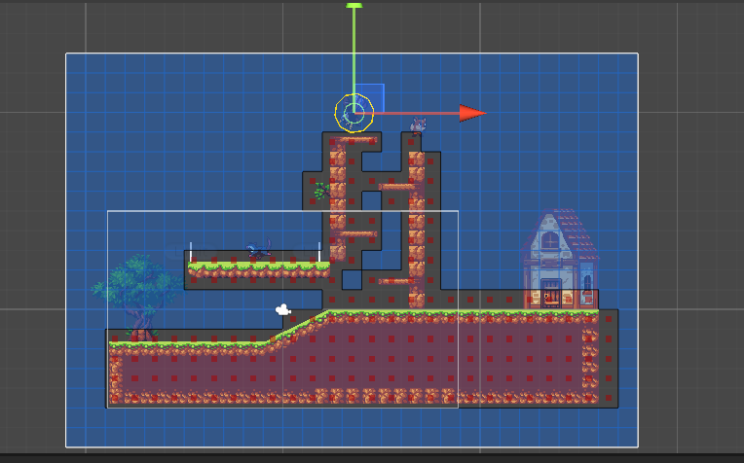

Cộng điểm

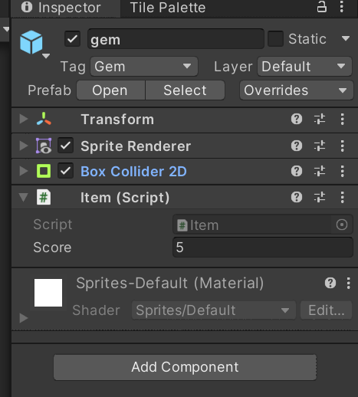

public class Item : MonoBehaviour

{

public int score;

bool firstTime = true;

private void OnTriggerEnter2D(Collider2D collision)

{

if (collision.gameObject.tag == "Player")

{

if (firstTime)

{

ScoreManager.Instance.AddScore(score);

Destroy(gameObject);

firstTime = false;

}

}

}

}

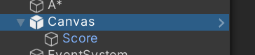

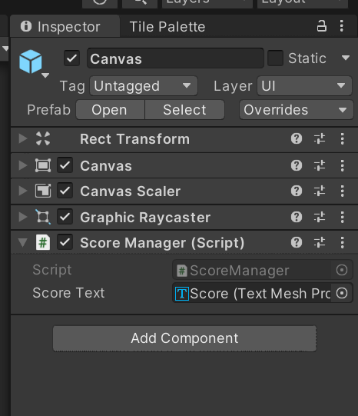

using TMPro;

public class ScoreManager : MonoBehaviour

{

[SerializeField]

TextMeshProUGUI scoreText;

public static ScoreManager Instance { get; set; }

int score;

private void Awake()

{

if(Instance == null)

{

Instance = this;

DontDestroyOnLoad(gameObject);

}else if(Instance != this)

{

Destroy(gameObject);

}

}

// Start is called before the first frame update

void Start()

{

UpdateUI();

}

public void AddScore(int n)

{

score += n;

UpdateUI();

}

public void UpdateUI()

{

scoreText.text = score.ToString();

}

}