# Admonitus setup

1. Download & install Tomcat 8 from <http://tomcat.apache.org/download-80.cgi>
   1. Direct link: <http://apache.mirrors.lucidnetworks.net/tomcat/tomcat-8/v8.0.27/bin/apache-tomcat-8.0.27.exe>
   2. Accept the setup defaults, EXCEPT do not start the service

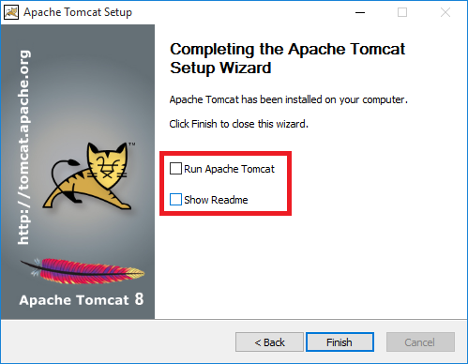

1. Download and extract the zip file, open the project in Eclipse
2. Right click the project and click properties
3. In the left menu, click “JPA” and click on the library button to add a library

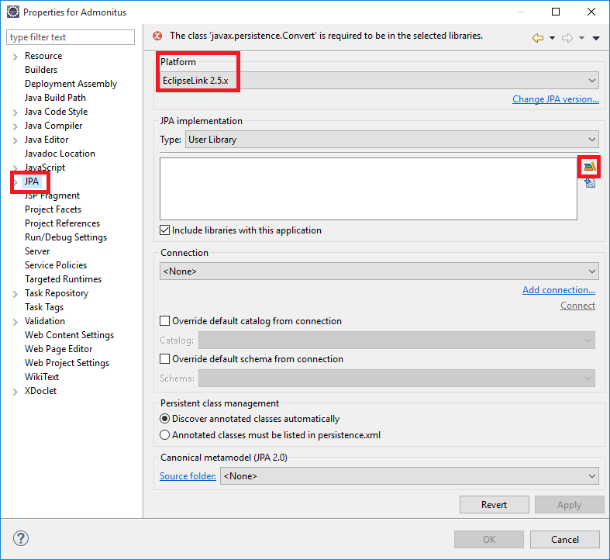

1. Add a new library and give it a name (name doesn’t matter)

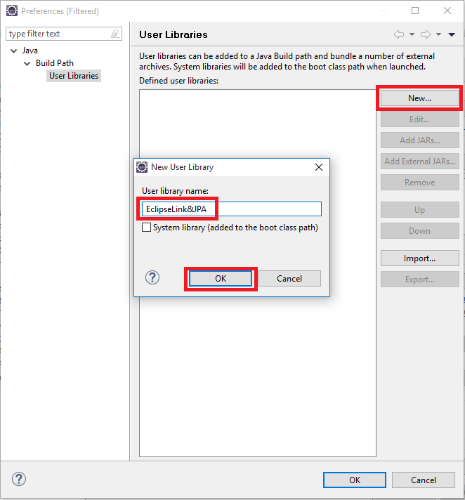

1. Select the library you just created and click on “Add External JARs…”

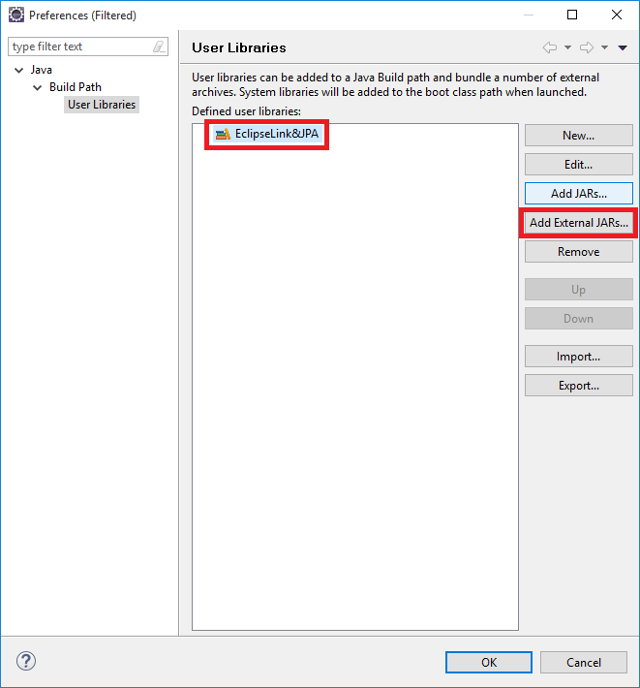

1. Select the eclipselink, javax.persistence and javax.persistence.source JARs

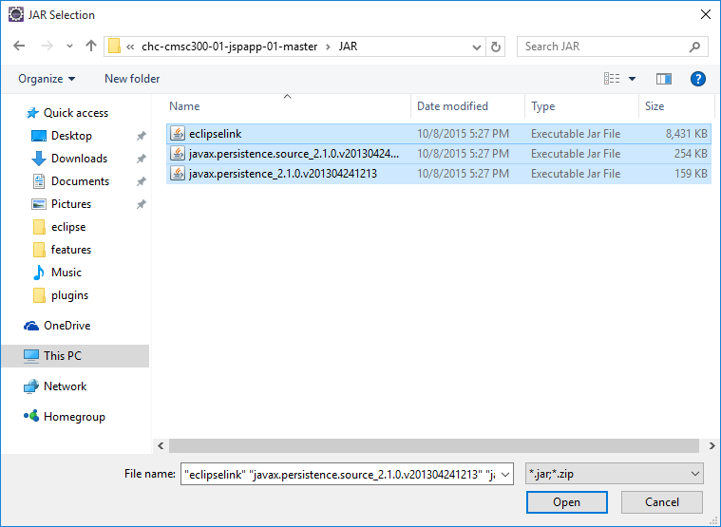

1. The end result should look like this:

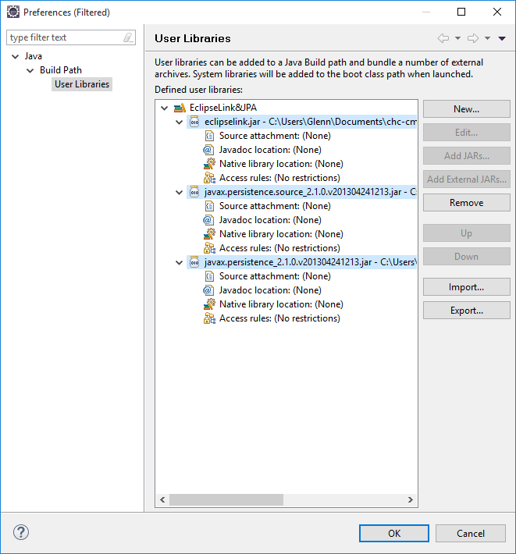

1. Apply & confirm all changes
2. Right click the project and click on “Validate”. Any errors should disappear now.

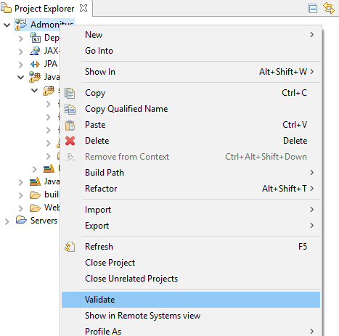

# Starting the application for the first time

1. Right click the project and select Run As -> Run on Server

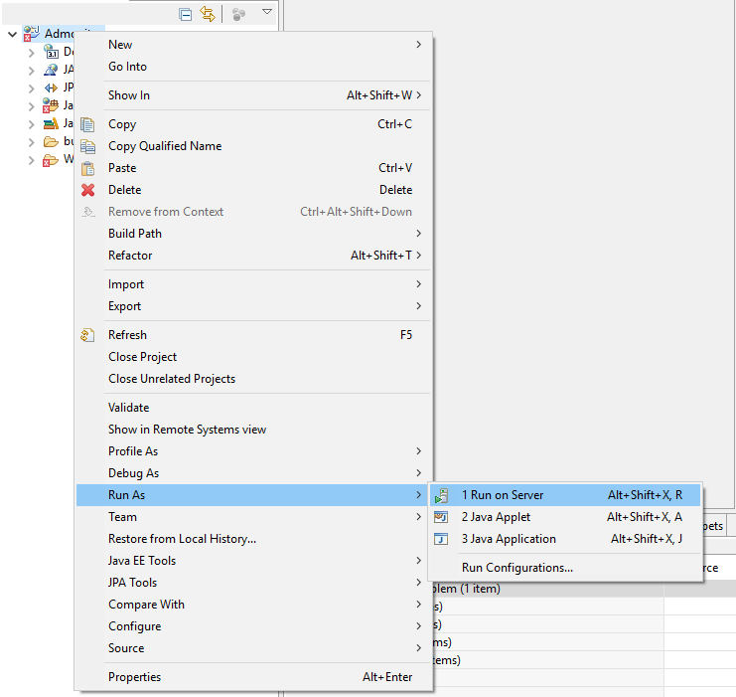

1. Select as server type “Tomcat v8.0 Server”

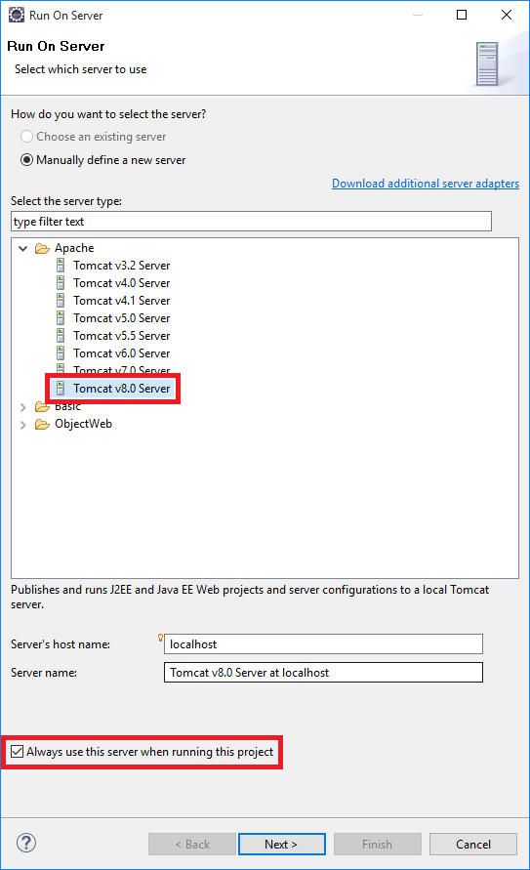

1. Set the installation directory to where Tomcat was installed

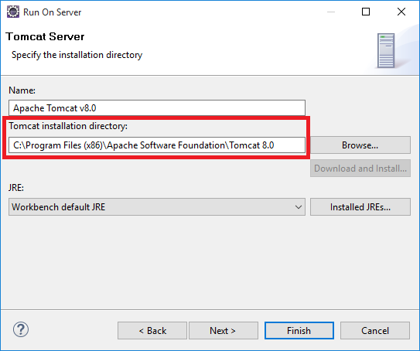

1. Click finish. The application should now run, accessible from:
   1. <http://localhost:8080/Admonitus>