Admonitus Structure and Setup

**Description**

Admonitus is a web application, that gives users the ability to log in to a personal interface, where it is possible to create, edit and store reminders. The reminders consists of the following data: text, frequency and start date for first reminder alert. The reminders are stored in a MySQL database, where a foreign key containing a user_id links each reminder to it's respective user/owner. The database also contains the information necessary for users to create accounts and use the application. The data stored in the user table is the credentials; email and password, a path to an optional picture associated with a users account, an activation key, an activation boolean, creation date and a last_update field. The password is encrypted with SHA-256, which stands for Secure Hash Algorithm, and is a cryptographic hash function.

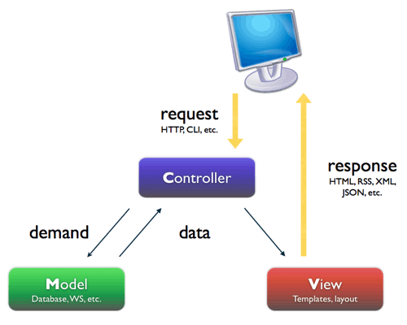**Structure**

The overall structure of the application complies with the software architectural pattern called **Model-View-Controller**. This means, that the application is divided into three parts, so as to hide the internal representation of data from the user.

**Setup**

Setting up the application is fairly straight forward:

1. Open and use the delivered MySQL database.
2. Import the delivered project into Eclipse
3. Run project → Choose 'Run on server'
4. Open web browser, and go to URL: localhost:8080/Admonitus/