Admonitus Structure and Setup

Description
Admonitus is a web application, that gives users the ability to log in to a personal interface, where it is possible to create, edit and store reminders. The reminders consists of the following data: text, frequency and start date for first reminder alert. The reminders are stored in a MySQL database, where a foreign key containing a user_id links each reminder to it's respective user/owner. The database also contains the information necessary for users to create accounts and use the application. The data stored in the user table is the credentials; email and password, a path to an optional picture associated with a users account, an activation key, an activation boolean, creation date and a last_update field. The password is encrypted with SHA-256, which stands for Secure Hash Algorithm, and is a cryptographic hash function.

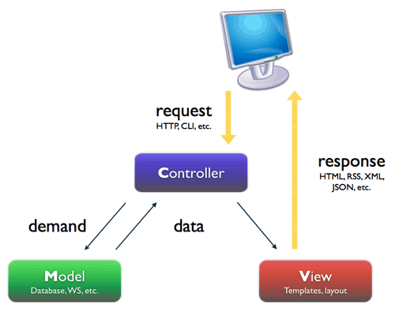
Structure

The overall structure of the application complies with the software architectural pattern called Model-View-Controller. This means, that the application is divided into three parts, so as to hide the internal representation of data from the user.

Setup

Setting up the application is fairly straight forward:

- Open and use the delivered MySQL database.
- Import the delivered project into Eclipse
- Run project → Choose 'Run on server'
- Open web browser, and go to URL: localhost:8080/Admonitus/

