**To James Smith**

Hello James,

I am sorry to hear you're having issues with our equipment.

It sounds like you're having issues with a router of ours

“See attached image for guidance on ensuring the router works”

I would recommend resetting the router.

This can be done from the backside where there should be a "tiny black round" button hold it down for a minimum of 5 seconds then release it.

Once reset wait 1-2 minutes for the router to reboot.

After a successful reboot   
Check the lights on the front of the router and ensure that the power icon is constantly lighting  
  
The WIFI & LAN lights are supposed to be blinking that indicates its working  
  
  
If you’re still experiencing issues with the router do not hesitate to email or call me directly

PersonalMail@ITCompany.com  
+45 1223 4567

Regards   
Some employee

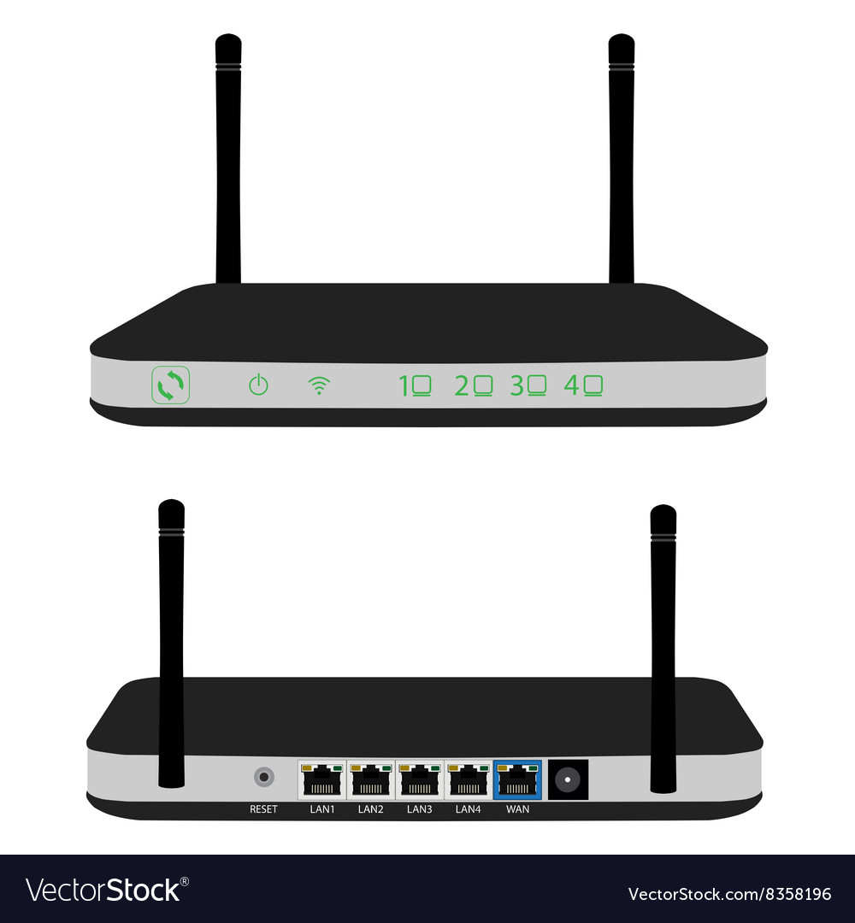

WIFI lamps

LAN lamps

Power lamp

Reset employee Button

**To Susan**Hello Susan,  
  
We have a dissatisfied customer “James Smith” according to the email he is experiencing router issues  
  
I have given detailed instructions on a solution for the issue   
and given my work email and phone number in-case the issues continue.  
  
Regards   
Some internal employee