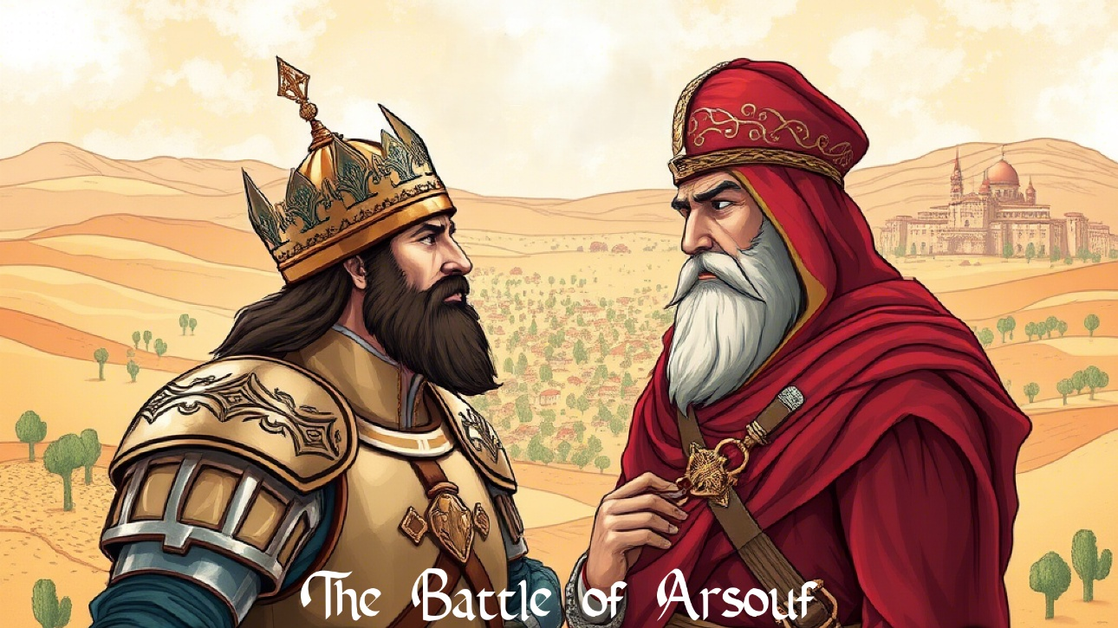Game Manual

# Main Menu

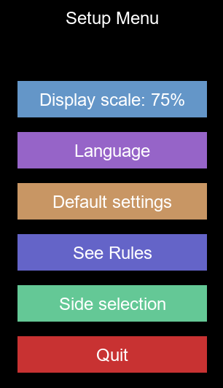

* **Display scale:** Change resolution, 40%, 50%, 60% or 75% of board size (2340x1740px)
* **Language:** Switch between EN and ES.
* **Default settings:** Restores the default values.
* **See Rules**: Displays the rules of the game and this manual.
* **Side selection:** See section 2 below.
* **Quit**: Quit the game.

# Side selection

* Choose between controlling Saladin or Richard Lionheart.

# Deployment

* The unit to be deployed is displayed in the log panel.
* Click on the desired hexagon to deploy the unit.

# Main screen (interface and controls)

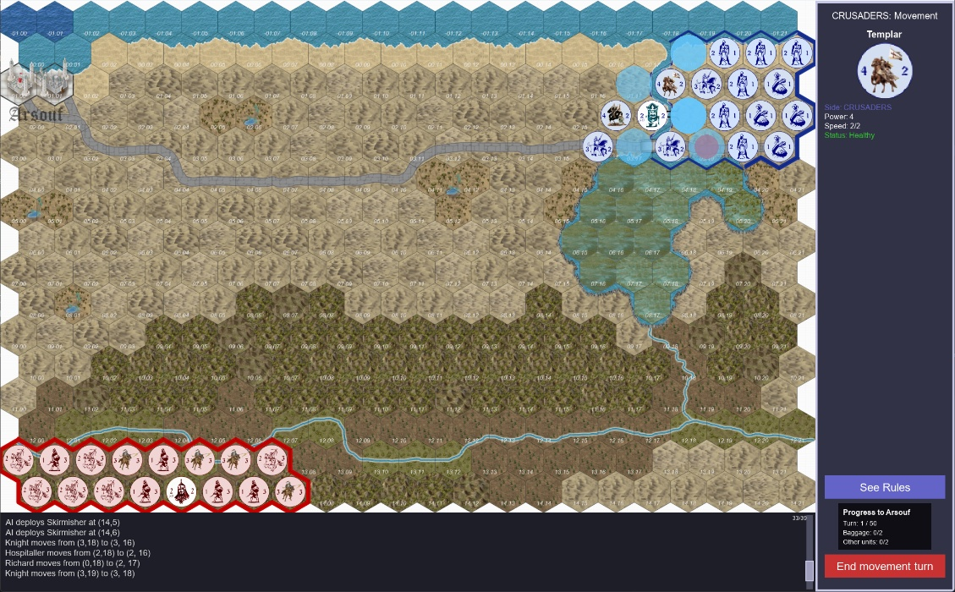

Unit details panel

Map

Log Panel

Manual

Victory Progress Panel

Side panel

End of phase button

* **Map**: Visualize the battlefield, allied and enemy positions.
* **Unit Details Panel**: Show information about your selected troops.
* **Side panel**: Displays relevant information about the state of the game.
* **Log Panel**: Game events are logged here.
* **Victory progress panel:** Shows the current game progress.
* **‘View Rules’ button:** Show this manual.
* **End of phase button:** Ends the current phase (see phases below).

Controls:

* **Mouse wheel**: Scroll vertically across the map.
* **CTRL + Mouse Wheel**: Scroll horizontally across the map.
* **ESC**: Quits the game.

# Movement Phase

* Select a unit. Its details will appear in the side panel, and its possible movements will appear marked with **cyan circles**.

* Left click on the selected destination to move the unit.
* A **red circle** will mark the original position of the moved unit.

* Right **click** the **red circle** to cancel the movement and return the unit to its original position.
* If a knight “charges” into an enemy, it will be logged in the log panel.

# Combat Phase

* Select the attacking unit. Its details will appear in the side panel, and its possible targets will be marked with a **red circle**.

* You can cancel attacker selection by **right-clicking**.
* Or you can attack an enemy at range by **left-clicking** on it.
* If a unit is injured during combat, it is marked with a **red cross,** and will appear as “injured” on the side panel when selected.

* The cross will disappear if the unit is later recovered (see game rules).

# Computer Turn

* When you finish your turn, the computer executes its movements and attacks.
* The actions of the computer are automatic and visible on screen, and are logged in the bottom panel.

# Victory Conditions

* In addition to the rules, the Crusader army is defeated if it fails to reach Arsouf with the necessary units within the turn limit.

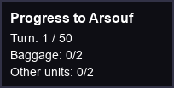

*Based on the board game “The Battle of Arsuf,” designed by Andrew McNeil for the book* ***Battle Games 2: Knights in War*** *© Usborne Publishing, 1975*

*This game is a fan-made implementation by Tony J. Soler (Red Tony), published under a CC BY-NC-SA 4.0 license.*

*](https://creativecommons.org/licenses/by-nc-sa/4.0/)*

Enjoy it!