**Red Team**

**Stargazer**

**Automatic Telescope Control System**

**User’s Guide**

**Team Members:**

Rob Grmek

Robert Smith

**Instructor:**

**Youry Khmelevsky**

**Course:**

**COSC 471**

**Date:**

**January 11th, 2010**

# ****Revision History****

|  |  |  |  |
| --- | --- | --- | --- |
| **Date** | **Version** | **Description** | **Author** |
| 10/28/2009 | 1.0 | Document created. | Robert, Rob |
| 1/11/2010 | 1.1 | Document filled in. | Robert |

# ****Table of Contents****

**Page**

|  |  |
| --- | --- |
| Introduction | 1 |
| System Description | 1 |
| Environment | 1 |
| Step by Step Instructions for Using the System | 2 |
| Logging In | 2 |
| Viewing the Scheduling Log | 2 |
| Scheduling the Telescope | 4 |
| Viewing the Image Gallery | 6 |
| Appendix A: Glossary | 7 |

# ****User’s Guide****

This document contains information that operators may find hopeful in utilizing the telescope control system.

#### System Description:

The telescope control system contains two main components:

The website allows operators to schedule a time, date and location to take images of a specific area of sky. Also, operators will be able to review scheduling logs and view images pertaining to past schedules in a gallery.

The application which controls the telescope and camera based on the scheduled time and coordinates inputted by the operator through the web site. This part of the system is abstracted from the operator and is completely automated.

Environment:  
Operators may connect to the website at the following address: [http://142.23.93.226 or <http://cis470star09f.okanagan.bc.ca/>]

Alternatively, one may connect to the site via mobile devices at the same URL, although they will have limited functionality.

## Step by Step Instructions for Using the System

#### Logging In:

The user name and password is initially assigned to a user by an administrator. In order to login, the user must supply the correct user name and password.

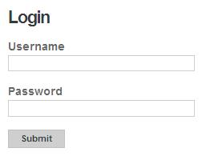

Once logged in, the user can click the "Edit Profile" button on the main navigation bar to edit his or her profile. This enables the user to change his or her: username, email address or password.

#### Viewing the Scheduling Log:

Once a user has logged in to the system, they can review the currently scheduled telescope activity. To do this the user should first click on the "Schedule Log" tab at the top of any page; this will list all schedules.

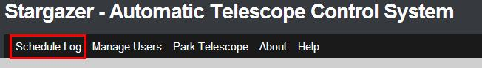

Using the calendar, the user can perform searches to filter schedules to a certain day. One can do so by opening up the calendar by clicking the calendar icon. Then, one can select a date using the mouse.

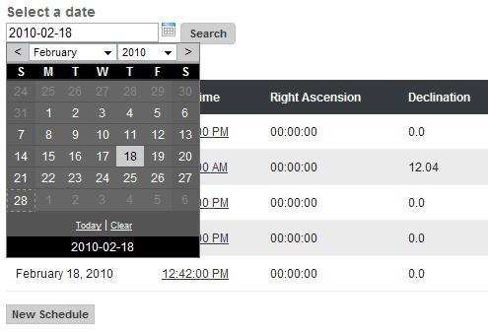

Also, the user may also input the date in the text box. The format used is 'YYYY-MM-DD' (i.e. 2010-02-26).

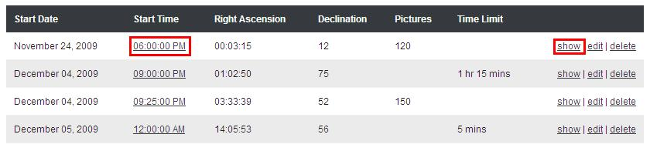

Last, the user can click on the start time or on the show link of any schedule entry to view the full schedule details.

#### Scheduling the Telescope:

Once a user has logged in to the system, they can schedule the telescope to capture images. To do this the user should first click on the "Schedule Log" tab on the main navigation bar, if they are not already viewing the schedule log.



To add a new schedule click the "New Schedule" button located at the bottom of the list of schedules. This takes the user to the New Schedule page where they can specify what options the telescope and camera should use for this set of images.

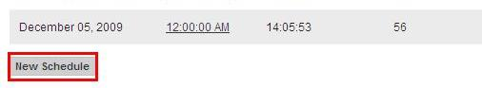

The user should select a start time for when the image capturing should start. This time has to be in the future and cannot conflict with any pre-existing schedules.

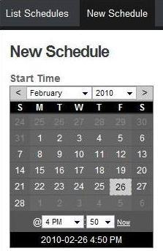

Then, coordinates must be entered. This can be done in one of two ways - either by typing the name of a celestial object in the text field or by supplying right ascension and declination coordinates.  
  
Next, the camera settings must be supplied. However, the default values can be used, if the user does not wish to supply any changes.  
  
Finally, duration must be given. This can also be done in one of two ways - either by a duration (how long the telescope should be positioned at this position and capture images for) or a number of pictures (maximum amount of images to be captured). These two options are mutually exclusive and only one duration method is allowed. 

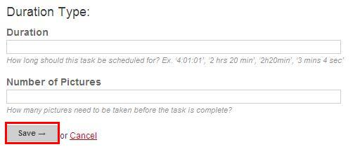

Once all options have been set the user can click the "Save" button at the bottom of the New Schedule page to save the schedule.  
  
Then, the telescope will move to the indicated position at the time specified and take the requested number of numbers.

#### Viewing the Image Gallery:

While a user is viewing the full details for a schedule (see: [Viewing the Scheduling Log](http://localhost:3000/info/log)) a user can view any images that have been captured for that schedule. To do this the user can click on the "List Images" tab at the top of the schedule details. This will list thumbnail versions of any images that have been captured.

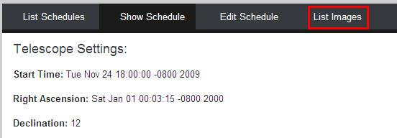

Clicking on the image file name or the show link for any image will show the details of the image and clicking on the thumbnail image will show the full size image.  
  
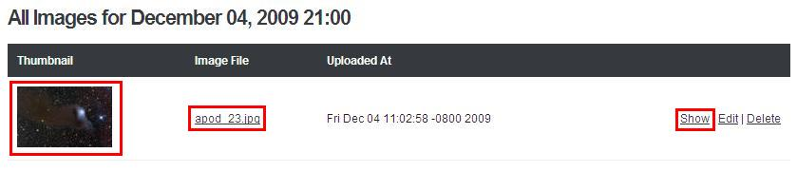

# Appendix A: Glossary

|  |  |
| --- | --- |
| **Term** | **Definition** |
| Stargazer | Internal project name for the automated telescope control system. |