**General Setup for MicroMouse project**

First get Mingw from msys2

<https://www.msys2.org/>

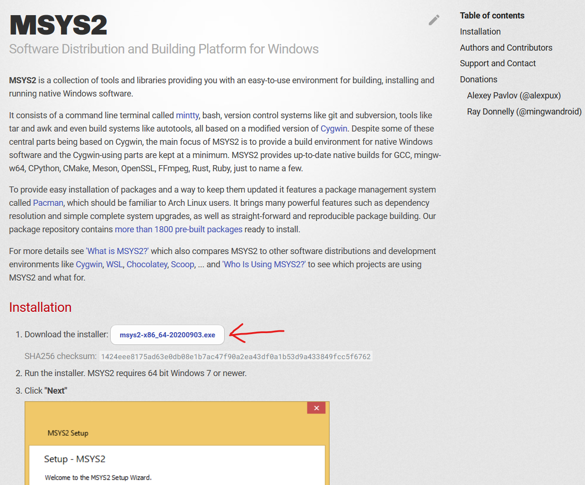

Save exe, run it

Next, open msys2 terminal and run the following command to get the mingw toolchain (might take a bit)

‘pacman -S mingw-w64-x86_64-toolchain’

Next get jetbrains toolbox, install Clion (you can get them for free from isu here <https://it.engineering.iastate.edu/software/students/>)



Apply for license, once you get it download jetbrains toolbox and clion, and provide the license when prompted for it when opening clion for the first time.

Once your in clion, open your settings and navigate to Build, Execution, Deployment -> Toolchains, and make sure you add the mingw toolchain. (you might need to restart clion if it doesn’t show up)

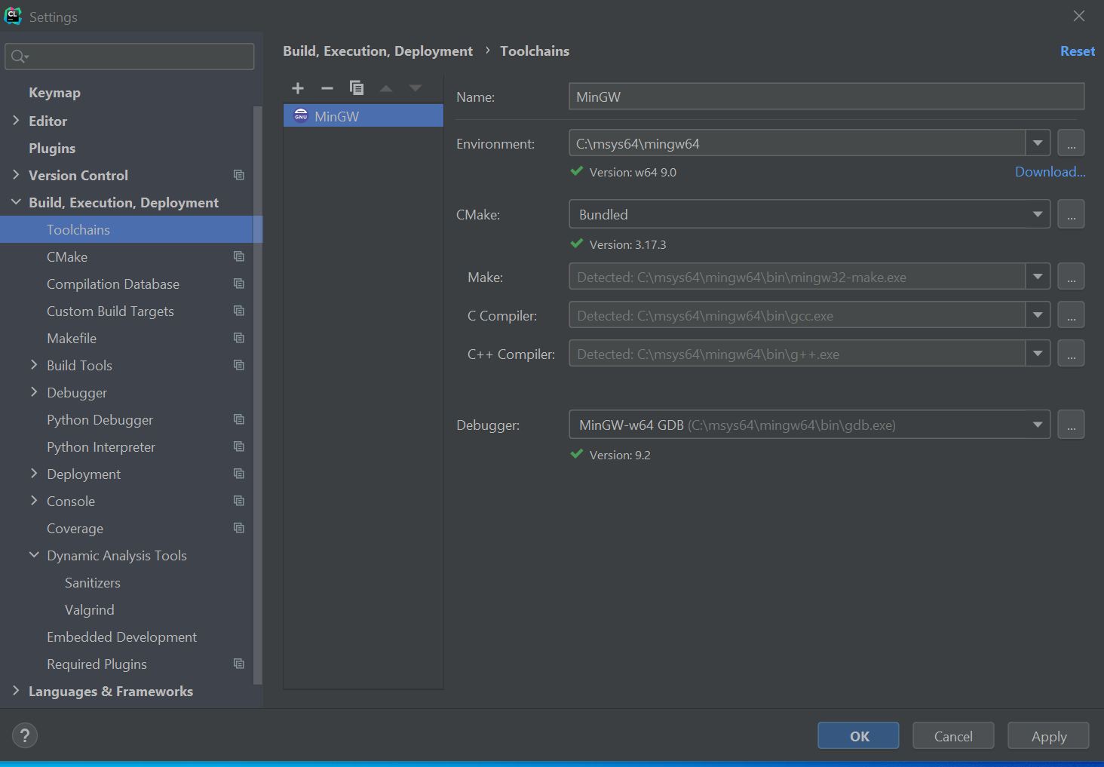

Once that’s all good, navigate to plugins and install the platformio plugin.

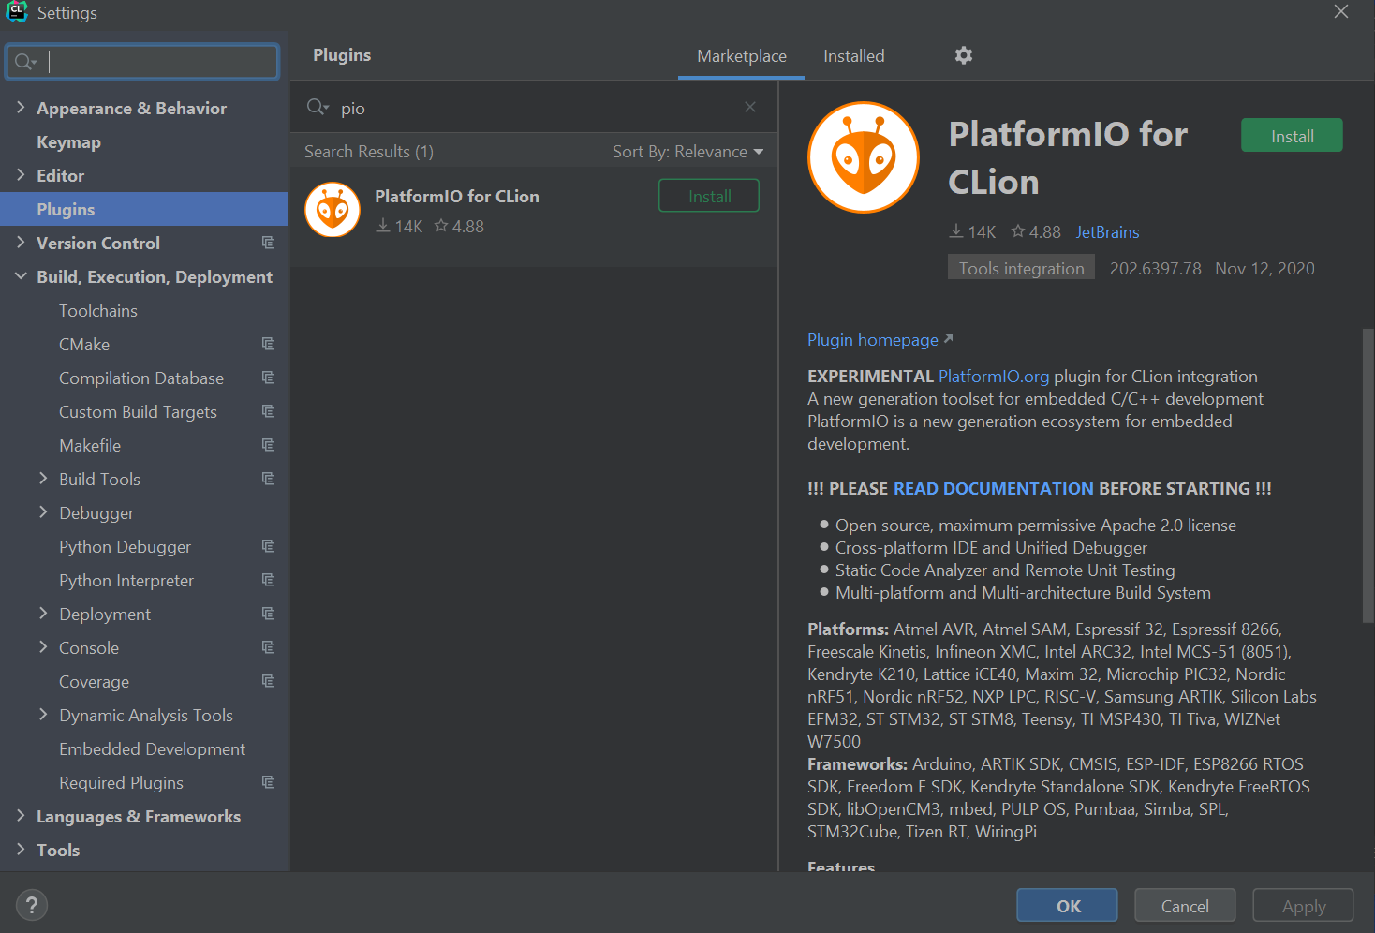

Next go to the link below and save the page as a python file (.py),

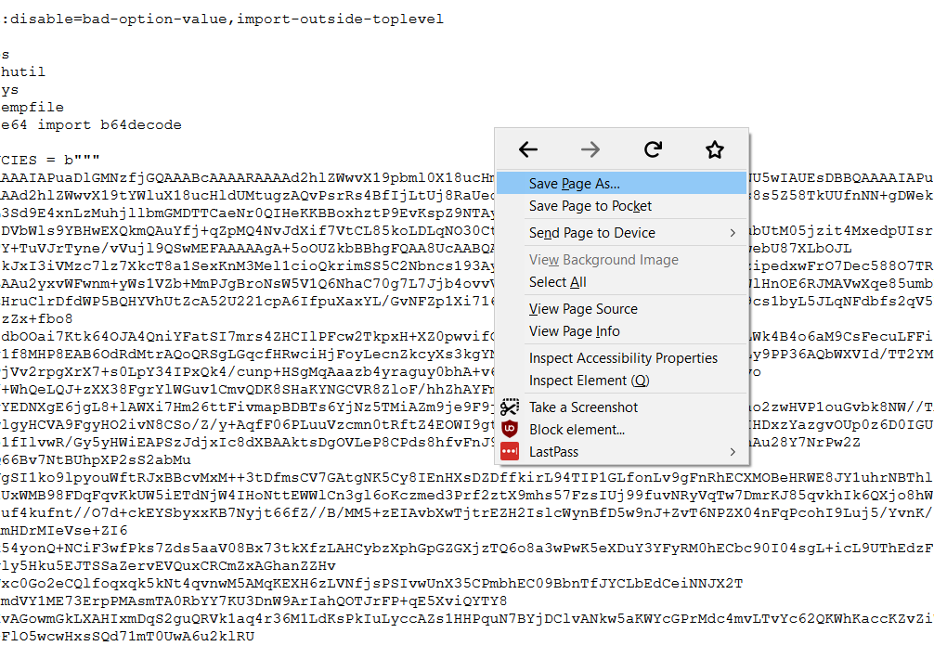

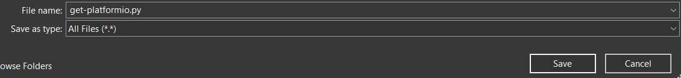

and then run it using the command below.

‘python get-platformio.py’

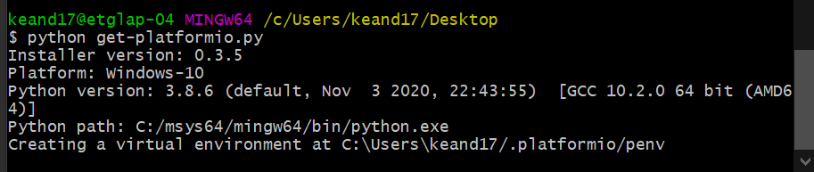

After this, you may need to add the path variable.

Add your directory …\.platformio\penv\scripts to the path.

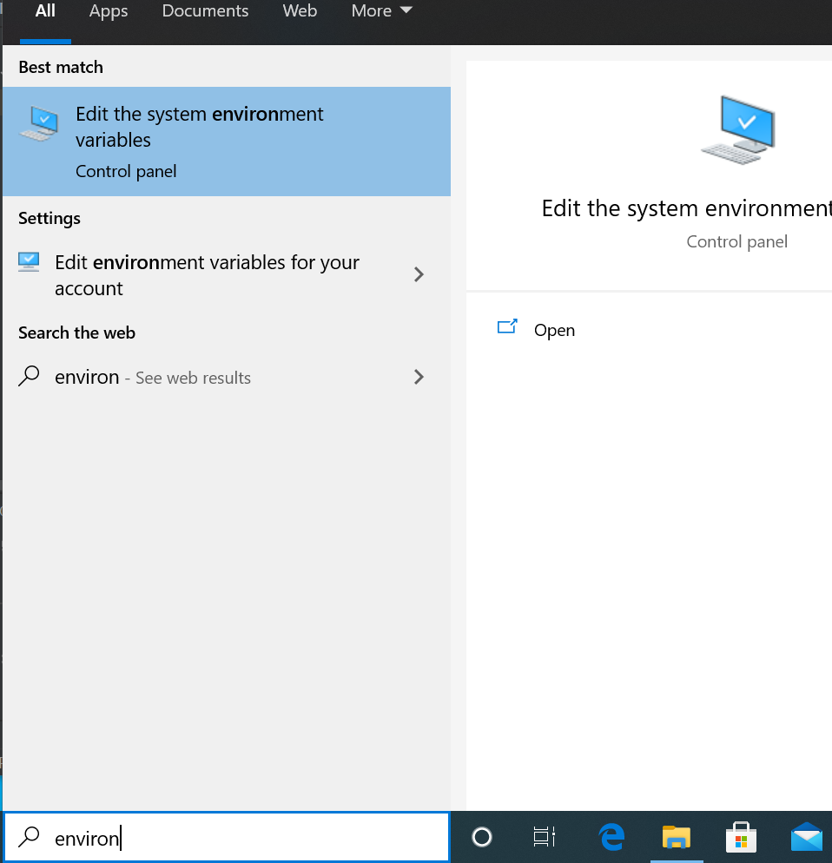

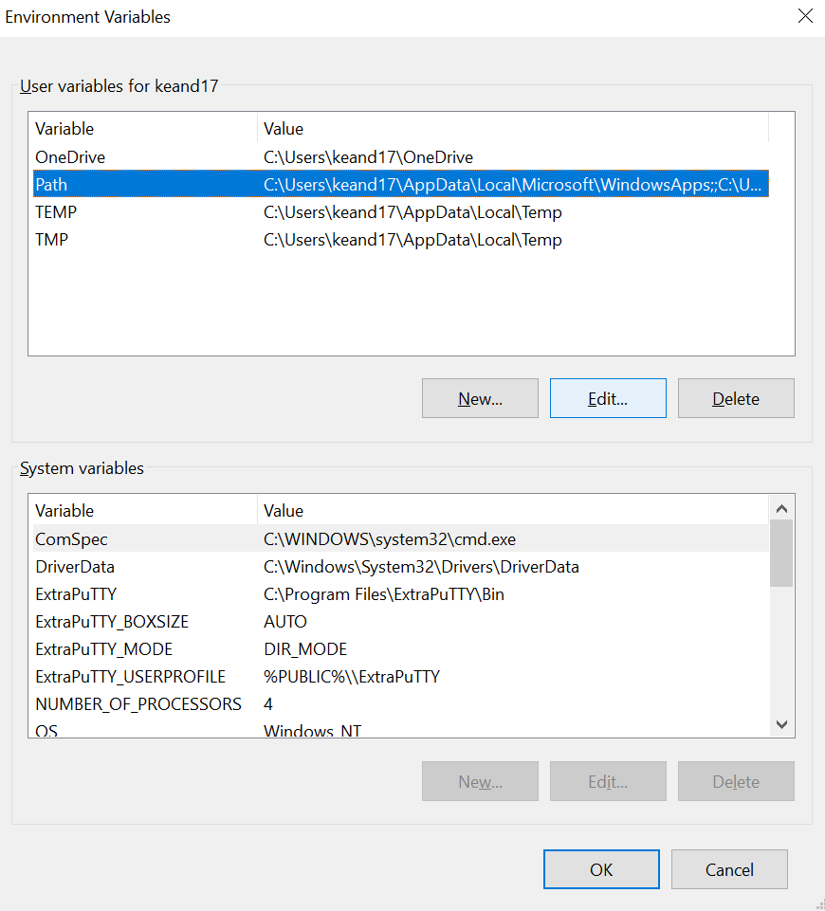

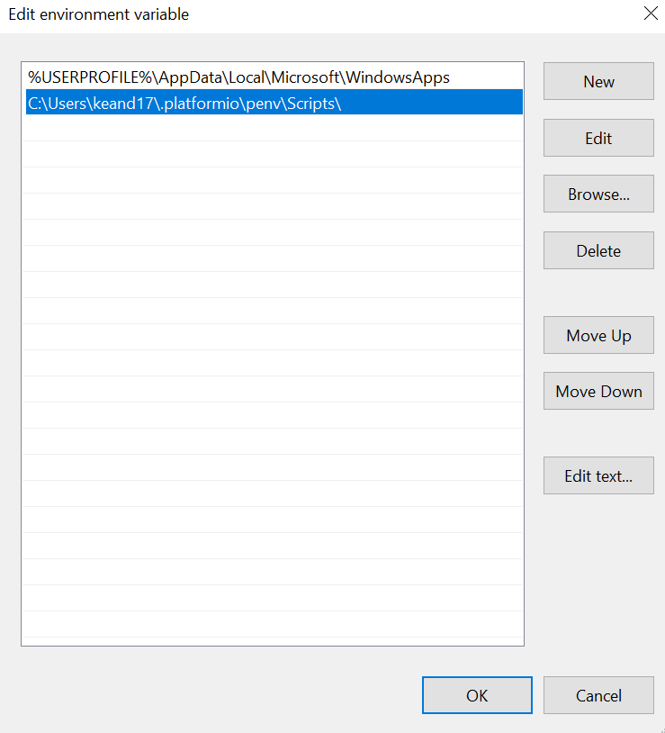

Once pio is on your path, restart clion, and then open it back up and go to tools -> cmake -> reset cache and reload project.

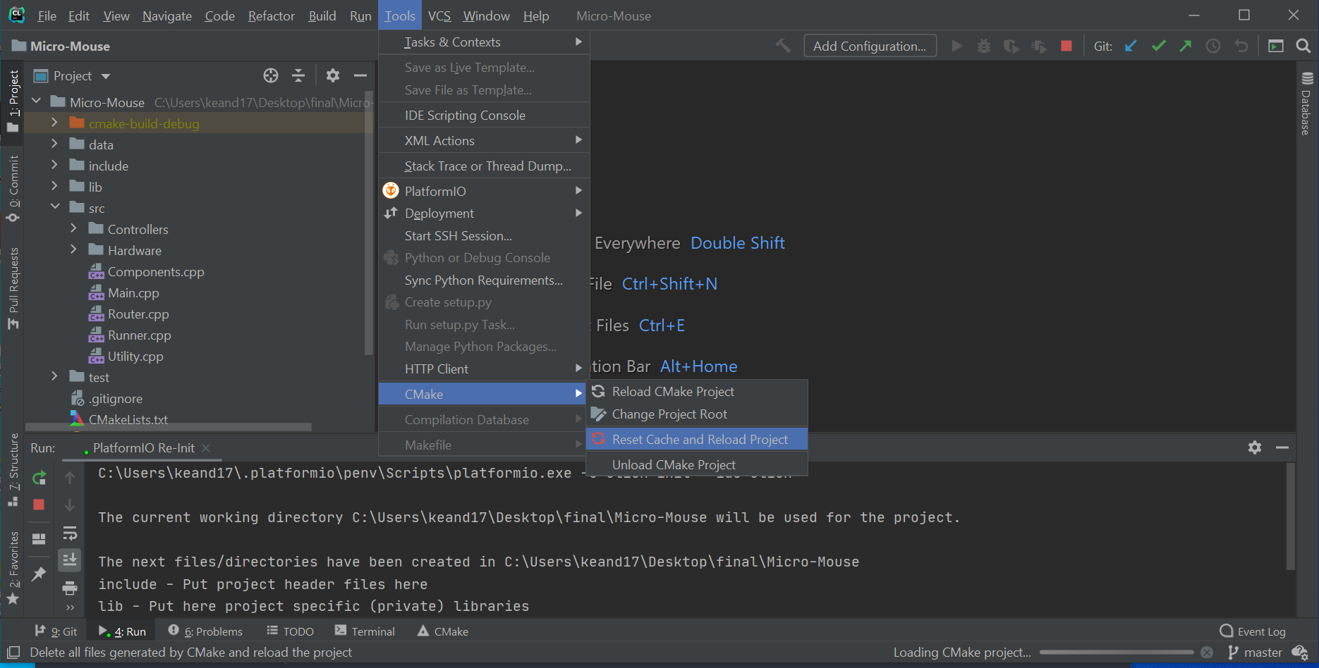

After this, go back to Build, Execution, Deployment and go to the cmake tab, and make sure the build type is featheresp32.

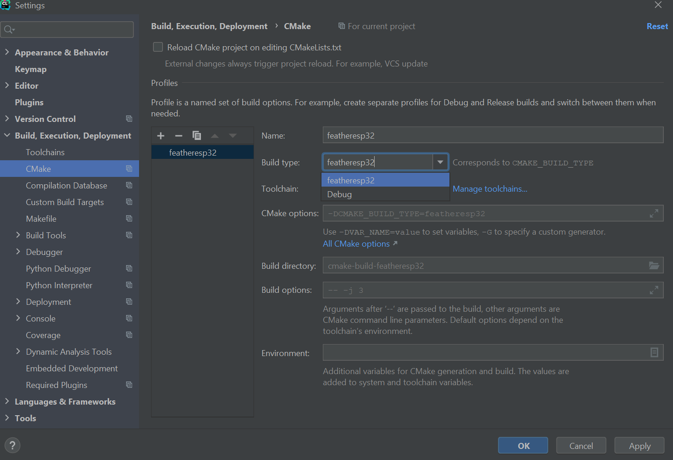

After all of this, you should be able to exit the menus and build the project.