Dhruv Joshi, SrinivasMarmamula, SaumyaKumaar, SonaliAndani, Sheetal Reddy, Jaspreet Singh

Bruckner’s Cam

[1]

**Abstract -** Eye is the only part of the body which allows the doctors to directly view the blood vessels and the brain activities. The light reflected from the retina contains a lot of information, which can be processed using certain devices. The Bruckner’s cam is a similar device that captures the red eye reflex, and processes the image to deduce certain medical aspects. The red reflex is basically the reflection of the retina which is observed when a light is flashed, and an image is taken by a camera. Costly medical equipment like ophthalmoscopes and retinoscopes use the same concept for diagnosing the eye. The prototype described in this report works on a similar principle to develop affordable, portable, and easy to handle device for automated screening of the eyes.

*Keywords*—Red reflex, Bruckner’s test, imaging, retinoblastoma, strabismus

# INTRODUCTION

T

he project involves capturing the red reflexes coming from the both the eyes of the patient through a camera. The processor analyses these images and calculates the difference in the intensity and symmetry between both the eyes. Depending on the results, the patient is suggested for medical attention.

# CHALLENGE

## Challenge

The attention span of small children is very less. The conventional methods take time for screening and need a doctor for examination of the eyes. Moreover, in rural areas where doctors cannot reach, an automated efficient testing method is required which can be used as a tool for mass screening.

# CLINICAL IMPACT

## Clinical Impact

The device can be used as a cheap mass screening tool in rural areas without the help of a technician, as the process is based on computerized image processing. The processor does binary classification of the images into healthy or unhealthy thereby automating the early detection of eye diseases.

# PROPOSED METHODS AND PROCEDURES

## Hardware Setup

For capturing reflection of retina from the eyes, the source, observer and patient all should be in same line of sight. However that is not practically possible so a beam splitter has been used. Light from a warm LED operating at 3200K is collimated with the help of a convex lens (as shown in fig). These collimated rays fall into the beam splitter and half of the beam goes into the patient’s eyes which gets reflected and is captured by the camera as a red reflex image.

## Image Processing

The captured image is then processed using OpenCV software which detects the pupil of the eyes using Hough Transform. If the reflex is white then it shows that the eyes are unhealthy indicating presence of diseases like cataract, retinoblastoma or glaucoma. Further implementation involves gaze tracking to help in detection of strabismus and any asymmetry between the eyes.

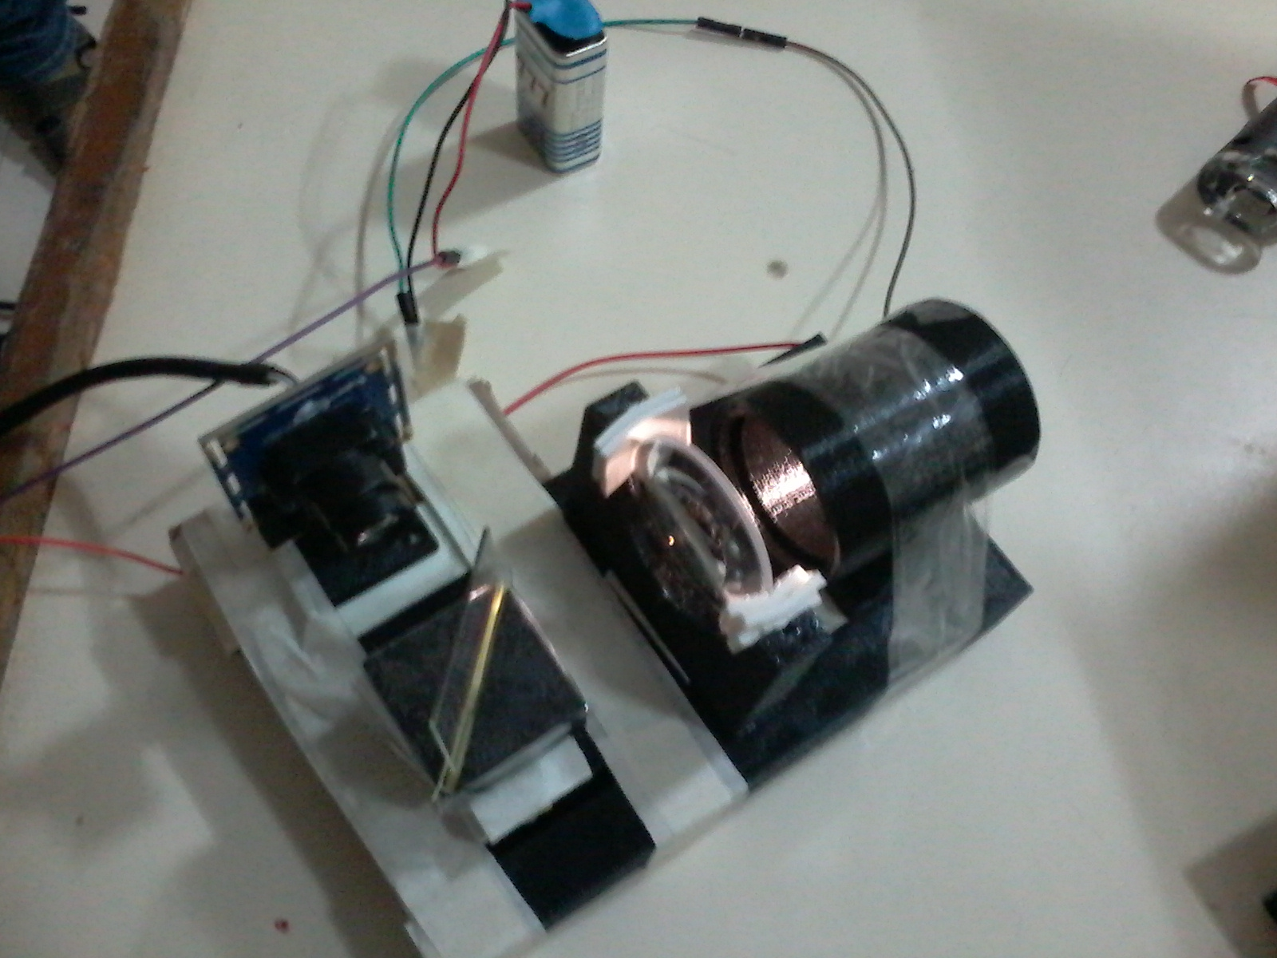

# FUTURE DIRECTION AND ACTIONS

## Concluding Remarks

The prototype developed provides good red reflex images of people even with constricted pupil. At present, the algorithm detects the pupils and the red reflex intensities. Future work involves comparison of red reflex of both the eyes to classify the, as healthy or unhealthy. A large data set needs to be collected so that it is possible to detect diseases like strabismus, cataract and any form of disorientation in the eyes. In the near future, this prototype also has the potential to be a cheap replacement of costly eye imaging instruments like ophthalmoscope and retinoscope.

References

1. Paysse, Evelyn A., et al. "Detection of red reflex asymmetry by pediatric residents using the Brückner reflex versus the MTI photoscreener." Pediatrics 108.4 (2001): e74-e74
2. Apushkin, Michael A., et al. "Retinoblastoma and simulating lesions: role of imaging." Neuroimaging clinics of North America 15.1 (2005): 49-67.
3. Mohrman, Richard C. "Optical alignment method and apparatus." U.S. Patent No. 3,600,098. 17 Aug. 1971.

1.