.

# CONTACT

11/24/2019

**El OUAHABI Reda**

**2nd year Computer Engineering student**

* Email : [**redaelouahabi98@gmail.com**](mailto:redaelouahabi98@gmail.com)
* Phone : **+212 618-409886**
* Address : MD TAIDA LARACHE, Morocco.
* GitHub : [**github.com/reda-ELOUAHABI/**](https://github.com/reda-ELOUAHABI/)
* Icône Langue - Téléchargement gratuit en PNG et vecteursLinkedIn:[**/reda-el-ouahabi-181451189/**](https://www.linkedin.com/in/reda-el-ouahabi-181451189/)

# LANGUAGES

**Arabic :**

**English :**

**French :**

# ACADEMIC BACKGROUND

* Currently: **Mohmmadia school of Engineers**

Second year Computer Engineering, Rabat.

* 2019 - 2017**: CPGE Moulay Al Hassan** Option: Math and Physics, Tangier.
* 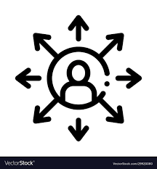2016 - 2017: **Baccalaureate degree** Physics science, Moulay Rachid, Chefchaouen

# EXTRACURRICULAR EXPERIENCES

* **2021 - 2020: Operations Manager at Enactus EMI** **-** **Social Entrepreneurial -**
* **2020 – 2019: Operations Associate at Enactus EMI - Demi-Finalist World Cup 2020-**
* **2020 - 2019: Active Member of the Informatics club -Linux Party-**
* **Military** **Instruction -** **Reserve officer -**

# IoT Cloud DeveloperCERTIFICATES

*  **Iot Cloud Developer** 2020 Mastery Award (IBM)
*  Figma for **UI/UX Design** 2020 (Udemy)

# PERSONAL VALUES

 Self-ruling - Team spirit - Versatile

# HOBBIES

* Problem solving
* Reading
* Gaming

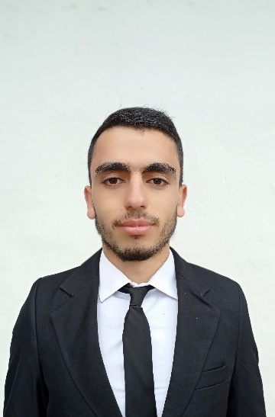

# SKILLS

* **Development:**

**Web:**

**Back-End:** JEE – Spring Framework

ASP .Net Core - PHP

**Front-End:** React JS – jQuery - HTML5/CSS3

**Mobile:** Flutter

**Desktop:** JAVA Swing/AWT - Visual Basic (VB)

* **Databases:**
* MySQL
* Oracle 11g
* PL/SQL
* Access - SQLite3
* **Version Control:** Git - GitHub
* **Programming Languages:**
* Java, JavaScript, Python, Dart, PHP, C#, VB
* C, Assembly Language.
* **Object Oriented Modeling:** UML 2.0
* **Computer Network:**
* TCP/IP, Sockets
* **Agile Project Management-SCRUM**
* **Design UI/UX et Graphisme :**
* Figma – Axure RP
* Adobe Photoshop

# PROJECTS

* **FinTbat** [-Web-](https://location-app-monolithic.herokuapp.com/)

Idée - Icônes entreprise gratuites **Rental management website**

JEE Spring-boot MYSQL Heroku

ReactJS HTML5 CSS3 Bootstrap

* **EMI-SHOP** [-Web & Mobile-](https://emi-shop.herokuapp.com/)

Idée - Icônes entreprise gratuites **E-commerce website**

Web Version : PHP MySQL Heruko

HTML5/CSS3 JS Bootstrap

Mobile Version : Flutter

* **Contoso-University** -Web-

Idée - Icônes entreprise gratuites **Tuition management application**

ASP .net Core MVC

* **BMI Calculator** -Mobile-

Idée - Icônes entreprise gratuites **Health tracking app**

Flutter

* **AGRBA** -Desktop-

Idée - Icônes entreprise gratuites **Airline Ticket Reservation**

**Management Application**

JAVA Oracle-11G