Working with GitHub Pages

You can create a website directly from a GitHub repository.

GitHub Pages 适用于具有 GitHub Free 和组织的 GitHub Free 的公共仓库，以及具有 GitHub Pro、GitHub Team、GitHub Enterprise Cloud 和 GitHub Enterprise Server 的公共和私有仓库。 更多信息请参阅“[GitHub 的产品](https://help.github.com/articles/github-s-products)”。

[目录](https://help.github.com/cn/github/working-with-github-pages#%E7%9B%AE%E5%BD%95)

* [Getting started with GitHub Pages](https://help.github.com/cn/github/working-with-github-pages/getting-started-with-github-pages)
  + [关于 GitHub Pages](https://help.github.com/cn/github/working-with-github-pages/about-github-pages)
  + [Creating a GitHub Pages site](https://help.github.com/cn/github/working-with-github-pages/creating-a-github-pages-site)
  + [Adding a theme to your GitHub Pages site with the theme chooser](https://help.github.com/cn/github/working-with-github-pages/adding-a-theme-to-your-github-pages-site-with-the-theme-chooser)
  + [配置 GitHub Pages 站点的发布源](https://help.github.com/cn/github/working-with-github-pages/configuring-a-publishing-source-for-your-github-pages-site)
  + [为 GitHub Pages 站点创建自定义 404 页面](https://help.github.com/cn/github/working-with-github-pages/creating-a-custom-404-page-for-your-github-pages-site)
  + [使用 HTTPS 保护 GitHub Pages 站点](https://help.github.com/cn/github/working-with-github-pages/securing-your-github-pages-site-with-https)
  + [Using submodules with GitHub Pages](https://help.github.com/cn/github/working-with-github-pages/using-submodules-with-github-pages)
  + [Unpublishing a GitHub Pages site](https://help.github.com/cn/github/working-with-github-pages/unpublishing-a-github-pages-site)
* [Setting up a GitHub Pages site with Jekyll](https://help.github.com/cn/github/working-with-github-pages/setting-up-a-github-pages-site-with-jekyll)
  + [关于 GitHub Pages 和 Jekyll](https://help.github.com/cn/github/working-with-github-pages/about-github-pages-and-jekyll)
  + [Creating a GitHub Pages site with Jekyll](https://help.github.com/cn/github/working-with-github-pages/creating-a-github-pages-site-with-jekyll)
  + [Testing your GitHub Pages site locally with Jekyll](https://help.github.com/cn/github/working-with-github-pages/testing-your-github-pages-site-locally-with-jekyll)
  + [Adding content to your GitHub Pages site using Jekyll](https://help.github.com/cn/github/working-with-github-pages/adding-content-to-your-github-pages-site-using-jekyll)
  + [Setting a Markdown processor for your GitHub Pages site using Jekyll](https://help.github.com/cn/github/working-with-github-pages/setting-a-markdown-processor-for-your-github-pages-site-using-jekyll)
  + [Adding a theme to your GitHub Pages site using Jekyll](https://help.github.com/cn/github/working-with-github-pages/adding-a-theme-to-your-github-pages-site-using-jekyll)
  + [About Jekyll build errors for GitHub Pages sites](https://help.github.com/cn/github/working-with-github-pages/about-jekyll-build-errors-for-github-pages-sites)
  + [Troubleshooting Jekyll build errors for GitHub Pages sites](https://help.github.com/cn/github/working-with-github-pages/troubleshooting-jekyll-build-errors-for-github-pages-sites)
* [配置 GitHub Pages 站点的自定义域](https://help.github.com/cn/github/working-with-github-pages/configuring-a-custom-domain-for-your-github-pages-site)
  + [关于自定义域名和 GitHub 页面](https://help.github.com/cn/github/working-with-github-pages/about-custom-domains-and-github-pages)
  + [Managing a custom domain for your GitHub Pages site](https://help.github.com/cn/github/working-with-github-pages/managing-a-custom-domain-for-your-github-pages-site)
  + [Troubleshooting custom domains and GitHub Pages](https://help.github.com/cn/github/working-with-github-pages/troubleshooting-custom-domains-and-github-pages)

Getting started with GitHub Pages

You can set up a basic GitHub Pages site for yourself, your organization, or your project.

GitHub Pages 适用于具有 GitHub Free 和组织的 GitHub Free 的公共仓库，以及具有 GitHub Pro、GitHub Team、GitHub Enterprise Cloud 和 GitHub Enterprise Server 的公共和私有仓库。 更多信息请参阅“[GitHub 的产品](https://help.github.com/articles/github-s-products)”。

[关于 GitHub Pages→](https://help.github.com/cn/github/working-with-github-pages/about-github-pages)

您可以使用 GitHub Pages 直接从 GitHub 仓库托管关于自己、您的组织或您的项目的站点。

[Creating a GitHub Pages site→](https://help.github.com/cn/github/working-with-github-pages/creating-a-github-pages-site)

You can create a GitHub Pages site in a new or existing repository.

[Adding a theme to your GitHub Pages site with the theme chooser→](https://help.github.com/cn/github/working-with-github-pages/adding-a-theme-to-your-github-pages-site-with-the-theme-chooser)

You can add a theme to your GitHub Pages site to customize your site’s look and feel.

[配置 GitHub Pages 站点的发布源→](https://help.github.com/cn/github/working-with-github-pages/configuring-a-publishing-source-for-your-github-pages-site)

如果您使用 GitHub Pages 站点的默认发布源，您的站点将自动发布。 您也可以选择从不同的分支或文件夹发布您的项目站点。

[为 GitHub Pages 站点创建自定义 404 页面→](https://help.github.com/cn/github/working-with-github-pages/creating-a-custom-404-page-for-your-github-pages-site)

您可以自定义在人们尝试访问您站点上不存在的页面时显示的 404 错误页面。

[使用 HTTPS 保护 GitHub Pages 站点→](https://help.github.com/cn/github/working-with-github-pages/securing-your-github-pages-site-with-https)

HTTPS 增加一层加密，用于防止其他人窥探或篡改您的站点的流量。 您可对 GitHub Pages 站点强制实施 HTTPS，从而将所有 HTTP 请求透明地重定向到 HTTPS。

[Using submodules with GitHub Pages→](https://help.github.com/cn/github/working-with-github-pages/using-submodules-with-github-pages)

You can use submodules with GitHub Pages to include other projects in your site's code.

[Unpublishing a GitHub Pages site→](https://help.github.com/cn/github/working-with-github-pages/unpublishing-a-github-pages-site)

You can unpublish your GitHub Pages site so that the site is no longer available to the public.

Adding a theme to your GitHub Pages site with the theme chooser

You can add a theme to your GitHub Pages site to customize your site’s look and feel.

GitHub Pages 适用于具有 GitHub Free 和组织的 GitHub Free 的公共仓库，以及具有 GitHub Pro、GitHub Team、GitHub Enterprise Cloud 和 GitHub Enterprise Server 的公共和私有仓库。 更多信息请参阅“[GitHub 的产品](https://help.github.com/articles/github-s-products)”。

[本文内容](https://help.github.com/cn/github/working-with-github-pages/adding-a-theme-to-your-github-pages-site-with-the-theme-chooser#in-this-article)

* [About the theme chooser](https://help.github.com/cn/github/working-with-github-pages/adding-a-theme-to-your-github-pages-site-with-the-theme-chooser#about-the-theme-chooser)
* [Adding a theme with the theme chooser](https://help.github.com/cn/github/working-with-github-pages/adding-a-theme-to-your-github-pages-site-with-the-theme-chooser#adding-a-theme-with-the-theme-chooser)
* [延伸阅读](https://help.github.com/cn/github/working-with-github-pages/adding-a-theme-to-your-github-pages-site-with-the-theme-chooser#further-reading)

People with admin permissions for a repository can use the theme chooser to add a theme to a GitHub Pages site.

[About the theme chooser](https://help.github.com/cn/github/working-with-github-pages/adding-a-theme-to-your-github-pages-site-with-the-theme-chooser#about-the-theme-chooser)

The theme chooser adds a Jekyll theme to your repository. For more information about Jekyll, see "[About GitHub Pages and Jekyll](https://help.github.com/cn/articles/about-github-pages-and-jekyll)."

How the theme chooser works depends on whether your repository is public or private.

* If GitHub Pages is already enabled for your repository, the theme chooser will add your theme to the current publishing source.
* If your repository is public and GitHub Pages is disabled for your repository, using the theme chooser will enable GitHub Pages and configure the master branch as your publishing source.
* If your repository is private and GitHub Pages is disabled for your repository, you must enable GitHub Pages by configuring a publishing source before you can use the theme chooser.

有关发布源的更多信息，请参阅“[关于 GitHub Pages](https://help.github.com/cn/articles/about-github-pages#publishing-sources-for-github-pages-sites)”。

If you manually added a Jekyll theme to your repository in the past, those files may be applied even after you use the theme chooser. To avoid conflicts, remove all manually added theme folders and files before using the theme chooser. For more information, see "[Adding a theme to your GitHub Pages site using Jekyll](https://help.github.com/cn/articles/adding-a-theme-to-your-github-pages-site-using-jekyll)."

[Adding a theme with the theme chooser](https://help.github.com/cn/github/working-with-github-pages/adding-a-theme-to-your-github-pages-site-with-the-theme-chooser#adding-a-theme-with-the-theme-chooser)

1. 在 GitHub 上，导航到站点的仓库。
2. 在仓库名称下，单击  **Settings（设置）**。
3. Under "GitHub Pages," click **Choose a theme** or **Change theme**.
4. On the top of the page, click the theme you want, then click **Select theme**.
5. You may be prompted to edit your site's *README.md* file.
   * To edit the file later, click **Cancel**.

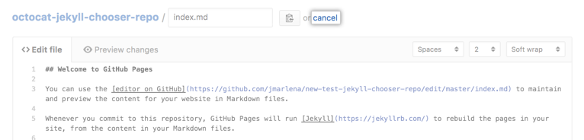

* + To edit the file now, see "[Editing files in your repository](https://help.github.com/cn/articles/editing-files-in-your-repository)."

Your chosen theme will automatically apply to markdown files in your repository. To apply your theme to HTML files in your repository, you need to add YAML front matter that specifies a layout to each file. For more information, see "[Front Matter](https://jekyllrb.com/docs/front-matter/)" on the Jekyll site.

[延伸阅读](https://help.github.com/cn/github/working-with-github-pages/adding-a-theme-to-your-github-pages-site-with-the-theme-chooser#further-reading)

* [Themes](https://jekyllrb.com/docs/themes/) on the Jekyll site

配置 GitHub Pages 站点的发布源

如果您使用 GitHub Pages 站点的默认发布源，您的站点将自动发布。 您也可以选择从不同的分支或文件夹发布您的项目站点。

GitHub Pages 适用于具有 GitHub Free 和组织的 GitHub Free 的公共仓库，以及具有 GitHub Pro、GitHub Team、GitHub Enterprise Cloud 和 GitHub Enterprise Server 的公共和私有仓库。 更多信息请参阅“[GitHub 的产品](https://help.github.com/articles/github-s-products)”。

[本文内容](https://help.github.com/cn/github/working-with-github-pages/configuring-a-publishing-source-for-your-github-pages-site#in-this-article)

* [选择发布源](https://help.github.com/cn/github/working-with-github-pages/configuring-a-publishing-source-for-your-github-pages-site#choosing-a-publishing-source)
* [GitHub Pages 站点发布问题疑难排解](https://help.github.com/cn/github/working-with-github-pages/configuring-a-publishing-source-for-your-github-pages-site)

拥有仓库管理员权限的人可为 GitHub Pages 站点配置发布源。

有关发布源的更多信息，请参阅“[关于 GitHub Pages](https://help.github.com/cn/articles/about-github-pages#publishing-sources-for-github-pages-sites)”。

[选择发布源](https://help.github.com/cn/github/working-with-github-pages/configuring-a-publishing-source-for-your-github-pages-site#choosing-a-publishing-source)

在配置发布源之前，请确保您要用作发布源的分支或文件夹已经存在于您的仓库中。 例如，您或协作者必须在仓库的 master 分支上创建 /docs 文件夹，然后才可从 master 分支上的 /docs 文件夹发布项目站点。

1. 在 GitHub 上，导航到站点的仓库。
2. 在仓库名称下，单击  **Settings（设置）**。

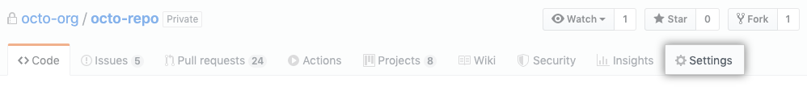

1. 在“GitHub Pages”下，使用 **Source（源）**下拉菜单选择发布源。

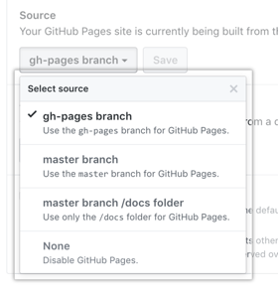

[GitHub Pages 站点发布问题疑难排解](https://help.github.com/cn/github/working-with-github-pages/configuring-a-publishing-source-for-your-github-pages-site)

**注**：如果网站的源文件位于默认发布源 - master（对于用户和组织站点）或 gh-pages（对于项目站点）- 但您的站点未自动发布，请确保有一个拥有管理权限和经验证的电子邮件地址的人已推送到默认发布源。

如果在选择 docs 文件夹作为发布源后从 master 分支删除 /docs 文件夹，您的站点不会构建，你将收到页面构建因缺少 /docs 文件夹而出错的消息。 更多信息请参阅“[关于 GitHub Pages 站点的 Jekyll 构建错误疑难排解](https://help.github.com/cn/articles/troubleshooting-jekyll-build-errors-for-github-pages-sites#missing-docs-folder)”。

为 GitHub Pages 站点创建自定义 404 页面

您可以自定义在人们尝试访问您站点上不存在的页面时显示的 404 错误页面。

GitHub Pages 适用于具有 GitHub Free 和组织的 GitHub Free 的公共仓库，以及具有 GitHub Pro、GitHub Team、GitHub Enterprise Cloud 和 GitHub Enterprise Server 的公共和私有仓库。 更多信息请参阅“[GitHub 的产品](https://help.github.com/articles/github-s-products)”。

1. 在 GitHub 上，导航到站点的仓库。
2. 导航到站点的发布来源。 有关发布源的更多信息，请参阅“[关于 GitHub Pages](https://help.github.com/cn/articles/about-github-pages#publishing-sources-for-github-pages-sites)”。
3. 在文件列表上方，单击 **Create new file（创建新文件）**。

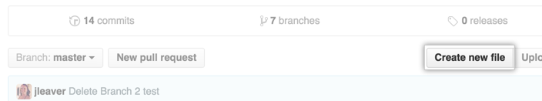

1. In the file name field, type 404.html or 404.md.

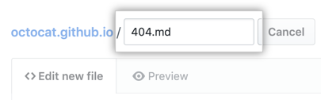

1. If you named your file 404.md, add the following YAML front matter to the beginning of the file:
2. **---**
3. permalink: /404.html
4. **---**
5. Below the YAML front matter, if present, add the content you want to display on your 404 page.
6. 在页面底部，输入一条简短、有意义的提交消息，描述您对文件所作的更改。 您可以在提交消息中将提交归于多个作者。 更多信息请参阅“[创建有多个合作作者的提交](https://help.github.com/cn/articles/creating-a-commit-with-multiple-authors)”。

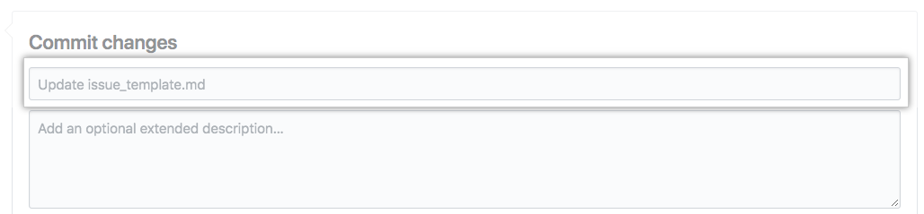

1. 以下是提交消息字段，请单击电子邮件地址下拉菜单并选择 Git 作者电子邮件地址。 只有经过验证的电子邮件地址才会出现在此下拉菜单中。 如果您启用了电子邮件地址隐私保护，则 <username>@users.noreply.github.com 为默认的提交作者电子邮件地址。 更多信息请参阅“[设置提交电子邮件地址](https://help.github.com/cn/articles/setting-your-commit-email-address)”。

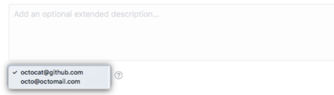

1. 在提交消息字段下面，确定是要将提交添加到当前分支还是新分支。 如果当前分支是 master，则应选择为提交创建新分支，然后创建拉取请求。 更多信息请参阅“[创建新的拉取请求](https://help.github.com/cn/articles/creating-a-pull-request)”。



1. 单击 **Propose new file（提议新文件）**。

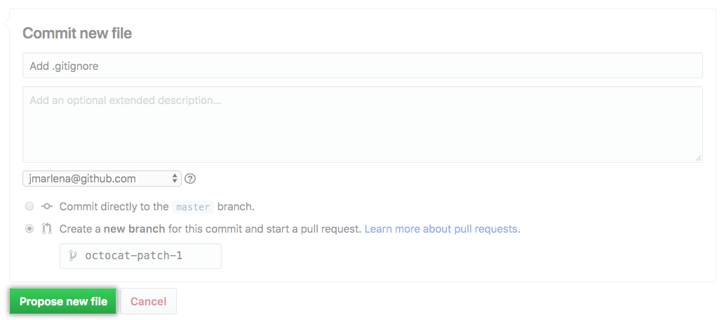

[延伸阅读](https://help.github.com/cn/github/working-with-github-pages/creating-a-custom-404-page-for-your-github-pages-site#further-reading)

* [Front matter](http://jekyllrb.com/docs/frontmatter) in the Jekyll documentation

使用 HTTPS 保护 GitHub Pages 站点

HTTPS 增加一层加密，用于防止其他人窥探或篡改您的站点的流量。 您可对 GitHub Pages 站点强制实施 HTTPS，从而将所有 HTTP 请求透明地重定向到 HTTPS。

GitHub Pages 适用于具有 GitHub Free 和组织的 GitHub Free 的公共仓库，以及具有 GitHub Pro、GitHub Team、GitHub Enterprise Cloud 和 GitHub Enterprise Server 的公共和私有仓库。 更多信息请参阅“[GitHub 的产品](https://help.github.com/articles/github-s-products)”。

[本文内容](https://help.github.com/cn/github/working-with-github-pages/securing-your-github-pages-site-with-https#in-this-article)

* [About HTTPS and GitHub Pages](https://help.github.com/cn/github/working-with-github-pages/securing-your-github-pages-site-with-https)
* [对您的 GitHub Pages 站点强制实施 HTTPS](https://help.github.com/cn/github/working-with-github-pages/securing-your-github-pages-site-with-https)
* [解决具有混合内容的问题](https://help.github.com/cn/github/working-with-github-pages/securing-your-github-pages-site-with-https#resolving-problems-with-mixed-content)

People with admin permissions for a repository can enforce HTTPS for a GitHub Pages site.

[About HTTPS and GitHub Pages](https://help.github.com/cn/github/working-with-github-pages/securing-your-github-pages-site-with-https)

所有 GitHub Pages 站点（包括使用自定义域正确配置的站点）均支持 HTTPS 和 HTTPS 强制实施。 For more information about custom domains, see "[About custom domains and GitHub Pages](https://help.github.com/cn/articles/about-custom-domains-and-github-pages)" and "[Troubleshooting custom domains and GitHub Pages](https://help.github.com/cn/articles/troubleshooting-custom-domains-and-github-pages#https-errors)."

对于使用 2016 年 1 月 15 日后创建的 github.io 域的 GitHub Pages 站点，需要强制实施 HTTPS。 If you created your site before June 15, 2016, you can manually enable HTTPS enforcement.

GitHub Pages 站点不应该用于敏感事务，例如发送密码或信用卡号码。

**警告**：GitHub Pages则站点将成为互联网上的公开内容，即使其仓库是私有的或内部的。 如果站点的仓库中有敏感数据，您可能想要在发布前删除它。 更多信息请参阅“[关于仓库可见性](https://help.github.com/cn/github/creating-cloning-and-archiving-repositories/about-repository-visibility)”。

[对您的 GitHub Pages 站点强制实施 HTTPS](https://help.github.com/cn/github/working-with-github-pages/securing-your-github-pages-site-with-https)

1. 在 GitHub 上，导航到站点的仓库。
2. 在仓库名称下，单击  **Settings（设置）**。



1. Under "GitHub Pages," select **Enforce HTTPS**.

[解决具有混合内容的问题](https://help.github.com/cn/github/working-with-github-pages/securing-your-github-pages-site-with-https#resolving-problems-with-mixed-content)

If you enable HTTPS for your GitHub Pages site but your site's HTML still references images, CSS, or JavaScript over HTTP, then your site is serving *mixed content*. Serving mixed content may make your site less secure and cause trouble loading assets.

To remove your site's mixed content, make sure all your assets are served over HTTPS by changing http:// to https:// in your site's HTML.

Assets are commonly found in the following locations:

* If your site uses Jekyll, your HTML files will probably be found in the *_layouts* folder.
* CSS is usually found in the <head> section of your HTML file.
* JavaScript is usually found in the <head> section or just before the closing </body> tag.
* Images are often found in the <body> section.

**Tip:** If you can't find your assets in your site's source files, try searching your site's source files for http in your text editor or on GitHub.

[Examples of assets referenced in an HTML file](https://help.github.com/cn/github/working-with-github-pages/securing-your-github-pages-site-with-https#examples-of-assets-referenced-in-an-html-file)

| **前端资源类型** | **HTTP** | **HTTPS** |
| --- | --- | --- |
| CSS | <link rel="stylesheet" href="http://example.com/css/main.css"> | <link rel="stylesheet" href="https://example.com/css/main.css"> |
| JavaScript | <script type="text/javascript" src="http://example.com/js/main.js"></script> | <script type="text/javascript" src="https://example.com/js/main.js"></script> |
| 图像 | <A HREF="http://www.somesite.com"><IMG SRC="http://www.example.com/logo.jpg" alt="Logo"></a> | <A HREF="https://www.somesite.com"><IMG SRC="https://www.example.com/logo.jpg" alt="Logo"></a> |

Using submodules with GitHub Pages

You can use submodules with GitHub Pages to include other projects in your site's code.

GitHub Pages 适用于具有 GitHub Free 和组织的 GitHub Free 的公共仓库，以及具有 GitHub Pro、GitHub Team、GitHub Enterprise Cloud 和 GitHub Enterprise Server 的公共和私有仓库。 更多信息请参阅“[GitHub 的产品](https://help.github.com/articles/github-s-products)”。

If the repository for your GitHub Pages site contains submodules, their contents will automatically be pulled in when your site is built.

You can only use submodules that point to public repositories, because the GitHub Pages server cannot access private repositories.

Use the https:// read-only URL for your submodules, including nested submodules. 您可以在 *.gitmodules* 文件中进行此更改。

[延伸阅读](https://help.github.com/cn/github/working-with-github-pages/using-submodules-with-github-pages#further-reading)

* "[Git Tools - Submodules](https://git-scm.com/book/en/Git-Tools-Submodules)" from the *Pro Git* book
* "[Troubleshooting Jekyll build errors for GitHub Pages sites](https://help.github.com/cn/articles/troubleshooting-jekyll-build-errors-for-github-pages-sites)"

Unpublishing a GitHub Pages site

You can unpublish your GitHub Pages site so that the site is no longer available to the public.

GitHub Pages 适用于具有 GitHub Free 和组织的 GitHub Free 的公共仓库，以及具有 GitHub Pro、GitHub Team、GitHub Enterprise Cloud 和 GitHub Enterprise Server 的公共和私有仓库。 更多信息请参阅“[GitHub 的产品](https://help.github.com/articles/github-s-products)”。

[本文内容](https://help.github.com/cn/github/working-with-github-pages/unpublishing-a-github-pages-site#in-this-article)

* [Unpublishing a project site](https://help.github.com/cn/github/working-with-github-pages/unpublishing-a-github-pages-site#unpublishing-a-project-site)
* [Unpublishing a user or organization site](https://help.github.com/cn/github/working-with-github-pages/unpublishing-a-github-pages-site#unpublishing-a-user-or-organization-site)
* [延伸阅读](https://help.github.com/cn/github/working-with-github-pages/unpublishing-a-github-pages-site#further-reading)

People with admin permissions for a repository can unpublish a GitHub Pages site.

[Unpublishing a project site](https://help.github.com/cn/github/working-with-github-pages/unpublishing-a-github-pages-site#unpublishing-a-project-site)

1. 在 GitHub 上，导航到仓库的主页面。
2. If a gh-pages branch exists in the repository, delete the gh-pages branch.
3. If the gh-pages branch was your publishing source, skip to step 6.
4. 在仓库名称下，单击  **Settings（设置）**。
5. Under "GitHub Pages", use the **Source** drop-down menu and select **None.**
6. 如果为站点启用了自定义域，为避免域名被占用，请更新您的 DNS 设置。 更多信息请参阅“[为 GitHub Pages 站点配置自定义域](https://help.github.com/cn/articles/configuring-a-custom-domain-for-your-github-pages-site)”。

[Unpublishing a user or organization site](https://help.github.com/cn/github/working-with-github-pages/unpublishing-a-github-pages-site#unpublishing-a-user-or-organization-site)

1. 在 GitHub 上，导航到仓库的主页面。
2. Delete the master branch, or delete the entire repository. For more information, see "[Creating and deleting branches within your repository](https://help.github.com/cn/articles/creating-and-deleting-branches-within-your-repository#deleting-a-branch)" and "[Deleting a repository](https://help.github.com/cn/articles/deleting-a-repository)."
3. 如果为站点启用了自定义域，为避免域名被占用，请更新您的 DNS 设置。 更多信息请参阅“[为 GitHub Pages 站点配置自定义域](https://help.github.com/cn/articles/configuring-a-custom-domain-for-your-github-pages-site)”。

[延伸阅读](https://help.github.com/cn/github/working-with-github-pages/unpublishing-a-github-pages-site#further-reading)

* "[Creating and deleting branches within your repository](https://help.github.com/cn/articles/creating-and-deleting-branches-within-your-repository#deleting-a-branch)"

Setting up a GitHub Pages site with Jekyll

You can use Jekyll, a popular static site generator, to further customize your GitHub Pages site.

GitHub Pages 适用于具有 GitHub Free 和组织的 GitHub Free 的公共仓库，以及具有 GitHub Pro、GitHub Team、GitHub Enterprise Cloud 和 GitHub Enterprise Server 的公共和私有仓库。 更多信息请参阅“[GitHub 的产品](https://help.github.com/articles/github-s-products)”。

[关于 GitHub Pages 和 Jekyll→](https://help.github.com/cn/github/working-with-github-pages/about-github-pages-and-jekyll)

Jekyll 是一个静态站点生成器，内置 GitHub Pages 支持。

[Creating a GitHub Pages site with Jekyll→](https://help.github.com/cn/github/working-with-github-pages/creating-a-github-pages-site-with-jekyll)

You can use Jekyll to create a GitHub Pages site in a new or existing repository.

[Testing your GitHub Pages site locally with Jekyll→](https://help.github.com/cn/github/working-with-github-pages/testing-your-github-pages-site-locally-with-jekyll)

You can build your GitHub Pages site locally to preview and test changes to your site.

[Adding content to your GitHub Pages site using Jekyll→](https://help.github.com/cn/github/working-with-github-pages/adding-content-to-your-github-pages-site-using-jekyll)

You can add a new page or post to your Jekyll site on GitHub Pages.

[Setting a Markdown processor for your GitHub Pages site using Jekyll→](https://help.github.com/cn/github/working-with-github-pages/setting-a-markdown-processor-for-your-github-pages-site-using-jekyll)

You can choose a Markdown processor to determine how Markdown is rendered on your GitHub Pages site.

[Adding a theme to your GitHub Pages site using Jekyll→](https://help.github.com/cn/github/working-with-github-pages/adding-a-theme-to-your-github-pages-site-using-jekyll)

You can personalize your Jekyll site by adding and customizing a theme.

[About Jekyll build errors for GitHub Pages sites→](https://help.github.com/cn/github/working-with-github-pages/about-jekyll-build-errors-for-github-pages-sites)

If Jekyll encounters an error building your GitHub Pages site locally or on GitHub, you'll receive an error message with more information.

[Troubleshooting Jekyll build errors for GitHub Pages sites→](https://help.github.com/cn/github/working-with-github-pages/troubleshooting-jekyll-build-errors-for-github-pages-sites)

You can use Jekyll build error messages to troubleshoot problems with your GitHub Pages site.

配置 GitHub Pages 站点的自定义域

您可以自定义 GitHub Pages 站点的域名。

GitHub Pages 适用于具有 GitHub Free 和组织的 GitHub Free 的公共仓库，以及具有 GitHub Pro、GitHub Team、GitHub Enterprise Cloud 和 GitHub Enterprise Server 的公共和私有仓库。 更多信息请参阅“[GitHub 的产品](https://help.github.com/articles/github-s-products)”。

[关于自定义域名和 GitHub 页面→](https://help.github.com/cn/github/working-with-github-pages/about-custom-domains-and-github-pages)

GitHub Pages 支持使用自定义域名，或者将网站的 URL 根目录从默认值（如 octocat.github.io）更改为您拥有的任何域名。

[Managing a custom domain for your GitHub Pages site→](https://help.github.com/cn/github/working-with-github-pages/managing-a-custom-domain-for-your-github-pages-site)

You can set up or update certain DNS records and your repository settings to point the default domain for your GitHub Pages site to a custom domain.

[Troubleshooting custom domains and GitHub Pages→](https://help.github.com/cn/github/working-with-github-pages/troubleshooting-custom-domains-and-github-pages)

You can check for common errors to resolve issues with custom domains or HTTPS for your GitHub Pages site.

关于自定义域名和 GitHub 页面

GitHub Pages 支持使用自定义域名，或者将网站的 URL 根目录从默认值（如 octocat.github.io）更改为您拥有的任何域名。

GitHub Pages 适用于具有 GitHub Free 和组织的 GitHub Free 的公共仓库，以及具有 GitHub Pro、GitHub Team、GitHub Enterprise Cloud 和 GitHub Enterprise Server 的公共和私有仓库。 更多信息请参阅“[GitHub 的产品](https://help.github.com/articles/github-s-products)”。

[本文内容](https://help.github.com/cn/github/working-with-github-pages/about-custom-domains-and-github-pages#in-this-article)

* [支持的自定义域](https://help.github.com/cn/github/working-with-github-pages/about-custom-domains-and-github-pages#supported-custom-domains)
* [对您的 GitHub Pages 网站使用子域名](https://help.github.com/cn/github/working-with-github-pages/about-custom-domains-and-github-pages)
* [对您的 GitHub Pages 网站使用 apex 域](https://help.github.com/cn/github/working-with-github-pages/about-custom-domains-and-github-pages)
* [在 GitHub Pages 站点禁用时更新自定义域](https://help.github.com/cn/github/working-with-github-pages/about-custom-domains-and-github-pages)
* [延伸阅读](https://help.github.com/cn/github/working-with-github-pages/about-custom-domains-and-github-pages#further-reading)

[支持的自定义域](https://help.github.com/cn/github/working-with-github-pages/about-custom-domains-and-github-pages#supported-custom-domains)

GitHub Pages 可使用两种类型的域名：子域名和 apex 域名。 有关不支持的自定义域名列表，请参阅“[自定义域名和 GitHub Pages 疑难解答](https://help.github.com/cn/articles/troubleshooting-custom-domains-and-github-pages/" \l "custom-domain-names-that-are-unsupported)“。

| **支持的自定义域类型** | **示例** |
| --- | --- |
| www 子域 | www.example.com |
| 自定义子域 | blog.example.com |
| Apex 域 | example.com |

您可以为您的网站设置一种或两种自定义域。 建议始终使用 www 子域名，即使您也同时使用 apex 域。 更多信息请参阅“[对您的 GitHub Pages 网站使用 apex 域](https://help.github.com/cn/github/working-with-github-pages/about-custom-domains-and-github-pages#using-an-apex-domain-for-your-github-pages-site)”。

After you configure a custom domain for a user or organization site, the custom domain will replace the <user>.github.io or <organization>.github.io portion of the URL for any project sites owned by the account that do not have a custom domain configured. 例如，如果您的用户网站的自定义域名为 www.octocat.com，并且您拥有一个未自定义域名的项目网站，该网站从名为 octo-project 的仓库发布，则该仓库的 GitHub Pages 网站将在 www.octocat.com/octo-project 上提供。

[对您的 GitHub Pages 网站使用子域名](https://help.github.com/cn/github/working-with-github-pages/about-custom-domains-and-github-pages)

子域名是根域前 URL 的一部分。 您可以将子域名配置为 www 或网站的独特部分，如 blog.example.com。

子域名配置通过 DNS 提供商使用 CNAME 记录配置。 更多信息请参阅“[管理 GitHub Pages 网站的自定义域](https://help.github.com/cn/articles/managing-a-custom-domain-for-your-github-pages-site#configuring-a-subdomain)。

[www 子域](https://help.github.com/cn/github/working-with-github-pages/about-custom-domains-and-github-pages)

www 子域名是最常用的一种子域名。 例如，www.example.com 包含 www 子域名。

www 子域名是最稳定的一种自定义域，因为 www 子域名不受 GitHub 服务器 IP 地址变动的影响。 您的网站加载速度也会更快，因为拒绝服务 (DoS) 攻击保护可以更有效地实施。

[自定义子域](https://help.github.com/cn/github/working-with-github-pages/about-custom-domains-and-github-pages#custom-subdomains)

自定义子域是一种不使用标准 www 子域的子域。 自定义子域主要在您需要将网站分为两个不同的部分时使用。 例如，您可以创建一个名为 blog.example.com 并自定义该部分与 www.example.com 分开。

[对您的 GitHub Pages 网站使用 apex 域](https://help.github.com/cn/github/working-with-github-pages/about-custom-domains-and-github-pages)

Apex 域是一个不包含子域的自定义域，如 example.com。 Apex 域也称为基础域、裸域、根 apex 域或区域 apex 域。

Apex 域配置通过 DNS 提供商使用 A, ALAS 或 ANAME 记录配置。 更多信息请参阅“[管理 GitHub Pages 网站的自定义域](https://help.github.com/cn/articles/managing-a-custom-domain-for-your-github-pages-site#configuring-an-apex-domain)。

如果使用 apex 域作为自定义域名，建议还设置一个 www 子域。 如果通过 DNS 提供程序配置每种域类型的正确记录，GitHub Pages 将自动在域之间创建重定向。 例如，如果您配置 www.example.com 作为站点的自定义域，并且为 apex 和 www 域设置了 ALIAS 和 CNAME 记录，则 example.com 将重定向到 www.example.com。 更多信息请参阅“[管理 GitHub Pages 网站的自定义域](https://help.github.com/cn/github/working-with-github-pages/managing-a-custom-domain-for-your-github-pages-site/#configuring-a-subdomain)”。

[在 GitHub Pages 站点禁用时更新自定义域](https://help.github.com/cn/github/working-with-github-pages/about-custom-domains-and-github-pages)

如果您的 GitHub Pages 站点设置了自定义域，并且站点已禁用，您应立即通过 DNS 提供商更新或删除 DNS 记录，以避免域接管的风险。 在您的网站被禁用时拥有通过 DNS 提供商配置的自定义域，可能会导致其他人在您的一个子域上托管网站。 更多信息请参阅“[管理 GitHub Pages 网站的自定义域](https://help.github.com/cn/articles/managing-a-custom-domain-for-your-github-pages-site)。

有许多原因会导致您的网站被自动禁用。

* 如果您从 GitHub Pro 降级到 GitHub Free，则目前发布自您的帐户中私有仓库的任何 GitHub Pages 站点都会取消发布。 更多信息请参阅“[Downgrading your GitHub 结算方案](https://help.github.com/cn/articles/downgrading-your-github-billing-plan)”。
* 如果将私人仓库转让给使用 GitHub Free 的个人帐户，仓库将失去对 GitHub Pages 功能的访问，当前发布的 GitHub Pages 站点将取消发布。 更多信息请参阅“[转让仓库](https://help.github.com/cn/articles/transferring-a-repository)”。

[延伸阅读](https://help.github.com/cn/github/working-with-github-pages/about-custom-domains-and-github-pages#further-reading)

* "[自定义域名和 GitHub Pages 疑难解答](https://help.github.com/cn/articles/troubleshooting-custom-domains-and-github-pages)"

Managing a custom domain for your GitHub Pages site

You can set up or update certain DNS records and your repository settings to point the default domain for your GitHub Pages site to a custom domain.

[Mac**Windows**Linux](https://help.github.com/cn/github/working-with-github-pages/managing-a-custom-domain-for-your-github-pages-site)

GitHub Pages 适用于具有 GitHub Free 和组织的 GitHub Free 的公共仓库，以及具有 GitHub Pro、GitHub Team、GitHub Enterprise Cloud 和 GitHub Enterprise Server 的公共和私有仓库。 更多信息请参阅“[GitHub 的产品](https://help.github.com/articles/github-s-products)”。

[本文内容](https://help.github.com/cn/github/working-with-github-pages/managing-a-custom-domain-for-your-github-pages-site#in-this-article)

* [About custom domain configuration](https://help.github.com/cn/github/working-with-github-pages/managing-a-custom-domain-for-your-github-pages-site#about-custom-domain-configuration)
* [Configuring a subdomain](https://help.github.com/cn/github/working-with-github-pages/managing-a-custom-domain-for-your-github-pages-site#configuring-a-subdomain)
* [Configuring an apex domain](https://help.github.com/cn/github/working-with-github-pages/managing-a-custom-domain-for-your-github-pages-site#configuring-an-apex-domain)
* [延伸阅读](https://help.github.com/cn/github/working-with-github-pages/managing-a-custom-domain-for-your-github-pages-site#further-reading)

People with admin permissions for a repository can configure a custom domain for a GitHub Pages site.

[About custom domain configuration](https://help.github.com/cn/github/working-with-github-pages/managing-a-custom-domain-for-your-github-pages-site#about-custom-domain-configuration)

Make sure you add your custom domain to your GitHub Pages site before configuring your custom domain with your DNS provider. Configuring your custom domain with your DNS provider without adding your custom domain to GitHub could result in someone else being able to host a site on one of your subdomains.

The dig command, which can be used to verify correct configuration of DNS records, is not included in Windows. Before you can verify that your DNS records are configured correctly, you must install [BIND](https://www.isc.org/bind/).

**Note:** DNS changes can take up to 24 hours to propagate.

[Configuring a subdomain](https://help.github.com/cn/github/working-with-github-pages/managing-a-custom-domain-for-your-github-pages-site#configuring-a-subdomain)

To set up a www or custom subdomain, such as www.example.com or blog.example.com, you must create a *CNAME* file in your site's repository and configure a CNAME record with your DNS provider.

1. 在 GitHub 上，导航到站点的仓库。
2. 在仓库名称下，单击  **Settings（设置）**。
3. 在 "Custom domain（自定义域）"下，输入自定义域，然后单击 **Save（保存）**。 这将创建一个在发布源根目录中添加 *CNAME*文件的提交。

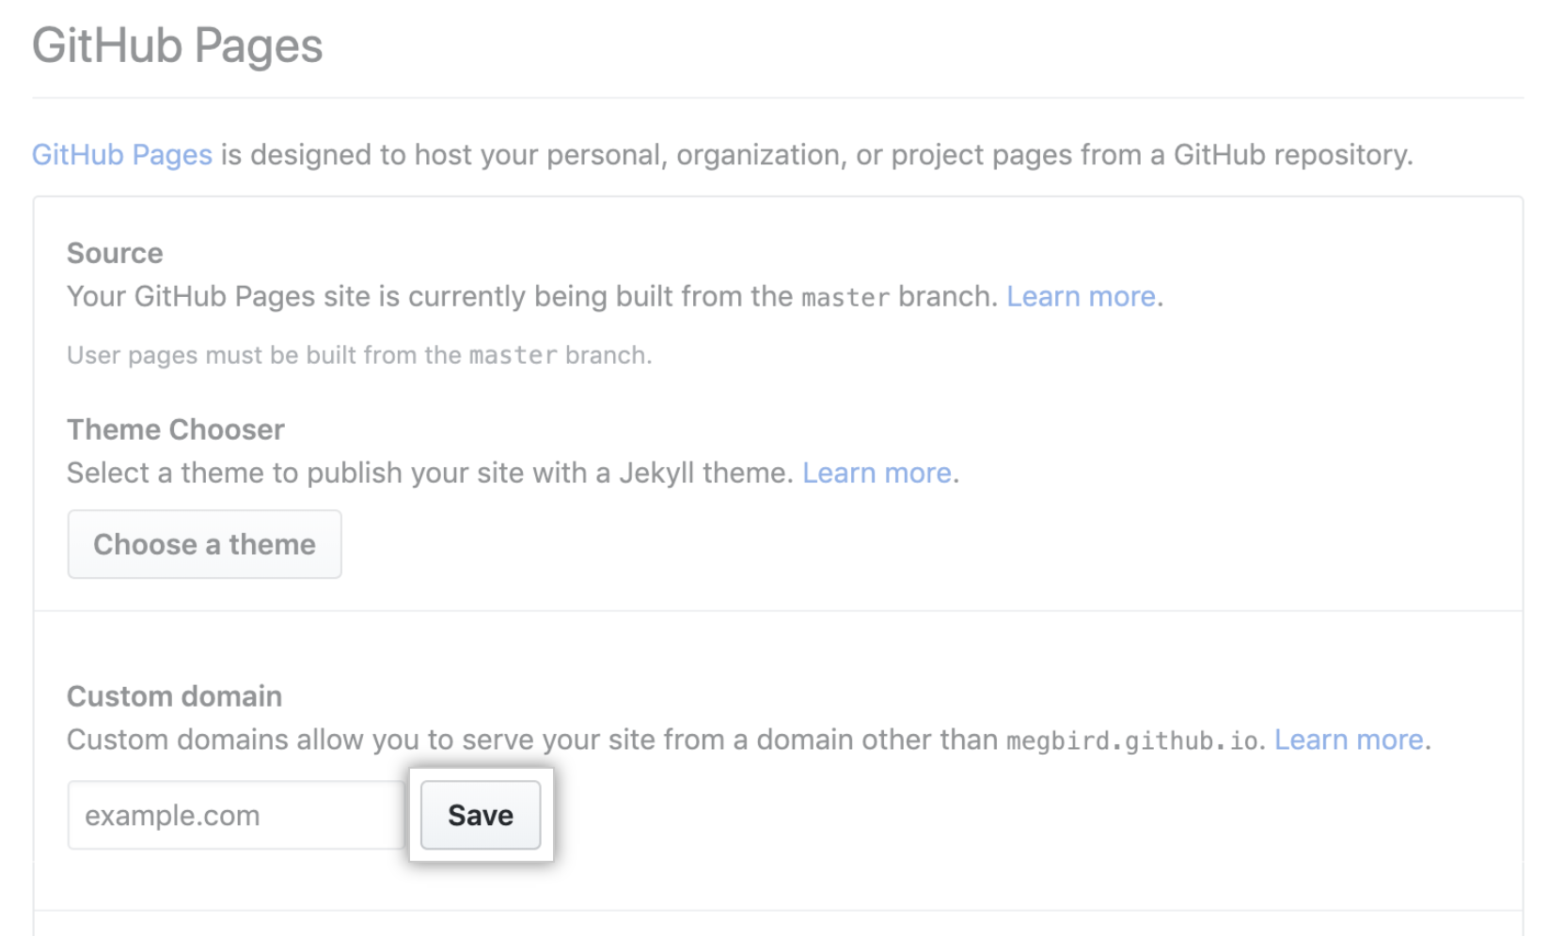

1. Navigate to your DNS provider and create a CNAME record that points your subdomain to the default domain for your site. For example, if you want to use the subdomain www.example.com for your user site, create a CNAME record that points www.example.com to <user>.github.io. 有关如何创建正确记录的更多信息，请参阅 DNS 提供程序的文档。有关站点默认域的更多信息，请参阅“[关于 GitHub Pages](https://help.github.com/cn/articles/about-github-pages#types-of-github-pages-sites)”。
2. 打开 Git Bash。
3. To confirm that your DNS record configured correctly, use the dig command, replacing *WWW.EXAMPLE.COM* with your subdomain.
4. $ dig *WWW.EXAMPLE.COM* +nostats +nocomments +nocmd
5. > ;*WWW.EXAMPLE.COM.* IN A
6. > *WWW.EXAMPLE.COM.* 3592 IN CNAME *YOUR-USERNAME*.github.io.
7. > *YOUR-USERNAME*.github.io. 43192 IN CNAME  *GITHUB-PAGES-SERVER* .

>  *GITHUB-PAGES-SERVER* . 22 IN A 192.0.2.1

1. 如果您使用静态站点生成器在本地构建站点，并将生成的文件推送到 GitHub，请拉取将*CNAME*文件添加到本地仓库的提交。 更多信息请参阅“[自定义域和 GitHub Pages 故障排除](https://help.github.com/cn/articles/troubleshooting-custom-domains-and-github-pages#cname-errors)”。
2. （可选）要为您的站点实施 HTTPS 加密，请选择 **Enforce HTTPS（实施 HTTPS）**。 可能要过 24 小时才能使用此选项。 更多信息请参阅“[使用 HTTPS 保护 GitHub Pages 站点](https://help.github.com/cn/articles/securing-your-github-pages-site-with-https)”。

[Configuring an apex domain](https://help.github.com/cn/github/working-with-github-pages/managing-a-custom-domain-for-your-github-pages-site#configuring-an-apex-domain)

To set up an apex domain, such as example.com, you must configure a *CNAME* file in your GitHub Pages repository and an ALIAS, ANAME, or A record with your DNS provider.

如果使用 apex 域作为自定义域名，建议还设置一个 www 子域。 如果通过 DNS 提供程序配置每种域类型的正确记录，GitHub Pages 将自动在域之间创建重定向。 例如，如果您配置 www.example.com 作为站点的自定义域，并且为 apex 和 www 域设置了 ALIAS 和 CNAME 记录，则 example.com 将重定向到 www.example.com。 更多信息请参阅“[管理 GitHub Pages 网站的自定义域](https://help.github.com/cn/github/working-with-github-pages/managing-a-custom-domain-for-your-github-pages-site/#configuring-a-subdomain)”。

1. 在 GitHub 上，导航到站点的仓库。
2. 在仓库名称下，单击  **Settings（设置）**。



1. 在 "Custom domain（自定义域）"下，输入自定义域，然后单击 **Save（保存）**。 这将创建一个在发布源根目录中添加 *CNAME*文件的提交。



1. Navigate to your DNS provider and create either an ALIAS, ANAME, or A record. 有关如何创建正确记录的更多信息，请参阅 DNS 提供程序的文档。
   * To create an ALIAS or ANAME record, point your apex domain to the default domain for your site. 有关站点默认域的更多信息，请参阅“[关于 GitHub Pages](https://help.github.com/cn/articles/about-github-pages#types-of-github-pages-sites)”。
   * To create an A record, point your apex domain to the IP addresses for GitHub Pages.
   * 185.199.108.153
   * 185.199.109.153
   * 185.199.110.153

185.199.111.153

1. 打开 Git Bash。
2. To confirm that your DNS record configured correctly, use the dig command, replacing *EXAMPLE.COM* with your apex domain. Confirm that the results match the IP addresses for GitHub Pages above.
3. $ dig *EXAMPLE.COM* +noall +answer
4. > *EXAMPLE.COM* 3600 IN A 185.199.108.153
5. > *EXAMPLE.COM* 3600 IN A 185.199.109.153
6. > *EXAMPLE.COM* 3600 IN A 185.199.110.153

> *EXAMPLE.COM* 3600 IN A 185.199.111.153

1. 如果您使用静态站点生成器在本地构建站点，并将生成的文件推送到 GitHub，请拉取将*CNAME*文件添加到本地仓库的提交。 更多信息请参阅“[自定义域和 GitHub Pages 故障排除](https://help.github.com/cn/articles/troubleshooting-custom-domains-and-github-pages#cname-errors)”。
2. （可选）要为您的站点实施 HTTPS 加密，请选择 **Enforce HTTPS（实施 HTTPS）**。 可能要过 24 小时才能使用此选项。 更多信息请参阅“[使用 HTTPS 保护 GitHub Pages 站点](https://help.github.com/cn/articles/securing-your-github-pages-site-with-https)”。

[延伸阅读](https://help.github.com/cn/github/working-with-github-pages/managing-a-custom-domain-for-your-github-pages-site#further-reading)

* "[自定义域名和 GitHub Pages 疑难解答](https://help.github.com/cn/articles/troubleshooting-custom-domains-and-github-pages)"

Troubleshooting custom domains and GitHub Pages

You can check for common errors to resolve issues with custom domains or HTTPS for your GitHub Pages site.

GitHub Pages 适用于具有 GitHub Free 和组织的 GitHub Free 的公共仓库，以及具有 GitHub Pro、GitHub Team、GitHub Enterprise Cloud 和 GitHub Enterprise Server 的公共和私有仓库。 更多信息请参阅“[GitHub 的产品](https://help.github.com/articles/github-s-products)”。

[本文内容](https://help.github.com/cn/github/working-with-github-pages/troubleshooting-custom-domains-and-github-pages#in-this-article)

* [*CNAME* errors](https://help.github.com/cn/github/working-with-github-pages/troubleshooting-custom-domains-and-github-pages)
* [DNS misconfiguration](https://help.github.com/cn/github/working-with-github-pages/troubleshooting-custom-domains-and-github-pages#dns-misconfiguration)
* [Custom domain names that are unsupported](https://help.github.com/cn/github/working-with-github-pages/troubleshooting-custom-domains-and-github-pages#custom-domain-names-that-are-unsupported)
* [HTTPS 错误](https://help.github.com/cn/github/working-with-github-pages/troubleshooting-custom-domains-and-github-pages#https-errors)
* [URL formatting on Linux](https://help.github.com/cn/github/working-with-github-pages/troubleshooting-custom-domains-and-github-pages#url-formatting-on-linux)
* [Browser cache](https://help.github.com/cn/github/working-with-github-pages/troubleshooting-custom-domains-and-github-pages#browser-cache)

[*CNAME* errors](https://help.github.com/cn/github/working-with-github-pages/troubleshooting-custom-domains-and-github-pages)

Custom domains are stored in a *CNAME* file in the root of your publishing source. You can add or update this file through your repository settings or manually. 更多信息请参阅“[管理 GitHub Pages 网站的自定义域](https://help.github.com/cn/articles/managing-a-custom-domain-for-your-github-pages-site)。

For your site to render at the correct domain, make sure your *CNAME* file still exists in the repository. For example, many static site generators force push to your repository, which can overwrite the *CNAME* file that was added to your repository when you configured your custom domain. If you build your site locally and push generated files to GitHub, make sure to pull the commit that added the *CNAME* file to your local repository first, so the file will be included in the build.

Then, make sure the *CNAME* file is formatted correctly.

* The *CNAME* filename must be all uppercase.
* The *CNAME* file can contain only one domain. To point multiple domains to your site, you must set up a redirect through your DNS provider.
* The *CNAME* entry must be the bare domain. For example, www.example.com,blog.example.com, or example.com.
* The *CNAME* entry can only be used once on GitHub. For example, if another repository's *CNAME* file contains example.com, you cannot use example.com in the *CNAME* file for your repository.

[DNS misconfiguration](https://help.github.com/cn/github/working-with-github-pages/troubleshooting-custom-domains-and-github-pages#dns-misconfiguration)

If you have trouble pointing the default domain for your site to your custom domain, contact your DNS provider.

You can also test whether your custom domain's DNS records are configured correctly. 更多信息请参阅“[管理 GitHub Pages 网站的自定义域](https://help.github.com/cn/articles/managing-a-custom-domain-for-your-github-pages-site)。

[Custom domain names that are unsupported](https://help.github.com/cn/github/working-with-github-pages/troubleshooting-custom-domains-and-github-pages#custom-domain-names-that-are-unsupported)

If your custom domain is unsupported, you may need to change your domain to a supported domain. You can also contact your DNS provider to see if they offer forwarding services for domain names.

Make sure your site does not:

* Use more than one apex domain. For example, both example.com and anotherexample.com.
* Use more than one www subdomain. For example, both www.example.com and www.anotherexample.com.
* Use both an apex domain and custom subdomain. For example, both example.com and docs.example.com.

**Warning:** We strongly recommend not using wildcard DNS records, such as *.example.com. 通配符 DNS 记录将允许任何人在您的其中一个子域上托管 GitHub Pages 站点。

For a list of supported custom domains, see "[About custom domains and GitHub Pages](https://help.github.com/cn/articles/about-custom-domains-and-github-pages/#supported-custom-domains)."

[HTTPS 错误](https://help.github.com/cn/github/working-with-github-pages/troubleshooting-custom-domains-and-github-pages#https-errors)

通过 *CNAME*、ALIAS、ANAME 或 A DNS 记录正确配置的使用自定义域的 GitHub Pages 站点可通过 HTTPS 进行访问。 更多信息请参阅“[使用 HTTPS 保护 GitHub Pages 站点](https://help.github.com/cn/articles/securing-your-github-pages-site-with-https)”。

It can take up to an hour for your site to become available over HTTPS after you configure your custom domain. After you update existing DNS settings, you may need to remove and re-add your custom domain to your site's repository to trigger the process of enabling HTTPS. 更多信息请参阅“[管理 GitHub Pages 网站的自定义域](https://help.github.com/cn/articles/managing-a-custom-domain-for-your-github-pages-site)。

If you're using Certification Authority Authorization (CAA) records, at least one CAA record must exist with the value letsencrypt.org for your site to be accessible over HTTPS. 更多信息请参阅 Let's Encrypt 文档中的“[证书颁发机构授权 (CAA)](https://letsencrypt.org/docs/caa/)”。

[URL formatting on Linux](https://help.github.com/cn/github/working-with-github-pages/troubleshooting-custom-domains-and-github-pages#url-formatting-on-linux)

If the URL for your site contains a username or organization name that begins or ends with a dash, or contains consecutive dashes, people browsing with Linux will receive a server error when they attempt to visit your site. To fix this, change your GitHub username to remove non-alphanumeric characters. 更多信息请参阅“[更改 GitHub 用户名](https://help.github.com/cn/articles/changing-your-github-username)”。

[Browser cache](https://help.github.com/cn/github/working-with-github-pages/troubleshooting-custom-domains-and-github-pages#browser-cache)

If you've recently changed or removed your custom domain and can't access the new URL in your browser, you may need to clear your browser's cache to reach the new URL. For more information on clearing your cache, see your browser's documentation.

**问问别人**