## Project 2 – User Requirement and Design Report

## (By Varinder Singh) Needs and Goals Analysis

Based on my research, elderly individuals have a strong desire for a comprehensive solution that addresses their unique needs and challenges related to physical activity and overall well-being. One of the primary requirements is the facilitation of social interaction and community engagement, as maintaining meaningful connections and a sense of belonging is crucial for their mental and emotional health. Additionally, they seek personalized exercise routines tailored to their individual abilities, health conditions, and limitations. This customization is essential to ensure safety, prevent injuries, and maximize the effectiveness of their physical activities. Motivational support and encouragement are also highly valued, as many elderly individuals struggle with staying motivated and adhering to regular exercise routines. Furthermore, the solution should feature an easy-to-use interface with large fonts and simple navigation, catering to potential visual or cognitive impairments common among the elderly population. Progress tracking and feedback mechanisms are desired to monitor their achievements, celebrate milestones, and provide a sense of accomplishment. Overall, the elderly users seek a comprehensive solution that not only promotes physical fitness but also fosters social connections, provides personalized guidance, and creates an engaging and rewarding experience tailored to their unique needs and abilities.

## Device Overview

The proposed wearable IoT device is designed to be a compact and user-friendly device that can be worn comfortably by elderly individuals. It incorporates a range of sensors and components to collect vital health data, activity levels, and environmental information. The device will feature a small display to show the time and weather details, providing a familiar smartwatch-like design for easy adoption.

## Data Collection and Transmission

The wearable IoT device will continuously collect data from the various sensors, including vital signs, activity levels, location, and emotional state. The collected data will be processed by the microcontroller and transmitted to a secure cloud platform using wireless communication protocols such as Wi-Fi.

Integration with Healthcare Ecosystem

The collected data from the wearable IoT device will be seamlessly integrated into a comprehensive healthcare ecosystem, consisting of a mobile application and a web-based platform. This ecosystem will provide the following features:

* Interactive Data Visualization

1. Intuitive dashboards and graphs for tracking vital signs, activity levels, and health trends.
2. Personalized goal setting and progress monitoring

* Personalized Exercise System

1. Customized exercise routines based on individual abilities and health conditions.
2. Video demonstrations and audio instructions for proper form and technique

* Event Tracking and Notifications

1. Real-time alerts for potential falls, wandering, or health emergencies.
2. Reminders for medication, appointments, and daily activities

* Social Engagement and Community Support

1. Virtual exercise groups and challenges
2. Social feed for sharing progress and motivational messages.
3. Integration with local fitness classes and community programs

* Caregiver Access and Remote Monitoring

1. Authorized caregivers can monitor the health and well-being of elderly individuals remotely.
2. Secure access to health data and activity logs

## Security and Privacy Considerations

Data security and privacy are of utmost importance in healthcare applications. The wearable IoT device and the associated ecosystem will implement robust security measures, including:

1. Encrypted data transmission and storage
2. User authentication and access control mechanisms
3. Compliance with relevant data protection regulations
4. Secure communication protocols and regular software updates

## Microcontroller Comparison

The comparison of three microcontrollers that are suitable for wearable IoT devices, particularly in the context of elderly care: ESP8266, Arduino Nano 33 IoT, and Adafruit FLORA. The comparison covers various aspects, including specifications, features, and suitability for wearable applications.

**1. ESP8266**

The ESP8266 is a low-cost Wi-Fi microchip designed for IoT applications requiring wireless connectivity. It is primarily focused on providing Wi-Fi capabilities rather than being specifically tailored for wearable devices.

Specifications:

1. Low-power 32-bit microcontroller
2. Wi-Fi connectivity (802.11 b/g/n)
3. Limited processing power compared to other options.

Features:

1. Low-cost solution for simple IoT applications
2. Primarily designed for Wi-Fi connectivity
3. May not be as powerful for complex wearable applications.

Suitability for Wearable IoT Devices:

While the ESP8266 offers Wi-Fi connectivity, which is essential for IoT devices, it lacks specific features tailored for wearable applications. The search results do not mention a compact or wearable form factor, making it less suitable for elderly care wearables compared to the other options.

**2. Arduino Nano 33 IoT**

The Arduino Nano 33 IoT is a compact microcontroller board based on the ARM Cortex-M0+ processor. It is designed to be suitable for wearable devices and offers both Wi-Fi and Bluetooth Low Energy (BLE) connectivity.

Specifications:

1. ARM Cortex-M0+ processor.
2. Wi-Fi and BLE connectivity
3. Compact form factor suitable for wearable devices

Features:

1. Arduino-compatible, making it easier to integrate with various sensors and components.
2. Supports Wi-Fi and BLE for wireless communication.
3. Compact size suitable for wearable applications

Suitability for Wearable IoT Devices:

The Arduino Nano 33 IoT is a suitable choice for wearable IoT devices due to its compact size and wireless connectivity options (Wi-Fi and BLE). Its Arduino compatibility also makes it easier to integrate with various sensors and components required for elderly care applications.

3. Adafruit FLORA

The Adafruit FLORA is a wearable electronics platform specifically designed for wearable applications. It is Arduino-compatible and offers a range of features tailored for wearable projects.

Specifications:

1. Compact, round form factor (1.75" diameter, 4.4 grams)
2. Arduino-compatible
3. Built-in USB support for easy programming
4. Flexible power options (LiIon/LiPoly, LiFe, alkaline, NiMh/NiCad batteries)

Features:

1. Designed as a wearable electronics platform with a sewable form factor.
2. Extensive ecosystem of accessories and modules (sensors, GPS, LED NeoPixels)
3. Beginner-friendly with tutorials and community support
4. Flexible power management options

**Suitability for Wearable IoT Devices:**

The Adafruit FLORA is an excellent choice for wearable IoT devices, particularly for elderly care applications. Its compact, sewable form factor, Arduino compatibility, and extensive ecosystem of accessories make it well-suited for developing wearable devices with various sensors and components. However, the search results do not explicitly mention Wi-Fi capabilities, which may require the addition of an external Wi-Fi module or adapter.

**Comparison Summary**

When it comes to wearable IoT devices for elderly care, the Adafruit FLORA and Arduino Nano 33 IoT stand out as more suitable options compared to the ESP8266. The FLORA is purpose-built for wearable applications, offering a compact, sew-able form factor, Arduino compatibility, and a supportive ecosystem of accessories and resources. The Arduino Nano 33 IoT also has a compact size and offers both Wi-Fi and BLE connectivity, making it a versatile option for wearable IoT projects.

As Wi-Fi connectivity is a critical requirement, the Arduino Nano 33 IoT may be the better choice between the two, as the search results do not explicitly mention Wi-Fi capabilities for the FLORA. In that case, you may need to explore adding an external Wi-Fi module or adapter to the FLORA, which could potentially increase the complexity and size of the wearable device.

## Key Components and Sensors

1. **MPU6050 Accelerometer and Gyroscope**

The MPU6050 is a crucial component for monitoring mobility and detecting potential falls in elderly individuals. By combining a 3-axis accelerometer and a 3-axis gyroscope, this sensor can accurately track body movements, posture, and orientation changes, enabling fall detection and activity monitoring.

1. Heart Rate and Pulse Oximeter Module

* MAX86150: The MAX86150 is an advanced biosensor module that integrates both photoplethysmography (PPG) and electrocardiography (ECG) measurements in a single package. It can measure heart rate, blood oxygen saturation (SpO2), and electrocardiogram signals, providing comprehensive cardiovascular monitoring capabilities. The integrated ECG functionality sets the MAX86150 apart from the other two sensors, making it a more versatile option for monitoring heart health.

However, the MAX86150 may be more complex and power-hungry compared to the other sensors due to its advanced features.

* MAX30102:

The MAX30102 is a high-sensitivity pulse oximeter and heart rate sensor designed for wearable health applications. It can measure heart rate and blood oxygen saturation (SpO2) using PPG technology. While it lacks ECG functionality, the MAX30102 is a more specialized and optimized sensor for PPG measurements compared to the MAX30100. It offers improved performance and accuracy in heart rate and SpO2 monitoring compared to the MAX30100.

* MAX30100:

The MAX30100 is an earlier generation pulse oximeter and heart rate sensor from Maxim Integrated. Like the MAX30102, it can measure heart rate and blood oxygen saturation (SpO2) using PPG technology. However, the MAX30102 is generally considered a more advanced and higher-performance sensor compared to the MAX30100.

When considering these options for your wearable IoT device for elderly care, the MAX86150 stands out as the most comprehensive and feature-rich sensor. Its ability to measure both PPG and ECG signals can provide valuable insights into cardiovascular health, which is crucial for elderly care applications. However, it may come at the cost of increased complexity, power consumption, and potentially higher cost.

If ECG functionality is not a strict requirement, and you prioritize optimized PPG measurements for heart rate and SpO2 monitoring, the MAX30102 could be a more suitable choice. It offers improved performance and accuracy compared to the MAX30100, while being more power-efficient and potentially less complex than the MAX86150.

1. NEO-6M GPS Module

The NEO-6M GPS module is an important component for location tracking, allowing caregivers to monitor the whereabouts of elderly individuals. This feature can be particularly useful in cases of wandering or emergency situations, ensuring the safety and timely assistance of the wearer.

1. Human Body Temperature Sensor

A comparison between the MAX30205 and LM35DZ temperature sensors for monitoring body temperature in a wearable IoT device for elderly care:

MAX30205 Human Body Temperature Sensor

* + 1. The MAX30205 is a highly accurate and specialized sensor designed specifically for measuring human body temperature.
    2. It uses a thermistor-based sensing element and provides a digital output over an I2C interface.
    3. The MAX30205 offers high accuracy of ±0.1°C (typical) over a temperature range of 35°C to 42°C, which is ideal for body temperature monitoring.
    4. It has a small form factor (2.0 x 2.0 x 0.75 mm) and low power consumption, making it suitable for wearable applications.
    5. The MAX30205 includes features like fault detection, resolution configuration, and a built-in temperature sensor for cold junction compensation.

LM35DZ Precision Temperature Sensor

1. The LM35DZ is a general-purpose precision temperature sensor from Texas Instruments.
2. It provides an analog output voltage that is linearly proportional to the temperature in Celsius.
3. The LM35DZ offers a wide temperature range of -55°C to +150°C, with an accuracy of ±0.5°C at room temperature.
4. While not specifically designed for body temperature monitoring, it can be used for that purpose with appropriate calibration and packaging.
5. The LM35DZ has a larger form factor (TO-92 package) compared to the MAX30205, but it is still relatively compact.
6. It is a cost-effective and widely available temperature sensor but lacks some of the specialized features of the MAX30205.

**Comparison Summary**

The MAX30205 is specifically designed and optimized for human body temperature monitoring, offering high accuracy (±0.1°C) within the typical body temperature range. Its small size, low power consumption, and specialized features make it an ideal choice for wearable devices targeting elderly care applications. On the other hand, the LM35DZ is a general-purpose temperature sensor that can be used for body temperature monitoring but may require additional calibration and packaging to achieve the desired accuracy. While it offers a wider temperature range and is cost-effective, its accuracy (±0.5°C) is lower than the MAX30205 within the typical body temperature range. If high accuracy and specialized features for body temperature monitoring are critical requirements, the MAX30205 would be the preferred choice. However, if cost is a significant factor, and slightly lower accuracy is acceptable, the LM35DZ could be a viable alternative, especially if used in conjunction with other temperature sensors for redundancy and improved overall accuracy.

1. White I2C OLED Display

A small OLED display can be integrated into the wearable device to provide visual feedback and information to the wearer. This can include displaying vital signs, notifications, or other relevant data in a clear and readable format.

1. BME680 Environmental Sensor

Integrates temperature, humidity, barometric pressure, and gas sensing capabilities. Enables monitoring of ambient conditions and air quality. Compact size (3.8 x 3.6 x 0.93 mm) and low power consumption.

## Evaluating Other Sensor’s and their Relevance and Suitability

The sensors - Analog Sensor Pin Definition, Touch Sensor V2, Digital Tilt Sensor V2, Flame Sensor V2, Analog Ambient Light Sensor V2.1, Digital Vibration Sensor V2, buzzer, gas sensor, and DHT22 - are designed for various applications and environments but may not be directly relevant or suitable for a wearable IoT device focused on elderly care.

* The Analog Sensor Pin Definition, Touch Sensor V2, Digital Tilt Sensor V2, and Analog Ambient Light Sensor V2.1 are primarily used for detecting touch, tilt, and light levels, respectively. While these sensors could potentially be integrated into a wearable device, their direct relevance to elderly care may be limited unless specific use cases are identified, such as detecting falls or monitoring ambient light conditions.
* The Flame Sensor V2 and Gas Sensor are designed to detect the presence of flames and combustible gases, respectively. These sensors are more commonly used in industrial or environmental monitoring applications and may not be directly applicable to a wearable device for elderly care, unless there are specific safety concerns related to fire or gas leaks in the intended environment.
* The Digital Vibration Sensor V2 is typically used for detecting vibrations or movements, which could be useful for activity monitoring or fall detection in a wearable device. However, the accelerometer and gyroscope sensors mentioned earlier (e.g., MPU6050) may be more suitable for these purposes, as they are specifically designed for motion tracking and can provide more accurate and comprehensive data.
* The buzzer is a simple audio output device that could be used for notifications or alerts in a wearable device. However, its inclusion should be carefully considered, as audible alerts may not be the most appropriate or user-friendly approach for elderly individuals, who may have hearing impairments or prefer more discreet notifications.
* The DHT22 is a temperature and humidity sensor, which could be useful for monitoring environmental conditions. However, the MAX30205 temperature sensors mentioned earlier may be more suitable for monitoring body temperature, which is a critical parameter for elderly care.

While these sensors may have their applications in various domains, their inclusion in a wearable IoT device for elderly care should be carefully evaluated based on the specific requirements, user needs, and potential trade-offs in terms of complexity, power consumption, and cost. Focusing on the most relevant and essential sensors, such as those for monitoring vital signs, activity levels, and location, may be a more practical approach to ensure a user-friendly and effective solution tailored to the needs of elderly individuals.

## Final Component List

1. Arduino Nano 33 IOT

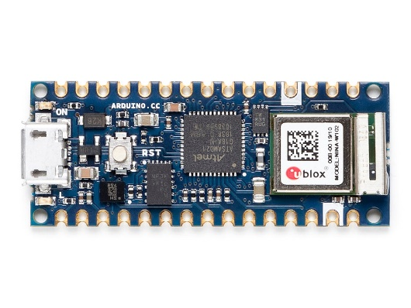

1. 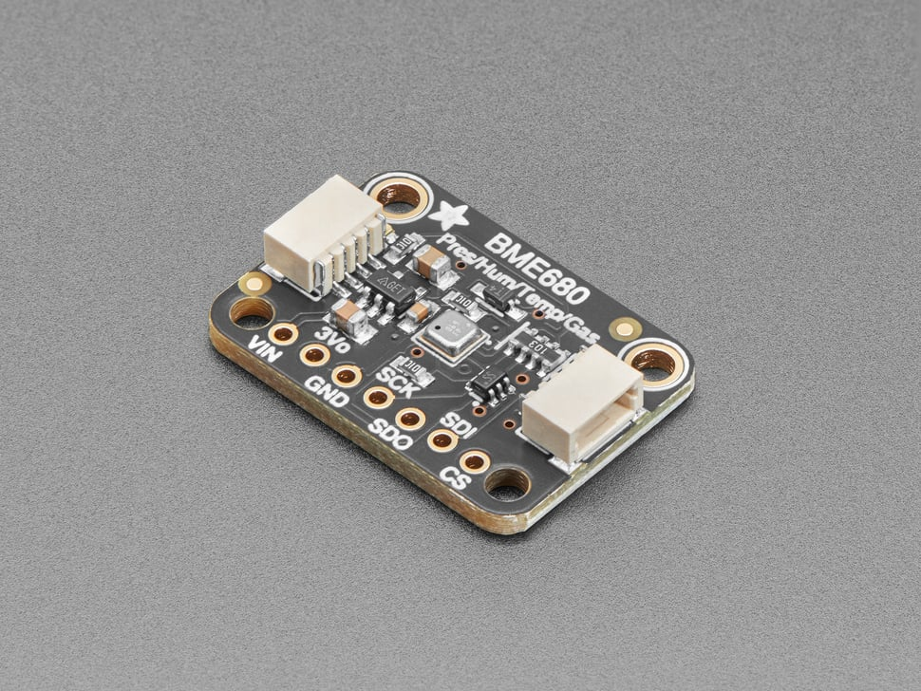BME680 Environmental Sensor (Temperature, Humidity, Barometric Pressure, and Gas Sensing Capabilities)

Link - <https://www.adafruit.com/product/3660>

1. I2C Display
2. MAX30205 Human Body Temperature Sensor

Link - <https://www.digikey.com.au/en/product-highlight/m/maxim-integrated/max30205-human-body-temperature-sensor-kit>

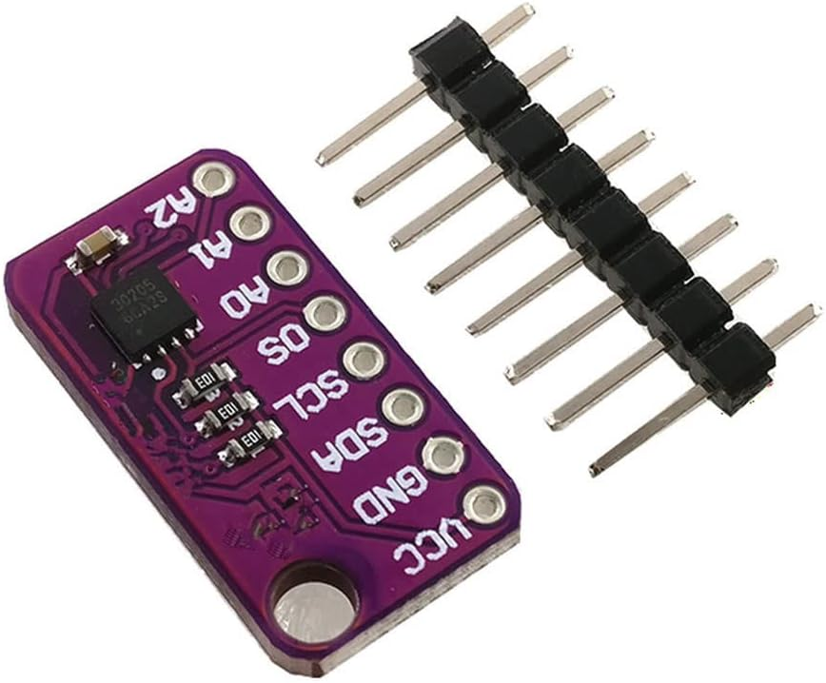

1. NEO-6M GPS Module

Link - <https://core-electronics.com.au/u-blox-neo-6m-gps-module.html>

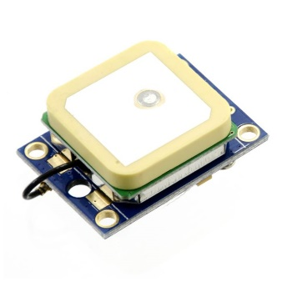

1. MAX30102 Heart Rate and Pulse Oximeter Module

Link - <https://core-electronics.com.au/dfrobot-max30102-heart-rate-and-oximeter-sensor.html>

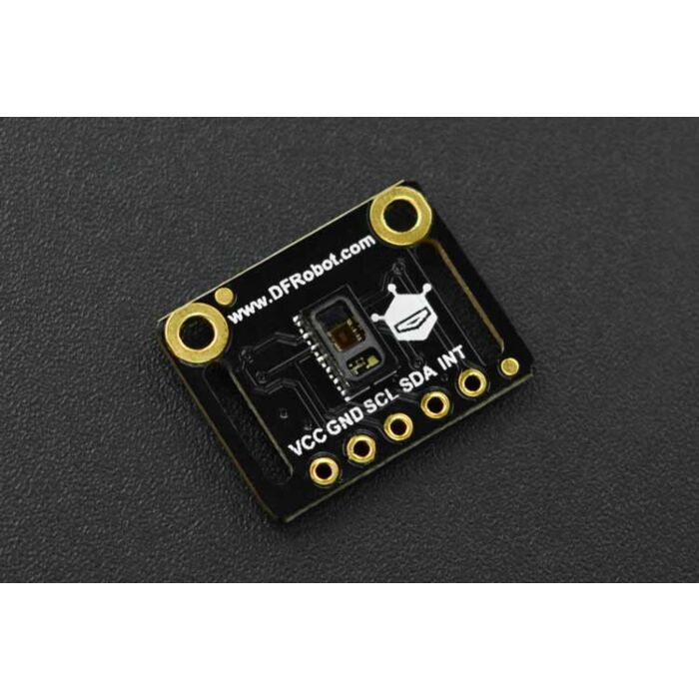

1. MPU6050 Accelerometer and Gyroscope

Link - <https://core-electronics.com.au/mpu-6050-module-3-axis-gyroscope-acce-lerometer.html>

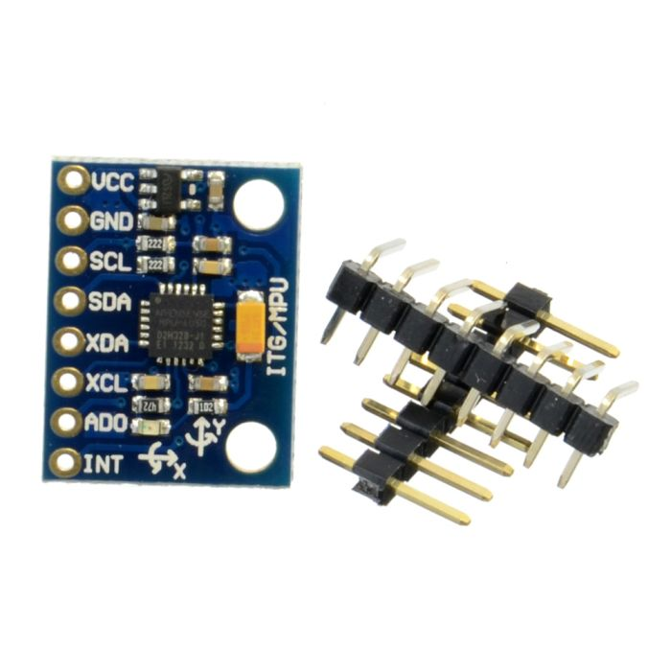

Here's a breakdown of how the sensors can be connected:

The Arduino Nano 33 IoT has the following available pins:

* 14 digital input/output pins
* 8 analog input pins
* 1 UART (serial) interface
* 1 SPI interface
* 1 I2C interface

The sensors in the final component list and their respective communication interfaces are:

* BME680 Environmental Sensor (I2C)
* I2C Display (I2C)
* MAX30205 Human Body Temperature Sensor (I2C)
* NEO-6M GPS Module (UART/Serial)
* MAX30102 Heart Rate and Pulse Oximeter Module (I2C)
* MPU6050 Accelerometer and Gyroscope (I2C)

Since the Arduino Nano 33 IoT has a single I2C interface, all the I2C sensors (BME680, I2C Display, MAX30205, MAX30102, and MPU6050) can be connected to the same I2C pins (SDA and SCL). However, each I2C device must have a unique address to avoid conflicts. The NEO-6M GPS Module can be connected to the UART (serial) interface using the RX and TX pins.