**Smart Contract Address**

Tier 2

Pre-Sale

From June 1st 2018 till June 21st 2018

**15% Bonus**

1 ETH = 2682 REDC

Minimum Contribution is 0.1 ETH – Max 425 ETH

Send Only ETH to the below address

Pre-Sale Smart Contract Address

0xC14ef3E7aA3FbAAd9931dc3f4B1594334C9d647f

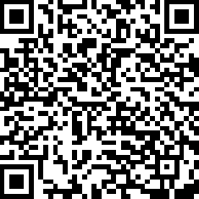

Important!

Send Ether to the crowd sale address with a MethodID: 0xa6f2ae3a

The MethodID (buy method) is implemented to ensure that Ether is not sent from an Exchange

*Please transfer funds from an ERC20 compatible wallet as MyEtherWallet.*

*Visit* [*https://clearify.io*](https://clearify.io) *to authenticate the address before investing*

**Invest from MetaMask**

* Open MetaMask Chrome plugin
* Connect to mainnet Network
* Choose an account with sufficient balance in this network.
* Send a transaction to the relevant address of the **RedCab Sale Contract** with the Transaction data 0xa6f2ae3a (signature of the buy method).
* Value to send is in ETH. For example, if you put 25 to input, you will invest 25 ETH.

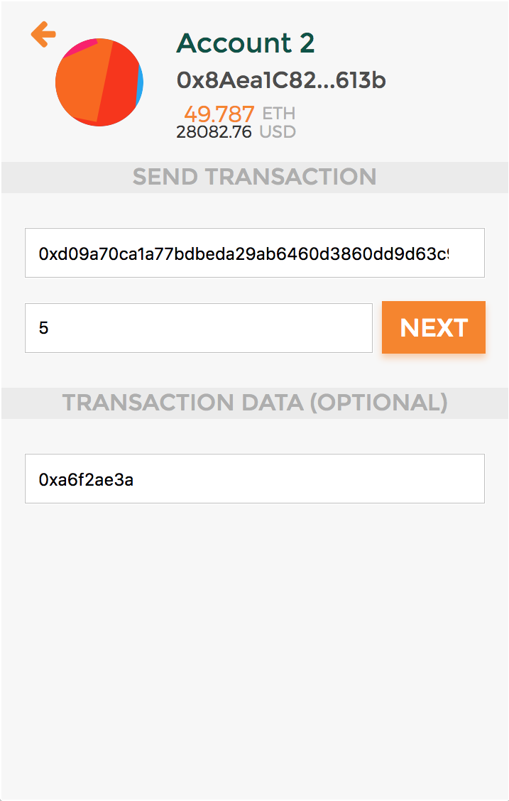

If the transaction fails, make sure that your ETH address is whitelisted.

Contact us at [support@redcab.io](mailto:support@redcab.io) if you need help

After your purchase, you can check your REDC balance by visiting your wallet address on <https://etherscan.io> and view your Token Balance

