Stack-GAN (s1 64x64+ caption - > 64x64 and S2 -> 64x64+ caption > 256x256)

300+ (Pre trained LM)

8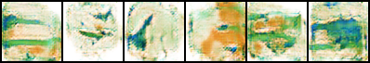 S1 64x64

1100+ (Own Language Model)

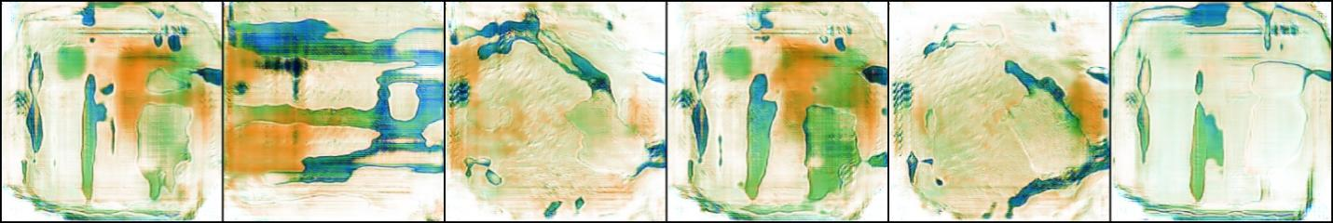 S2 256 x 256

1600+ (Pretained LM) 2500

S1 64x64

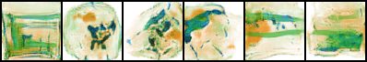 500epoch

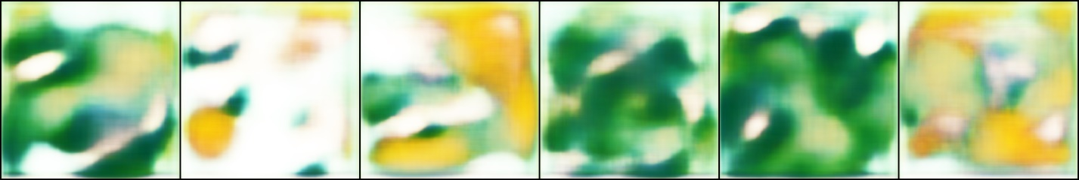epoch0 S2 256x256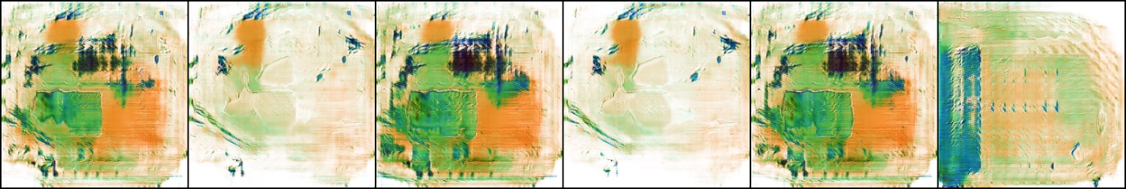

Epoch 500 S2 256x256 1000*10 =

Sharpening Algorithms – Classical

A gun in the center

3

1. Image count
2. Caption count

**May 25, 2023, 17:32**

Epoch 500, 1000DIM Fasttext Custom, 1800+ captions

64x64 Train Images

64x64 Test Images

256 x 256 Train Images

256 x 256 Test Images